PROPOSED RESEARCH TITLE: ANALYSING THE IMPOST OF CULTURE ON PROJECT PERFORMANCE IN THE IT INDUSTRY
Name of the university: University of Wales Trinity Saint David (London Campus)
Student name:Nadya Vasileva
Student ID:1908838
Submission date:02.09.2022

Table of Contents
Chapter 1: Introduction 2
1.1 Research Topic Overview 2
1.2 Significance of Research 3
1.3 Purpose of Research 3
1.4 Aim 3
1.5 Objectives 3
1.6 Questions 4
Chapter 2: Key Literature 5
2.1 Concept imposition of culture on project performance 5
2.2 Critical analysis of impact of imposing cultural elements on project performance 5
2.3 Factors associated with culture impacting project performance management 6
2.4 Challenges in integrating culture in project performance management 6
2.5 Theoretical Perspectives 6
Chapter 3: Research Methods and Methodology 8
3.1 Research Philosophy 8
3.2 Research Paradigm 8
3.3 Research Approach 8
3.4 Research Methodology 8
3.5 Research Strategy 9
3.6 Sampling Methods 9
3.7 Data Collection Methods 9
3.8 Data Interpretation Methods 9
3.9 Gantt Chart 10
(Refers to Appendix 1) 10
3.10 Ethical Considerations 10
Chapter 4: Conclusion 11
Chapter 5: References 12

Chapter 1: Introduction

1.1 Research Topic Overview
Background
Organisational culture is an essential part of projects assisting in maintenance of teamwork elements in performance improvement. It includes elements such as management processes, leadership style, employee management as well as communication, collaboration activities with risk tolerance and project risk management attributes. Henderson et al. (2018) poised that effective culture integration in project management guides in maintaining communication, negotiation and decision making activities. This would be effective for developing a cohesive and collaborative organisational culture for project performance improvement. It would have a positive influence on sharing effective knowledge, information and communication sharing attributes for improvement of project team performance, especially in international backgrounds.
Problem Statement
Culture of projects developing a specific nature in individual, social conventions along with maintenance of rigid working norms creates issues in flexibility for individual progression. It would also increase challenges for management processes, leadership styles for maintaining consistency, creativity and innovation obstacles in an ineffective and inflexible organisational culture.
Research Rationale
Ineffective culture management in project performance creates issues in decreasing likelihood of success and competitive position in an organisation. As per the study by Denicol et al. (2020), lack of flexibility in project culture management contributes to miscommunication and execution problems in declining quality of project performance. This would have a negative influence on management of smooth and sound management of organisational culture for improvement of operational effectiveness in IT industry. It would further increase challenges to management of employees with ineffective managerial and leadership progression in IT organisations. Changing business environments with evolving employee requirements has increased issues in maintaining effective organisational culture in performance improvement (Carvalho et al. 2019). It would decrease communication, collaboration, and creativity attributes assisting projects to become more flexible and innovative in producing high quality performance. Besides, ineffective cultural imposing would have a negative influence on productivity and efficiency management in project performance management in IT industry.

1.2 Significance of Research
Consideration of cultural elements in project performance management would be beneficial for understanding importance of maintaining individual identity, and its role in maintaining high efficiency in product development. As observed by Quisenberry (2018), effective cultural management attributes in project management assists in increasing verbal communication and relationship management attributes. This would be effective for businesses to increase challenges associated with management of personal values, beliefs and preferences for improvement of organisational performance management activities. Conduction of this research would be effective for development of an effective set of norms assisting in manifestation of cultural benefits in project performance improvement in future.

1.3 Purpose of Research
This research serves the purpose to identify different aspects of project development on management of employees' effectiveness in improving overall performance. In the views of Rodríguez-Sánchez et al. (2020), incorporation of employees' needs and preferences benefits in increasing motivation, attracting talents along with profitability management in businesses. This would be beneficial for making decisions in maintenance of personal and professional attributes in organisational performance improvement. Changing business environments along with individual differences between workforce management and project development would be beneficial for increasing profitability in organisational performance in project team management.

1.4 Aim
Aim of this research would be to critically analyse imposing of culture on project performance in IT industry.

1.5 Objectives
- To develop a concept of imposing culture on project performance.
- To critically analyse the impact of imposing culture on project performance in IT industry.
- To overview factors associated with culture impacting project performance management in IT industry.
- To evaluate challenges in integrating culture in project performance management in IT industry.
- To provide recommendations for improving culture integration effectiveness in project performance management in IT industry.

1.6 Questions
- What is the concept of imposing culture on project performance?
- What is the critical analysis of imposing culture on project performance in IT industry?
- What are the factors associated with culture impacting project performance management in IT industry?
- What are the challenges in integrating culture in project performance management in IT industry?
- What would be recommendations for improving culture integration effectiveness in project performance management in IT industry?

Chapter 2: Key Literature

2.1 Concept imposition of culture on project performance
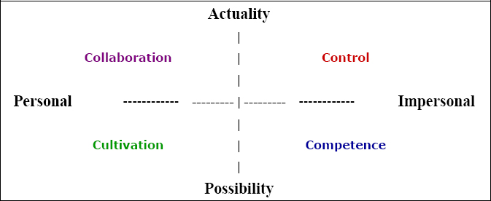
Figure 1: Importance of culture on project performance
(Source: Influenced by Zeb et al. 2021)
Culture in organisational performance can be identified as an effective process for businesses to manage and execute organisational performances effectively. In the views of Zeb et al. (2021), effective organisational cultural elements benefit in smooth progression of organisational performance. This effectively helps in increasing employee motivation as well as their preferences in actively participating in attending to organisational aims and objectives. Business managers focusing on organisational culture would be assisting in enhancing dedication and determination of employees while improving project performance. This has required emphasis on development of effective organisational managerial and leadership styles assisting in generation of positive work culture in projects.

2.2 Critical analysis of impact of imposing cultural elements on project performance
Organisational structure and culture can be identified as two major elements helping businesses to manage effective operational attributes for performance improvement. Project managers lacking in maintaining highly effective organisational culture attributes including ineffective communication and inconsistency create issues regarding organisational performance improvement (Pathiranage, 2019). Organisational processes focusing on development of effective operational attributes including creating highly efficient organisational practices along with a clear description of operational aims and objectives would be beneficial. Similarly, decreasing ambiguity and communication management between employees and executives would be helpful for maintaining a highly productive organisational culture in business performance management.

2.3 Factors associated with culture impacting project performance management
Culture management in a project guides businesses to develop effective support management for organisational performance improvement. As per the study by Meng and Berger (2019), positive organisational culture helps businesses to develop effective relationships with employees. This would have a positive influence on a generation of highly coordinated operational activities assisting in improvement of organisational performance. Besides, maintenance of effective relationships with team members would have a positive influence on increasing organisational productivity for development of positive organisational performance in future. It has benefitted businesses for maintenance of communication, collaboration and consistency management for encouraging team members in pursuit of a common goal in project performance improvement.

2.4 Challenges in integrating culture in project performance management
Project performance management faces issues of gaining effective consideration from managers and leaders style effectiveness to attract and retain employees. In the opinion of Safapour et al. (2019), ineffective designing of culture in projects increases challenges in integration of project management tools. This would decrease maintaining a profitable change management and flexibility inclusion attributes for organisational performance. In addition, a lack of leadership commitment in addressing project related issues would also increase challenges for maintenance of highly effective business operations. This indicated that incompetence in managerial and leadership roles along with ineffective organisational culture management would increase issues in performance improvement of businesses.

2.5 Theoretical Perspectives
Edgar Schein’s Culture Framework
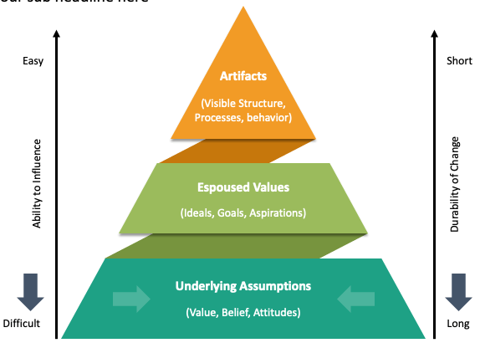
Figure 2: Edgar Schein’s Culture Framework
(Source: Inspired by Serra et al. 2019)
"Edgar Schein's Culture Framework" can be identified as an organisational culture management model providing an understanding of its systematic improvement. This helps in emphasis on employees' assumptions and knowledge in attending to solutions to external and internal problems for cultural improvements. Serra et al. (2019) identified that "Edgar Schein's Culture Framework'' included "artefacts, espoused values and underlying assumption" for organisational culture management. Application of this theory benefits organisational managers to focus on shaping organisational culture, and values by considering individuals for improvement of project management attributes.

Chapter 3: Research Methods and Methodology

3.1 Research Philosophy
"Research Philosophy" refers to a researcher's belief in processes associated with data analysis and gathering attributes in a research topic. Dougherty et al. (2019) suggested that "research philosophy" assists in maintaining quality sources for research conclusion development. It can be segregated into three categories of "pragmatism, realism, positivism and interpretivism". This research will use "interpretivism research philosophy" for development of better research conclusions. It will assist in maintaining high subjectivity in research information gathering and assumption development activities on cultural elements in project improvement of IT industry.

3.2 Research Paradigm
“Research paradigm” can be identified as commonly held beliefs and assumptions prevailing within research community for improving understanding of community beliefs on research development. It included "ontological, epistemological and phenomenological" concerns. This research will use an "ontological research paradigm" for research development, maintaining a positive approach to understanding positive influence of culture on projects.

3.3 Research Approach
“Research approach” assists in developing an effective plan and procedure helping in maintenance of broad assumptions in information gathering activities. In the views of Fortes et al. (2019), effective research approaches assist in attending to research problems effectively. Among "deductive, inductive and abductive" approaches, this research will adapt to "inductive" research approaches. This will be beneficial for gathering information from a wide range of samples with greater insight development on importance of cultural elements in IT industry.

3.4 Research Methodology
“Research methodological” activities help in identification of procedures for identification of information on research attributes in conclusion development. Research "qualitative" and "quantitative" research methodologies, this research will use "qualitative research methodology" for increasing research conclusions effectively. Additionally, maintaining a "mono qualitative nature" would be effective for management of quality information management in research conclusion generation.

3.5 Research Strategy
“Research strategy” can be described as action research for management of effective research data collection and analysis activities. In the views of Rong et al. (2020), “research strategy” assists in maintaining effective processes for development of effective research conclusions. “Case study, experiment, survey, action research, grounded theory, archival and ethnography” were commonly used research strategies. This research strategy will be used as an “archival research strategy” for research development.

3.6 Sampling Methods
Sampling methods assist in development of effective representation of information while accumulating data from a wide range of sources. This would be beneficial for maintaining high quality management of research findings and information on a research topic. However, this research will not use any sampling method for management of effective research activities.

3.7 Data Collection Methods
“Data collection activities” plays an important role in research development activities for evaluation of information attributes in research conclusion management. Mazhar et al. (2021) suggested that data collection attributes assist in storing as well as analysing information on research variables. This research will use “secondary data collection” activities for developing conclusions. It would be beneficial for maintaining cost efficiency as well as quality and flexibility management in research finding development in culture management in project improvement in IT industry.

3.8 Data Interpretation Methods
Data interpretation activities help researchers in categorisation, manipulation as well as summarisation of information in addressing research questions. Zhou et al. (2021) stated that data interpretation assists in simplistic and accurate data analysis attributes. This research would be focusing on using “thematic data analysis” techniques for research conclusion development assisting in flexible data interpretation through theme development.

3.9 Gantt Chart

(Refers to Appendix 1)

3.10 Ethical Considerations
“Ethical considerations” assist in management of authenticity, originality and sound management of information attributes in research development. This research will use “Copyright, Designs and Patents Act 1988 (c. 48)” for management of information on research topics. It would manage effective research attributes by providing credibility to original researchers as well as eliminating misinterpretation challenges for business management of effective research attributes.

Chapter 4: Conclusion
Critical understanding of importance of cultural elements in project performance elements would be beneficial for understanding different challenges associated with organisational performance management. This research focusing on organisational characteristics of different aspects of communication, collaboration and information management would be effective for maintenance of highly effective international business operations. However, a lack of understanding of importance of leadership and managerial elements has increased issues regarding generation of better organisational attributes. Critical understanding of internal organisational activities would be effective potential leadership and managerial characteristics for improving project performance. This would be effective for developing effective relationships between employees and managers in international projects for developing positive organisational performance in changing business environments. Hence, it can be summarised that focusing on the development of effective research understanding of organisational policies for cultural improvement would be beneficial for improving organisational performance.

Chapter 5: References
Carvalho, A.M., Sampaio, P., Rebentisch, E., Carvalho, J.Á. and Saraiva, P., (2019). Operational excellence, organisational culture and agility: the missing link?. Total Quality Management & Business Excellence, 30(13-14), pp.1495-1514.
Denicol, J., Davies, A. and Krystallis, I., (2020). What are the causes and cures of poor megaproject performance? A systematic literature review and research agenda. Project Management Journal, 51(3), pp.328-345.
Dougherty, M.R., Slevc, L.R. and Grand, J.A., (2019). Making research evaluation more transparent: Aligning research philosophy, institutional values, and reporting. Perspectives on Psychological Science, 14(3), pp.361-375.
Fortes, S., Santoyo-Ramón, J.A., Palacios, D., Baena, E., Mora-García, R., Medina, M., Mora, P. and Barco, R., (2019). The campus as a smart city: University of Málaga environmental, learning, and research approaches. Sensors, 19(6), p.1349.
Henderson, L.S., Stackman, R.W. and Lindekilde, R., (2018). Why cultural intelligence matters on global project teams. International Journal of Project Management, 36(7), pp.954-967.
Mazhar, S.A., Anjum, R., Anwar, A.I. and Khan, A.A., (2021). Methods of data collection: A fundamental tool of research. Journal of Integrated Community Health (ISSN 2319-9113), 10(1), pp.6-10.
Meng, J. and Berger, B.K., (2019). The impact of organizational culture and leadership performance on PR professionals’ job satisfaction: Testing the joint mediating effects of engagement and trust. Public Relations Review, 45(1), pp.64-75.
Pathiranage, J., (2019). Organizational culture and business performance: an empirical study. International Journal of Economics and Management, 24(2), pp.264-278.
Quisenberry, W.L., (2018). Exploring how emotional intelligence contributes to virtual teams: Interpretive analysis of a phenomenological study. European Scientific Journal, 14(5), pp.19-36.
Rodríguez-Sánchez, J.L., González-Torres, T., Montero-Navarro, A. and Gallego-Losada, R., (2020). Investing time and resources for work–life balance: The effect on talent retention. International journal of environmental research and public health, 17(6), p.1920.
Rong, S., Wang, L., Peng, Z., Liao, Y., Li, D., Yang, X., Nuessler, A.K., Liu, L., Bao, W. and Yang, W., (2020). The mechanisms and treatments for sarcopenia: could exosomes be a perspective research strategy in the future?. Journal of cachexia, sarcopenia and muscle, 11(2), pp.348-365.
Safapour, E., Kermanshachi, S., Kamalirad, S. and Tran, D., (2019). Identifying effective project-based communication indicators within primary and secondary stakeholders in construction projects. Journal of Legal Affairs and Dispute Resolution in Engineering and Construction, 11(4), p.04519028.
Serra, B.P., BUSSLER, N.R.C., TOMEI, P.A. and Storopoli, J.E., (2019). Edgar Schein’s Contributions To Organizational Culture: A Proposed Research Agenda. XLIII Encontro da ANPAD.
Zeb, A., Akbar, F., Hussain, K., Safi, A., Rabnawaz, M. and Zeb, F., (2021). The competing value framework model of organizational culture, innovation and performance. Business process management journal.
Zhou, J., Gandomi, A.H., Chen, F. and Holzinger, A., (2021). Evaluating the quality of machine learning explanations: A survey on methods and metrics. Electronics, 10(5), p.593.

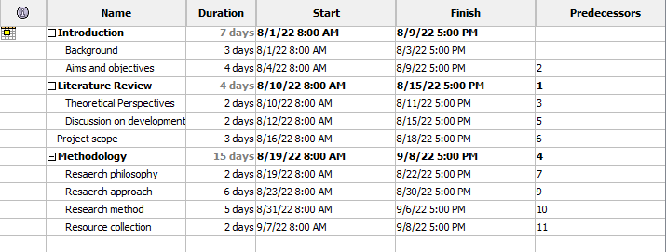
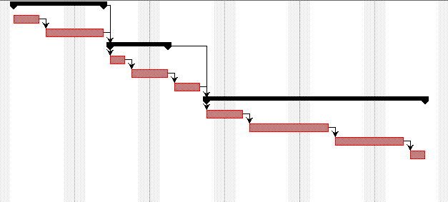
Research Timeline
(Source: Self-developed)

