During this essay I will discuss how current initiatives support the development of numeracy across the curriculum within education settings, while critically analysing theoretical perspectives and key trends in the development of numeracy. Numeracy introduces children and young people to new skills, perceptions and thinking strategies that will support their development further. ‘Numeracy can help learners become ethical, informed citizens of Wales by providing tools to analyse data critically, enabling them to develop informed views on social, political, economic and environmental issues’. (Welsh Government, 2019). Following the new Curriculum for Wales which will be put in place in Wales from 2022. ‘We are numerate if we have developed the confidence and competence in using number’ (The Scottish Government, 2009, p. 10). However, some children may experience barriers to learning in numeracy, this may be due to a language barrier or additional learning needs. Critical numeracy in educational settings allows participation in numeracy to be inclusive and allow children to think freely and critically in a way that they feel comfortable and confident to learn. Examples for this essay have been observed in a Welsh medium primary school in a semi-rural community in South West Wales within a key stage 2 classroom. “Over a three-year-period, around 25% of pupils have been eligible for free school meals, higher than the national percentage of 18%. The school has identified 29% of its pupils as having additional learning needs, higher than the national percentage of 21%.” (Locrating, 2019). Studies taken place by Taylor (2017) and the Millennium Cohort Study in Wales in regard to free school meals found that ‘on average, they are much less likely to achieve expected levels at the end of their primary years.’ (See Appendix A).
It is vital for children and young people to participate in numeracy across the curriculum as it promotes and develops skills in order to prepare children and young people for their adult lives such as budgeting and shopping. ‘Numeracy involves connecting the mathematics that students learn at school with the out-of-school situations that require the skills of problem solving, critical judgement, and sense-making related to applied contexts.’ (Victoria State Government, 2020). This supports children and young people to become enterprising, creative contributors within the recommended four purposes in the Curriculum for Wales. It is vital for professionals to provide enriched learning to support the children to reach their full development. Children need to be supported but also challenged to be able to develop their critical thinking skills. Following Freire’s pedagogy of the oppressed, ‘critical education must involve problem- posing in which all involved are challenged to reconsider and recreate their prior knowledge.’ (O’Keeffe and Paige, 2019, p. 4). Planning and preparing for the children are very much a joint effort within the classroom, children participate in pupil voice which provides them with an opportunity to discuss what they would like to learn about throughout each term. This ensures that they are prepared and ready for future learning as they have a base line of knowledge ready for development. Critical pedagogy suggests that discussing and suggesting ideas with children provides learners with empowerment which ‘saves them from being objects of education to subjects of their own autonomy and emancipation.’ (Aliakbari and Faraji, 2011, p. 77). Vygotsky also believed that ‘Interaction contribute to children’s construction of knowledge - to their learning’. (Mooney, 2000, p. 83). However, some may view the critical pedagogy as unrealistic due to curriculum and schemes that are followed in educational settings, meeting children’s needs through the curriculum may not correlate with pupil’s voice.
In school A numeracy can often be seen throughout the curriculum where children are involved physically with their learning. For instance, children have written a letter to the headteacher regarding fundraising within a budget in order to plan an entertainment day, they have also produced a shopping list and attended the local supermarket and purchased items on their list. This allows children to be active learners and extended their stimulation ‘by providing novel first-hand experiences and opportunities to explore, investigate and solve problems’ (Whitebread, 1996, p. 60). This correlate with the theorists Dewey, Montessori and Froebel. They believed that ‘active learners must be involved in experiences, learning by doing, not just by reading and listening’ (Adeeb, et al. 2020 p. 61). This also associates with the 1967 Plowden Report, this was momentous to education. ‘The report recommended that teachers should promote experiential methods of learning whilst planning and using an interdisciplinary curriculum’ (Martlew, et al. 2011). This allows the children to stay engaged while reinforcing their prior knowledge, concept and skills. Taken from the curriculum policy in School A, (2020) ‘The planning for skills from the Numeracy Framework in cross curricular learning provides opportunities for pupils to apply their skills and develop this application of skills to the same standard of attainment as in Maths lessons’. However, an Estyn report taken from an inspection at school A states ‘Opportunities for pupils to apply their numeracy skills across the curriculum, to the same standard that is seen in mathematics lessons, are limited. As a result, pupils’ progress is not as good.’ (Estyn, 2019, p. 7). It is also important to use a holistic approach while using multi-sensory techniques when teaching numeracy. ‘From the earliest teaching, educators have embraced a range of multi-sensory techniques in order to make learning richer and more motivating for learners.’ (Obaid, 2013, p. 75) This is also supported by Gardner’s theory of multiple intelligences, as he believed that all children learn differently, there are eight different types of learners and that ‘schools focus most of their attention on linguistic and logical-mathematical intelligences.’ (Sivakumar and Thirumoorthy, 2018, p. 69). However, all children should be supported and encouraged to reach their full potential as they are at the centre of educational practice.
Within educational settings, there are barriers that some children may face when learning numeracy. Multiplication is one of the four operations that children need to be confident with. Maths coordinator Cheung, 2020 states (children that struggle with multiplication often struggle with other aspects of the maths curriculum, so multiplication is a fundamental aspect of teaching maths to then develop in numeracy). For example, at the end of year 3 children should be confident to ‘recall 2, 3, 4, 5 and 10 multiplication tables and use to solve multiplication and division problems’. (Curriculum for Wales, 2016, p. 3). This is one of many skills that requires confidence in the area of multiplication. However, children may struggle using and recognising their numbers. To support this school A uses an initiative called TT Rockstars, this is used daily for children that may face barriers in learning. TT Rockstars is a one to one support while using technology to allow children to practise their times tables electronically, this is set at their attainment level to support development with personal log in’s that can be accessed at home which encourages home school learning. A study by Safdar, (2011) ‘on the effectiveness of teaching mathematics through technology compared to using traditional teaching methods found that teaching mathematics with technology led to better academic achievements’. However, Safdar also stated that relying on technology for teaching ‘might lead to significant problems as students might deviate from current lessons. Without following the guidance of the teacher, the student’s performance in the subject will suffer.’ (Safdar et al, 2011, p. 67).
Another initiative that is used in School A to support children when facing barriers to learning numeracy is the Concrete, Pictorial, Abstract approach (CPA), a key feature of Singapore maths. This is an extremely successful approach which allows children to develop a deep and sustainable understanding of numeracy. According to (The Welsh Assembly Government, 2009, p. 17), During Key Stage 2 children should be able to ‘select and use the appropriate mathematics, materials, units of measure and resources to solve problems in a variety of contexts’. The CPA approach allows children to support their own education by ‘learning new ideas and building on their existing knowledge by introducing abstract concepts in a more familiar and tangible way.’ (Moore, 2020). Appendix B contains an in-depth definition of the CPA approach. Bruner’s constructivism approach is also visible in the CPA approach. Constructivism principles are demonstrated within current classrooms with cross curriculum teaching using the CPA approach. As we as professionals should understand that every child is different and develops differently also. ‘The classroom of tomorrow will consist of flexible ecosystems, designed to cater for the literacy, numeracy and digital competence needs of the future citizens of the world.’ (Welsh Government, 2015). Through his Modes of Representation, Bruner recognised that development occurs through Enactive, Iconic and Symbolic means. Resulting in a fully embedded understanding of the perception throughout the classroom as it supports each child individually, looking at their level of development holistically. According to (The Cockcroft Report, 1982, p. 83) ‘For most children, practical work provides the most effective means by which understanding of mathematics can develop’. This means the children are able to have an understanding of what is being asked of them while the activity is happening. This allows progress to be made within each topic. For instance, a child may start with handling objects to gain an understanding of the numeracy activity then develop confidently to use pictures or diagrams as a representation to then using symbols which can be used in an abstract way.
Conversely, ‘not every student will be able to learn this way, for some, manipulatives will just be a distraction. Therefore, it becomes very challenging for teachers, having to evaluate the learning styles of every student and determine what will motivate students in a way that will further their understanding.’ Student, (2017). Still, children within school A have responded extremely well to using the CPA approach with manipulatives and from studies taken, it has been proven that using manipulatives have increased mathematical skills amongst children (see Appendix c) this shows that using the CPA approach is important to use with children that may face barriers to learning numeracy. However, the CPA approach needs many resources, this can be time consuming for teachers to create objects such as place value charts, fraction walls and number sticks or the school budget doesn’t allow extra money to be spent on resources. Some teachers may not feel comfortable using the CPA approach with the age range of their children, this may be down to the professional not applying the approach effectively or that the children are at an older age to which they believe they are too old to use objects to support their numeracy.
An additional initiative that is used to support children with barriers to learning is Big Maths. ‘Big Maths is a systematic and structured approach to ensuring all children become numerate and then become fully rounded mathematicians.’ (Big Maths, N.D). Big Maths covers the whole maths curriculum in Wales, however the main focus for this initiative is the development of number skills. The number skills strands on the Maths Programme of Study in Wales contains 22 skills as shown in appendix D (The Welsh Assembly Government, 2015) making Big Maths a vital scheme to develop children’s fluency and confidence in number while bridging the learning gaps. Big Maths creates activities that are set at the individual’s level of development, making it a holistic approach. This allows children to see their constant increase in knowledge, setting a growth mindset. This initiative simplifies the process of transferring new learning to long term memory with engaging activities and enriched focus lessons, this is called the Making it Stick journey, evident in Appendix E. This is similar to Bruner’s Spiral Model; ‘an approach to education that involves re-visiting the same educational topics over the course of a student’s education. Each time the content is re-visited, the student gains deeper knowledge of the topic.’ (Drew, 2020). The spiral model is used frequently in the education setting as teachers revisits the curriculum by teaching the same contexts in different ways, varying on the children's level of development. The children will revisit the subject where the activity will increase in complexity, this will then be applied to new learning so the children will have prior knowledge. Vygotsky’s scaffolding theory also supports children overcoming barriers to learning as it allows each child to make sense of their surroundings. Vygotsky believed that ‘Learners complete small, manageable steps in order to reach the goal. Working in collaboration with a skilled instructor or more knowledgeable peers help students make connections between concepts.’ (Kurt, 2020).

Big Maths also allows professionals to track each child’s progress in core number and Primary Maths Curriculum, this allows educational professionals to support children that are not making necessary progress. In turn, this will address any learning gaps and encourage the individual in a smaller group basis to support their development further. This is also known as a formative assessment as it is part of the instructional process that in turn supports future planning based on individual needs. Farrar, 2020 states that (My eldest has autism and learning disabilities but he really enjoys big maths. I believe that it helps them to remain focused and helps him engage his brain as it’s a different way of learning). However, an interview taken place with a maths coordinator, Cheung, 2020 stated that (As much as Big Maths supports children it is very time consuming for teachers. You have to create separate planning for Big Maths on the portal and it also needs you to take time out of the week to complete individualised CLICs, SAFEs and Learn it challenges. Also, Big Maths introduction starters are approximately thirty minutes long, however the foundation phase framework states that children should not be on the carpet for longer than 12 minutes at one time).
In conclusion, there may be children in each educational setting that may experience barriers to learning numeracy that require a range of enriching initiatives to support their development and reach their full potential. Initiatives such as TT Rockstars, the CPA Approach, Big Maths, scaffolding and group support all creates enhanced and stimulating learning for all pupils that can be utilised through the medium of the Digital Competence Framework. Numeracy supports children to become informed citizens of Wales, following the new Curriculum for Wales Framework, as well as frameworks there have also been many reports produced in regard to supporting, promoting and planning effective lessons in which stimulate and encourage children’s progress. However, as evidently stated in the opening of this essay, it has been proven that settings with a high free school meal intake are less likely to achieve their set target levels. More support should be put in place to bridge the learning gaps between free school meal children and non-free school meal children as they are all equal and deserve the same standard of education. Furthermore, I believe that ICT should be considered more in schools to support learners that may face barriers to learning. When using ICT in education, it offers more opportunities to advance critical thinking skills while producing a creative learning environment. (Das, 2019, p. 25). Although the education system has come a long way in which children have a more enriched learning environment to develop within, there are area in which need to be improved in order to support children and young people furthermore. Additional training could be provided for professionals to develop their confidence and career professional development (CPD) in order to deliver the best learning experiences for children and young people of all abilities through the medium of Digital Competence Framework (DCF) and numeracy.

Reference list:
Adeeb, J. et al. (2020). ‘Implementing pragmatic and John Dewey’s educational philosophy in Emirati elementary schools.’ Abu Dhabi: Inderscience Enterprises Ltd.

Aliakbari, M and Faraji, E. (2011). ‘Basic principles of critical pedagogy.’ Singapore: IACSIT
press.

Big Maths, (N.D). ‘The Best Whole School Primary Maths Programme’ Available at: https://www.bigmaths.com (Accessed 28th December 2020).

Cheung, M. (2020). Conversation. Sadie Maddox, 28th December 2020.

Cockcroft, WH. (1982). ‘The Cockcroft Report (1982) Mathematics count.’ London: Her Majesty’s Stationery Office.

Curriculum for Wales, (2016). ‘Mathematics Programme of Study key stages 2-4’ Cardiff: Welsh Government.

Das, K. (2019). ‘Role of ICT for Better Mathematical Teaching’ India: Shanlax.

Drew, C. (2020). ‘Bruner’s Spiral Curriculum – the 3 key principles.’ Available at: https://helpfulprofessor.com/spiral-curriculum/ (Accessed 28th December 2020).
Estyn, (2019). ‘A report on Ysgol Glannau Gwaun’. Cardiff: Estyn.

Farrar, M. (2020). ‘Thrilled with the big maths they use’ Review of Big Maths by Big Maths. Available at: https://www.bigmaths.com/reviews/ (Accessed 29th December 2020).

Kurt, S. (2020). ‘Vygotsky Zone of Proximal Development and Scaffolding’. Available at: https://educationaltechnology.net/vygotskys-zone-of-proximal-development-and-scaffolding/ (Accessed 30th december 2020).
Locrating. (2019). ‘Ysgol Glannau Gwaun.’ Available at: https://www.locrating.com/schools-Ysgol-Glannau-Gwaun-0wlsh6682389.aspx (Accessed 11th August 2020).

Macmillan Education, (2020). ‘The CPA Approach’ Available at: https://www.macmillanic.com/the-cpa-approach/ (Accessed 29th December 2020).
Martlew, J. Et al. (2011). ‘Play in the primary school classroom? The experience of teachers supporting children’s learning through a new pedagogy’ Available at: https://www.researchgate.net/publication/236685783_Play_in_the_primary_school_classroom_The_experience_of_teachers_supporting_children%27s_learning_through_a_new_pedagogy (Accessed 27th November 2020).
Mooney, C. (2000). ‘Theories of childhood’ America: Redleaf Press.
Moore, K. (2020). ‘What is concrete pictorial abstract approach in maths?’ Available at: https://www.theschoolrun.com/what-is-the-concrete-pictorial-abstract-approach-in-maths (Accessed 26th December 2020).
O’Keeffe, L and Paige, K. (2019). ‘Re-highlighting the potential of critical numeracy’ Australasia: Mathematics Education Research Journal
Obaid, (2013). ‘The Impact of Using Multi-Sensory Approach for Teaching Students with Learning Disabilities ‘Jordan: The Clute Institute.
Safdar, A. Yousuf, M. Parveen, Q and Malik, G. (2011). ‘Effectiveness of Information and Communication Technology (ICT) in Teaching Mathematics at Secondary Level’, International Journal of Academic Research, vol. 3, p. 67.

School A, (2020). ‘Curriculum policy’. Available at: https://primarysite-prod-sorted.s3.amazonaws.com/ysgol-glannau-gwaun/UploadedDocument/59020c285a0d402389551722bc13bbfa/curriculum-policy.pdf (Accessed 28th December 2020).
Sivakumar, A and Thirmumoorthy, G. (2018). ‘Educational Psychology’ United States: Lulu Publication
Student, A. (2017). ‘Does the use of manipulatives to move pupils from a concrete to abstract idea help or hinder their problem-solving skills?’ Available at: https://www.google.com/url?sa=t&rct=j&q=&esrc=s&source=web&cd=&ved=2ahUKEwiV9Ya_nPbtAhXOOcAKHU-zDa44ChAWMAJ6BAgDEAI&url=http%3A%2F%2Feprints.chi.ac.uk%2Fid%2Feprint%2F5086%2F1%2FManipulatives%2520High%25202.1.docx&usg=AOvVaw2GT4zjPaYnppTr9T054TC3
(Accessed 29th December 2020).

Taylor, C. (2017). ‘The Reliability of Free School Meal Eligibility as a Measure of Socio-Economic Disadvantage: Evidence from the Millennium Cohort Study in Wales’ (Available at: https://www.tandfonline.com/doi/full/10.1080/00071005.2017.1330464 (Accessed 28th November 2020).
The Scottish Government, (2009). ‘Curriculum for excellence building the curriculum 4 skills for learning, skills for life and skills for work’. Edinburgh: Scottish Government.
Victoria State Government. (2020). ‘Numeracy for all learners’ Available at: https://www.education.vic.gov.au/school/teachers/teachingresources/discipline/maths/Pages/numeracy-for-all-learners.aspx (Accessed 28th December 2020).

Welsh Assembly Government, (2009). ‘Mathematics Guidance for Key Stages 2 and 3’. Cardiff: Welsh Assembly Government, Department for Children, Education, Lifelong Learning and Skills.

Welsh Government, (2015). ‘Curriculum for Wales Foundation Phase Framework Revised (2015)’. Available at: https://gov.wales/sites/default/files/publications/2018-02/foundation-phase-framework-revised-2015.pdf (Accessed 27th December 2020).
Welsh Government. (2019). ‘Mathematics and Numeracy’. Available at: https://hwb.gov.wales/curriculum-for-wales/mathematics-and-numeracy (Accessed 27th November 2020).
Whitebread, D. (1996). ‘Teaching and learning In the early years’. London: Routledge Falmer.

Appendices
Appendix A - Percentage of Wales-domiciled children in the MCS who achieved the Core Subject Indicator (CSI) at the end of KS1 in 2006–2007.
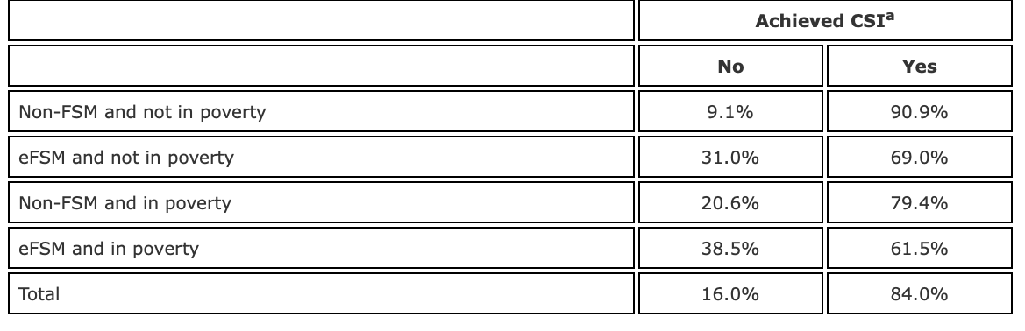

Source: Taylor, C. (2017).

Appendix B – An in-depth description of the Concrete, Pictorial, Abstract approach used in School A to support children with numeracy.

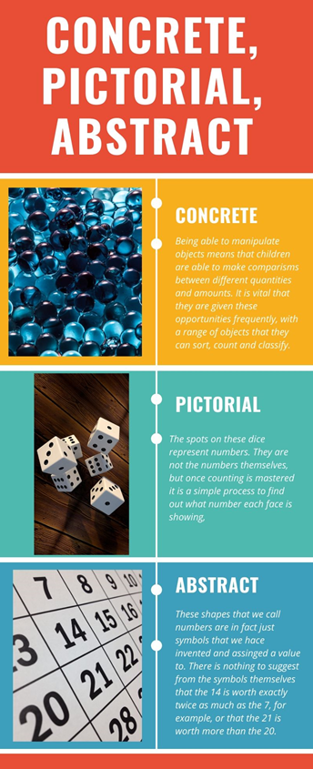

Source: Macmillan Education, (2020).

Appendix C - Figures 4.1, 4.2 and 4.3 show that for all questions asked, there was a higher number of correct answers when manipulatives were used, in all instances.

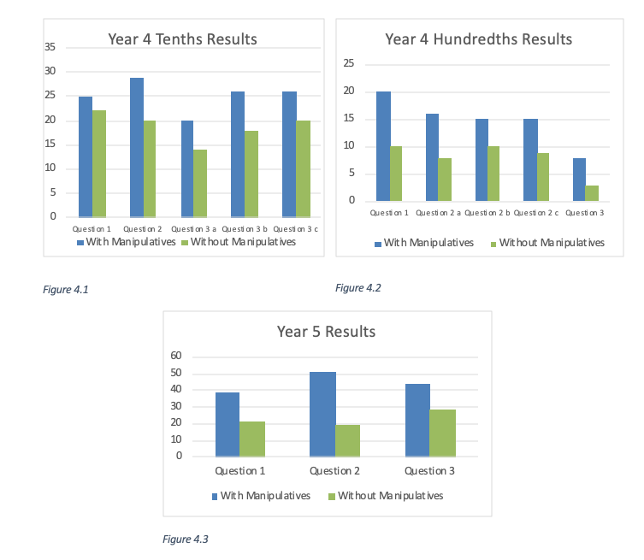

Source: Student, A. (2017).

Appendix D – Strand skills for year 3 from the Maths Programme of Study in Wales.

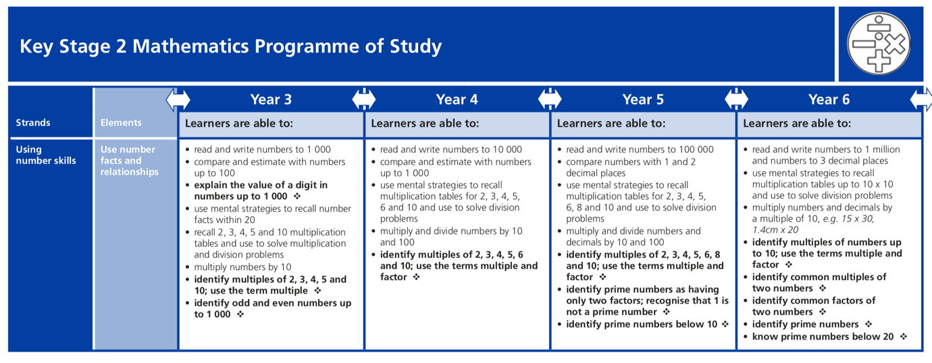
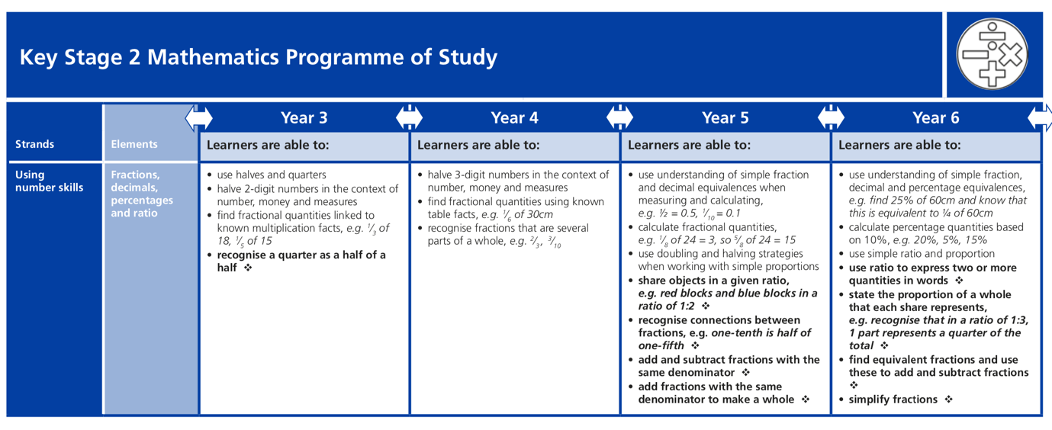
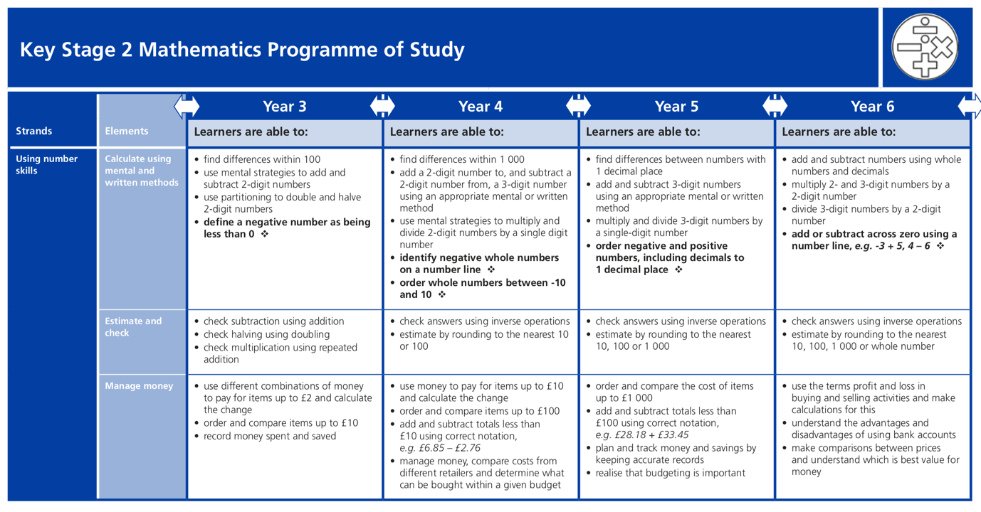

Source: The Welsh Assembly Government, (2015).

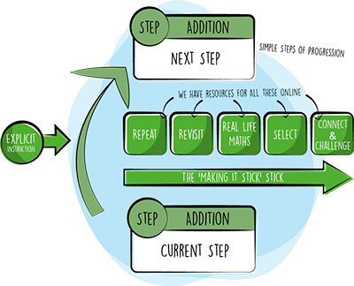
Appendix E – the Make it Stick journey, similar to the Spiral Model by Bruner.

Source: Big Maths, (N.D).

