critical reflective practitioner >>

ON BECOMING A CRITICALLY REFLEXIVE PRACTITIONER >>

three ways of stimulating critically reflexive practice >>

(a) an exercise to help students think about the socially constructed nature of reality >>

(b) a map to help situate reflective and reflexive practice >>

(c) an outline and examples of critically reflexive journaling. >>

DEFINITIONS AND REASONS >>

Pollner (1991) defined reflexivity as “an ‘unsettling >>

The concept of reflexivity has been debated across a variety of disciplines includ- ing sociology, the natural sciences, and psychology (e.g., Clifford, 1986; Gergen, 1994; Latour, 1988) and more recently in organization and manage- ment studies (e.g., Calás & Smircich, 1999; Chia, 1996b; Hardy & Clegg,1997; Weick, 1995) >>

I suggest that the practice of critical reflexivity is of particular impor- tance to management education >>

management education is not just about helping manag- ers become more effective organizational citizens but also about helping them become critical thinkers and moral practitioners, then critical reflex- ivity is of particular relevance. >>

Critically reflexive practice offers a way of surfacing these pressures by encouraging us to examine the assump- tions that decisions are justified solely on the basis of efficiency and profit >>

Critical reflexivity draws upon very different ways of thinking about the nature of reality as well as a different way of thinking about management learning. >>

Existential: Who am I and what kind of person do I want to be? >>

Relational: How do I relate to others and to the world around me? >>

Praxis: The need for self-conscious and ethical action based on a critical question- ing of past actions and of future possibilities (Jun, 1994). >>

ASSUMPTIONS UNDERLYING CRITICALLY REFLEXIVE PRACTICE: IMPLICATIONS FOR LEARNING >>
The work of Paulo Freire (1972)

different assump- tions about the nature of reality and leads to a different way of teaching >>

Social reality is objective. >>

We can apply knowledge to practice and use it to change situations, people, and events. >>

teaching management and administration as a system and set of principles; as relationships involving authority, control, and account- ability; as a process of making and implementing objective rational deci- sions; and as a concern with means rather than questioning ends. >>

Learning is a disembodied, structured, cognitive activity. >>

Critical thinking, as commonly defined, is also based on this idea that there is a reality out there that we can analyze in a systematic way, using established concep- tual knowledge, and to which we can apply universal, rational standards (Caproni & Arias, 1997; Elder & Paul, 2001). >>

Freire (1972) suggested that a critical pedagogy is one that transforms reality and unites critical thinking and dialogue to develop a more humanistic approach to learning >>

puts a self-conscious being able to think criti-cally about the impact of his or her actions firmly at the center of learning. >>

social constructionist perspective >>

our social realities and sense of self are created between us in our everyday interactions and conversations >>

In practical terms, we can equate learning with moments in which we are “struck” (Wittgenstein, 1980, p. 85) and moved to change our ways of talking and acting. >>

Developing Critically Reflexive Practice >>

by encouraging students to think about how they, with others, construct realities and identities >>

Schön’s (1983) idea of “reflective practitioners >>

Argyris’s (1982, 1991) distinction between single- and double-loop learning >>

single-loop learning as reflective (problem solving, identify- ing, and correcting errors) >>

double-loop learning (thinking more critically about behavior; questioning assumptions, values, and espoused theories; disconfirming, inventing, producing, and evaluating new theories in action) as the beginning of critical reflexivity >>

Three teaching practices I find particularly useful in helping students develop their skills as critically reflexive practitioners >>

(a) the idea of reflex interaction/reflective analysis/ critically reflexive questioning, >>

(b) a class activity to highlight a different way of thinking about how we constitute reality >>

(c) the use of critically reflexive journals. >>

A MAP: REFLEX INTERACTION, REFLECTIVE ANALYSIS, CRITICALLY REFLEXIVE QUESTIONING >>
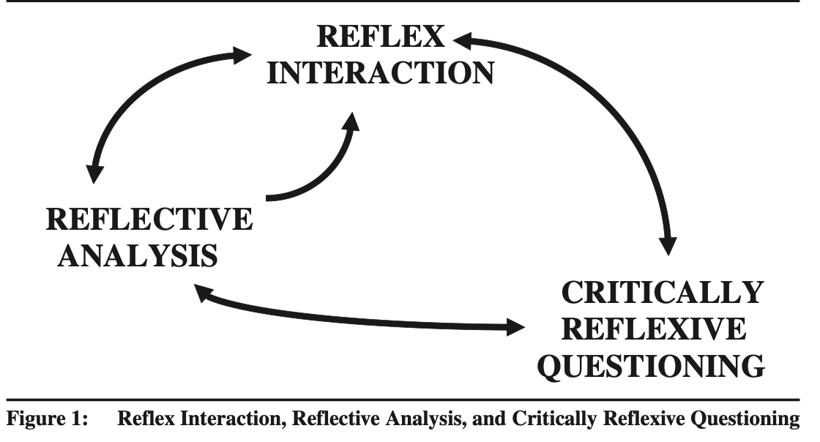

Reflex interaction refers to the instantaneous, unselfconscious, reacting- in-the-moment dialogue and action that characterizes much of our experi- ence. >>
(Polanyi, 1966
something we do without having to think about how we do it; it is comfort- able, habitual, and unselfconscious.

Reflective analysis (single-loop learning) means creating order >>
the outcome is not always comfortable

retrospective—making sense of something that happened in the past and examining reasons why we made a decision or acted in a particular way >>

anticipatory—planning our future actions. >>

critically reflexive questioning draws on social constructionist assumptions to highlight subjective, multiple, constructed realities. >>

also means exposing contradictions, doubts, dilemmas, and possibilities (see Hardy & Palmer, 1999, for further discussion) >>

GRASPING THE NATURE OF INTERSUBJECTIVE REALITIES: A CLASS ACTIVITY1 >>

We constitute our realities in spontaneous and taken-for-granted ways >>

Interactions are responsive relationships (Bakhtin, 1986). >>

offers an example of the practical implications of social constructionism and how we can draw out practical understandings from within experience >>

developing theory about something/ someone else—that is, observing and reflecting (an outside-in approach, Journal Excerpt 1 >>

creating theory in practice—surfacing and ques- tioning tacit knowledge (an inside-out approach, Journal Excerpt 2). >>
more effective in valuing diversity and plurality in organizations

There is intertwined complexity in what may seem like a simple activity >>
Shotter (1993) called this a “third realm of activ- ity”—jointly and intricately structured yet under no one person’s control

BECOMING A CRITICALLY REFLEXIVE PRACTITIONER: USING JOURNALS >>

powerful in helping students develop their skills as critically reflexive practitioners, because they are a means by which students engage in their own learning (Bickford & Van Vleck, 1997) and surface tacit knowing. >>
Journals can be used to improve writ- ing skills, improve analytic and creative thinking

Students complete three journals over the semester, moving from a reflective analysis of a situa- tion they encountered to a critically reflexive questioning of their own learn- ing (about 6 to 8 pages each) >>

they complete one journal (8 to 12 pages) to be handed in at the end of the semester (see appendix) >>

inside-out form of writing—“finding one’s voice” (Boys, 1999, p. 131) >>
talking from within

Journals by students >>

ISSUES RELATING TO THE JOURNALS >>

1. Comfort Zone >>

Drucker’s (1999) article, “Man- aging Oneself” (see appendix >>

2. Is This a Diary >>

it is not a description of daily activi- ties but, rather, a critical questioning of experiences. >>

3. Are Critically Reflexive Journals Just Naval Gazing >>

The answer is no. I expect students to take their reflexive questioning and assess possibilities for change >>

4. And You Grade These . . . >>

there are no right or wrong answers >>
grading criteria

Linking personal experience to ideas, theories, and material from class and explor- ing how these may offer possibilities for practices. >>

Ability to make connections between actions and responses. >>

Challenging his or her thinking and ways of acting…… >>

My written comments in journals consist of questions and possibilities rather than judgments: >>

FINAL THOUGHTS >>

it depends upon the comfort zone of each. It is a time- intensive process for a student and a faculty member >>

>>

