Group Project
Princes gate spring water | Narbeth
Group Project assingment b
Ben Leach
2020
Table of Contents
Table of figures. 1
1.0 Summary 2
2.0 Introduction 3
3.0 Basic team working principles. 4
3.1 Success Principles. 4
3.2 Principle 1: Identify what unite us. 4
3.3 Principle 2: Work together on how to achieve the shared vision. 5
3.4 Principle 3: Building team potency. 5
3.5 Principle 4: Be clear on roles and responsibilities. 5
3.6 Principle 5: Create an environment learning and psychological safety. 6
4.0 Example on team working methodologies. 7
4.1 Tuckmann’s method. 7
4.2 Stage 1: Forming. 7
4.3 Stage 2: Storming. 7
4.4 Stage 3: Norming. 8
4.5 Stage 4: Performing. 8
4.6 Stage 5: Adjourning. 8
4.7 Difference between a group of employees and a team. 8
5.0 Personal Project within a work environment. 9
5.1 Project. 10
6.0 Applying methodologies. 12
References 13
Works Cited 14

Table of figures.

Figure 1Tuckmann graph for forming a team. 7
Figure 2 Example of Gantt chart. 10

Summary

During this report we spoke about different methodologies for forming a team and maintaining a team, some prime examples are Tuckmann’s method which goes through the process of forming a team and maintaining it during different stages.
We also have Belbin’s method on giving roles to everyone in the team based on experience and personalities, sometimes its better to allow each member to choose their role even if they require some guidance.
We encountered various issues throughout the project due to these turbulent times with a pandemic, which involves isolation shifts and maintaining social distancing in a manufacturing environment.

Introduction

For this report, we are going to discuss how a group of individuals form an effective team to complete a given task. This can be achieved in many ways, for example personalities and similar attitudes.
“Every employee is dependent on his fellow employees to work together and contribute efficiently to the organization. No employee can work alone; he has to take the help of his colleagues to accomplish the tasks efficiently. It has been observed that the outcome comes out to be far better when employees work in a team rather than individually as every individual can contribute in his best possible way. In organizations, individuals having a similar interest and specializations come together on a common platform and form a team.” (Juneja, 2015)
Throughout the essay we be conducting research on various topics for example different team working methodologies Tuckman’s and Belbin’s, conflict and cohesion with groups and planning.

Basic team working principles.

In most manufacturing industries it can be quite volatile and production operators are often replaced as quickly as they arrive, so it is important that organisations are active and innovative when facing very complex challenges, they also need to realise the increasingly need for good leadership which can bring a group of individuals together new and old to help them achieve their goals.
Bad leadership can have massive impacts for example in the healthcare industry research has shown poor team working has a major impact with clinical errors and patient deaths.
(Paul O'connor, 2016)
Also, teams will need to be reliable to have any success. “A study in the NHS found that while 96% of staff reported they worked in teams, only 53% said they worked in “authentic”, well-structured teams.” (Matthew Carter, 2008)
What makes a reliable team? There are three criteria which would make a reliable team.
- Shared objectives.
- Members of the team working independently.
- Weekly/Monthly reviews on team effectiveness.

Success Principles.
Several organisational psychologists have identified several key principles which would increase the wellbeing and engagement of team members thus increasing the effectiveness of the team and success rate.
- The affective – This means that individuals of the team will get emotionally involved in the processes and are motivated to engage fully in the tasks given.
- Behavioural processes – This will include allocating roles, gathering information, been giving responsibilities, and keeping the information up to date.
- Cognitive states – Several examples can give such as having a shared understanding of the issue, reflecting and members learning from experience.
(Alban-Metcalfe, 2018)

3.2 Principle 1: Identify what unite us.

The best way of increasing a sense of mutual identity is to actively engage all team members in creating a shared vision together. Most people will have a vision of what they want to achieve in day to day life even if the information is rather vague.
Often individuals who complain about work are often just stating that this not how they thought they be spending their working hours doing. Leaders will need to find ways of actively engaging their team members to create a vision together. This will include looking into their frustrations and tensions but can also lead to suggestions as to what can be changed to make the team and environment more fulfilling. If the leaders try to ignore such emotions, it can backfire to due increase levels of frustration and stress which can be infectious to the team and potential reduce their effectiveness.
Spending time on a vision will have benefit of increasing resilience in the team so they can better cope with setbacks and emerge stronger than ever.
(Alban-Metcalfe, 2018)

Principle 2: Work together on how to achieve the shared vision.

To achieve a major engagement with a team is to make sure all team members have a strong sense of purpose and meaning in what they do at work. Enabling each member to identify their role will set them on a path to achieve the groups shared vision.
You can also provide this by giving each team member opportunities to share their ideas and suggestions as this would allow each member to feel valued and respected.
(Alban-Metcalfe, 2018)

Principle 3: Building team potency.

If the group can strengthen the other principles, then team leaders are able to produce a strong sense of team potency which means team will be confident to overcome challenges and setbacks.
(Alban-Metcalfe, 2018)
“Research has found that this significantly predicts engagement and wellbeing results. Team members are willing to work harder and more innovatively to enable their team to succeed.”
(NHS South West Yorkshire Partnership, 2012)

Principle 4: Be clear on roles and responsibilities.

If confusion should arise due to unclear team roles and responsibilities, this can rise team members frustration and stress, which will likely cause conflict between members. Every effort should be made to make it as clear as possible to better cement each member into their role and responsibilities.
(Alban-Metcalfe, 2018)

Principle 5: Create an environment learning and psychological safety.

As the team goal progresses, the group will also need to deal with an increase of demand and complex challenges. This will require the team to adapt to changes and inevitably an increase frequency of mistakes. This does not necessary mean it is a bad thing, as mistake can be treated like cognitive catalysts that will challenge their assumptions and create an entire new generation of better ideas.
(Alban-Metcalfe, 2018)

Example on team working methodologies.

Tuckmann’s method.

One of the most known methods of creating a team of motivated individuals is known as the Tuckmann method. This method was named after Bruce Tuckmann who was a educational psychologist who identified a 5-stage method on forming a team. Figure 1 shows the graph of stages to create a strong well-formed team. (Team building, 2016)
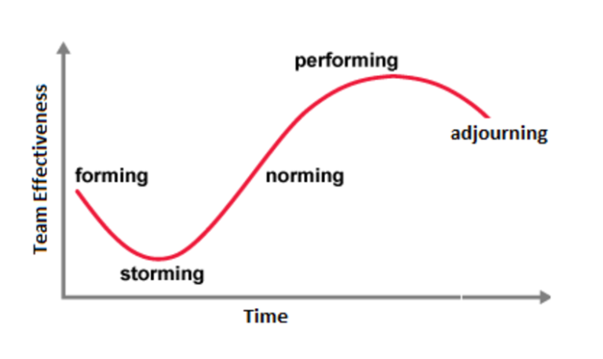
Figure 1Tuckmann graph for forming a team.

4.2 Stage 1: Forming.

This is the initial stage of forming a team, which involves the team members to orientate themselves with each other. During this stage uncertainty is high and members with lower confidence are looking for leadership. Most interactions during this stage are for social purposes only as members get to know each other. (Team building, 2016)

4.3 Stage 2: Storming.

This stage is usually the most difficult but crucial stages the team will go through during their development. During this period, conflict is common and different personalities clash. During this time, the performance of team decreases as you can see from figure 1, this is due to energy being spent on internal competitions and conflicts. The reason this stage is the most crucial is because if the conflicts are not resolved in a timely manner then the team will be bogged down and failure to resolve will leave long term problems. (Team building, 2016)

4.4 Stage 3: Norming.

If the team managed to get through the storming stage with conflict being minimized and unity slowly coming together then we should have a functioning team that can effectively work together, but strong leadership will still be required as the team can still revert back to the storming stage if conflicts should arrive or leadership is challenged. (Team building, 2016)

4.5 Stage 4: Performing.

During the performing stage, the team will now work well together, cooperation between members is now well established and organized with clear leadership. With a clear structure of the team, the members are now committed completely for furthering their agenda. There is a possibility of conflicts and issues appearing, but they are quickly dealt with. The team during this stage is more focused on working on the problem solving and attaining their goal. (Team building, 2016)

4.6 Stage 5: Adjourning.

The final stage of Tuckmann method is the adjourning stage, this is when the team is coming to the end of their overall goal. Members of the team will be wrapping up any final tasks they might have and documenting their results for management. As the final stage progresses and the workload decreases, some members of the team might be reassignment to different roles outside their team before it finally disbands. Sometime members will be replaced with newer members for a different task and then they will revert to stage 2 which is the storming stage. (Team building, 2016)

4.7 Difference between a group of employees and a team.

To determine when a group of employees become a team, we must know the difference between the two. A group is merely a community which have no direction or goal while a team share a common goal which all members aim for.
A group and team will also have different characteristics to each other such as.
- Trust (A well-formed team can trust each other to complete different tasks.)
- Communication (This can vary greatly, but teams formed across a single shift which work together are able to communicate for effectively.)
- Clarity (Jobs and meetings must be clear to avoid confusion among members of the team.)
(Gast, 2015)

Personal Project within a work environment.

For the personal project which he was involved in a group happening in Prince’s gate spring water, the company produces bottled water and was recently bought over by Nestle. The project involved several engineers and operators on reducing downtime between the warehouse and production. Over the last several months its been recorded that production loses on average 4 hours a week due to poor planning between the warehouse and production with emptying the line. There are several factors that causes this such as.
- Warehouse unable to keep track on how full the line is when busy with deliveries.
- Production unable to see how full the outfeed section of the line from their room.
If they were able to keep track on how full the line was then downtime will be reduced and saving will be made.
On average every hour down for the high-speed line is £1000 loss.
Engineer manager has tasked two shifts and one day shift engineer to come up with a solution. With the day shift engineer being in charged due to experience.
In total there was four shift engineers with the day shift engineering in lead.
The lead engineer also had a yellow belt in six sigma and actively works on continues improvement. So, they made the ideal choice for leading the team. Using Belbin’s method, she was able to give use a suitable role on our personalities. This was done using Belbin’s questionnaire which will give a report on which roles was deem suitable to each person. At the end of this we had these roles applied to each engineer.
Day shift engineer - Co-ordinator.
Shift engineer 1 – Resource investigator, Team worker.
Shift engineer 2 – Specialist.
Shift engineer 3 – Implementor and Shaper.
Shift engineer 4 – Completer finisher and monitor evaluator.
Shift engineer four would be author in question due to his strengths and weakness. The biggest challenge is communicating between shifts as the shift engineers work opposite to each other while the day shift engineer would be unable to cross both shifts with her current shift pattern. To overcome this the engineering manager gave permission to adjust the day engineer shift pattern so she will be able to communicate both engineering shifts better.
After several brainstorming sessions on each shift, several ideas where put forward and arguments happened due to personality clashes. Each shift had a vastly different idea, to counter this problem the day shift engineer discussed the two possible proposals to management. Management clearly liked one of the ideas more.

Project.

The goal which was chosen was to create a display for production and warehouse is able to access via a sensor network along the outfeed and a IP address website on their computer which would state how full the line was, this meant they were able to plan ahead and have someone there ready before the line reached max capacity. The specialist and resource investigator put a proposal forward and the parts required to complete it. Once the list of materials was gathered, it was sent to management for approval. This was not initially approved, and the resource investigator had to source the parts from other 3rd party manufacturers for cheaper parts.
Technology that been around for most our lives helped a great deal throughout the project, Microsoft excel was used to create a Gantt chart so each member was able to monitor the progress of the project and make changes accordingly while making sure the rest of the team was aware of the changes. See figure 2 on an example of a Gantt chart.
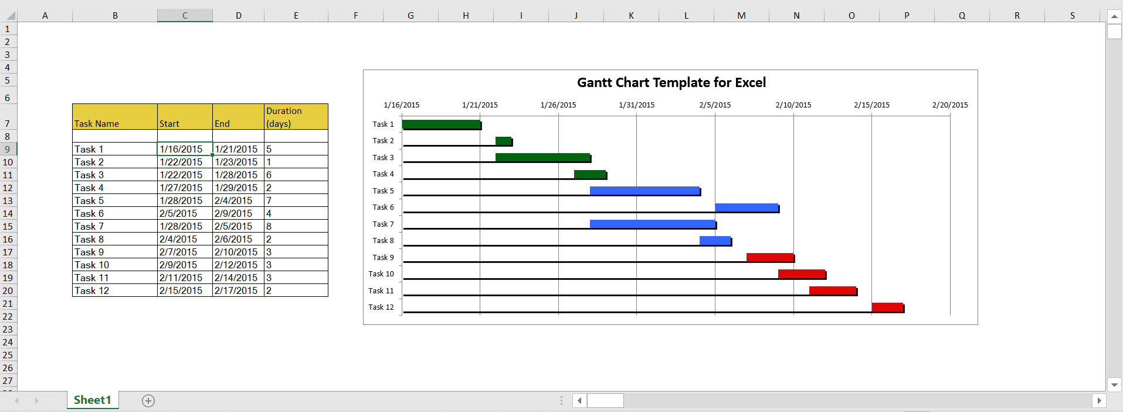
Figure 2 Example of Gantt chart.
Once the order was approved and the materials gathered, shift engineer three and four, had to build the part and arrange the line to be down for several days to get the new design to be inserted into the line. The team leader had to organize with management, which she was unable to get the time required but made an agreement to complete the job over a week during the line changeovers and CIP (Cleaning in progress) which gives the team several hours each shift to complete the changes. This led to conflict between production and engineers, due to the line being down longer then intended. The specialist did the most work due to the unique nature of the project, PLC programming experience was in short supply within the industry, budgets and the recent Covid-19 would not allow for offsite contractor for fear it would potential bring the virus on site.

Halfway through the project, Nestle brought in new procedures due to the Covid-19 virus, this meant each shift was to have zero contact with each other to prevent the virus from spreading if it was to infect anyone. This made communication difficult due to day shift engineer being removed from site to work from home, and zero communication with the other shift.
To get around this procedure and maintain social distance, management arranged to have suitable software in place to maintain meetings during the project, Microsoft teams has helped the group maintain daily contact with each other. This allowed us to discuss any issues and new ideas we might have, this allowed us to deal with them straight away then wait for each person to reply by email.
The project was an overall success, even during these challenging times. Each week Nestle enforced more procedures in place to prevent the infection from getting on site, for example daily temperature checks, a ban of all contractors from accessing the site, parcels being quarantined for up to 24 hours and every item to be cleaned every several hours. The project under normal circumstances would have been completed sooner but due to the turbulent times, we expected delays and compensated for it which results in as little downtime as possible for production.

Applying methodologies.

When the team was formed, Belbin principle was used to give each team member a role which suited each person experience and personality. Several roles were given to a single engineer due to their experience. Each role that was mention is discussed in further detail below.
- Co-ordinator.
Mainly this role is for team leaders, as they tend to be more mature, confident and can identify talent within the team members. These people tend to be manipulative and might try too offload their own work on others.
- Resource investigator.
Due to their inquisitive nature they tend to find ideas better then most and brings them to the team. They are usually outgoing and enthusiastic. They also tend to be over-optimistic and can lose interest in the project once the enthusiasm leaves.
- Team worker.
These types of people will usually help the team stick together, they are very versatile and are able to identify the work required and complete it without being asked too. They can be indecisive and tends to avoid confrontation of any kind.
- Specialist.
This role is intended for people with in-depth knowledge of the key areas of the project. They are single-minded and dedicated to the task but tends to contribute on a small part of the project due to their specialization.
- Shaper.
Provides the drive to ensure they members keep moving and do not lose focus. They like a challenge, and thrives on pressure, but tend to prone to provocation and will occasionally offend other team members.
- Implementer.
This role is for members that can effectively plan a workable strategy and are able to carry it out very efficiently. They tend to be practical, reliable and can keep the project organised. People that tend to suit this role can be inflexible and slow to respond to new changes.
- Completer finisher.
These members tend to be the most effective at the end of the task, which will tend to polish and analyse the work for any errors. They can also be reluctant to delegate any tasks.
(Belbin, 2019)
Each role was dependant on the personality and experience of each team member, this is vital to forming a strong effective team, but they should make sure each member is happy with their role as they feel more satisfied if they choose too. If not they will have lower motivation and conflicts will arise between members.

References
Alban-Metcalfe, P. B.-M. (2018, May 18). Five principles of high-performing teams. Retrieved from personeltoday: https://www.personneltoday.com/hr/five-principles-of-high-performing-teams/
Belbin. (2019, April 12). The nine belbin team roles. Retrieved from Belbin: https://www.belbin.com/about/belbin-team-roles/
Gast, B. (2015, June 30). When does a group become a team? Retrieved from Quadrant International: https://quadrantinternational.net/when-does-a-group-become-a-team/
Juneja, P. (2015, April 10). Importance of team and team working. Retrieved from Management study guide: https://www.managementstudyguide.com/importance-of-team.htm
Matthew Carter, M. W. (2008). DEVELOPING TEAM-BASED WORKING IN NHS TRUST. Team based working, 1-24.
NHS South West Yorkshire Partnership. (2012, May 12). Team wellbeing. Retrieved from southwest yorkshire nhs: https://www.southwestyorkshire.nhs.uk/wp-content/uploads/2012/06/LTQ-report.pdf
Paul O'connor, A. O. (2016). A mixed-methods study of the causes and impact of poor teamwork between junior doctors and nurses. International Journal for Quality in Health Care, Volume 28, Issue 3, 339–345.
Team building. (2016, May 12). Tuckman's forming - Storming - Norming - performing - Adjourning. Retrieved from TeamBuilding: https://www.teambuilding.co.uk/theory/Forming-Storming-Norming-Performing.html

Works Cited

Juneja, P. (2015, April 10). Importance of team and team working. Retrieved from Management study guide: https://www.managementstudyguide.com/importance-of-team.htm
Matthew Carter, M. W. (2008). DEVELOPING TEAM-BASED WORKING IN NHS TRUST. Team based working, 1-24.
NHS South West Yorkshire Partnership. (2012, May 12). Team wellbeing. Retrieved from southwest yorkshire nhs: https://www.southwestyorkshire.nhs.uk/wp-content/uploads/2012/06/LTQ-report.pdf
Paul O'connor, A. O. (2016). A mixed-methods study of the causes and impact of poor teamwork between junior doctors and nurses. International Journal for Quality in Health Care, Volume 28, Issue 3, 339–345.

