Appendices

Appendices 1:
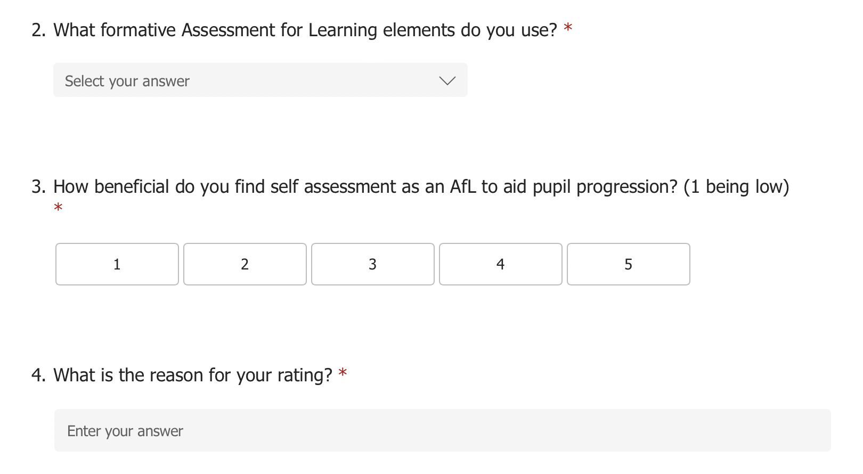
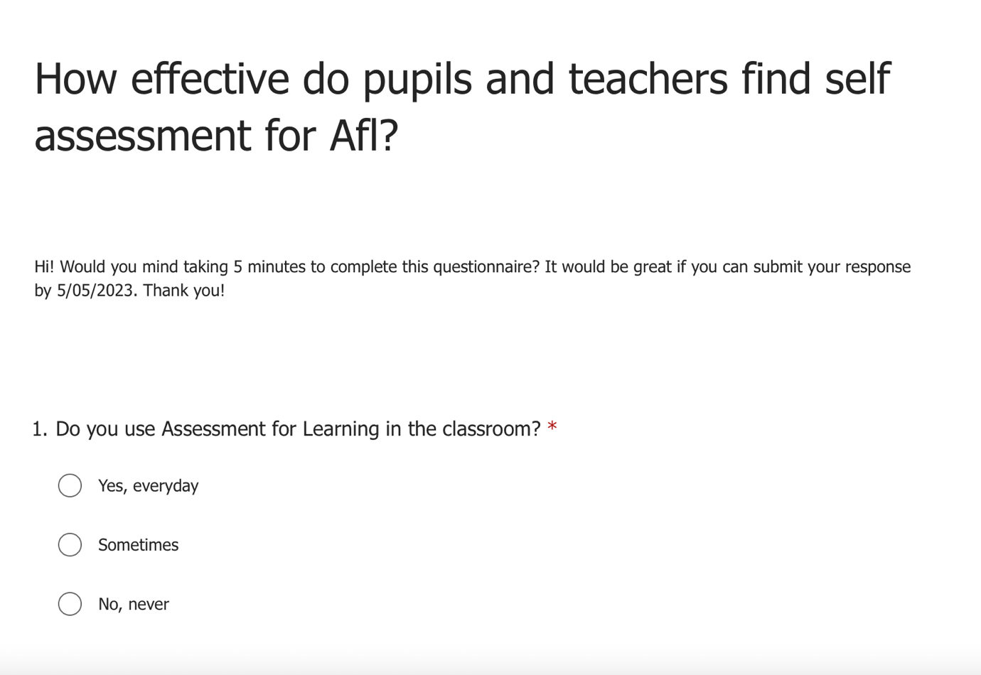

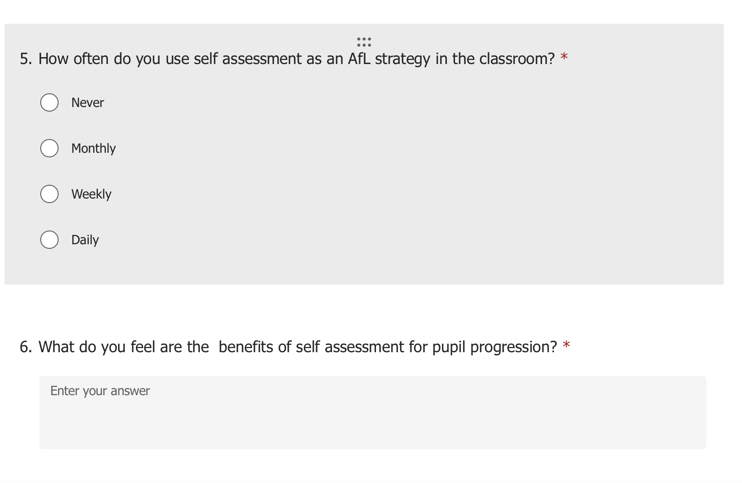

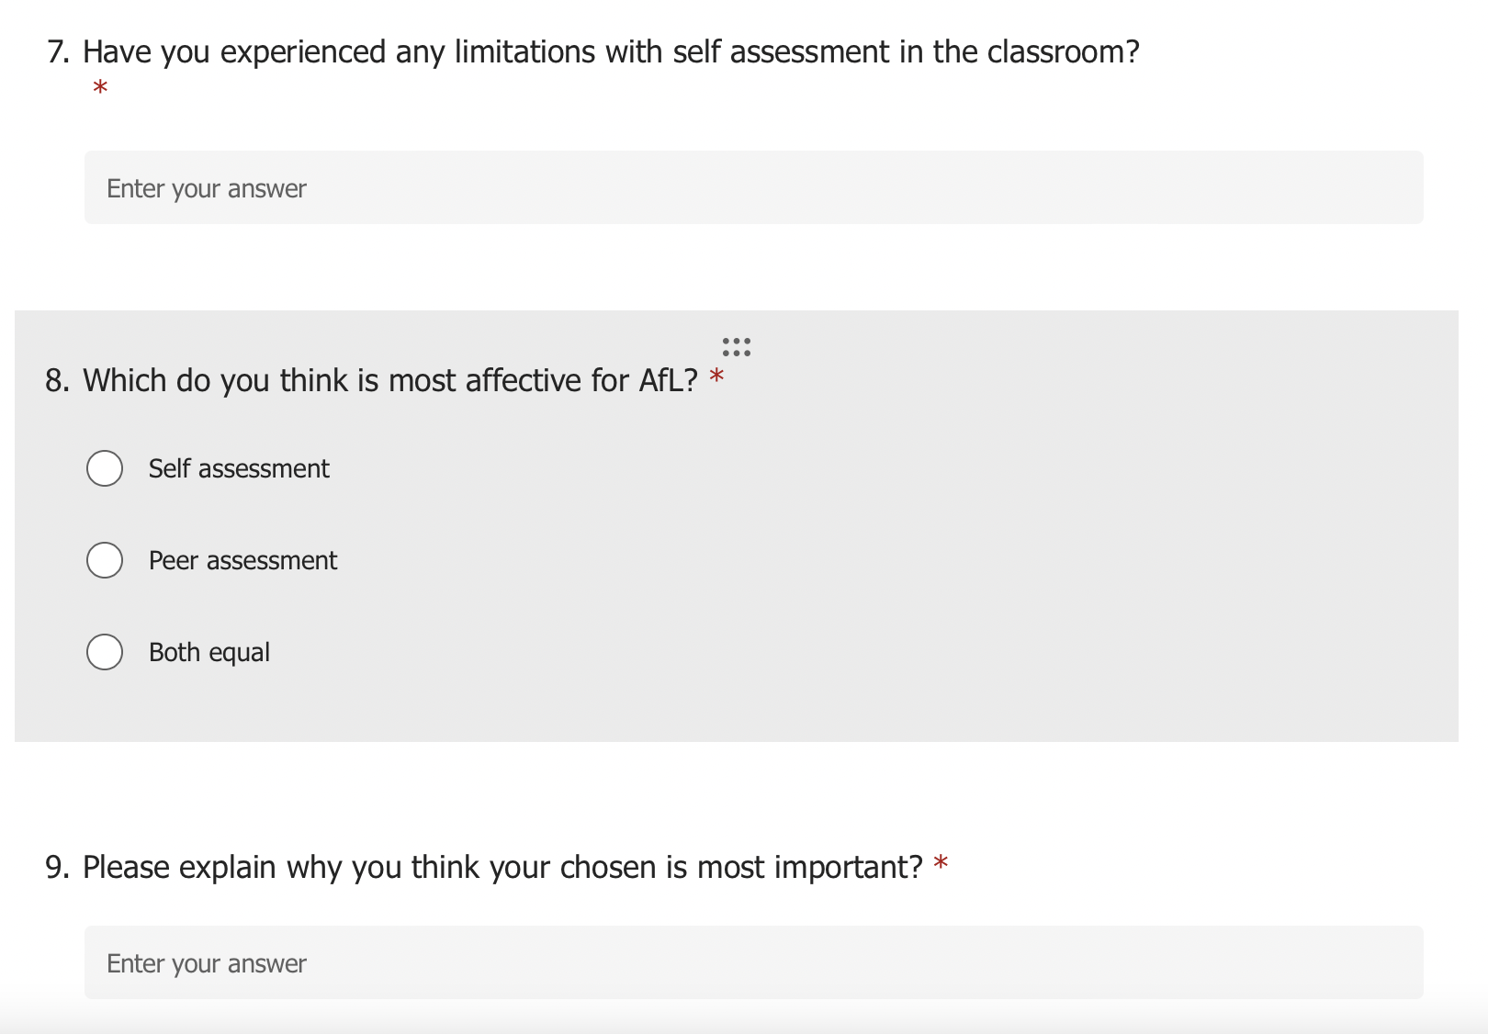

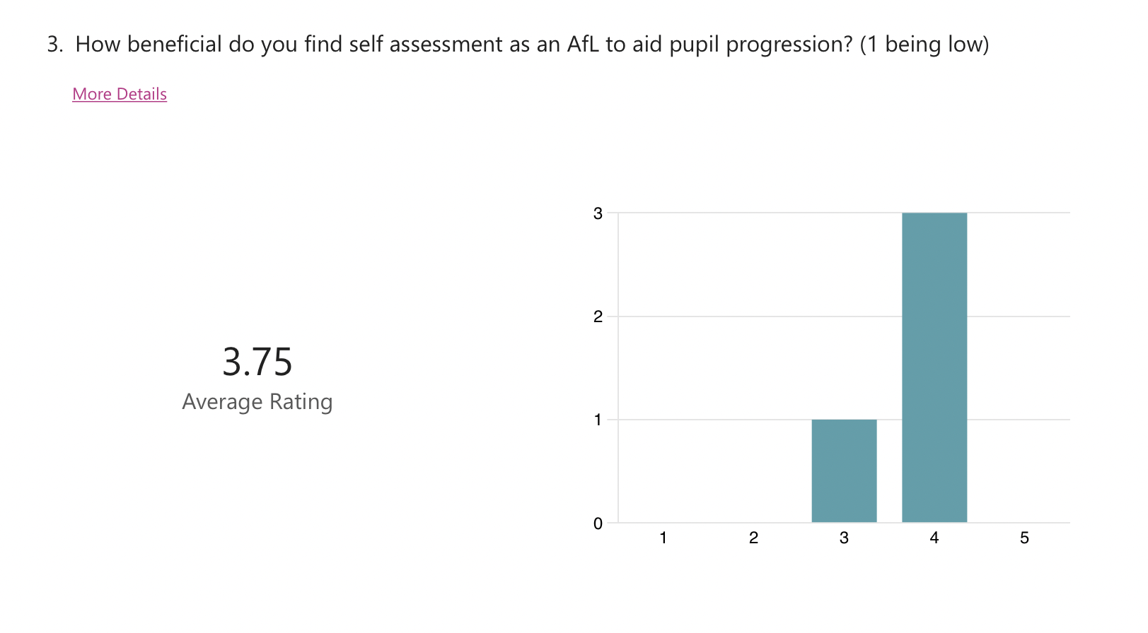
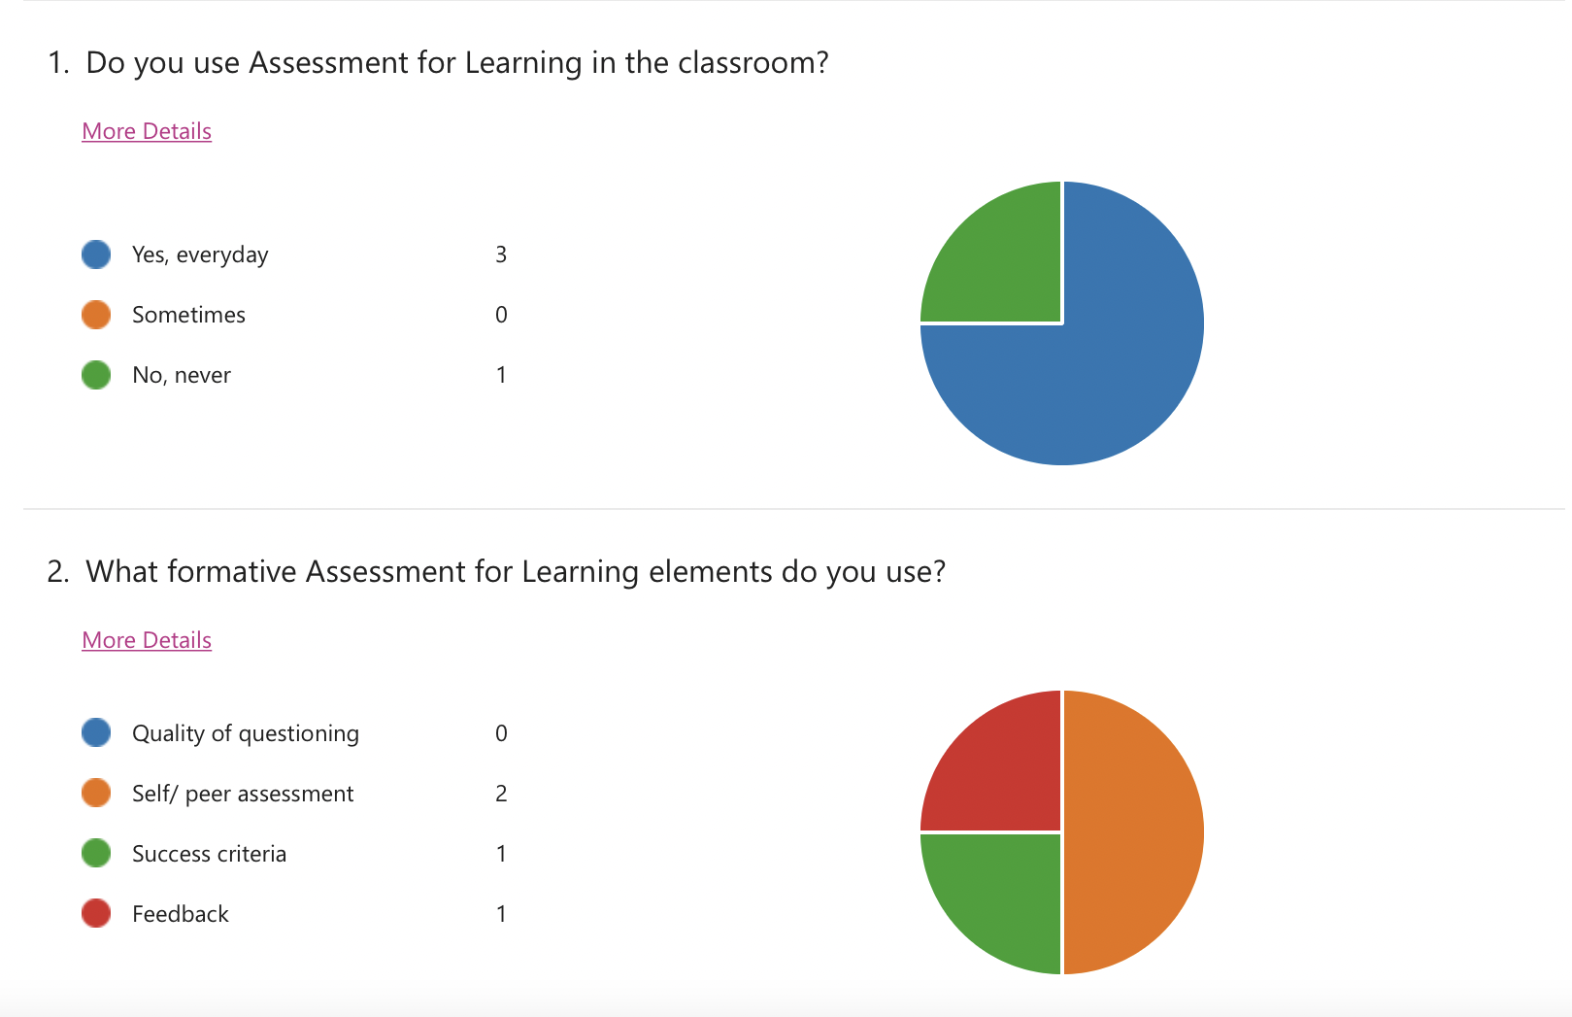
Appendices 2:

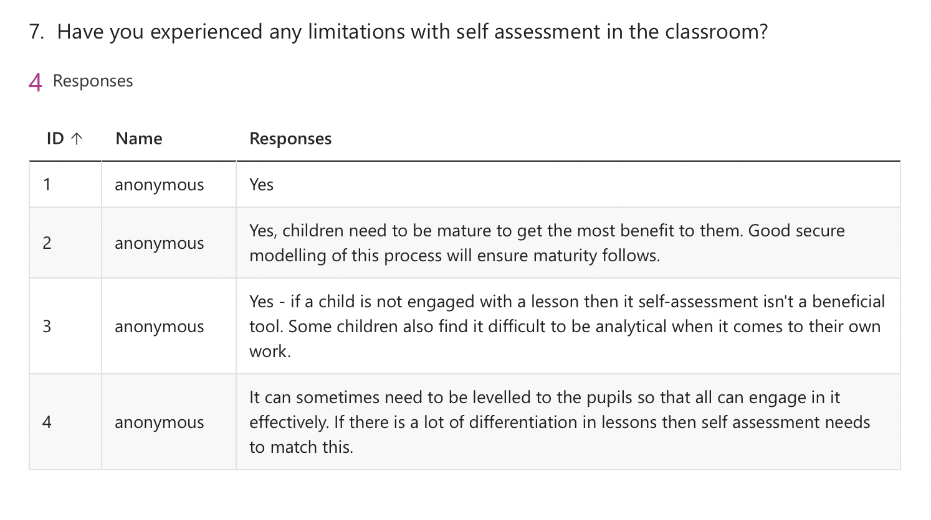
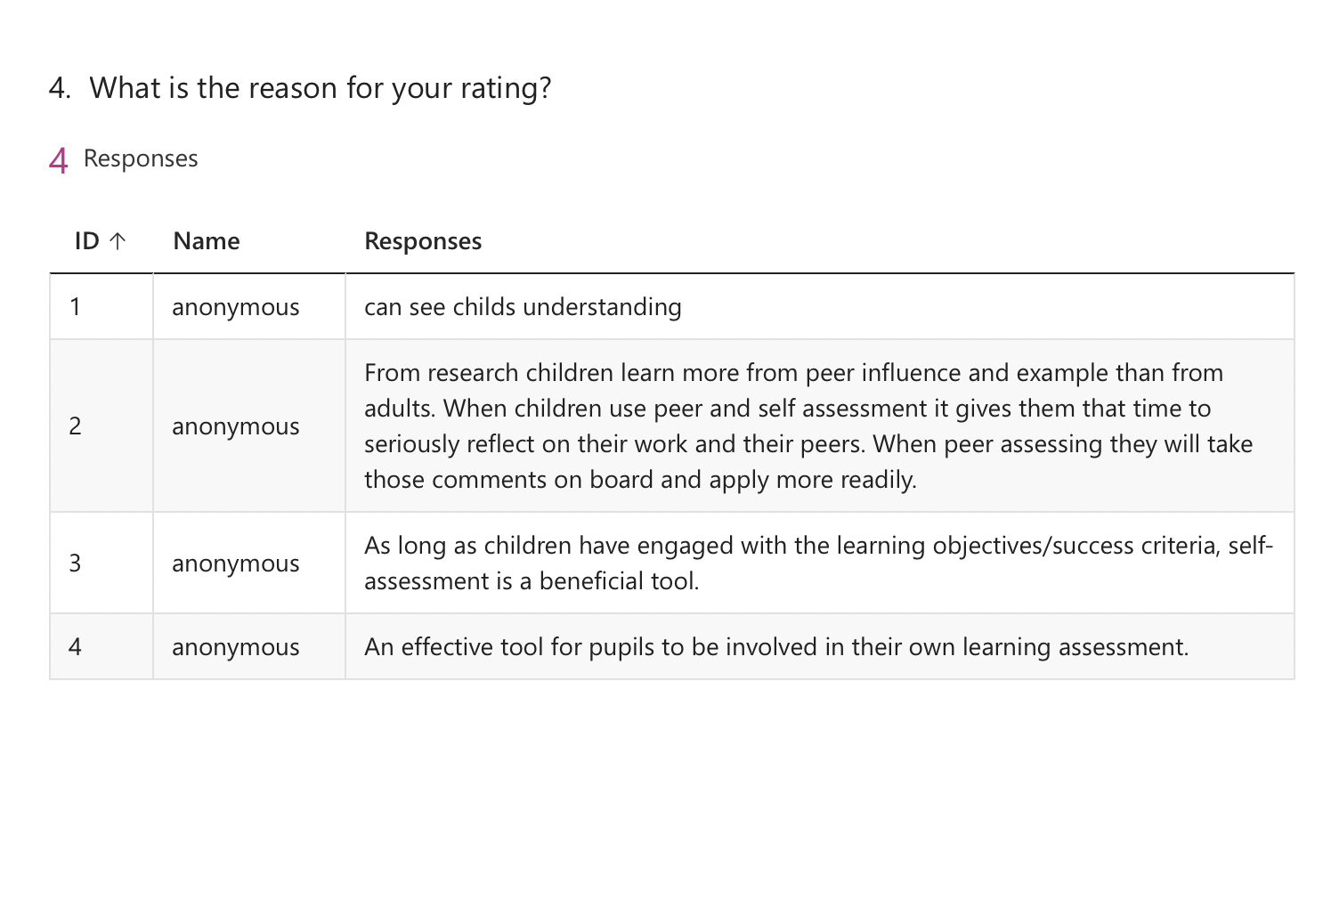
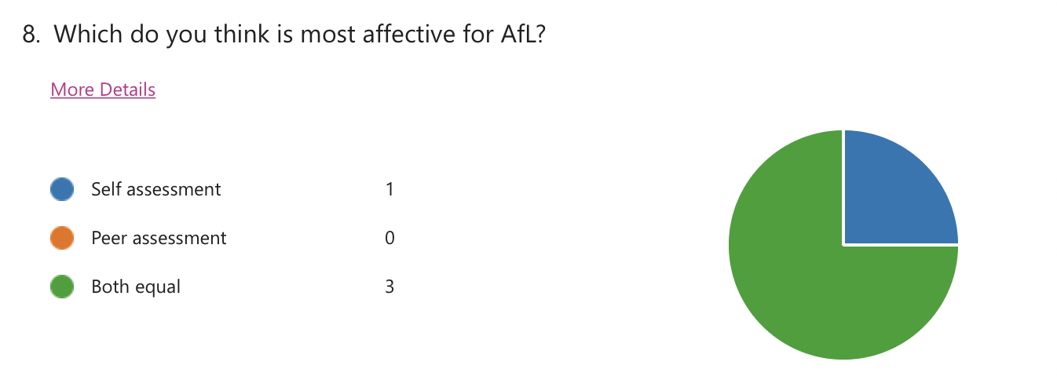
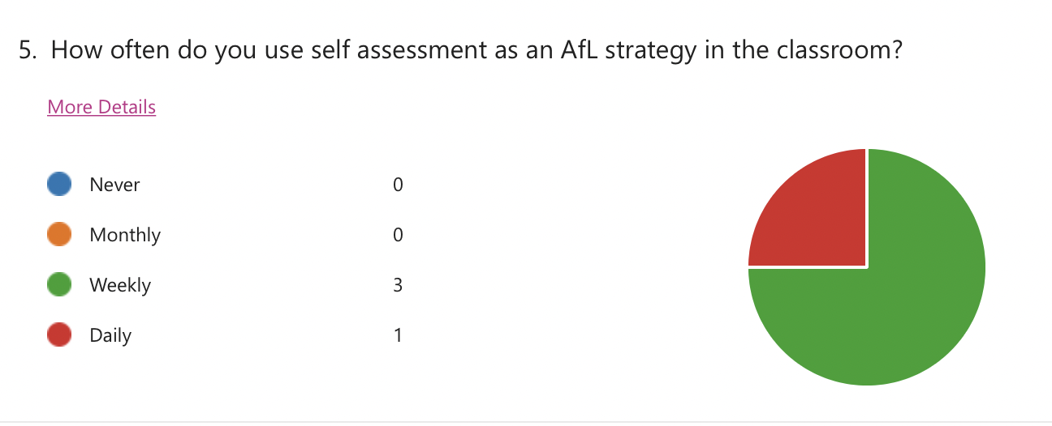

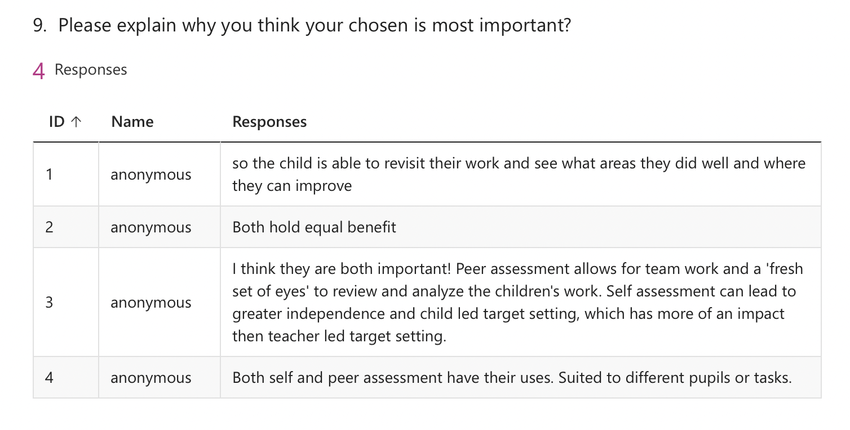

Appendices 3:
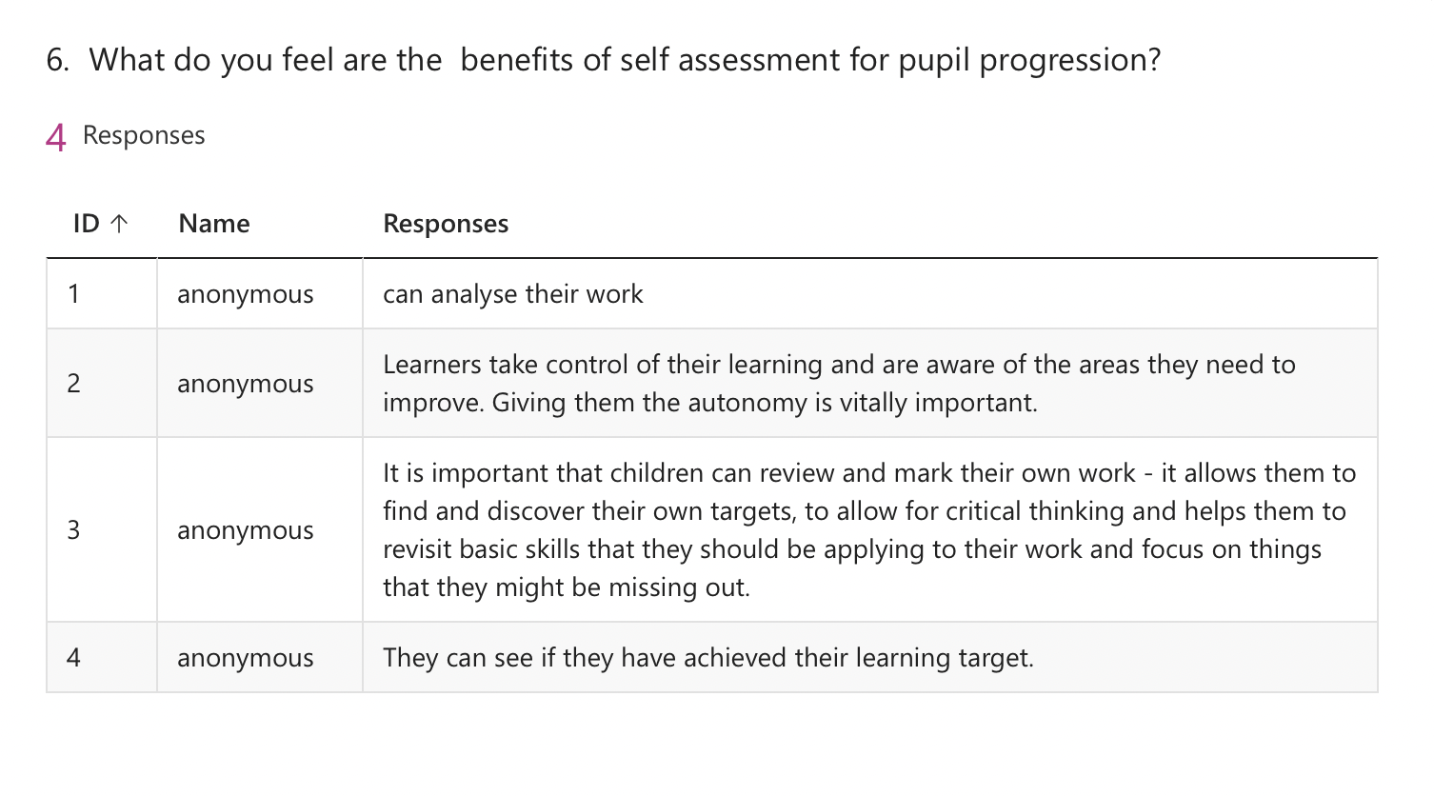
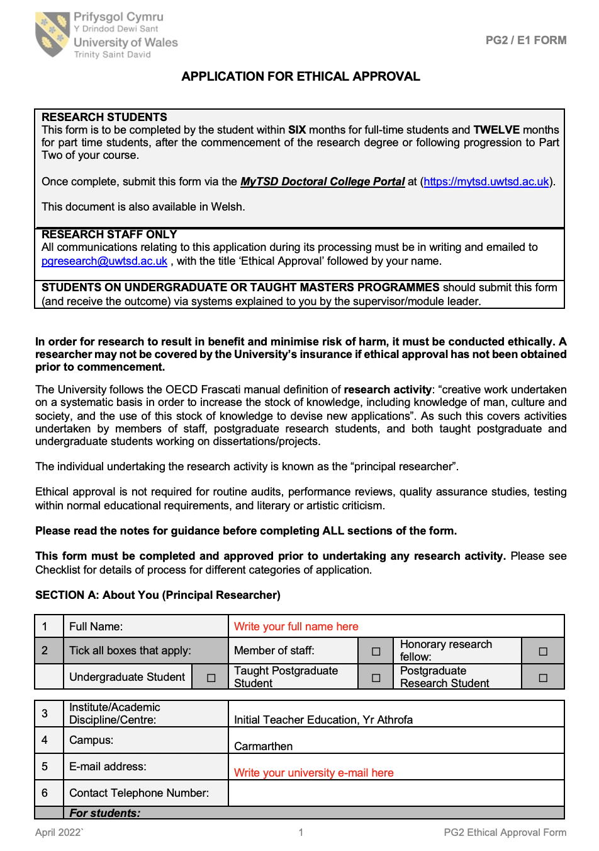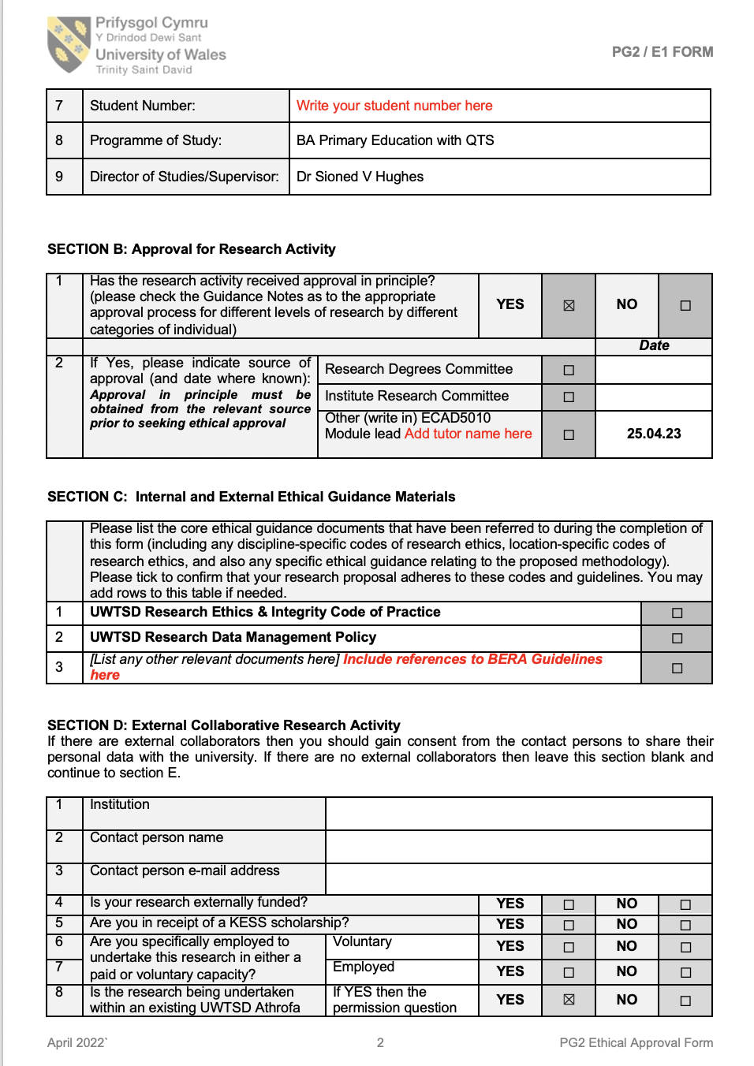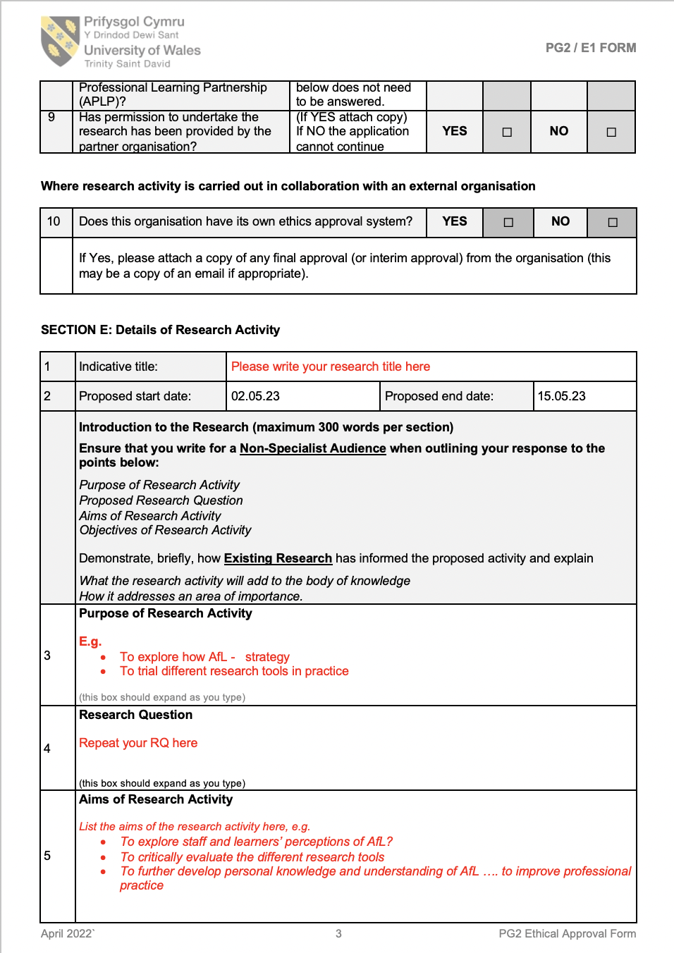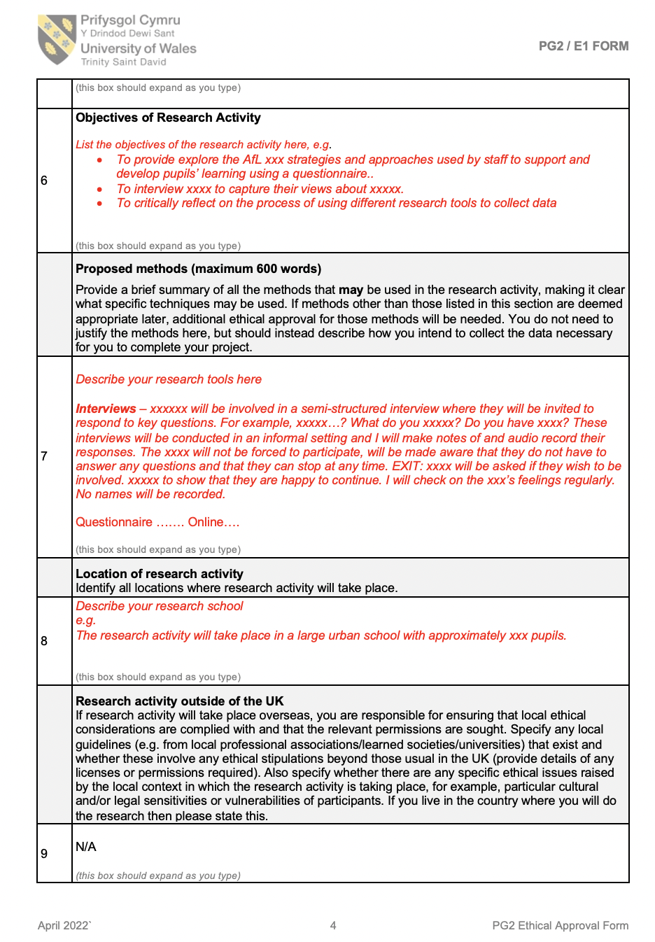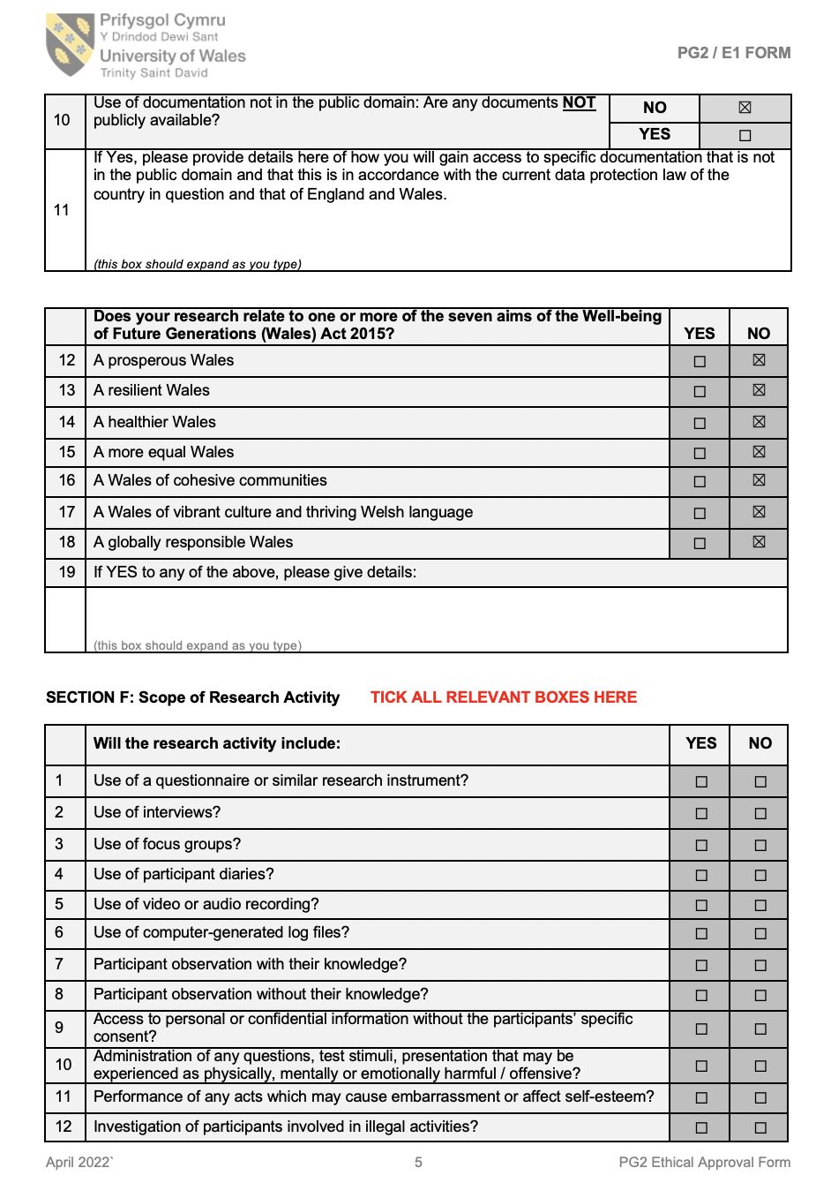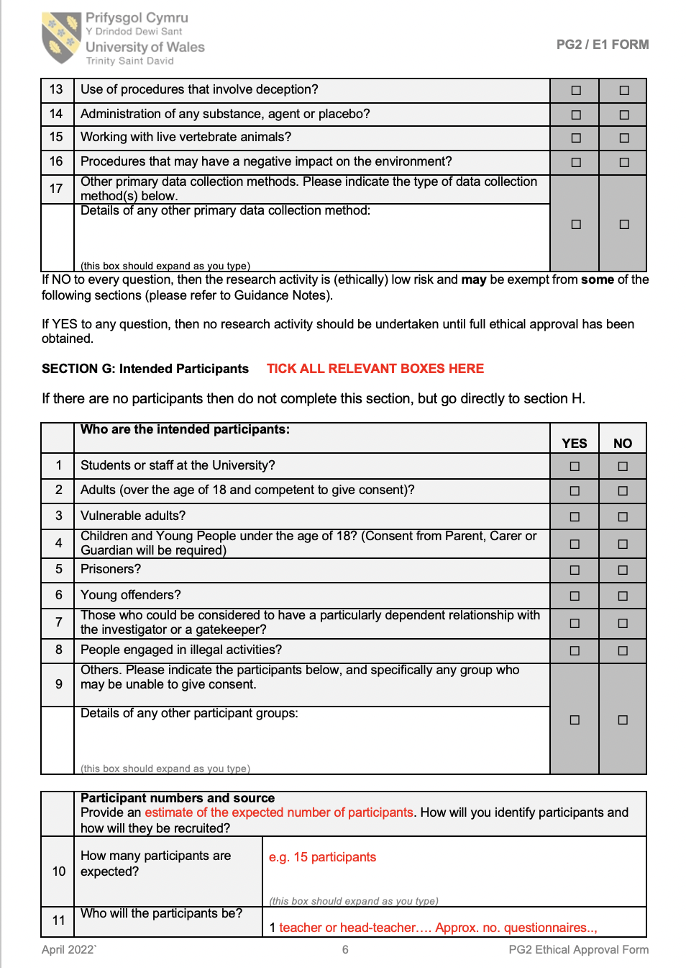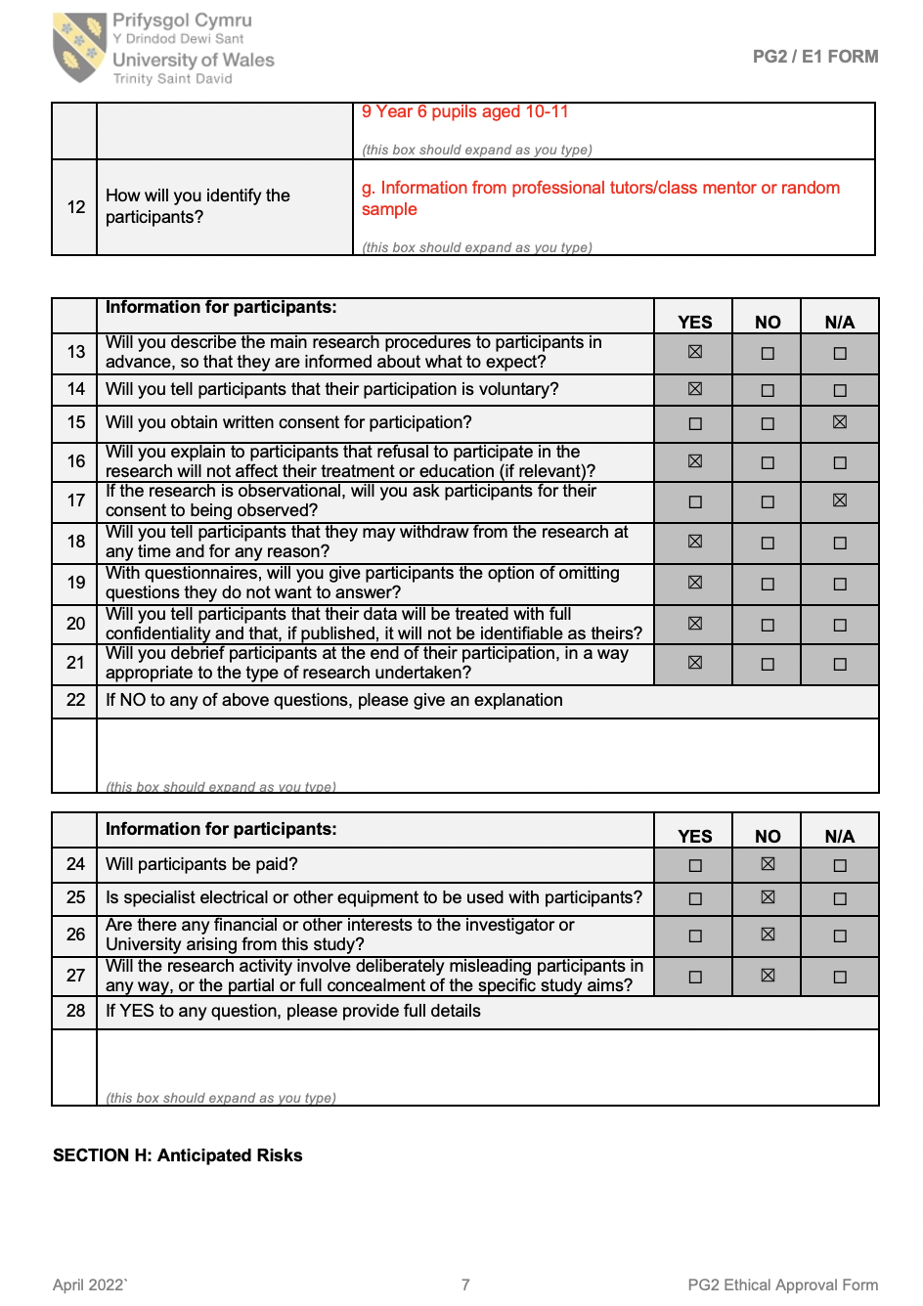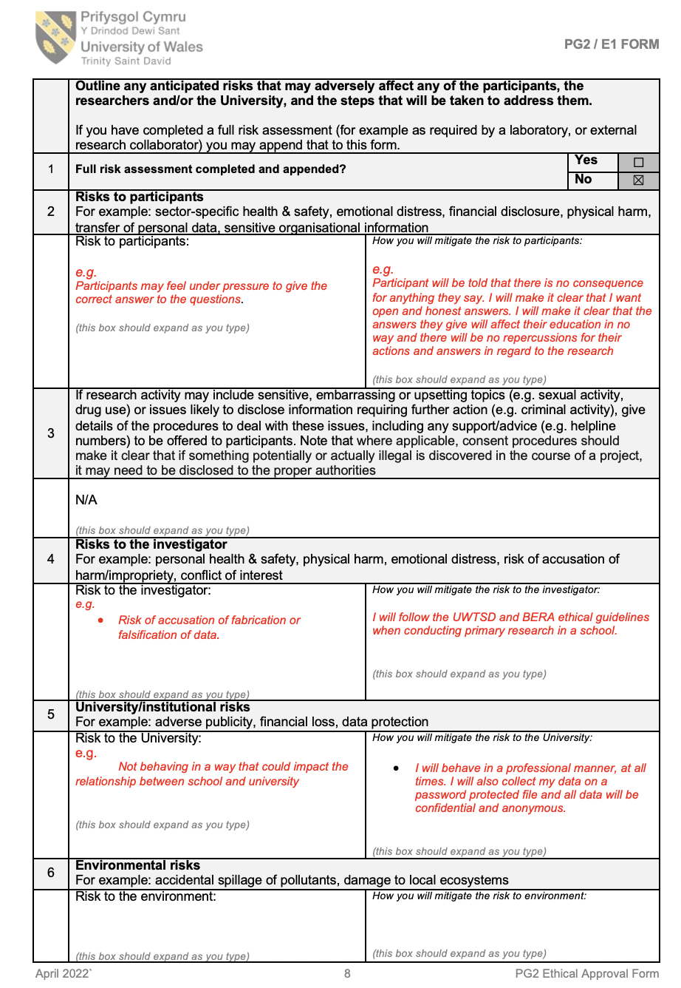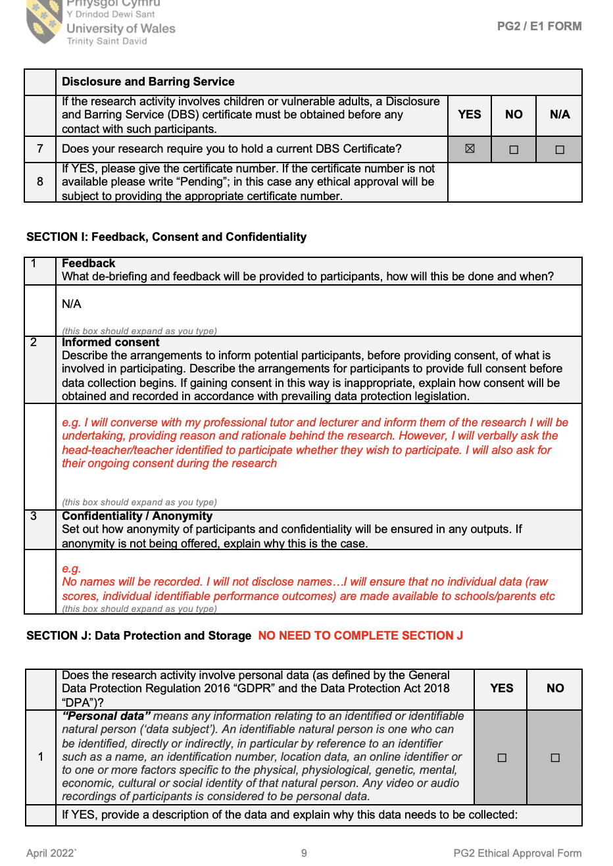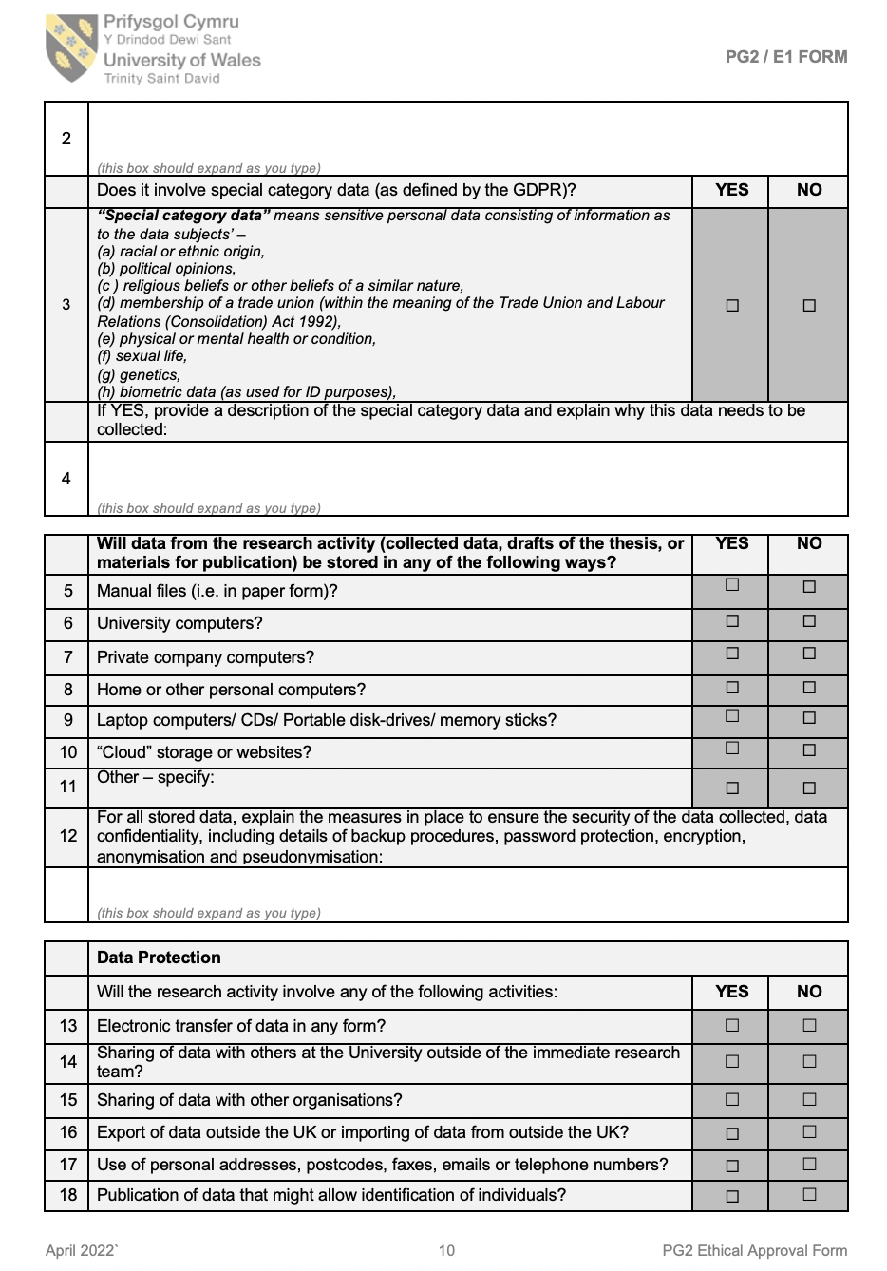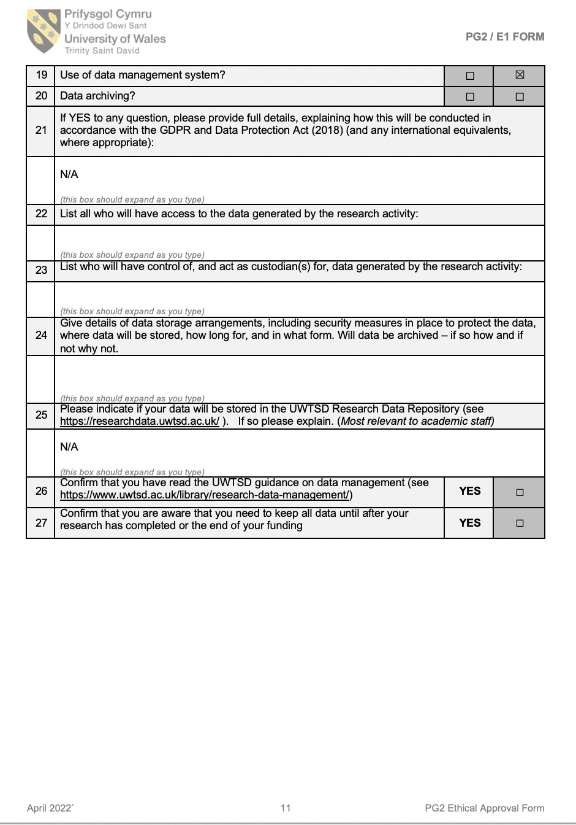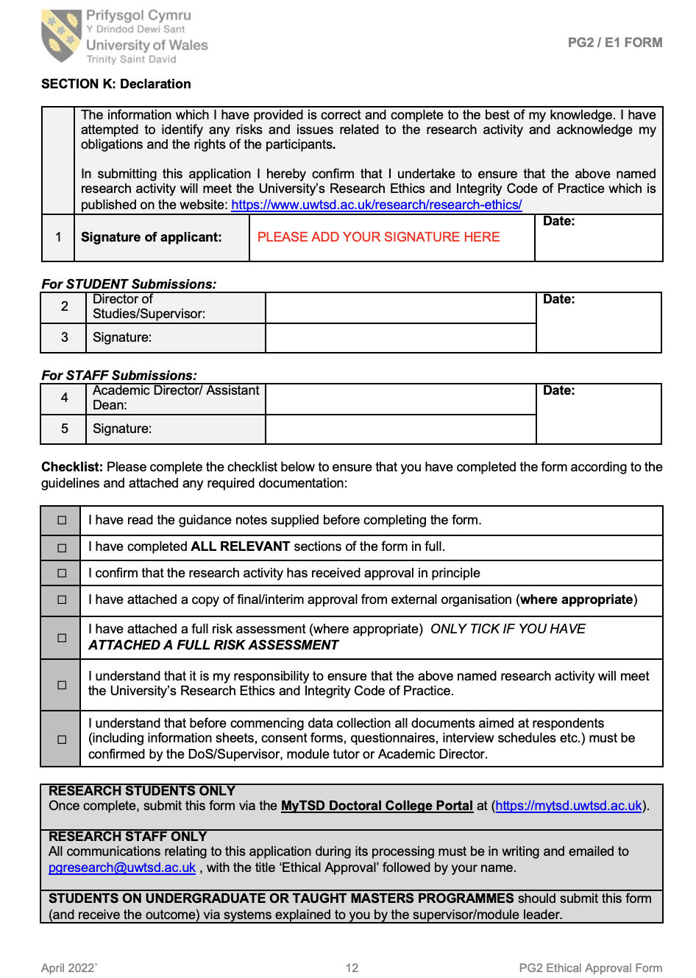

Appendices 4:

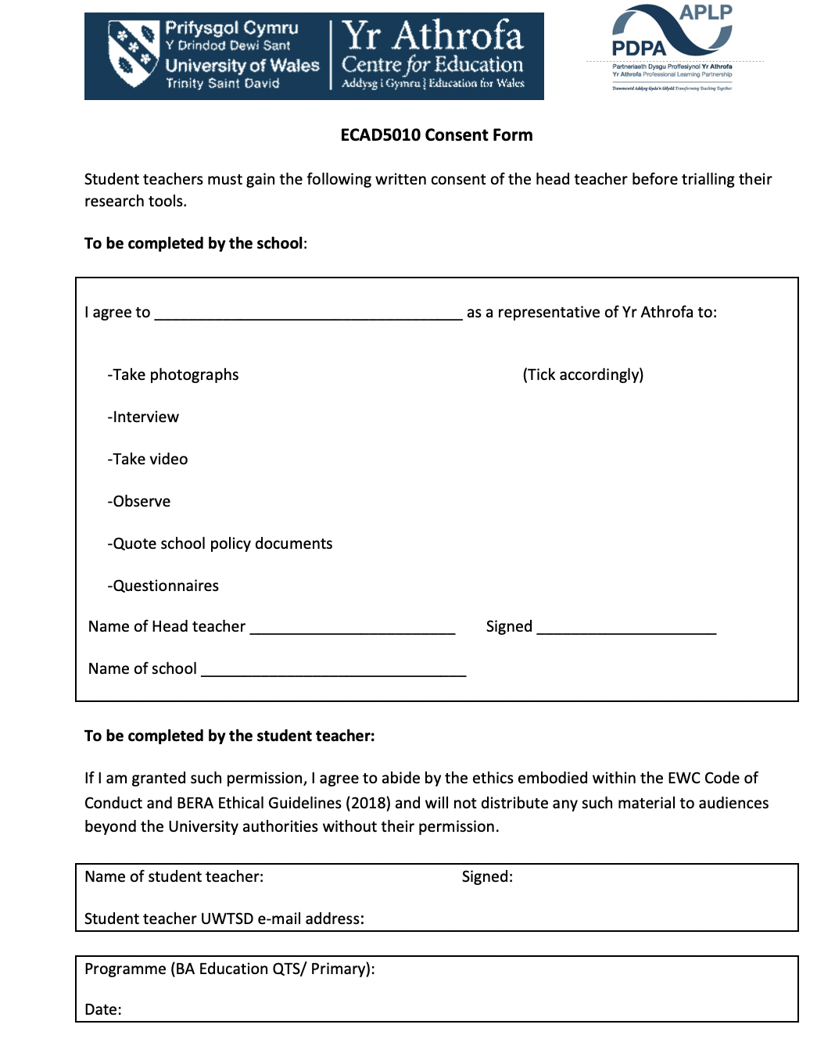

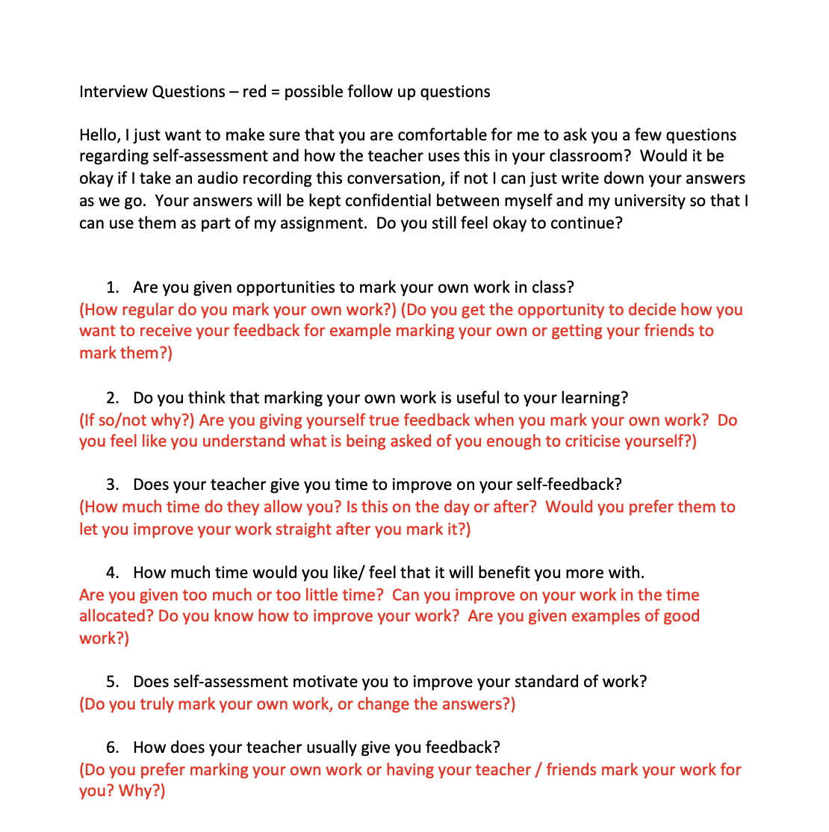
Appendices 5:

Appendices 6:

Child A:
Q1- Yes, Sir puts the answers on the board when we finish our maths work.
We only mark our own work during the maths class, but we can decide if we want sir to mark our work or if we mark our own.
Q2- I like marking my own work so I can see if I have done bad or good.
We go through PowerPoints before the work, so I feel like I know enough to mark my own work.
Q3- We are only allowed to improve our work sometimes, mainly during wake up times. But sir tells us how long we have left so if I finish early, I can have my work marked and improve it during the lesson.
Q4- We get given a WAGOLL sometimes but usually he will stop us and show us an example of someone’s work in the class when they have done a good job.
Q5- I feel better when I mark my own work compared to sir or my friends marking my work.
Q6- Sometimes in literacy we get to mark each other’s work, but I feel happier when I mark my own as nobody needs to know what I had and they can’t make fun of me.

Child B:
Q1- We do get to mark our own but when get split off into our spelling groups, during class we sometimes don’t get to decide who marks our work and we have to do it.
Q2- I like to mark my own work it makes me feel good about my learning. We often don’t get given a success criteria but I feel like it would be easier for me to mark my own work if I was given one.
Q3- We don’t really get much time to go back and improve maybe the next day during wakeup time we will have 5 minutes that we can improve stuff in.
Q4- No I prefer sir to mark my book so he knows how well I have done.
Q5- I prefer it when the teacher marks my work so he can give me targets that I can improve on next time.
Q6- We sometimes use peer-assessment and I like giving my work to my friends so they can see what I’ve done.

Child C:
Q1- We get to mark our own work all the time in maths but sometimes we can choose whether we mark it or the teacher marks it.
Q2- I don’t like to mark my own work because I’m lazy. I prefer for the teacher to mark my work I get more out of that.
Q3- Usually we can improve our work the next day but some people can do it the same day but I cant as the lesson has already finished so it takes me too long.
Q4- I would like to have more time in the lesson to improve my own work I feel like another 15 minutes would be okay.
Q5- I don’t like to criticise my own work so I’m not really a fan of marking my own work, I much prefer it when someone else marks it.
Q6- We get a success criteria sometimes or the teacher tells me what I ca do to improve my work.

Child D:
Q1- We get to mark our own working during literacy and sometimes topic.
Q2- I find self-assessment helpful so I can see how many I have right. I prefer marking my own work when we are learning about something I enjoy.
Q3- We usually get around 5-20 minutes to improve our work the next morning when we are given our wake up task.
Q4- We get given an example of someone’s good work or we will make one together so we know what we need to do.
Q5- No I don’t really enjoy it that much.
Q6- Sometimes the teacher will say well done or our friends will mark our work and they will say what I did good.

Child E:
Q1- We get to mark our own during maths so we get the answers on the board and they use them to see of we have the right. We don’t do maths everyday though so we only mark our work just in maths. The teacher gets to decide who marks our work.
Q2- I like marking my own work and I feel like I give myself truthful feedback.
Q3- We get to improve our own work wither during break time or sometimes in Friday finishing off. We are usually given about 5 to 10 minutes to improve our work but I think that’s too much time.
Q4- We get shown how we can improve our work.
Q5- I like to mark my work when we have a list of what needs to go in it.
Q6- I like my friends to mark my work it makes me feel good about what I’ve done.

