Programme: BSc Health and Social Care
Lecturer: Zakiyyah Ahmed
INTRODUCTION TO INDEPENDENT RESEARCH SKILLS
MODULE CODE: BMHP5019
ASSIGNMENT
TITLE: COMPONENT 2: WRITTEN ASSIGNMENT (RESEARCH REPORT)

STUDENT NAME: Lilieana -Lavinia Victoria
STUDENT ID: 2412370

Acknowledgement
I would also wish to thank my lecturer and supervisor for offering me their guidance, support and constructive critique during this scoping review. Another point that I would like to mention is that the published work by the authors and researchers informed my study. And lastly, I owe this project to my family and friends who have provided me with continuous support and motivation.

Abstract
Autism Spectrum Disorder (ASD) is a long-term neurodevelopmental disorder that is linked with difficulties in social communication, limited behaviours, and sensory processing variations. This scoping review sought to elicit the essential themes, in connection with ASD diagnosis, early intervention and long-term support through the Simplified Thematic Analysis of Aveyard. A total of six peer-reviewed articles on the topic that were published since 2020 were synthesised. Results revealed the presence of three broad themes, including difficulties in attaining timely and precise diagnosis, effectiveness and restrictions of early intervention, and the necessity of coordinated support throughout the long-term health, school, and community contexts. The review serves as a conclusion that multidisciplinary collaboration could be enhanced to improve the results and quality of life of autistic people, since it is necessary to eliminate diagnostic disparities and reinforce person-centred lifelong assistance.

Table of Contents
Acknowledgement 2
Abstract 3
1. Introduction 5
Research Aim and Objectives 5
Research Question 6
2. Background 6
2.1 Understanding Autism Spectrum Disorder and the UK Policy Context 6
2.2 Diagnosis, Early Intervention and NHS Services 6
2.3 Long-Term Support Needs and Evidence Gaps 7
3. Methodology 8
3.1 Research Design 9
3.2 Literature Search Strategy and Study Selection 9
3.3 Data Analysis and Ethical Considerations 9
4. Results 10
5. Discussion 14
5.1 Thematic Analysis 14
5.1.1 Theme 1: Challenges in Achieving Timely and Accurate Diagnosis 14
5.1.2 Theme 2: Effectiveness and Limitations of Early Intervention 14
5.1.3 Theme 3: Long-Term Support Needs Across Healthcare, Education and Community Settings 15
5.2 Interpretation of the Findings 15
6. Conclusion and Recommendation 16
6.1 Conclusion 16
6.2. Recommendations 16
References 19

1. Introduction
Autism Spectrum Disorder (ASD) is a lifetime neurodevelopmental disorder that is typified by long-standing problems in social communication and social interaction, and limited, repetitive behavioural, interest, or activity patterns (Hirota and King, 2023). The spectrum term captures the existence of high variation in the presentation and severity of symptoms, and as autistic persons age, they have different strengths, challenges, and support needs in life. Besides the main diagnostic symptoms, many autistic individuals have sensory processing differences, mental illnesses, intellectual disabilities, or attention deficit hyperactivity disorder (ADHD), and the assessment and support process is more complicated (Rosen et al., 2018).
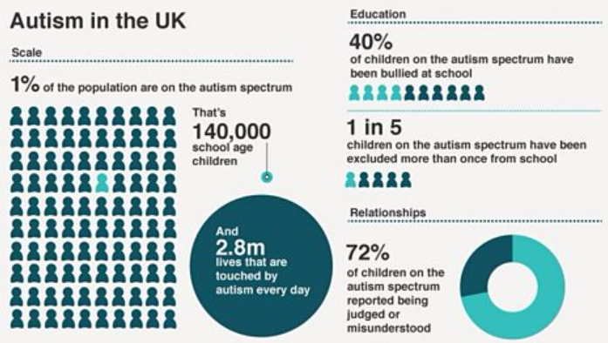
Figure 1: Autism facts
Source: (BBC, 2026)
Autism is acknowledged as a major public health concern due to the fact that it is getting more common and that it has long-lasting effects on the lives of individuals, families, health systems and the society. At the Global level, 1 in 127 individuals were estimated to have autism in 2021, yet due to the variation in diagnosing autism among regions, the rate of autism also differs among regions due to variation in the rate of awareness and access to health services (WHO, 2025). There was an increase in the cases of ASD in the United States in 2022. The prevalence of ASD among 8-year-old children rose to 32.2 per 1,000 children (1 in 31) (Shaw, 2025). Even though these rising rates can be mostly explained by better awareness, more liberal diagnostic criteria, and increasingly widespread screening, instead of an actual increase in incidence, many people still experience delayed diagnosis, disparities in access to early intervention, and insufficient long-term support. These issues are especially noticeable in females, adults, and ethnically diverse or socioeconomically disadvantaged citizens.

Research Aim and Objectives
The aim of this scoping review is to map existing literature on autism spectrum disorder (ASD) by identifying major themes related to diagnosis, early intervention, and support using Aveyard’s Simplified Thematic Analysis.
The objectives are to:
- To examine current evidence regarding methods and challenges of ASD diagnosis.
- To explore the effectiveness and limitations of early intervention strategies.
- To identify key support needs and gaps across healthcare, education, and community settings.

Research Question
What are the key themes relating to diagnosis, early intervention, and support for individuals with autism spectrum disorder (ASD) identified within existing literature?

2. Background

2.1 Understanding Autism Spectrum Disorder and the UK Policy Context
Autism Spectrum Disorder (ASD) is a neurodevelopmental disorder that is lifelong and is defined by persistent dissimilarities in social interaction and communication, as well as limited or stereotypical behaviours and variations in sensory processing (Lord et al., 2020). Instead of being considered a disorder to be cured, contemporary knowledge sees autism as a spectrum whereby people manifest differently with various strengths, weaknesses, and support needs. As a result, the best care must be provided through individual evaluation and treatment, instead of the one-size-fits-all care. Policy In policymaking in the United Kingdom, autism has increasingly assumed a direction of advocacy for an early diagnosis, individual treatment, and inclusion of individuals with autism. The first law on disability in England was the Autism Act 2009, followed by the statutory obligation on the Government to implement and systematically revise an adult autism strategy (Challenging Behaviour, 2023). This act resulted in the release of Think Autism and later national strategies, which were meant to enhance the diagnosis, employment prospects, health care and independent living of autistic adults. In the case of children and young viewers, Education, Health and Care (EHC) plans are used to replace Statements of Special Educational Needs so as to enhance the coordinated provision of education, health, and social care (GOV.UK, 2014). The Special Educational Needs and Disability (SEND) Code of Practice 2015 is a statutory guideline that guides local authorities, schools, and healthcare providers with the primary focus on early identification, a family-centred approach, and cooperative work of multiple agencies (Saxton et al., 2026). All these initiatives, combined, form a set of legal provisions aimed at helping autistic people to get the proper support both during the education process and later in their lives.
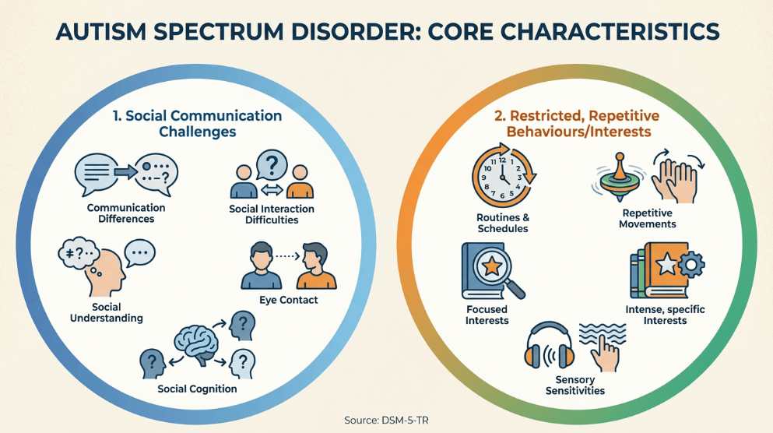
Figure 2: Core Characteristics of Autism Spectrum Disorder
Source: (Shepherd, 2026)

2.2 Diagnosis, Early Intervention and NHS Services
Early and precise diagnosis is core as it permits access to the educational support, healthcare services, behavioural intervention, and family guidance in a timely manner. In England, the National Institute for Health and Care Excellence (NICE) advises that the assessment of children should be based on the Clinical Guideline CG128 (autism spectrum disorder in under 19s: recognition, referral and diagnosis) (National Institute for Health and Care Excellence (NICE), 2017). Clinical Guideline CG142 (autism spectrum disorder in adults: diagnosis and management) needs to be evaluated in adults (Allison and Baron-Cohen, 2018). Moreover, NICE Guideline NG87 offers the information on how to identify and treat attention deficit hyperactivity disorder (ADHD), and since the co-occurring ADHD is prevalent in autistic persons, it is necessary to consider it. Further standardisation of assessment is observed with the NHS England National Autism Diagnostic Pathway for Children and Young People 2023, in which it is recommended to refer children at an early age, take a full developmental history, conduct a multidisciplinary assessment, and make decisions with the family (NHS England, 2023). Nevertheless, despite these recommendations, there is a difference in service provision among regions. Prolonged waiting times, a deficit of specialist clinicians, inconsistency in referral pathways, and variations that impact girls, adults, and ethnic minorities are persistent factors that delay diagnosis. These delays can delay access to educational modification, therapeutic interventions and family support and can have a long-term developmental impact.
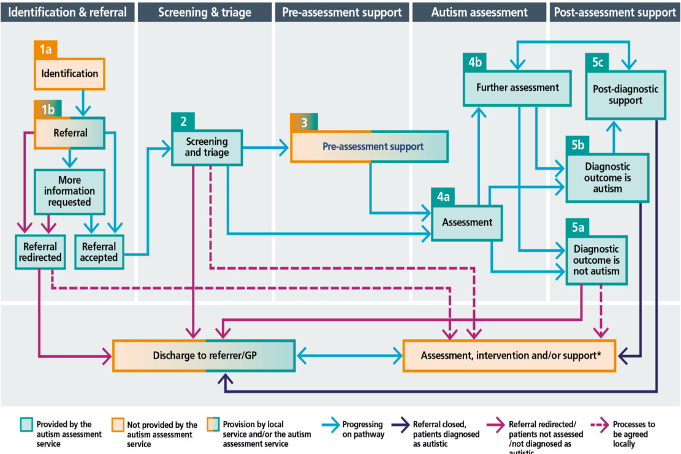
Figure 3: The five stages of the autism assessment pathway
Source: (NHS England, 2023)

2.3 Long-Term Support Needs and Evidence Gaps
Despite the consistently observed positive effect of early intervention on communication, adaptive behaviour and social functioning, autism is a long-term disorder that needs sustained support even after childhood. Thoughtful interventions often include family-focused services, speech and language therapy, occupational therapy, behavioural interventions, learning accommodations, and mental health services that are more individualised based on the diagnosis instead of diagnosis alone (Liu et al., 2025). Nevertheless, adolescence and adulthood can frequently disrupt support, especially when children are leaving child services to join adult services, where many individuals with autism experience a decrease in the quality of specialist healthcare, job assistance and service provision by their community. Some key research gaps are also indicated in the currently existing evidence. A large portion of the existing literature is conducted on young children, and in comparison, fewer studies have been done on autistic adults, older adults, females, and culturally diverse populations. Also, there is not much evidence on the effectiveness of the post-diagnostic support and integrated health and social care services in the long term.

3. Methodology

3.1 Research Design
In this research, a scoping review approach was used to review the available evidence on autism spectrum disorder (ASD) in terms of diagnosis, early intervention and long-term support. The best research design was found to be a scoping review. It helps the researchers to visually provide a map of the scope and type of evidence accessible on a subject and reveals those important concepts, gaps in knowledge, and other aspects that need more facts (Munn et al., 2022). As opposed to systematic reviews, which are mainly aimed at studying the effectiveness of certain interventions, scoping reviews offer a more comprehensive picture of the research based on various study designs. In order to facilitate the process of data synthesis, Aveyards Simplified Thematic Analysis has been implemented, whereby findings of various studies can be categorised into shared themes.

3.2 Literature Search Strategy and Study Selection
The literature search followed a systematic approach with the four electronic databases, PubMed, Scopus, CINAHL, and PsycINFO, as all the four databases are fully covered in healthcare and study topics, psychology, nursing, and allied health research applicable to autism. Medical Subject Headings (MeSH) and keywords were used in the search, which included: "autism spectrum disorder," ASD diagnosis, early intervention, support services, and autism support needs, each combined with Boolean operators (AND/OR) to limit the search.
Included in the studies were those which:
- were peer-reviewed research papers;
- have been written in English and published between 2015 and 2026;
- investigated ASD diagnosis, early intervention, support services, or lived experiences; and
- used both qualitative and quantitative and mixed methods research design.
The studies were filtered out when they:
- had not been published in English;
- was made up of editorials, opinion articles, conference abstracts or grey literature; or
- failed to directly answer the review question.
After the search of the database, titles and abstracts were filtered in accordance with the inclusion criteria and full-text articles were evaluated by the inclusion criteria. In this review, thematic synthesis identified six articles that best addressed the research question.

3.3 Data Analysis and Ethical Considerations
The information in the included studies was summarised in a table that included the author, year of publication, country, study design, participants, study aim, and key findings. These results were then analysed by the Simplified Thematic Analysis of Aveyard. This encompassed the thorough repetition of the chosen studies, drawing of common themes, clustering of similar results, and crafting of general themes that answered the review question (Fleshman, 2026). This method of analysis helped to compare studies across the board as well as identify similarities, dissimilarities and gaps in the current base of evidence. Since this study was conducted using published literature only, no formal ethical approval was needed since there would be no human subjects or personal data. However, the academic standards of integrity were observed during the review process, with the transparent search process, precise expression of the findings of the authors, critical assessment of the evidence, and proper referencing of all sources to reduce bias and keep the research credible.

4. Results
The inclusion criteria were to include peer-reviewed studies published between 2020 and 2025, and six studies met these criteria and were included in this scoping review. These studies included evidence on autism diagnosis, early intervention, and long-term support and consisted of a systematic review, a narrative review, an empirical survey, and observational research. Tracing the paths laid out by the Simplified Thematic Analysis by Aveyard, three general themes emerged: (1) the difficulty of timely and correct diagnosis, (2) how effective and restricted early intervention may be, and (3) the necessity of long-term support at the level of healthcare, education, and community. The initial theme was the ongoing challenges in timely and precise diagnosis. Qin et al. (2024) highlighted the new developments in diagnostic methods and pointed out persistent problems with the heterogeneity in diagnostics and biomarker unreliability. In line with this, McCarty and Frye (2020) indicated that multiple overlaps in symptoms, clinical presentation variability, and late recognition often add to late diagnosis, thus limiting access to services.
The second theme was about early intervention. As demonstrated by Maksimović et al. (2023), early intervention has been shown to be effective in enhancing communication skills and alleviating symptoms of autism, especially when used in early childhood. The authors, however, wrote that traditional models of intervention must think more strongly in terms of neurodiversity since it should focus on the wellbeing, autonomy, and quality of life of autistic individuals instead of only pursuing a normalisation of behaviour (Leadbitter et al., 2021). The last theme was the long-term support requirements. Detecting significant diversity in the service of autism assessment in the United Kingdom, Parr et al. (2024) suggest the effect of workforce shortage as well as the fluctuation in diagnostic pathways. Similarly, Babalola et al. (2025) have discovered that autistic children and their families still face barriers to seeking healthcare because of a lack of understanding in communication, limited professional knowledge, and disjointed healthcare. All these results have shown that although there has been an improvement in the diagnosis and intervention of ASD, there exist extensive disparities in regard to access and ongoing support of services throughout the lifespan.
Author (Year) | Country | Study Design | Aim | Key Findings | Related Theme
Qin et al. (2024) | China | Narrative review | To review recent advances in ASD diagnosis and treatment. | Advances in genetics and neuroimaging have improved understanding of ASD; however, diagnosis remains challenging because of symptom heterogeneity and the absence of reliable biomarkers. | Theme 1: Challenges in achieving timely and accurate diagnosis
McCarty and Frye (2020) | USA | Narrative review | To examine barriers to early detection and diagnosis of ASD. | Early diagnosis is hindered by variable symptom presentation, co-occurring conditions, and limited awareness among healthcare professionals, delaying access to intervention. | Theme 1: Challenges in achieving timely and accurate diagnosis
Leadbitter et al. (2021) | UK | Review article | To explore the implications of the neurodiversity movement for autism early intervention. | Early intervention should prioritise quality of life, autonomy, and individual strengths rather than focusing solely on reducing autistic behaviours. | Theme 2: Effectiveness and limitations of early intervention
Maksimović et al. (2023) | Serbia | Observational study | To evaluate the effectiveness of early intervention for children with ASD. | Early intervention significantly improved speech, language development, communication, and adaptive functioning, supporting the importance of early diagnosis. | Theme 2: Effectiveness and limitations of early intervention
Parr et al. (2024) | United Kingdom | National survey | To investigate autism assessment services across the UK. | Considerable variation exists in diagnostic pathways, workforce capacity, and waiting times, highlighting inequalities in service provision and the need for service improvement. | Theme 3: Long-term support needs across healthcare, education and community settings
Babalola et al. (2025) | United Kingdom | Systematic review | To identify barriers and facilitators to healthcare access for autistic children. | Families experienced barriers including communication difficulties, insufficient professional knowledge, and fragmented healthcare services, emphasising the need for coordinated long-term support. | Theme 3: Long-term support needs across healthcare, education and community settings
Table 1. Summary of Included Studies
Source: (Developed by author)

5. Discussion

5.1 Thematic Analysis

5.1.1 Theme 1: Challenges in Achieving Timely and Accurate Diagnosis
The results prove that the timely and accurate diagnosis of autism spectrum disorder (ASD) is still a major challenge even with the current development in diagnostic knowledge and clinical practice. Qin et al. (2024) emphasised that progress in genetics, neuroimaging, and artificial intelligence has enhanced the knowledge of ASD, but none of the advances have thus far been translated into valid clinical diagnostic instruments due to the high degree of behavioural and biological heterogeneity of ASD. In a similar vein, McCarty and Frye (2020) hypothesised that symptom overlap with other neurodevelopmental disorders, age- and gender-specificity in symptom manifestations, and poor professional awareness are the causes of delayed diagnoses. These results are critical, especially considering that delayed identification usually delays the provision of educational support, therapeutic services, and family services. Even though existing diagnostic guidelines recommend multidisciplinary assessment, the data indicate that the disparities in clinical pathways still influence diagnostic accuracy. Hence, enhancing professional training, equalising assessment practices, and decreasing the diagnostic waiting time must continue to be focused on by the healthcare system to enable timelier intervention and improve the prognosis of autistic patients over the long term.

5.1.2 Theme 2: Effectiveness and Limitations of Early Intervention
The analysed studies reveal that early intervention can still be considered as one of the most effective methods of positive change in developmental outcomes of autistic children, though the purposes and methods of intervention delivery are still being updated. Maksimović et al. (2023) established that early-childhood intervention played a big role in improving the outcomes of communication and speech-language development, as well as adaptive functioning, which complements the fact that timely identification of children can help them to obtain advantageous services at crucial age stages. Leadbitter et al. (2021), however, criticised traditional models of intervention, which mainly aim to minimise autistic behaviours and instead argued that intervention should be based on the principles of neurodiversity by fostering autonomy, wellbeing, and individual strengths. Such results imply that the quality of life and valuable engagement should be considered to measure intervention efficacy, rather than behavioural change. In turn, clinicians ought to embrace a personalised and family-centred practice that upholds autistic identities and offers evidence-based therapies that consider the needs and preferences of those concerned.

5.1.3 Theme 3: Long-Term Support Needs Across Healthcare, Education and Community Settings
The evidence suggests that despite the improvement of the diagnostic services and early intervention, there are serious difficulties related to offering the coordinated long-term support of autistic individuals and their families. According to Parr et al. (2024), there were significant differences and discrepancies in diagnostic pathways, workforce capacity, and waiting time across the United Kingdom, proving that there have always been disparities in access to specialist services. Likewise, Babalola et al. (2025) discovered that autistic children are often hindered in healthcare, with communication challenges, a lack of healthcare knowledge about autism, and discontinuous care delivery. These recommendations imply that the support needs to be not only limited to diagnosis and childhood-support programs but also lifelong healthcare, education, work, and community services. There is the need to have increased coordination of effort among the health, education, and social care providers as a way of offering continuity in the care and lessening disparities in service provision. These systemic barriers would contribute to the fair access to support, better health outcomes, and the overall quality of life of autistic individuals and their families.

5.2 Interpretation of the Findings
Results of this scoping review show that diagnosis, early intervention, and long-term support are also tightly linked to each other and have a combined impact on the outcome of persons with autism spectrum disorder (ASD). Delays in diagnosis remain one of the key limitations to the provision of relevant education, health, and therapy services, which means that changes in the diagnostic technology alone are inadequate without fair access to multidisciplinary evaluation (Kumar et al., 2025). The early identification in children was always correlated with the improved developmental outcomes, especially in communication and adaptive functioning, emphasising the significance of timely referral and intervention in the early childhood. Nonetheless, the same evidence would propose that the intervention must go beyond minimising the autistic behaviours to enhancing the specific strengths and autonomy, as well as the quality of life of the individuals, as the neurodiversity viewpoint is increasingly being faced in the modern practice of autism. In addition, the review also found that there were ongoing disparities that lasted in service provision in the long term, especially when autistic people were transitioning to adulthood, when fragmented healthcare and inadequate community services were still persistent problems for the victims and their families. Such results show that autism is better perceived as a lifetime experience that needs integrated and individualised support instead of individual instances of care. On the whole, the data indicate that enhancing multidisciplinary partnership, decreasing regional differences in service delivery, and enhancing continuity of support in healthcare, education, and community contexts hold the key to improving the outcomes and enabling more autistic people to enjoy a more inclusive life course.

6. Conclusion and Recommendation

6.1 Conclusion
Of the three sets of conceptual themes that were identified by this scoping review in the context of autism spectrum disorder (ASD), three themes were determined: difficulties in getting a timely and accurate diagnosis, effectiveness and limitations of early intervention, and the necessity of coordinated long-term intervention. Despite the current improvements in the level of diagnostic practices and intervention strategies, which have been made to improve the outcomes in the context of many autistic individuals, considerable disparities in service access and the continuation of services persist. Evidence-based policy, multidisciplinary collaboration, and person-centred support are vital to tackle these challenges to enhance health, educational and social outcomes throughout the lifespan.

6.2. Recommendations
Improve Timely Diagnosis
Healthcare professionals must enhance the early signs of detection, shortening the waiting time in order to examine autism cases and guarantee the application of multidisciplinary diagnostic approaches (Hine et al., 2020). General practitioners and teachers (as well as other frontline practitioners) would benefit in terms of recognising autism, especially among women and those with atypical presentations.
Enhance Person-Centred Early Intervention
Personalised strategies that pay attention to individual strengths, preferences and developmental needs of an individual instead of reducing the autistic behaviours should be used as early intervention services (Gaona, Castro and Palikara, 2020). To enhance both the long-term developmental and psychosocial outcomes, family-centred care ought to be given priority by engaging parents and caregivers in the process of planning and making decisions about interventions.
Strengthen Long-Term Support and Service Integration
It should be understood that Autism is a lifelong condition that needs continuous assistance in all areas of health care, education, work and community (Francis et al., 2021). To create a streamlined transition between childhood and adulthood, policymakers and service providers should enhance the integration between the NHS, local authorities, schools, and social care services to overcome disparities in access to specialist assistance.
Future Research Priorities
Further studies need to focus on how the interventions bring lasting efficacy to autism across various lifespan development stages, and especially how they will affect autism in adulthood. More consideration should also be given to underserved groups such as autistic women, the elderly, and ethnically diverse groups. Moreover, further UK studies would be needed to consider models of health, education and social care synergies in order to determine viable strategies for retaining care access, care persistence, and quality of life of autistic individuals and their families.

References
Allison, C. and Baron-Cohen, S. (2018). Improving the recognition of autism in children and adults. Practitioner, 262(1815), pp.11-16.
Babalola, T., Sanguedolce, G., Dipper, L. and Botting, N. (2025). Barriers and facilitators of healthcare access for autistic children in the UK: A systematic review. Review Journal of Autism and Developmental Disorders, 12(4), pp.780-808.
BBC (2026). How does a child experience autism? [online] BBC teach. Available at: <https://www.bbc.co.uk/teach/articles/zdwmkmn> [Accessed 17 July 2026].
Challenging behaviour (2023). Autism Act 2009. [online] Challenging Behaviour Foundation. Available at: https://www.challengingbehaviour.org.uk/wp-content/uploads/2023/08/Autism-Act.pdf[Accessed 17 July 2026].
Fleshman, D. (2026). Aveyard, Doing a Literature Review (2010): Step-by-Step Guide, Structure, and Real Examples. [online] Pages.dev. Available at: https://aveyard-doing-a-literature-review-2010ss.pages.dev/ [Accessed 17 July 2026].
Francis, K., Karantanos, G., Al-Ozairi, A. and AlKhadhari, S. (2021). Prevention in autism spectrum disorder: A lifelong focused approach. Brain Sciences, 11(2), p.151.
Gaona, C., Castro, S. and Palikara, O. (2020). The views and aspirations of young people with autism spectrum disorders and their provision in the new Education Health and Care plans in England. Disability and Rehabilitation, 42(23), pp.3383-3394.
GOV.UK (2014). Children and Families Act 2014. [online] Legislation.gov.uk. Available at: https://www.legislation.gov.uk/ukpga/2014/6/contents [Accessed 17 July 2026].
Hine, J.F., Allin, J., Allman, A., Black, M., Browning, B., Ramsey, B., Swanson, A., Warren, Z.E., Zawoyski, A. and Allen, W. (2020). Increasing access to autism spectrum disorder diagnostic consultation in rural and underserved communities: streamlined evaluation within primary care. Journal of Developmental & Behavioral Pediatrics, 41(1), pp.16-22.
Hirota, T. and King, B.H. (2023). Autism spectrum disorder: a review. Jama, 329(2), pp.157-168.
Kumar, P., Lionis, C., Andoko, D., Rahman, Z., Anastasaki, M. and Awankem, B. (2025). Evaluation of diagnostic services in rural and remote areas: bottlenecks, success stories, and solutions. Journal of Surgical Specialties and Rural Practice, 6(1), pp.32-37.
Leadbitter, K., Buckle, K.L., Ellis, C. and Dekker, M. (2021). Autistic self-advocacy and the neurodiversity movement: Implications for autism early intervention research and practice. Frontiers in Psychology, 12, p.635690.
Liu, S., Zhu, M., Yi, C. and Zeng, D. (2025). Early rehabilitation interventions for global developmental delay in children: a narrative review. Frontiers in Pediatrics, 13, p.1576324.
Lord, C., Brugha, T.S., Charman, T., Cusack, J., Dumas, G., Frazier, T., Jones, E.J., Jones, R.M., Pickles, A., State, M.W. and Taylor, J.L. (2020). Autism spectrum disorder. Nature Reviews Disease Primers, 6(1), p.5.
Maksimović, S., Marisavljević, M., Stanojević, N., Ćirović, M., Punišić, S., Adamović, T., Đorđević, J., Krgović, I. and Subotić, M. (2023). Importance of early intervention in reducing autistic symptoms and speech–language deficits in children with autism spectrum disorder. Children, 10(1), p.122.
McCarty, P. and Frye, R.E. (2020, October. Early detection and diagnosis of autism spectrum disorder: Why is it so difficult? In Seminars in pediatric neurology (Vol. 35, p. 100831). WB Saunders.
Munn, Z., Pollock, D., Khalil, H., Alexander, L., McInerney, P., Godfrey, C.M., Peters, M. and Tricco, A.C. (2022). What are scoping reviews? Providing a formal definition of scoping reviews as a type of evidence synthesis. JBI Evidence Synthesis, 20(4), pp.950-952.
National Institute for Health and Care Excellence (NICE), (2017). Autism spectrum disorder in under 19s: Recognition, referral and diagnosis: [A] evidence reviews for factors and neurodevelopmental disorders that increase the likelihood of a diagnosis of autism spectrum disorder. [online] PubMed. London: NCBI. Available at: https://www.ncbi.nlm.nih.gov/books/NBK550331/ [Accessed 17 July 2026].
NHS England (2023). NHS England: A national framework to deliver improved outcomes in all-age autism assessment pathways: Guidance for integrated care boards. [online] Www.england.nhs.uk. Available at: https://www.england.nhs.uk/long-read/a-national-framework-to-deliver-improved-outcomes-in-all-age-autism-assessment-pathways-guidance-for-integrated-care-boards/ [Accessed 17 July 2026].
Parr, J., Wigham, S., Farr, W., Male, I., Isard, L., Lees, R., Reddy, V., Saunders, G. and Grahame, V. (2024). A national research survey of childhood autism assessment services in the UK: empirical evidence of diagnostic practice, challenges and improvement opportunities. BMJ Paediatrics Open, 8(1), p.e002496.
Qin, L., Wang, H., Ning, W., Cui, M. and Wang, Q. (2024). New advances in the diagnosis and treatment of autism spectrum disorders. European Journal of Medical Research, 29(1), p.322.
Rosen, T.E., Mazefsky, C.A., Vasa, R.A. and Lerner, M.D. (2018). Co-occurring psychiatric conditions in autism spectrum disorder. International review of psychiatry, 30(1), pp.40-61.
Saxton, J.C., Albajara Saenz, A., Williams, O., Matthews, J., Winterburn, I., Chatburn, E., Nazeer, N., Black-Hawkins, K. and Ford, T. (2026). Examining local level variation in Special educational needs and disabilities (SEND) service provision and associated data sources in England: A scoping review. Humanities and social sciences communications. https://doi.org/10.1057/s41599-025-06319-0.
Shaw, K.A. (2025). Prevalence and Early Identification of Autism Spectrum Disorder Among Children Aged 4 and 8 Years — Autism and Developmental Disabilities Monitoring Network, 16 Sites, United States, 2022. MMWR. Surveillance Summaries, [online] 74(2). https://doi.org/10.15585/mmwr.ss7402a1.
Shepherd, A. (2026). Autism spectrum disorder (ASD) UK: Signs, diagnosis, support & physiotherapy guide. [online] StandSure. Available at: https://www.standsureonline.co.uk/autism-spectrum-disorder-asd-uk-signs-diagnosis-support-physiotherapy-guide/[Accessed 17 July 2026].
WHO (2025). Autism Spectrum Disorders. [online] World Health Organisation. Available at: https://www.who.int/news-room/fact-sheets/detail/autism-spectrum-disorders [Accessed 17 July 2026].

