PRINCIPLES OF SYSTEMS ENGINEERING ASSIGNMENT

Thomas Lumsden Principles of Systems Engineering
2427105

Table of Contents

1 | Introduction | 3
1a | Purpose of Assignment | 3
1b | Electric Kettle | 3
2 | Description | 3
2a | Context | 3
2b | Issue | 4
3 | Requirements | 4
3a | Requirements Gathering | 4
3b | Requirements Analysis | 6
3c | Functional Importance | 7
4 | Concept | 11
4a | Concept Generation | 11
4b | Concept Evaluation | 12
5 | References | 13

Introduction

1a) Purpose of Assignment
This assignment aims to apply systems engineering principles to the design of a household object, in this case an electric kettle, with the aim of identifying limitations in existing designs and proposing system-level improvements based on functional analysis and requirement driven design. It demonstrates how methods such as stakeholder analysis, requirements gathering, functional importance, and concept evaluation can be used to improve a familiar product, rather than relying on specific design decisions. It will aim to expand on the values of traditional systems engineering by considering multiple stakeholders, feedback loops, and long-term impacts. [1][2]
1b) Electric Kettle
Many household devices, such as the electric kettle, are widely perceived as standard products. However, they are actually technical systems operating within real domestic environments. The components of the electric kettle define its performance, safety, and usability, and therefore depend on the interactions between electrical, mechanical, control, and human subsystems. “The electric kettle is much different to the stove top kettle, which is less energy efficient and takes longer to boil the same volume of water as the electric kettle.”[3]
By utilising systems engineering principles, provides a structured approach to managing this by focusing on system functions, stakeholder needs, functional requirements, and interactions between subsystems. The systems approach ensures that the system performs reliably and safely under real-world operating conditions, rather than simply meeting performance targets for the specs and flashiness. In this report, a systems view is used to analyse the kettle’s context, gather and refine stakeholder requirements, identify critical functions, decide on alternative design concepts, and evaluate them against previously collected criteria and data.

Description

2a) Context
The operating context of an electric kettle includes a domestic kitchen environment, interaction with the users of varying physical capabilities, exposure to water, electrical power, and compliance with safety regulations. Within this context, failures or poor design choices can result in hazards such as overheating, electrical faults, or user injury. Understanding this broader context is essential for designing meaningful requirements and guiding system level improvements.
Standard operations of an electric kettle, such as repeatedly boiling water that has already cooled or routinely overfilling the kettle, also influence energy consumption and wear on components. Understanding this broader context is essential for extracting meaningful requirements and deciding on system-level improvements, because many issues arise from the interaction between the product, the user, and the environment.
2b) Issue
The Electric Kettle has evolved from simple stovetop pots to electrically powered devices with automatic shut-off mechanisms, and more recently smart control features. Despite this evolution, many commonly used kettles continue to show their limitations related to energy, efficiency, user safety, accessibility, and long-term reliability. “The residential sector accounts for about 38% of emission associated with economy-wide consumption of electricity” [4]. For example, conventional designs often encourage boiling more water than is needed, increasing energy use, while heavy bodies and small handles can make safe lifting and pouring difficult for older users. These issues are often the result of design decisions that prioritised manufacturing cost or headline performance while insufficiently considering system interactions and diverse user requirements.
“Food and Rural Affairs 2006 report 97% of UK households own a kettle”. Since then, demographic changes and rising energy costs mean that kettles are used by a growing proportion of older users, sometimes with reduced strength or dexterity, at a time when household energy efficiency is not ideal. “Look out for the most energy efficient option, as this will help you to save money in the long run. It is a significant investment, and you will be living with your choices for a long time.” [5] This combination reinforces the need for a systems engineering approach that can balance safety, usability, cost, and efficiency in a structured way.

Requirements

3a) Requirements gathering
In order to design an effective system, it will begin with identifying and gathering requirements from all relevant users and stakeholders. With this electric kettle, the stakeholders extend beyond the primary user to secondary users, and the environment itself. Each stakeholder requires unique needs and constraints that influence the design of the kettle.
“By adopting a systems “worldview,” various disciplines, such as designers, researchers, engineers, and stakeholders, can collaborate more effectively to develop sustainable and impactful solutions while considering complex, interconnected systems.”[6]

The following user personas are used to represent key stakeholder groups:
- The Operator represents a typical everyday user who fills, boils, and pours from the kettle.
- The Financial Advisor represents a cost-conscious stakeholder focused on energy use, running costs, and product lifetime. “By consuming less electricity or water, energy-efficient appliances lower utility bills. Over time, these savings can offset the initial higher cost of energy-efficient models.” [7]
- The Pensioner represents users with reduced strength, dexterity, or mobility who may have difficulty handling heavy or complex devices.
- The Doctor represents a safety-focused stakeholder concerned with preventing burns, scalds, and electrical injuries.

These will be the users that will have their specific needs met when it comes to gathering the user requirements to determine the best design. These requirements will then be taken forward to analyse, which will then sort for the functional importance of each, which will determine any design changes that should be made in order to satisfy these needs to the best of their ability.

From these perspectives, the main user requirements can be expressed as:
- Operator
  - The kettle shall provide clear feedback to the user during operation (indicating when it is heating and when the water is ready).
  - The kettle shall be easy to fill, pour, and clean.
  - The kettle shall fit within a standard domestic kitchen environment.
- Financial Advisor
  - The kettle shall boil water efficiently to minimise energy consumption over its lifetime.
  - The kettle shall operate reliably over its intended service life to avoid frequent replacement and excess costs.
- Pensioner
  - The kettle shall be suitable for use by users with reduced strength or dexterity, including stable support and low required lifting effort.
  - The kettle shall be simple and intuitive to operate with minimal user input.
- Doctor
  - The kettle shall minimise the risk of burns or electrical shock during normal use.
  - The kettle shall prevent operation under unsafe conditions, such as attempting to heat when no water is present.

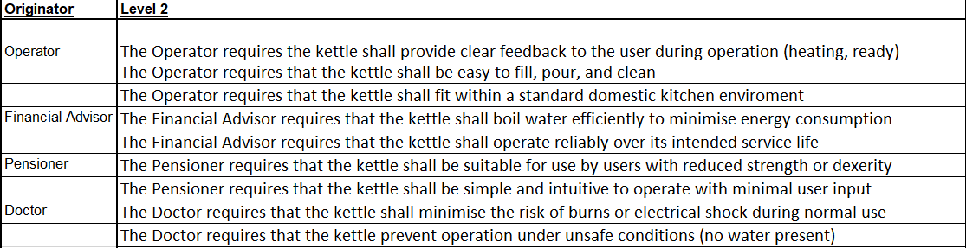

User requirements would usually focus on safety, ease of use, efficiency & minimal energy use, while the manufacturer would prioritise cost of making, complexity of manufacture, and robustness and reliability. The relevant regulatory bodies often have to highlight constraints to manufacturers in the design process due to having to maintain safety and electrical standards. These constraints often prevent over-the-top designs that seem useful but could end up being a safety risk. These user requirements provide a foundation for highlighting the needs of the users into a structured system requirement. [8]

3b) Requirements analysis
Now that stakeholder requirements have been gathered, they are analysed and transformed into clear, measurable system requirements. This process involves resolving ambiguity, identifying conflicts, and prioritising requirements based on their impact on safety, performance, and user satisfaction. The result is a set of engineering targets that can be traced back to stakeholder needs and used to guide design decisions. [8]
The process of requirements analysis enables informed trade-off decisions by linking stakeholder needs to technical constraints and system capabilities. Through this analysis, critical requirements such as automatic shut off, thermal insulation and intuitive user interfaces can be identified as essential to the overall system performance of the electric kettle. But conflicts also then become clear, for example:

- Increasing power rating can reduce boil time but raises peak current demand and may stress household wiring.

- Adding insulation reduces heat loss and repeated re-boiling, but increases material use, cost, and weight, which may conflict with the Pensioner’s need for a light, easy-to-handle kettle.

- Smart features can help users manage energy use but introduce additional failure modes and software complexity.

Prioritisation is therefore essential. Safety-critical and regulatory requirements should be treated as non-negotiable, followed by requirements that have a strong impact on energy consumption and everyday usability. This structured analysis is captured in a Quality Function Deployment (QFD), which links stakeholder requirements to technical characteristics and helps calculate the relative importance of each function.

3c) Functional Importance

Each of the listed user requirements were compared against each other and given a score of either:
1 = no preference
2 = slight preference
5 = preference
9 = strong preference
These scores were then calculated against each other to determine the functional importance of each one based against the others. This indicates which of the user requirements are the most critical when it comes to the design of the electric kettle, which further helps in design choices that benefit the users.
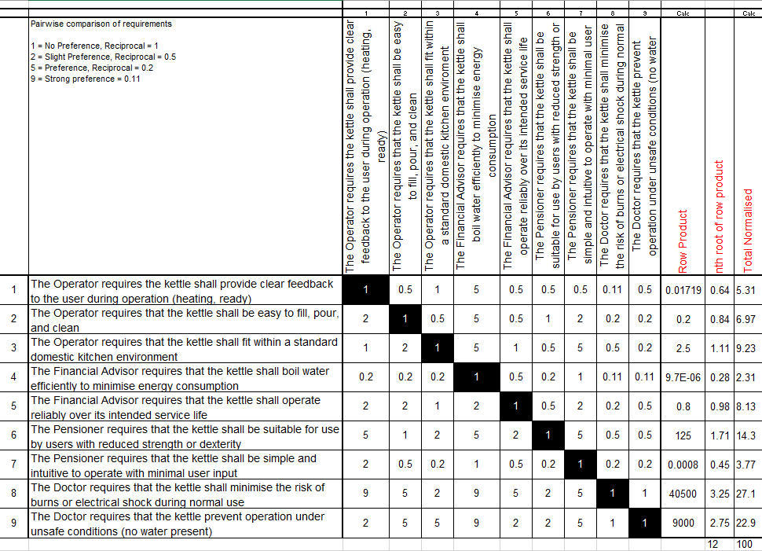
The correlating graph shows the functional importance of the user requirements:

To understand how the electric kettle fulfils its requirements, the system can be decomposed into a set of core functions. These functions describe what the system must do, independent of how those functions are physically implemented. Key functions include:

Fill Kettle
Detect water level
Prevent heating when insufficient water is present
Start Kettle
Convert energy to heat
Heat water
Hold water securely
Detect water temperature
Terminate once boiling is reached
Indicate status (off, on, finished)
Allow safe handling
Pour water
Dump waste water
Switch off

These system requirements have been derived from the user requirements and is a list of each task the electric kettle must perform in order to work correctly and at the users benefit. Each task must happen in order for the electric kettle to perform at the request of the user’s needs.
Some of these functions are performed by the system (for example, converting energy to heat, temperature detection, automatic termination), while others involve direct user input, such as filling and starting the kettle. Distinguishing between user performed and system performed functions is important when considering usability and failure modes, because it highlights where design can offload effort from the user and where it is possible human error can occur.
Not all of these functions are of equal importance. Safety-critical functions, such as temperature sensing, and automatic shut-off have a higher functional priority due to their role in preventing hazardous conditions. Performance critical functions like efficient heat transfer and minimising heat loss strongly influence energy consumption and boil time, while functions linked to feedback and handling are essential for usability and accessibility.
Within the QFD analysis, each function is linked to the stakeholder requirements and has been sorted from calculations to its priority in regard to the other requirements, which reflects its contribution to the systems objective. It highlights which functions should receive the greatest design attention and where more important implementations may be agreed upon.
The user requirements were placed in the QFD to be compared against each function of the kettle and given a number of relevance of how important that function was in relation to the user requirement.
9 = Critically important
3 = Moderately Important
1 = Minimally Important
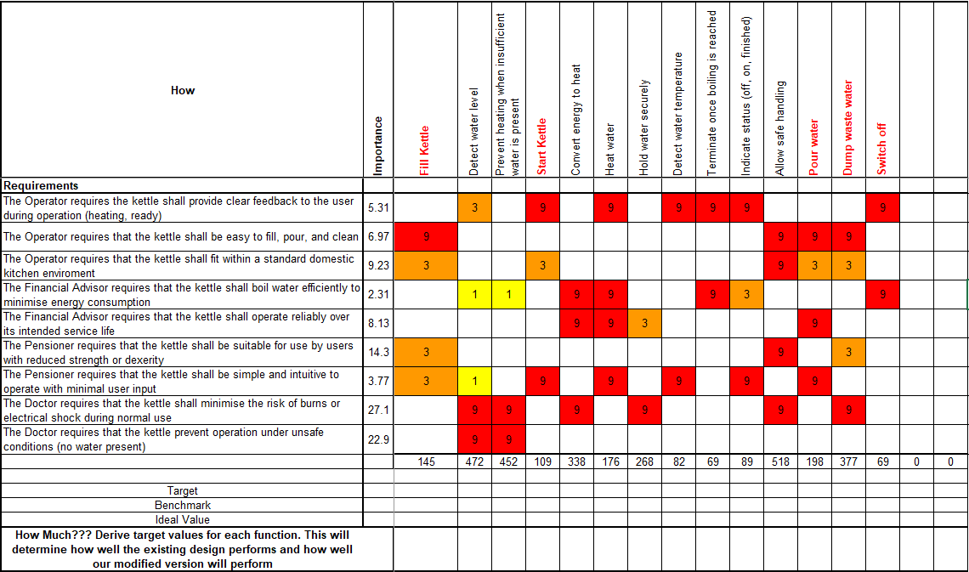
These values inherently determined the functional importance of the functional requirements of the kettle.

Concept

4a) Concept Generation
Based on the analysed requirements and user needs, multiple system improvement design concepts were thought through for the electric kettle. The ideas aim to satisfy the key requirements previously highlighted, while also managing trade-offs between safety, efficiency, cost and complexity. The benefit of producing multiple design concepts allows for different avenues for improvement to be compared in order to be outputted with the most ideal design. [9]
The concepts that were came up with range from an improved passive kettle design which focused on insulation and mechanical safety features, to enhanced sensors within the kettle to improve user feedback. But as the importance graph and QFD results highlighted, the most ideal kettle design is one that maintained its efficiency and ease-of-use, but really hammering down on the safety aspect of it.[1]
Recently studies showed that one of the most beloved and iconic drinks to hail from a kettle called tea has seen a decline in consumption over the past few years among younger age groups, which reinforces the idea that tea is a drink for older generations. “The ever-evolving competition from coffee and soft drinks continues to be the biggest threat and primary driver behind the long-term decline of ordinary tea bags”[10] .As these generations age, so does their physical abilities such as grip strength, balance, and reaction time, with these declining, the increase in risk comes when handling hot water. This emphasises the safety aspect of kettles, as the younger generations slowly become the minority when it comes to tea drinking, the safety of kettles should cater to their ‘older’ demographic. This makes aspects like reducing lifting loads, simplifying controls, and limiting consequences of human error key components to consider when designing a device like an electric kettle.
Three concepts were derived from this work:
- A high efficiency insulated kettle, with improved body insulation, clearer low-volume markings, and a simple energy-use indicator to discourage overfilling and repeated boiling.
- An accessible tipping kettle, designed to minimise lifting by allowing the user to pour while the kettle remains on a stable base, combined with a large ergonomic handle and high-contrast indicators for increased visibility.
- A sensor enhanced safety kettle, which incorporates additional temperature and water level sensors, more prominent status feedback, and stricter dry-boil protection.
Each of these concepts targets the most important functions identified earlier, but with different emphases on efficiency, accessibility, and safety.

4b) Concept Evaluation
To select the preferred design, the concepts were evaluated against criteria derived from the requirements and functional analysis. The main criteria were safety, energy efficiency, usability and accessibility, cost and manufacturability, and expected reliability. Safety and basic usability should be treated as essential, while efficiency and cost were balanced through trade-offs. [9][11]
The high efficiency insulated kettle scores strongly on energy use and running costs, as improved insulation and clearer volume indicators directly reduce wasted boiling. However, it offers limited additional benefit for users with reduced strength beyond the existing handle and weight, and as previously highlighted, the priority should be to effectively prevent injury and potential safety hazards as seen in the functional importance diagram. [12]
The accessible tipping kettle performs best in terms of usability and accessibility because it significantly reduces the need to lift and tip a heavy load of hot water and also provides clearer controls and indicators. Its additional mechanical structure may slightly increase cost and manufacturability but still relies on conventional heating and control technology.
The sensor enhanced safety kettle provides strong protection against unsafe conditions and offers rich feedback, but the added electronics and buttons introduce further potential failure modes and may increase both cost and perceived complexity for some users.
Considering the stakeholder priorities, the accessible tipping kettle concept is seen as the most beneficial in regard to the previously highlighted user and system requirements to be taken forward for further development. It directly addresses the needs of a pensioner persona and maintains compatibility with a standard domestic kitchen environment, and can still incorporate some of the benefits listed in the other concepts like a moderate insulation addition, and improved feedback to the user, all while prioritising the ease of handling and safety. This concept demonstrates how a systems engineering approach can lead to a design that balances all the values that make up the ideal design, rather than chasing improved performance without regards to user’s needs. [12]
7

References

[1] M. A. Hassan, R. Daud, S. N. S. Jamaludin, “Design and Analysis for the Improvement of Electric Kettle Performance,” Faculty of Mechanical Engineering, 2008
[2] C. Battistoni, “Using systemic design to drive the transition of the professional kitchen towards the circular economy,” Proceedings of Relating Systems Thinking and Design Symposium (RSD11), 2022
[3] D.M. Murray, J. Liao, L. Stankovic, V. Stankovic, “Understanding usage patterns of electric kettle and energy saving potential,” Applied Energy, Volume 171, 2016
[4] M.B. McElroy, “Energy and Climate: Vision for the Future,” Oxford: Oxford University Press, 2016
[5] N. Brinsmead, “A guide to choosing kitchen appliances” Homebuilding & Renovating, Article, 2024 [Online]: https://www.homebuilding.co.uk/advice/choosing-kitchen-appliances#section-don-t-forget-the-extra-appliances
[6] I. Batterbee, “Using systems thinking as a design leader,” Article, 2024 [Online]: “https://uxdesign.cc/using-systems-thinking-as-a-design-leader-d8b6f2108fa3”
[7] Saksons Interiors, “Kitchen Appliances: Essential Tools for Every Modern Kitchen”, Saksons Interiors, Blog, [Online]: https://www.saksonsinteriors.co.uk/blog/kitchen-appliances
[8] E. Fiore, “Systemic Design for the innovation of home appliances”, Thesis, 2018
[9] A.Paulus, A.Pomp, L.Poth, J.Lipp, T.Meisen, “Gathering and Combining Semantic Concepts from Multiple Knowledge Bases”, Institute of Information Management in Mechanical Engineering, 2018
[10] E. Clifford, “UK Tea and Other Hot Drinks Market Report 2025,” MINTEL, 2025 [Online]: https://store.mintel.com/report/uk-tea-and-other-hot-drinks-market-report
[11] A. Nuopponen, “Methods of concept analysis – a comparative study”, University of Vaasa, LSPJournal,Vol.1, 2010
[12] A. Marcinkowski, “Environmental performance of kettle production: product life cycle assessment” 2017, Vol. 25, Issue 4, pp 255-261

