Module: BMSK4014
Problem Solving and Decision Making
For this assignment I will be concentrating on a challenging issue at work for this project. Challenging implies there are several ways to solve the problem; nonetheless, I'm going to utilise a variety of techniques to determine which approach is effective. I will also quantify the extent to which this problem affects the workplace.
An traditional painting and decorating shop was recently converted by One Stop Store facilities into one of their locations. While the business was new to its surroundings, the structure was not, thus before we opened, there were some wear and tears in it. My discussion topic for this project will be Wi-Fi, which is one of our primary problems. In terms of technology, One Stop Stores is rather modern, which offers advantages and disadvantages. For instance, the only device we have access to anything on is our work PC. We can easily take orders and open the business using the computer, but occasionally we have internet problems that prevent us from opening to the public until later. Without any internet, tills, card readers, and our htt scanning equipment are useless.
Nature- When the WIFI is slow it prevents the store from running how it should.
Scope – The customers are the main people to be affected by this as well as the staff and then the business on a wider scale.
Impact- The customers are affected by this because as a ‘convenience store ‘ they expect to be able to come in and buy their items like any other time they have come. By us not being open on time it affects peoples routines such as ; children grabbing their breakfast/ lunch before going to school , the elderly taking an unnecessary trip to the store to go elsewhere etc. The staff feel helpless in some way due to them not having any guidelines in place for this issue, potentially lose a days wage due to not being able to open the store. This is the stores first year , the sales we make this year will determine if opening the store was a success or not.
On this matter, I made the decision to talk to the store manager. To make it abundantly evident that there is a problem that has to be fixed, I put together a presentation. I accomplished this by putting the six stages to efficient problem solving into practise, which I shall outline right here.

- Identify the problem- Poor Wi-Fi

- Specify the cause, the reasons and the effects - rush job due to time limit, no research on best provider for the area

- Identify possible solutions- change provider or put a plan in place for occasions when the Wi-Fi is down.

- Evaluate and select the most promising solutions

- Plan the action, and

- Action the plan and……monitor

The 5 Whys-The 5 Whys method was created in the 1930s by Japanese manufacturer, inventor, and Toyota Industries founder Sakichi Toyoda. It gained popularity in the 1970s, and Toyota continues to utilise it to resolve issues now. When those with firsthand knowledge of the issue or process in question provide the answers, it is most successful. The approach is very straightforward: five times you ask "Why?" to get to the core of each issue that arises. Once a countermeasure is identified, you implement it to stop the problem from happening again.
Although 5 Whys may be used for issue resolution, quality improvement, and troubleshooting, it works best on easy to moderately tough challenges. If you need to solve a difficult or significant problem, it might not be the best option. This is due to the fact that the five whys may drive you to focus on only one or a small number of lines of investigation when there may really be several causes.
The 5 Whys in action
What is the issue ? The Wi-Fi is poor for the facility
Why is the Wi-Fi poor ? Due the area not being the best for the provider we have
Why is it not the best ? Network used is the same the previous owner used for a smaller business
Why is it the one the previous owner used ? Time management for re-build rushed
Why was it rushed ? Crewe building the site behind schedule
Why were they behind schedule? Previous owners wiring was an issue for them.
Root cause – Rewire the shop for the current place which may improve the Wi-Fi

Brainstorming- In order to determine how and why brainstorming has become a popular technique, it was first utilised in 1953 by businessman and creativity theorist Alex Osborn.
“It is easier to tone down a wild idea than to think up a new one”
Alex Osborn
Alex F. Osborn originated the term "brainstorming" in 1953 with his book Applied Imagination: Principles and Procedures of Creative Thinking. The term "brainstorming" has become widely used since 1953, yet many people have different ideas about what it means. "A group problem-solving technique that involves the spontaneous contribution of ideas from all members of the group; the mulling over of ideas by one or more individuals in an attempt to devise or find a solution to problem" is how the Meriam Webster dictionary describes brainstorming (Webster 2015). Despite not fully capturing the many and numerous nuances of brainstorming as it has been theorised and used, this description is representative of the term "brainstorming" as it is often used. In popular culture, the practise of producing innovative ideas has been closely associated with brainstorming. While brainstorming has often been used as a technique for creative issue solving, the basic principles of Alex Osborn's initial explanation of the brainstorming process are substantially different from this.
Below is a brainstorm that shows some factors that could potentially improve our current situation. I believe that planning and having visual factors in front me allow me to see all the pros and possibly eliminate cons.
Change provider
Move location of router
Wi-Fi Issues
Manual system that doesn’t need Wi-fi

Boosters put throughout to enhance current Wi-Fi
Upgrade current package

Cause & Effect diagram ( Fishbone Diagram) - For his inventive contributions to quality management, Kaoru Ishikawa is regarded as the "Father of Japanese Quality." The fishbone diagram, a form of "root cause analysis" that is currently used in Quality Improvement (QI) to guide decision-making and action creation, is credited to him. Having played a key role in the creation of quality initiatives in Japan, Ishikawa is a highly esteemed person in the field of quality improvement. Kaoru Ishikawa was a major force in process improvement and quality control because of his Fishbone diagram, which is still used today to identify quality gaps and how they affect an organization's ability to function. Developed and conceived by Ishikawa, the Fishbone diagram (sometimes called the Ishikawa diagram or the cause and effect diagram) was initially used to study the root cause of issues within quality management. The form of the diagram gives it the name "fishbone diagram"; the bones represent the several reasons, and the head states the "problem." It is regarded as one of the seven instruments for quality assurance. You may use the programme to pinpoint the main reasons and pinpoint the most promising topics for additional research. It will make the situation easier for you to grasp. Colleagues who participate in the diagram-building process together improve understanding of the issue at hand as well as potential solutions. Everyone engaged gains from their combined efforts, which helps everyone to see the issue from the same perspective.

Here is a diagram that shows the effects of inefficient Wi-Fi. Each of main issues has a point of its own issue. By doing this it shows just how important it is to get this issue resolved. Each and every point affects the business on a daily basis.

Slow equipment Stock
Loss of sales Unable to place orders
Inefficient Wi-Fi
Venerable staff Missing data due
to system being down
Security issues
Reports
Now that we were both able to see our options and what could potentially be affect us , we decided to weigh some of the solutions and see which is best for the business. We did this by using a Grid analyse which measure the factors ( key factors that matter to you) to the weight ( the factors your willing to comprise for. For this Grid I used a 1-5 scoring system and when looking at the cost , I had to remember that the higher the score for that sector means that it fairly cheap in price and the lower the score means expensive. Once the scores are in place you then times the numbers to get a final score.
Grid Analysis
Factors | Speed | Efficiency | Time | Cost | total
Weight | 5 | 4 | 3 | 2
Move router | 3 15 | 4 16 | 2 6 | 3 6 | 43
Change system | 2 10 | 3 12 | 1 3 | 4 8 | 33
Upgrade package | 4 20 | 3 12 | 4 13 | 2 4 | 49
New provider | 3 15 | 4 16 | 3 9 | 3 6 | 46

Grid analysis, often referred to as a Pugh Decision Matrix, Decision Matrix, Weighted Scorecard, and other names, is a framework for ranking ideas according to a set of weighted criteria in order to evaluate and make judgements. Every concept is assessed in relation to every criterion, and a score is given according to how well the concept met each particular criterion. The decision-maker assigns a weight to each criterion based on how important they believe it to be. An ordered collection of ideas is the final product. Making decision-making and concept appraisal more objective is the primary advantage of employing grid analysis. By employing a specific set of weighted criteria, the decision-maker may introduce a degree of reason into the process and, in turn, more readily defend their choice to others should the need arise.
Originally I assumed that moving the router was going to be our best option , however when the factor in the time and effort that will take for the Wi-Fi to potentially get even worse , its an option we’re not willing to take. Once we have a have discussed the issues were having with the current network , perhaps the supplier has better option for us. By doing this allows us to keep the wiring the same and just have a new router fitted from the same supplier , which seem a lot less stressful.
Now the next move to implementing the solution is to call the network provider and put a plan in place to upgrade the package. By doing this , it allows the store to still run as usual without effecting customers or staff. However , the residents above the building may have an issue with this , as there might be some construction work done to fit the new wires. The majority of them are regular customers who can be informed word of mouth once a time frame is provided. I will now be demonstrating in stages the plan for the upgrade.
Stage 1- Contact current provider and express the interest in upgrading.
Stage 2- Once a target date to go live is put in place inform all staff the aim
Stage 3- Installation ,prepare for some interruptions such as network dipping in an out over the time period
Stage 4- Inform the residents above the store
Stage 5- Test and review the changes made within the 14 day cooling off period.
Gantt Chart -Henry Laurence Gantt (1861–1919) was a complex individual. He created Gantt charts in the latter half of the 1900s as a visual aid to display project progress, both projected and real. In the 1920s, it was a very revolutionary idea and a significant global invention, but it is now widely used as a project management tool. The first enormous scale building projects to employ Gantt charts were the Hoover Dam (1931–1932) and the interstate highway network (1956–1956). In a quite different age where people’s word was their bond, the Gantt chart was charmingly described thus: If a promise of a delivery is to be kept, all the work in a plant must be planned so accurately that when a new order is received, it is possible to tell almost to a day when the work will be completed. The Gantt progress chart enables the manager to keep before him all the promises he has made, to concentrate his attention on overcoming obstacles and avoiding delays, and, when it is impossible to live up to a promise, it enables him to give the customer advance notice of the fact. (Wallace Clark – ref.1). Before the invention of computers, Gantt charts were created by hand as Bar Charts, which are now often referred to as "Gantt charts." These needed human modifications whenever something changed. This is how a basic Gantt chart may have become apparent:
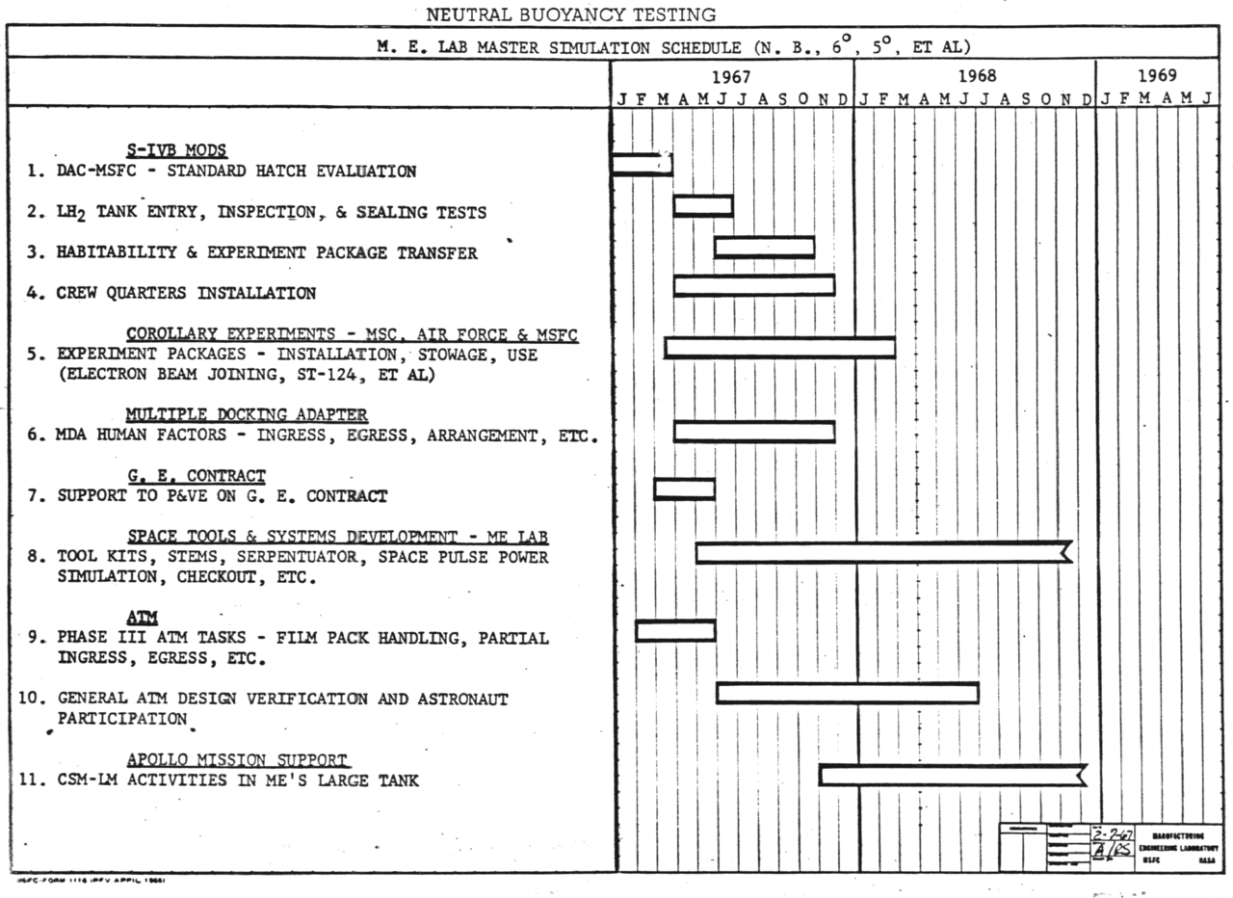

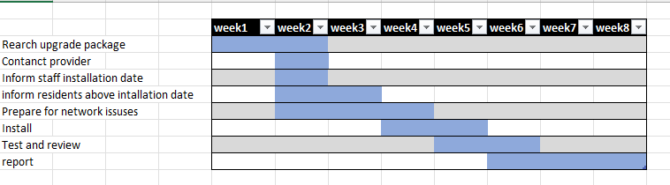

After the gantt chart was made and we knew how long the installation would take in its entirety, we were able to make a plan and let each member know what to expect over the following eight weeks. The installation team's work is mostly shown on the Gantt chart, but it also gives the team two weeks to address any problems they may find with the new installation. We may then plan how to resolve the problems and advise customers to exercise patience when they buy with us.

Conclusion- Given the evidence presented It was rather evident from the beginning of this task what the root of our problem was. By applying these strategies such as; the five whys, brainstorming, grid analysis and Gantt chart. I was able to make it readily apparent that the problem has to be fixed and through the use of these techniques, I also made it plain how to do so.

Refrences
Mind Tools Content Team (no date) Home, MindTools. Available https://www.mindtools.com/a3mi00v/5-whys (Accessed: 6 September 2023).
Besant , H. (2022) The journey of brainstorming, Regent University. Available at: https://www.regent.edu/journal/journal-of-transformative-innovation/the-history-of-brainstorming-alex-osborn/ (Accessed: 5 September 2023).
Creighton, S. (2022, October 10). Karou Ishikawa: The man who invented the fishbone diagram. Life QI. (Accessed September 6, 2023) from https://blog.lifeqisystem.com/kaoru-ishikawa
Kalinchenko, D. K. (2021, March 9). Using Grid Analysis for Idea Evaluation. Rationalize.io. Accessed September 5, 2023, from https://rationalize.io/2021/03/09/using-grid-analysis-for-idea-evaluation/
Lyons, T. (2018, January 4). A brief history of Gantt Charts. Association of Project Management. (Acessed September 5, 2023)https://www.apm.org.uk/blog/a-brief-history-of-gantt-charts/

