

Ellie Martin

Study skills ACDB4010

School of computing
Ordnance, Munitions and explosives (BENG)

Academic Year: 2024 - 2025

Supervisor: Jennie Steen
January 2025

Academic integrity declaration
I declare that:
- the thesis submitted has been written by me alone.
- the thesis submitted has not been previously submitted to this university or any other.
- that all content, including primary and/or secondary data, is true to the best of my knowledge.
- that all quotations and references have been duly acknowledged according to the requirements of academic research.
I understand that to knowingly submit work in violation of the above statement will be considered by examiners as academic misconduct.

Abstract
The learner is to critically analyse and evaluate the effectiveness of their presentation which was delivered in class. The learner will highlight areas of further development and establish how to implement this transferable skill in future presentations. The learner will also conduct skills evaluation research to gather a detailed understanding on learning styles which are imperative to be successful in higher education. The learner will apply the knowledge gained from their research and demonstrate their understanding by explaining the importance of; data backup, time management and showcase their ability to conduct independent study. These finding of the learner’s assignment will then be summarised in a conclusion where the common themes will be discussed.

Table of Contents
Academic integrity declaration i
Abstract 1
1 Section 1 – Presentation 3
1.1 Overview 3
1.2 Screengrabs from presentation 4
1.3 Key points highlighted when producing / delivering the presentation 6
1.4 Aspects to improve on for future presentations 7
2 Skills Evaluation 8
2.1 Skills required for successful learning in higher education 8
2.2 Transferrable skills for employment 8
2.3 self-evaluation 9
2.4 Goals and action plans 11
3 Section 3 Application 13
3.1 Looking after your data 13
3.2 Time management and self-organisation 13
3.3 Independent study: “Torpex- a powerful underwater explosive” 16
4 Section 4 Conclusion and evaluation 17
Section 5 Appendices 18
18
References 19
Appendices 20

Table of Figures
Figure 1- Agenda slide 4
Figure 2- Family slide 4
Figure 3- Previous roles 5
Figure 4- Goals 2025 5
Figure 5 - Learner style quiz results 9
Figure 6 – kinesthetics learner Strengths/ struggles 9
Figure 7- Learner style quiz (2) 11
Figure 8- Calander 14
Figure 9- portfolio 15

Section 1 – Presentation

Overview
The learner established that when conducting a presentation, it is important to ensure the audience is engaged and actively listening but adopting a suitable presentation style which best suits the audience. Ensure eye contact and body language is used in an appropriate manner to aid effective communication. The learner understood the importance of visual aids and how different neurodivergent conditions can cause difficulties in processing information. The learner used neutral colours which would be easy to read alongside the use of images to help support the corresponding information. To open the presentation the learner started by introducing themselves and began the presentation with an agenda (figure 1) outlining what topics would be covered during the presentation which were; family (figure 2) displayed images of family members and discussed how they were related. The learner includes a childhood slide which included brief information about when they were born and which star-sign they correlated too, also mentioned hobbies which they enjoyed when during their school years. This was followed by previous job roles and work experience (figure 3), hobbies and future goals (figure 4).
On each slide the learner used images which illustrated key points and expanded on the information- this allowed the learner to keep the audience engaged alongside responding to questions in an interactive fashion. The learner also used flow charts to show the progression within previous job roles, the visual technique was used alongside images. To summaries the presentation the learner included two truths and a lie to identify if the information provided to the audience during the presentation was retained by the audience before asking if there were any questions.

Screengrabs from presentation
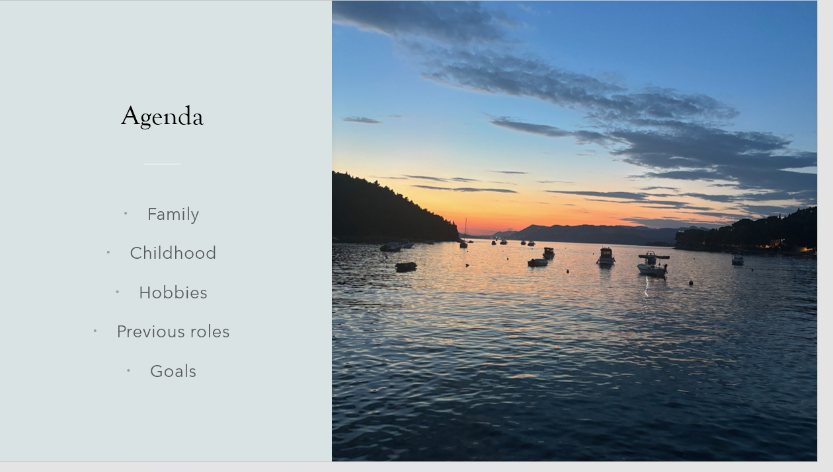
Figure 1- Agenda slide
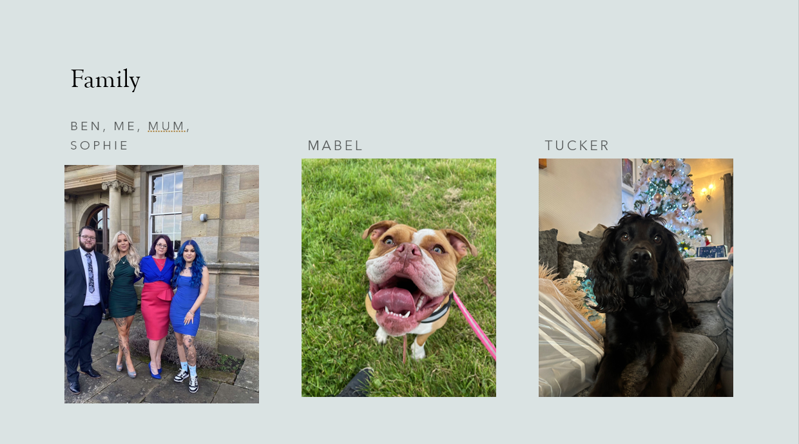
Figure 2- Family slide

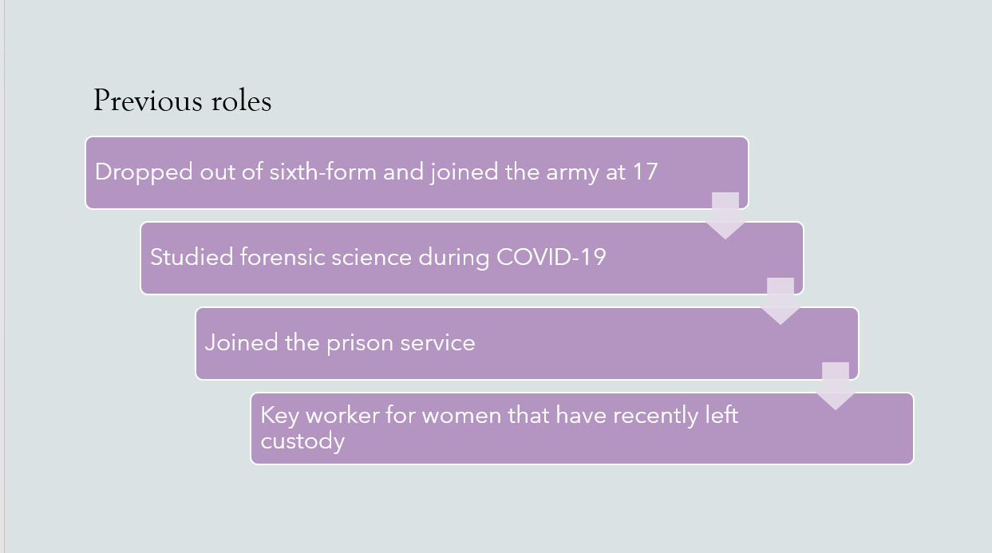
Figure 3- Previous roles
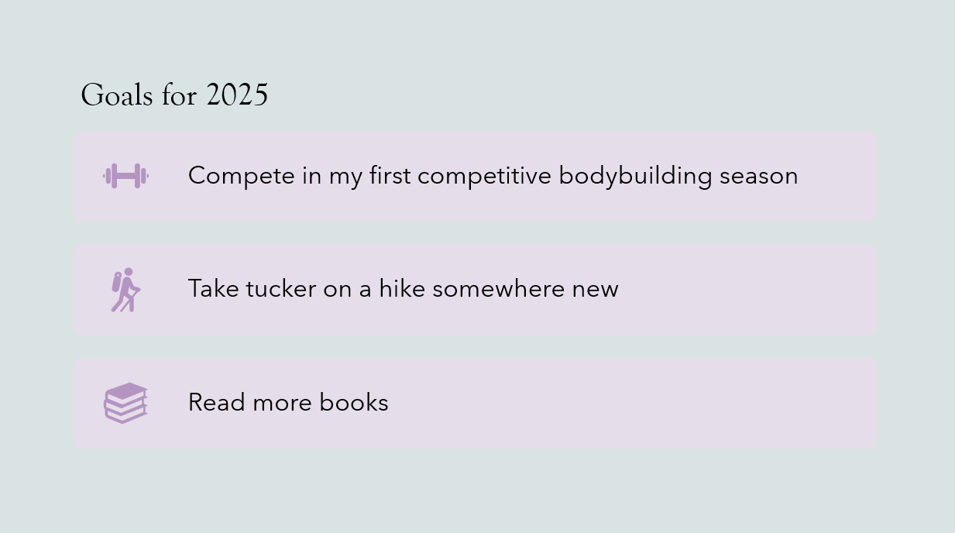
Figure 4- Goals 2025

Key points highlighted when producing / delivering the presentation
The learner ensured the colour scheme of the presentation was appropriate, for example not using a white background and black font to support any accessible needs of fellow learners. Not overwhelming the slides with information to provides balance with written information and supporting pictures. The learner engaged the audience by speaking in a clear manner to ensure the audience is focused and were able to identify common themes which were discussed.
The importance of having a good understanding of the topic allowed for learner to respond to questions with confidence, alongside having the ability to keep the audience focused on the narrative of the presentation and the next steps. The learner ensured to maintain open body language and the learner refrained from reading all information from the slides, this demonstrates a good understanding of topic as well as showing that the learner had prepared appropriately for the presentation. Following the formal teaching on the module the learner developed their understanding of how to format presentations. The prevented the learner from including excessive transitions between slides and this can cause a decrease in engagement.

Aspects to improve on for future presentations
The learner identified when delivering a presentation, future development is needed on reducing fidgeting. Also, not speaking quickly due to nerves- this will allow the audience to retain the information provided and minimise distractions. It is also important to deliver the presentation in an appropriate manner that is tailored to the audience, subject is and adapt during the presentation depending on the audience’s engagement. The learner feels it would be beneficial to practice delivering the presentation to an audience prior to reinforce confidence and identify areas of development.
The learner aims to structure future presentations more effectively, by providing specific details as supporting evidence to enable them to expand on specific topics. To ensure this is possible the learner to use time effectively to maximise the effectiveness of the overall presentation. Also, the learner needs to ensure the presentation is accessible and in line with any reasonable adjustments of colleagues.

Skills Evaluation

2.1 Skills required for successful learning in higher education
Throughout the learner’s research, literature identified the importance of critical thinking. Critical thinking can be defined as the ability to weigh up arguments, effectively understand the arguments to allow you to develop your personal assessment [1]. Another benefit of critical thinking is its ability to remain focused of information and identify bias.
The learner identified how effective time management can impact a learner’s ability to complete a task to a high standard. Furthermore, ineffective time management can have a negatively impact on a learner’s mental health. Research has demonstrated that stress and anxiety can reduce a individual's ability to concentrate and thinking critically [2]. To combat this, the learner used effective time management and planning to dedicate protected time to complete work and meet deadlines.
Digital skills are a vital aspect in a learner being able to demonstrate their knowledge and aid them in their job role. The learner identified the importance of effective research that is relevant to the subject. Effective use of resources can develop your ability to research academic potential [6]. The effective use of digital technologies can support the learner in displaying their knowledge effectively and transfer their knowledge into the professional role.

Transferrable skills for employment
There are mange elements that make candidates desirable to future employers, these elements include training, qualifications and the ability to articulate their knowledge effectively during a interview. An example of this is to utilise written formats when submitting a CV/covering letter and effectively answering a interviewer’s questions. The enable a candidate to demonstrate their active listening and technical skills to demonstrate their ability to be an effective member of the team.

self-evaluation
Learner conducted some research to establish which attributes they possess which are beneficial to being successful in the higher education environment and what strengths and weaknesses. It was identified that they are a kinaesthetic learner, this research conducted identified that the learner excels in being practical projects using physical material to help support their learning. It has been highlighted in the quiz conducted that’s the learner would find it more challenging conducting tasks that do not have a practical application to them as it means they struggle to apply knowledge as the learner finds It useful to understand why things are important.
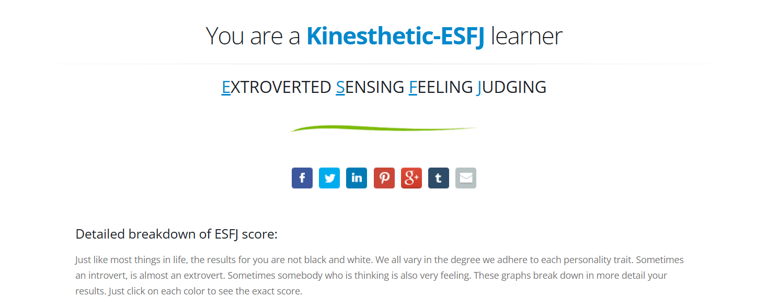

Figure 5 - Learner style quiz results
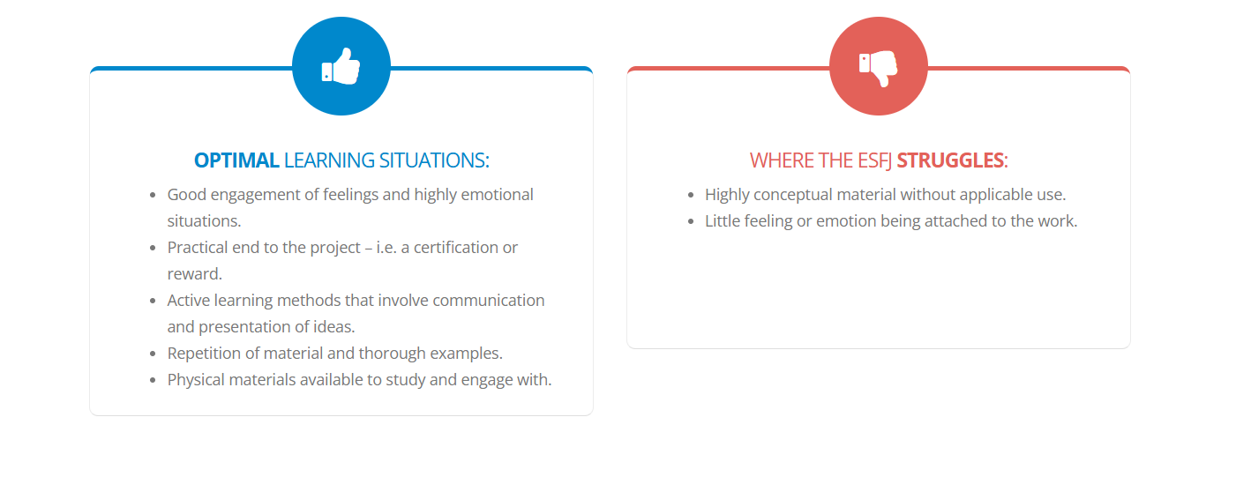
Figure 6 – kinesthetics learner Strengths/ struggles
Prior to conducting research on self-evaluation, the learner had an understanding that they can retain more information when there is a practical application alongside side using visual aids to help them retain information. The learner has gained an understanding why it is beneficial for them to use physical materials to support their learning as well as using forms of repetition to reinforce the information.
The learner will implement more physical applications to help them consolidate understanding as well as engaging with other individuals and discussing areas which could be approved on and strategies to successfully implement them effectively. The learner also completed another quiz to establish if the same result would be obtained and the same result was given (figure 7). This reoccurring theme supports the learner preference to being hands on in their approach to remembering information.
This is also supported by the fact the learn is very active and enjoys physical activities as ways to help them relax and decompress. The learned did some research on what types of subjects they would naturally excel at bases on their learning styles, and these would include ‘subjects such as chemistry and physics as they have the ability to explore the subject physically’ [8]
Following the learners research it was highlighted that the result of these types of tests can also be influence in mood of the individual which could cause discrepancies in the result. To combat this the learner ensured that when conducting these tests that they were in the same environment and controlled the external variable to ensure a more accurate result.

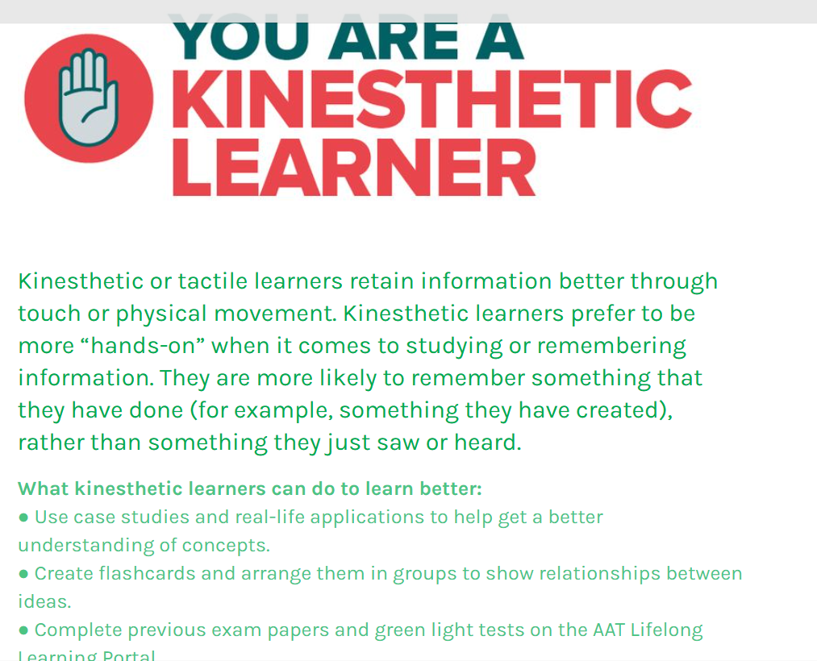
Figure 7- Learner style quiz (2)

Goals and action plans
Short term goals
- Successfully pass maths exams in March
- Do not leave assignments to the deadline
- Compete a bodybuilding show in September
Long term goals
- Complete OME Degree
- Identify what sector learner wants to work in after the apprenticeship
- Purchase first home in the next 5 years
The learner has used the SMART guidelines to establish an appropriate action plan for the following: 1) Successfully pass maths exams in March, this is measurable by the grade received- To ensure the learner can achieve this it has been highlighted that taking effect lecture notes and practising past papers are effective methods to prepare for these exams. This is relevant as it is essential to pass the exams to progress onto the next year, and is time bound by the exam date. It has also been highlighted that participating in study groups to expand knowledge can also be beneficial. 2) Compete in first body building in September, this is measurable because competing requires you to present you physique in a certain way. This goal is achievable by following the structured training and diet regime which is already implemented. This goal is relevant to the learner’s fitness goal and has wanted to take part in a show for over two years. It is time bound as the first show is on the 21st of September 2025.
The learner has also constructed and action plan for the following long-term goals: 1) complete OME Degree- learner can measure this as it is required to pass all modules to an appropriate standard as well as pass any examinations. The learner intends to achieve this by making effective notes and asking for further supported if required- the importance of applying knowledge which is gathered within the workplace to the degree to demonstrate the required knowledge, skills and behaviours have been ascertained. This is relevant as passing the degree is required as part of the learner’s apprenticeship and time bound as the degree will take five years to complete.
2) Discovering what sector, the learner wants to work in after completion of apprenticeship. This is specific as the learner will be working in the defence sector and could measure which sector they would like to work in by completing different placements that will provide insight into different areas on the defence sector. This is achievable as the learner will gain knowledge from different areas and can reflect on which placement is best suited to the strengths. This is relevant as the learner in their overall professional development and is time bound by them completing their apprenticeship and will have to apply for roles in industry.

Section 3 Application

Looking after your data
When protecting your data there is multiple ways in do this, one way is the 3-2-1 backup rule. This is the process in which three copies are maintained two of which are stored at separate locations in the case of an incident which could result in damage/ corruption or the loss of data which is why it is important of the copies to be kept at a separate location. Another way in which your data is stored is through cloud storage which is a very popular method due it requiring less hardware however ‘there is a grey area when it comes to establishing who is responsible for ensuring the data is kept safe’[3].
Due to this some companies are ensuring certain classification of documents are not sorted in the manner to protect the information from potential data breach- documents which contain extremely sensitive information would require other physical countermeasures such as being locked in an appropriate area. Another method of data storage is using a physical memory stick such as a USB, these size and storage capacity vary which means they can be easy to use and can be kept on keys if they are small enough to be stored on keys. These can also come with a layer of encryption in the form of password protection to attempt to protect the date in which is stored on the device preventing access from those without the code.
The learner plans to implement the use of memory sticks and storing copies in different locations when saving their university work as this will minimise the risk of assignments being completely lost in the event of a virus, loss or damage.

Time management and self-organisation
To optimise productivity the learner has established it is beneficial to write lists of what tasks are outstanding and identify which of these are most important in terms of time sensitivity- this allows them to be prioritised accordingly. Due to research into types of learning the learner identified that a mix of different learning styles helps maximise productivity and intends to implement restricting the use of a mobile devise when working as this helps removes motivated with tasks. An example of a visual aid to help manage time effectively is an electronic Calander (figure 8) which displays what lectures are being taught and the location. The learner uses this to structure their time as they are a visual learner which means they require the support of visual stimuli to increase productivity.

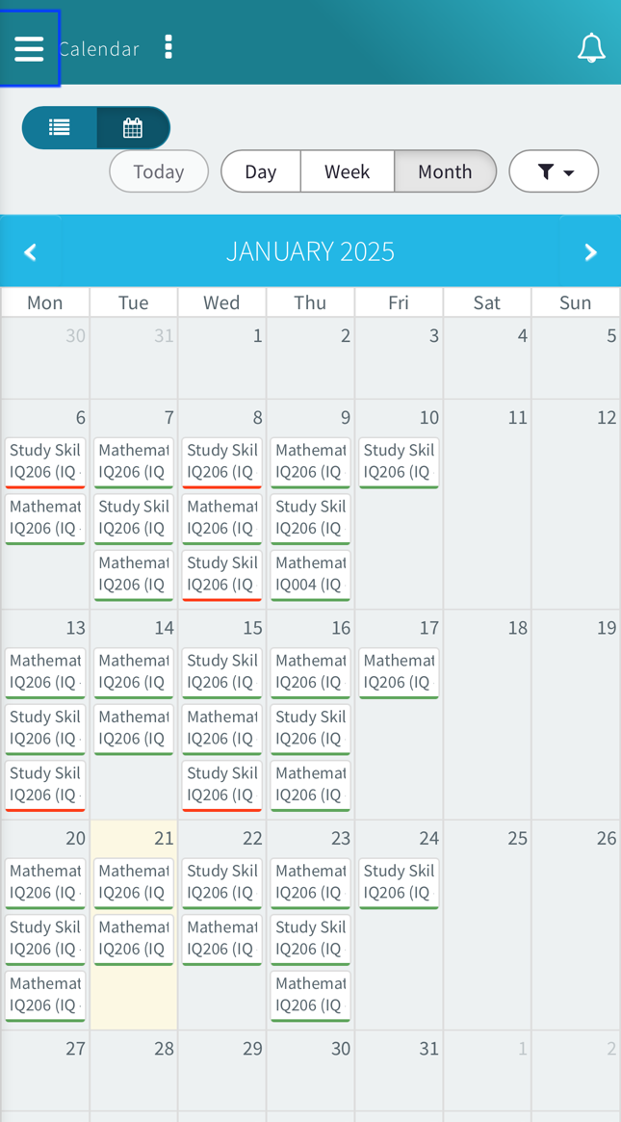
Figure 8- Calander

The learner has also identified it is beneficial for them to use exercise as an outlet to help them managing their stress levels. Exercise has been proven to have ‘neurochemical benefits as it reduces the levels of cortisol and adrenaline whilst stimulating endorphins’[5]. Another method which the learn finds beneficial to help manage stress levels is to speak to others abouts what is bothering in them as it could be possible, they are able to help come up with a solution to a issues that the learner is struggling to overcome.
Below the learner has attached their e-portfolio structure, inside the main folder there are three sub folders in this area: Modules, skills evaluation and self-evaluation; Inside the modules folder there are folders for each of these are sub folders for each assignment to separate work and assignment as demonstrated below (figure 9).This is a successful method of self-organisation as this allows different work to be separated into the appropriate folders to prevent confusing and allow them to be reviewed effectively.

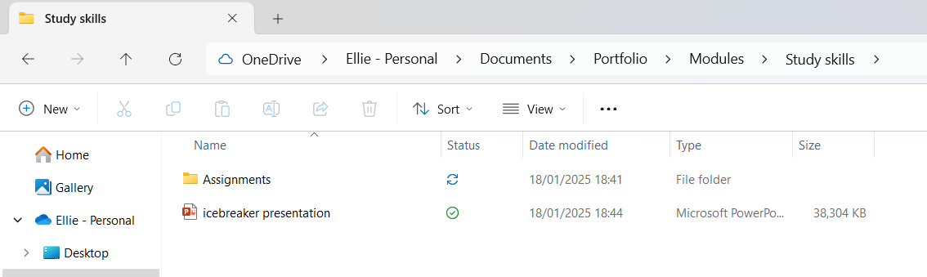
Figure 9- portfolio
The learner has also developed a professional development plan on how they can expand their knowledge and how this can support them in their career. An example of this is attending a training course to understand emergency planning protocol and how this is implemented to protect the public in the event of emergency event taking place. ‘It is a systematic and ongoing process which should evolve as lessons are learnt and circumstances change’[7]. This will help to ensure faith is public services and reduce the public panicking and potentially increasing risks to themselves. The learner has also completed all the mandatory training required for their organisation, this has allowed them to understand the safety protocols and how the organisation is structed which provides them with an insight into why their role is important. The learner has also enrolled in a digital skills course which help reinforce their confidence and knowledge on different software which they use and how this can be done effectively analyse data.

Independent study: “Torpex- a powerful underwater explosive”
Torpex is well known for its military applications in World War two and effectiveness in underwater warfare. This is due to it being comprised of ‘42% RDX 40% TNT 18% powered aluminium’[9] making it a more sensitive explosive in comparison to TNT. An explosive is a compound or mixture which when ignited can cause ‘rock fragmentation, rock displacement, ground vibration and air blast’[10]. The use of explosives heavily increased in 1941 following the attack which took place in pearl harbour which forced the US military to join The Uk to help support the war effort.

Originally, the focus was not on torpex, but an explosive called RDX. However, this was extremely hard to produce in the large quantities needed for it to be efficient. Due to production issues of TNT, this proved problematic in supplying enough explosives to fill warheads for both aircraft and submarines. Germany took control of the Atlantic coats using “wolf pack” tactics and even attacking British merchant ships on the surface at night. [11] Due to ineffective sonar systems the German U-boats were not detectable when travelling on the surface which left British forces vulnerable. ‘In the first two years of the war, Coastal Command aircraft made 245 attacks on enemy submarines. They sank only three.’ [12]. One of the main causes, the torpedoes themselves. The Mk10 replaced the Mk14 which was not affective.
Evidence demonstrates these issues specifically, warheads hitting Japanese vessels and not detonating [12] as well as warheads would run circular causing them to hit the vessel they were fired from or detonating prematurely. [16].

Research shows, allied forces required a more effective anti-submarine aircraft capability to combat the ‘German heavy hulled U-boat which threatened Atlantic lifeline between North America and the United Kingdom as they were difficult to sink with ordinary TNT depth charges, new RDX versions of the weapon proved to be very effective’ [14]. The role of a depth charge is to illuminate submarines by ‘detonating in the water near the target and subjecting it to a destructive hydraulic shock’ [15].

The use of torpex proved to be extremely effective as it was ‘weight for weight 50% better than TNT and volume for volume 75% better’ [11] which allowed the size of torpedoes could be reduced allowing smaller aircrafts to carry them and be used in the form of different munitions such as the hedgehog projectile. These ‘contact fused charges doesn’t require a target depth to be set for it to be effective’ [17]. There were also other advantages to using these projectiles, such as the target submarine would remain identifiable on the sonar even if the hit was not successful. This allowed the next attack could be initiated faster minimising the risk of the submarine escaping undetected.[17]

In conclusion, the introduction of torpex in World War two allowed allied forces to combat the wolf pack tactics used by the German U-boats to isolate the Atlantic life between north America and the United Kingdom. Torpex was more effective than the other forms of explosives for example, TNT. Torpex was effectively used in air and underwater combat. Topex was introduced to other projectiles in a range of forms to expand its capabilities.

Section 4 Conclusion and evaluation
The learner has critically discussed their developmental process and the delivery of the presentation. Future areas of development have been identified by the learner that can be utilised in both academic and employment settings due to their transferable skills. The conducted independent research to develop their knowledge of their learning style and how to actively implement their learning style during their studies.
The learner explored effective data storage and discussed the importance of handling data to prevent lost documents. Furthermore, the implementation of effective time management skills to reduce additional stress.
The learner conducted an independent study on torpex, discussed its history and how the explosive was effect alongside issues. These issues may have limited the explosives capabilities in combat. Also, highlighted different types of munitions and how this benefited the developments of effective anti-submarine warfare.

Appendices

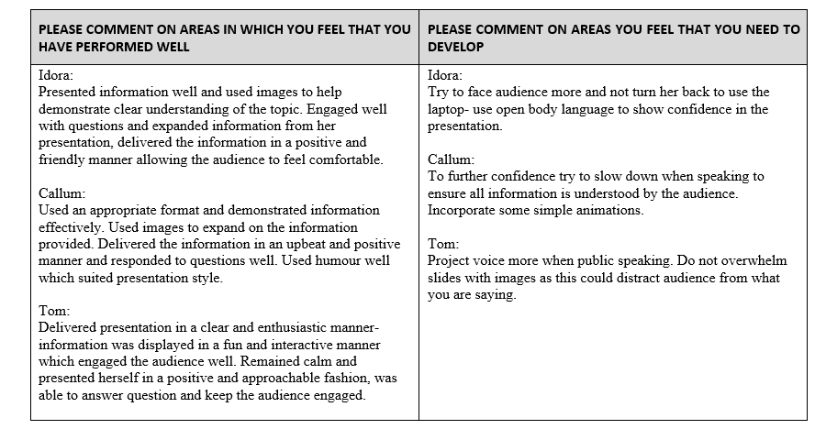
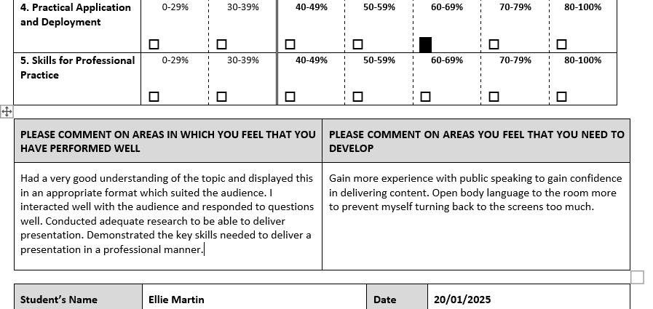

References
[1] R. Needleman, “What Are The 6 Essential Skills For University Students?,” UniAdmissions | World’s First Oxbridge Prep School, Jun. 30, 2021. https://www.uniadmissions.co.uk/application-guides/6-essential-skills-for-university-students/#CRITICAL (accessed Jan. 13, 2025).
[2] E. Team , “The Impact of Mental Health on Academic Performance: Explained,” GerosHealth.com, Aug. 18, 2024. https://geroshealth.com/how-does-mental-health-affect-academic-performance/#The_Link_Between_Mental_Health_and_Academic_Achievement (accessed Jan. 13, 2025).
[3] M. Mister, “10 Advantages and Disadvantages of Cloud Storage,” www.promax.com, Oct. 22, 2019. https://www.promax.com/blog/10-advantages-and-disadvantages-of-cloud-storage (accessed Jan. 13, 2025).
[4] J. Herrity, “15 Top Qualities Employers Look For in Job Candidates,” Indeed Career Guide, Feb. 02, 2023. https://www.indeed.com/career-advice/finding-a-job/qualities-employers-want (accessed Jan. 15, 2025).
[5] Harvard Health Publishing, “Exercising to Relax,” Harvard Health, Jul. 07, 2020.https://www.health.harvard.edu/staying-healthy/exercising-to-relax (accessed Jan. 21, 2025).
[6] T. S. Club, “Essential Skills Needed For University,” The Stay Club, Nov. 07, 2023. https://www.thestayclub.com/blog/essential-skills-needed-for-university/ (accessed Jan. 23, 2025).
[7] Cabinet Office, “Preparation and planning for emergencies: responsibilities of responder agencies and others,” GOV.UK, Feb. 20, 2013. https://www.gov.uk/guidance/preparation-and-planning-for-emergencies-responsibilities-of-responder-agencies-and-others (accessed Jan. 30, 2025).
[8]“A Career Guide for the Kinesthetic (Hands-On) Learner,” UTI Corporate, Feb. 17, 2021. https://www.uti.edu/blog/education/kinesthetic-learner (accessed Jan. 31, 2025).
[9] M. Hiske, “OP 1664 - U.S. Explosive Ordnance (Vol. 1): Introduction,” Michaelhiske.de, 2025. http://michaelhiske.de/Allierte/USA/OrdnancePamphlets/OP1664/Volume01/Introduction02.htm (accessed Feb. 01, 2025).
[10] U. States., National Park Service Handbook for the Storage, Transportation, and Use of Explosives. 1999.
[11] C. F. Baxter, The Secret History of RDX. University Press of Kentucky, 2018.
[12] logan Nye, “Why America’s World War II torpedoes were horrible,” We Are The Mighty, May 24, 2021. https://www.wearethemighty.com/popular/ww2-navy-torpedo-problems-mk14/ (accessed Feb. 04, 2025).
[13]imgA.Src=’https://Secure.gravatar.com/Avatar/A4d699ad772ae14ec2e4c5735674efd9?s=32,#038;d=blank,038;r=g’ Srcset=’https://Secure.gravatar.com/Avatar/A4d699ad772ae14ec2e4c5735674efd9?s=64, #038;d=blank, and 038;r=g 2x’ class=’avatar avatar-32 photo’ height=’32’ width=’32’ loading=’lazy’/> A. S. says, “Full Blast – How the High-Explosive Known as ‘RDX’ Helped the Allies Win WW2,” MilitaryHistoryNow.com, May 07, 2018. https://militaryhistorynow.com/2018/05/06/full-blast-how-the-high-explosive-known-as-rdx-helped-the-allies-win-ww2/
[14] “Depth Charge,” Wikipedia, Mar. 06, 2020. https://en.wikipedia.org/wiki/Depth_charge (accessed Feb. 04, 2025).
[15] Wikipedia Contributors, “Hedgehog (weapon),” Wikipedia, Nov. 15, 2024.
[16] Wikipedia Contributors, “Mark 14 torpedo,” Wikipedia, Feb. 02, 2

