
Richard Stephens
Student Number: STE19853654
Introduction to Web and Database Concepts
Web Concepts
Module Code: ACCA4XXX

10th January 2021

Web Concepts

Contents

Name | Page Number
Header Page | 1
Contents Page | 2
Introduction | 3
Requirements | 4
Implementation | 5
Validation | 10
Evaluation | 12
Search Engine Optimisation | 13
Accessibility | 14
References | 16

Introduction

This report is designed to provide insight and understanding of the concepts, principles and practice used in the construction, design and implementation of a 5-page website.

I chose a subject matter that I have particular interest and knowledge. My prior understanding of the subject enables me to already understand what the target audience would be interested in and produce an interesting and useful website.

The website itself is simple in design as ease of navigation between pages would give the readers access to different sections, enhancing their user experience and accessibility. Even though the target audience is the general public and not the business/commercial sector, the style chosen was in tune with the dramatic and horror genre, thus appealing to the correct audience.

This report will explain the design choices, the requirements, the implementation, evaluation and validation process used.

Requirements

My website, designed for this module, is entitled, "Top 30 Horror Films 2021". I selected the subject due to my interest in horror films and, I also noticed a gap in the market for functional websites that simply link the user to locations where they can view popular horror films in full. Essentially, it provides them with a catalogue of horror films, which any enthusiast (the target audience) would find is a very helpful, unique and functional tool.

Also, there is a blog page which will encourage visitors to comment on the site/films which could lead to a potential subscription element, should the visitors and followers increase. At the moment there is a link to the Bloody-Disgusting.com twitter feed as I do not as of yet have an active social media account. However, in the real world this website would have all the social media platforms added to encourage discussion and debate.

The target audience are avid watchers of horror movies, who (like me) would like to see a selection of highly popular horror films from one platform. It goes further than viewing the 'catalogue' of films as they are broken down into categories:

- Gory
- Supernatural
- Sci-fi & Fantasy horror

It was essential to produce a functional and useful website and produce a site that could grow over time and provide a service to the target audience. In time, there would potentially be an opportunity to monetise the website via the creation of an affiliate programme which would result in income every time a user clicks a movie to view as well as the potential creation of a YouTube Channel which could potentially also increase community engagement and create a source of income.

Implementation

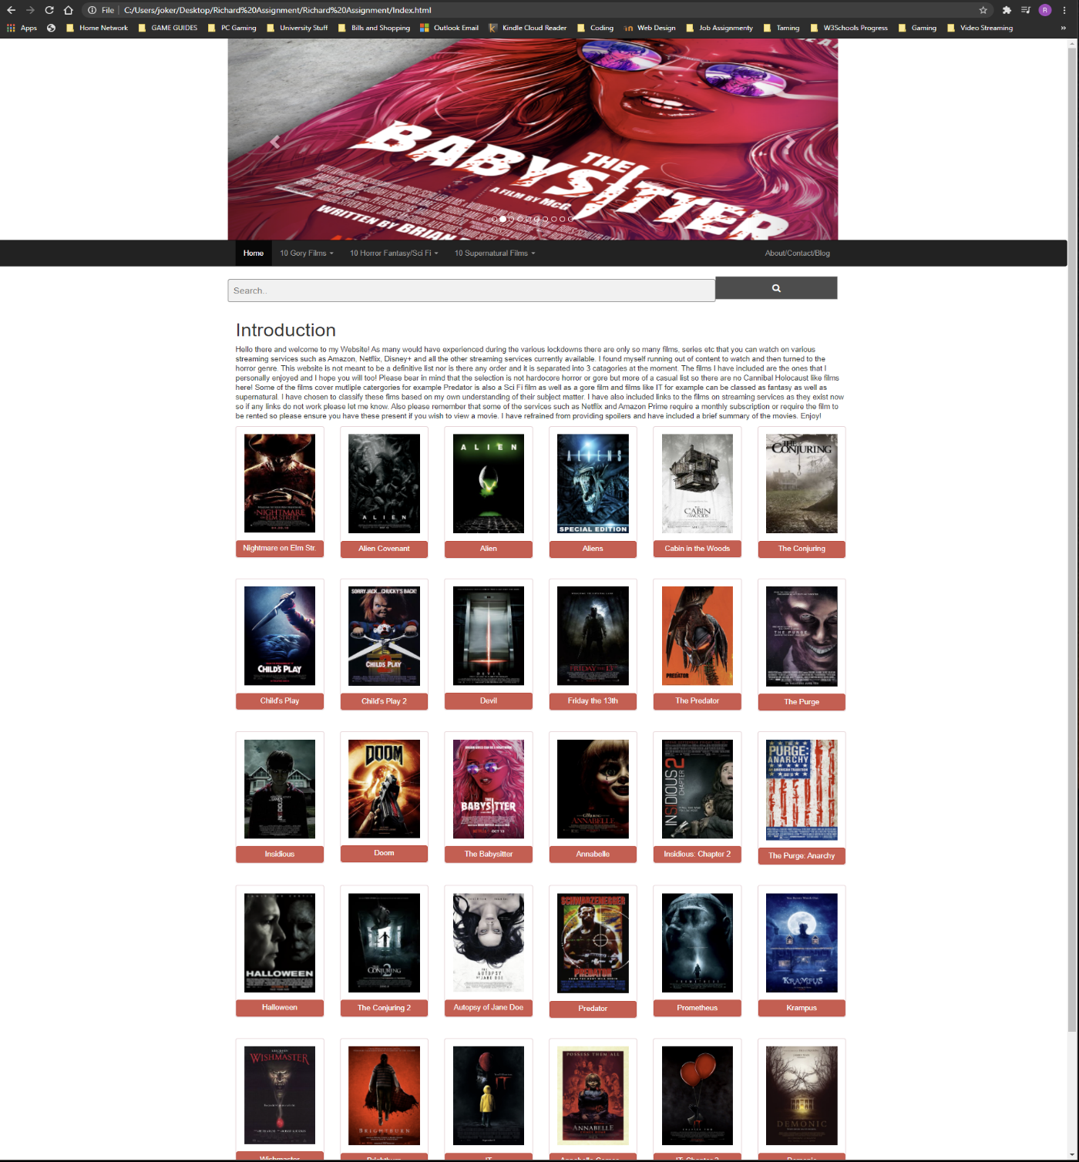
This my Home or Index page and contains links to individual films on each of the pages as well as a drop-down system placed inside the navigation bar in both the header and footer. The carousel at the top shows images of horror movies featured on this site, a potential improvement here would be to make the carousel clickable and take the visitor to an assigned page. A search bar is also included as a further accessibility measure and provide the visitor with a facility to search for a specific film. An improvement here would be to provide the visitor with an option to contact me with maybe a pop-up message. They would subscribe to the website and request a film and I would be able to start to build a following, helpful when I would look to monetise the website via a YouTube channel or affiliations.

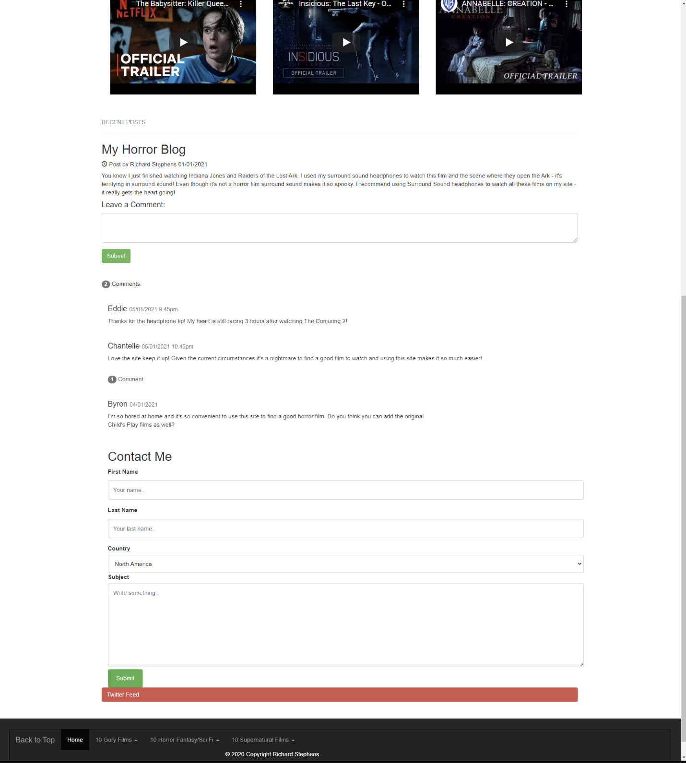

This is my ‘About me’, ‘Blog’ and ‘Contact page’ as well as a ‘Comments’ section and contains a collapsible Twitter Timeline. The decision to consolidate these pages together was for this specific task only, in the future these would be separated. The same Navigation and drop-down system as my index page and the other pages is also utilised. It contains an “About Me” write up at the top of the page as well as the same carousel as the index page. It also adds six more individual film trailers which are further recommendations for the reader. A search bar is also included as a further accessibility measure.

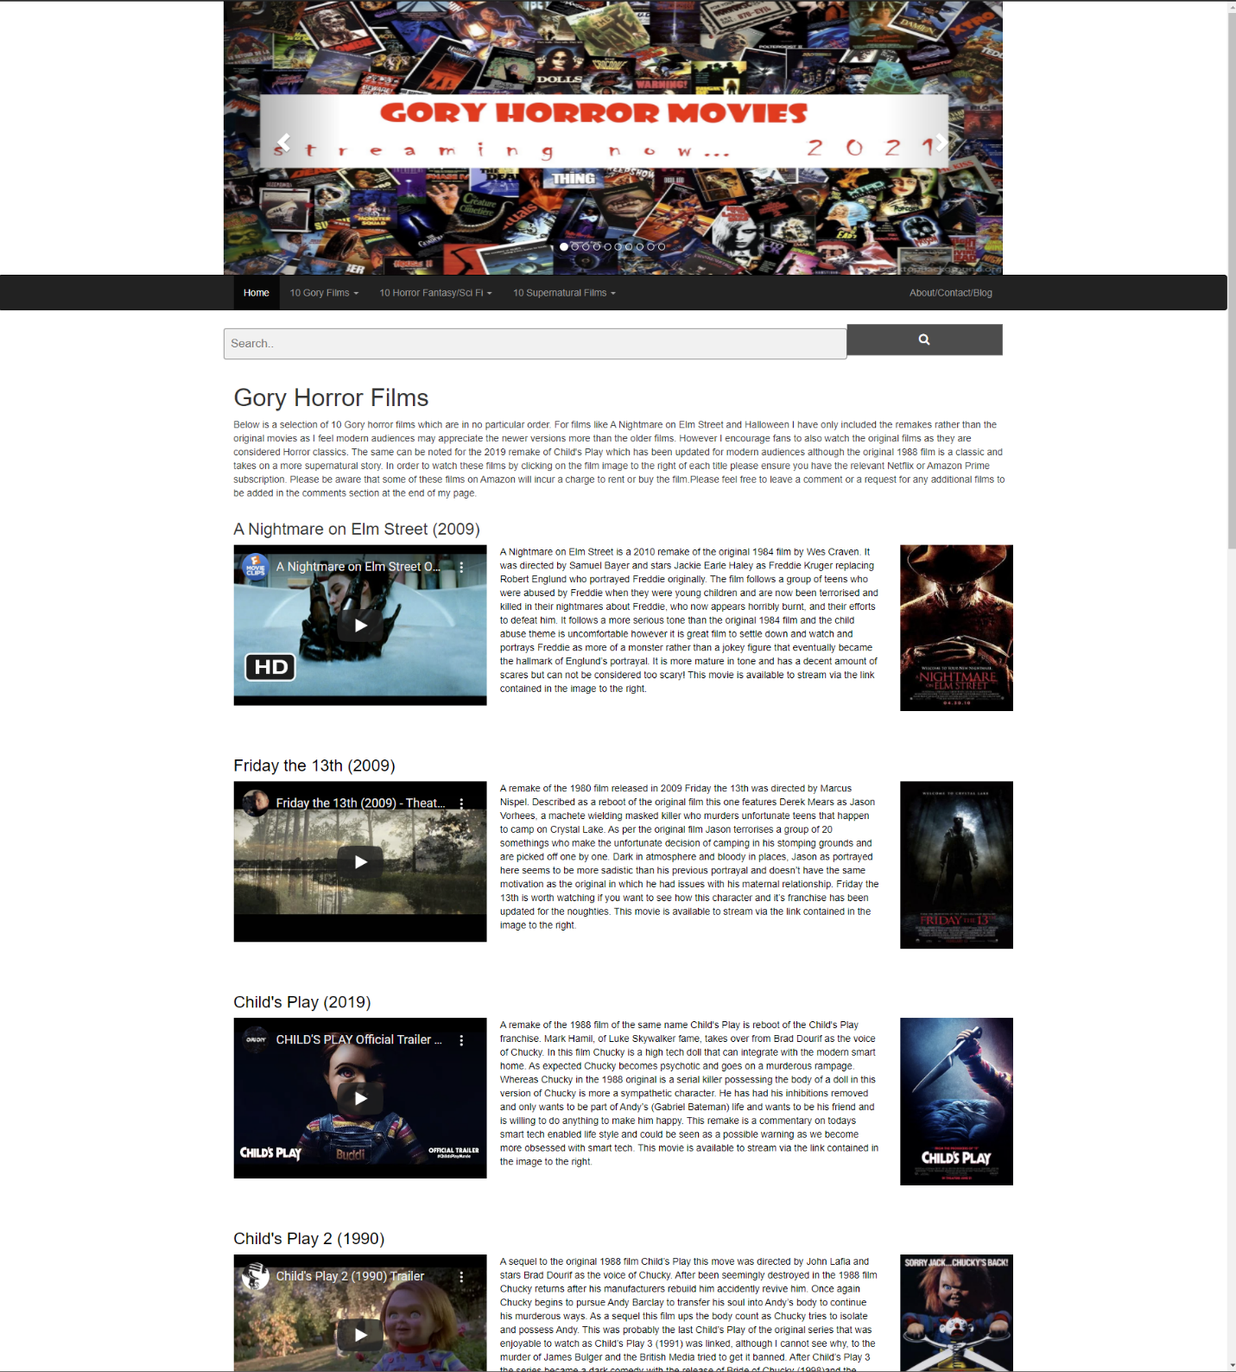

This is my first content page and contains the same Navigation system as the index page as well as a drop up system in the footer with a “return to top” button. The carousel shows images from all ten movies displayed on this page. Furthermore, the YouTube trailers are embedded in the page on the left and the user is encouraged to click on the image on the right which will take them directly to the movies and their respective streaming services. A search bar is also included as a further accessibility measure. A comments section is also included to encourage discussion and to allow the visitors to request additional films to be added.

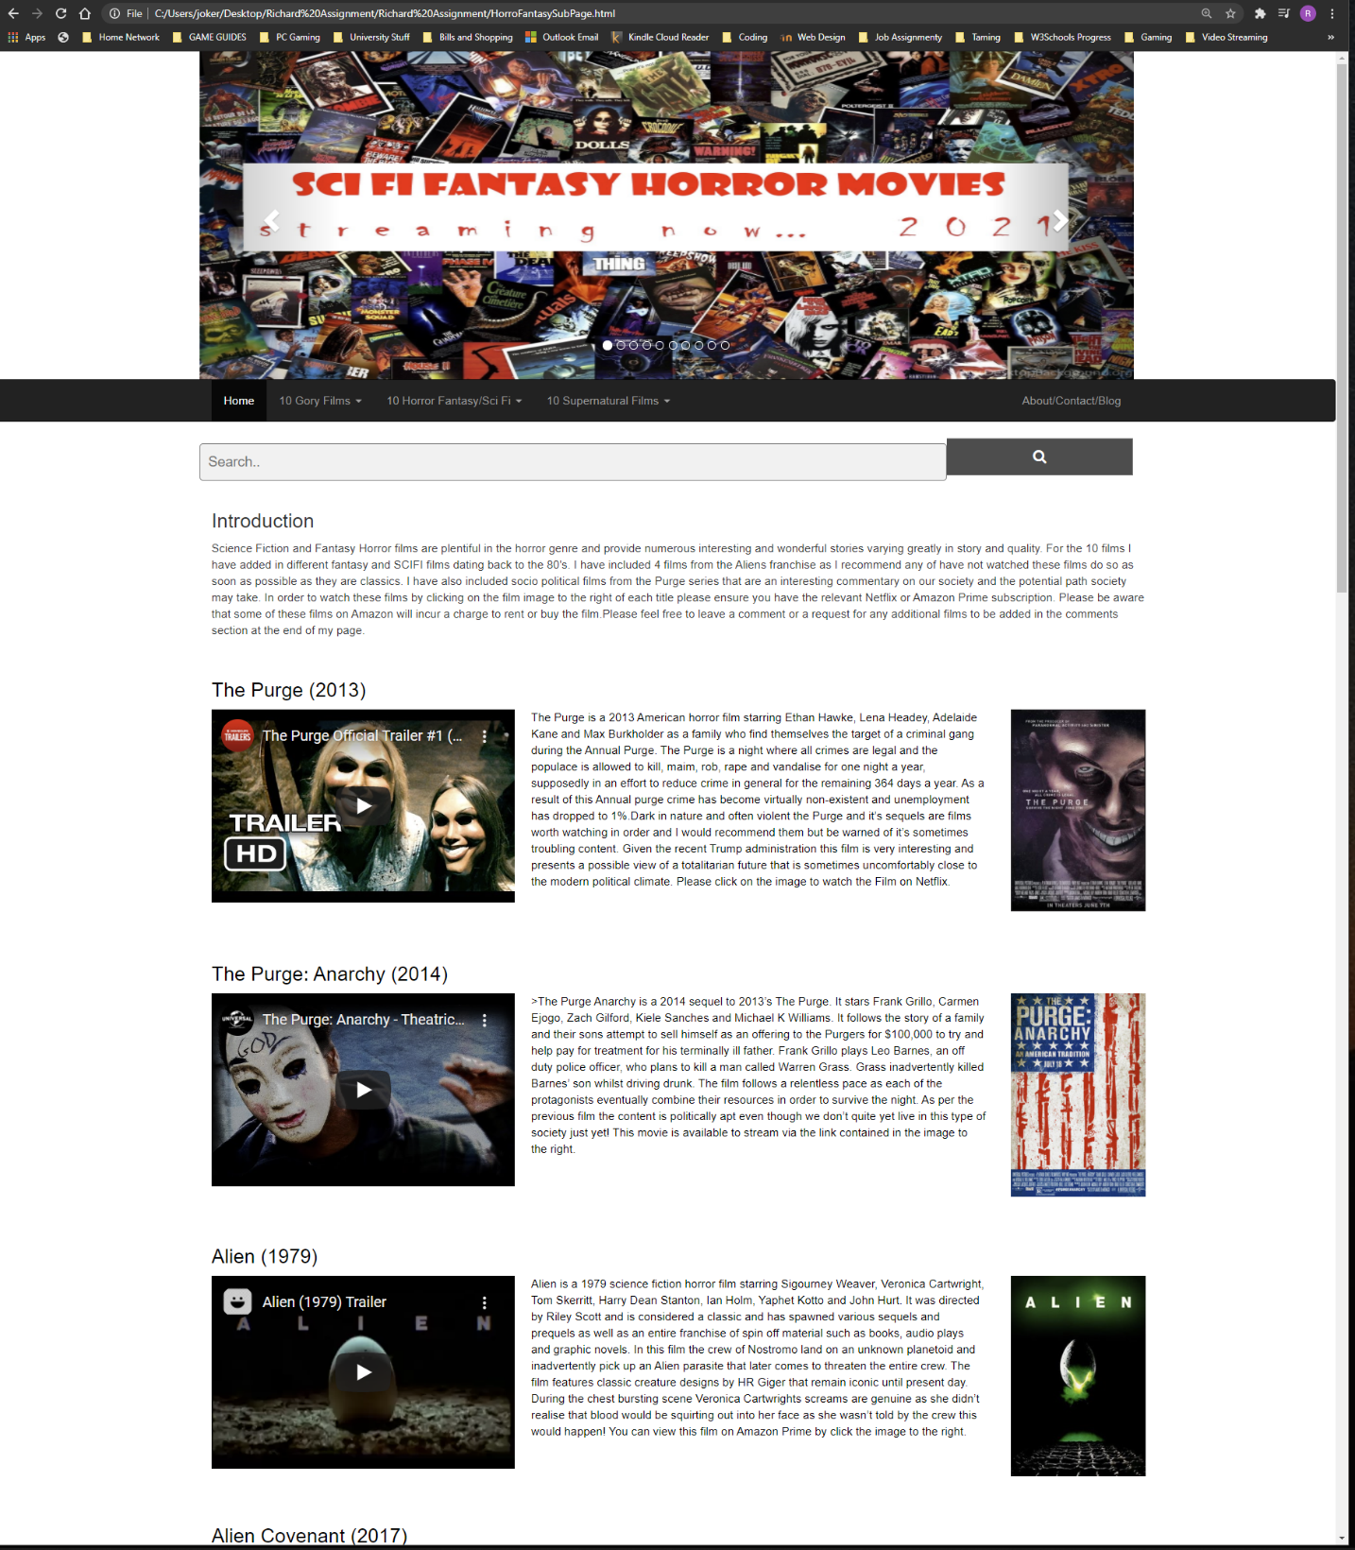

This is second content page and uses the same functions as the first content page. The images again contain the direct links to the movies. A comments section is also included to encourage discussion and to allow the visitors to request additional films to be added.

This is my third and final content page and has the same functionality as the other two.

Validation

For validation I have used the validator on the W3.org website. The results came back specifying 19 errors in total. For brevities sake I will discuss 3 of them.

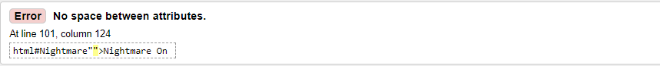

This is rectified by removing the addition “ from the code.

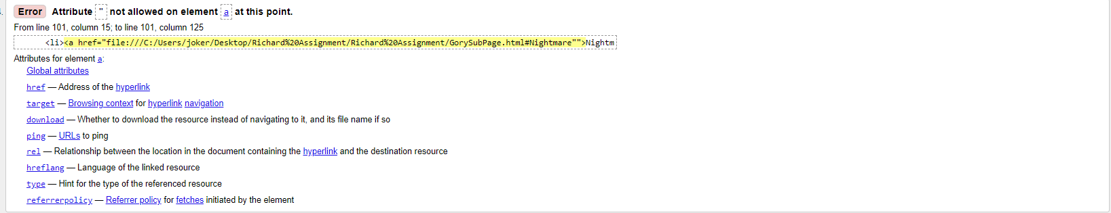

The resolution of this error is the same as above and involves removing the “.

This is resolved simply by adding a space in between Nightmare” and class.

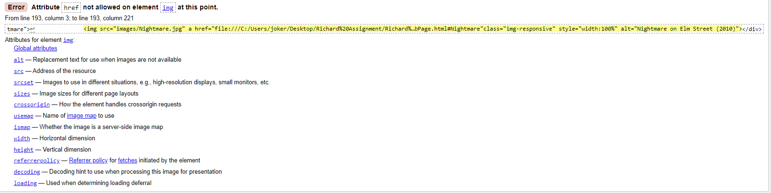

Resolved by moving the A Href element to the correct line which is in the Button Attribute.

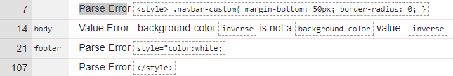

The inverse is an error that was removed. Furthermore I have corrected the style=”color=white; it is an error that has been removed. <style> and </style> are errors and are not required in an CSS file and have been deleted. I am very happy that only these 4 errors have been detected and my website is behaving as it should.

Evaluation

[4] Below I evaluate the essential aspects of web development such as it 'usability', 'accessibility' and 'search engine optimisation'.

Usefulness (usability and utility) [4]:
There is little point in creating a website that has no use, similarly one could produce a website that in general does have a use but its functionality is nil, it’s usability is poor, the content and ‘feel’ of the website could be boring and any engagement would be lost within a millisecond of entering the site. Such as waste of potential long. Term visitors who could bookmark your website and visit regularly.

Capturing the potential target audience’s attention and then holding their attention, allowing them to engage in the content and even share the content (because it is so interesting) is the goal.

As the target audience are potential ‘fans’ of horror, it was important to capture their attention and hold their interest as soon as they arrive on site. If a person immediately leaves the website, then that would affect the bounce rate on the site and search engines such as Google would deem the website page to be poor and that would affect any Google rankings you may have. So, I determined that the language on the site needed to be relatively informal, the colours needed to be reflective of the mood of the side (such as the font chosen on the home page banner was perfect and would be immediately recognisable as a horror font). Fortunately, the links to the films also showed an image that was used to market the individual film, so the site automatically gave the right tone and feel.

Keeping the site simple was also key, a search bar meant that visitors could search for films and then there are call to actions which encourage the user to send requests for films and make comments. With only a few pages, the user is unlikely to get lost but the tool bar makes it simple for them to jump around the website flawlessly and increase its usability and utility.

Potential
As explained previously, the site as it stands is a platform and from that there is a great deal of potential for monetization and the creating of a horror-esqe community that could be built. This would result in regular blog updates, the addition of a YouTube Channel and regular postings on Social Media such as Facebook/Twitter/Instagram. There is also a need for reviews as well and the audience could rank films in the same way that the Rotten Tomatoes voting works.

Search Engine Optimisation (SEO):

[5,6,7,8,9] Visibility on search engines is paramount, if no one can find my site then it isn’t going to be seen – which would be a shame, to say the least. Visitors who find your website without you paying for help from these search engines, are called Organic visitors and they are the type of visitors who generally would reach the website because they are looking for information that you are providing. Correct optimization of the pages on the website should increase traffic to the website and of course, the longer the user engages and remains on the website and even enjoys the experience, then the more Google will believe that the content and information on your website is a good quality and then your rank will increase. Search Engine Optimization consists of optimising the pages of your website so that they can better rank the keywords you are targeting on Google SERP (Search Engine Results Page).
The way in which to increase the site’s presence on search engines is to simply play by the rules set out by the search engine’s team who change the algorithms annoyingly quite regularly, making the whole game of trying to rank on the first page of (for example) Google, a continuous chase [9].

In 2011 an infamous change in Google’s algorithm resulted in many website which were ranking highly were wiped off the rankings overnight. This has happened a number of times because Google changes what it is looking for in a website. This change was called Panda [5] and left many companies utterly dismayed as they had to change their content and adhere to what the search engines wanted. Google had wised up to many ways that web developers were trying to fool Google into ranking their websites higher, for example by keyword stuffing. They then focused their attention on the quality of content, meaning that if your content is knowledgeable and people stay on your website then you are favoured by Google. Of course, if you pay for keywords with Google Ads then that would also increase your chances of ranking better.

For the purpose of this exercise, I looked at the content on my pages and chose to use a tool called SEO Moz [6] which is an aid to helping a web developer to ensure that the website ticks all the boxes, and the on-page optimisation is correct. There are tools which help to work out the best keywords to rank for on the site and it shows the competition. See below an example of keyword research. Another interesting tool is SpyFu [8] or Screaming Frog [7] which both can give insights into competitors websites, so you can actually see their meta data such as Titles, H1/2/3 headers, Descriptions and Keywords. Knowing what competing websites are telling Google gives me insight into any gaps that are not being addressed and then SEO Moz will be able to show me keywords that are being searched the most, with the least competition.

Keyword Suggestions from SEO Moz:

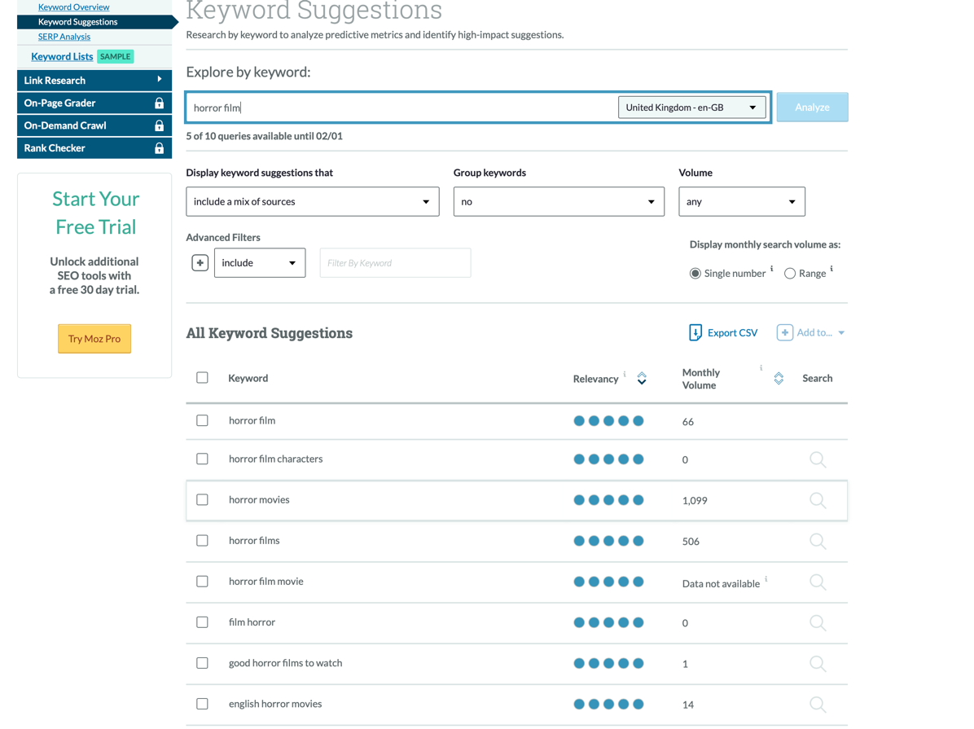

Accessibility

[3,10] In terms of accessibility I believe mine meets the required guidelines. The colours are not excessively bright and I have purposely chosen the dark theme for both the top Navigation Bar and the Footer. I have retained a neutral white background so the text is easy to read and the headers are of a size which a visitor can see. The images are scaled correctly and will scale when enhanced on a large display screen with high resolution. Should the images not load then there are alternative text descriptions so the user can understand exactly what the image was to represent. I have also included a “back to top” button at the bottom of each page for the user to utilise instead of scrolling back to the top.

The YouTube videos embedded in the site also allow the visitor to enlarge to full screen should this be required. This facility is also helpful to those who are sight impaired. There are additional functions that can be added to address those with sight impairment and blindness. [10] A quote from the British Standards Institution states,
“If an organization’s web product is not accessible to a disabled person, that person may have grounds for making a claim against the organization under the Equality Act 2010 or the Disability Discrimination Act 1995” BSI Group

My site also includes links in both the buttons and the images as well as the drop down and drop up menus to make it easier for the visitor to access all parts of the site with ease. Also included is a search bar for direct navigation to the content required although as this is not a live site it is not yet operable.

References

[1] http://validator.w3.org/
Used as a validator to check for errors in my HTML Code.

[2] http://jigsaw.w3.org/css-validator/

Used as a validator to check for errors within my CSS Code.

[3] https://developer.mozilla.org/en-US/docs/Learn/Accessibility/What_is_accessibility
Used to research Website Accessibility

[4] https://health.usf.edu/is/blog/2018/03/13/What-Is-Website-Usability--Why-Is-It-Important

Used to research Website Usability

[5] https://searchengineland.com/library/google/google-panda-update

Used to research Search Engine Optimisation and previous major algorithm updates

[6] https://analytics.moz.com/pro/keyword-explorer/keyword/suggestions?locale=en-GB&q=horror%20film
Used to research Search Engine Optimisation and understand keyword diagnostics

[7] https://www.screamingfrog.co.uk/seo-spider/
Used to research Search Engine Optimisation and understand keyword diagnostics

[8] https://www.spyfu.com

Used to research Search Engine Optimisation and understand optimisation tools

[9] https://www.mdpi.com/1999-5903/12/1/6/htm

Used to research and understand Search Engine Optimisation

[10] https://www.hobo-web.co.uk/design-website-for-blind/

Used to research and understand designing a website for the blind and sight impaired

