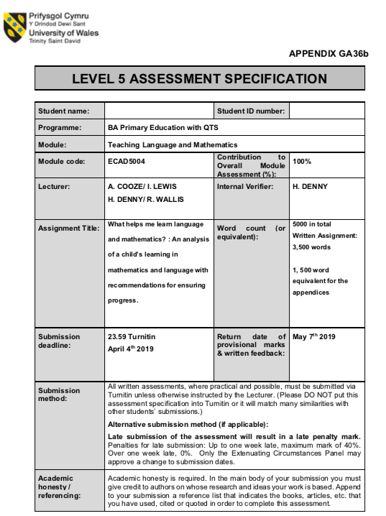
1704075
Kirsty Osinga
What helps me learn language and mathematics? : An analysis of a child’s learning in mathematics and language with recommendations for ensuring progress.
The purpose of this assignment is to analyse a child’s work in both mathematics and language within a primary school. Estyn (2013) reported that having Literacy and Numeracy skills are essential to a child reaching their full potential. To support this they developed the Literacy and Numeracy Framework (LNF) for the children of Wales to have the opportunity to the best learning opportunities for Literacy and Numeracy. Donaldson (2015) supports what Estyn reported, he believes that the curriculum needs to give children frequent opportunities to develop LNF skills throughout the curriculum. The data used for this assignment was gathered during time spent on Professional Teaching Experience (PTE). This data was gathered through following the University’s ethics guidelines, with permission granted from the school, as well as the child (see appendix 1). During this assignment in order to keep the child’s identity confidential they will be referred to as Child A. The data was gathered by using the Mosaic approach on an average attaining 4 year old girl within a reception class of a semi-rural school in South Wales. The Mosaic approach is a method of collecting data using a variety of different sources. This data can be combined together to gain an insight into how the child learns in different situations. Johnson and Ivan Smith see this method as a way of allowing adults to view things through the eyes of children (1998, cited in Clark and Moss, 2011, p.7). There was a range of evidence gathered from samples of work, observations and an interview with the child (see appendix 2). By gathering this evidence it is possible to analyse how Child A best learns language and mathematics, through this analysis it is possible to see what can be done to ensure that Child A is progressing their skills and achieving the best possible outcomes.
Language within the Foundation Phase Framework DFE (2015) is broken into three strands: Oracy, Reading and Writing. Whilst these strands are separated they are all equally as important. Many of the skills can be collaborated together during learning, they can also be taught cross circularly within the curriculum. It is recognised by Macblain (2014) that language is the key factor for children to develop socially as well as emotionally. Children must have Language skills in order to communicate their needs and feelings with others around them.
Oracy
During time spent on PTE there was a variety of opportunities to gather data on Child A using her Oracy skills, these range from planned group discussions, role play and observing the child during independent activities. From early on it was obvious to see that Child A was very confident in sharing information to the class, she had a strong desire to share her opinions and feelings with others. Whilst Oracy is part of the National Curriculum it is difficult to gather evidence on this strand of Language, as it is not something that can be evidenced on paper. The data gathered for this area of language was mainly through observations.
One of the first focused tasks carried out with Child A was to discuss within a group what they already know about farms and what they would like to know. Child A showed excitement in being able to share her own experiences with the group. Communicating her own personal experiences came easy to her however when it came to what she would like to know she struggled to come up with her own ideas. Child A showed curiosity to the other children’s experiences asking questions to deepen her own knowledge. Vygotsky believed that a child taking to an adult about familiar experiences is crucial in developing language skills (Pound, 2006) This view is also supported by Fisher, Frey and Hattie (2017).
Within the classroom there was a Farm shop role play area for the children. Whilst Child A was in this area she quickly took on the role of the leader by assigning the other children different characters, keeping her favourite role of ‘the shop keeper’ for herself. In future to develop Child A’s Oracy skills further she could play a different role within the shop, this will give her the opportunity to use a range of different specific vocabulary within play.
Within the interview Child A shared that she learns Oracy best by repeating what the teacher says. This is something that was practiced repeatedly throughout PTE using the model ‘My turn, your turn’. This model was used to introduce new vocabulary to the children. Another was this was practiced was during a Welsh lesson to introduce a new sentence structure. Child A shared that she found having the sentence structure beneficial to help her learn how to share information in Welsh. Cook (2008) supports the idea of giving children sentence structure to develop their Oracy skills.
Reading
Having good skills in reading is vital to children progressing throughout the curriculum. Estyn (2009a) believe that children’s progress is affected across the curriculum when they have a difficulty in reading and writing. Although no specific reading skills were taught during time spent on PTE the children were giving opportunities to read during independent tasks. DFE (2015) state that children should have access to a wide range of reading material and experience a language rich environment. The children had opportunities to sit in the classroom library choosing books that they would like to read. Child A would choose a book that she thought would be funny, she would decide this by looking at the picture on the front cover.
Within the classroom there was not a timetabled slot for the children to practice their reading, they had daily Read, Write, Inc sessions and books taken home to read with parents. Child A was at the stage of learning individual sounds, she could confidently sound out the letters and write them individually. However whilst observing I found that she couldn’t blend the different sounds together to make up a words. Meyer (2002) questions whether it is considered to be reading when a child can sound out the individual letters without applying to comprehension.
One of the independent tasks planned was to write a shopping list for the farm shop. There was a word bank with images of the different items of food prepared to help them with the different items available. Child A had successfully completed her shopping list, however when she was asked what she had included she didn’t know what she had written.
Writing
There were various opportunities for Child A to develop her writing skills during my time on PTE. These opportunities ranged from mark making to actually writing words and sentences. It is believed that mark making is the first steps on a child’s journey to writing letters and words (Tassoni, date unknown). By allowing Child A to mark make it was developing her fine motor skills as well as her pencil control in preparation for when it comes to writing.
During an independent task Child A was provided with a word bank of six words to practice writing. It was observed that she had confidently written all of these words correctly and very quickly. However when she was asked to write the words or letters independently she struggled to remember the formation of the various letters.
When planning a focused task which involved writing I wanted there to be a purpose to it, this is so the children would be more engaged and have a better understanding of what they were writing (Grigg, 2015; Graham and Kelly, 2003). From this the children were set the task of writing a question that they would like to ask a farmer. This activity provided the opportunity to observe Child A’s Oracy skills as well as writing skills as the children were discussing as a group which question they would like to ask. As previously mentioned Child A was confident in expressing her thoughts and opinions within the group. Once the group had decided on what question they would like to ask they were set the task of writing it down. As previously discussed with the class teacher Child A struggled with independent writing. It was decided that in order to support her I scaffolded her learning by writing it for her first so she could underwrite it (see appendix 3), during this she was encouraged to sound out each of the letters whilst writing them.
Mathematics
Mathematics within the Foundation Phase Framework DFE (2015) is broken into five strands: developing numerical reasoning, using number skills, using measuring skills, using geometry skills and using data skills. Within these strands there are different elements that need to be taught. Estyn (2009b) report that children need to apply mathematical skills confidently to all areas within the curriculum, applying these skills is vital to educational achievement.
During PTE the class teacher had requested that the mathematics lessons were planned by following the Numicon Framework. Whilst Numicon is a good visible resource for developing children’s mathematical skills I found the framework to be too structured not allowing the children to develop to their full potential. During an interview with Child A she declared that Numicon was her favourite part of mathematics, taking this on board I believe that Numicon would be best used as a resource alongside everyday teaching.
The main focus of the Numicon activities was to identify the different Numicon shapes using various techniques. Child A could confidently match the shapes to the Numicon number line, she could successfully identify the different shapes when given a number. Overall during focused tasks she was successful in completing the set tasks. During an interview with Child A she revealed that if she needed help with something she would copy a friends work, once she had disclosed this there was no way of knowing whether she had completed the set tasks herself or copied. Whilst Bandura’s social learning theory suggest that children learn well by copying and observing others (Lindon 2012) there was no way of knowing how much or how little she actually understood. By taking inspiration for Vygotsky’s Zone of Proximal Development (ZPD) Jaques and Hyland (2007) it was decided to set an individual task to identify the different Numicon shapes. During this task Child A was successful although it was observed that Child A was once again copying the work of others (see appendix 4). Following this a discussion was had with Child A to explain that she cannot copy others work as it’s not helping her to learn. During the next focused task Child A was moved away from her friend to see whether that would make a difference. The task was to create Numicon shapes using Numicon pegs. During the task it was observed that Child A could confidently make the shapes however, when she had to make them from memory she struggled and needed lots of guidance (see appendix 5).
One of the elements of Mathematics that was focused on whilst using the Numicon shapes was to mentally record one more and one less of a given number DFE (2015). To introduce the we counted forwards to ten and backwards from ten, Child A was confident in doing this. Child A was asked to show the Numicon shape that was one more than two, to begin with she struggled to understand what was mean by one more. Once it was explained to her what she needed to do she understood the concept but struggled to recall the number. In order to support the learning a number line was provided to visually see what numbers came next. Lee and Pound (2011) support this believing that children should be able to choose from a range of resources. Whilst having the number line benefited Child A’s understanding she and the majority of the class were still struggling with the concept of one more and one less of a given number. In order to improve the understanding there were planned independent and focused task with the classroom assistant to work further on this skill (see appendix 6).
Although the focused tasks were planned by following the Numicon Framework the independent activities were planned to develop other mathematical skills. During these independent task Child A showed that she could count different objects up to 10 she could also sort a variety of resources into different categories. Child A enjoyed independent activities which were outdoors on some occasions she was more engaged during these. Child A also enjoyed activities which involved using scissors, she needed to cut out numbers from 1 - 10 and put them into order creating a number line. During this activity I could see that Child A found it difficult to identify the different numbers without the aid of a number line.
During the end of PTE I was given the opportunity to plan activities away from the Numicon Framework, the topic I was given was 2D shapes. Askew (2011) believes that children should make connections between shapes in the real world that they can see everyday and the examples of shapes that are given in the classroom. From this the first activity planned was to identify and sort images of everyday shapes into their shape categories. Child A was confident in identifying each shape independently. From this the children were asked to go on a shape hunt during their break to see what shapes they could find on the playground. Once Child A had returned to the class she was excited to share the different shapes she had found and to be praised for her efforts, she could successfully identify what different shapes she had found in the outdoor environment. Nottingham (2013) believes that praising children for something that they have control over in this case using her own free time to complete an optional task will empower them to learn and grow.
Another task which was planned was to identify and count shapes within a picture. Knowing that Child A was confident in identifying shapes this was more to asses her counting and number formation skills. During the activity it was clear that Child A was confident in counting the various shapes within the picture. Child A struggled to recall how to write the various number asking for lots of guidance, it was decided to provide a number line to support her. Even after providing the number line Child A required lots of support and guidance in deciding which was the correct number.
Whilst teaching 2D shapes on PTE I found that Child A was at Level one within the Van Hiele Levels of Geometric Thought. Level one is the visual stage where children can visualise shapes and identify them as a whole. The children will use basic names for the shapes but cannot describe the properties of the shape (Way, 2011).
Next steps
During this part of the assignment I will be using the outcomes as set out in DFE (2015) to assess Child A’s development in Mathematics and Language during my time spent on PTE. When a child in reception class they are assessed to form a baseline, this baseline can be used to track the children’s progress through until the end of year two. Whilst outcomes are important they are only one means of assessment used to create the baseline, other elements are included such as formative assessments and observations (DFE, 2017).
Child A’s Oracy skills reached an outcome 3, she was very confident in using these skills responding to various questions, speaking clearly and using an increased range of vocabulary. In order to progress to an outcome 4 Child A will need to blend sounds together to create a word. She would also need to extend on ideas including more detail, show an awareness need to the needs of listeners and to take on roles of various other characters during role play activities. For Child A’s writing skills I believe that she reached an outcome 2, she could write letters during mark making, she could identify some letters from the sounds. On reflection Child A was reaching some of the skills set out within outcome 3. To progress to Outcome 3 she would need to spell out words independently rather than underwriting, she would also need to use capital letters and full stops correctly. I believe that in order for Child A to progress she needs to move into the next stage of Read, Write, Inc where the children are blending individual sounds together to read a word. Moving on to this stage would also benefit Child A with her reading skills, as no specific reading skills were seen during PTE it would be unfair to give Child A an outcome for this area of language. Whilst I cannot provide Child A with an outcome for reading I would suggest that more opportunities are provided for her to read within the class’ weekly timetable. She shared that she enjoyed reading in the library, there could be an independent activity where the children can choose a book to read within this area of the classroom. During an interview with Child A she shared her favourite areas to learn different elements of Language and also what would help her learn. Taking these into account I believe that Child A would benefit from planned activities in various areas of the classroom alongside being provided with the opportunity to access a wide range of resources such as whiteboards to practice her writing.
Within mathematics it is difficult to give an accurate outcome as not all of the elements were taught during my time within the class, taking this into account I will base my assessment on only the elements that were taught. Child A was reaching elements of an outcome 3 she could confidently recite up to 20 and count up to 10. Child A could recognise 2D shapes and describe them simply by how many sides they have. Although Child A struggled with mentally recalling one more and one less of a given number she was more confident in this aspect after spending more time on it during independent and focused tasks. In order to develop these specific skills to an outcome 4 Child A would need to count up to 20 objects, write the numbers independently, she would also need to describe 2D shapes using more detail than simply how many sides it has. Another area I would suggest Child would need to develop is her ability to identify and write numbers correctly without the use of a number line. Providing Child A with opportunities to learn mathematics in both the indoor and outdoor environments could encourage her to want to learn as she shared that she enjoys learning mathematics in the outdoor environment. Developing confidence in her abilities would benefit Child A, she shared on various occasions during an interview that to help her learn mathematics she would either ask the teacher for help or copy the work of a friend.
Although these assessments are not 100% accurate as only a short amount of time was spent working with Child A during PTE they give a good indicator on what she can achieve. From these assessments it is possible to see which areas Child A needs to focus on in order to progress further. Research shows that good assessment allows for children’s needs to be met through planning to their needs, ensuring that all children are moving forward (Estyn, 2015). I believe that in order for Child A to progress to the best of her ability she needs to gain confidence in herself, on various occasions she required lots of reassurance that she was doing something correctly. I believe that once she gains confidence in herself she will progress much quicker, this would possibly help with the issue of copying others work.

Word count: 3321

Reference list

Askew, M. (2011) Transforming Primary Mathematics. Oxon: Routledge.

Cook, V. (2008) Second language learning and language teaching. 4th Ed. London: Hodder Education.
Clark, A. and Moss, P. (2011) Listening to Young Children: The Mosaic Approach (2nd ed.) National Children’s Bureau
Department For Education (2015) Curriculum for Wales: Foundation Phase Framework. Cardiff: Welsh Government.

Department For Education (2017) Foundation Phase Profile Handbook. Cardiff: Welsh Government.
Donaldson, G. (2015) Successful Futures: Independent Review of Curriculum and Assessment Arrangements in Wales. Welsh Government.
Estyn (2009a) Best practice in the reading and writing of pupils aged five to seven years, Cardiff: Estyn.
Estyn (2009b) Best practice in mathematics for pupils aged 3 to 7 years, Cardiff: Estyn.
Estyn (2013) National Literacy and Numeracy Framework: To support schools in introducing the National Literacy and Numeracy Framework, Cardiff: Welsh Government.
Estyn (2015) Assessing children's learning to make teaching more effective, Cardiff: Welsh Government.
Fisher, D, Frey, N and Hattie, J. (2017) Teaching literacy in the visible learning classroom. USA: Corwin.
Graham, J and Kelly, A. (2003) Writing Under Control. 3rd edn. Oxon: Routledge.
Grigg, R. (2015) Becoming an Outstanding Primary School Teacher. Oxon: Routledge.
Jacques, K and Hyland, R. (2007) Professional Studies Primary and Early Years (3rd ed.) Exeter: Learning Matters.
Lee, T and Pound, L. (2011) Teaching Mathematics Creatively. Oxon: Routledge.
Lindon, J. (2012) Understanding﻿ Children’s﻿ Behaviour﻿ 0–11 ﻿Years. London: Hodder Education.
Macblain, S. (2014) How Children Learn. London: Sage.
Meyer, R.J. (2002) Phonics Exposed Understanding and Resisting Systematic Direct Intense Phonics Instruction. London: Lawrence Erlbaum Associates.
Nottingham, J. (2013) Encouraging Learning How you can help children learn. Oxon: Routledge.
Pound, L. (2006) How Children Learn – Book 1. London: MA Education
Tassoni, P. (date unknown) Making their mark – children’s early writing. Available at: https://www.early-education.org.uk/sites/default/files/Making%20their%20mark%20-%20children%27s%20early%20writing.pdf (Accessed: 1st April 2019).

Way, J. (2011) The Development of Spatial and Geometric Thinking: The Importance of Instruction. Available at: https://nrich.maths.org/2487 (Accessed: 2nd April 2019).

Appendix 1

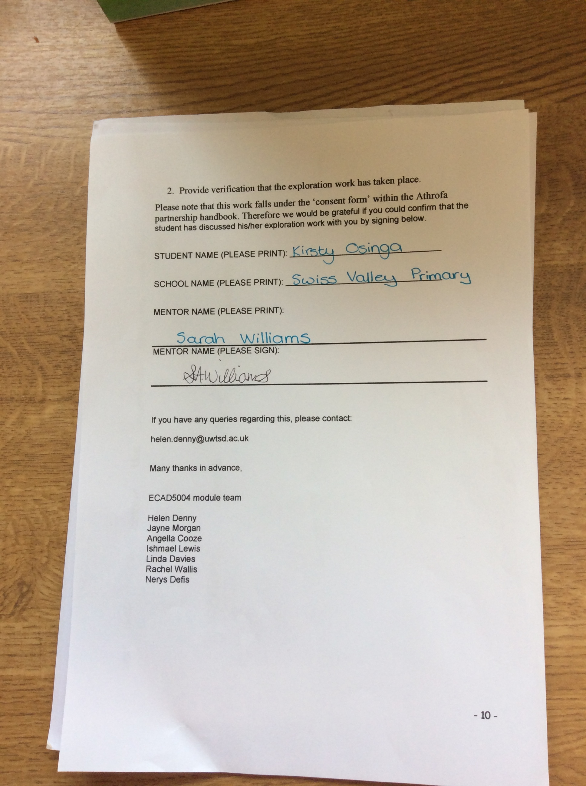

Appendix 2

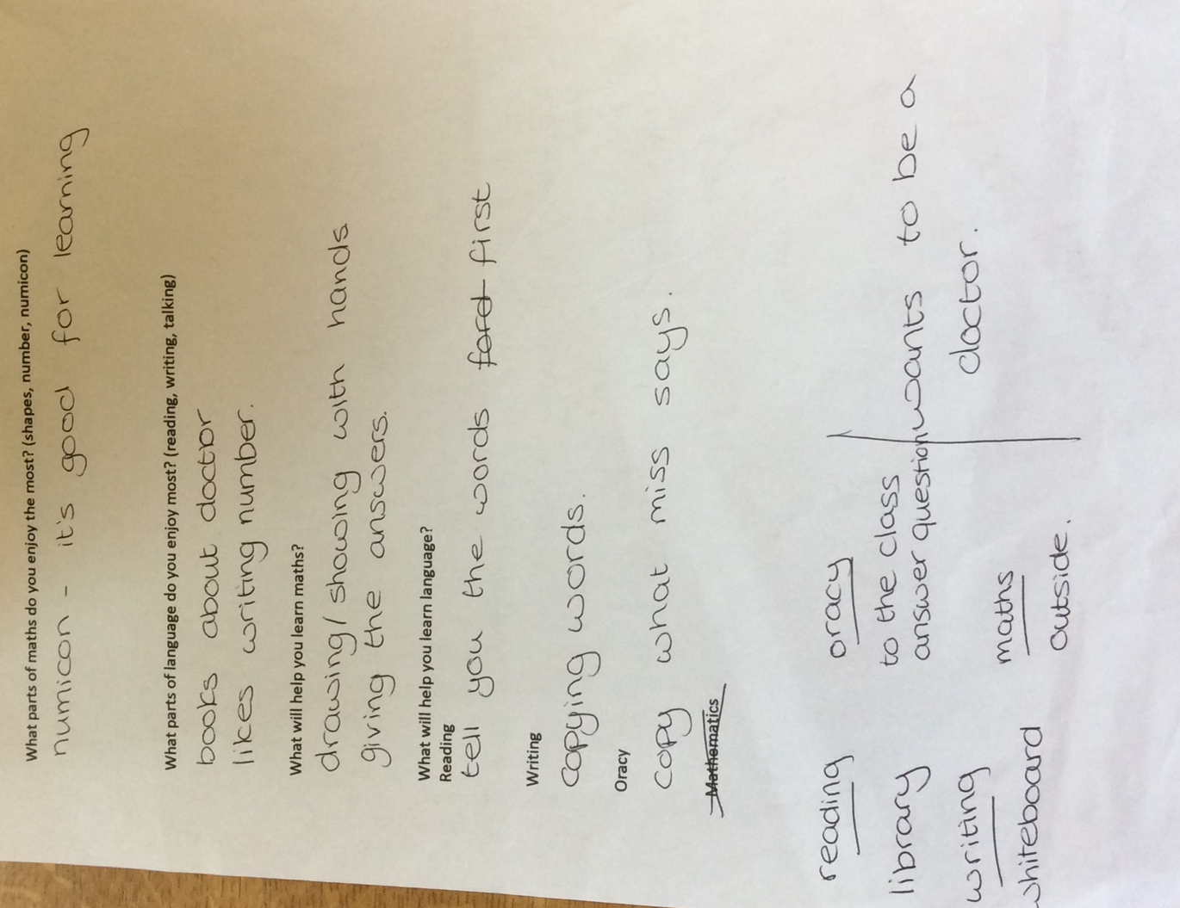

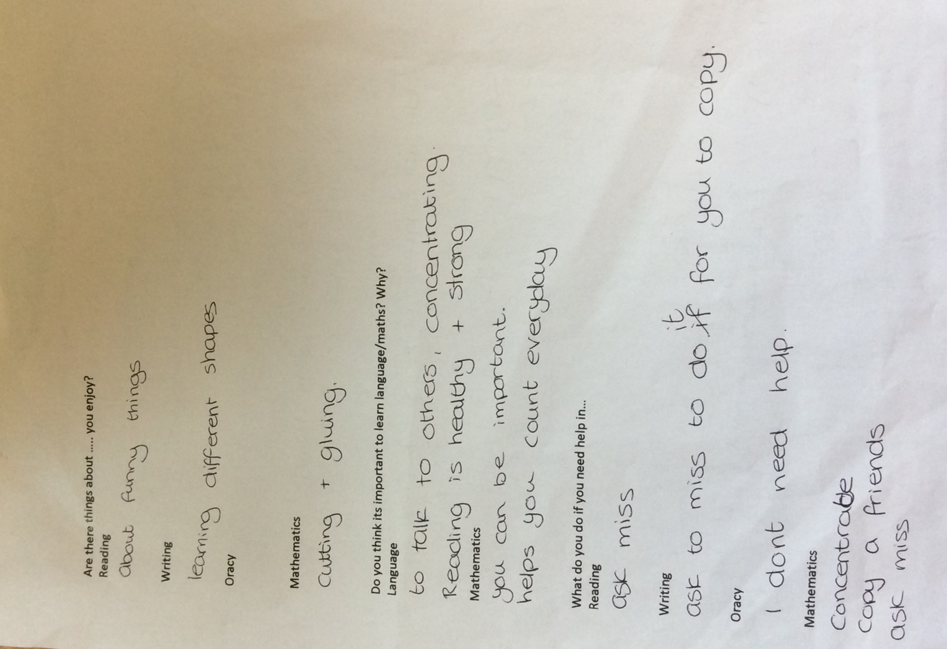

Appendix 3

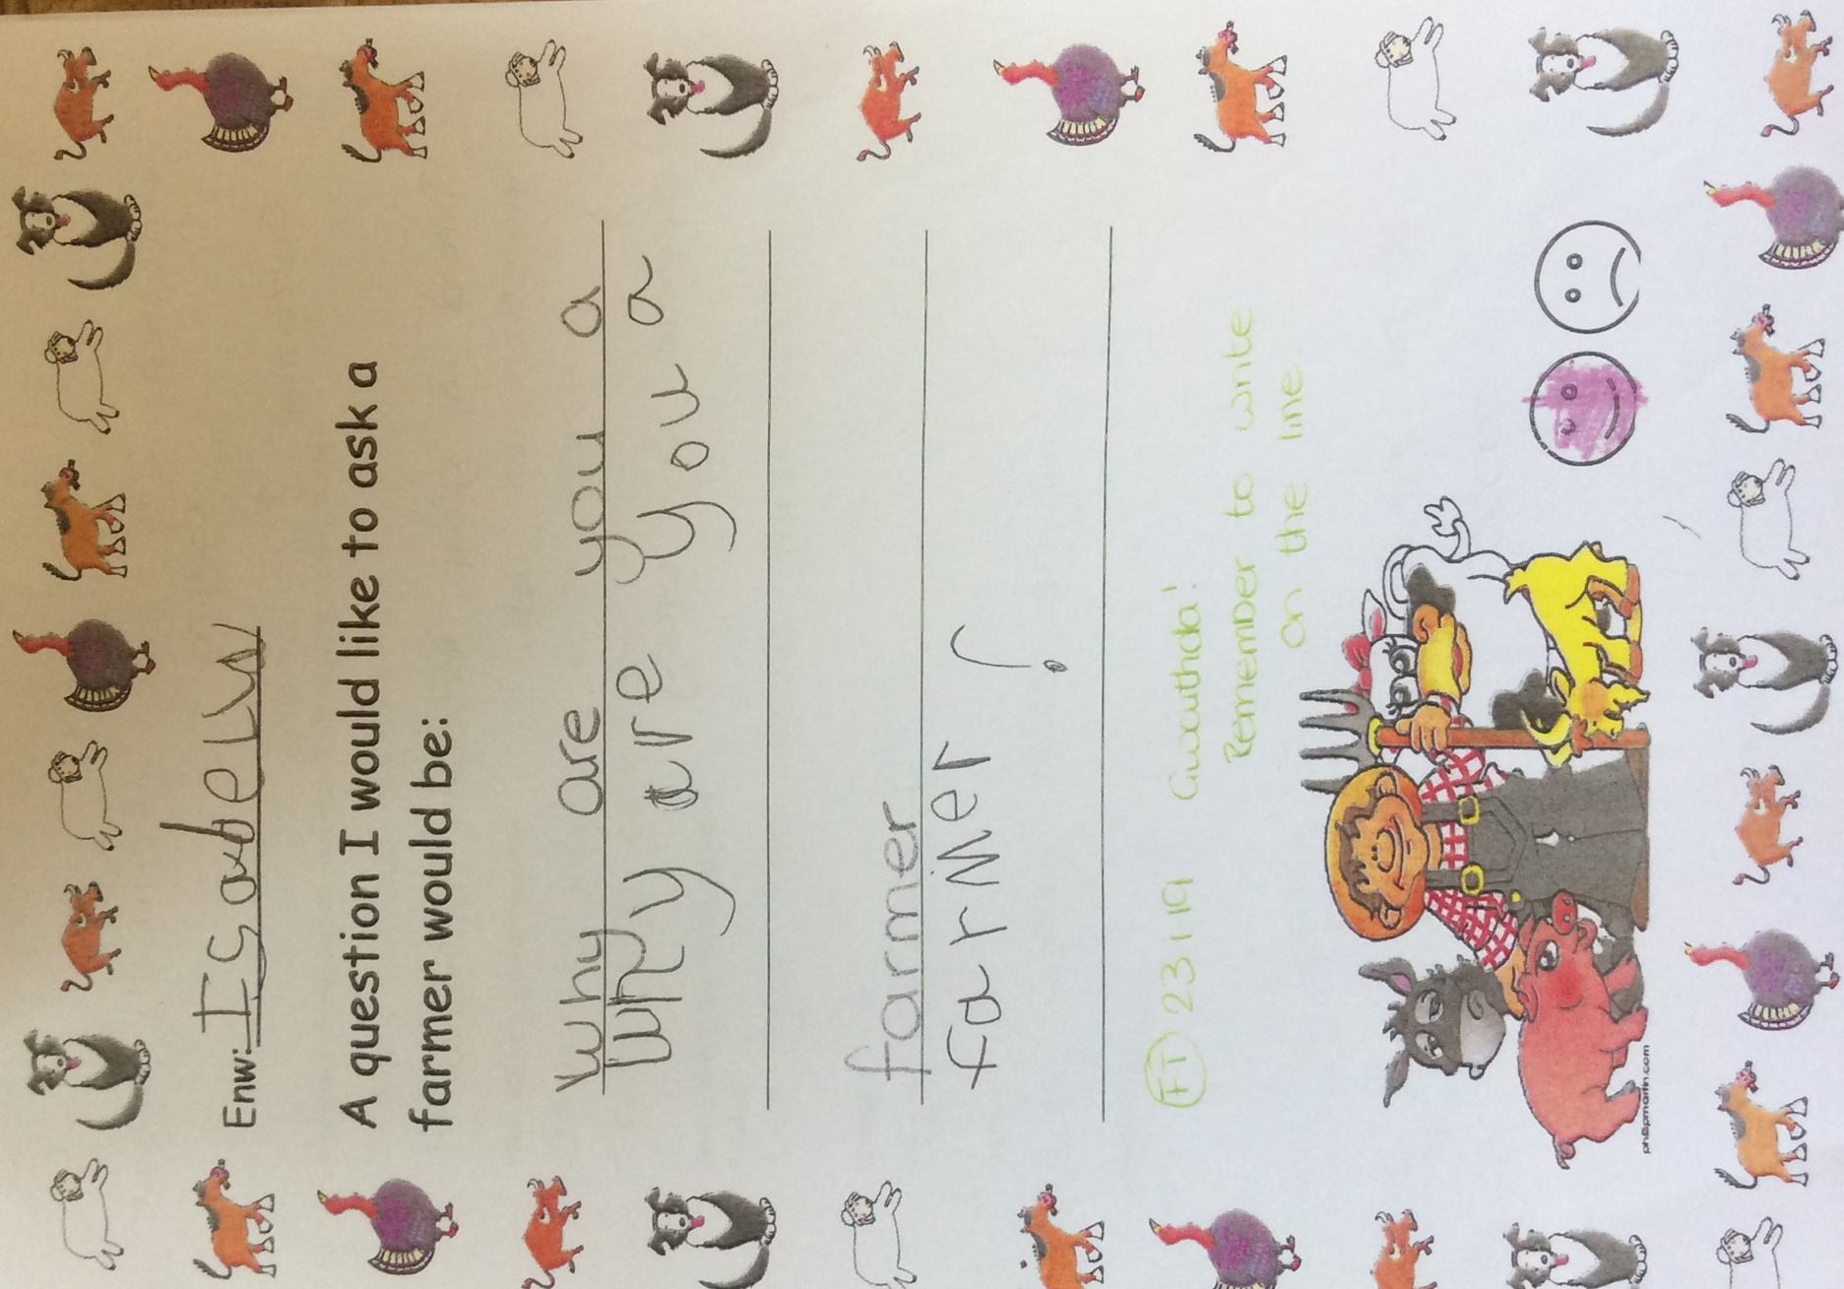

Appendix 4

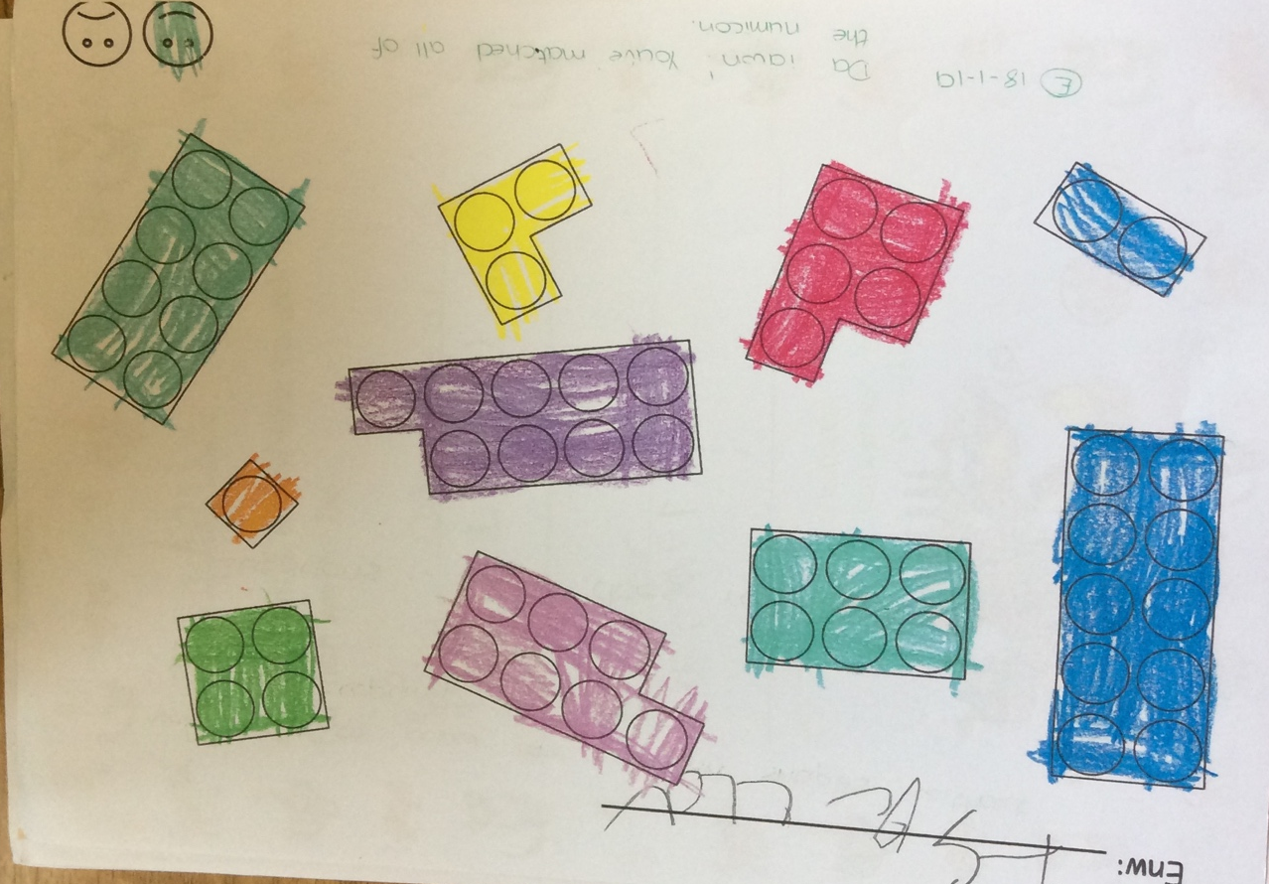

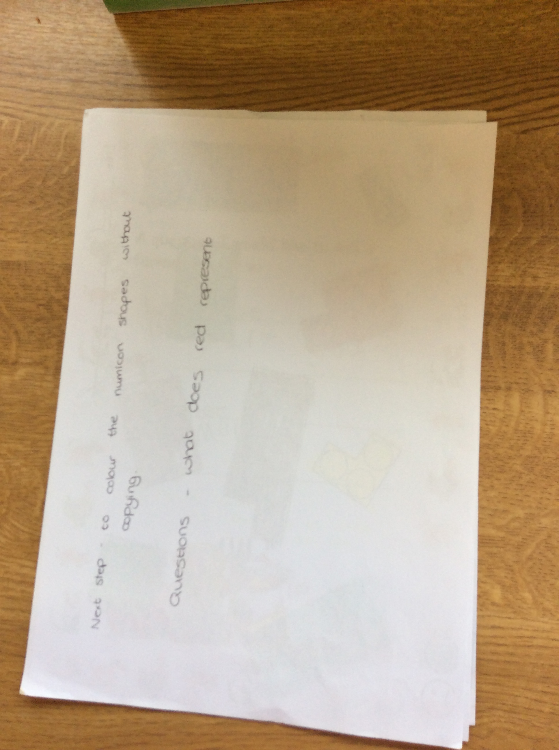

Appendix 5
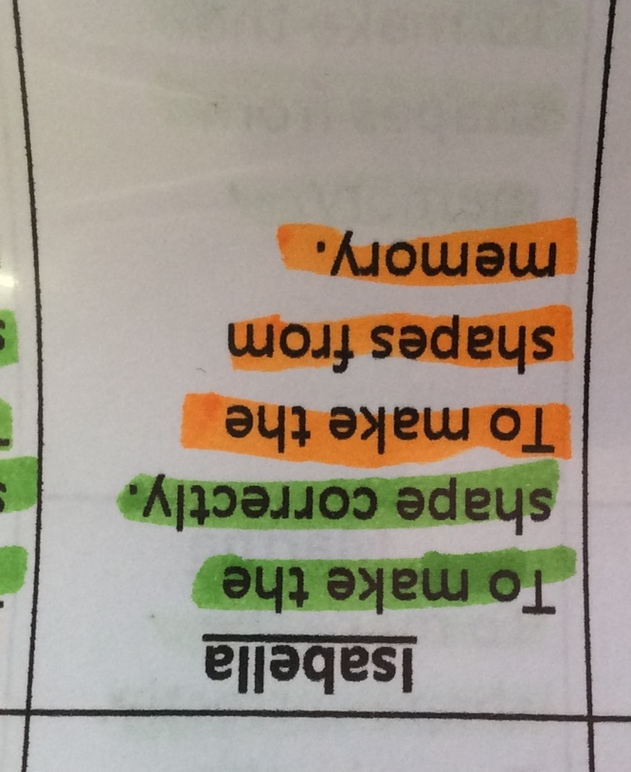

Appendix 6



