- Calculate the total Resistance across PQ
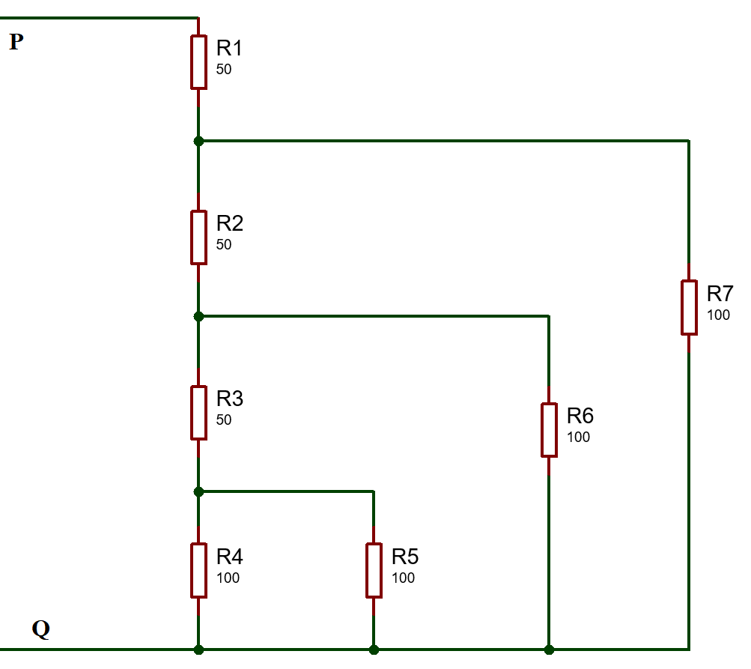
Answer: 100$Ω$

- Given four 1Ω resistor, state how the resistors must be connected to give an overall resistance of
- $0.25Ω$
- $1Ω$
- $1.33Ω$
- $2.5Ω$
Answer:
- 4 Resistors in Parallel
- Two pair of resistors in series connected in parallel
- 3 Resistors in Parallel and 1 resistor in series with the parallel resistors
- 2 resistors in series connected to 2 resistors in parallel
- For the circuit shown below find the value of the supply voltage V and the value of current I.
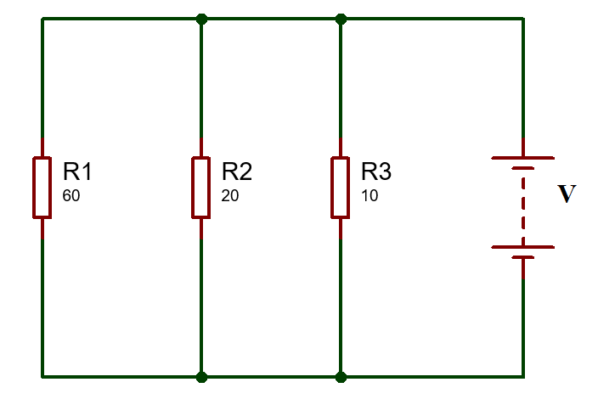
Answer:
Supply voltage = 60V
Total current= 10A
Current across $60Ω=1A$
Current across $20Ω=3A$
Current across $10Ω=6A$
- For the series Parallel circuit shown below calculate the supply current, the current flowing through each resistor and potential difference across each resistor.
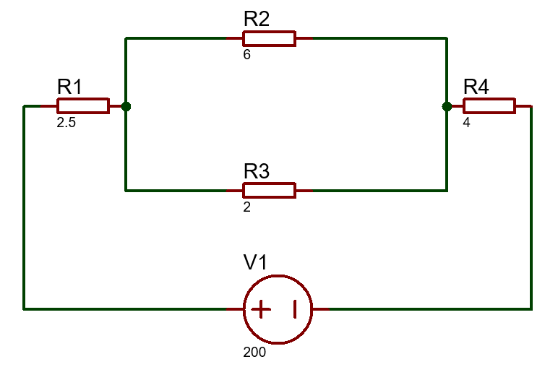
Answer:
Total current = 25A
Current across $2.5Ω=25A$
Current across $6Ω=6.25A$
Current across $2Ω=18.8A$
Current across $4Ω=25A$
Voltage across $2.5Ω=62.5V$
Voltage across $6Ω=37.5V$
Voltage across $2Ω=37.5V$
Voltage across $4Ω=100V$

- For the circuit shown below calculate
- the value of resistor $R_{x}$ such that the total power dissipated in the circuit is $2.5KW$
- Current flowing in each of the resistor
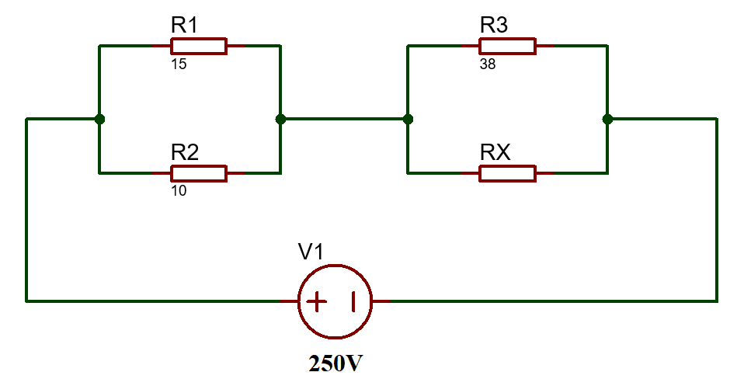
Answer:
Total current=10A
Current across $15Ω=4A$
Current across $10Ω=6A$
Voltage across 15 and 10 ohm resistor =60V
Voltage across 15 and 10 ohm resistor =190V
Rx=38Ohms
Current across $38Ω$ =5A
Current across $38Ω$ =5A
- For the circuit shown below calculate the current across $8Ω$ Resistor.
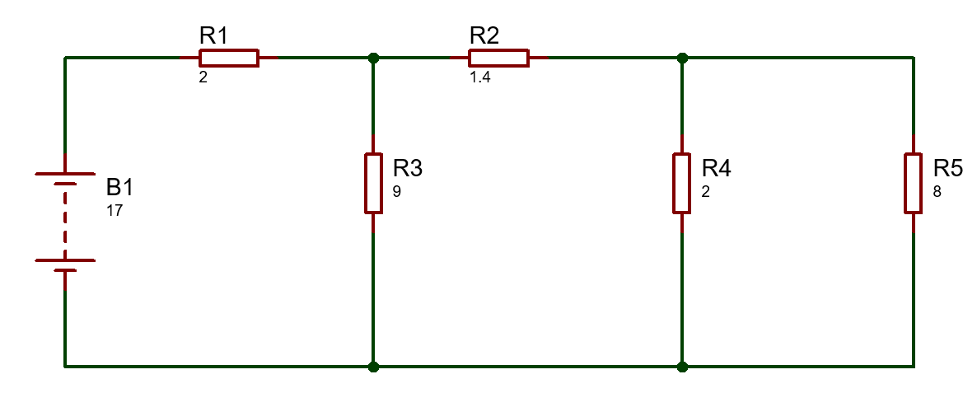
Answer:
Total current = 3.9A
Current across $9Ω=0.98A$
Current across $1.4Ω=2.93A$
Current across $2Ω=2.34A$
Current across $8Ω=0.58A$

- For the circuit shown below determine the current supplied by the source of 20V to circuit.
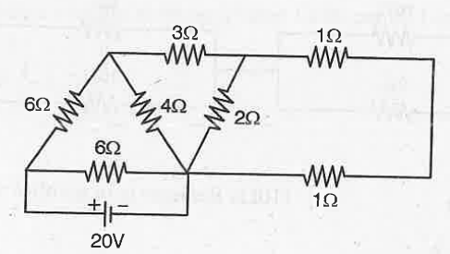

Answer:
Total Resistance =$3.428Ω$
Total Current= 5.83A
- For the circuit shown below determine the current across each resistor.

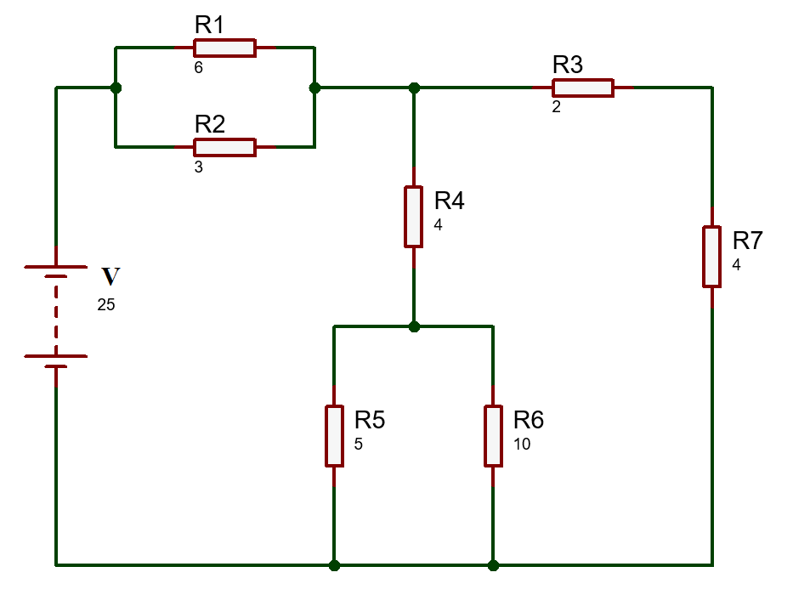
Answer:
$R_{Total}=5.3Ω$
Total current=$=4.71A$
Current across $R_{1}$=$I_{1}=1.57A$
Current across $R_{2}$ = $I_{2}=3.14A$
Current across $R_{3}$=$I_{3}=2.1A$
Current across $R_{3}$=$I_{3}=2.1A$
Current across $R_{4}=I_{4}=1.4A$
Current across $R_{5}=I_{5}=0.7A$
Current across $R_{6}=I_{6}=2.55A$
- For the circuit shown below determine the current across each resistor.
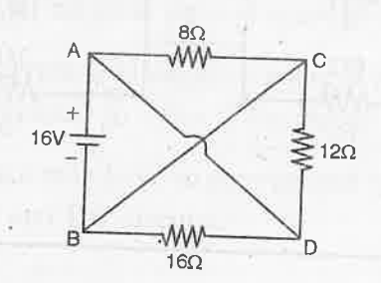
Answer:
Total Resistance$= 3.7Ω$
Total current=4.324A
Current across $8Ω=1.996A$
Current across $12Ω=1.33A$
Current across $16Ω=1A$

