

Postgraduate/Distance Learning
Assignment coversheet & feedback form

THIS SHEET MUST BE THE FIRST PAGE OF THE ASSIGNMENT YOU ARE SUBMITTING (DO NOT SEND AS A SEPARATE FILE)

For completion by the student:
Student Name:
Danielle Marie Goldstein
Module code: HPCA7002  Module title: Researching Contemporary Cosmologies | Student ID number: 1710933 |  |  | Educational support needs:  No
Module tutor: Bernadette Brady, Nick Campion and Carole Taylor

Assignment due date: May 13th, 2019
If your module has multiple submissions, please indicate which piece of work this is.

1st 2nd X 3rd 4th 5th 6th
I confirm that this is my original work and that I have adhered to the University policy on plagiarism.
Signed Danielle Marie Goldstein
Email submission: if you are submitting this form via email, please tick this box X
(as a substitute for your signature) to confirm that you agree to the above declaration.
Assignment Mark
1st Marker’s Provisional mark
2nd Marker’s/Moderator’s provisional mark
Agreed Internal Mark:

External Examiner’s mark (if relevant)
Final Mark

NB. All marks are provisional until confirmed by the Final Examination Board.

For completion by Marker 1:
Comments:

Marker’s signature: |  |  | Date:
For completion by Marker 2/Moderator:

Comments:

Marker’s Signature: |  | Date:
AGREED INTERNAL MARK (where necessary):

Comment on process of arriving at agreed mark:

External Examiner’s comments (if relevant)

External Examiner’s Signature: |  | Date:

‘Research Project in Contemporary Cosmology’
Word Count: 4200 words

Introduction
One of my first memories of the sky stems from the age of five when I stayed up until the wee hours of the morning watching Halley’s comet with my neighbourhood friends and our parents in our Georgia neighbourhood. I knew in that moment that I wouldn’t have the opportunity to view Halley’s Comet again until I was in my eighties. At such a young age this felt profound. I remember wondering who I would be at the age of eighty. While living in Germany around the age of seven, a classroom was set up in my school where we crawled into a dark simulated dome, and met a traveling storyteller who lit the sky up with the major constellations, introducing my classmates and I to the realm of starlore. I was in heaven. I made a promise to myself in that moment that I would come to know the stars through their myths. During my early teens while I was facing the collapse of my parent’s marriage, it was my connection to the sky that offered me stability. I would often gather with my dear friends who cared for me as if I was their daughter. Often, we would spend our time together by walking from their lakeside house through the dark forest, only lit by our torches and the stars above, to a wide grassy field in Eastern North Carolina. There we would spread a large wool blanket on the grass and lie on our backs as we intentionally communed with the Pleiades through eye gazing and meditation.

It was these experiences that shaped my connection to the stars as vast, friendly and available. As a practicing astrologer, I find myself looking up at the sky each day and night, questioning whether astrologers have a responsibility to connect with the living sky. I also find myself feeling frustrated with how little I actually know and understand of the sky. Many contemporary astrologers are highly knowledgeable on the techniques of casting and reading charts, yet appear to have a limited connection to the heavens above. The aim of this qualitative research project is to explore the relationship astrologers have with the sky. This topic has been researched by connecting with eighteen different astrologers through a process of questionnaire and in-depth interviews, rooted in academic study. The research taught me that astrologers do have an intimate relationship with the sky, albeit the variations of sky knowledge. Sky literacy and astrology do not go hand in hand in the minds of all astrologers, which points to the debate on the cultural implications of starry wisdom and the lessening of the dark night-sky.

Literature Review
One of the aims of this research project was to explore the relationship that contemporary astrologers have with the sky, while clarifying if there is any disconnect between astrologers and the sky. Regardless of sky literacy, it is clear that the heavens invoke deep emotions and memory. Nick Campion defined that astrology ‘presents the sky as a source of awe, wonder and meaning, as a sacred canopy which shelters the earth below.’ In relation to the topic of phenomenology, the sky is a mirror of intelligence for each individual, or as Maurice Merleau-Ponty pointed out, the sky is the essential contact point between consciousness and environment. Chris Tilley spoke of phenomenology as a field that allows any absolute truth to be experienced by an unique consciousness, ‘. . .”object” and “subject”, “nature” and “consciousness” are dialectically related moments of totality which is constituted through the Being of the body in the world.’

In the classical world astronomy and astrology overlapped, and up until the seventeenth century, these terms were interchangeable. However, in contemporary culture, there is often a wide gap between practicing astrologers and astronomers. As astronomers are defined as scientific, astrologers often find themselves working to gain credibility in the realm of professional occupations. This project explored the potential that although many astrologers are fluent in reading a chart, they may not be able to identify a planet through naked eye astronomy, or even know how to name the phase of the moon by gazing up in the sky. Another factor to consider is that the spread of urban sprawl has resulted in many contemporary astrologers facing a limitation in having the dark skyscape accessible. In 2007 the Starlight initiative was launched to protect the night sky.

Aden, is a practicing astrologer who also considers himself a naked eye astronomer and is one that believes the astrological chart and living sky are not separate. He currently lives in Las Vegas where he readily has access to dark night skies and astronomical events. He has been teaching the Living Sky for the past decade and noted that it has been his ‘most significant teacher and guide as an astrologer, well beyond any individual, book or technique.’ His main intention in working with students and clients is to emphasize that they must get out of their head, and to instead ask what the experience is relaying to them. This process correlates directly back to the process of phenomenology that Tilley defined. The ramification of a disconnect between the astrologer and the sky may affect the culture of astrology moving forward. In Foundations of New World Cultural Astronomy, Anthony Aveni noted that ‘the practice of observing and making sense of celestial phenomena is as much a cultural activity as any other, and consequently it is equally sensitive to the varied processes of culture change.’ Ultimately this research explored a more penetrating concern as to whether astrologers have an obligation to have a relationship with the sky in order to cultivate and maintain a culture of sky literacy.

Methodology
The design of this project included a combination of questionnaires and open-ended interviews, where each participant defined themselves as an astrologer. This study was approached from an interpretative perspective, and grounded in qualitative research, meaning that the researcher was committed to being open minded, curious, and flexible. The questionnaire consisted of approximately fifty questions on the topic of astrology and the sky. It was created digitally and then emailed to thirty-three astrologers. Eighteen completed the questionnaire by the proposed deadline.

The principle recruitment process of the astrologers consisted of the researcher making a list of potential astrologers, while considering their local and global community. The participants were recruited via email, Facebook messages and verbal conversations. One third of the eighteen participants were female, one third of the participants were male, three participants defined themselves as they/them, and one defined themselves as ze/zem. All of the astrologers reside in the Northern Hemisphere with ten living in the Western NC region of the United Sates. Other astrologers reside in Eugene, Portland, Southern California, Las Vegas, Mexico, and Spain. The majority of the astrologers have been studying astrology in the range of ten to nineteen years, while more than one third of the participants began studying astrology over twenty years ago. Two thirds are professional astrologers, four named themselves as hobbyist astrologers and four defined themselves as student astrologers. The astrologers that have other professions include non-profit executive directors, healers, artists, an economic development consultant, a psychologist, a professional land surveyor, and a chef. Each of the participants have a practice of studying astrology weekly. More than half of the astrologers study at least ten hours each week, and the rest of the participants responded that they study in the range of one to seven hours each week. Every single participant responded that they practice Western Astrology. Three fourths of the astrologers also defined their astrology to be psychological and spiritual, and almost half of these participants also defined their astrology as evolutionary and traditional. Other forms of astrology that were noted include shamanic, electional, medical, astrocartography, Vedic, Centauric, intuitive, somatic, hermetic, Sabian symbols, Western Sidereal and mythic.

The goal of the questionnaire was to find three or four astrologers to interview in-depth for roughly sixty minutes. Due to time constraints and scheduling, only two astrologers were able to connect live for these interviews by the necessary deadline. One interview was held virtually through the platform Zoom with Aden from Las Vegas, and the other was completed face to face in a local tea shop with Rio in Asheville, North Carolina. The virtual interview was video recorded, and notes were captured through google documents dictation software. The in-person interview was audio recorded through a cell phone application.

The astrologers who participated in the in-depth interviews completed a release form, giving explicit permission for their contribution to be used for public reference, for research purposes, for academic presentations, in research material which may be published at a future date, and the use of their name. The interviews were carefully structured with opening questions, key questions and closing questions as suggested in Qualitative Research Methods. Care was given in the interview process so that trust was built and a quality space was cultivated with the interviewee, ‘To achieve both the in-depth and emic perspectives, in depth interviewing involves: using a semi structured interview guide to prompt the data collection, establishing rapport, asking questions in an open, empathic way, motivating the interview to tell their story by probing.’ The interviews were intentionally brought to a close by asking the astrologer about their plans for their future work with astrology. As was stated in Qualitative Research Methods, the interview questions were organized in a logical order for the interviewee, not the researcher.

The data collection process included using different kinds of technology. Google forms was used to create and capture the results of the questionnaires. Following the guidance of Judith Bell, the questionnaires included lists, categories, ranking, quantity, and short responses. Google forms proved to be very useful as this software created metrics to simplify the data collection process. Since this was a time limited study, the data collected in this project was ultimately analysed manually, which Bell emphasized may be even better than engaging computer data analysis for a short-term project. The in-depth interviews were transcribed from the recordings, while the results were sifted through so that themes could emerge. There was a period of time where the researcher ‘lived’ with the data, allowing the project to take on its own life-force. The data was sensitively analysed with as much reflexivity as possible, so that the results emerged in a pure way, as it is essential that ‘researchers take constant stock of their actions and their role in the research process, and subject these to the same critical scrutiny as the rest of their “data”’.’

Ethical considerations were kept in mind by clearly stating at the beginning of the questionnaire what the aim of the research project was and that the purpose was an assessment by the University for examination purposes only. Each participant understood that if the question of publication were to arise at a future date, they would be contacted, and that permission would be sought out for the use of their data. They clearly understood that unless they gave explicit permission for their name to be used, their answers to the questionnaire would remain anonymous. Regardless, a pseudonym was given to each participant in this research project. Participants were also encouraged that when filling out the questionnaire, or being asked questions in the interview process, to be as honest as possible, and to even skip a question if they preferred to not answer. All information captured through the process was treated with the strictest of confidentiality, living in a password protected digital file.

As the researcher, I must be transparent about who I am and my intentions in this project as, ‘A primary focus of qualitative research is to understand behaviour, perceptions, or experience.’ I am an American female nearing her 40s, who is a self-employed artist, teacher, healer and practicing professional astrologer. My main intention in pursuit of higher education in the field of astrology has been largely driven by a desire to know more about the living sky, while witnessing what I term the disconnect between contemporary astrology and the living sky. As a researcher it is my obligation to be aware of the strengths and weaknesses of being an insider in the midst of this project, and that I have an obligation to the process of reflexivity.

Findings
The findings of this research detailed that despite the extent of sky literacy an astrologer may have with the living sky, each and every astrologer truly has a relationship with the sky. Astrologers are aware of phenomena in the sky, and what most stood out in research are the sightings of shooting stars and full moons. Key emotions of connection, love and awe of the sky surfaced through this research, highlighting that the sky and memory are inextricably linked together for astrologers. There is also a debate in the astrological community concerning if astrologers are obligated to sky knowledge. It seemed essential to anchor this research by asking the astrologers how they define astrology and astronomy. Amanda, a full time professional astrologer based in New York City said that astrology is magic of the heavens made manifest, while Margaret, a hobbyist astrologer claimed that it is a hologram, allowing us to project the psyche, both individual and collective onto a map of symbols. Henry defined astronomy as the art of understanding what we see in the sky, whereas three astrologers specifically noted that astronomy is about ‘celestial bodies’, stating in regard to ‘their movements and appearances’, or ‘the composition and math of these bodies’.

Sky literacy
Despite the reality of growing light pollution, fifteen of the eighteen astrologers stated have viewed the night sky from their backyard. The three who are unable to view from their home needed to travel from five minutes and up to one hour to have a clear view of the night sky. More than half of the astrologers have based holidays upon being able to connect clearly with the night sky or to witness some sort of astronomical phenomenon. The sky watching destinations included Fire Island, NY, the American Southwest, the Bahamas, Alaska, and Scandinavia. One third of the astrologers named themselves a naked eye astronomer. These astrologers found themselves gazing at the sky anywhere from two to seven days and nights each week and have spent a varying degree of time studying astronomy and the sky, ranging up to five hours each week.

The participants were asked which planets they were able to confidently able to identify through the naked eye. Venus and Mars were most easily identified, with Jupiter, Saturn and Mercury also being detectable as seen in Table 1. When asked about the constellations they could locate on their own (see Table 2), the popular ones were Ursa Major, Ursa Minor, Polaris and Cassiopeia. Some of these astrologers stated they are drawn to specific constellations like the Pleiades, Orion and Ursa Major. Almost all of the astrologers have viewed a Solar and Lunar eclipse. The astrologers have used an array of tools to connect with the sky including star charts, binoculars, telescopes, and applications on their smart phones. All but two astrologers have visited a planetarium, seven have attended star parties and five have attended a local astronomy club. Henry, a full-time professional astrologer in Western North Carolina found astrology through researching a dream where the glyph of Venus appeared. He currently teaches astronomy and keeps a sky journal.

Table 1
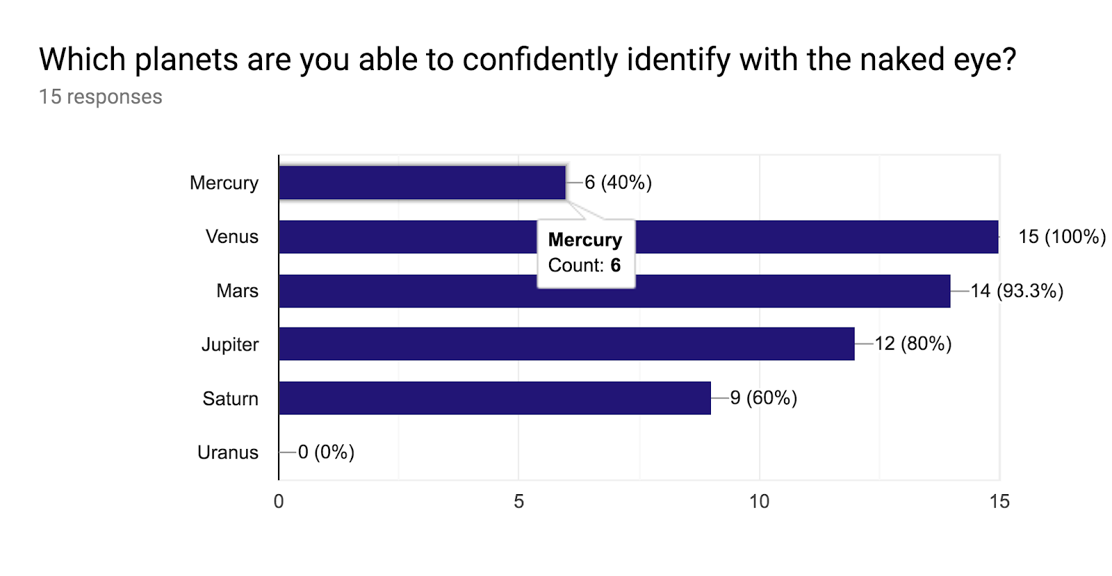
Table 2
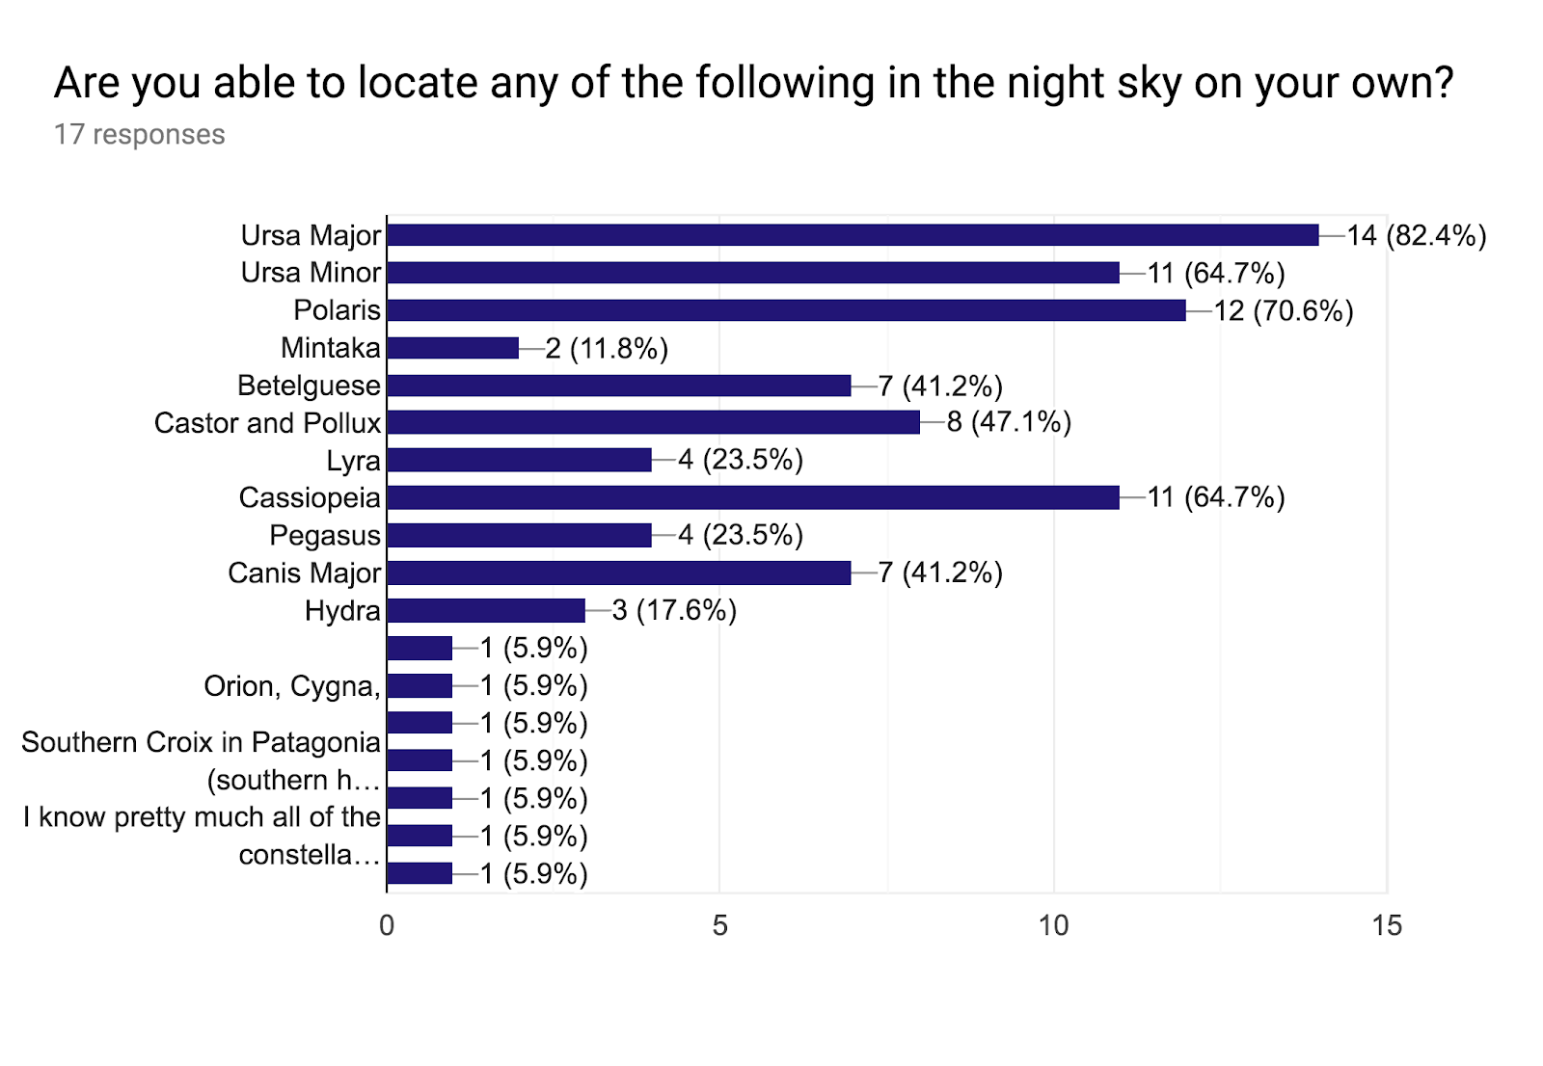
Awareness of phenomena
Shooting stars and the moon’s phases inspired consistent responses from the astrologers. Shooting stars stirred up emotions of depth, as they remarked on their feelings of awe, excitement, and pleasure. Many noted that viewing a shooting star is a gift. Aden remarked shooting stars conjured, ‘excitement, feeling “being with” the phenomena as it’s happening.’ Merleau-Ponti referred to phenomenology as a ‘philosophy for which the world is always ‘already there’ before reflection begins … and all its efforts are concentrated upon re-achieving a direct and primitive contact with the world’…’ this primal moment connects directly to the human experience of sky gazing. In consideration of the lunar cycle, thirteen of the eighteen questionnaire participants claimed they have a regular practice of viewing the moon phases, while five responded that they sometimes engaged. Many of these astrologers have the ability to name the cycles of the moon through visibility as seen in Table 3. When asked what they most notice and remember about the moon, a number of the participants commented on the moon’s regularity, brightness, the halo, and the sensations the full moon inspires. Rio remarked, ‘I especially notice the waxing crescent moon after the new moon. For me, it is linked to the High Priestess archetype, and is the first light of the moon seen after the new moon seed is sown.’

Table 3

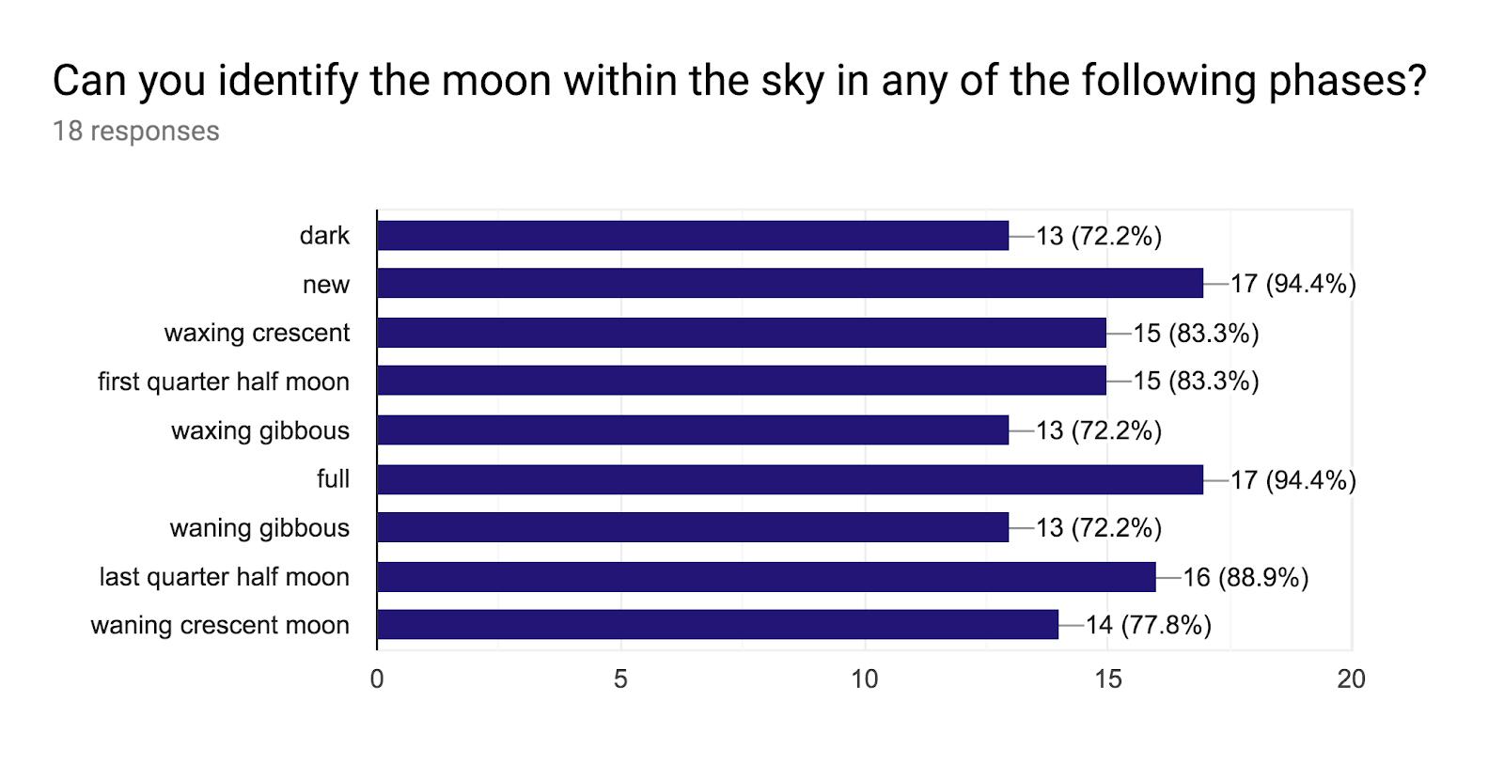
Emotion and Memory
The sky stirred up deep emotions of connection, love, and awe for astrologers, which ultimately is an experience of cultural astronomy. As Aveni wrote, ‘the study of cultural astronomies is concerned with the diversity of way in which cultures, both ancient and modern, perceive celestial objects and integrate them into their world view.’ Margaret noted that the sky inspired her to feel wonder, protection, belonging and warmth. She specified the connection to self, with others, and the greater collective whole is ‘also a mediator between our individual felt experience and the real world that surrounds us, both on earth and in the sky.’ Daniel, a Centauric astrologer based in Asheville, North Carolina spoke of how he felt reconnected to their greater self and, ‘place in the universe of time and space, and during peak experiences ‘feel an actual communion with various stars and planets and their intelligences.’ Henry said the sky is the ‘vitalizing source of being for, and the Soul of the beloved Art’ that he is called to practice. The sky was tied to feelings of love as recorded by numerous astrologers, ‘I love it’ and ‘deep love’ were specifically stated. Henry said, ‘She has kept me going when giving up on being an astrologer would have been easy to rationalize. When you love and serve Her, She loves you back.’

This sky devotion leads to a feeling of worship when considering the vastness of the sky. A common theme was the awe of the sky, or the idea of being ‘starstruck’. Greg commented that his feelings about the sky are as numerous as the types of weather. Jonathan said that the sky is vastness beyond measure, ‘The sky is a portal to infinite voids and intricate worlds. The possibilities of what the sky could contain quickly overwhelm my mind.’ Rose, an intuitive astrologer in Asheville, North Carolina noted that the sky contains everything and gives us life, while Rio said that it is overwhelmingly vast, endless. Luke said they feel like the sky is a hologram, a magical container. Dana, a student astrologer in Asheville, North Carolina said that the sky is a mystery and a compass, invoking the concept of sky as limitless, ‘The advancing knowledge brings an appreciation that life forms and the macroscopic properties of the universe are logically inter-linked and that our universe may be just one in a limitless multiverse. Ultimately astrologers have a varied relationship with the sky ranging from ‘a place of observation’, ‘the dome of heaven’, to feelings of deep love beyond measure, and this variance is woven like a web.

What is clear from this research is that the sky, memory, and phenomenon are united. Dana said she has always had a memory of the sky. Henry wrote of a childhood he had where all the planets lined up. Jamie discussed being a child riding in the back of the car and he felt as if the moon was following him. Margaret reminisced being the age of four when her mother woke her up at four in the morning to view the first total lunar eclipse of her life, ‘We made a pot of tea and snuggled in blankets on the front porch with a perfect view of the show right in front of us.’ Rio spoke of a time they were staring out of the car window, driving from their great-grandmother’s house in Maryland to their Georgia home. Rio’s great-grandmother spoke that she was friends with a fairy who was a star in the sky, ‘I was about five years old and the star seemed to dance and communicate with me as it twinkled. I was mesmerized.’

Table
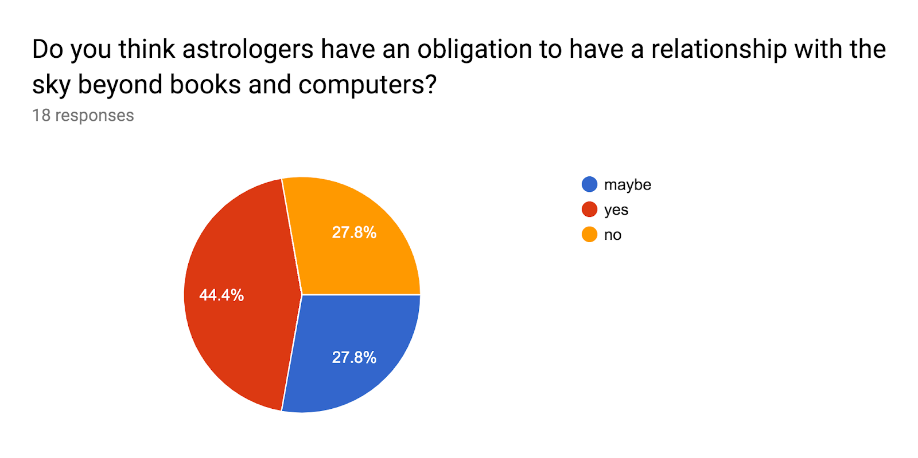
An obligation to sky literacy
Each participant answered the question regarding if astrologers have an obligation to have a relationship with the sky beyond books and computers. Eight astrologers believe they have a responsibility to know the living sky, five replied maybe and five replied no. Rose stated that she doesn’t believe anyone is obligated to have a relationship with the sky, that this relationship is a gift, ‘A blessing. A celebration. A yearning and fulfillment.’ She went on to describe, ‘It would be great is astrology and embodied sky-worship went hand-in-hand and to me they do, but I respect however astrologers experience the portal for themselves,’ knowing not all astrologers have clear skies to view. Meanwhile Jonathan said that for them ‘Astrology functions primarily as a way to communicate with people, and perhaps to refer them to aspects of their experience that have been neglected or overlooked.’ Although they find the sky fascinating, they have yet to explore the sky in more detail, and they are comfortable with this separation.

Aden believes that sky literacy is essential, that it is the key element missing in the modern astrological practice. He said modern astrology is dead without this bridge, and astrologers who do not know the sky may be brilliant, yet disembodied, ‘Not that astrologers should memorize a ton of astronomy but (they) should learn the Sky as a complex dynamic, ever moving, alive and sentient (being).’ Rio said that they believe the origin of astrology is all about looking up and looking around. For them, ‘to divorce from that only onto a paper, onto a chart, onto like an abstract model. . . I feel like that the stars are calling, and it is our responsibility to listen. . .they have always been calling and speaking to us.’ A number of astrologers agreed that a lack of connection with the sky misses the essence of what astrology is.

Conclusion
This research project questioned astrologers about their relationship to the sky, while being rooted in an academic literature review, methodology and sensitively determining the data. Each astrologer questioned has a relationship with the sky regardless of their ability to name the sky bodies. Astrologers are connected to the sky through phenomena, emotions and memory. Aden specified that the sky gives us an immediate visceral experience, which in his work evolves instinct into knowing. He defined instinct as human biological instinct, specifically the autonomic nervous system, explaining that the chart does not give a person this experience because it is merely a representation or symbol. Campion questioned ‘First, when did humans beings develop a symbolic consciousness? When in other words, might they have concluded that the sun, a physical object, either was, or represented, a deity, an intangible being, force or presence,’ which draws upon this possibility that the symbolism of these bodies has ultimately disembodied us. Aden referred that when you are looking up at the sky, it is just that connection, of you and sky, ‘And that directness gets down to our tissue. Chart gets us into consciousness and awareness and awakening. Sky gives it to you directly.’

Although many astrologers do not think the living sky is essential to their practice, there are astrologers out there like Rio who have believe that their work is to help connect clients with the sky. Aden described that when a person gets out of the way through the mental projection, there is an ability to have an experience of the sky land in the body. When this happens, ‘it gets very personal and usually some healing shows up. Astrology where the practitioner gets out of the way, (is when) the astrologer isn’t focused on consciousness, they are focused on the experience they are having with consciousness. When I am body first, it includes consciousness. Movement, dance, being in water. I’ve had some wonderful experiences in natural hot springs, just being in the water, looking up at night.’ This being in water, looking up at the night sky weaves directly to Tilley’s ‘Being of the body in the world’ and is fully based on experience. Aveni stated that star lore cannot be expected to survive cultural shifts and what one society might perceive as significant, may not arouse little or no interest in another. The same applies for astrologers, in regards to whether an astrologer has a responsibility to the culture of astrology to know the living sky. However, the evidence of this research points to the concept that Aden also stressed, that the coupling of astronomy and astrology, that which is more experienced based, connecting to the bodies that are present above, versus solely technical seems like a remedy for these times, and a way to protect our dark night-skies.

Bibliography

Aveni, Anthony. Foundations of New World Cultural Astronomy, (Colorado: University Press of Colorado, 2008)

Bell, Judith. Doing your Research Project (Buckingham: Open University Press, 2002)

Campion, Nick. A History of Western Astrology, Vol 1, (London: Bloomsbury Academic, 2008).

Hennink, Monique, Inge Hutter, & Ajay Bailey, Qualitative research methods, (Los Angeles; London: SAGE, 2011)

Tilley, Christopher. A Phenomenology of Landscape (Oxford: Berg, 1997)

Valls-Gabaud, David and Boksenberg, Alec (eds.), The Role of Astronomy in Society and Culture, International Astronomical Union Symposium 260, UNESCO, Paris, 19-23 January 2008, (Cambridge: Cambridge University Press, 2011)

Appendix

Astrologers and the Sky Questionnaire
Dear Astrologer,
The aim of this research project is to explore the relationship astrologers have with the sky. The results of this questionnaire are for a post graduate research project through the Sophia Centre for the Study of Cosmology in Culture at the University of Wales and will be assessed by the University for examination purposes only. Should the question of publication arise at a future date, you will be contacted, and permission will be sought out for the use of your data. Unless you give explicit permission for me to use your name, your answers to this questionnaire will remain anonymous. All information captured through this process will be treated with the strictest confidentiality.
As a participant, if you are interested in receiving a copy of the final results, I will be happy to share this information with you upon request. You can expect about 20 minutes needed to complete the questionnaire. There are no correct answers and I encourage you to be as honest as possible when filling out the form. If you prefer to not answer a question, you are welcome to skip it. I truly appreciate your time and effort in filling out the form. Please submit this questionnaire no later than 15th April 2019.
With gratitude,
Danielle Marie Goldstein
* Required
1. Email address *
2. I agree to allow Danielle Marie Goldstein to use my data in her post graduate research project
through the Sophia Centre. * Mark only one oval.
Yes
No
Yes, and I also give explicit permission for her to use my name in this research project. I understand that if I do not give my permission here, all of my data will remain anonymous.

Please answer each question to the best of your ability. However, if you wish to skip over a question, feel free.
3. What is your name? Please note this is not for
public use unless you provided explicit permission above.
4. What is your preferred pronoun(s)?
Mark only one oval.
They/Their
She/Her
He/Him
Other:
5. What is your birthdate, time and place?
6. What age were you when you found astrology?
7. How did you find astrology? How did you become interested in studying astrology?

8. How many years have you been studying astrology?
Check all that apply.
0-5
6-10
11-15
16-20
20+
9. How would you define the style of astrology you practice? You may check as many as you like.
Check all that apply.
Western
Vedic
psychological
spiritual
evolutionary
traditional
shamanic
medical
electional
astrocartography
Other:
10. Briefly in a sentence or two, how would you define astrology?

11. How many hours/week do you spend studying astrology?
Mark only one oval.
0 1 2 3 4 5 6 7 8 9 10
12. Do you consider yourself a
Check all that apply.
student astrologer
hobbyist astrologer
professional astrologer
Other:
13. If you are not a professional astrologer, or have
another profession, what is it?

14. If you are a professional astrologer how often do you work as an astrologer?
Mark only one oval.
part time
full time
15. If you are a professional astrologer how many
clients do you work with in an average week?

16. How do you work with clients?
Mark only one oval.
in person
via phone
online
Other:
17. If you work with clients in person, where do you see them?
Mark only one oval.
home
office/professional space
tea shop or other public setting
Other:
18. Do you teach astrology?
Mark only one oval.
Yes
No
19. If you are a member of any professional
astrology organizations, please list them. . .

20. Where do you currently live? Please answer as
specifically as possible.

21. Which hemisphere do you live within?
Mark only one oval.
Northern
Southern

22. Are you able to view the night sky from your backyard?
Mark only one oval.
Yes
No
23. If not, how far do you need to travel from your home to see a dark night sky?
Mark only one oval.
5-10 minutes
up to 30 minutes
up to an hour
more than 60 minutes
24. Do you ever base travel/vacations upon places where you can view the sky or some sort of
astronomical phenomenon? Mark only one oval.
yes
no
25. If yes, would you share where you travel to and
how often?

26. Briefly in a sentence or two, how would you
define astronomy?

27. How many hours a week do you spend studying the sky/astronomy?
Mark only one oval.
0 _{1 2 25 Other:}
28. Do you consider yourself a naked eye astronomer?
Mark only one oval.
Maybe
Yes
No
29. Do you teach astronomy?
Mark only one oval.
Yes
No
30. On average, how many days each week do you find yourself gazing at the sky?
Mark only one oval.
1 2 3 4 5 6 7
31. On average, how many sunrises do you view weekly?
Mark only one oval.
1 2 3 4 5 6 7

32. How many sunsets do you view weekly?
Mark only one oval.
1 2 3 4 5 6 7
33. On average, how many nights each week do you find yourself gazing at the sky?
Mark only one oval.
1 2 3 4 5 6 7
34. When viewing the sky, either night or day, what do you notice about the relationship between
visibility and the weather?

35. Do you view the lunar cycle through the sky?
Mark only one oval.
Sometimes
Yes
No
_{Other:}

36. Can you identify the moon within the sky in any of the following phases?
Check all that apply.
dark
new
waxing crescent
first quarter half moon
waxing gibbous
full
waning gibbous
last quarter half moon
waning crescent moon
37. What do you most notice and remember about the phases of the moon?
38. Which planets are you able to confidently identify with the naked eye?
Check all that apply.
Mercury
Venus
Mars
Jupiter
Saturn
Uranus

39. Have you observed Venus as. . .
Check all that apply.
Morning Star
Evening Star
40. Are you able to locate any of the following in the night sky on your own?
Check all that apply.
Ursa Major
Ursa Minor
Polaris
Mintaka
Betelguese
Castor and Pollux
Lyra
Cassiopeia
Pegasus
Canis Major
Hydra
Other:
41. Have you seen a shooting star? If so, what do you remember about how you feel when you see
a shooting star?

42. How many meteor showers have you witnessed?
Mark only one oval.
0 1 2 3 4 5 6 7 8 9 10
43. Do any particular meteor showers stand out? If so, why?
44. Have you seen any of these phenomenon in the sky?
Check all that apply.
Solar Eclipse
Lunar Eclipse
Halley's Comet
Aurora Borealis
Other:
45. Do you keep a journal of what you see in the sky?
Mark only one oval.
yes
no

46. Do you have any tools for viewing the sky?
Check all that apply.
star chart
binoculars
telescope
Other:
47. Do you use any apps to help navigate the sky?
If so, will you share which ones?

48. Have you ever participated in any of the following?
Check all that apply.
local astronomy club
attended a star party
visited a planetarium
chatted on forums like Cloudy Nights
Other:
49. Please briefly explain your first memory of the
sky?

50. Do you find yourself drawn to finding specific constellations in the night sky? Which ones? Do
you notice yourself tracking them in different locations besides your home?

51. What do you wish you knew about the sky?
52. In a sentence or two, how do you feel about the sky?
53. Do you think astrologers have an obligation to have a relationship with the sky beyond books
and computers? Mark only one oval.
maybe
yes
no
54. Is there anything else you would like to share about your relationship with the sky?

55. Would you be willing to participate in an interview where we could speak more in depth about your relationship with the sky? We could meet virtually or in person, depending on where you live. This interview would be about 3060 minutes in length and would be recorded for research purposes. However, if you request, your identity would remain anonymous. The interview must be completed by 1st May 2019, and please note that I will only select 3 astrologers for an interview. Mark only one oval.
Yes
No
Thank you so much for your time in answering this questionnaire. Your participation is greatly appreciated.

Nick Campion, A History of Western Astrology, Vol 1, (London: Bloomsbury Academic, 2008), p. 1.
Maurice Merleau-Ponty, The Phenomenology of Perception, trans. By Routledge and Kegan Paul (London: Routledge, 2005 [1945]), p. 73.
Christopher Tilley, A Phenomenology of Landscape (Oxford: Berg, 1997), p. 13.
Campion, A History of Western Astrology, p. x.
David Valls-Gabaud and Alec Boksenberg (eds.), The Role of Astronomy in Society and Culture, International Astronomical Union Symposium 260, UNESCO, Paris, 19-23 January 2008, (Cambridge: Cambridge University Press, 2011), p. 7.
Anthony Aveni, Foundations of New World Cultural Astronomy, (Colorado: University Press of Colorado, 2008), pp. 726-727.
Monique Hennink, Inge Hutter, & Ajay Bailey, Qualitative research methods, (Los Angeles; London: SAGE, 2011), p. 9.
Hennink, Hutter & Bailey, Qualitative research methods, p. 114.
Hennink, Hutter & Bailey, Qualitative research methods, p. 109.
Hennink, Hutter & Bailey, Qualitative research methods, p. 114.
Hennink, Hutter & Bailey, Qualitative research methods, p. 116.
Judith Bell, Doing your Research Project (Buckingham: Open University Press, 2002), p. 119.
Bell, Doing your Research Project, p. 119.
Hennink, Hutter & Bailey, Qualitative research methods, p. 19.
Hennink, Hutter & Bailey, Qualitative research methods, p. 17.
Hennink, Hutter & Bailey, Qualitative research methods, p. 19
‘Most people now growing up in cities rarely experience the extraordinarily endowed night ‘skyscape’ still accessible to astronomers at the remote mountain sites where, major observatories are now placed.’ Valls-Gabaud and Boksenberg (eds.), The Role of Astronomy in Society and Culture, p. 7.
Merleau-Ponti, Phenomenology of Perception (London: Routledge and Kegan Paul 1962) p. vii.
Aveni, Foundations of New World Cultural Astronomy, p. 725.
Valls-Gabaud and Boksenberg (eds.), The Role of Astronomy in Society and Culture, p. 6.
Campion, A History of Western Astrology, p. 2.
Aveni, Foundations of New World Cultural Astronomy, p. 728.

