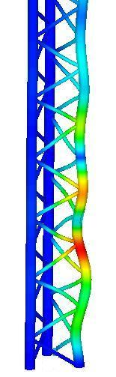

Solidworks: The Six Degrees of Emotion in CAE

A UWTSD School of Applied Computing
Computer Aided Engineering (M2X0938_Q)
For Andrew Harrison
17/02/17

Written by Kenneth Johnston, P148567
Figure 1: Triangular lattice mast under load.

Contents:
Contents: 2
Figures: 3
Introduction: 4
Tools, Utilities and Buttons. 5
Results Analysis. 6
Applicability in the workplace. 7
Conclusion: 10
Bibliography: 11
References: 12

Figures:
Figure 1: Triangular lattice mast under load. 1

Introduction:
My introduction to CAE was at the beginning of this course. My first forays with engineering drawings occurred in school with a pencil and progressed as far as third angle projections. Later, an introduction to AutoCAD proved a wonderful surprise but it seemed lacking somehow. Being introduced to SolidWorks and the suite of powerful tools contained within felt almost like Christmas – an Engineers Christmas.

Tools, Utilities and Buttons.
There are many tools available for the design, modification and testing of models created within the SolidWorks application ^{[1]}. Utilising long since forgotten technical drawing techniques I found the creation and manipulation of parts and assemblies and the speed at which they can be created to be both quick and simple. As with many other applications the ability to export work in different formats ^{[2]} is inherent. However, the import tool for AutoCAD drawings not only converts to SolidWorks format, but it is possible then to create parts using the imported data ^{[3] [4]} – a very useful tool for legacy designs.

Once parts have been designed, they can be combined in assemblies using relationships or mates to ensure each part behaves within the simulation as intended. ^{[5]} These mates not only define relationships between parts but also the freedom of movement they retain and in which degrees of motion.
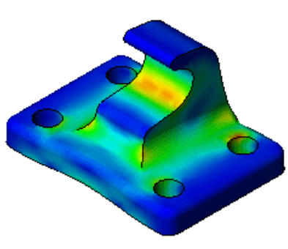
Finite Element Analysis (FEA) can then be conducted on the parts, showing vulnerable areas that that need strengthened or others that could have unnecessary material removed.
Figure 2: FEA results

Results Analysis.
The results available and the level of manipulation possible to each part within a simulation ensure that repeated testing of each component and configuration is possible without the need to expend resources conducting live testing. This way there is a method of rejecting models that consistently fail in favour of those that prove more reliable.

In the automotive industry, such analysis is “driven by the need to simultaneously reduce costs (manufacturing costs, warranty costs, etc.), reduce time-to-market, improve product quality and product reliability” ^{[6]} This however, is only one example.

Motorsport racing analysis might develop lighter, more aerodynamic structural components which are safer that before. “One of the main drivers in design of structures is the ability to predict their performance using computer aided engineering (CAE) methods, in particular finite element analysis (FEA), to decrease development time and cos. ^{[7]} Armoured vehicle systems manufacturers may prefer attempting to increase the safety, where the “use of modern simulation tools in the development of new armoured vehicles permits shorter development times and a reduction in the number of prototypes” ^{[8]}

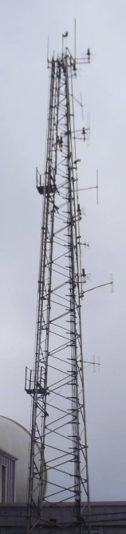
Applicability in the workplace.

I have not yet had the opportunity to exercise my knowledge of Computer Aided Engineering (CAE) tools within the workplace in a constructive manner. However, I have identified an area of interest which may be of benefit – Wind Loading analysis of Masts and Towers.

At the M.o.D. Hebrides Test and Evaluation Range data gathering and transmission and radio communications systems constitute a large proportion of the equipment we rely on to safely conduct live weapons testing and evaluation activities. Many these systems rely on mast or tower mounted antennas.

As we are constantly striving to improve our capabilities, provide customers with as many communications methods they require, or indeed, demand, the masts and towers are slowly becoming crowded by more and more antennas. This creates both structural stresses and Radio Frequency (RF) interference between co-located emitters and receivers.
Figure 3: Radio Tower G025, MoD Hebrides.
Therefore, the additional items and the structure itself must be assessed before each planned change. This requires specific data regarding the length and type of feeder cable being utilised, the type of antenna being fitted and the mechanical fixings, extension poles and mounting brackets. Not only is this a protracted data gathering process, the off-site structural engineer assessments are expensive and in some cases after a wait of several months prove fruitless. An on-site feasibility assessment using an industry standard modelling tool would provide a suitable indication as to the viability of the proposal and if it should be progressed.

Wind Load Analysis.
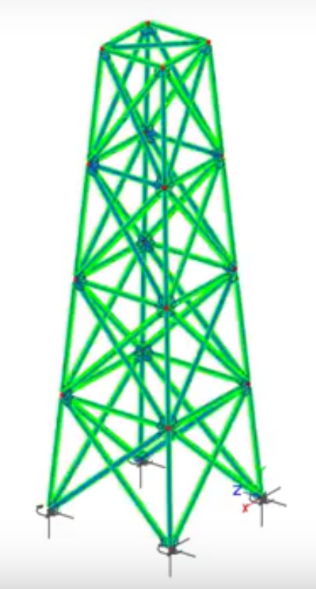
Wind load analysis of a mast or tower installation using CAE tools would require a slightly different approach than those we have been introduced to during our course. A fixed structure would be modelled and then populated with feeders, antennas, access systems and other mechanical fixings. A computational area surrounding the structure would be identified, effectively creating a wind tunnel. Then the process of Fluid Structure Interaction (FSI) - or Flow Control - could take place.
Figure 4: Square Steel Tapering Lattice Tower

The proposed analysis would focus on two areas: the point at which the antenna joins the structure and the effect of the increased load on the structure itself.

Point Loading.
The point loading of the new antenna would focus on the stresses induced in the individual parts of the new installation – bolts, brackets, extension poles – ensuring they are not only adequate and fit for purpose but have no lesser factor of safety that that of the structure itself.

Structural Stress.
Analysing the structural effects would concentrate on any element or part which may breach the factor of safety applicable. Due to the nature of the structure, the factor of safety is fixed and cannot be breached or modified during modelling as it might in the analysis of engine parts where any real-world failure may result in a damaged engine, not a collapsed metal structure.

Conclusion:
While setting up a model in this manner might take a significant time investment, the cost-benefit of self-analysis before approaching a certified engineering assessment would be considerable. Once each model has been created, existing installations could be re-evaluated, have all loads removed and re-distributed and perhaps improve the efficiency of the existing structure without costly modification, or investment in a new structure.

Using such a powerful too as Solidworks, like emotions, boils down to knowing which button to press.

Bibliography:
- “FE Structural and Buckling Analysis of the Telecommunication Masts” Internet: http://en.fea.ru/project/34, CompMechLab, Saint Petersburg, Russia. 2008 [ 01/03/17]
- “Intercad Webinar: Analysis of Wind Loading on a Structure using SOLIDWORKS Simulation”, https://www.youtube.com/watch?v=fuVLPlJS4hY, Intercad, 27/07/15 [01/03/17].
- “Ice + Wind Loading on Members in VisualAnalysis 10” Internet: https://www.youtube.com/watch?v=-BQs1caCKmk, IES Inc., 26/11/12 [01/03/17]

References:
- “CAD Productivity Tools - SolidWorks Utilities” Internet: http://www.solidworks.com/sw/products/3d-cad/solidworks-utilities.htm [01/03/17].
- “Save or convert to PDF”. Internet: https://support.office.com/en-gb/article/Save-or-convert-to-PDF-d85416c5-7d77-4fd6-a216-6f4bf7c7c110. Microsoft Office Online Support. [01/03/17].
- SolidWorks Help “Importing .DFX or .DWG files” Internet: http://help.solidworks.com/2016/English/SolidWorks/slddxf/t_importingdxfdwg.htm, Dassault Systems SolidWorks 2015 application. [01/03/17].
- Cadcast. “Convert a 2D DWG to SolidWorks 3D Model” Internet: https://www.youtube.com/watch?v=FoYqtNgqLNA, , 30/01/14 [01/03/17]
- SolidWorks Assembly Mates Tutorial, Dassault Systems SolidWorks 2015 application, accessed 01/03/17.
- Stefan Reh et. al., “Probabilistic finite element analysis using ANSYS”, Structural Safety, Vol. 28, Jan-April 2006.
- Ari G. Caliscan. “Design & Analysis of Composite Impact Structures for Formula One Using Explicit FEA techniques” presented at the 2002 SAE Motorsports Engineering Conference & Exhibition, Indianapolis, U.S.A, 2002.
- M. Hönhlinger, U. Glauch, G. Steger. “Modelling and Simulation in the Design Process of Armored Vehicles. “Krauss-Maffei Wegmann GmbH & Co.KG, Munich, Germany, Rep. ADP014190, undated.

