Leadership and Management Skills for the Workplace Understanding and Engaging in the Customer Experience Lecturer: Mohammad Rahman
BMSW 5103
Oksana Mrsic
Student ID: 2131895
August 2023

Table of Contents

Executive summary 2
Introduction 3
Company Context 5
Models Review 6
Model Selection and Application 7
IDIC Model 8
Marketing mix 10
Swat Analysis 12
Pestle analysis 14
The cause-related marketing (CRM) strategy employed by Tesco. 14
The significance of Customer Relationship Management (CRM) 15
Recommendations 17
References 20

Organisation’s Quality Systems and Customer Relationship Management at Tesco

Executive summary
Tesco has established itself as a socially responsible corporation, promoting healthy eating practices. This is evident in its initiatives, such as incorporating the glycaemic index on food product labels and providing customers with a Gi Guide lifestyle book. The utilisation of Tesco club cards and home delivery services for CRM operations has been identified as a fundamental element of Tesco's marketing strategy to bolster its corporate reputation, brand equity, customer loyalty, sales, and commitment to corporate social responsibility. Customer Relationship Management (CRM) has advantages over traditional marketing because it establishes emotional and rational customer connections. Consequently, this facilitates the development of a more robust and enduring relationship between the company and its customers as stakeholders.
Tesco is a leading exponent of Customer Relationship Management (CRM) due to its comprehensive understanding of customers' attitudes, perceptions, and emotions about grocery shopping. Tesco has emphasised enhancing customer satisfaction by implementing personalised coupon offerings tailored to specific customer segments. This approach is supported by using demographic data, lifestyle data, information on total expenditures on food items, and customer response to offers and promotions facilitated by the Tesco Clubcard.
Tesco has effectively implemented customer relationship management (CRM) strategies in its home delivery services. The company and its clients have derived benefits from their contributions, as seen by implementing new technological applications, specifically a website designed by Microsoft. This has led to a decrease in delivery time variability and an enhancement of the order-picking process. The organisation employs specialised software to oversee the process of picking, encompassing tasks such as routing and substitution. The implementation of Customer Relationship Management (CRM) has resulted in enhanced accessibility to products that are very likely to be requested by diverse customers. This is facilitated by including individual customers' preferred product histories on the server of each Tesco store. In addition, Tesco stores enhance their value proposition by optimising wholesale orders and ensuring regional pricing differentiation, catering to their customer's preferences and satisfaction.

Introduction
Tesco is a multinational retail corporation headquartered in the United Kingdom, specialising in selling groceries and a wide range of other products. Recently, Tesco has implemented various marketing initiatives to enhance its marketing tactics and fulfil its corporate social responsibility. The organisation has made investments in a variety of proprietary products, conducted extensive market research with its customer base, implemented in-store amenities such as bakeries, meat counters, and baby changing facilities, and introduced a high-quality training programme to equip its employees with the necessary skills to provide optimal customer service (Chaffey & Smith, 2008, p. 55). The emphasis on a customer-centric culture is seen in the favourable outcomes associated with the implementation of the Tesco Club Card and Tesco Direct.
The Tesco Club Card is a loyalty programme offered by Tesco, a multinational grocery and general merchandise retailer.
The utilisation of consumer loyalty schemes has experienced a notable rise in various sectors, including the retail industry. Retailers are progressively embracing the use of customer club cards to foster customer loyalty by providing added value to their clientele. Client loyalty for mutual advantage is a fundamental strategy within relationship marketing, encompassing additional factors such as trust, commitment, satisfaction, and value.
In comparison to its primary industry rivals, Tesco boasts the most triumphant consumer loyalty initiative, commonly referred to as the Tesco Club Card. Tesco has gained a competitive edge due to its ability to foster genuine customer loyalty, whereas its competitors have only managed to cultivate superficial loyalty. Although several organisations have successfully developed loyalty programmes, they have encountered challenges in establishing brand value from the consumer's perspective, resulting in customer discontentment.
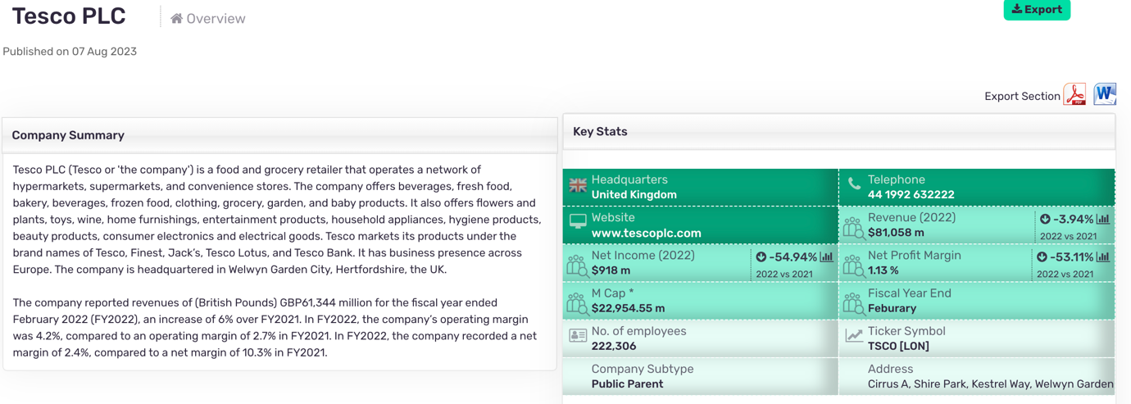
(Uwtsd.ac.uk, 2023).
The Tesco Club card initiative, introduced in 1995, gives tangible advantages to its members, who are rewarded with one point for every £1 they spend at Tesco outlets or on the company's online platform. Additionally, users can earn double points on select promotional deals the supermarket provides. Points are collected and aggregated, resulting in the cardholder receiving vouchers equivalent to the accumulated points four times annually. Subsequently, these coupons can be used for in-store purchases or redeemed for Club card promotions, resulting in a quadrupling of their monetary worth. Furthermore, those with a Club Card are eligible for complimentary admission to several Club Card clubs offered by Tesco, including those focused on healthy food, baby and toddler food, and Christmas. Customers who own a Tesco card may conveniently purchase air miles by redeeming their club card points, thanks to the agreement between Tesco and Virgin Atlantic.
The Tesco Club card system allows users to earn "green points" as a reward for participating in environmental sustainability initiatives, such as bringing their carrier bags while shopping. The initiative forms a component of Tesco's 10-point Community Plan, which aims to enhance environmental sustainability across all Tesco stores and strengthen the company's relationship with the local community. The proposal also encompasses Tesco's initiatives to implement thicker and more biodegradable bags. This initiative enables Tesco customers to engage in environmentally conscious practices, contributing substantially to sustainability.
Tesco derives significant advantages from the implementation of the Tesco Club Card programme. The benefits provided to customers enable Tesco to gain insights into consumer behaviour and categorise them into micro-segments based on their living preferences. The data acquired from this process allows Tesco to effectively tailor their specials and marketing initiatives to individual clients. Tesco can collect comprehensive data about the purchasing patterns of individual customers while concurrently upholding feedback mechanisms that facilitate direct communication between the stores and their customers, thereby fostering customer loyalty. The Tesco Club Card system has proven to be a valuable source of information, continually updated and revised. It has dramatically enhanced the grocery chain's understanding of its customer base and improved sales and consumer loyalty. Furthermore, Tesco can reap operational advantages such as decreased product assortment, display, and inventory levels.

Company Context
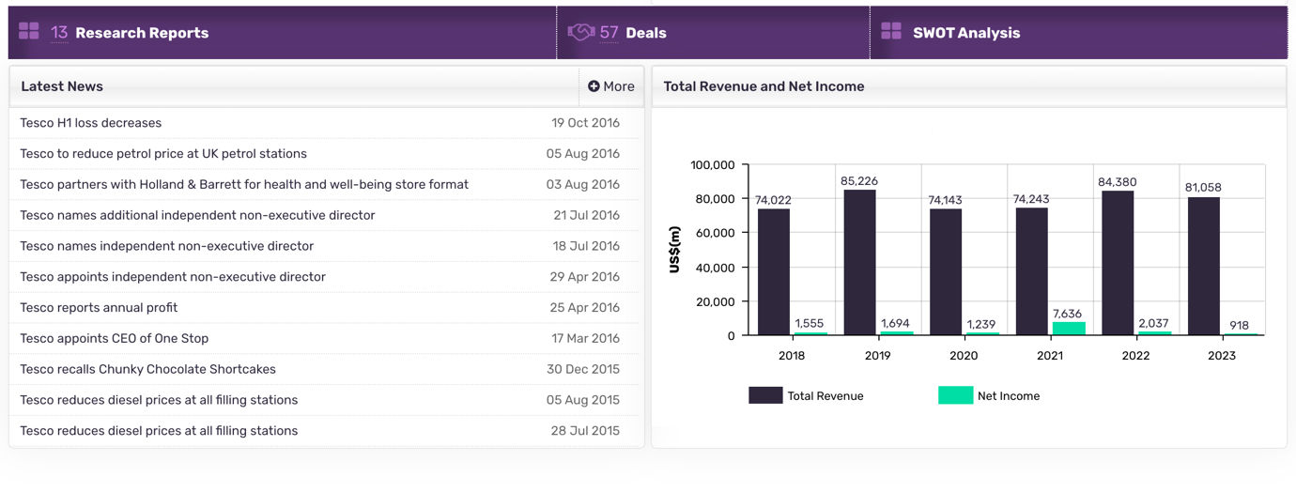
(Uwtsd.ac.uk, 2023).
The company has significantly transformed individual club card data utilisation in Tesco's online marketing strategy. Significant modifications have been implemented on Tesco.com, the corporation's official website. The transition from physical club cards to digital platforms has facilitated the integration of individual consumer behaviour data with other sources of information, including mobile phone data, social networking data, and payment methods. This integration enables the provision of highly tailored offers to customers. Consequently, value-oriented promotions are targeted at clients who prioritise price, whereas tailored messages primarily focus on high-end club card members, emphasising the main offerings of Honest products.
The Home Delivery Service offered by Tesco.com, formerly recognised as Tesco Direct, has garnered a substantial and devoted consumer following due to the company's exceptional home grocery delivery service. The original intention of this initiative was to cater to individuals with limited availability who sought to purchase Tesco products online. This action was undertaken with the recognition that a specific segment of customers expressed a preference for online purchases. Accordingly, Tesco implemented a user-friendly operating system to develop a versatile home delivery system that was meticulously customised to satisfy the demands and anticipations of the intended consumer base. The online platform Tesco.com has experienced significant growth and has established itself as a robust business model. This success has been further enhanced by implementing Tesco's Club Card loyalty programme. Through this programme, the prominent grocery chain has effectively identified, categorised, and motivated its most promising consumers.
The primary objective of the home delivery service is to replicate, to the greatest extent feasible, the shopping encounter one would typically have at a nearby Tesco store. The home delivery approach results from Tesco's strategic efforts to gain a deeper understanding of its customers, surpassing that of competing supermarkets and other online merchants. Tesco's dedication to actively listening to customers and effectively addressing their needs has improved its reputation, according to Chaffey and Smith (2008, p. 98). Tesco possesses a fleet of light commercial vehicles numbering at least 3,200, effectively enabling the execution of around 500,000 weekly deliveries. The home delivery vans of the supermarket chain are operational throughout the week, spanning a maximum of 16 hours per day. Improving the supermarket chain's customer service standards is a significant result of this operational arrangement. Tesco drivers employ a robust satellite navigational system to adhere to optimal delivery routes, ensuring punctuality in meeting all timetables. The presence of a proficient team of expert pickers facilitates the company's ability to fulfil online orders effectively.

Models Review
The viability of a business is contingent upon its capacity to establish and cultivate relationships with many entities, including employers, employees, investors, customers, suppliers, and other stakeholders. Additionally, the level of success achieved is influenced by the concerted endeavours undertaken in this regard. Tesco establishes marketing relationships with its stakeholders by actively engaging in listening practices and adopting a collaborative approach with suppliers, employees, and partners, driven by its commitment to fostering transparent and mutually beneficial partnerships. Similarly, Tesco actively engages with and collaborates with the communities it operates to comprehend and address local concerns and requirements. As a publicly traded limited company, Tesco exhibits a varied ownership structure, thereby granting the investment community heightened influence over the retailer's strategic decisions. Consequently, this structure also allows the supermarket greater flexibility to prioritise sustainability initiatives, even when they may conflict with short-term financial considerations.
Given the dynamic nature of the marketplace where Tesco works, characterised by intense competition and frequent shifts in consumer preferences, purchasing patterns, and store formats, the company must consistently develop proactive strategies to navigate these fluctuations effectively. The company's motto, "Every Little Help," encapsulates its approach to collaborating with all its stakeholders.
Tesco has had a track record of successfully attracting and retaining customers from diverse socio-economic backgrounds, expanding its customer base considerably. Tesco endeavours to achieve its aims and objectives of generating value for its consumers and cultivating their enduring loyalty by using direct mail and email marketing strategies to promote product offers and specials. The messages are customised for each client based on their purchase history, obtained from the Tesco Club card's customer database built using data collected through the Tesco Club card. Tesco cultivates robust customer relationships through its commitment to comprehending client preferences and proactively addressing their demands. Tesco consumers are regularly notified about the most recent product offerings in physical stores and on the official Tesco.com website. The grocery chain additionally provides promotions and reduced prices on its merchandise to align with the preferences and demands of its clientele.
Tesco uses relationship marketing strategies on its website to promote exclusive discounts to customers around festive occasions, such as Easter. The website offers a variety of products and presents for clients to select and purchase. Customers can pre-order their delivery, allowing them to reserve the desired products they wish to buy online and have them conveniently delivered to their homes.

Model Selection and Application
Models that can be applied to Tesco's CRM focus on building and maintaining long-term customer relationships by understanding their needs, preferences, and behaviours. Here's why a model is relevant for Tesco. The Relationship Marketing Model puts the customer at the centre of all activities. As a customer-oriented company, Tesco can benefit from this approach by prioritising customer satisfaction and loyalty.
Long-term relationship building: Tesco aims to establish long-lasting relationships with its customers rather than focusing solely on one-time transactions. By implementing the model, they can focus on nurturing these relationships through personalised experiences and targeted marketing efforts.
Customer segmentation: The Relationship Marketing Model emphasises segmenting customers based on their needs and preferences. This aligns well with Tesco's diverse customer base, as they can tailor their offerings and communication strategies to specific segments.
Data-driven insights: This model relies heavily on collecting and analysing customer data to gain insights into their behaviour patterns, purchase history, preferences, etc. Tesco already has access to vast amounts of data through its Clubcard loyalty programme, which can be leveraged to personalise marketing campaigns and improve the overall customer experience.

Two-way communication: The Relationship Marketing Model encourages open communication between the company and its customers. Tesco can strengthen its relationship with customers by actively listening to feedback, addressing concerns promptly, and engaging in dialogue through various channels (such as social media or surveys).
Customer lifetime value (CLV): This model recognises that each customer has a lifetime value beyond individual transactions; it focuses on maximising CLV by fostering loyalty through personalised offers or rewards programmes like Clubcard point accumulation at Tesco.
Cross-selling opportunities: By better understanding individual customers' needs through data analysis within this CRM model framework, Tesco can identify cross-selling opportunities where additional products or services may be relevant for specific customers, thereby increasing revenue.
Overall, the Relationship Marketing Model is relevant for Tesco because it aligns with its customer-centric approach, emphasises long-term relationship building utilises data-driven insights and promotes effective communication. By implementing this model effectively, Tesco can address its CRM problems by enhancing customer satisfaction and loyalty while driving business growth (Stern, 2006).

IDIC Model
(Identify-Differentiate-Interact-Customise) model for Tesco's CRM problem, covering each step with relevant evidence:

Identify: Tesco can utilise its customer data from the Clubcard loyalty programme to better identify and understand its customers. This data includes purchase history, demographics, and preferences. By analysing this information, Tesco can gain insights into customer behaviour patterns and segment them accordingly.
Evidence: Sales reports and customer data collected through the Clubcard programme provide evidence of customer identification. These sources offer valuable information on purchasing habits, product preferences, and demographic details.

Differentiate: Once customers are identified, Tesco can differentiate them based on various factors such as shopping frequency, spending levels, or specific product preferences. This allows for targeted marketing efforts tailored to each segment's unique needs.

Evidence: Sales reports can help identify high-value customers or frequent shoppers contributing significantly to revenue generation. Additionally, Tesco’s market research efforts may provide insights into specific product preferences among different segments.

Interact: Tesco should actively engage with its customers through various communication channels like social media platforms, email campaigns, and personalised offers. This interaction helps build relationships by promptly addressing queries or concerns while gathering feedback to improve the customer experience.
Evidence: Customer feedback obtained through surveys, social media interactions, and online reviews provides evidence of successful interaction strategies. Customer satisfaction scores or positive reviews indicate effective engagement efforts by Tesco.

Customise: Utilising the data collected from Clubcard transactions, Tesco can customise offerings based on individual customer preferences. This could include sending personalised promotions via email or offering tailored discounts at checkout based on previous purchases. Customisation enhances the overall shopping experience for customers.
Evidence: Increased sales resulting from customised offerings, such as targeted promotions or personalised recommendations, would be evident in sales reports. Customer feedback indicating satisfaction with personalised experiences also indicates successful customisation efforts.

By following the IDIC model and utilising relevant evidence from sales reports, customer data, and feedback, Tesco can effectively address its CRM problem by enhancing customer satisfaction and loyalty and driving business growth.

Marketing mix
The conventional 4Ps marketing mix has recently expanded to encompass an extended services marketing mix, incorporating three new elements known as the 3Ps. These components include physical evidence about in-store atmospheres, people, and procedures.
The physical evidence component pertains to the discernible features or in-store ambience that customers can assess. The significance of the physical arrangement is paramount in contemporary times, given the growing interaction between customers and retail products or services and their heightened expectations for a superior level of presentation (fliphtml5.com, n.d.) Although Tesco's investment in store design is relatively modest compared to its competitors, its stores are renowned for their inviting atmosphere and well-organised arrangement of merchandise. Tesco endeavours to provide customers who enter their stores with an outstanding personalised experience by using appropriate lighting, adequate signage, and well-groomed workers with extensive knowledge regarding the merchandise available for purchase within the establishment.
So here is a 4Ps:

- Product: Tesco offers a wide range of products, including groceries, household items, clothing, electronics, and more. They have private label brands (such as Tesco Finest) alongside popular national brands. They also provide additional services like banking and insurance.

- Price: Tesco follows a competitive pricing strategy by offering affordable prices to attract customers. They frequently run promotions and discounts on various products to provide value for money.

- Place: Tesco has an extensive network of physical stores across the UK and other countries where customers can conveniently shop for their desired products. Additionally, they offer online shopping through their website and mobile app, with home delivery or click-and-collect options.

- Promotion: Tesco engages in various promotional activities to communicate with its customers effectively. This includes advertising campaigns through TV commercials, print media ads, and online advertisements, as well as loyalty programmes like Clubcard that offer personalised discounts and rewards based on customer spending.

Tesco also focuses on community engagement by supporting local initiatives and charities through its "Community Champions" programme.
Overall, Tesco's marketing mix is designed to cater to the diverse needs of its customers by providing a wide range of products at competitive prices through multiple channels while promoting customer loyalty through targeted promotions and community involvement.

Swat Analysis
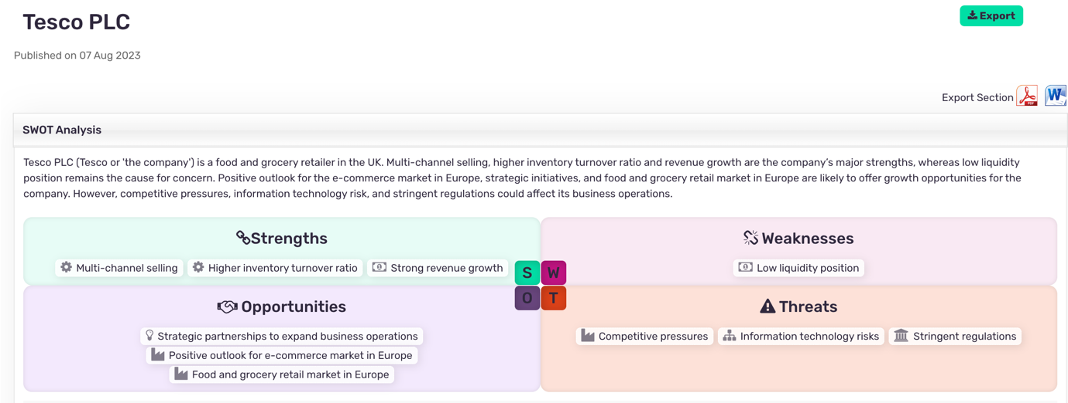
(Uwtsd.ac.uk, 2023).

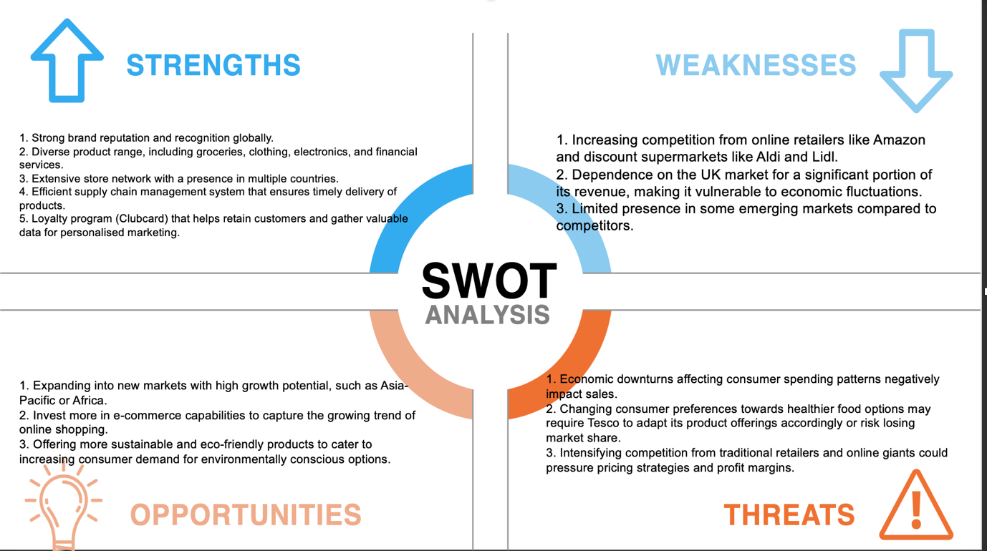

Pestle analysis
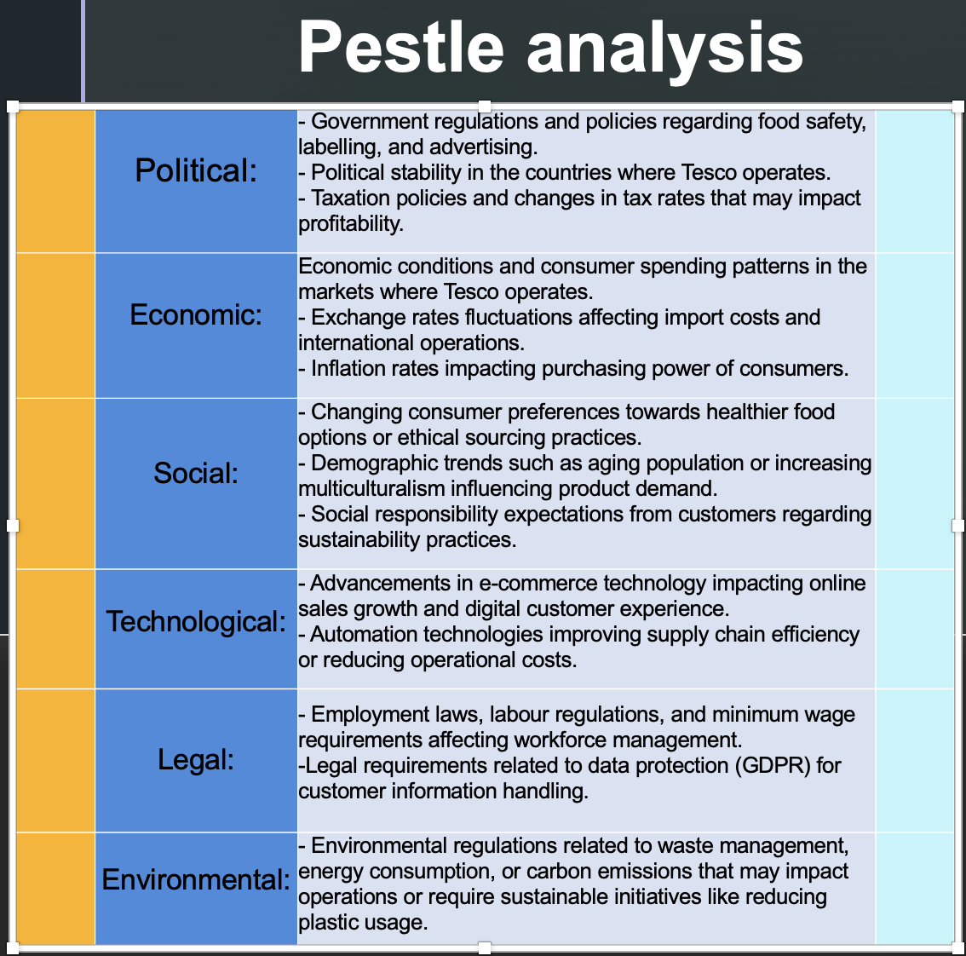

The cause-related marketing (CRM) strategy employed by Tesco.

Terms like "corporate reputation" and "corporate citizenship" have become more prevalent in marketing discourse as firms acknowledge the importance of being viewed as responsible entities by customers and society. Cause-related marketing is a collaborative effort between a company and a charitable programme that aims to promote a product, service, or brand image for the mutual advantage of both parties. Tesco stands at the forefront of a distinguished cohort of firms that have successfully included significant cause-related marketing initiatives into their overall marketing strategies. Tesco's recognition of the importance of customer relationship management (CRM) has influenced its decision-making, resulting in notable advantages for the firm and a favourable influence on the broader community. Customer Relationship Management (CRM) programmes have become indispensable in response to evolving circumstances.
The implementation of CRM activities has had a positive impact on Tesco's communication and marketing capabilities. The grocery company has allocated significant advertising funds to endorse many community initiatives, such as "Computers for Schools" and "Sports for Schools and Clubs".Tesco customers who make purchases exceeding £10 at Tesco stores or on Tesco's website are provided with vouchers that can be allocated to educational institutions and community organisations.
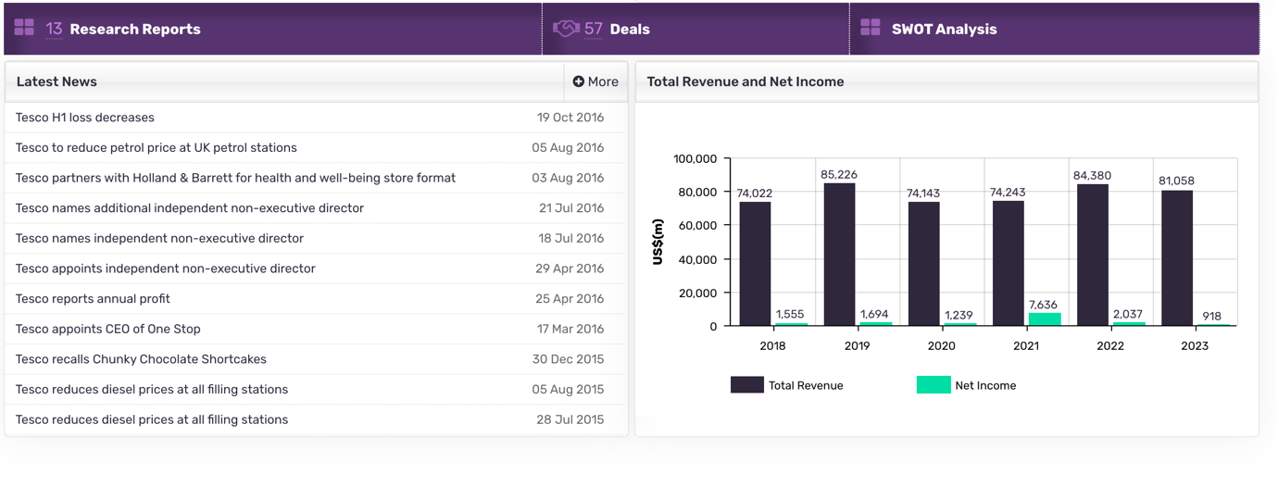
(Uwtsd.ac.uk, 2023).

The significance of Customer Relationship Management (CRM)

In contemporary times, Customer Relationship Management (CRM) has emerged as a potent marketing instrument, resulting in substantial growth in sales and the optimisation of profits within the retail industry. This phenomenon is particularly evident considering the growing competitiveness of the contemporary marketplace, where customers are becoming increasingly assertive. Consequently, businesses must prioritise customer-centric strategies to maintain existing customers and attract new ones. Customer Relationship Management (CRM) encompasses various techniques and tools that Human Resource Management (HRM) implements to enhance interactions with customers, suppliers, or other stakeholders. These interactions occur through multiple channels, including salespersons, distributors, call centres, physical stores, online platforms, and more. The primary objectives of CRM are to acquire, retain, and cross-sell customers.
Customer Relationship Management (CRM) is a strategic approach to cultivating and enhancing an organisation's interactions with customers by utilising real-time transactional processes facilitated by information technology. Customer Relationship Management (CRM) incorporates several technologies, including databases, customised engines, targeted marketing, response function analysis, online preference surveys, and software developed to monitor and assess customer activity. This is grounded in established marketing ideas, with a strong focus on identifying and describing customers' perceived value and making efforts to provide it effectively. Customer Relationship Management (CRM) extends beyond marketing as it encompasses a variety of business practices aimed at fostering deeper connections between the organisation and its consumers. The primary goal is to facilitate mutual understanding and knowledge exchange, with the ultimate objective of enhancing the value of both parties to the Human Resource Management (HRM) function. Retailers heavily depend on adopting customer relationship management (CRM) policies, procedures, and frameworks to secure their commercial achievements (Buttle, 2008).
Tesco implemented customer relationship management (CRM) in the early 1990s by collaborating with a marketing services firm, HRM Dunnhumby. This partnership introduced a pilot loyalty card programme, initially tested in six Tesco stores in 1994. In the context of Tesco Clubcard, customer relationship management (CRM) can be described as a set of strategic measures to enhance the supermarket chain's performance across all customer touchpoints. These activities are intended to increase customer satisfaction while driving financial gains for the company. The primary impetus for establishing the Tesco Clubcard was to acquire a comprehensive understanding of the purchasing behaviours of Tesco's clientele while concurrently offering them a kind of reciprocation. The implementation of this initiative involved the introduction of a novel point-of-sale (POS) technology at Tesco, accompanied by the establishment a specialised call centre designed to address customer inquiries. Tesco has employed customer relationship management (CRM) strategies to develop, sustain, and enhance customer connections. Tesco's customer relationship management (CRM) initiatives include implementing loyalty cards, providing home delivery services, establishing a company support desk, catering to mobile customers, and utilising the Point of Sale (POS) till system.
The extent to which CRM successfully generates value and advantages for all stakeholders is contingent upon the actions and interactions of product or service suppliers and consumers. Nevertheless, considering swift technological advancements, prominent corporations like Tesco have effectively employed Client Relationship Management (CRM) as a strategic methodology to enhance shareholder value by establishing robust connections with critical client segments. This assertion holds particular significance because the successful implementation and efficacy of Customer Relationship Management (CRM) heavily rely on the proficient utilisation of information technologies in conjunction with relationship marketing strategies to achieve tangible objectives over an extended period.
Customer relationship management (CRM) strategies possess significant potential for generating value for the business organisation and its stakeholders due to their undivided focus on the consumer ‌ (Buttle, 2008).
Tesco's utilisation of Customer Relationship Management (CRM) has facilitated a closer connection with its current and prospective customers, fostering mutual comprehension and providing enhanced value to both parties involved. Sent a magazine from the supermarket chain every quarter, which includes information on the latest and unique offers of Tesco's products and services. Additionally, over 8 million Tesco shoppers receive this magazine.

Recommendations
Based on the analysis of various models in CRM, here are some practical recommendations that can be applied to resolve the company's CRM:
- Implement a Customer Relationship Management (CRM) system: Invest in robust CRM software that effectively manages customer data, interactions, and feedback.
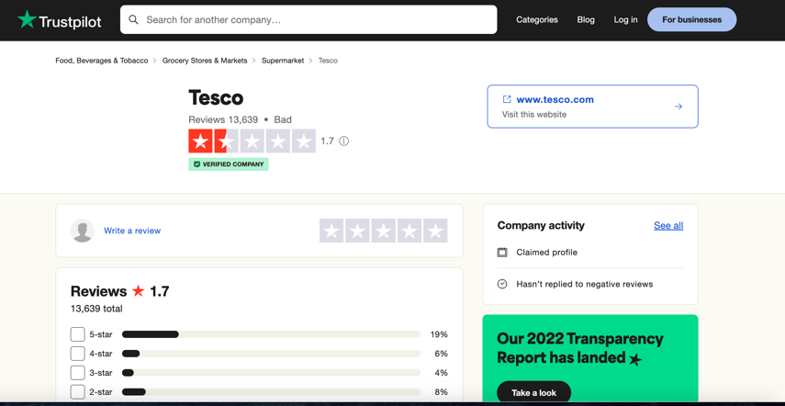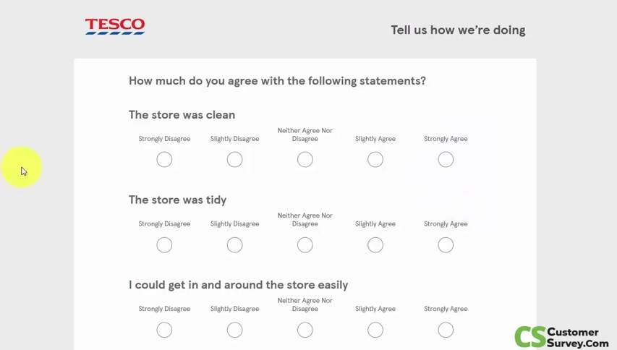
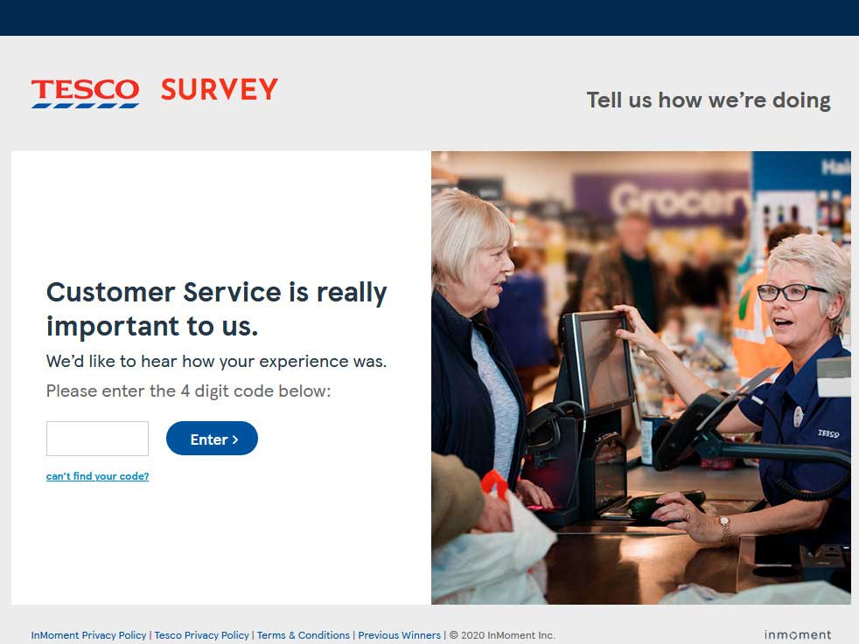
This will enable the company to have a centralised customer information database, track customer interactions across different touchpoints, and provide personalised experiences.
- Develop a comprehensive customer segmentation strategy: Utilise market research techniques to segment customers based on their needs, preferences, and behaviours. This will help tailor marketing efforts and communication strategies to specific customer segments, resulting in more targeted and relevant messaging.
- Enhance communication channels: Offer multiple channels for customers to reach out and provide feedback, such as phone calls, emails, live chat support, social media platforms, etc. Ensure prompt responses to queries or complaints through these channels to demonstrate excellent customer service.

- Implement loyalty programmes: Design loyalty programmes that incentivise repeat purchases and reward loyal customers. This can include offering exclusive discounts or rewards based on purchase history or engagement with the brand.

- Personalise marketing campaigns: Leverage data from the CRM system to create personalised marketing campaigns tailored to individual customers' preferences and behaviours. Use automation tools within the CRM system for targeted email marketing or personalised product recommendations.

- Continuously gather feedback: Regularly collect customer feedback through surveys or questionnaires at various touchpoints along their journey with the company. Analyse this feedback systematically using CRM analytics tools to identify areas for improvement in products or services.

- Train employees on practical customer service skills. Provide training programmes for employees that focus on building strong interpersonal skills and empathy towards customers' needs. Empower employees with knowledge about products and services to promptly provide accurate information.
By implementing these recommendations, the company can enhance its CRM practises, build stronger customer relationships, improve customer satisfaction, and ultimately drive business growth (Grazdanes, 2013).
Conclusion
In conclusion, by implementing the recommendations derived from the application analysis, the company can significantly improve its CRM practices and enhance customer relationships. Investing in a robust CRM system will centralise customer data and enable personalised experiences. Developing a comprehensive customer segmentation strategy will allow for targeted marketing efforts. Enhancing communication channels and promptly responding to queries will demonstrate excellent customer service. Implementing loyalty programmes and personalising marketing campaigns will incentivise repeat purchases and engage customers on a deeper level. Continuously gathering feedback, training employees on effective customer service skills, implementing proactive problem-solving measures, fostering a customer-centric culture, and regularly reviewing CRM strategies are all essential to ensuring ongoing improvement in CRM practices. By following these recommendations, the company can resolve its CRM challenges effectively and drive business growth through enhanced customer satisfaction and loyalty.

References
‌Academized.com. (2016). Customer relationship management (CRM) in Tesco Research by Academized.com. [online] Available at: https://academized.com/samples/customer-relationship-management-in-tesco [Accessed 9 Aug. 2023].
Amir Khanlari (2015). Strategic customer relationship management in the age of social media. Hershey, Pa.: Business Science Reference.
‌Buttle, F. (2008). Customer Relationship Management. Routledge. doi:https://doi.org/10.4324/9780080949611
Buttle, F. (2011). Customer Relationship Management, Second Edition. [online] Available at: https://knowledgestreams.files.wordpress.com/2013/07/francis_buttle-customer_relationship_management_second_edition-butterworth-heinemann2008_2.pdf [Accessed 9 Aug. 2023].
Evert Gummesson (2008). Total relationship marketing. Oxford: Butterworth-Heinemann.
‌fliphtml5.com (n.d.).

Greenberg, P. (2009). CRM at the Speed of Light. 4th ed. McGraw-Hill.
Hans Ruediger Kaufmann and Fateh, M. (2017). Socio-economic perspectives on consumer engagement and buying behavior. Hershey: Business Science Reference.
Irina Grazdane A Customer Relationship Management Approach for Optical Retail Business. (2013). Available at: https://core.ac.uk/download/pdf/38096618.pdf [Accessed 9 Aug. 2023].

Marketing Strategy Text and Cases, 8th Edition _O.C. Ferrell Pages 1-50 - Flip PDF Download | FlipHTML5. [online] fliphtml5.com. Available at: https://fliphtml5.com/xzfda/vmfa/basic [Accessed 9 Aug. 2023].
Samaniya, D. (2022). Marketing strategy of Tesco: Every little helps! [online] MarqueEx. Available at: https://marqueex.com/marketing-strategy-of-tesco-every-little-helps/ [Accessed 9 Aug. 2023].

Stern, P. (2006). Marketing management and strategy (4a. ed.). Harlow: Pearson Educación.
Uwtsd.ac.uk. (2023). Available at: https://advantage-marketline-com.ezproxy.uwtsd.ac.uk/Company/Summary/tesco-plc_ml_5006739_2717385 [Accessed 9 Aug. 2023].

