Writing for Heritage

Contents Page
- "Tales of Sion "
  - Description: A short interactive walking play set in the medieval city of Sion in 1307. The piece immerses participants in the town's historical and cultural legacy through a guided tour delivered by a charismatic medieval Mayor.
  - Themes: History, immersion, community, cultural heritage.
  - Format: Interactive play / walking tour.
- " The House That We Left Behind"
  - Description: A reflective personal narrative about a family home in São Roque, Brazil, built by the narrator's grandfather. The piece explores themes of memory, family, and the passage of time as the house transitions from a family refuge to a distant memory. It also reflects on different locations, but always about habitations, or the idea of home.
  - Themes: Family, legacy, memory, change, belonging.
  - Format: Memoir / personal essay.
- "Letters Across Exile"
  - Description: An epistolary piece capturing the emotional landscape of expatriation through a letter from a daughter to her mother. It delves into intergenerational stories of migration, homesickness, and cultural identity, tying emotional experiences to physical spaces.
  - Themes: Migration, identity, family, psychogeography, nostalgia.
  - Format: Epistolary / reflective essay.

Part 1:
Tales of Sion
This immersive walking tour weaves theatrical storytelling with historical exploration, taking visitors to the year 1307 in the medieval city of Sion. Led by reenactors portraying the City Mayor, participants will walk through iconic landmarks like the Château de Valère and Château de Tourbillon, experiencing the city’s history, cultural heritage, and medieval society through life-like storytelling and interactive nature. The tour combines education and entertainment, offering a unique way to showcase Sion’s architectural and natural treasures while promoting tourism.
Future expansions could include additional characters, live re-enactments, or themed tastings, making it a versatile and memorable experience for diverse audiences.
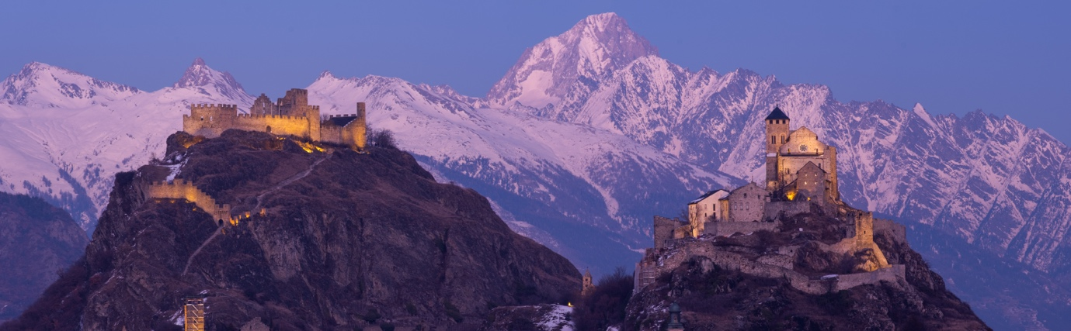
Tourbillon (on the left), Notre-Dame de Valère (on the right).
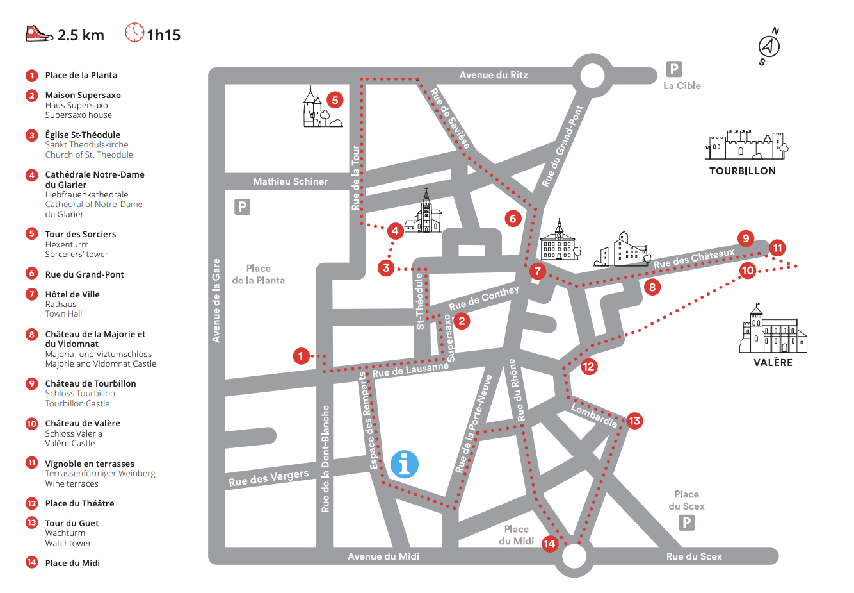
Available Walking Tour Offered by Sion’s Office du Tourism

The Reenacted tour will follow the same route with perhaps some alterations according to needs and demands. This text is a sample of what could be acted on a few locations and does not exactly follow the plan provided by the tourism board.

(The guide steps into the scene, dressed in traditional medieval costume, greeting the group with enthusiasm.)
Guide "Hear ye, hear ye! Welcome, travellers, to the fair and noble city of Sion! The year is 1307, and you stand in the heart of our most esteemed and ancient town. My name is Guillaume Favre , Mayor and humble servant of the good people of Sion. Come, let me take you through our winding streets and towering castles, to show you the wonders and tales of our time!"
(Gestures to the landscape)
Guide:
"You see before you the grand hills of Valère and Tourbillon. On one side, the fortified Château de Valère stands proud, where our clergy dwell, protecting our most sacred treasures, and atop the other is the mighty Château de Tourbillon, the seat of our noble bishops, who have ruled these lands with wisdom and strength for generations."
(Guide starts walking, motioning for the group to follow)
Guide
"Our city of Sion is old, older than memory itself, for it was born long before I or my fathers walked this earth. But in these times, it flourishes under the hand of the Holy Roman Empire. We are known across the valleys for our fine wines, strong fortifications, and good people. But, beware! Not all is peaceful, as even now, the winds whisper of rivalries between noble families and the Church. Fear not, as long as you stay within our walls, you are safe under our watchful eye."
(Guide pauses in front of a grand building)

Guide:
"Here we stand before our very own Cathedral of Notre-Dame du Glarier. Look upon its walls, freshly built to last the ages. It is here that our most pious citizens come to worship and seek solace. Inside, the chants of monks echo through the stone halls, and the relics of saints are held with great reverence."
(Leans in as if telling a secret)
Guide:
"Ah, but not all the wonders of Sion are for the eyes of the Church. Just down the road, if you look closely, you might find a tavern where merchants gather to exchange goods and tales from distant lands. Spices from the East, wool from the North, and wines from our very own vineyards fill their carts."
(The guide takes the group to a higher vantage point a short walk up to the Place du Chateau, where some vineyards lay.)
Guide:
"Now, cast your eyes upon the Rhône River below. That river has seen armies march along its banks, it has carried trade goods to distant lands, and it has fed our fields for as long as Sion has stood. In times of war, the towers you see up high serve as beacons, lighting the way for messengers bearing news from afar."
(Dramatically points towards Tourbillon Castle)
Guide:
"Up there, in the Château de Tourbillon, our bishops hold court. Do you know they say that the walls up there are so thick, no army could ever hope to breach them? But, alas, it is not the sword that rules these lands, but faith and wisdom. Our bishop protects us not only from the dangers of men but from the darkness that lurks beyond the mortal world."
(Guide’s tone shifts to a lighter, more playful one)
Guide:
"But enough of politics and battles! I see you are a curious lot! Perhaps you’d like to taste a bit of our fine Sion wine after our journey? It is said that the sun shines differently on our vineyards, gifting us the richest grapes in all of Christendom."
(Pauses and smiles warmly)
Guide:
"Before I send you off, let me remind you—should the bells toll from atop Tourbillon tonight, take heed, for it could mean danger is near, or that it’s time to gather for a feast! Either way, I trust you will find your way back to the safety of the city walls before nightfall."
(He gives a deep bow)
Guide:
"May the saints protect you on your travels, and may you carry the stories of Sion with you wherever you go. Farewell, dear friends, and enjoy your time within these ancient walls!"

Part 2:
The House That We Left Behind
The House That We Left Behind is a poignant narrative exploring the legacy of a family home that served as a refuge and cornerstone for generations. Set in São Roque, Brazil, this deeply personal story intertwines themes of migration, memory, and the inevitable passage of time. Through vivid storytelling, the piece reflects on the house’s evolution—from a symbol of hope and family unity built by European immigrants to a space slowly succumbing to the forces of neglect, loss, and generational change.
This narrative aims to evoke a profound sense of nostalgia and explore the emotional weight carried by spaces imbued with family history. It captures the universal experience of watching the places that once defined our lives shift into something unrecognizable as time, distance, and changing priorities take their toll. By weaving together vivid memories, intergenerational relationships, and the cultural contrasts of a diasporic family, the piece offers a moving reflection on what it means to belong to a place that no longer feels like home.
The House That We Left Behind could expand into a memoir, blending family history with cultural and historical contexts, such as post-war migration and life in Brazil during its mid-20th-century boom. The story also lends itself to visual adaptations, such as a short film or a documentary, capturing the house’s transformation and its layered emotional resonance. With its rich themes of memory, loss, and identity, the narrative has the potential to resonate deeply with readers or viewers from diverse backgrounds.

My grandmother tended to that garden millions of times until the day her hands were too wrinkled to work her majestic corner of tropical heaven. I remember my first conscious steps around the different paths of their home. My mother demanded that Louis and I stop chasing around the chickens, which made him hysterically cry with laughter. We both have a plethora of memories of the house that never belonged to us, from times we had not even been possibilities, of our mother’s childhood and well before that, when our grandfather put down the foundations of this place we call home. I have never lived there. I never will. The house held memories. For my grandfather, it might have been a place to rest and forget. Like thousands of Europeans after the war, he’d arrived in Brazil awaiting an American visa. He loved to say that he stayed for my grandmother’s eyes. He could also have been drawn by the promise of São Paulo’s booming economy, its factories hungry for skilled men. It was 1954, the city’s 400th anniversary, and São Paulo was celebrating, throwing its own birthday party as if to prove it was ready to be one of the world’s great cities. Skyscrapers like Edifício Itália and the new MASP museum were breaking ground; concrete and glass were replacing gardens and historic homes. For him, the city was progress. For her, the garden was her escape from the busy and polluted air.
The path that leads away from the house into the wild garden doesn’t go anywhere anymore. It used to wind down past the chickens’ coop, ending at the small paddock where Bolhas the donkey would stand but now it’s overgrown, lost in the tangle of plants. Today, it’s just a trail worn by a colony of cats my aunt’s been collecting over the years—no one seems to remember where they all came from. This place has never been anyone’s primary home; it’s been more of a family refuge, a sanctuary for whoever needed an escape. In the past, it was the children escaping the heavy, metallic haze of São Paulo. My grandparents’ garden was the remedy, a quiet heaven where the air was clean, and the trees thickened the silence.
I notice that the gardener Aunt Eveline hired, lacks the sensitivity my grandmother had, and the hedge chosen to replace the one that went up in flames the previous week is going to be the dullest. What a waste. I heard my mother and her sister argue, they cannot get along since their father died and their mother can’t travel here anymore. I don’t think my aunt takes care of the house well and she has left the premises to its own devices.
Two of the dogs that lived here last time we visited have died. Four years is a long time. Some things, though, never change—the pool heater is still broken, and I can almost hear Pépé laughing, saying the cold water reminded him of the northern sea of his childhood. Odd, since my parents always said he was born in Gaillac, in the South of France, far from any icy coast. We never questioned it. Now, in the quiet left behind, he’s everywhere, lingering in each corner of this place he turned into his sanctuary.
Had we lived closer, maybe these walls would hold more memories of us and feel less like a familiar inn, more like a true home. This has always been a home away from home, but as the family disperses and fewer people visit, my brother and I, raised in a different culture, have fewer reasons to return. Each day away makes this place feel stranger. I stand here now, looking at the single-story yellow-brick house my grandfather built, in the garden my grandmother left to overgrow. How long until the house meets the same fate?

Ten Years Later
Aunt Eveline is going to sell the house, and some strangers will walk in our memories. Mémé’s apartment is empty now, Louis spent the entire the afternoon hoovering the accumulated dust of 60 years of furniture perfectly place who was not even once moved. To what end? They were going to live forever. She is dead now. We don’t know what of, if it was old age or her poor broken heart, or if Covid got her in the end, like the millions of elderly in Brazilian nursing homes when everyone there was still in denial. We all dropped like flies on the other side of the Atlantic and out here they though they wouldn’t suffer it. Bernard and Carolina were with us when the news broke out and they had to quickly return home. She was taken ill just before they could make it back to where they thought it was safe and lost something precious in the process. Two years later, among the cleaning and the sorting, we also attend a little bittersweet to the baptism of a child so long awaited, but that will never meet the one supposed to come before him. He is a sweet child, smiles a lot too. He will never meet our grandma. I never felt close to my cousins. They are a lot older than me, and we had different childhood across oceans. But amidst his own family conflicts he turned to his aunt, my mother, for counsel. That is funny. I wouldn’t do it myself, but I can understand. He was their oldest grandchild, he lived across the city, he was there for all of it. It was his grandparents more than they were ours. The apartment was his memories more than mine’s, even if that feels unfair. I’ll walk across the road in a little while to get us some of those sweetcorn popsicles Mama loves. Maybe it will comfort her.
Today, we have arrived in Sao Roque for what I feel is going to be the last time. I ought to make the most out of it, but everyone is in some sort of miserable slump. I went to the garden straight out of the car, and it reminded me of when we were little, and we’d fly out to hug whoever had arrived first. Eveline is the only one who comes now. My cousins have their families and are far too busy. I thought Bernard would have wanted to bring his new little one here and experience it like we did. Perhaps his memories of here are not as happy. It is like the spirit of this place died alongside Mémé, or even before, when Pépé went and took her heartbroken heart with him.

Part 3:
Letters Across Exile

Letters Across Exile is an autobiographical epistolary piece exploring themes of expatriation, identity, and intergenerational longing. Framed as a heartfelt letter from a daughter to her mother, it reflects on the shared but distinct experiences of migration and homesickness. Through vivid memories of food, landscapes, and family traditions, the piece captures the emotional weight of leaving one home to build another and the bittersweet pull of cultural heritage across time and distance.
The piece aims to convey the intimate and universal struggles of displacement and belonging, using psychogeography to connect physical spaces with emotional landscapes. By juxtaposing the mother’s migration story with the narrator’s own, it highlights the complex ways familial ties and cultural identities are preserved and transformed across generations.
This work could expand into a collection of letters or essays, blending personal reflections with cultural and historical analysis of migration. Its intimate tone and universal themes make it well-suited for memoir or narrative non-fiction formats, resonating with readers who have experienced the challenges and beauty of living between worlds.

My dearest mother,
I hope that you are doing well. It has been quite a while since I last wrote to you. I do not know yet if I will send you this one, as we seem far better at sharing gossips and recipes rather than our feelings and regrets. It is okay, I know how hard it is for you. Please forgive me. I am finally getting used to life among these parts and you know it hasn’t been easy. Do you remember when as I child I would ask you if you missed Brazil and you’d say you loved your new home? My child’s mind couldn’t understand loving more than one place at a time, so it would mean that Switzerland was your home, and you had forgotten about yours before. Then I grew up and it was more complicated than that. Everything about you was an act of love for where you had once belonged.
It was the carrot cakes for our birthday party, the one your only other Brazilian friend taught you when you were still living in Lucerne and remind both of you of the parties you went to. It wasn’t a typical birthday cake, but it became ours throughout the years. My first birthday here alone I tried to make it, and it didn’t work out exactly like yours and I wept. Today I am not sure it was about the cake. Louis cried too that year; he later told me on the phone. It was our first birthday apart. Have I ever told you that?
And the other foods: Pão de Queijo, Feijoada, Pudim de Leite, Graviola smoothies. Each meal was a story, feeding me with love and a knowledge of a place I yearned to be. Mama, it must have been so hard to gather the ingredients. I know I struggle with it now. But I keep trying, because you always said that the best way to cure homesickness was to feed it. Feed it, and it will be gone. I was happy when I first came here. I felt free and full of opportunities. I didn’t miss our voluptuous mountains and the valley, not even the Rhone bank. It was only pretty in postcards but for nothing else. I know the truth. I know of the behaviour of some and how they talked about us. You know of what I speak.
Sion was our island, wasn’t it? We arrived there, and though I grew up in it, I always felt different. It wasn’t so different from the islanders Jo used to talk about in my archaeology class. She’d say island communities developed differently from the mainland; their mindsets as sharp as their shores. Lydia, my classmate, said her English village felt like an island too, because people there cut themselves off from the rest. That’s how I felt about Sion. We were better among ourselves.
I didn’t miss you Mama. I am sorry I didn’t. I didn’t miss our endless arguments, the kind that seem to plague all mother-daughter relationships. The ones you had with your own mother before you left. I understand now what it’s like. To need some distance even if it kills you slowly.
Now I wake up in the morning without fumes of coffee. No one makes me the special recovery cough tea you always made me. You couldn’t find the tea you grow up with, so you found a German alternative and added slices of orange to make up for it. I sometimes wished you got sick too, so I could make it for you like your mother did. You told me you felt loved when she would go to the market of the Rua Caconde and ask for the vendors best Lima Oranges for you. Your family had a maid, but she just wanted to do it for you. You left for love; you left for us that were still only a foreign idea. You left the sun behind to meet the grey lakes. You left sandy beaches and found the glorious Mount Pilatus. You saw so much natural beauty and local traditions you have yourself described as unforgivable, yet it slowly drowned you. You waited weeks for your letters to reach Sao Paulo and Mémé and Pépé didn’t travel too much. You didn’t speak German, and you didn’t have anybody but Papa. He tried his best but how can he possibly understand.
I understand how it feels now, I do. I feel this melancholy a lot and at times, I thought I was going to go mad. Now I understand, Mama. I feel the same melancholy you must have felt. At times, I thought it might drive me mad. The English say the fog isn’t as frequent as people think, but I don’t believe them. It’s here, swallowing my happy thoughts and carrying them out to sea. I like the coast. I have many happy memories walking the over the dunes and sitting down at one of the coastal cafés with Cameron. He likes to take me to Sea Palling because of the seal pups. I took you there last Christmas, do you remember? You find it so picturesque. I like the coast, though. Cameron takes me to Sea Palling to see the seals. I took you there last Christmas, remember? You found it so picturesque. But just as the lakes made you feel homesick, the coast fills me with anxiety. The valley—the same country you found claustrophobic—feels like a comforting hug to me. Why can’t I see over the sea, Mama? How do people accept it as a fact of life? If you had wanted to go home, I am sure you would have gone. You lived there ten years before I was born, so it couldn’t only have been for Louis and I. Papa had a good job there too so maybe you could have had a life there too.
I think a lot of going back sometimes, back to Sion. But then I also find millions of excuses why I cannot. I have memories here now too. Cameron would follow me, I am sure. But it is not so simple as just going back. I am torn, Mama, between this life I have always longed to have and the one I always wished to depart. It’s strange, isn’t it, to feel happy and yet carry this weight of sadness and longing? How did you manage to find the balance? You always said it is a privilege to leave your home willingly, knowing you can return if you wish. I miss the childhood insolence of wanting to escape—when everything seemed easy, and the future felt so far away. Maybe if I hadn’t left, I wouldn’t love Switzerland as much as I do now. Like you.
Do you love Brazil more because you left it? Is it a better place as a place of respite rather than a dwelling which you need to face the reality of our lives? Is it easier to hold on to as a memory than to face it as a reality? I miss your home more than my own because it reminds me of you. I miss the smell of tropical plants I hardly know because they are the ones you love. I miss foods I have never even tried because you loved them growing up. Did you long for your Father’s home when you travelled with him to France ? Did you also pretend, like Louis and I, that we had always lived there and when the summer ended, we felt like we were being ripped of our land?
It is most peculiar, the feeling of belonging to a place we hardly know.
All my love,
Your daughter.

