 | Contemporary Challenges: Making a Difference  Assignment 2  Shivarni Nair D/O Gunasegaran 2226207

TOPIC - SOCIETY CONTINUES TO THROW AWAY HUGE AMOUNTS OF SINGLE USE PLASTICS
STUDENT NAME:
STUDENT ID:

Table of Contents
Section 1: Decision making frameworks and techniques 3
Introduction 3
Extended Producer Responsibility (EPR) 3
Bans and Regulatory Measures 5
Strategies for a Circular Economy 5
Innovation in Technology 6
Conclusion 7
Section 2: Reflection on the process Using Gibbs Reflective Cycle 8
Reference List 10
Appendix……………………………………………………………………………………………

Topic: Society continues to throw away huge amounts of single use plastics

Section 1: Decision making frameworks and techniques.
Introduction
Effective decision-making frameworks and methods that may drive sustainable solutions are required because the problem of large amounts of waste from single-use plastics in society continues to be a chronic one. Plastics that are only used once provide significant risks to human health and the environment because they add to pollution, endanger marine life, and wreak havoc on ecosystems (Chen et al., 2021). This group assignment digs deeply into the complex issues surrounding this problem, examining the causes of our continued reliance on single-use plastics, their negative effects, and possible solutions for moving away from them. As we peel back the layers of this issue, it becomes clear that new and cooperative strategies are necessary to solve this urgent issue and open the door to a cleaner, healthier Earth.

Extended Producer Responsibility (EPR)
In the fight against the growing single-use plastic catastrophe, extended producer responsibility (EPR) is emerging as a potent and groundbreaking tactic. EPR fundamentally alters how society manages product lifecycles, particularly those of single-use plastics. This represents a break from traditional waste management methods. This tactic places all responsibility for the environmental effects of their products, from conception to disposal, squarely on the shoulders of the makers. By altering the dynamics of accountability in product lifecycle management, EPR encourages the creation of more sustainable practices and alternatives (Godfrey, 2019).
The essential elements of EPR include a comprehensive strategy for product stewardship. The "Design for Environment" philosophy, in which things are created with consideration for their ultimate fate, is the first thing it encourages firms to adopt (OECD, 2023). This means choosing recyclable or compostable materials, reducing harmful components, and emphasizing product robustness and reparability. Producers can lessen the negative environmental effects of their products and help to create a more circular economy by incorporating such factors into the design phase (Williams et al., 2019).
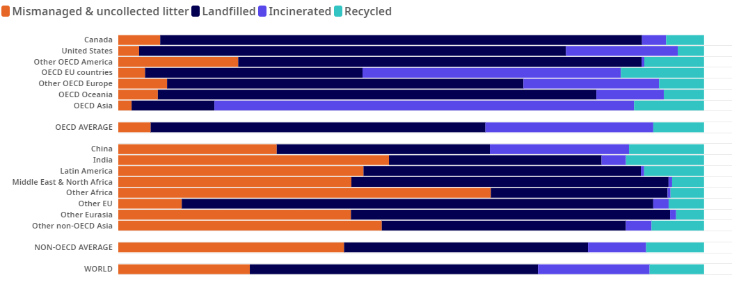
Figure 1: Share of plastics treated by waste management
(Source- OECD, 2023)

EPR also demands the development of effective collection systems and strong recycling infrastructure. To ensure the appropriate disposal and recycling of their products, manufacturers frequently need to set up collection stations or work with already-existing waste management facilities (Herberz et al., 2020). This cooperative strategy creates a beneficial waste management cooperation by increasing the efficacy of recycling procedures and reducing the strain on regional governments.
The advantages and effects of EPR are felt in many different ways. First off, it acts as an energetic innovation catalyst by pressuring firms to investigate environmentally friendly production methods, sustainable materials, and thoughtful packaging techniques. Businesses are motivated to look for solutions that minimize negative externalities and promote environmental stewardship by the inherent financial responsibility for waste management (Tullo, 2019). Although there is much promise in the deployment of EPR, difficulties do arise. It is crucial to create roles and responsibilities that are clearly defined, to have effective monitoring and enforcement systems, and to take into account the various capacities of various businesses. Governments, businesses, and waste management organizations must work together effectively for EPR to be implemented (Simon et al., 2021).

Bans and Regulatory Measures
Bans and regulatory restrictions are crucial weapons in the arsenal of decision-makers fighting the challenge of single-use plastic. Governments all across the world have started putting rules into place to limit or do away with the usage of specific single-use plastic products. These regulations affect both consumer behavior and business processes, acting as potent change agents (Filiciotto & Rothenberg, 2021).
Governments are gradually passing laws banning particular single-use plastic products like plastic bags, straws, and throwaway cutlery. certain restrictions not only lower the demand for certain products but also promote the creation of substitutes. For instance, the Single-Use Plastics Directive of the European Union focuses on the top ten plastic objects discovered on European beaches and seeks to dramatically reduce their environmental impact by 2025 (Borg et al., 2020).
Plastic taxes and levies: Some jurisdictions have put single-use plastic items subject to plastic taxes and levies. Decision-makers establish an economic disincentive for consumers and businesses to use and produce these things by assigning a monetary cost to them.

Strategies for a Circular Economy
Strategies for a circular economy are essential for changing how society manufactures, consumes, and discards plastics. The circular economy strategy, which emphasizes decreasing waste, reusing materials, and recycling products, is challenging the conventional linear economy, which is typified by the "take-make-dispose" concept (Narancic & O'Connor, 2019).
Design with sustainability in mind: Policymakers can nudge companies to create goods with this concept in mind. This entails developing items that are robust, simple to repair, and made of recyclable or repurposed materials.
Building and enhancing recycling infrastructure is essential for the successful application of circular economy strategies. Investments can be made in technology, collection methods, and recycling facilities that improve the sorting and processing of plastic garbage. Additionally, encouraging consumers to recycle properly guarantees that plastics are kept out of landfills and burned.
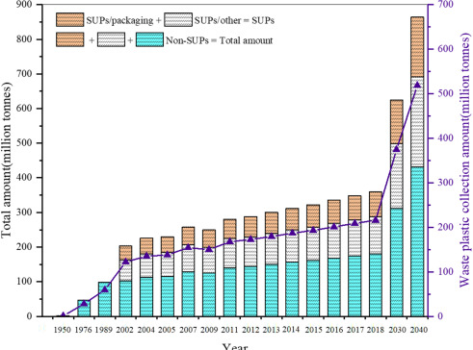
Figure 2: Single-use plastics: Production, usage, disposal, and adverse impacts
(Source- Chen et al., 2021)

Programs called "Product Stewardship" require producers to take accountability for the entire lifecycle of their products, including disposal. The establishment of collection and recycling systems for items can be mandated by decision-makers, which encourages the design of products that are simple to recycle and discourages the use of materials that are difficult to recycle.

Innovation in Technology
The challenge of single-use plastic is largely addressed by technological innovation (Gibb, 2019). The use of conventional plastics can be considerably decreased with the development of substitute materials, recycling technology, and waste management solutions.
Advanced Materials: Scientists and inventors are attempting to create compostable materials, biodegradable plastics, and other environmentally friendly replacements for conventional plastics. To hasten the development and use of these materials, decision-makers might grant funds for research and work with researchers and businesses (Xu & Ren, 2021).
Decision-makers can implement incentive schemes that compensate businesses and individuals for coming up with original ways to reduce single-use plastic waste in order to encourage technological advancements (Ncube et al., 2021). A wide range of stakeholders might be encouraged to contribute to the resolution of this urgent problem through competitions, grants, and tax incentives.

Conclusion
Decision-makers are challenged with developing efficient methods that solve this pressing environmental issue in the face of rising single-use plastic trash. Three major channels can be used to advance: legislative restrictions and bans, circular economy plans, and technical innovation. Decision-makers can direct society toward a more sustainable and plastic-aware future by combining these strategies.

Section 2: Reflection on the process Using Gibbs Reflective Cycle
The investigation of decision-making frameworks and methods intended to address the single-use plastic dilemma has been enlightening, bringing up a variety of feelings and insights. I will explore my thoughts, feelings, and insights throughout this process using the Gibbs Reflective Cycle.
Description
The investigation of decision-making frameworks and methods started with a basic comprehension of the gravity of the single-use plastic problem. The complex relationships between human behavior, governmental actions, technological developments, and environmental effects were fascinating. As I learned more about the subject, I discovered a complicated network of interconnected elements that support the continued usage of single-use plastics in modern society.
Feelings
At first, there were feelings of alarm and sympathy for the devastating effects that single-use plastics have on the environment. The seriousness of the situation prompted a desire to investigate potential remedies out of a mixture of haste and irritation. A glimmer of optimism was provided by the exploration, which uncovered novel approaches and frameworks that might help stop the plastic issue (Adeani et al., 2020). A sense of optimism and encouragement was provided by the constructive steps being made through policies, circular economy programs, and technology advancements.
Evaluation
The thorough examination of decision-making frameworks revealed the complex processes at work. Regulations and prohibitions became effective instruments, causing people to consider how governments may influence behavior and promote sustainable behaviors (Markkanen et al., 2020). The examination of circular economy strategies brought home how crucial it is to move away from a linear consumption model and toward a more comprehensive, sustainable strategy. An important shift in accountability was shown by the study of Extended Producer Responsibility (EPR), which has the potential to transform waste management.
Analysis
The study revealed how these frameworks work in concert, with legislative actions laying the groundwork for change, circular economy methods directing sustainable production and consumption, and EPR bridging the gap by coordinating financial incentives with environmental responsibility. It became clear how significantly behavioral economics and public awareness campaigns have impacted societal change. This interconnection made it clear that the problem required a thorough, multifaceted solution.
Conclusion
My comprehension of the intricacy of the single-use plastic dilemma and the variety of options needed to address it has deepened as a result of the exploration process. The range of feelings—from worry to hope—reflected the necessity and opportunity for progress in this area. The report emphasized the need for cross-sector cooperation and a paradigm shift in how people view plastics and environmental responsibility.
Action Plan
The knowledge I've received through this investigation compels me to actively advocate for change. I want to have discussions on single-use plastics' effects with my friends and coworkers in order to spread the knowledge I've learned. Additionally, I intend to take part in or support projects that advance sustainable practices, whether that means promoting laws that encourage the use of less plastic or supporting companies with strong EPR programs (Sekarwinahyu et al., 2019). The significance of both individual and collective acts in bringing about real change has been reaffirmed by this process of reflection.

Reference List
Adeani, I. S., Febriani, R. B., & Syafryadin, S. (2020). Using GIBBS’reflective cycle in making reflections of literary analysis. Indonesian EFL Journal, 6(2), 139-148. https://journal.uniku.ac.id/index.php/IEFLJ/article/view/3382
Borg, K., Curtis, J., & Lindsay, J. (2020). Social norms and plastic avoidance: Testing the theory of normative social behaviour on an environmental behaviour. Journal of Consumer Behaviour, 19(6), 594-607. https://onlinelibrary.wiley.com/doi/abs/10.1002/cb.1842
Chen, Y., Awasthi, A. K., Wei, F., Tan, Q., & Li, J. (2021). Single-use plastics: Production, usage, disposal, and adverse impacts. Science of the total environment, 752, 141772. https://www.sciencedirect.com/science/article/pii/S0048969720353018
Filiciotto, L., & Rothenberg, G. (2021). Biodegradable plastics: Standards, policies, and impacts. ChemSusChem, 14(1), 56-72. https://chemistry-europe.onlinelibrary.wiley.com/doi/abs/10.1002/cssc.202002044
Gibb, B. C. (2019). Plastics are forever. Nature Chemistry, 11(5), 394-395. https://www.nature.com/articles/s41557-019-0260-7
Godfrey, L. (2019). Waste plastic, the challenge facing developing countries—ban it, change it, collect it?. Recycling, 4(1), 3. https://www.mdpi.com/2313-4321/4/1/3
Herberz, T., Barlow, C. Y., & Finkbeiner, M. (2020). Sustainability assessment of a single-use plastics ban. Sustainability, 12(9), 3746. https://www.mdpi.com/2071-1050/12/9/3746
Markkanen, P., Välimäki, M., Anttila, M., & Kuuskorpi, M. (2020). A reflective cycle: Understanding challenging situations in a school setting. Educational Research, 62(1), 46-62. https://www.tandfonline.com/doi/abs/10.1080/00131881.2020.1711790
Narancic, T., & O'Connor, K. E. (2019). Plastic waste as a global challenge: are biodegradable plastics the answer to the plastic waste problem?. Microbiology, 165(2), 129-137. https://www.microbiologyresearch.org/content/journal/micro/10.1099/mic.0.000749
Ncube, L. K., Ude, A. U., Ogunmuyiwa, E. N., Zulkifli, R., & Beas, I. N. (2021). An overview of plastic waste generation and management in food packaging industries. Recycling, 6(1), 12. https://www.mdpi.com/2313-4321/6/1/12
OECD (2023), Share of plastics treated by waste management, https://www.oecd.org/environment/plastic-pollution-is-growing-relentlessly-as-waste-management-and-recycling-fall-short.htm
Sekarwinahyu, M., Rustaman, N. Y., Widodo, A., & Riandi, R. (2019, February). Development of problem based learning for online tutorial program in plant development using Gibbs’ reflective cycle and e-portfolio to enhance reflective thinking skills. In Journal of Physics: Conference Series (Vol. 1157, No. 2, p. 022099). IOP Publishing. https://iopscience.iop.org/article/10.1088/1742-6596/1157/2/022099/meta
Simon, N., Raubenheimer, K., Urho, N., Unger, S., Azoulay, D., Farrelly, T., ... & Weiand, L. (2021). A binding global agreement to address the life cycle of plastics. Science, 373(6550), 43-47. https://www.science.org/doi/abs/10.1126/science.abi9010
Tullo, A. H. (2019). Plastic has a problem; is chemical recycling the solution. Chemical & Engineering News, 97, 39. https://cendev.acs.org/environment/recycling/Plastic-problem-chemical-recycling-solution/97/i39
Williams, M., Gower, R., Green, J., Whitebread, E., Lenkiewicz, Z., & Schröder, P. (2019). No time to waste: Tackling the plastic pollution crisis before it’s too late. https://opendocs.ids.ac.uk/opendocs/handle/20.500.12413/14490
Xu, E. G., & Ren, Z. J. (2021). Preventing masks from becoming the next plastic problem. Front. Environ. Sci. Eng, 15(6), 125. https://journal.hep.com.cn/fese/EN/article/downloadArticleFile.do?attachType=PDF&id=29199

