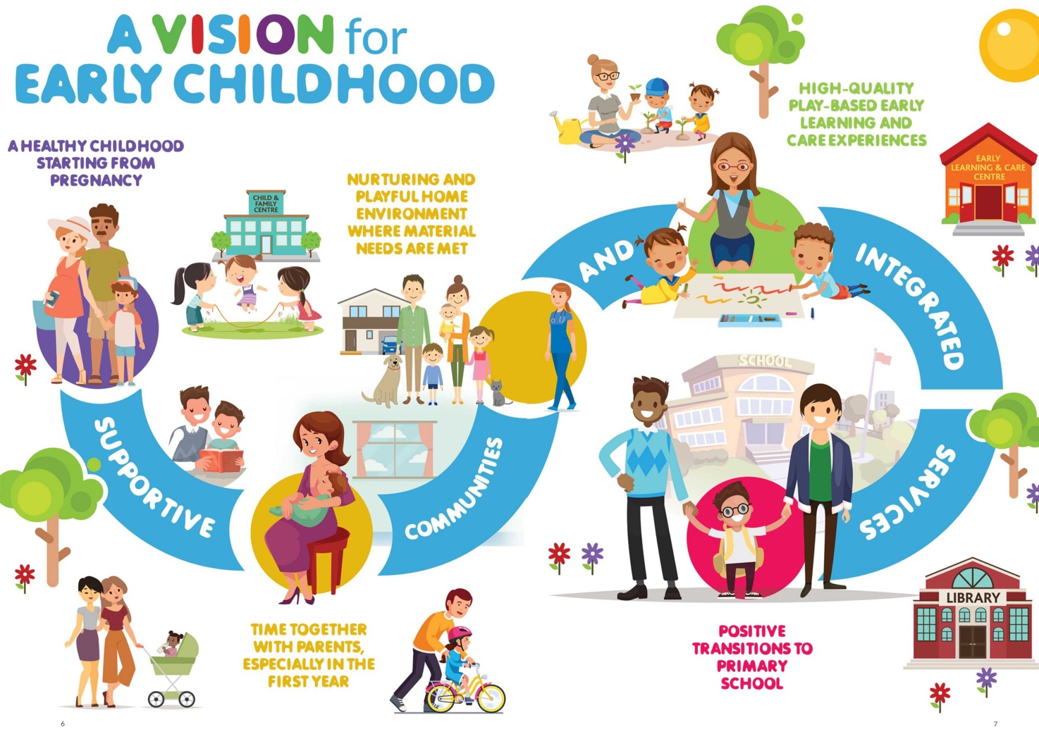
A handbook to guide key workers in Early years setting to understand importance of learning during transitions.
‘Transitions are key events or processes of change over the life course. It is the process of change’.
(Welsh Government, 2017: 3)

Ana Martins (2005133)
EAEE4003/C
Contents Page Number

Using this handbook…………………………………….. 3

Introduction: Transitions………………………………. 4

The needs of the child…………………………………. 6

The role of the adult……………………………………. 10

Partnerships…………………………………………….. 13

Interventions…………………………………………….. 17

Proposed Outcomes……………………………………. 20

Reference list……………………………………………. 22

Using the handbook

This handbook has been designed for childcare settings with children ranging from the age of 2–4 years in a reception class in a school setting.

The handbook can be used by key workers to guide them to fully understand transitioning and the importance of effective communication throughout the transitioning process, especially between the key worker and the parent, the key worker and the child and the key worker and partnerships.

The aim of the handbook is to ensure that practitioners and key workers have the guidance to successfully manage a smooth transitioning process from nursery to reception class in a school setting.

This handbook is divided into 6 key sections for transitions
- Introduction: Transitions
- The needs of the child
- The role of the adult
- Partnerships
- Intervention
- Proposed outcomes.

Each section ensures that efficient guidance is given for keyworkers to plan and manage a transition process efficiently.

Introduction: transitions

Transitioning –According to New York State, (no date) ‘transitioning is the act of making a change, of going from one set of characteristics or circumstances to another’ (New York State, no date). Transitions can happen during a time and stage in a child’s life that will sometimes be involved with an activity, for example, showing a child transitioning through a story or song. Early Years Matters (2020) argues that, transitions are important milestones that will affect a child’s development.

Croner-I (2019) suggests, transitions are vital to a child’s development and well-being. It is important to ensure that support and guidance is provided for the children before a key transition, as it can impact on their capability to handle other changes. Transitions can be overwhelming for the child as well as the parent, so it is essential for practitioners to plan and support the child as well as their families. Policies and procedures need to be established as they will ensure a positive transition for the child. As Croner-i (2019) points out, transitions can also happen within the family, for example, bereavement, divorce or a new sibling. It is important for practitioners and parents to work together to ensure a protected environment for the child. Having a key worker will allow the child to feel a secure attachment and build a safe relationship to support their feelings and emotions during transitions. Early Years Matters (2020) suggests, that when children move from the home environment to pre-school it can impact on their development, for example, a child may feel uncomfortable and anxious due to the new environment, sometimes when the child feels this way they may not be able to make friends and play with the other children as easily.

Meggit et al. (2011: 87) suggests that transitions can affect 4 areas in a child’s development, these are their physical, emotional, intellectual and psychological areas. As Meggit et al. (2011: 81) points out, transitions have an effect on the development of children in various ways. They can be positive, negative, short-term or long-term, this will depend on the effective support the child will receive in the school or home setting.

The needs of the child

Practitioners can support the child’s needs within a setting during a transition by ensuring the child has a continuity of experiences throughout the transition as they will be able to feel relaxed and settled in the setting. It is essential for practitioners to be aware of the child’s holistic needs before they are to transition. By doing so practitioners are able to plan activities and tasks that will help the children to develop during the transitioning process. Meggit et al. (2011: 113) indicates, how important it is to ensure the child is at the center as this will allow practitioners to meet the child’s individual needs and respect their preferences during transition. It is essential for practitioners and parents to explain to the child what will happen during transitioning as this will allow them to settle into the setting quickly. It is important to always reassure the child that everything will be okay, this will make the child feel comfortable within the setting with the practitioners and other children.

As Croner-I (2019) points out, a child with special educational needs or a disability needs further planning for their transition. This will ensure that the child will have the required support and help. Any resources and equipment need to be put into place before the child is to transition into a setting. Croner-i (2019) indicates, that it is essential that the setting provide any needed training for the staff before the child is to begin the setting. Parents and practitioners need to be able to effectively communicate to ensure the child gets the essential support to meet their individual needs.

According to Oxfordshire County Council (no date), there are 4 key principles to ensure good practice in early years when children experience transitions.
Children with special needs –
- It is essential for early years practitioners to be aware that children can be vulnerable while experiencing change, especially children with special educational needs. It is important for practitioners to plan and support these children so that all their individual needs are met.
- Ensuring that the children are prepared for change is important as this will ensure a positive transition. Parents and practitioners need to prepare and explain about the transition to the children as this will make them feel secure and settled into their new environment.
Positive Relationships –
- Planning and effective communication between parents and practitioners will help to ease the child into the setting. It is important for the role of parents and practitioners to be recognized during the transition process.
- By practitioners, other professionals and parents working together will allow the children to have an effective transition. This will allow them to understand each other’s plans and aims for each child’s individual needs.
- Settings should give parents the opportunity to access information about transitions through open days, one to one’s, booklets and letters.
Environment –
- Children are able to learn and manage transitions more efficiently when the settings circumstances are similar to the home environment, children need to be encouraged to communicate with one another.
- Practitioners and parents need to ensure that transitions take time as this will allow the child to settle in quicker into the new environment. Effective welcoming procedures are important as they will make the child instantly feel comfortable once they enter the setting.
- Thought needs to be taken into consideration by practitioners, professionals and parents to meet the child’s holistic needs. ‘It is important to ensure that the continuity of children’s experiences involves all aspects of their care and learning’ (Oxfordshire County Council, May 2017).

Maslow Hierarchy of needs

Maslow’s Hierarchy of needs discusses that humans have different levels of needs. He suggested that each level should be completed before a child is to progress onto the next level. The levels are tiered into a pyramid with the basic human needs at the bottom, this includes things like water, shelter, food, chlothing. At the top of the pyramid is self-actualization, this involves a child’s creativity, morality, spontaneity. According to Discovery days (2018), Maslow suggests that each level should be completed before a child is to progress onto the next level. Practitioners must ensure they are able to understand Maslow’s hierarchy of needs as they are able to use it in practice. Maslow’s theory shows practitioners a wider perspective that can relate to the behaviour and actions of a child. When a child’s basic needs are not met it can become difficult for the child to concentrate, learn and behave.

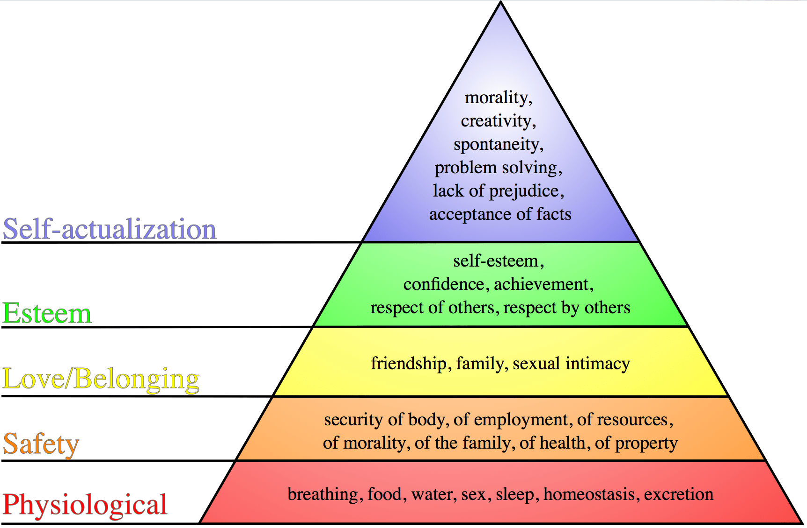

(Source: St.Emlyn’s, 2020)

The role of the adult

PETIT early learning journey (2020) shows that, practitioners role is to listen and ensure that the child’s needs are met during transitions as they can be turned into learning experiences for the children. Making the child feel safe and secure throughout the transition process is essential for their holistic development.

Children will be able to learn to be independent when they have a caring and secure relationship with their parents and practitioners. Having a key worker allows the child to be secure and independent in the setting’s environment. Early years matters (2020) indicates, that children’s learning can be developed if they feel safe and secure inside the setting, this is due to the parent and practitioner working together to make sure that all the child’s needs are met. Having a key worker inside the setting provides the child with reassurance making it easier for them to leave the home environment and their parents when being dropped off at the setting. According to Early years matters (2020), parents and practitioners both have a vital role in the child’s life. They need to provide children with the correct environment as this will allow each child to grow and develop. In the settings environment children need to feel respected and valued and their well-being must always come first. This will allow the child to thrive emotionally and socially.

RaisingChildren (2020) suggests, that the relationships children have with adults can affect the way they see the world and their developmental areas. Children are able to learn about the world and its environment through the relationships they build with parents, family member and practitioners. By a practitioner having a relationship with the child it allows the child to express themselves openly with their key worker, for example, if a child smiles it indicates to the practitioner that they are happy. By the key worker having an effective relationship with the child it will allow them to develop their resilience, confidence and communication, these skills are needed by the child for their future life, they will help the child to deal with stress and form relationships with others.

John Bowlby’s Theory

John Bowlby describes that attachment is ‘a long-lasting psychological connection with a meaningful person that causes pleasure while interacting and soothes in time of stress’ (Learning theories, 2020). Learning theories (2020) states that, Bowlby’s theory shows that the quality of attachment has an impact on the development of the child and can influence a diversity of aspects on the child’s holistic development. Being attached to a key person in the setting will help the child to become confident, relaxed and happy as they will feel like they have someone they can ask for help, talk too and play with.

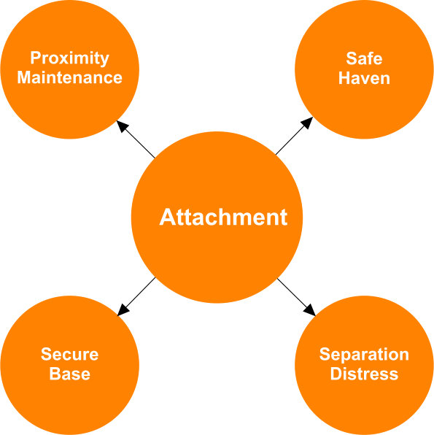

(Source: Family Matters, 2020)

Partnership


(Source: MTC, 2019)

Linc (2013-2020) shows, that parents are very important in a child’s life as they play a key role in their development. It is important for parents to sense that practitioners acknowledge and value their opinions and expertise on their own child. Practitioners should encourage parents to be involved during their child’s transitioning process as it will benefit the adaptation of the child into a new environment. Linc (2013-2020) indicates that by practitioners building a positive relationship with the child’s parent it will make them feel comfortable when visiting the setting and will give them the confidence to have a conversation with their child’s key worker to discus and plan the holistic development of their child. Working with parents is a very important approach, as it develops a trust between the parent and key worker, this is very essential for both the parent and practitioner to have effective communication. Having a trusting relationship gives the key worker and parent more confidence to talk about any developmental difficulties the child may have. Key workers should allow the parent and child to visit the setting before they begin their transition as this will allow the child to feel settled in quicker when they first begin their transition. This will encourage parents to feel comfortable around the practitioners and speak to them about any worries or concerns they may have on the child’s development or behaviour.

Early Years Careers (2015) suggests, that at some point practitioners will work with multi-agencies, this is due to a variety of adults with different backgrounds working with the child. Multi-agency is when different professionals work together to offer the necessary support for the child. Melbourne graduate school of education (2011: 4) states that, working in partnership benefits children, including a child with disability, a delay in their development or with additional learning needs as it requires multi-agencies to work together to support the child and their family. Practitioners are also able to benefit from working in partnership with other professionals as they provide different views and professional understanding of their background, allowing others to learn and expand their own knowledge and expertise. Working with other professionals requires both the child’s parents and key workers to be committed and show respect for each other’s roles. Melbourne graduate school of education (2011: 4) claims that, communication and planning to support the child’s needs is essential to each professional’s role as it ensures that continuous support, guidance and care is being considered by each professional to benefit the child’s holistic needs.

Bronfenbrenner’s theory

Bronfenbrenner developed the theory in which the ecological system explains how the child’s environment and everything in the child’s life can affect their development and growth. West Texas Centers (1995-2018) states, that Bronfenbrenner ‘labeled different aspects of levels of the environment influence children’s development, including the microsystem, the mesosystem, the exosystem and the macrosystem’ (Walker Texas Centers, 1995-2018). The microsystem is the proximate contact the child settles in, for example, parents, siblings and practitioners. Bronfenbrenner indicates, how the people in the microsystem interact with the child can affect how they grow. Bronfenbrenner’s Bioecological Theory (no date) shows, that it is important for practitioners to build relationships with the child and ensure effective communication with the parents within a positive environment, this will allow the child to achieve their full potential. Children need to feel safe during transitions for them to be able to have an effective change. By children having a relationship with parents and practitioners they are able to feel safe and relaxed within the new home or setting environment, as they will have a secure attachment where they will rely on that parent or practitioner to reassure them that they are secure and that everything will be okay.
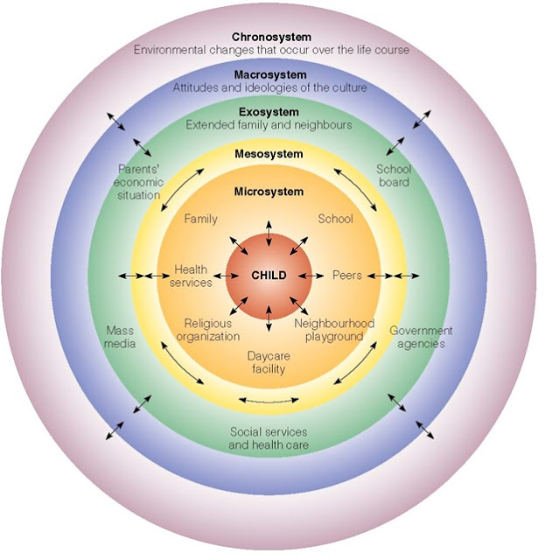

(Source: Osmitty, 2014)

Intervention

Teach Early Years (2020) indicates, that it is very essential for children to build positive and respectful relationships with their key worker during their early years as they will be able to adapt to the changes during the transition a lot quicker. Teach Early Years (2020) also suggests, that having a positive and happy environment with structured routines encourages the child to build friendships with the other children and it also gives them a secure and safe feeling within the settings environment.

ECCP (2013-2020) indicates, that practitioners should try to plan transitions to meet each child’s individual needs as this will cause less stress for the child during the transitioning process. It is important for key workers to let children know about the transition beforehand and let the child know what is happening at the time it is happening. If children are not told about their transition, they can become resistant towards the practitioners and other children.

Reggio Emilia

According to Meggit et al. (2011: 206) Reggio Emilia was found by Loris Malaguzzi who was a teacher and humanitarian. This approach was initiated after World War II in Reggio Emilia, Italy. Reggio Emilia’s approach looks at how strategies are able to allow teachers to show children world topics in depth. They want children to be able to learn about a world topic that will get their full attention. Meggit el at. (2011: 207) also shows, that the Reggio Emilia approach focuses on the teaching, learning and the advocacy of children. It considers the knowledge of what children are aware of, are curious about and what challenges them. In a Reggio classroom practitioners and key workers record the observations they have completed on the child, this allows them to discuss appropriate ways in which they can help and support the child to develop their academic knowledge and social potentials. If practitioners support is long term the child’s areas of development can be supported inside and outside of a setting by both the parents and key workers. Reggio Emilia believe that all children have the potential to learn and expand their knowledge about the world and the environment around them.

It is important for practitioners to give children the opportunity to decide the activities they would like to do. This links into the Reggio Emilia approach which supports practitioners providing opportunities for child-initiated play. Children should also be given the chance to have free play when they first come into the setting and before being collected, this helps them to settle in and feel relaxed inside the setting during their transition. This helps the children settle after being separated from their parents. The Reggio Emilia approach also influences today’s curriculum as there is sensory and outdoor play opportunities given.
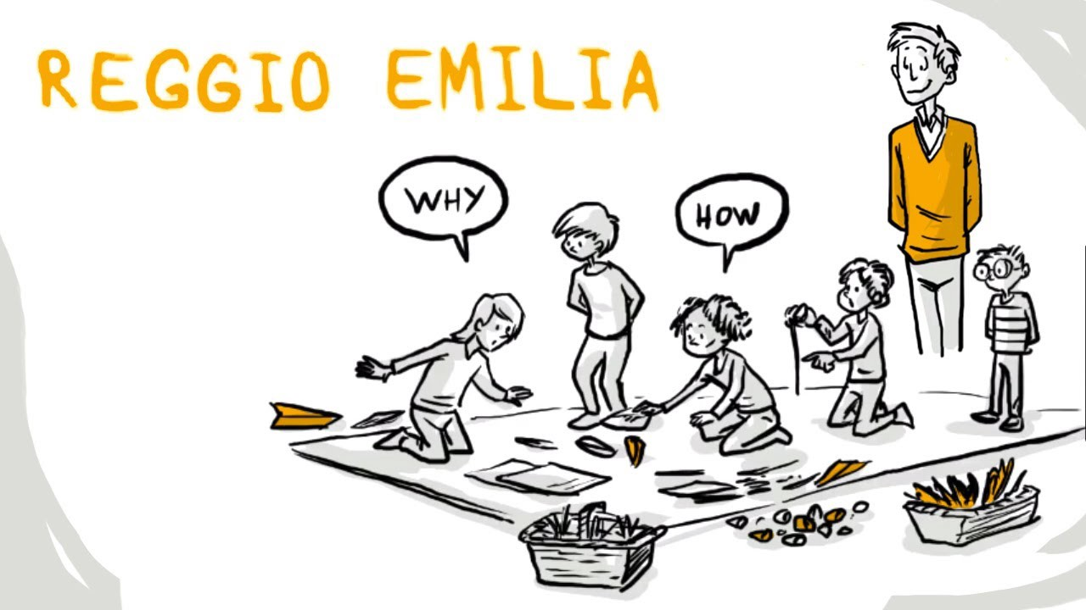
(Source: Krishnamurthy, 2020)

Proposed Outcomes

According to Butler and Ostrosky, (2018) key workers should share any ideas they may to create a smooth transitioning process, with the parents. This will help with any difficulty the child may have settling in or with any challenging behaviours the child may demonstrate in the setting or at home. Hunt (no date) states that, the more confident a child is the easier it is for them to settle into the setting, however, the ‘more vulnerable and disadvantaged a child is the more difficulty they have adapting to new relationships and surroundings, acting as a barrier to engagement and learning’(Hunt, no date).

As Thomas (2019) points out, sending e-mails and letters to parents to ask if they have any questions or worries about the development or learning of their child, is important as it will ensure the parents can get answer from the child’s key worker of any worries they may have regarding the child. Practitioners should organize questionnaires on thoughts and feelings on the effectiveness of the child’s transition, for parents to complete. This will give key workers an insight on how parents feel regarding their child’s development and learning during and after their transition. Oxford Bibliographies (2017) indicates, that assessments should be completed by the key worker before, during and after a transition as they identify the areas of learning a child needs support and guidance with. This helps key workers to become aware of areas the child’s needs nurturing and the areas the child is strong and confident in.
The Effective Provision of Pre-school Education, (EPPE) (2004) studied a child’s development between 3-7 years of age. They gathered a variety of information on over 3,000 children. EPPE (2004) also, looks at a variety of characteristics that relate to a child’s parent/s, their home environment and the settings environment that the child attends. They discovered that pre-school occurrences improve the development of the child. Their findings also showed that children who are underprivileged benefit from a productive and supportive experience in pre-school, especially when involved with children from a variety of background. EPPE (2004) suggests, that when key workers view education and social development as important and essential each child is more likely to make progress in their learning. The significance and quality of children learning within the home environment is very important for the child’s social and intellectual development.

Reference List

Bronfenbrenner’s Bioecological Theory. (no date) Summary of Bronfenbrenner’s work. Available at: https://bronfenbrenner3040.weebly.com/real-life-examples (Accessed on: 14th November 2020)

Butler.A., Ostrosky.M. (September 2018) Reducing challenging behaviours during transitions: Strategies for early childhood educators to share with parents. Available from: https://www.naeyc.org/resources/pubs/yc/sep2018/reducing-challenging-behaviors-during-transitions (Accessed on: 25th November 2020)

Croner-I. (9th May 2019) Managing Transitions in early years. Available at: https://app.croneri.co.uk/feature-articles/managing-transitions-early-years-provisions (Accessed on: 8th November 2020)

Discovery days. (9th December 2018) Early Childhood and Maslow’s Hieracrchy of Needs. Available at: http://www.discovery-dayschildcare.com/blog/earlychildhood-and-maslows-hierarchy-of-needs# (Accessed on: 18th November 2020)

Early Years Matters. (2020) Positive Relationships. Available on: https://www.earlyyearsmatters.co.uk/eyfs/positive-relationships/ (Accessed on: 23rd November 2020)

Early Years Matters. (2020) Transitions. Available at: https://www.earlyyearsmatters.co.uk/eyfs/positive-relationships/transitions/ (Accessed on: 10th November 2020)

Earlyyearscareers. (29th October 2015) Accessing multi-agency support in the early years. Available from: https://www.earlyyearscareers.com/eyc/latest-news/accessing-multi-agency-support-in-the-early-years/ (Accessed on: 25th November 2020)

ECCP. (2013-2020) The Classroom Environment: Support Children with Transitions. Available from: http://www.eccpct.com/Resources/Classrooms/Tips-for-Tots/Support-Children-with-Transitions/ (Accessed on: 24th November 2020)

Family Matters. (2020) Attachment Theory: Main Characteristics of Attachment. Available from: https://www.ronitbaras.com/family-matters/parenting-family/attachment-theory-main-characteristics/ (Accessed on: 23rd November 2020)

Flying Start – Annex. (May 2017) Transition Guidance. Available from: https://gov.wales/sites/default/files/publications/2019-07/flying-start-transition-guidance-for-professionals.pdf (Accessed on 23rd November 2020)

Hunt.M. (no date) Successful transitions in early years. Available from: https://afaeducation.org/blog/successful-transitions-in-early-years/successful-transitions-in-early-years/ (Accessed on: 25th November 2020)

Krishnamurthy.S. (21 September 2020) What is the Reggio Emilia Approach and How is it different form other approaches? [image]. Available from: https://medium.com/@pallikkoodam/what-is-the-reggio-emilia-approach-and-how-is-it-different-from-other-approaches-811814a8d739 (Accessed on: 24th November 2020)

Learning theories. (2020) Attachment Theory (Bowlby). Available from: https://www.learning-theories.com/attachment-theory-bowlby.html (Accessed on: 19th November 2020)

LINC. (2016-2020) Supporting Transitions from the Home to the Early Learning and Care Setting – Advice and Best Practice.[image]. Available from: https://lincprogramme.ie/blog/supporting-transitions-from-the-home (Accessed on 23rd November 2020)

LINC. (2016-2020) Supporting Transitions from the Home to the Early Learning and Care Setting – Advice and Best Practice. Available from: https://lincprogramme.ie/blog/supporting-transitions-from-the-home (Accessed on 23rd November 2020)

McLachlan. C. (27th April 2017) Assessment in Early Childhood Education. Available from: https://www.oxfordbibliographies.com/view/document/obo-9780199756810/obo-9780199756810-0179.xml#backToTop (Accessed on: 26th November 2020)

Meggit C et al, 2011. Children and young people’s workforce. CACHE Level 3 Diploma, London, Hodder Education.

Melbourne graduate school of education. (2011) Victorian Early Years Learning and Development Framework. Available from: https://www.education.vic.gov.au/Documents/childhood/providers/edcare/pracpartner.pdf (Accessed on: 25th November 2020)

New York State. (no date) What does ‘transition’ mean? Available at: https://www.msnavigator.org/transition-to-adulthood/transitions-big-picture/what-does-transition-mean (Accessed on: 10th November 2020)

Osmitty. (4th June 2014) Bronfenbrenner’s Bioecological Theory. [image]. Available at: http://osmitty.blogspot.com/2018/06/bronfenbrenners-bioecological-theory.html (Accessed on: 15th November 2020)

Oxfordshire County Council. (May 2017) Smooth Transitions in the Early Years: A Good Practice Guide. Available at: https://www2.oxfordshire.gov.uk/cms/sites/default/files/folders/documents/childreneducationandfamilies/informationforchildcareproviders/Toolkit/goodpractice/EYTransitionPack.pdf (Accessed on: 11th November 2020)
Patel. A. (2020) Supporting Transitions in the Early Years. Available from: https://www.teachearlyyears.com/a-unique-child/view/supporting-transitions-in-the-early-years (Accessed on: 24th November 2020)

PETIT early learning experiences. (2020) Supporting Children’s Transition to School: Saying Goodbye. Available form: https://www.petitjourney.com.au/transition-to-school/ (Accessed on 23rd November 2020)

Raisingchildren.net.au. (13th August 2020) Relationships and child development. Available on: https://raisingchildren.net.au/newborns/development/understanding-development/relationships-development (Accessed on 23rd November 2020)

St.Emlyn’s. (2020) Educational theories you must know: Maslow. St.Emlyn’s. [image]. Available from: https://www.stemlynsblog.org/better-learning/educational-theories-you-must-know-st-emlyns/educational-theories-you-must-know-maslow-st-emlyns/ (Accessed on: 18th November 2020)

The Effective Provision of Pre-school Education (EPPE) Project. (November 2004) Findings from Pre-school to end of Key Stage 1. Available from: https://dera.ioe.ac.uk/18189/2/SSU-SF-2004-01.pdf (Accessed on: 26th November 2020)

The Midlands Training Company (MTC). (2019) EYFS – Partnership working. Available from: https://themidlandstrainingcompany.co.uk/product/eyfs-partnership-working/ (Accessed on: 26th November 2020)

Thomas. E. (8th April 2019) Supporting transitions: Effective partnership working between families, careers and practitioners. Available from; https://www.nurseryworld.co.uk/knowledge-bank/article/supporting-transitions-effective-partnership-working-between-families-carers-and-practitioners (accessed on: 25th November 2020)

West Texas centers (1995-2018) Child and Adolescent Development: Overview, Uri Bronfenbrenner and Child Development. Available at: (https://www.wtcmhmr.org/poc/view_doc.php?type=doc&id=7930&cn=28 (Accessed on: 16th November 2020)

