Managing a Hardware/Software Project for Disaster Recovery
Project Management and Research Methods
ACDA5004
Imran Ali
1701017
Sue Maw

Table of Contents

- Introduction
- Risk Management
- Sustainability Issues
- Ethical and Legal Issues
- Quality Assurance Issues
- Screenshots of Demo & Plan
- Conclusion
- References

- Introduction

This report will detail the concept of quality and quality management whilst analysing the role quality plays in project development. The ability to initiate, plan and manage a project will be assessed in multiple ways prior to ultimate implementation.

Risk management is the ability to assess any factors that will affect the outcome of your end product [1]. Risks can be internal or external depending on the type of project being undertaken and are able to be overcome with adequate risk assessments and planning.

- Risk Management

There are many risks that can affect the quality and efficiency of a project, the main way to assess risks would be to create a PESTLE analysis and a SWOT analysis [2], this would in turn discuss risks in terms of politics, economic, social, technological, legal and ethical/environmental issues as well as displaying the strengths, weaknesses, opportunities and threats to the project in hand.

The main risks highlighted within this project in relation to the overall system and its deliverables include:

System Risks:

Availability of the system [3] – this risk is related to how quickly the system will be available when a disaster has occurred at the organisation, to overcome this risk, the strategy that has been chosen is to test availability by creating “drill” situations to check how fast response time is.

Capability to cover a large geographic area [4] – this risk is associated with the system’s ability to provide coverage in a large area, the strategy to prevail this risk will be to use cloud networking, this will provide coverage for large areas with the ability to expand.

Signal strength, bandwidth speeds for data recovery [4] – related to the systems network connectivity and speeds, this can be a huge risk as this will affect the organisations ability to restart operations, to overcome this problem, signal strengths will be tested by passing through high volumes of information and data with large storage capacities.

Security of data, information and resources/Data protection [5]– this is a huge risk for the organisation, whilst the all systems are down, the back-up system must always keep data up-to-date as well as highly secured and encrypted to keep safe from threats, to overcome this risk, data security will be tested by ethically damaging data to ensure security is always at a high level.

The overall ability of the system to overcome the problem of disaster and recovery – this risk is the main problem to show that the system is working, if the system isn’t working then the whole project will be deemed as a failure. To overcome this risk, system testing will be taken out regularly to mitigate any risks related to the systems capabilities and efficiency to work.

The main risks related to the overall project include:

Project Risks:

Schedule and timing to provide the system (there may be a disaster that can occur any time) – this risk is related to the ability to provide the system within the shortest timeframe possible as disaster can occur at any time, the solution to this is to plan the project effectively in terms of resources and time management to provide the system as quickly as possible to limit any risks.

Cost and availability of equipment, resources, staff and tools – this project risk is related to all the resources and the availability of resources, to solve this risk, equipment and resource planning will be handled carefully, selecting the best and efficient resources to reduce problems further down the line, this will reduce any problems that may occur in the future such as slow equipment.

Quality and efficiency of the provided system and its characteristics – related to the ultimate implemented system, this risk will test if all client requirements have been met as well as the overall capacities and capabilities of the system, the only way this can be fully tested is if a disaster has occurred and if the system has overcome the problem at hand.

- Sustainability Issues

Sustainability is the ability to maintain something at a rate for a long period [6] of time without the worry of it degrading.

The main issue with any IT related project/device/system is the impact they create when they are being made, used or destroyed. As well as providing benefits such as automation and fast data transfer for the world, such IT relations create problems in first, second and third order sustainability.

A first order sustainable issue is the first problem created, in relation to IT, the existence of IT creates many issues.

In relation to the project at hand, a first order problem that is created due to the use of the system is greenhouse gas emissions [7].
This problem is created in the overall creation of each separate device (router, truck, PC, switch etc.), further, this is a direct result of the existence of IT.

Another problem related to first order issues is electronic waste (E-Waste) [8]. E-Waste is automatically created when parts are destroyed in factories or after being sold and thrown away for new technology, the by-product of E-Waste is unrecyclable materials that are burned, further creating greenhouse gases.

A second order sustainable issue is the second problem created, in relation to IT, the second problem of any device would be the transporting of the products to other parts of the world for sale or destruction.

A second order problem that is created due to this project is substitution in terms of a wireless cloud network and optimization [9] related to creating a smaller network that uses lower energy than the whole organisation, although both factors can be seen as positive, problems such as radio wave emissions and energy consumption need to be considered.

A third order sustainable issue is the “final” problem that is created that cause long-term impacts, in relation to IT, the overall power and energy usage and wastage of devices/systems [10] is a huge problem.

Another sustainability issue related to the third order is the uncertainty and innovation of technology. New technology surfaces regularly which questions capabilities of present technology, this creates an issue where consumers are continuously looking for the latest technology and throwing away working condition devices due to uncertainties of products.

Other sustainability issues that can be considered and related to the project:

- The use of devices that are created with bio-materials, eco-plastics are low-carbon alternatives and require less energy to create as well as emit low wastage compared to metals
- Smart monitoring and adequate predictive analytics can help increase efficiency in energy consumption allowing resource usage to be maximized

Other considerations:
- Virtualization [11]: Virtualization allows accessing multiple applications on different operating systems at the same time, while abstracting (virtualizing) the machine hardware. The main ideation of virtualization is to optimize IT infrastructure to reduce operational costs.

- Ethical and Legal Issues

Ethical and legal issues relate to laws and legislations set by a country’s government or body, giving strict rules that must be abided whilst doing a certain task. Ethics are in place to allow for trust, security and comfort.

In relation to this project and IT in general, the main legislation that must be followed is the Data Protection Act [5] (updated in 2018), this legislation controls how personal information is used by organisations, businesses or the government.

Another legislation that applies is the Computer Misuse Act (1990), this legislation details the unauthorised use of a computer and its materials/resources and the result of doing so.

Both legislations are directly related to the project in hand due to accessibility of an organisations data, usage of data and the overall security of the data.

The BCS Code of Conduct applies to all members of the BCS, it sets out professional standards required by BCS that relate to public interest, professional competence and integrity rules and duty to the profession [12].

In relation to public interest, this project will have “due regard for public health, privacy, security and wellbeing of others and the environment” [12], acting in the public and employees interests, planning will be conducted in a high standard with all potential risk factors and strategies to overcome them considered to ensure safety rights are met.

In relation to professional competence & integrity rules, the project will follow the conduct of “You should seek out and observe good practice exemplified by rules, standards, conventions or protocols that are relevant in your area of specialism” [12], this ensures that the project and system will follow the guidelines set by IT related bodies and the government to ensure security of data and networking.

In relation to duty to the profession, every individual working on the project will “share knowledge and understanding of IT and support fellow members in professional development” [12] , this will act in favour of all the employees & clients related to the project allowing them to improve ways of work and working knowledge.

Accordingly, the IEEE Code of Conduct follows a similar route for individuals involved within the IEEE and its activities. The code of conduct rules state: be respectful of others, treat people fairly, avoid injuring others, their property, reputation or employment, refrain from retaliation and comply with applicable laws in all countries where IEEE does business and with the IEEE policies and procedures [13].

BCS Digital Brexit Report

Further, due to the UK having a probationary period (Brexit), leaving the EU is yet undecided, the BCS has created a digital Brexit report detailing possible legal and ethical outcomes for third sector UK organisations as a result of Brexit. The report solely focuses on the UK’s choices related to a future that is: data driven, digitally-capable, secure and connected [14].

A possible outcome that will be created if the UK decides to leave the EU is changes to legislations and ethics that will focus solely on the UK only and not EU countries. These changes will directly affect organisations that are within the IT sector as well as other sectors and may require changes to be made on the way data, security and the way data is used, hence, why the BCS would like to see the UK becoming a leader and innovator in data protection [14].

Another possible outcome due to Brexit for third sector organisations is the BCS predicts that “every” sector will be heavily reliant on technology and its developments. These changes will require organisations to become more used to having a technological counter-part, which will require organisations to have professionals in IT (and related) to be working within the organisation with up-to-date knowledge and training [14].

Cyber-security issues will be high profile due to losing EU legislations and the UK creating its own [14], further allowing criminals to carry out attacks unless new legislations are put in place. According to [15], UK digital exports are worth more than £30bn per year, in contrast to this, cyber security breaches cost organisations £2620 per attack due to unknown problems in security features.

As the UK looks likely to be leaving the EU, an issue would be connectivity [14] in terms of business for third sector organisations. If the UK leaves the EU, countries that are within the EU would see the UK as competition as the UK will not have a benchmark or similar standards of trade, in the present day, the UK is able to trade freely with all EU countries, upon leaving, tariffs and other fees will be required to be paid by organisations that would like to trade.

- Quality Assurance Issues

Quality assurance is measuring if the stated requirements, practices, procedures and methods are met without any hiccups after the implementation period.

Firstly, to ensure the quality of the system, the client requirements and deliverables will be taken into consideration and will be checked to see if they have been met, ensuring the quality of the overall project as well as the client’s overall satisfaction with the project.

Productivity will be measured by assessing the excessive use of resources in achieving the project goals. The use of low energy products will be used, avoiding the use of extra resources that are not required, in return providing a highly efficient system/project.

In relation to project management, the quality metrics that are used are “Key Performance Indicators” (KPI), which measure planned value, actual cost and earned value.

Planned value is an estimation of the cost required for the project, also, the use of a cost benefit analysis to choose what resources need to be required and if they are beneficial or not. Actual cost relates to the money that has been spent and the analysis of the benefits of the project outweighing the costs. Earned value relates to the successful results of the project – if it is still working, providing results that the client requirements stated and if the project is continuously providing benefits after all expenses.

In regard to ISO 25010 Software Qualities, functionality of the project will be measured if the network truck will overcome the problem of a disaster and continue to provide the organisation with their back-up network and continuing all work-related activities. Reliability of the project will be measured upon checking if the truck reacts to disaster situations from drills without any hiccups at any given time. Maintainability will be measured upon if the organisation changes any software on their systems and checking if the network truck is able to adapt to various changes with minimal effort.

- Screenshots of Demo & Plan

The following image displays the project plan that is being followed in order to implement the system that has been asked by the client.
Currently, system implementation is staged at technical documentation and will be ready for testing in the upcoming days.
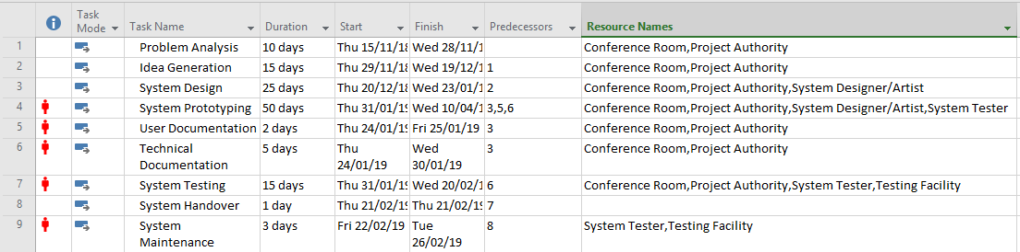

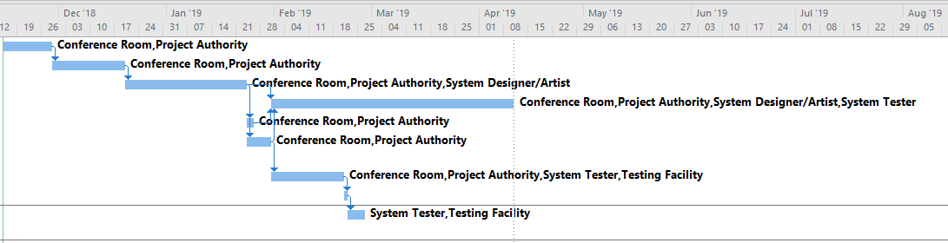
The following Gantt chart displays the timeframes of each task associated with the project.

The following images display the main features of the system from the system demonstration presentation talking about key features of the truck, components and security.

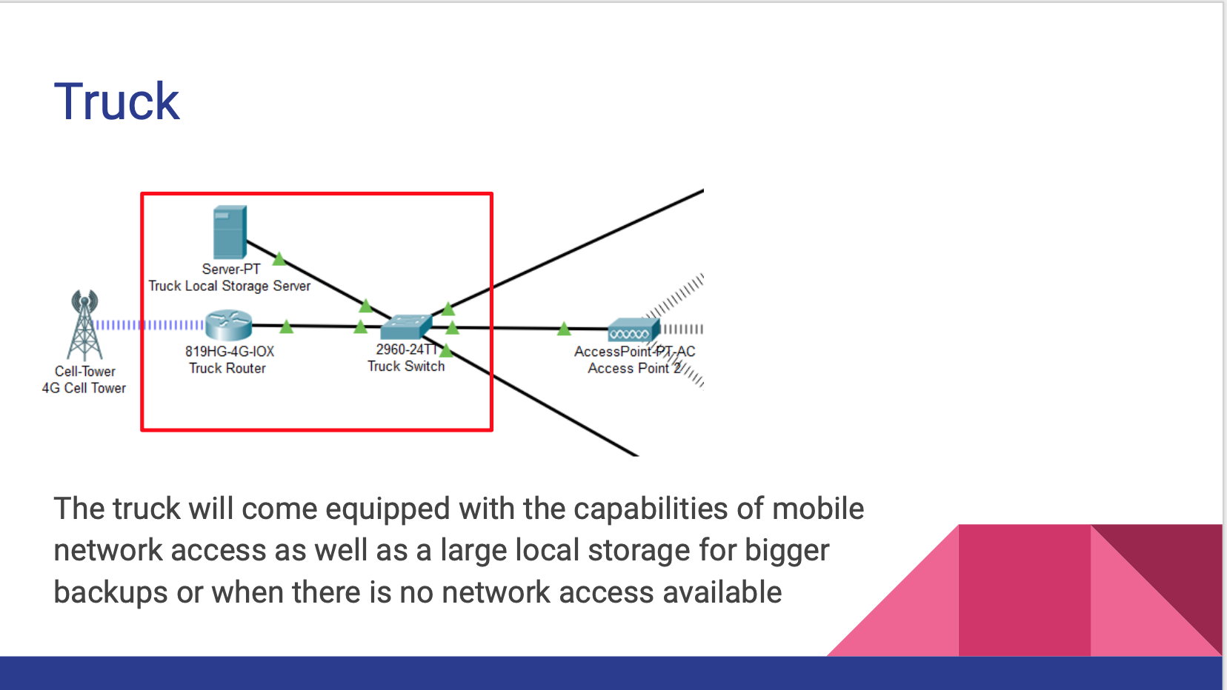
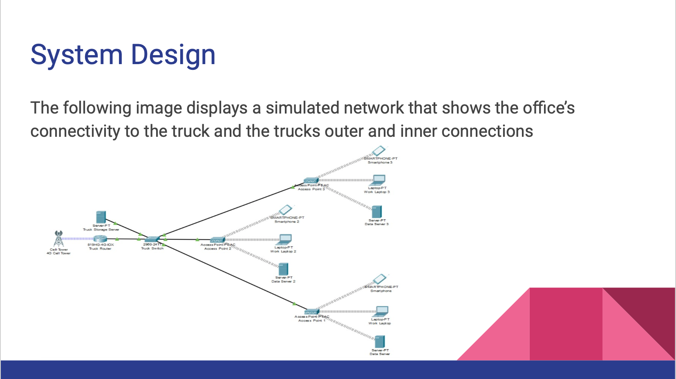
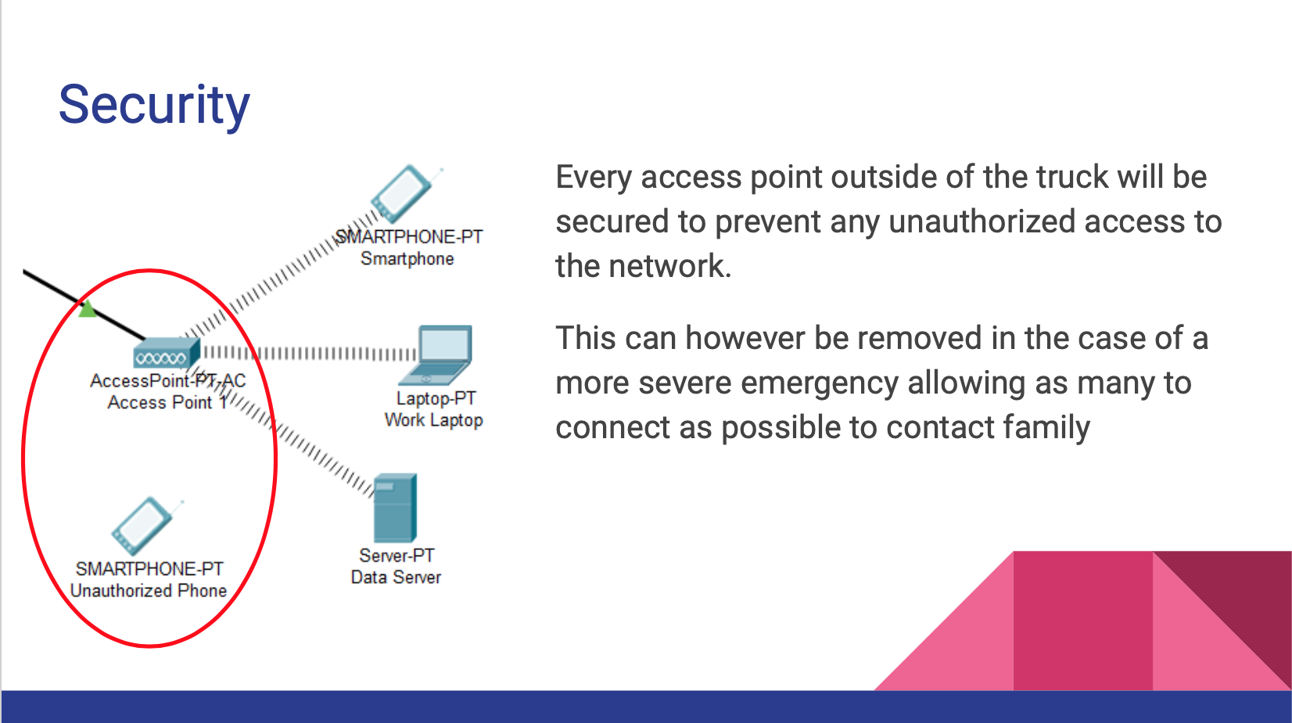
- Conclusion

To conclude this report, the key features of project management were covered; risks, prevention, PESTLE issues and quality assurance issues.

The system in hand has followed a strict project plan, staying within each tasks timeframe without running into any hiccups. Overall the system is able to provide the back-up system required by the organisation with strict data security management with prompt availability in any disaster situation, allowing the organisation to continue their business activities.

The only issue with this system will be the uncertainty of Brexit which can affect the way the organisation and system will work, so adapting to legislations will have to be looked into for the future, but should not be difficult to adapt to depending on the new legislations set out.

References

[1] | F. L. S. v. K. Daniella van Well-Stam, Project Risk Management: An Essential Tool for Managing and Controlling Projects, Netherlands: Kogan Page Limited, 2003.
[2] | R. Perera, The PESTLE Analysis, Sri Lanka: Nerdynaut, 2017.
[3] | H. Kern, "IT should establish realistic availability requirements," Tech Republic, 10 December 2002. [Online]. Available: https://www.techrepublic.com/article/it-should-establish-realistic-availability-requirements/. [Accessed 22 January 2019].
[4] | V. T. C. M. S. K. S. A. D. B. Jan Holler, Internet of Things, Oxford: Elsevier, 2014.
[5] | UKGovernmeny, "Data Protection," GOV.UK, [Online]. Available: https://www.gov.uk/data-protection. [Accessed 22 January 2019].
[6] | C. Pugh, Sustainability the Environment and Urbanisation, Oxfordshire: Routledge, 1996.
[7] | B. Caldecott, "The technology to tackle greenhouse gas emissions now exists. Are we brave enough to use it?," Independent, 31 October 2012. [Online]. Available: https://www.independent.co.uk/voices/comment/the-technology-to-tackle-greenhouse-gas-emissions-now-exists-are-we-brave-enough-to-use-it-8269479.html. [Accessed 22 January 2019].
[8] | G. Achieng, "The six-year-old Kenyan fighting electronic waste," BBC News, 2 November 2018. [Online]. Available: https://www.bbc.co.uk/news/av/world-africa-46060196/the-six-year-old-kenyan-fighting-electronic-waste. [Accessed 22 January 2019].
[9] | S. Shrinate, "After 18 months, 5G will take centrestage in tech world," Economic Times India, 23 January 2019. [Online]. Available: https://economictimes.indiatimes.com/markets/expert-view/after-18-months-5g-will-take-centrestage-in-tech-world-cp-gurnani-tech-mahindra/articleshow/67651467.cms. [Accessed 23 January 2019].
[10] | B. Lufkin, "50 Grand Challenges for the 21st Century," BBC News, 1 April 2017. [Online]. Available: http://www.bbc.com/future/story/20170331-50-grand-challenges-for-the-21st-century. [Accessed 23 January 2019].
[11] | F. F. M. F. Giuseppe Lami, "A Methodology to Derive Sustainability Indicators for Software Development Projects," Pisa, 2013.
[12] | BCS, "Code of Conduct For BCS Members," BCS, uk.
[13] | IEEE, "IEEE Code of Conduct," IEEE Board of Directors, New York.
[14] | BCS, "Digital Brexit," BCS, UK, 2016.
[15] | M. a. S. S. E. E. Department for Culture, "UK Digital Exports," August 2016. [Online]. Available: https://www.gov.uk/government/uploads/system/uploads/attachment_data/file/544103/DCMS_Sectors_Economic_Estimates_-_August_2016.pdf. [Accessed 24 January 2019].

