
Write a report of 2000 words demonstrating your understanding of the models of communication, the communication skills discussed in class and the advantages and disadvantages of Communication Technology and refer to any case studies done to show how these helped your understanding.
Firas Jghaimi student number: 2029865 Lecturer: Soban Sadiq Module: “Effective team working and communication” (BMSW4002_LON)


Introduction
“Communication”. From the Latin “communicare”, “to be in relation with”. An apparently simple word that hides a lot of meanings. It is difficult to give a definition to such a complicated concept. It could be described as an imaginary bridge built between two or more people to share their thoughts, news and feelings towards something. Its importance in nowadays businesses is huge, without communication no business would survive because it is simply the base of our society and everything involving social interactions.
Due to the importance communication has, people usually ensure no misunderstandings occurs during the process, but sometimes people may face some problems that can create uncomfortable situations such as barriers.
There are a lot of types of communication barriers: physical, emotional, linguistic, cultural and so on.
Physical barriers are anything tangible in real world that can interfere with the communication just by being there or by not being there. Nowadays physical barriers mainly obstacle the journey of a message from one point to another. They can be whether natural or human made, natural physical barriers may be rivers, trees, mountain and so on, while human made barriers can be walls.
Emotional barriers are the negative feelings we might have while listening to something unpleasant said by people we are having a conversation with. Our feelings and emotional state are determined by the people surrounding us and the message’s subject delivered to us. Emotions that usually impact negatively communication are anxiety, fear and sadness.
Linguistic barriers are the difficulties that people face when working in a multicultural environment and they are faced by two or more people whose main language is not the same. For this reason now more than ever everyone need to learn at least English and another language to make sure they can communicate with everyone no matter where they come from, in order to make sure there are no misunderstandings while communicating. Experts advise to learn one from Spanish, French, or Arabic because they are the languages used in a lot of countries all over the world in different continents and Arabic in particular is known as the language of the future because it is used in the countries that supply oil all over the world such as United Arab Emirates, Kuwait and Qatar.
Cultural barriers are a type of barriers that are usually bonded to languages ones. People coming from different countries, or even different continents, will inevitably have a different cultural background which may cause some uncomfortable situations or even clashes during the time. The main reason this happens is that some of the actions people do on a daily basis may be unusual or even forbidden for people from a different ethnicity. For example in the western countries, pork meat is very important in the daily diet of the people there, while in Middle-Eastern countries and in the northern part of Africa people do not deal with this animal in the food environment because majority of the people there are Muslim and they are forbidden to eat this specific meat. A similar situation can be found in India as well, where a high percentage of the population follows Hinduism, a religion which believes Cow is a holy animal and for this reason it is absolutely forbidden to eat beef meat.
Models of communication
Nowadays experts agree in saying that there are four main types of communication: verbal communication, which happens while we are speaking to someone; written communication, such as emails, postcards and letters; visual communication, which includes graphics and maps; and last but not least, non-verbal communication, like body language and proxemics.
Verbal communication consists in transmitting information through speech. In the workplace environment, verbal communication consists in team meetings, phone calls, informal and formal discussions, normal conversations and presentations. An efficient verbal communication is a priority in the employability business because in an organization with a lot of people with different cultural backgrounds it can prevent having problems caused by cultural and language barriers.
Written communication is when information are shared through written words. In the business environment, written communication happens when someone send an email, a letter, a report and so on. Since this written documents are used in a professional environment, they must be formal, clear and concise. It is vital for the businesses to ensure that these points are followed because by doing so they will define themselves. If the points are not matched, readers may think the company is not professional and that it is only a matter of time before it fails. When this specific type of communication is done properly, clients and other businesses will be more likely to start a partnership.
Non-verbal communication is a type of communication based on body language. According to Forbes, 93% of communication is made through body language, this percentage has been determined thanks to a research did by Dr. Albert Mehabrian in which he stated that the overall impact of a message depends on a lot of different aspects: 7% words used; 55% hand gestures, postures, facial expressions and other types of body language; 38% rate of speech, tone of voice, vocal pitch and volume. That means that our body speaks more than the words we pronounce, but we still need to use verbal communication after non-verbal communication to make a complete conversation.
Visual communication is the transmission of information via images, symbols and visual forms. To improve the efficiency of visual communication people usually use some visual aids such as short sentences that summarize the main idea behind the project. The most used ways to communicate visually are pictures, maps, posters, graphics and so on. In addition, we can also help ourselves sending a message using body language.
Communication theories
Shannon and Weaver (1948/49)
In 1949, the two social scientists E. Shannon and Warren Weaver decided to create a communication model and named it after them. This model is also known as the “mother of all models”, and it can be represented in this way:
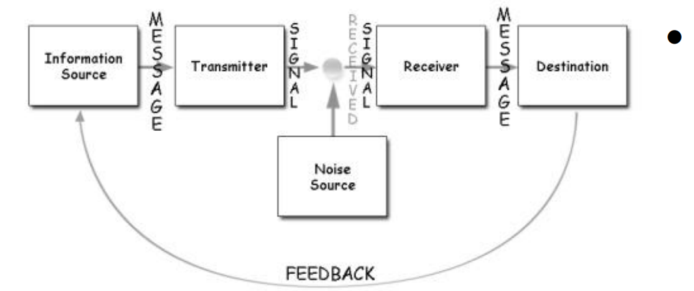
As shown in the picture, the sender, marked as “information source” is the person who makes the messages and makes the decision regarding what channel the messages shall be sent from.

