

International Business LCMB7014

Samsung International Business in Brazil
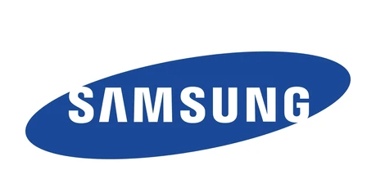

Student name: Viralkumar Panchal
Student Number: 2210866
Lecturer: Dr Hossein Shokri
Submission Date: 03/05/2023
Table of Contents
Introduction 2
Company Background 2
Company’s Objectives and Strategies 2
Countries’ Specifications 3
Home Country 3
Host Country 3
External Analysis 3
A Comparative PESTEL Analysis 3
Industry Five Forces 6
Market Analysis 7
Host Country Analysis 8
Country’s National Diamond 8
Country Business Risks 10
Internal Analysis 11
Global value chain 11
SWOT analysis Global Value chain 11
Global Value chain 11
SWOT analysis 11
International Strategies 11
Entry Modes 11
Corporate Social Responsibility 11
Conclusion 11
References 11
Appendix 11
Appendix 1: Population growth of Brazil 11
Appendix 2: Hofstede country comparison between Brazil and South Korea 11

Introduction
International business suggests business transactions that occupy two or more nations. The transaction can be undertaken either by the government or by a private company. However, the aim and objective of going international tend to be different in a private or public company. For a private company, the salient reason for setting a footprint in an international market is to boost up the profit margin. However, government companies can avail of internationalisation strategy for varied reasons, including achievement of strategic interest, geopolitical interest and various other economic interests. As stated by Hamilton and Webster (2018), some of the striking features associated with international business encompass the exchange of foreign currencies, legal obligations, and engagement of two or more countries. Within international business settings, key activities encompass investment, logistics and sales and so on. International business facilitates companies in terms of enjoying a large consumer base by expanding trade among countries. The purpose of designing the report is to explicate the international business of Samsung. Based on the given case scenario, Samsung is going to expand in Brazil. The business unit selected for the company is a phone. The discussion of the report covers a succinct background of the company, specification of home and host nation, external and internal environment analysis, a comprehensive analysis of the host country, international strategy, market entry mode and CSR and a concise conclusion.

Company Background
Samsung is a manufacturing conglomerate which was established in 1938. Headquartered in Seoul, South Korea, some of the prominent industrial affiliates of the company encompass Samsung Engineering, Samsung Electronics, Samsung Heavy Industries, Samsung Life Insurance and so on (Samsung Global Newsroom, 2023). Among the aforementioned industrial affiliates, Samsung Electronics has been considered the second-largest technology company in the globe by considering revenue (Samsung Global Newsroom, 2023). The product range of Samsung Electronics includes Electronic components, image sensors, batteries, smartphones, home appliances, medical devices and so on. Samsung's mission is to devote its technology and talent in pursuit of developing outstanding services and products that can make an effective contribution to developing a better global society.

Company’s Objectives and Strategies
The objective of Samsung is to encourage its company and products across the globe and ensure that products are well-made, useful and long-lasting (Samsung Global Newsroom, 2023). Besides, as far as strategies are concerned, the business strategy of Samsung is characterised by a high magnitude of flexibility in a manner that reflects the determination of the company to transform itself based on the challenges imposed by the external environment. The salient components of Samsung's strategy include effective market leadership, the development of innovative products and leveraging market opportunities.

Countries’ Specifications
Based on the given scenario, the home nation of Samsung is South Korea and the host nation considered for the assessment will be Brazil. The specification of the home and host country has been elaborated below.
Home Country (Jepan)
As stated by Harzing and Pudelko (2016), in international business, the home country suggests the nation where a business entity maintains its main office. Samsung's home country is South Korea. As pointed out by Harzing and Pudelko (2016), a number of present models and theories concerning multinationals have paid little attention to examining the attractiveness of the home country. The home country of Samsung imparts a range of advantages for the businesses including, internet connectivity, diverse geography, controlled inflation and so on. Further, as far as the economy of South Korea is concerned, it has been observed that the country possesses the 13th largest economy in the globe (Froese, 2019). All these elements have contributed to the overall success of Samsung.
Host Country (China)
In the realm of international business host countries relates to the foreign nations where a company wishes to invest in order to set up a business and ascertain growth (John, WILD and Kenneth, 2019). In the current report, the chosen host country is Brazil. One of the impressive features of Brazil is that the country has a robust infrastructure, connected by ports and railways. The third largest economy of Brazil has also contributed to the enhanced image of the nation to potential investor. As argued by Ekel, et al. (2022), the extent of development of a host country imposes considerable implications on the internationalisation of a company from emerging markets.

External Analysis
The external environment suggests a constellation of elements that a company needs to take into account in pursuit of administering business effectively (Buckley, Enderwick and Cross, 2018). Some of the external environmental elements encompass legal, political, demographic and technological and environmental elements (Rugman and Colinson, 2012). In order to elucidate the opportunities and threats presented by the external business environment of Brazil, a comparative analysis has been presented below.

A Comparative PESTEL Analysis
Political elements:
South Korea is a politically stable country and it has facilitated companies like Samsung to focus more on the international market place for accumulating more profit. However, some of the major political issues that have affected the consumer electronics industry are spiral of corruption (Hui-ya, 2016). However, owing to trade alliances of South Korea, companies of the country are getting immense benefits. Similarly, Brazil has been fostering effective alliances with a number of nations, including Argentina, the United States and Venezuela (de Oliveira et al., 2018). Further, Brazil's membership at different regional and international levels can generate opportunities for new investors.
Economic elements:
South Korea's economy has made considerable progress in recent times and is now regarded as one of the most advanced economies in the globe. As reported by Statista (2023), in the year 2021, the GDP growth has witnessed a 4.15% growth compared to 2020.
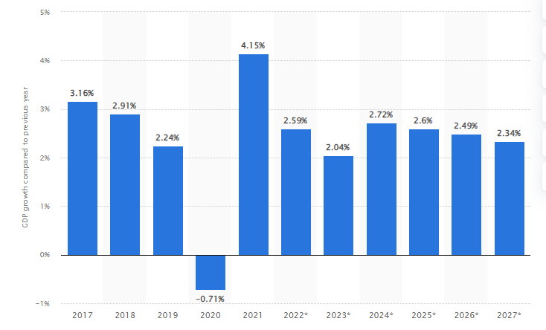
Figure 1; GDP Growth of South Korea
(Source: Statista, 2023)
As reported by Statista (2023), in 2021, the GDP growth rate of Brazil was around 4.62%. Compared to the GDP growth of South Korea, Brazil is little ahead. For a long time, Brazil possesses an enriched history of being the top ten economies of the globe. The impressive GDP growth rate and amplifying consumer purchasing power of Brazil can generate more opportunities for the international and domestic investors to invest in technology and consumer electronics sector.
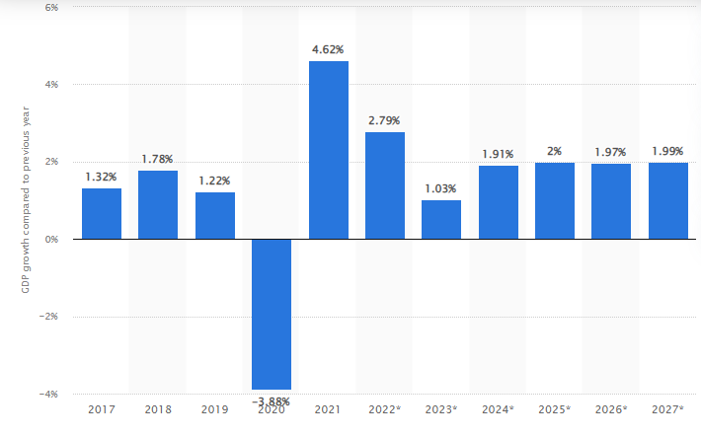
Figure 2: GDP Growth rate of Brazil
(Source: Statista, 2023)
Social elements:
As far as social elements are concerned, South Korea is regarded as one of the most well developed and prosperous nations within South Asia and across the globe. The population of the nation is around 51 million (World Bank, 2023). Compared to South Korea, the population of Brazil is considerably high. Brazil is a populous country with more than 210 million people (World Bank, 2023). The middle class people of Brazil prefer to invest more on expensive and luxury goods. Further, Brazilians love for availing cutting-edge technology. For instance, as reported by Bnamericas (2022), starting from January to May 2022, sales of 5G compatible mobile grew by 230% analogising with the previous year. Therefore, Brazil can be investment destination for Samsung given the favourable social condition.
Technological elements:
As far as technological development is concerned, South Korea’s advanced technology has assisted technological conglomerates like Samsung in terms of increasing its business and garner innovation in order to become a market leader. Further, the country’s progress is also impressive in the realm of AI. While the technology sector of South Korea has been emphasising on futuristic technology, the technological sector of Brazil has witnessed exponential growth of mobile, web development and software and so on. Further, as stated by de Oliveira et al. (2018), Brazil possesses world’s leading information and communication technology market. All these can generate opportunity for Samsung to increase the sale of mobile phone within the country.

Environmental elements:
In recent times, South Korea has been encountering some pressing environmental challenges. As stated by So (2022), some of the key environmental issues prevalent in South Korea encompass Air pollution, emissions, global warming and climate change, overpopulation, deforestation and depletion of natural resources and so on. It has led the government of the country to incorporate strict environmental standards and legislations. Compared to South Korea, environmental legislations are less stringent in Brazil. Therefore, it can assist Samsung to take some time to acclimatise with the country’s environmental standards and legislations. While this factor generated threat in South Korea, it can be an opportunity for Samsung to grow rapidly in Brazil thanks to its flexible legislation.
Legal elements:
As far as the legal system is concerned, South Korea abides by civil law system that has been greatly influenced by European and Japanese law. Further, rules pertaining to foreign investment are rigid in South Korea (Hui-ya, 2016). However, Brazil depends considerably on written contracts with employees. It can assist an international company to eschew lawsuits in the country. Further, compared to South Korea, Brazil inspires the foreign investors to make investment in the country. The legal restrictions in Brazil are restricted to certain industries only.

Industry Five Forces
Formulated by Porter, the Five Force can help businesses in perceiving the extent of competition in the industry, possibility of new entrants, power of consumers, power of suppliers and product alteration threats (Havard et al., 2021).
Competitive rivalry:
In the electronics industry, the extent of competition is overwhelming. Some of the key players in the industry imposing direct challenge to Samsung mobile include LG, Motorola, Apple, Oppo and Xiaomi and so on (Sun and Fah, 2020). By offering cheaper price, China based smartphone manufacturing companies are posing direct challenge to well established brands like Samsung. Thus, the extent of competitive rivalry is remarkably high in the electronics industry.
Entry barriers:
The electronic gadget industry is typified by amplified entry barriers since newcomers need huge financial resources in order to set up R&D, establishing manufacturing facility, setting up distribution channels and developing after sales service infrastructure. Further, nowadays, with the evolution of m-commerce, people are using their smartphones at an extensive scale to search product and process payment (Havard et al., 2021). Therefore, brand trust matters a lot in this industry. It will be daunting challenge for the newcomers to develop brand image in a short time. Resultantly, threat is low to moderate in this industry.
Buyers’ power:
In recent times, the purchasing power enjoyed by the buyers is high owing to the rising domination of low cost mobile companies. Most of these companies are utilising social media and e-commerce platforms in order to sale their products to large number of consumers without engaging any intermediaries like Samsung (Haizar et al., 2020). In price sensitive markets, consumers enjoy high barging power because they want more modern features with lower pricing.
Suppliers’ power:
Suppliers’ power in the realm of consumer electronics industry is low owing to the abundant availability of suppliers in developing countries like China, Vietnam. Further, larger companies like Samsung usually opt for long-term agreement with the suppliers so that it can enjoy smooth supply of raw materials without encountering the challenges of frequent price hike.
Threat of substitution:
In the electric gadget segment, phone has gained tremendous popularity. Moreover, with its rising importance in the realm of digital economy, it has become a part and parcel of the lives of the consumers. Therefore, at present there is hardly any alternative to phone (Sun and Fah, 2020). However, as argued by Haizar et al. (2020), tablets and laptops can be considered as partial substitute of smartphone. Therefore, Samsung might experience low threat in the product substitution quadrant.
Market Analysis
Ad observed by Savitri et al., (2022), in recent times, phones are largely replaced by smartphones. One of the major reasons behind the skyrocketing popularity of smartphone is that it loaded with advanced features and computing capabilities. As reported by Statista (2023), some of the leading smartphone brands include Apple, Xiaomi, Oppo and Samsung. During the fourth quarter of 2022, the market share of Samsung was 19.4%. On the other hand, during the same time, the market share of Apple was 24.1%. Therefore, Apple has substituted Samsung as the top smartphone player (Statista, 2023). As far as market size is concerned, the size of global smartphone market reached at 1,417mn units in the year 2022 (Imarcgroup, 2022). The market is demonstrating a growth rate of 3.6 % from 2023 to 2028 (CAGR). However, as reported by Counterpointresearch (2023), the global revenue of smartphone segment is curtailed by 9% which is seen as lowest since 2017. Some of the key challenges faced by mobile market include growing security and privacy concerns, battery issues, growing consumer demand of launching new features without additional costs. Further, during Covid-19, owing to declined demand, most of the smartphone companies had to incur more inventory cost. It has contributed to price hike of the smartphone across the globe.

Host Country Analysis
Country’s National Diamond (host country)
The interest of setting footprint in the Brazilian market can be explicated by the application of Porter’s diamond model (Tsiligiris, 2018). Following is an elucidation of each of the elements of the model based on the point of view of Brazil.
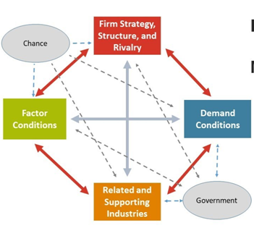
Figure 3: Porter’s Diamond Model
(Source: Tsiligiris, 2018)
Factor conditions:
Factor conditions are expounded as conditions in a nation that business entities can leverage in pursuit of generating an advantage. In the yardstick of Brazil, factor conditions encompass huge labour pool (Tsiligiris, 2018). However, as argued by Anderson (2019), a large section of the population is semi-skilled or low. In accordance with the Diamond Model, overall quality of factor condition is more crucial compared to pure existence. Hence, it is important for Brazil to impart exponential emphasis on qualitative facts and offer necessary platforms for development and innovation. Among the factor conditions, infrastructure is also regarded as an essential element. As averred by Anderson (2019), Brazil lacks basis infrastructure in many aspects. For instance, ports and railroads are still in the developing stage. However, in recent times, a great willingness is discernible from the national Government’s side in order to improve the country’s infrastructure. Growing investment in the telecommunication sector has contributed to the development of a great communication structure in the country.

Demand conditions:
With the improvement of standard of living in Brazil, there is a great demand of different types of consumer goods and appliances. On account of the huge population in the country, the demand market of Brazil is vast and evolving. This has unfurled new investment opportunities in the country. As stated by Gouvea, Kapelianis and Montoya (2018), higher income generates high demands for more verities and quality products to select from. The growth of the middle-class has exerted positive effectuations on the demand. There are also lucrative export potentialities on account of border sharing of the country to most of the South American nations (Anderson, 2019). Considering the GDP growth rate of Brazil, it can be assured that per capita income of the people is also growing.
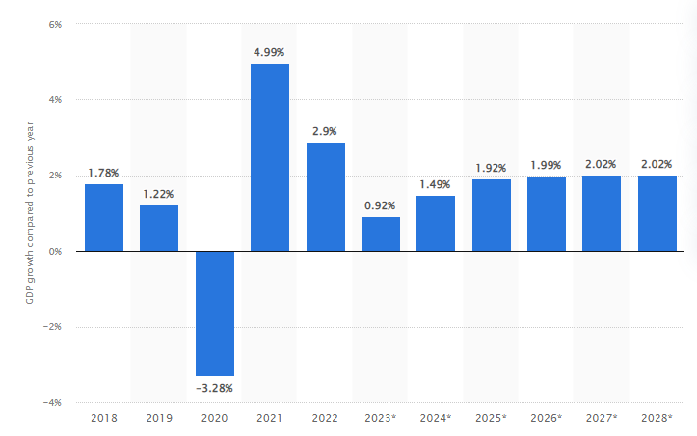
Figure 4: GDP Growth Rate of Brazil
(Source: Statista, 2023)

Supporting industries:
Supporting industries are associated with the capabilities of the local suppliers and in many instances the effective presence of local suppliers can exert positive effectuations (Tsiligiris, 2018). As far as the supporting industries of Brazil are concerned, it can be averred that lack of infrastructure in some places of the country can create obstacles for the foreign investors (Anderson, 2019). However, thanks to the rapid development of infrastructure in the metropolitan area, foreign investors can witness some positive effects in terms of supply chain management.
Firm strategy, structure and rivalry:
With the indemnification of rivalry, companies are required to improve relentlessly in pursuit of staying competitive in the market (Rugman and Colinson, 2012). With the penetration of foreign companies, the extent of competition has been intensified further. As stated by Anderson (2019), the climate of beginning a venture in Brazil is loaded with both positive and negative effectuations. Positive effects are predominantly emerging from deregulation process incorporated by the national government of Brazil in recent years (Ibid, 2019). However, the presence of bureaucracy can generate some challenges for the foreign investors in terms of starting and operating a venture in Brazil.
Government and chance:
In the Porter’s Diamond Model, additional two categories can also be sported that are connected to the four pivotal elements. The Government can play a leading role to create a favourable climate where the economy of Brazil can grow and allure prospective investors. However, as reported by Financial Times (2023), in recent times, Brazil has been undergoing considerable political crisis. Increasing political turmoil can hinder the government to emphasise on innovation and establish a healthy business climate. Therefore, Brazil has the opportunity tom improve macroeconomic stability. As suggested by Anderson (2019), the country has been working towards tax reforms that can create opportunities for the foreign investors.
Country Business Risks (host country)
Some crucial facts about Brazil
GDP | 1.61 trillion USD in 2021 (World Bank, 2023)
Population | 216,667,810 (World Bank, 2023)
Ease of Doing Business rank | 124 (World Bank, 2023)
Global Peace Index ranking | 130 (Visionofhumanity, 2022)

Country Business Risk is expounded as the uncertainty entailed with investing in a specific nation and more particularly the magnitude to which the uncertainty can effectuate losses for the investors (DanielsJohn, RadebaughLee and SullivanDaniel, 2019). The uncertainty can emerge from various factors including political, technological and various economic factors and so on. Some of the key factors that have contributed to the reduction of country business risk include:
- Growth of middle class (Statista, 2023)
- Significant inflows of foreign direct invest, high magnitude of foreign exchange reserves
- Diversification of economy
On the other hand, some of the factors that has contributed to the increasing country business risk in Brazil include:
- Growing political and social tensions (Financial Times, 2023)
- Higher cost of production
- Presence of red tape and high tax rate
Further, as stated by Anderson (2019), although the pro-business reform pipeline was motivating, Brazil’s pre-pandemic fiscal outlook was exponentially fragile. Moreover, the economy of the nation has been encountering amplified risk on account if rising inflation and social risks.

Internal Analysis

Global value chain
- Global Production
- Global Marketing
- Global HRM

SWOT analysis Global Value chain

Global Value chain
Global production:
Samsung is one of the biggest smartphone makers in the globe. The company has manufacturing facilities in various parts of the world. For manufacturing Samsung has exponential dependence on low-cost countries like India and Vietnam. Earlier, Samsung has greater dependence on China. However, in recent times, the company has terminated its dependence on China and emphasising more on India and Vietnam (Yeung, 2021). The company has invested a lion’s share in India in order to ramp up its production in India. In Vietnam, the existing factories are capable to produce 120 million units of smartphones every year. Apart from manufacturing facilities, the R&D centres of Samsung are situated in different parts of the globe, including Bangaluru (India), Austin (United States), SanJose (United States), Tel Aviv (Israel) and so on (Yeung, 2021).
Global marketing:
The Global marketing strategy of Samsung emphasises on evolving innovative products that are largely backed by effective promotional campaigns and branding. As stated by Szo et al. (2019), incorporation of strategic marketing approaches has contributed to the solidification of the Samsung’s brand value. The company’s extensive utilisation of leading social media platforms has offered an exponential impetus in its strategic marketing approaches. Samsung has active presence in all the leading social media sites, including Twitter, Facebook, Instagram, and YouTube and so on. It is relevant to point out that Samsung’s social media profiles are aligned with local country cultures and preferences. For example, Samsug’s Instagram has country specific profiles like Samsung UK, Samsung India and Samsung Mobile and so on. Further, by emphasising constantly on product quality and opting for adaptation as per necessity, Samsung has managed to establish a consistent global brand image. However, as argued by Havard et al. (2021), as far as global marketing is concerned, Samsung is lagging behind Apple.
Global HRM:
Samsung’s Human Resource Management is situated on the ethos that company lies within its people. Samsung has demonstrated enough commitments to set up a creative environment where employees belonging to diverse culture and orientation can sustain and survive. Further, as a global company, Samsung seeks to fulfil its social responsibilities by incorporating ethics in human resource management (Bailey et al., 2018). As reported by Statista (2022), Samsung has an employee of base of 266,673. As a part of its global HRM policies the company has demonstrated strong commitment in order to terminate discrimination based on academic background, gender, age and race. The company has training arrangement for the employees in both online and offline. Further, in order to assist employees to the farthest, Samsung has global career consulting centres. Some of the salient aspects of Samsung’s Global HRM are as follows:
- HR development for the future
- Dynamic organisational culture (Bailey et al., 2018)
- Creative and innovate performance-based system

SWOT analysis
Strengths | Weaknesses
- In the domain of global smartphone market, Samsung has exponential domination and ranked second after Apple (Savitri et al., 2022)  - The company has a world-class infrastructure concerning research and development  - The company is famous for eco-friendly innovations and has ranked 8th in among the telecom companies by Environmental Protection Agency  - Samsung possesses diversified portfolio, including consumer electronics, device solutions and information technology and so on (Haizar et al., 2020) | - One of the major challenges encountered by Samsung in recent times is the decline of the sale of smartphones  - Extreme competition with Apple and other low-cost Chinese smartphone manufacturing brand has been affecting the revenue of Samsung (Čirjevskis, 2019)  - The brand image of the company has received severe jolt due to increasing number of faulty products (Ibid, 2023)  - The company has greater dependence on North America in terms of generating revenue
Opportunities | Threats
- Samsung has the opportunity to curtail its overdependence on North American countries  - The company needs to opt for more innovation to Smartphones more sustainable, for instance innovating on sustainable battery technology | - Increasing competition with Apple, Huawei and Xiaomi can cause sales debacle for Samsung  - As reported by AnTuTu (2023), growth of counterfeit products can emergence as a great threat for the coming days since 36% of Smartphones are just the counterfeit of Samsung

International Strategies
As far as international strategy is concerned, application of Bartlett and Ghoshal Model can be effective to explicate the existing international strategies of Samsung as well as propose new strategy for the company to expand in Brazil. Based on the aforesaid Model, available strategic options for Samsung encompass multidomestic, transnational, international and global (Grant and Phene, 2022).
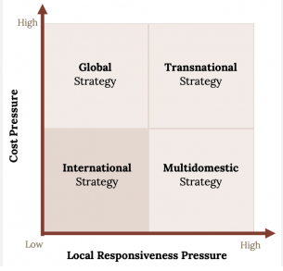
Figure 5: Bartlett and Ghoshal Model
(Source: Grant and Phene, 2022)
Firms usually pick multidomestic strategy to provide enhanced emphasis on responding to local requirements in respective markets. Rather than enforcing the consumers towards standardisation, the strategy assists the company to opt for greater adaptation in order to increase the possibility of success by addressing various posed by each country (Grant and Phene, 2022). Global strategy dismisses the options of responding to local market needs and advocates for greater standardisation. While seeking a middle ground between global and multidomestic tactics, firms usually opt for transnational strategy. At present, Samsung has been utilising this strategy across the globe. It has assisted the company to keep the core product-lines same while making moderate adaptation in product features and pricing (Stallkamp and Schotter, 2021). When firms are neither bothered about costs nor about local culture, selection of international strategy can be justified.
In order to expand in Brazil, one of the essential aspects that need extensive emphasis is national culture of the two nations. Based on the application of the country comparison model of Hofstede, it is evident that there are some common grounds between the cultures of two countries. Similarities are discernible in areas like power distance, individualism, uncertainty avoidance and masculinity (Hofstede-insights, 2023). Therefore, Samsung can capture the market of Brazil without opting for extensive adaptations. Therefore, the company can continue to opt for transnational strategy in order to set footprint in Brazil. Adoption of transnational strategy can confer following advantages to Samsung:
- Swift and better market penetration (Grant and Phene, 2022)
- Enhanced comprehension about local culture
- Cost advantage due to the necessity of little adaptation

Entry Modes
As stated by Schellenberg, Harker and Jafari (2018), Samsung is a multinational conglomerate that is typified by its strategic geo-centric orientation concerning external markets. As far as international market entry modes are concerned, Samsung has entered into international market in three predominant ways, including direct export, merger and acquisition, joint venture and foreign direct investment (Samsung, 2023).
Export:
Export is assumed as the easiest entry modes for the companies in order to make their presence happen in a foreign country. As defined by Kotabe and Helsen (2022), export is defined as the processing of selling the production of a firm to foreign nations where the company has no manufacturing facility. All products are usually sourced from home nations. For a long time, Samsung has been exporting some of its flagship models directly to the United States and EU countries owing to huge production cost in the Western countries (Samsung, 2033). It has assisted the company to achieve significant cost saving.

Merger & acquisition:
The process that facilitates consolidation of enterprises or their salient business assets via financial transactions is known as merger and acquisitions. Some of the notable advantages of this market entry mode include improved economies of scale, enhanced financial resources, amplified market share and enhanced distribution capabilities (Schellenberg, Harker and Jafari, 2018). Some of the challenges frequented by firms during merger and acquisitions encompass job losses, cultural disparity, high employee turnover and loss of business opportunity to delay. As reported by Samsung (2023), Samsung acquires network service provider TeleWorld Solutions in pursuit of accelerating the expansion of 5G network in the United States.
Joint venture:
At present, Samsung has opted for joint venture in order to outsource some of its smartphone model from China-based manufacturers. It has assisted the company to achieve cost advantage. Further, as stated by Samsung (2023), Samsung has opted for joint venture with the leading Indian telecom service provider Jio to upgrade mobile communication.
Foreign direct investment:
As far as foreign direct investment is concerned, it has been observed that it has also remained a viable choice for Samsung in terms of expanding in countries like China, Vietnam and India. Salient advantages associated with FDI include enhanced control over production and quality (Samsung, 2023), development of human resource and technology development. However, huge cost requirement often obstructs companies to opt for this entry mode.
Entry mode selection for Samsung to enter in Brazil:
After exploring all the options, the prudent choice for Samsung will be joint venture. Considering the developing nature of the country, FDI will not be a suitable option since it can pose high risk. Further, rising threat in social and political arena, opting for joint venture with an indigenous company can assist Samsung to save huge cost of setting up infrastructure. JV can also impart the company a better clarity about the mobile market dimension of Brazil.

Corporate Social Responsibility
Corporate Social Responsibility is based on the idea that a company needs to play a leading role within the community and pay much consideration on the social and environmental effects associated with business decisions. A famous model to explicate the CSR strategy of a company is Carroll’s Pyramid. The CSR strategy of Samsung has been expounded below with the help of this model:
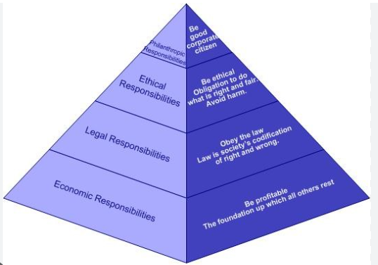
Figure 6: Carroll’s CSR Pyramid
(Source: Štreimikienė and Ahmed, 2021)
Economic responsibilities:
Economic responsibility is the concerned with the duty of a company to manufacture services and goods as per the wants and needs of the consumers (Štreimikienė and Ahmed, 2021). Samsung’s economic responsibility is well demonstrated in the company’s consistent effort of launching midrange phones in Asian markets based on the demand of the consumers (Chang, Zhang and Xiong, 2019).
Legal responsibilities:
Failing to abide by respective laws of countries can result in shuttered brand image of a company. As reported by Economist (2020), Samsung has been encountering a series of legal challenges owing to stock price manipulation, unfair trading and infringing accounting rules.
Ethical responsibilities:
Being fair in all circumstances is regarded as one of the major ethical responsibilities of the modern day corporations. Samsung has formulated Samsung Global Code of Conduct to encourage all the employees to take necessary actions and ensure value judgement. As reported by Samsung (2023), Samsung has set an ambitious goal of attaining operation backed by clean energy by 2050.
Philanthropic responsibilities:
Samsung has been well known in business world for its charitable activities across the world, especially in developing countries. For instance, as reported by Samsung (2023), the Samsung Hope for Children program was developed to bring difference in the lives of the children all over the globe. The program also encompasses financial and medical support for children.

Conclusion
In conclusion, it can be averred that based thanks to the faster growth prospect and huge population base in Brazil, it can be a viable option for Samsung to enter in the country. Based on the SWOT analysis, it is apparent that Samsung’s market is consolidated in North America only. Therefore, by expanding in Brazil Samsung can reduce the competitive pressure to some extent. Further, based on the application Porter’s Five Force Model, it has become apparent that Samsung has been encountering neck-to-neck rivalry with Apple and other Chinese mobile brands. Based on the comparative external environment analysis between South Korea and Brazil, it is evident that although Samsung has been facing a number of challenges in its home country, including environmental challenges, growth issues and prevalence of corruption. Therefore, international expansion has become indispensable for Samsung to mitigate various challenges posed by the external environment of its home country. Based on the application of Porter’s diamond on Brazil, it is evident that despite some challenges factor conditions, supporting industries, Brazil has been developing at quick space. Despite weaknesses in legal compliance, Samsung has a robust CSR strategy that has been translated into enhanced brand image of the company. Summing up, Samsung can consider Brazil as a gateway to pave the way for growth in Latin American region in future.

References
Aantutu. (2018) Antutu Labs: Knockoff smartphone market report 2017. Available at: https://www.antutu.com/en/doc/113012.htm (Accessed: April 21, 2023).
Anderson, P., (2019). Brazil Apart: 1964–2019. Verso Books.
Bailey, C., Mankin, D., Kelliher, C. and Garavan, T., (2018). Strategic human resource management. Oxford University Press.
BNamericas (2022) BNAMERICAS - 5G smartphone sales grow 230% in Brazil, BNamericas.com. BNamericas. Available at: https://www.bnamericas.com/en/news/5g-smartphone-sales-grow-230-in-brazil#:~:text=A%20survey%20carried%20out%20by,period%20of%20the%20previous%20year. (Accessed: March 31, 2023).
Brazil (2022) Data. Available at: https://data.worldbank.org/country/BR (Accessed: March 31, 2023).
Buckley, P.J., Enderwick, P. and Cross, A.R. eds., 2018. International business. Oxford University Press.
Chang, V., Zhang, W. and Xiong, C., (2019). The strategic view and development of corporate social responsibility: the case study of Samsung. International Journal of Strategic Decision Sciences (IJSDS), 10(1), pp.105-130.
Čirjevskis, A., (2019). The role of dynamic capabilities as drivers of business model innovation in mergers and acquisitions of technology-advanced firms. Journal of Open Innovation: Technology, Market, and Complexity, 5(1), p.12.
Counterpointresearch (2023) Global smartphone market share: Q1 2021 to Q4 2022, Counterpoint Research. Available at: https://www.counterpointresearch.com/global-smartphone-share/ (Accessed: April 21, 2023).
DanielsJohn, D., RadebaughLee, H. and SullivanDaniel, P., (2019). International business: Environments and operations. Pearson Prentice Hall.
de Oliveira, J.A.S., Basso, L.F.C., Kimura, H. and Sobreiro, V.A., (2018). Innovation and financial performance of companies doing business in Brazil. International Journal of Innovation Studies, 2(4), pp.153-164.
Economist. (2020). No end in sight for Samsung's legal troubles (no date) The Economist. The Economist Newspaper. Available at: https://www.economist.com/business/2020/06/18/no-end-in-sight-for-samsungs-legal-troubles (Accessed: April 21, 2023).
Edwards, T., Schnyder, G. and Fortwengel, J., 2019. Mapping the impact of home‐and host‐country institutions on human resource management in emerging market multinational companies: A conceptual framework. Thunderbird International Business Review, 61(3), pp.531-544.
Ekel, P., Bernardes, P., Vale, G.M.V. and Libório, M.P., (2022). South American business environment cost index: reforms for Brazil. International Journal of Business Environment, 13(2), pp.212-233.
Financial Times. (2023) Brazil's political crisis gives Lula chance to solidify his support, Subscribe to read | Financial Times. Available at: https://www.ft.com/content/4c87a33c-f1ac-4d0d-9cd2-fd5c9901bda5 (Accessed: April 21, 2023).
Froese, F.J. ed., (2019). Doing business in Korea. Routledge.
Gouvea, R., Kapelianis, D. and Montoya, M., (2018). Marketing challenges and opportunities in emerging economies: A Brazilian perspective. Thunderbird International Business Review, 60(2), pp.193-205.
Grant, R. and Phene, A., (2022). The knowledge based view and global strategy: Past impact and future potential. Global Strategy Journal, 12(1), pp.3-30.
Haizar, N.F.B.M., Kee, D.M.H., Chong, L.M. and Chong, J.H., (2020). The impact of innovation strategy on organizational success: A study of Samsung. Asia Pacific Journal of Management and Education (APJME), 3(2), pp.93-104.
Haizar, N.F.B.M., Kee, D.M.H., Chong, L.M. and Chong, J.H., (2020). The impact of innovation strategy on organizational success: A study of Samsung. Asia Pacific Journal of Management and Education (APJME), 3(2), pp.93-104.
Hamilton, L. and Webster, P., 2018. The international business environment. Oxford University Press.
Harzing, A.W. and Pudelko, M., (2016). Do we need to distance ourselves from the distance concept? Why home and host country context might matter more than (cultural) distance. Management International Review, 56, pp.1-34.
Havard, C.T., Havard, C.T., Hutchinson, M. and Ryan, T.D., (2021). Are you team Apple or team Samsung? Investigating rivalry in sport and mobile phone brands. Rivalry and Group Behavior Among Consumers and Brands: Comparisons In and Out of the Sport Context, pp.57-79.
Hofstede Insights. (2023). Country comparison. Available at: https://www.hofstede-insights.com/country-comparison/brazil,south-korea/ (Accessed: April 21, 2023).
Hui-ya, W., (2016). A study of negotiating strategies in South Korea. Journal of Literature and Art Studies, 6(8), pp.951-957.
Imarcgroup. (2023). Smartphone market share, size, growth and forecast 2023-2028 (no date) Share, Size, Growth and Forecast 2023-2028. Available at: https://www.imarcgroup.com/smartphone-market#:~:text=Market%20Overview%3A,3.6%25%20during%202023%2D2028. (Accessed: April 21, 2023).
John, J., WILD, W. and Kenneth, L., 2019. INTERNATIONAL BUSINESS: The Challenges of Globalization, Global Edition. Pearson Education Limited. Pearson.
Kotabe, M.M. and Helsen, K., (2022). Global marketing management. John Wiley & Sons.
Malek, J., (2016). Environment of doing business in East Asia: South Korean experience. The Journal of Industrial Distribution & Business, 7(1), pp.19-25.
O'Neill, A. (2023) South Korea - gross domestic product (GDP) growth 2027, Statista. Available at: https://www.statista.com/statistics/263758/gross-domestic-product-gdp-growth-in-south-korea/ (Accessed: March 31, 2023).
Rugman, A.M., and Colinson, S., (2012). International business. Pearson UK.
Samsung (2021) Samsung global_nw. Available at: https://www.samsung.com/global/business/networks/insights/press-release/jio-and-samsung-shift-the-indian-lte-mobile-market-landscape-once-again/ (Accessed: April 21, 2023).
Samsung (2023). Acquisition archives (no date) Samsung US Newsroom. Available at: https://news.samsung.com/us/tag/acquisition/ (Accessed: April 21, 2023).
Samsung (2023). Samsung earns Energy Star Partner of the year awards for environmental protection (no date) – Samsung Global Newsroom. Available at: https://news.samsung.com/global/samsung-earns-energy-star-partner-of-the-year-awards-for-environmental-protection (Accessed: April 21, 2023).
Samsung Global Newsroom (2023). All the latest news, key facts and inspiring stories about Samsung Electronics. Available at: https://news.samsung.com/global/ (Accessed: March 31, 2023).
Savitri, C., Hurriyati, R., Wibowo, L. and Hendrayati, H., (2022). The role of social media marketing and brand image on smartphone purchase intention. International Journal of Data and Network Science, 6(1), pp.185-192.
Schellenberg, M., Harker, M.J. and Jafari, A., (2018). International market entry mode–a systematic literature review. Journal of Strategic Marketing, 26(7), pp.601-627.
So, W. (2022) South Korea: Leading Environmental Issues 2019, Statista. Available at: https://www.statista.com/statistics/999569/south-korea-leading-environmental-issues/ (Accessed: March 31, 2023).
Stallkamp, M. and Schotter, A.P., (2021). Platforms without borders? The international strategies of digital platform firms. Global Strategy Journal, 11(1), pp.58-80.
Statista (2022) Brazil - gross domestic product (GDP) growth rate 2027, Statista. Available at: https://www.statista.com/statistics/263615/gross-domestic-product-gdp-growth-rate-in-brazil/ (Accessed: March 31, 2023).
Statista (2023) Smartphone market shares by vendor 2009-2022, Statista. Available at: https://www.statista.com/statistics/271496/global-market-share-held-by-smartphone-vendors-since-4th-quarter-2009/ (Accessed: April 21, 2023).
Statista. (2022) Samsung Employees Worldwide 2009-2021, Statista. Available at: https://www.statista.com/statistics/236919/number-of-samsung-electronics-employees-worldwide/ (Accessed: April 21, 2023).
Štreimikienė, D. and Ahmed, R.R., (2021). Corporate social responsibility and brand management: Evidence from Carroll’s pyramid and triple bottom line approaches. Technological and Economic Development of Economy, 27(4), pp.852-875.
Sun, L. and Fah, C.T., (2020). Xiaomi-transforming the competitive smartphone market to become a major player. Eurasian journal of social sciences, 8(3), pp.96-110.
Szot, T., Specht, C., Specht, M. and Dabrowski, P.S., (2019). Comparative analysis of positioning accuracy of Samsung Galaxy smartphones in stationary measurements. PloS one, 14(4), p.e0215562.
Tsiligiris, V., (2018). An adapted Porter Diamond Model for the evaluation of transnational education host countries. International Journal of Educational Management.
Visionofhumanity. (2022). Global peace index map " The most & least peaceful countries (2023) Vision of Humanity. Available at: https://www.visionofhumanity.org/maps/ (Accessed: April 21, 2023).
World Bank. (2023). Brazil - World Bank Open Data. Available at: https://data.worldbank.org/country/BR (Accessed: April 21, 2023).
Worldbank . (2022). Population, total (no date) World Bank Open Data. Available at: https://data.worldbank.org/indicator/SP.POP.TOTL (Accessed: April 21, 2023).
Worldbank. (2022). World Bank Open Data. Available at: https://data.worldbank.org/indicator/IC.BUS.EASE.XQ%22 (Accessed: April 21, 2023).
Yeung, H.W.C., (2021). The trouble with global production networks. Environment and Planning A: Economy and Space, 53(2), pp.428-438.

Appendix

Appendix 1: Population growth of Brazil
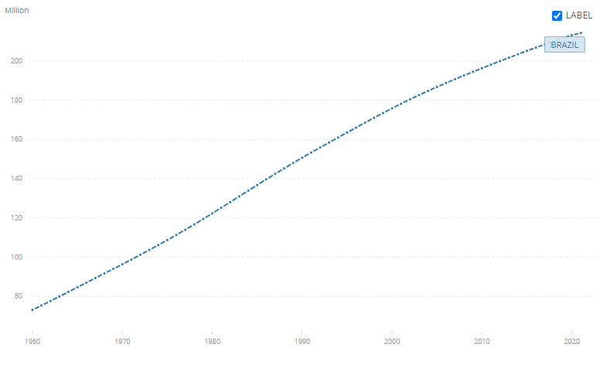
(Source: World Bank, 2023)

Appendix 2: Hofstede country comparison between Brazil and South Korea
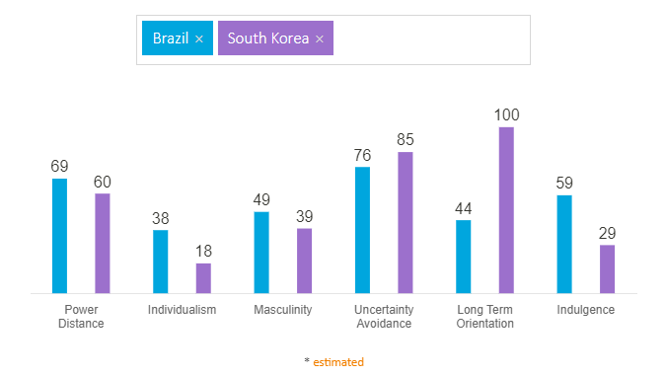
(Source: Hofstede-insights, 2023)

