
STUDENT NUMBER: 2313492
PROGRAMME: BA Leadership and Management Skills for the Workplace
MODULE NAME: Leading and Implementing Change (LIC)
MODULE CODE: LCLM6003
ASSIGNMENT: A Strategic Change Plan
LECTURER: Sujeewa Herath Mudiyanselage

TABLE OF CONTENTS
INTRODUCTION 3
ENVIRONMENTAL AND ORGANISATIONAL ANALYSIS – JLR (UK) 4
INTERNAL ENVIRONMENTAL ANALYSIS: (SWOT/McKinsey 7S) 4
SWOT ANALYSIS: 4
MCKINSEY'S 7S FRAMEWORK: 5
EXTERNAL ENVIRONMENTAL ANALYSIS: (PESTLE/PORTER’S FIVE FORCES) 6
PESTLE ANALYSIS: 6
PORTER'S FIVE FORCES: 7
HOW EXTERNAL ENVIRONMENT MAY IMPACT ORGANIZATIONAL CHANGE – JLR (UK) 8
BARRIERS TO ORGANISATIONAL CHANGE: 8
TRIGGERS OF CHANGE: 9
DIGITAL DISRUPTION (CYBER ATTACK 2025) 9
EVALUATION OF CHANGE MANAGEMENT MODELS – JLR (UK) 10
CHANGE MANAGEMENT MODELS: 10
COMPARING AND CONTRASTING CHANGE MANAGEMENT MODELS 11
THE SUITABLE MODELS: 13
EVALUATION OF LEADERSHIP AND ORGANISATIONAL CULTURE IN CHANGE – JLR (UK) 13
ROLE OF LEADERSHIP STYLES AND CULTURE: 13
LEADERSHIP STYLES: 14
ORGANISATIONAL CULTURE: 14
PROPOSED STRATEGIC CHANGE MANAGEMENT PLAN - JLR (UK) 14
PROPOSED PLAN: 15
CHANGE VISION AND OBJECTIVES: 15
STAKEHOLDER ANALYSIS: 15
COMMUNICATION PLAN: 16
FINANCIAL AND RESOURCE PLAN: 16
RISK ASSESSMENT AND MITIGATION: 16
EVALUATION AND KPIS: 16
Evaluation: 17
KPIs: 17
DISCUSSION AND CRITICAL REFLECTION 17
CONCLUSION 18
REFERENCE LIST 19

INTRODUCTION
Jaguar Land Rover Limited (short JLR), a British automotive company, was established in 2008 when Jaguar and Land Rover merged into one. Jaguar began way back in 1922, with Sir William Lyons starting the Swallow Sidecar Company, later Jaguar Cars Limited. Land Rover was created in 1948 by the Rover Company. Jaguar Land Rover is currently owned by Tata Motors, an Indian multinational automotive manufacturing conglomerate. Jaguar Land Rover became part of Tata Motors when it bought the two brands from Ford in 2008. Jaguar Land Rover’s head office is based in Whitley, Coventry.
Jaguar Land Rover employs approximately 30,000 employees within the UK, across its various manufacturing plants and offices. Some of their most notable locations within the UK are Solihull, Castle Bromwich, and Halewood. JLR holds a considerable market share within the premium car sector, rivalling BMW, Mercedes-Benz, Audi, and Volvo, to name a few. However, like any other company, JLR has experienced its ups and downs. Demand for premium cars has fallen due to various economic and social factors such as the change in consumer behaviour, cost of living crisis, uncertainty around Brexit and the need for manufacturers to switch to electrification.
Moving into 2024, Jaguar Land Rover continues to face many of these problems. Consumer behaviour has now changed towards more sustainable luxury vehicles, as well as started the change to electrified vehicles. JLR have implemented their “Reimagine” plan, which aims to target these problems with a shift towards sustainable luxury and electrification. Finance-wise, the company is still recovering from the pandemic but is slowly seeing improvement. However, there are some challenges with the supply chain due to the shift to EVs
Analysts forecast that Jaguar Land Rover's (JLR) market share of new car sales in the UK will be around 3.14% in 2025. Continuing investment in electric vehicles and model revisions, JLR look to strengthen their position within the luxury sector against growing competition from both existing and emerging car manufacturers. (smmt, 2025)

Brand | Estimated Share (%)
BMW | 6.1
Toyota | 4.5 estimated
Mercedes-Benz | 4.4 estimated
Jaguar Land Rover | 3.1
Others | 81.9
(“Others” includes Volkswagen, Ford, Kia, Audi, MG, Nissan)
Figure 1 (Market Share)

ENVIRONMENTAL AND ORGANISATIONAL ANALYSIS – JLR (UK)
On an environmental level, Jaguar Land Rover UK is acting against changes in the automotive industry by investing time and money into electrification. Sustainability and carbon neutrality efforts include their Reimagine strategy, which pledges that by 2039 Jaguar Land Rover will have reached zero tailpipe emissions across its product lineup while becoming net-zero carbon. Additional work in recycling, sustainable materials, and ethical sourcing has been done.
On an organisational level, JLR UK has changed by restructuring its business, embracing digital transformation, and developing talent to build a more innovative company culture that can adapt to unexpected events. Global events such as Brexit and the COVID-19 pandemic have proven to JLR that they need to become more versatile and adaptive to thrive in today's world. Implementing shifts to more sustainable business practices can be challenging in legacy operations and supply chains. (Qamar, et al, 2025)

INTERNAL ENVIRONMENTAL ANALYSIS: (SWOT/McKinsey 7S)

SWOT ANALYSIS:
For JLR UK to maintain and improve its already existing business strategies, gaps in their cyber security governance, culture, and technology should be addressed. After experiencing a cyber-attack in 2025, they were forced to view cybersecurity as a risk to the organisation and could use their attack as an opportunity to make cybersecurity a long-term strength. (Sihite, et al, 2025)
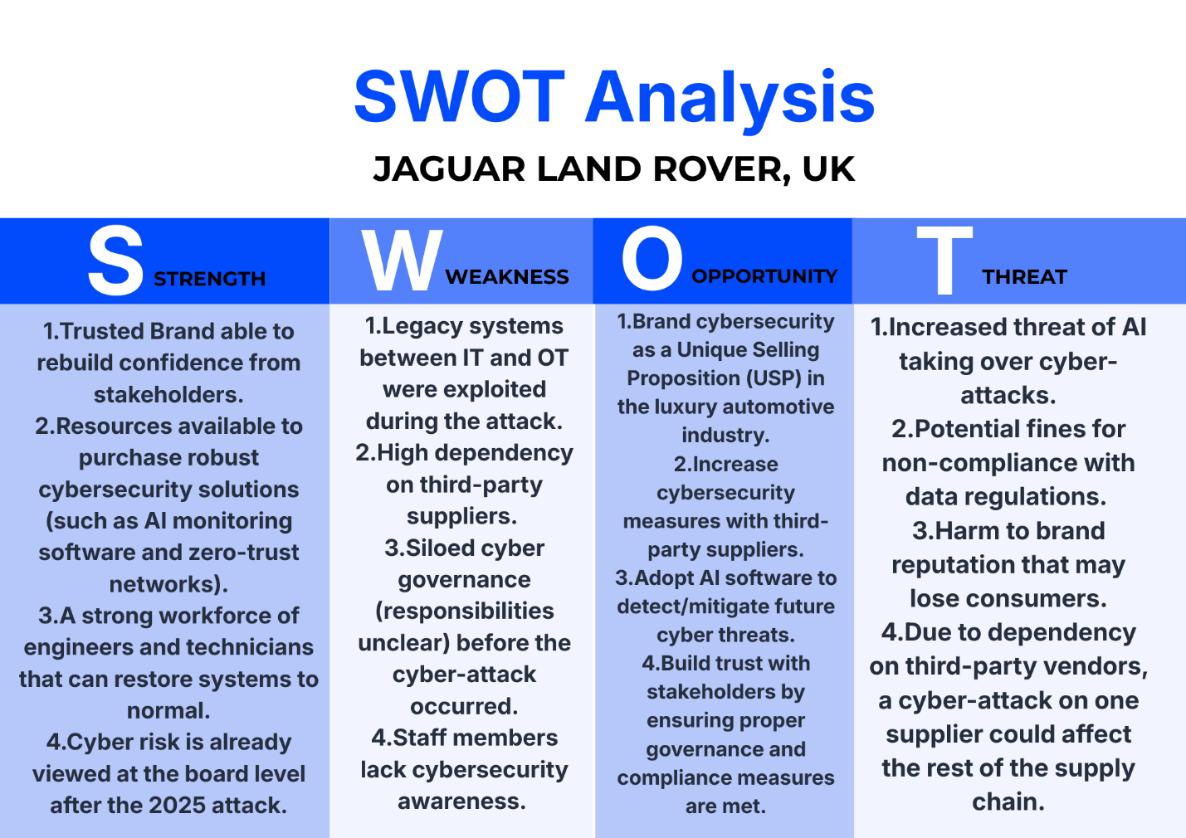
Figure 2 (SWOT Analysis)

MCKINSEY'S 7S FRAMEWORK:
McKinsey's 7S is aligned by Innovation and Upskilling Employees (systems) and Leadership for learning and adapting (leadership). JLR's reaction to the 2025 cyber-attack showed us that cyber resilience will need organisation-wide change, as well as treating cyber-attacks like a crisis. Studies have also shown that Cyber resilience needs alignment across strategy, structure, culture and skills. McKinsey's 7S framework can help JLR change their "HARD" elements. Such as obsolete systems, lack of cybersecurity skills and "SOFT" elements to adapt to changes involving cyber resilience. (Brass, 2025)
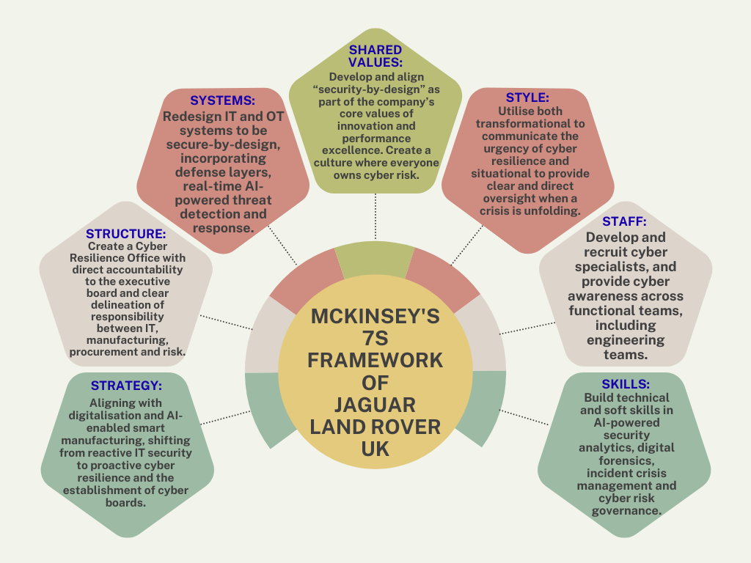
Figure 3 (McKinsey's 7S Framework)

EXTERNAL ENVIRONMENTAL ANALYSIS: (PESTLE/PORTER’S FIVE FORCES)

PESTLE ANALYSIS:
While cyber-attacks can be thought of as purely technological risks, this exercise shows that the attack JLR suffered in 2025 affected us across a variety of facets of our business. JLR will need to consider regulations, technology, cost and culture when looking to effectively manage cybersecurity moving forward. (Ricci, et al., 2021)
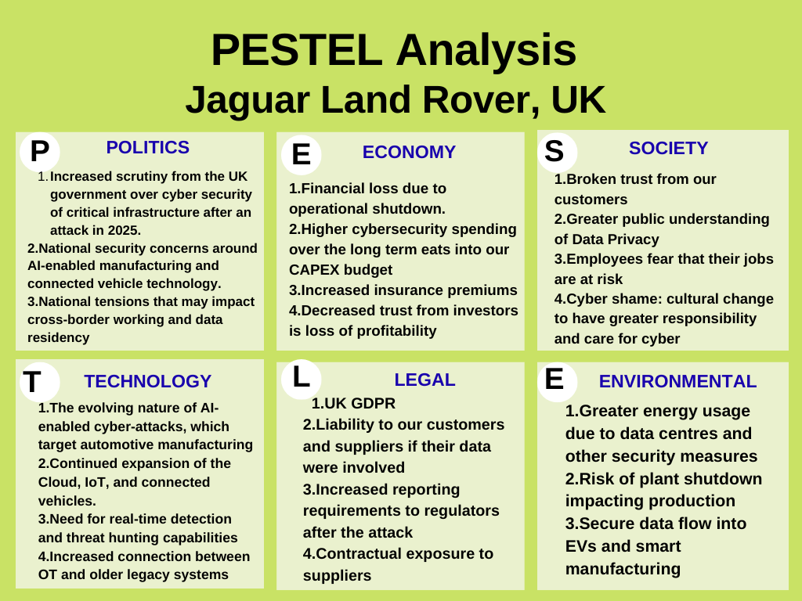
Figure 4 (PESTLE Analysis)

PORTER'S FIVE FORCES:
The 2025 cyber-attack directly fueled a more competitive landscape. Digital trust and resilience became key battlegrounds in the market. To stay competitive, cybersecurity needs to become a strategic advantage for JLR UK by defending market share, mitigating supplier risk and hardening competitive advantage. The JLR follows competitive advantages. (Miura, 2025)
Threat of New Entrants (Moderate but Growing)
Power of Suppliers (High)
Power of Buyers (Increasing)
Threat of Substitutes (Moderate)
Competitive Rivalry (High and Intensified Post-Attack)
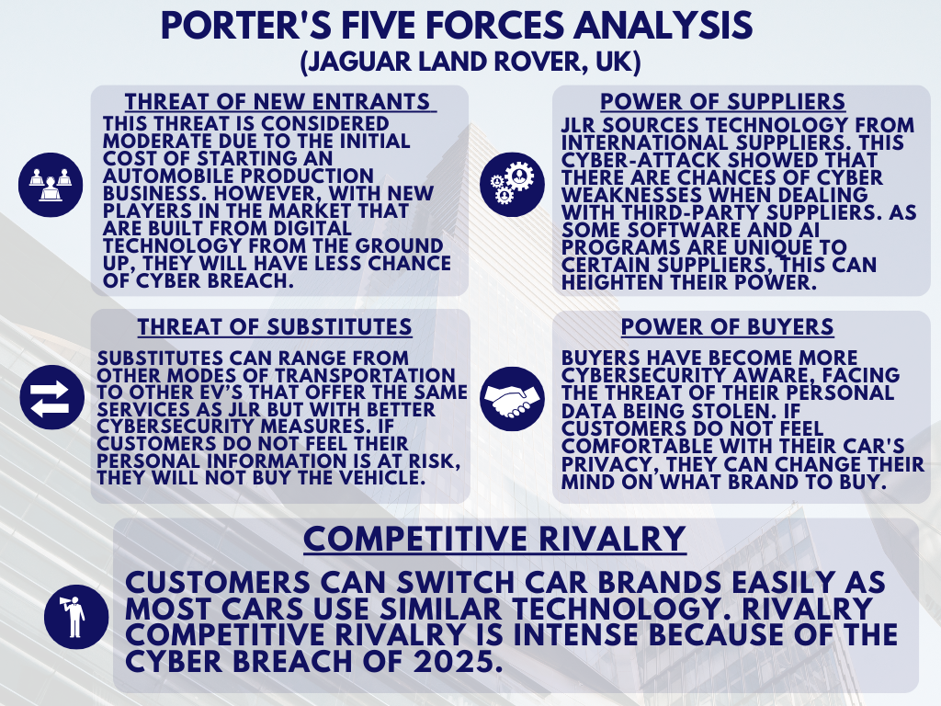
Figure 5 (Porter’s Five Forces Framework)

HOW EXTERNAL ENVIRONMENT MAY IMPACT ORGANIZATIONAL CHANGE – JLR (UK)
Organisational changes at JLR may include strategic shifts towards sustainability and digital transformation in response to political and environmental factors. Economic pressures may lead to cost optimisation initiatives. Social trends could drive product innovation towards EVs. Technological forces might push JLR to invest in R&D for advanced automotive technologies. Legal requirements could necessitate compliance-driven changes in manufacturing processes. (Gborogbosi and Amah, 2025)

BARRIERS TO ORGANISATIONAL CHANGE:
Resistance from employees, fear of the unknown, poor communication, lack of leadership, and resource constraints are some of the main barriers to organisational change. Other factors, such as organisational culture, lack of training, and lack of vision, can also impede change.

TRIGGERS OF CHANGE:
Triggers of change at Jaguar Land Rover include technological advancements, changes in consumer preferences, environmental regulations, and market competition. Economic factors such as Brexit and global economic shifts are also influential. These factors prompt initiatives in innovation, restructuring, and sustainability efforts. (Zangana, 2025)

DIGITAL DISRUPTION (CYBER ATTACK 2025)
Digital transformation - one of Jaguar Land Rover's core business continuity risks - has expanded rapidly in response to the growing demand for digital services from customers and the business's own need for advanced operational technology. These advances covered connected-car services, as well as electric vehicle options, presenting both opportunities and risks to manufacturing and supply chain operations. Digital change has been a differentiator for Jaguar Land Rover, but the cyberattacks of July/August 2025 demonstrated that cyber resilience should be a priority when undergoing digital transformation. (Derrick, 2025)
Operational technology relies more on software and connectivity; Jaguar Land Rover (JLR) tracks fleet data in real time, utilises digital twin technology tools, and has connected factories for manufacturing. JLR is upgrading its production lines to software-defined vehicles and automatic quality control. As industrial capabilities grow digitally, so do cybersecurity threats. Attackers are becoming more sophisticated, with potential future threats including AI-powered attacks. JLR suffered from growing digitally without proper cybersecurity governance, which impacted their business. (Collins, 2025)
On September 2nd, 2025, Jaguar Land Rover became a victim of a cyber-attack that “triggered the emergency shutdown of its global IT network and production”. The shutdown forced JLR to pause production at its main UK locations, including Solihull, Halewood, and Wolverhampton, as well as factories in China and Slovakia. The shutdown impacted business for weeks and was “among the most serious cyber-attacks on a UK manufacturer”. The factory was unable to produce any vehicles if the network was shut down, JLR cut their systems off from the intruder. (Jaguar Land Rover, 2025)
First and foremost, production came to a halt at JLR’s four main UK factories. “Building approximately 1,000 cars every day,” now no cars were coming off the line, which led to hundreds of thousands of missed vehicles and millions of pounds lost in revenue that quarter. Jaguar Land Rover breach led to substantial financial losses for the company, which reported £310m loss after a lengthy cyber-attack. (ITV News Central, 2026)
Digitally transforming a company has always included change management. With JLR recently experiencing a cyber-attack due to their digital transformation, there are some changes that will need to be implemented. JLR wants to go back to the drawing board with any kind of digital change and make sure cyber resilience is integrated into the project. With any change, there will be formal governance around the process, but cyber resilience can be built into that by doing cyber risk assessments when first starting any project. Another change that will need to happen is having IT, OT, and safety teams all meet and communicate. These three teams will need to know what each other’s plans are to keep the company running if another attack were to happen.

EVALUATION OF CHANGE MANAGEMENT MODELS – JLR (UK)
Change Management Models at Jaguar Land Rover UK are frameworks used to implement organisational change effectively and efficiently. These models provide structured approaches and tools, such as ADKAR, Kotter's 8-Step Process, and Lewin's Change Model, to plan, implement, and monitor changes in areas like processes, technology, people, and culture. Utilizing change management models allows Jaguar Land Rover UK to increase change adoption, reduce resistance, involve stakeholders, and foster a change-ready culture, contributing to the company's ongoing success and competitiveness in the automotive industry.

CHANGE MANAGEMENT MODELS:
After the 2025 cyber-attack on Jaguar Land Rover's UK-based IT systems, there was a large-scale reorganisation within multiple aspects of the business. Attackers disrupted JLR's smart factories and supply-chain integration software, along with customer records. The change implemented defensive system updates as well as a wider cyber hygiene culture. As a digital-first automotive company that places a large focus on AI developments and cloud dependency. The car manufacturer's resilience to cyber-attacks affects customer trust/concern and competition, making adaptation to changes to its digital rules important. (Ahmed, et al, 2025)
Lewin’s Three-Stage Model, which includes Unfreeze, Change, and Refreeze, applies to JLR's response to a cyber-attack. The attack serves as a stimulus for the "Unfreezing" phase, while JLR's efforts to manage the situation and redesign its digital architecture represent the "Changing" phase. However, the model is criticised for being descriptive rather than instructive, which may create a false sense of security regarding a return to normalcy in the context of ongoing cyber risks. Consequently, it is primarily useful for initial emergency responses and establishing new cyber policies. (Gautam, Mishra and Maheshwari, 2025)
Kotter's model start-up process begins with the 'Jolt' to the system. This is like JLR being cyber breached and manufacturing stopping. Recruiting specialists and installing defences is equivalent to building a guiding coalition and producing short-term wins. Kotter's model would be less useful during high-stress times such as these, as some steps cannot be completed. The model is ideal for leading wide-scale changes, such as the transformation from crisis to sustaining change.
ADKAR model occurs at the employee level. By using ADKAR training, JLR employees will need to recognise the dangers of cybersecurity, know how to avoid them, and adopt safer computer usage habits. When ADKAR is properly implemented, it can result in staff following more stringent cybersecurity rules. One major flaw of this model is that even if you have people who are aware and want to there could be flawed communication within the organisation. ADKAR's Model allows employees to learn and apply new behaviours and technologies consistently. (Chahine, Mouazen and Jibai, 2025)

COMPARING AND CONTRASTING CHANGE MANAGEMENT MODELS
Aspect | Lewin’s Three-Stage Model | Kotter’s 8-Step Model | ADKAR Model
Founder | Kurt Lewin (1951) | John Kotter (1996) | Andrew Pettigrew (1987)
Overview | Simple process | Step-by-step process | Outcome-oriented approach
Stages | Unfreeze → Change → Refreeze | 8 Steps (Urgency to Anchoring Change) | Awareness → Desire → Knowledge → Ability → Reinforcement
Focus | Organisation as a whole | Leadership and group engagement | Individual employee
Application to JLR Cyber-attack | Preparing JLR for change (Unfreeze); implementing new cybersecurity measures (Change); making improvements permanent (Refreeze) | Establish urgency post-attack, communicate vision, and empower teams. | Build individual awareness of threat, secure behaviour, train in new protocols, and develop employees’ ability.
Strengths | Easy to communicate | Detailed and actionable steps with clear guidance | Focus on individuals, ensure personal adoption
Weaknesses | May oversimplify complex changes | It can be time-consuming. | May neglect bigger organisational issues
Rate of Adoption | Moderate | Slower but thorough | Fast for specific behaviours, depends on engagement
Sustainability of Change | High if well-embedded (Refreeze) | High (anchors in culture) | High if reinforcement is ongoing
Example Steps for JLR Cyber-attack | 1. Unfreeze: Communicate impact, get buy-in.  2. Change: Deploy new cyber defences, train staff.  3. Refreeze: Integrate security in daily ops. | 1. Establish urgency: Highlight attack threat. 2. Build coalition: Create cyber response team.  3. Vision: Secure future security culture. | 1. Awareness: Explain attack causes.  2. Desire: Motivate safe practices.  3. Knowledge: Train on new systems.  4. Ability: Practice new skills.  5. Reinforcement: Regular reviews, rewards.
Best For | Quick, broad organisational change | Large, complex organisational transformation | Ensuring every employee understands and adopts new behaviours
Popular Tools | Communication, leadership forums | Workshops, communications | Surveys, training, coaching, feedback
Figure 6 (Change Management Plan)

THE SUITABLE MODELS:
To navigate the 2025 cyber-attack, JLR UK requires a comprehensive change framework encompassing Lewin's Three Stage Model, Kotter's Eight Step Model, and the ADKAR Model. Lewin's model starts with unfreezing existing beliefs about legacy systems and the realised risk in digital supply chain connections. Change occurs by adopting zero trust architecture, improved incident response, and AI for threat detection. Refreezing solidifies this through cybersecurity policies, regular audits, and compliance checks.
Kotter's model complements this by building urgency towards digital risk and building a guiding coalition to lead cyber transformation. Short-term wins include restoration of manufacturing systems and protection of customer data. ADKAR focuses on individual change by ensuring employees know about and want to follow new cybersecurity procedures, understand how to implement security measures, are trained on new systems (Ability), and know they will be reviewed on security measures during performance evaluations (Reinforcement).
By combining elements of both Lewin, Kotter and ADKAR, we can create organisational change at every level. (Reuters, 2025)

EVALUATION OF LEADERSHIP AND ORGANISATIONAL CULTURE IN CHANGE – JLR (UK)
Leadership style and organisational culture impact change management at Jaguar Land Rover (JLR). JLR fosters innovation, agility, and collaboration, supporting adaptation to changes such as electric vehicles. The company's culture values heritage and continuous improvement, instilling pride and openness in change among employees. During change initiatives, JLR promotes employee involvement and open communication, which is important for introducing new products and sustainable practices. Overall, JLR's leadership style and culture contribute to effective management changes. (Bhattacharya and Bhattacharya, 2025)

ROLE OF LEADERSHIP STYLES AND CULTURE:
Jaguar Land Rover’s (JLR) response to the cyber-attack it suffered in 2025 illustrates how leadership style and organisational culture can affect an organisation’s ability to respond to unforeseen changes.
JLR's transformational leaders communicated a vision of what a cyber-secure organisation would look like, which fit within the strategy of digital transformation. Cross-department collaboration to improve cyber resilience was championed. This positioned cybersecurity as a strategic competency, which aided employees' buy-in to working with AI-enabled cybersecurity technology. Studies have found a link between transformational leadership and the success of change, particularly when changes are reactive. Without penalties for non-compliance with daily cybersecurity practices, though, this strong vision could be for nothing. (Aniebonam, et al, 2025)

LEADERSHIP STYLES:
Both situational leadership and transactional leadership played important roles in responding to the cyber-attack. Situational leadership allowed leaders to move between directing/closing ranks during the containment phase to coach behaviours that promoted organisational learning and employee involvement. This approach helped build long-term commitment to cultural change and cybersecurity. In contrast, Transactional leadership emphasised compliance, formal controls, and performance monitoring to ensure cyber policies were followed. This is important for standardising behaviour and mitigating near-term risk. However, transactional leadership may not lead to lasting behaviour change.

ORGANISATIONAL CULTURE:
The Schein model's focus on embedded assumptions offers valuable internal insights into how JLR's culture made it susceptible to attack. The misalignment between its artefacts (complex systems), espoused values (innovation), and underlying assumptions (speed over security) fostered a weak security culture. Schein’s analysis would prescribe vertical cultural alignment to prioritise security at all levels. In contrast, Hofstede’s dimensions focus more on explaining JLR’s macro culture, with high uncertainty avoidance leading to careful post-attack decisions and role culture providing robust coordination. However, Hofstede’s framework doesn’t diagnose internal factors as well as Schein’s.
The combination of transformational vision, situational flexibility, and transactional control, together with intentional cultural realignment, led to JLR's overall successful change management. Sustainable recovery, as opposed to only short-term cyber containment, was made possible by this integrated strategy. (Ghaleb and Pardaev, 2025)

PROPOSED STRATEGIC CHANGE MANAGEMENT PLAN - JLR (UK)
At Jaguar Land Rover (JLR), change management refers to a Change Management Plan that describes how changes will be managed. Change management plans may include employee communication, training, resistance, and change management. For example, JLR may employ change management when implementing new technologies or restructuring the company. Effective change management can reduce downtime during transitions, allow for successful implementation, maintain those gains, and help a business stay ahead of the competition. (Raman, et al, 2025)

PROPOSED PLAN:
Jaguar Land Rover UK should institute a change management program that establishes cyber as a business risk and issue, not just an IT problem. Future board-level leaders can create plans to avoid a breach like what occurred in 2025 by including cyber reviews as part of the design process of new products and examining the supply chain. Continuing to conduct cyber awareness training will help employees to maintain a behaviour change. This can be supported by transactional and transformational leadership. JLR can look at the 7S's that were affected by the breach and change them going forward with the help of the McKinsey 7S model. (Strategy, Systems, Skills, and Shared Values).

CHANGE VISION AND OBJECTIVES:
Jaguar Land Rover UK should shift its change vision toward maintaining long-term digital resilience instead of simply reacting to cybersecurity incidents. Based on insights gained from the 2025 Cyber-Attack, this effort would position cybersecurity as being vital to business operations, customer trust and brand differentiation. Goals should include executing on AI-powered cybersecurity technologies, reskilling employees and adapting cyber governance processes. Setting quantifiable targets and holding leaders accountable will help embed cyber resilience into the organisation.
STAKEHOLDER ANALYSIS: Essential stakeholders for Jaguar Land Rover UK to collaborate with on cybersecurity include internal stakeholders such as employees and top-tier leadership, as they hold accountability and awareness of the brand as well. External stakeholders JLR should focus on collaborating with includes suppliers and technology associates, to understand any vulnerabilities from third-party software, as well as regulators and customers, to gain transparency with. However, JLR may only allow certain information to be transparent to avoid risking its reputation. (ENISA, 2023)
IMPLEMENTATION FRAMEWORK: To address potential coordination and timing gaps highlighted by the 2025 cyberattack scenario, Jaguar Land Rover UK (JLR) could implement a comprehensive response framework. This framework may draw from the principles of the McKinsey 7S model to ensure organisational alignment, despite its diagnostic limitations. Essential elements include phased implementation strategies, clear accountability assignments, and feedback loops to ensure activities are strategically aligned. Additionally, JLR should balance structured governance with sufficient flexibility to adapt to dynamic cybersecurity challenges, including agile decision-making processes and a culture of continuous improvement.

COMMUNICATION PLAN:
The communication plan could consider what went wrong during the recovery from the 2025 attack, including inconsistent messaging and a slow flow of information. Transparency and accuracy are critical during a cybersecurity incident response, but communication should also be quick and tailored to the needs of different stakeholders. Centralising communication can also slow response efforts, and too much transparency can increase risk. Communications should be two-way, particularly internal communications, to reinforce the desired cultural change around cybersecurity. Communicating with external stakeholders such as regulators, suppliers, and customers also requires a unified message.

FINANCIAL AND RESOURCE PLAN:

Preparing a budget for future cybersecurity will also be necessary. In 2025, Jaguar Land Rover UK experienced a breach which cost it £485 million in losses and reactive spending, before tax. Allocating funds for AI security, infrastructure, and employee training could prevent future risks. Overspending on cybersecurity can hinder the innovation of your main business. It's a catch-22; if you don't spend money on cybersecurity, your company is at risk. Budget with risk in mind and use cross-department resources when you can. Continue to allocate funds for cybersecurity, but always prepare your workforce.
RISK ASSESSMENT AND MITIGATION:
Risk assessment and mitigation processes at JLR UK need to be revisited post-breach 2025. Better identification of systemic and third-party risk is required. Threat modelling should be improved with better AI-enabled behaviour monitoring, but it could lead to a false sense of security. Cyber risk needs to be integrated into key business processes, e.g. enterprise risk management, supply-chain management, so that it does not rely too heavily on technological controls. However, becoming too militant in our risk mitigation could stifle digital transformation initiatives and create a risk-averse culture. Balancing both is key for JLR. (Shackelford, 2020)
EVALUATION AND KPIS:
Jaguar Land Rover UK should consider how its evaluation framework and KPIs need to adapt when resolving future cybersecurity attacks. One lesson learned was that during the incident in 2025, KPIs only measured how quickly they could recover from an attack, rather than how resilient they were during it. KPIs should measure technical responses (time to detect incidents) as well as behaviour and culture-based metrics (training completed, compliance).

Evaluation:
The initial evaluations show better resilience, faster threat detection, and more robust data security. Continued investment in AI-driven security solutions and joint crisis teams builds stronger readiness and recovery.

KPIs:
Mean Time to Threat Detection/Response (<4 hours)
Less Than Critical Vulnerabilities (Decrease by 80% year-over-year)
Employee cybersecurity training completion rates (≥98%)
Incident response time related to downtime (Objective: no major outages)
Penetration test results – third-party systems (Aim for 95%+ Pass Rate)

DISCUSSION AND CRITICAL REFLECTION
The proposed change management plan has the strengths of addressing future cybersecurity attacks through embedding cyber resilience into the core decision-making processes of strategic governance, organisational culture, and leadership practice. These core strengths are supported through taking an integrated approach to organisational change, using an established change management framework, ensuring that learning is taken from the catastrophic attack in 2025, and that cybersecurity is considered from a systems thinking lens and not only as an IT issue. This helps build sustainable and long-term learning throughout the organisation. The potential weaknesses are that having links across strategy, culture, people skills and organisational systems can create difficulty when responding and implementing decisions during times of extreme pressure. There is a large emphasis on following the model/framework, which leaves little room for adaptation.
Numerous ethical considerations align with the proposed plan of change. These include committing ethical responsibilities to customers and stakeholders by practising due care when handling data, working transparently with regulators, and holding individuals accountable for their actions. The two ethical considerations that could conflict with the plan include transparency and providing accountability. Measuring and analysing cyber performance could come into conflict with ethical practices if information is not shared transparently with stakeholders.
The proposed plan has both short-term and long-term sustainable impacts. From a short-term perspective, the plan allows JLR UK to improve upon current practices by implementing continuous training, continuous risk assessment, and measuring and analysing cyber performance. Long-term, sustainable impacts may be difficult to see if the company is in financial distress, as it may not have funds to allocate to improving cybersecurity. (Ghosh and Batcha, 2026)

CONCLUSION
In conclusion, lessons learned from the cyber-attack suffered by Jaguar Land Rover UK in 2025 have shown gaps across technology, third-party risk, and the maturity of organisational cyber security practices. The crisis management afterwards also proved the value cyber security presents from a leadership and organisational culture standpoint. Amidst the cyber-attack, it was observed that cybersecurity was treated as a subset of IT, rather than a strategic risk that the Board & Executive Leadership Team should be responsible for. As such, when the attack took place, there were issues with escalation, ownership, and communication. With stronger leadership from the top that connected with the organisational culture and aligned with an organisation-wide change management approach, Jaguar Land Rover was able to respond and recover. (Kumar and Sharma, 2025)
Recommendations for the Board include ensuring cybersecurity is positioned as a strategic priority tied to corporate governance and Enterprise Risk Management (ERM). From a technological standpoint, investments should be focused on building sufficient capabilities to prevent similar attacks from happening in the future, such as AI/machine learning for threat detection and response, regular employee cybersecurity training, and ensuring third-party/vendor assurance practices are robust. From a leadership perspective, the Board should focus on working with leadership that has transformational and situational leadership skills. This will help keep employees engaged but empowers leadership to make quick decisions when experiencing times of crisis. In addition, the Board should implement cyber security KPIs that track both technological/resilience measures as well as cultural or behavioural aspects. By taking a security-by-design approach to cybersecurity with continuous oversight from the Board, Jaguar Land Rover UK can leverage its experience with the 2025 cyber-attack to its advantage. (Ghaleb and Pardaev, 2025)

REFERENCE LIST
Aniebonam, E.E., Chukwuba, K., Toromade, A.S. and Ekpobimi, H., 2025. Transformational leadership and cyber-security innovation: How visionary leaders drive technological progress and security. International Journal of Multidisciplinary Research and Growth Evaluation, 6(1), pp.1729-1742.
Ahmed, S., Zaki, A., Fahim, B. and Shaikh, A., (2025) Digital Mentoring at Three Levels in Industry 5.0: Impact on Individuals, Groups, and Organizations in the UK Manufacturing Sector.
Bhattacharya, S. and Bhattacharya, S., 2025. Leading With Compassion: Mindfulness, Emotional Intelligence, and Purposeful Leadership. In Strategic Approaches to Mindful Leadership and Change Management (pp. 169-202). IGI Global Scientific Publishing.
Brass, M., (2025) Building an effective business-aligned security programme. In Governance, Risk and Compliance (pp. 36-47). CRC Press.
Chahine, J., Mouazen, A.M. and Jibai, B., 2025. Aligning Leadership Styles with the ADKAR Model: A Dual-Approach Framework for Sustainable Organisational Change.
Collins, G. (2025). How JLR’s Category 3 cyber-attack caused production shutdown, Cyber Magazine, 30 October. Available at: https://cybermagazine.com/news/jlr-cyber-breach-financial-disaster (Accessed: 24 February 2026)
Derrick, M. (2025) Jaguar Land Rover confirms data theft in major cyber-attack, Cyber Magazine, 11 September. Available at: https://cybermagazine.com/news/jaguar-land-rover-confirms-data-theft-in-cyber-attack (Accessed: 24 February 2026)
ENISA (2023) European Union Agency for Cybersecurity — Cybersecurity Cooperation and Stakeholder Engagement. Available at: https://www.enisa.europa.eu/publications/cybersecurity-cooperation (Accessed: 28 February 2026).
Ghaleb, M.M.S. and Pardaev, J., 2025. Controlling Cyber Crime through Information Security Compliance Behavior: Role of Cybersecurity Awareness, Organizational Culture and Trust in Management. International Journal of Cyber Criminology, 19(1), pp.1-26.
Gautam, V., Mishra, A.A. and Maheshwari, M., 2025. Through Lewin’s Eyes: HRM 4.0 Adoption as Change Management. In Academy of Management Proceedings (Vol. 2025, No. 1, p. 14976). Valhalla, NY 10595: Academy of Management.
Gborogbosi, L.G. and Amah, E., (2025) The effectiveness of change management models in different industries. South Asian Research Journal of Business and Management, 7(03), pp.333-343.
Ghosh, S. and Batcha, J.K., 2026, January. Implementation of Automotive Cybersecurity Assurance Level. In Symposium on International Automotive Technology (2026). SAE Technical Paper.
ITV News Central (2026) Jaguar Land Rover reports £310m loss after lengthy cyber-attack, 5 February. Available at: https://www.itv.com/news/central/2026-02-05/jlr-reports-310m-loss-after-lengthy-cyber-attack (Accessed: 24 February 2026)
Jaguar Land Rover (2025) Statement on Cyber Incident. Available at: https://static-assets.tatamotors.com/Production/www-tatamotors-com-NEW/wp-content/uploads/2025/09/JLR-Statement-on-Cyber-Incident.pdf (Accessed: 22 February 2026).
Kumar, A. and Sharma, G., (2025) Amazing Growth of TATA Group. Workscapes.
Miura, T., (2025) Managerial Frameworks for Analysing Industry Profitability: Enriching Porter's Five Forces. Available at SSRN 5379419.
Ricci, S. et al. (2021) “PESTLE Analysis of Cybersecurity Education,” in Proceedings of the 16th International Conference on Availability, Reliability and Security. New York, NY, USA: ACM, pp. 1–8. Available at: https://doi.org/10.1145/3465481.3469184.
Sihite, M., Suparwata, D.O., Arafah, M.N. and Uhai, S., (2025) SWOT Analysis of the Strategy of Digital Transformation of SMEs. International Journal of Business, Law, and Education, 6(2), pp.1546-1555.
Shackelford, S. J. (2020) Managing Cyber Attacks in International Law, Business, and Relations: In Search of Cyber Peace. Cambridge: Cambridge University Press.
Smmt, 2025, December 2025 new car pre-registration figure; Available: https://www.smmt.co.uk/december-2025-new-car-pre-registration-figures/? (Access: 10 February 2026)
Qamar, A., Clegg, B., Bryson, J. and Du, B., 2025. Risk mitigation, adaptability and sectoral resilience: Buffering in automotive supply chains prior and post disruption. Transportation Research Part E: Logistics and Transportation Review, 201, p.104263.
Raman, R., Singh, H., Mishra, N., Thakur, A., Tripathy, R., Nayak, R.K. and Thakur, A., 2025. Cyber Attacks Through the Ages: Impact Assessment and Defense Strategies. In Cryptography, Biometrics, and Anonymity in Cybersecurity Management (pp. 367-394). IGI Global Scientific Publishing.
Reuters (2025) JLR’s UK factory stoppage from cyber-attack stretches to three weeks, 16 September. Available at: https://www.reuters.com/en/jlrs-uk-factory-stoppage-cyber-attack-stretches-three-weeks-2025-09-16/ (Accessed: 16 September 2025).
Zangana, H.M., Mustafa, F.M., Mohammed, A.K. and Omar, M., 2025. The Role of Change Control Boards in Ensuring Cybersecurity Compliance for IT Infrastructure. JITCE (Journal of Information Technology and Computer Engineering), 9(1).

