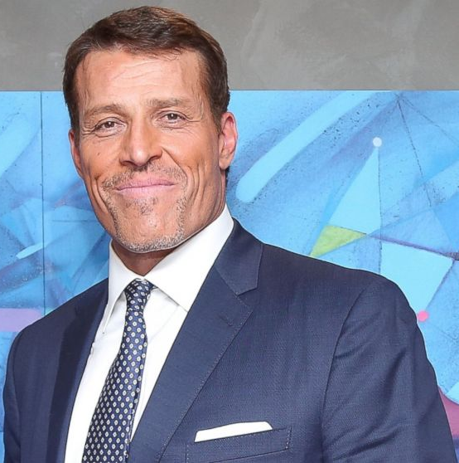
Tony Robbins
Robbins’ charismatic quality using Antonakis’ three traits on his TED talk “Why we do what we do”
By using the work of John Antonakis whose endeavours into charisma and charismatic leadership are ground-breaking, informative and can be easily applied to modern day and historical businessmen and leaders, Tony Robbins can be analysed down to his very hand gestures and one can understand how he is so popular. The three tactics Antonakis described that make charismatic leadership effective are frame, which include metaphors and stories, substance which involve ambitious goals and moral conviction and delivery, this means animation in performance, passion, and certain gestures. From looking at his background and project, one can already see a link to the aforementioned tactics. For this part however, a case study of a TED talk would be more suitable as it will demonstrate on a physical level how Tony Robbins is a charismatic leader.
Frame
The TED talk “Why we do what we do” from 2020 encases these techniques. First of all is framing, during his talk Tony Mentions a story about how his father and mother argued everyday about poverty and having no food, one day a man came when Tony was young which a box of food for his family. He told his father and he reacted angrily and saying that his pride wouldn’t allow him t accept but the man was forceful and told him not to make his family suffer. Tony explains that he didn’t understand pride and in future he began making his own gift boxes for families every year and that it spiralled into where he is now. This can make the audience feel included as the majority of people experience financial hardships, moreover it demonstrates substance by including heavily moral message of the importance of giving. Instead of just a talk about facts and why you should help, he allows you to sympathise and empathise with him, whilst advertising the meaning behind his business and makes you feel as though he is a trusted figure. As a philanthropist this correlated to his business, as trusting in him means trusting in his company as the core figure advertised on everything.
Substance
Secondly substance is something that Tony Robbins provides in bounds, he is a passionate man who believes emotions are the most vital part of everything he does, starting his business with giving, which means he cared about other people. In this TED talk Robbins’ sentiment of the collective transpires in his rant about decisions about destiny, with firstly focus and what to focus on. He then talks about state, in long term and short term, short term is the physical and emotional state of a person when they make decisions. Long term is the world view of a person then turning into meaning, emotion, and action. The long-term he states is a filter and is how we influence people, which is made of three parts, one being needs which he states there are 6 of. This is all said in a short moment and when writing it back one can see it is very confusing, however, by missing out pieces and offering different teases of what he is about, he is luring you into buying his products which will include all of this. Moreover, the presentation plays highly into how he can get away with this confusing ramble and will be discussed later. However, at the core of all of this his substance always seems to be at the forefront, all of these are goals that he believes people can activate and include to change themselves and this substance inspires people, as he is the case study who practices all these and is thriving.
Delivery
When it comes to delivery Robbins is an amazing example of this, using the theory of situated cognition, the smaller gestures, and movements someone uses can trigger certain parts of our brain to react in certain ways. When looking at hand gestures there has been evidence to say that certain ones encourage learning in younger people, moreover, in media it is a sign of intelligence when one uses hand gestures in a swift and precise way, much like Robbins does. When looking at his speech pattern, he is loud, precise, passionate and simplifies what he is talking about, much like Antonakis demonstrates when he speaks about the use of speech at seminars. Robbins is always animated and smiling providing a welcoming environment and joking with his audience to relive tension and allow people to get comfortable and focus on what he is saying.
Summary
It is clear that Robbins uses frame, substance and delivery to become charismatic when he talks, he has perfected these techniques and this charisma has afforded him to become a prominent, wealthy and respected person in society. He is a good example of someone who knows how to use charisma to get ahead in life and he has manged to use it to help other people as well. I am sure that he also seeks personal benefits as would most people, but nevertheless his charities are helping people and here is a major example of how one charismatic person who was environmentally challenged growing up changed a lot of people’s lives.

Tony Robbins’ Philanthropy Project
The Tony Robbins Foundation is a non profit that aims to help youth, seniors, the hungry, homeless and the imprisoned population have a better quality of life. They offer grants, scholarships, volunteer programmes, there are projects like the basket brigade. The individual will deliver a basket of food that has been donated to a family. He also created the feeding America Project which aims to provide 100 million families with food through 2025. There is also the chance for personal life coaching and personal seminars. Moreover, in his store you can see that he sells supplements, plans for certain personal changes, including audio, video, and written help by the company. These are valued around $249. Which is interesting considering the people he seems to be most invested in cannot afford to feed their families. The Tony Robbins Philanthropy Project website encapsulates all of his messages of giving and includes how to help his different ventures. It also makes sure to put Tony Robbins’ name available on every product, events, and part of the page. However, one cannot deny that the work his projects have done are helping people: “Tony Robbins has provided over 325 million meals in the last 3 years to those in need.”
“The secret to living is giving, we all know life is not about me, it’s about we”
Tony Robbins, 2020

Background
Tony Robbins an inspirational coach speaker, author, and philanthropist. He centres his motives around giving and strives to portray a morally divine message of caring for fellow humans. In his TED talks he explains that he came from a background of poverty and that this caused high tensions and a hard childhood with his parents fighting a lot. It is clear that he had to overcome a diverse background to get to such an esteemed position today, becoming someone that can tell people how they should behave. According to his own website he is now the author of 6 international best-selling books, he is the chairman of a holding company which includes 70 privately held businesses grossing $6 billion annually, this puts him in the top 1%. He has worked with 4 U.S. presidents, including Bill Clinton. His status is shown for example by a segment on major news networking show CNBC who had him give advice to Donald Trump on his speech skills and the messages he delivers. For a motivational speaker to advise the ceremonially most powerful man in the country, it is clear Tony Robbins has created a reliable and trusted picture of himself to the media.

