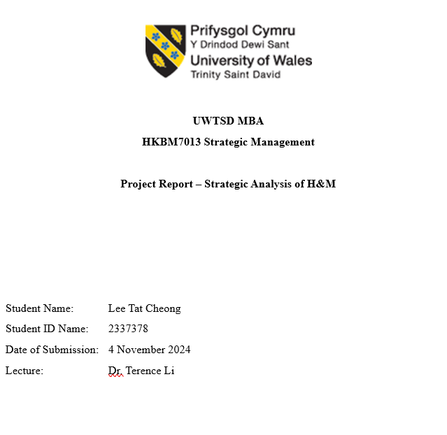

Abstract
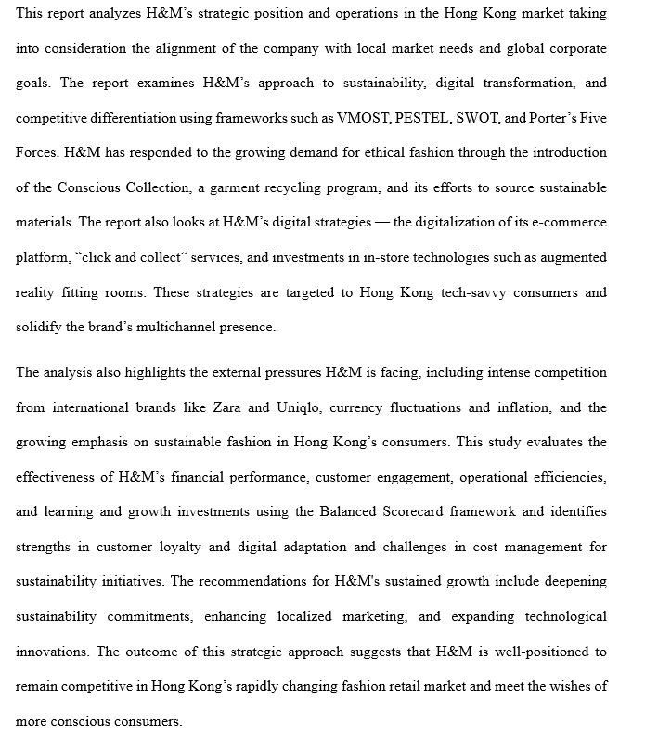
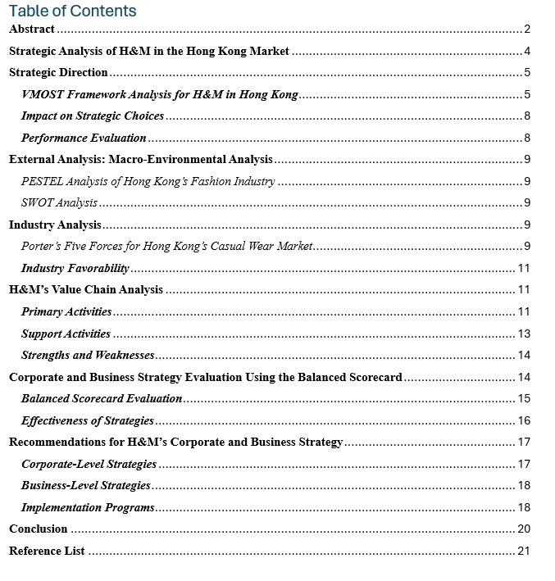

Strategic Analysis of H&M in the Hong Kong Market
Having originated in Sweden in 1947, H&M has grown to be one of the biggest fast fashion companies, and it is well known for its affordable and stylish clothing for every class of people. With the concept of fast fashion being highly inherent in this organization, H&M is involved in the timely design, manufacturing, and delivery of new clothing collections within a short span (Pastore et al. 2022, p.162). H&M has a good position in Hong Kong since fashion-conscious customers give preference to established brands. The Hong Kong market is characterized by highly fashion-oriented consumers increasingly concerned with issues like sustainability and ethical production, making it challenging for international brands to balance low-cost offerings with environmental considerations (Pastore et al. 2022, p.168). Hong Kong has great competition from local and global brands. However, the company is still relevant and powerful enough to survive in this market due to factors such as its relatively low prices and flexibility to offer customers good products appropriate to the right seasons.
The purpose of this report is to make an evaluation of how H&M can strategically manage its operations within the framework of the Hong Kong environment. This paper also discusses the method the company used to ensure compatibility of its corporate vision, mission, objectives, strategy, and operation tactics in the improvement of its strategic direction. Analyzing the specifics of the company’s activity in Hong Kong, this report compares the ways in which H&M successfully accommodates the demands of the local market to the ways in which it contends with pressures of competition and local cultural differences that characterize the area. Furthermore, this report will analyze the value chain of H&M – the strengths and weaknesses that the company has been experiencing, which hampers its competitive edge in Hong Kong. Finally, this report offers corporate and business level development recommendations to aid in the formulation of the future direction of H&M within the region.

Table of Contents
Abstract 2
Strategic Analysis of H&M in the Hong Kong Market 2
Strategic Direction 5
VMOST Framework Analysis for H&M in Hong Kong 6
Impact on Strategic Choices 8
Performance Evaluation 9
External Analysis: Macro-Environmental Analysis 9
PESTEL Analysis of Hong Kong’s Fashion Industry 10
SWOT Analysis 12
Industry Analysis 14
Porter’s Five Forces for Hong Kong’s Casual Wear Market 14
Industry Favorability 16
H&M’s Value Chain Analysis 16
Primary Activities 16
Support Activities 18
Strengths and Weaknesses 19
Corporate and Business Strategy Evaluation Using the Balanced Scorecard 20
Balanced Scorecard Evaluation 20
Effectiveness of Strategies 22
Recommendations for H&M’s Corporate and Business Strategy 23
Corporate-Level Strategies 23
Business-Level Strategies 23
Implementation Programs 24
Reference List 27

Strategic Direction
Using the VMOST framework gives a better understanding of H&M’s strategic direction in Hong Kong as elements such as vision, mission, objectives, strategy, and tactics co-relate with the operation strategies in this highly competitive market area. The VMOST framework allows systematic analysis of how the company organizes its operations to be relevant in the market, satisfy customers, and grow sustainably in Hong Kong. The model is built on each of the elements supporting H&M’s attempt to balance affordability, trendiness, and sustainability, which are crucial success factors in Hong Kong’s fast-moving fashion space.

VMOST Framework Analysis for H&M in Hong Kong
Vision. The vision of H&M is “to lead the change towards a circular and renewable fashion industry while being a fair and equal company” (H&M Group 2023, p.19). This reflects its ambition to be a leader in a sustainable and accessible fashion, emphasizing both global and local goals. In the future, H&M sees itself becoming a responsible and pioneering brand that not only meets but exceeds Hong Kong’s fashion-forward and environmentally-conscious consumers (H&M Group 2023, p.19). This vision is that of production that integrates environmentally sustainable practices, fair labor standards, and recycling efforts to reduce waste. H&M’s sustainability vision is relevant in Hong Kong, where customers are especially sensitive to global trends, environmental issues, and the city’s forward-thinking approach to social responsibility. Using the outlined vision to guide its local operations, H&M can create a clear differentiation from other companies through the presentation of the value that the company can offer clients beyond mere apparel.
Mission. The mission statement of this company is "to offer fashion and quality at the best price" (H&M Group 2023, p.19). The pricing strategy centers on delivering fashion and quality sustainably at the lowest possible cost, thus summarizing its customer orientation, brand equity, and pricing goals. This mission is especially timely for Hong Kong because of the market saturation and customer sophistication (H&M Group 2023, p.20). Thus, the strategic objective of H&M is to provide a great number of targeted products that will find customer acceptance while keeping the price level affordable for the majority. The mission highlights quality and sustainability as key values integrated into the brand and vital in building the trust and loyalty of the consumers in Hong Kong. More importantly, when H&M positions itself as an environmentally and socially responsible brand that sells fashionable and affordable clothes, it resonates with the current demographic and the expectations of Hong Kong consumers.
Objectives. The company’s goals in Hong Kong include the overall market position and strengthening the company’s position within the market through sustainable and consumer-oriented approaches. H&M Group (2023, p.19) lists key objectives, including expanding its digital and in-store presence, improving customer engagement, and enhancing its sustainability initiatives to reflect better the values of Hong Kong’s environmentally conscious consumer segment. Also, as part of the company’s growth objectives, it desires to grow by increasing market share by providing click-and-collect services and other options, such as customization, to attract a new, tech-savvy audience (Chen and He 2020, p.6). It hopes to continue to achieve consistent revenue growth while maintaining a competitive pricing model, high product quality, and design standards in order to solidify its reputation as a top brand for Hong Kong’s fashion-conscious and value-driven consumers.
Strategy. Localization, digital transformation, and sustainability are the strategic edges of H&M in Hong Kong (Chen and He 2020, p.9). H&M has also recognized the importance of tailoring its offerings to local tastes and has invested in developing store concepts that are tailored to the Hong Kong market and contribute to an immersive shopping experience that meets local tastes. In fact, H&M has adopted digital tools to improve customer convenience, such as presenting new styles for digital exploration before trying them on and interactive customization options (Chen and He 2020, p.5). Another focus is on sustainable production and sourcing practices, as H&M advertises such practices in its marketing campaigns in Hong Kong to match consumer expectations. H&M’s strategy also includes a strong digital presence with advanced e-commerce capabilities and mobile app engagement, allowing H&M to reach consumers who like shopping online and reinforcing that H&M is still relevant in today’s digital age (Su 2020, p.13).
Tactics. H&M measures in Hong Kong are the discrete activities and decisions that benefit the organization’s long-run strategy. Such promotional tools as targeted messages, partnerships, and store experiences engage consumers and enhance their perception of brands (Rana and Tajuddin 2021, p.254). Sometimes, through green advertisements, where it focuses on its environmental-friendly options like ‘Conscious Collection.’ Local influencers and sustainability-related organizations also give H&M a way to market itself as a socially conscious brand as well as tap into the fashion scene in Hong Kong (Rana and Tajuddin 2021, p.255). The specified business arrangements include digital kiosks and interactive arrangements that integrate with customers for new trends and customization of products at H&M stores as well as the provision of sustainability policies (Rana and Tajuddin 2021, p.269). These activities are essential within a tactical context so the retailer can offer continuity and prominence within the retail landscape of Hong Kong and remain in harmony with the customers, as per the detailed profile provided on H&M.

Impact on Strategic Choices
Based on the VMOST framework, a firm’s strategic choices are evident in terms of how H&M adapts its customer relations, brand positioning, and competitiveness in Hong Kong market. By combining general vision and mission statement with practical objectives, strategies, and tactics, H&M is capable of responding to the requirements of the Hong Kong market. The VMOST framework identifies sustainability and affordable prices as key marketing communication promotion strategies. Therefore, all its plans reflect the importance of environmentally friendly products for H&M (Rana and Tajuddin 2021, p.270). This alignment allows it to distinguish itself from its rivals by being trendy, ethically conscious, and appealing to a wide sample of consumers in Hong Kong. Furthermore, the VMOST framework enables H&M to strategize for competitive advantage by strengthening customer loyalty and engaging customers through digital as well as in-store experiences (Hong 2023, p. 19).

Performance Evaluation
H&M’s performance aligning its VMOST elements in Hong Kong demonstrates the successful execution of its strategic vision and mission (David 2022, p.3). Hong Kong consumers have well received the company’s efforts to harmonize strategic goals with operational activities as the company possesses a strong market presence, robust customer loyalty, and positive brand perception. H&M’s efforts to address sustainability and digital engagement reflect well on its objectives and are consistent with a cohesive brand experience that resonates with its target audience. Nevertheless, there are ongoing challenges to striking a balance between affordability and the high cost of applying sustainable practices (Clarke et al. 2023, p.26). However, this strategic alignment under the VMOST framework has been effective for H&M in achieving visibility, customer satisfaction, and market share in Hong Kong, as a highly competitive market requires a brand to adapt to survive.

External Analysis: Macro-Environmental Analysis
A detailed macro environmental analysis (PESTEL and SWOT) helps explain how it is to understand the external factors that affect H&M operations in Hong Kong. The PESTEL framework consists of each of the pressures and opportunities the company faces in Hong Kong, a nation with East and West cultural aspects, advanced technology, and a very competitive fashion market. SWOT analysis of its products, services, strengths and weaknesses assessment gives H&M’s internal strengths and weaknesses and external opportunities and threats from which the company’s strategic choices arise.

PESTEL Analysis of Hong Kong’s Fashion Industry
Political. Hong Kong’s retail sector is subject to a relatively stable regulatory framework, but its political environment puts it under unique pressure. Hopefully, Hong Kong is a Special Administrative Region (SAR) that enjoys a very high degree of autonomy, but it is increasingly subject to political influence from Mainland China (Redding 2020, p.74). Recent political events, including the 2019-2020 protests and the implementation of the National Security Law, have introduced a degree of uncertainty in the business climate, affecting consumer behavior and tourism – both critical drivers of retail activity (Redding 2020, p.76). Additionally, as Hong Kong is subject to trade policies influenced by China’s economic strategy, it faces potential disruptions from international trade tensions, particularly between China and the U.S., which could impact H&M's supply chain and logistics.
Economic. Hong Kong’s economy, impacted by the global economic downturn and local disruptions, still boasts one of Asia’s highest per capita GDPs at approximately USD 43548.25 in 2023 (Gao 2024, p. 432). However, factors like inflation, rising living costs, and a high degree of income disparity affect consumer spending power. Hong Kong’s currency is pegged to the U.S. dollar, which brings stability but also leads to currency-related challenges (Muthu and Gardetti 2020, p. 168). Fluctuations in the U.S. dollar can influence H&M’s profitability, especially as H&M’s products are imported from various regions. Furthermore, the economic recovery in the post-COVID era has shown gradual improvement, which could positively impact retail spending as consumer confidence rises. Still, these economic pressures necessitate a strategic approach to pricing and product offerings to remain competitive while catering to diverse income segments within Hong Kong’s consumer base.
Social. Social values in Hong Kong are shifting, with increasing emphasis on sustainability, quality, and brand integrity. Hong Kong consumers are fashion-conscious, favoring brands that reflect both style and ethical practices. Millennials and Gen Z, who comprise a significant portion of the market, prioritize sustainability and are more likely to support brands with eco-friendly practices and transparent supply chains (Abdelmeguid et al. 2022, p.509). This demographic values affordability but is increasingly critical of “fast fashion” practices, which can conflict with H&M’s business model. Additionally, fashion trends in Hong Kong reflect a blend of Western and Asian influences, with local consumers favoring global brands that offer trendy, affordable, and accessible styles, creating opportunities for H&M to maintain strong market relevance while addressing sustainability concerns (Abdelmeguid et al. 2022, p.510).
Technological. Technological advancements are crucial in Hong Kong’s retail landscape, where e-commerce and digital shopping channels are highly prevalent. The COVID-19 pandemic accelerated digital shopping adoption, leading H&M to enhance its online platform, offering features such as a mobile app, “click and collect,” and seamless return options (Ullah 2021, p.5). Furthermore, Hong Kong’s tech-savvy consumers expect integrated online and offline shopping experiences, pushing H&M to innovate through in-store technologies like self-checkout, augmented reality fitting rooms, and digital customization. As a cashless society, mobile payment methods are popular in Hong Kong, making it essential for H&M to offer seamless digital payment options to meet consumer expectations and enhance the shopping experience (Ullah 2021, p.8).
Environmental. Sustainability has become a critical issue within Hong Kong’s fashion industry, influenced by both consumer demand and government policy. With a growing focus on climate change, waste reduction, and resource conservation, consumers are increasingly favoring brands that demonstrate environmental responsibility. H&M has responded to this shift by promoting its Conscious Collection, which incorporates sustainable materials, and by implementing a garment recycling program in stores (Zhu 2023, p.936). However, balancing these initiatives with cost-efficiency in a highly price-sensitive market remains challenging. Hong Kong’s government is also pushing for green practices, including a recent pledge to become carbon neutral by 2050, which could lead to stricter environmental regulations impacting the fashion retail sector (Zhu 2023, p.937).
Legal. Hong Kong’s legal environment for retail is characterized by stringent labor laws, such as the Minimum Wage Ordinance (MWO), which imposes minimum wage standards and employee welfare requirements that directly affect operational costs for H&M, particularly in maintaining compliance with wage and benefits provisions for its in-store staff (Zhu 2023, p.940). Additionally, consumer protection regulations enforce transparency in advertising and fair trading practices, which means H&M must ensure accurate product descriptions and avoid misleading advertisements. Its sourcing and distribution are also impacted by trade regulations mandated by the Consumer Goods Safety Ordinance (CGSO), which requires imported goods to meet safety standards. While being a foreign-owned retailer, H&M also must face not only the difficult compliance questions that arise with supply chain operations in Hong Kong but also some regulatory business responsibilities as they are tied to Hong Kong's legal alignment with Mainland China.

SWOT Analysis
Strengths. H&M’s primary strengths in Hong Kong include its well-established brand reputation and cost leadership. They are known for having trendy clothing at an affordable price and appealing to all consumers. This advantage of H&M’s international reputation as a leader in fast fashion, alongside its ability to promptly adapt to seasonal trends, contributes to its competitive position in Hong Kong’s highly dynamic market (Rizaldy 2023, p.17). In addition, its emphasis on reducing its environmental impact through its Conscious Collection and garment recycling program is a perfect fit with the local market’s growing green consciousness, making it attractive to eco-conscious consumers.
Weaknesses. Though it has strengths, H&M is also confronted by weaknesses stemming from its fast fashion business model, which has been under the spotlight for its environmental impact and unsustainable practices. Younger demographics in Hong Kong are becoming increasingly critical of fast fashion’s impact on the environment. Furthermore, the company’s reliance on a global supply chain puts it at risk of supply chain disruptions and currency fluctuation risks that could impact profitability (Chan et al. 2020, p. 53). The second internal challenge is to remain affordable while addressing the demand for sustainable materials; eco-friendly practices can be expensive to implement at scale.
Opportunities. H&M has a huge opportunity to grow its online sales and exploit technological innovations in the retail industry through Hong Kong’s digital transformation. Enhanced e-commerce offerings like augmented reality shopping and personalized mobile app experiences can drive customer engagement and sales growth. Furthermore, the market demand for sustainable fashion gives H&M the opportunity to continue with its eco-friendly practices by furthering more sustainable collections or expanding its recycling programs (Adizka et al. 2024, p. 130). Yet they also might explore store concepts in high-traffic areas or partner with local designers to serve regional tastes and build brand loyalty.
Threats. Besides the four walls of H&M, it is threatened by several external factors, such as intense competition from both local and international fashion retailers in the Hong Kong market. Global brands such as Zara and Uniqlo and emerging local brands focusing on quality and sustainability pose significant competition (Adizka et al. 2024, p. 135). Fluctuations in exchange rates and inflation could reduce a consumer’s spending power, resulting in lower sales volume. Additionally, if H&M cannot quickly adapt to changing consumer preferences away from fast fashion towards more sustainable, long-lasting clothing, then these changes could threaten its brand perception (Adizka et al. 2024, p. 136). More regulatory requirements for sustainability could also result in higher operating costs, which could essentially hurt the profitability of the business in an extremely competitive market.

Industry Analysis

Porter’s Five Forces for Hong Kong’s Casual Wear Market
Through Porter’s Five Forces analysis, this paper gains valuable insight into the casual wear industry in Hong Kong. It is found that competitive dynamics have a great influence on H&M’s strategies and operations. The next part of this analysis will examine how each force affects the market and its positioning.
Bargaining Power of Suppliers. H&M is a global fast fashion retailer that sources materials and products from an extensive network of suppliers worldwide. Most of these suppliers work in countries with low production costs, such as Bangladesh, China, and India. The company’s scale allows it to negotiate favorable terms with suppliers, reducing supplier power (Adizka et al. 2024, p. 134). However, the need for environmentally conscious suppliers is strengthened by Hong Kong's specific demand for sustainable practices in the market. H&M's investment in a partnership program in which suppliers report compliance with sustainable practices could limit sourcing flexibility and add to the cost.
Bargaining Power of Buyers. Consumers in Hong Kong exercise a lot of power in terms of bargaining because they expect quality products to be cheap and ethically sourced. As more and more people prefer to wear sustainable fashion, Hong Kong Millennials and Gen Z consume more than the older generations, and therefore, impact brands in adapting to environmentally friendly practices (Ullah 2021, p.8). This creates tension for H&M to compete on price while continuing to invest in sustainability to keep up with customer demands. The widespread availability of alternative brands (local and international) further enhances buyer power, as shoppers can easily switch to competitors like Zara or Uniqlo if H&M fails to meet their demands (Ullah 2021, p.8).
Threat of New Entrants. Barriers to entry in Hong Kong’s casual wear market are moderate, driven by high operational costs, brand loyalty, and the need for substantial initial investment. However, with the rise of e-commerce, small online brands have established a market presence, increasing the threat of new entrants, especially niche brands that appeal to sustainability-focused consumers (Ullah 2021, p.9). Established retailers like H&M benefit from significant brand equity and established supply chains, which present barriers to new entrants.
Threat of Substitute Products. Hong Kong consumers have numerous alternatives in casual wear, including local designer brands, premium fashion labels, and online platforms offering imported goods. E-commerce giants such as Taobao and Zalora provide easy access to international brands and affordable fashion alternatives, which are becoming more popular among price-sensitive consumers (Ullah 2021, p.9). Premium brands also attract customers seeking higher quality and exclusivity, while local and independent brands often appeal to those preferring unique, non-mass-produced options. These alternatives represent a growing threat to H&M’s market share, as Hong Kong’s discerning consumers may shift toward substitutes if they perceive H&M’s products as lacking in uniqueness or quality.
Competitive Rivalry. Competitive rivalry within Hong Kong’s casual wear market is high, with major international brands like Zara, Uniqlo, and Gap competing for similar customer demographics (Djogo and Morrison 2020, p.43). Zara’s fast-fashion model directly challenges H&M with frequent style updates, while Uniqlo attracts customers by focusing on quality, comfort, and functionality. In addition, international e-commerce platforms and local brands compete by offering more affordable and personalized fashion options.

Industry Favorability
In general, the casual wear industry in Hong Kong is favorable for H&M. The company has a strong brand presence, strong supply chain, and adaptation to local market preferences. Still, it faces high competition and strong buyer bargaining power. However, the increasing demands for sustainability and the requirement to cater to environmentally conscious consumers dampen the industry's favorability.

H&M’s Value Chain Analysis
H&M's competitive position in Hong Kong is mainly achieved by optimizing efficiencies in the value chain through primary and support activities, from sourcing to customer engagement.

Primary Activities
Inbound logistics. The supply chain for this Hong Kong market is based on its global sourcing network, which draws raw materials and finished products from suppliers in Asia and other regions. The company has adopted sustainability initiatives in the supply chain to increase transparency by monitoring which suppliers meet sustainable practices (Djogo and Morrison 2020, p.43). H&M's investment in logistics technology has helped simplify customs processing, reduce delays, and get seasonal stock to Hong Kong stores on time.
Operations. The company’s operations in Hong Kong are centered around efficient retail and sustainability. H&M uses eco-efficient store designs and energy-saving practices in its Hong Kong locations in order to minimize costs and environmental impact. As Hong Kong’s young consumers have fast-changing fashion preferences, the production cycle is organized to produce frequent, trend-responsive collections (Djogo and Morrison 2020, p.45). However, balancing on the one hand sustainability and production speed is difficult because meeting the environmental standards in all operations may have an impact on efficiency.
Outbound logistics. It markets its Hong Kong distribution strategy through physical and digital stores. Customers can choose from “click and collect” to pick up online orders in stores, and home delivery options are also provided by the digital platform (Muthu and Gardetti 2020, p. 171). Furthermore, H&M’s convenient return policies across online and offline channels also ensure customer convenience and provide opportunities for brand loyalty as well as repeat purchases.
Marketing and Sales. The marketing strategy for the company in Hong Kong uses a mix of traditional advertising and digital and social media campaigns aimed at fashion-conscious young consumers. For example, the Conscious Collection is strategically used as sustainability-focused campaigns, like promoting its campaigns to appeal to the eco-conscious shopper (Nimwal et al. 2023, p.1). H&M also works with local influencers and hosts in-store events to strengthen its community presence and engage customers directly. H&M Membership, its loyalty program, provides customers with special deals and discounts, as well as enticing customers to come back and purchase again.
Service. In Hong Kong, consistent in-store service, simple return policies, and post-purchase support help H&M to focus on the high-quality customer experience. Customer service initiatives for the brand are geared towards creating long-term relationships with shoppers, focusing on accessibility and customer care. For example, H&M’s flexible return policies and in-store recycling program enhance the customer experience and strengthen the company’s dedication to sustainability (Muthu and Gardetti 2020, p.175).

Support Activities
Firm infrastructure. Its organizational structure in Hong Kong follows the company’s global standards by introducing localized leadership in order to respond to regional market trends appropriately. Its management structure allows for streamlined decision-making and flexibility, allowing the company to remain competitive in Hong Kong's fast-moving fashion market.
Human resource management. According to Nimwal et al. (2023, p.1), H&M’s HR strategy in Hong Kong focuses on recruitment, training, and employee development. It offers its staff training in customer service and brand values to make sure that employees are on the same page as the company is with their commitment to sustainability and quality service. Competitive wages and career development opportunities, especially in managerial roles, form part of retention efforts by the business to keep its workforce motivated as it reflects its brand values (Muthu and Gardetti 2020, p.173).
Technology Development. In Hong Kong, H&M is investing heavily in technology to make its retail operations better. Inventory management systems have been integrated with digital solutions such as inventory management systems that have increased stock efficiency and allowed real-time tracking (Djogo and Morrison 2020, p.7). The use of in-store technology, such as self-check-in kiosks and digital fitting room technology, enhances the customer experience by providing a more convenient and personalized experience. Through digital engagement, H&M’s mobile app helps customers shop online, get personalized recommendations, and see sustainability information on products.
Procurement. Hong Kong’s environmentally conscious consumers would expect H&M to prioritize sustainable sourcing in its procurement practices. Djogo and Morrison (2020, p.34) indicate that the brand works with suppliers that meet its environmental and ethical standards and sources materials that align with its commitment to a circular economy. However, sustainable procurement can come at a cost, and H&M buys bulk and streamlines its supply chain to reduce costs and keep prices competitive.

Strengths and Weaknesses
Several strengths of H&M’s Hong Kong value chain include a well-coordinated supply chain, efficient retail operations, and strong marketing strategies that appeal to the broad customer base. Digital channels and in-store technology integration improve customer convenience, and sustainable procurement and customer service initiatives meet the market demand for ethical practices (Djogo and Morrison 2020, p.38). Despite that, H&M has a hard time striking a balance in terms of cost efficiency and sustainability, as eco-friendly material and ethical sourcing will cost more. Furthermore, H&M depends on a global supply chain, making it vulnerable to external risks such as international trade tensions or currency fluctuations that can affect operations in the Hong Kong market.

Corporate and Business Strategy Evaluation Using the Balanced Scorecard
In Hong Kong, H&M recently adopted several corporate and business strategies in response to the changes in the business environment and the competitive pressure. Sustainability initiatives, digital transformation, and localization efforts are vital strategies. H&M’s “Conscious Collection” in Spring 2019, which features organic cotton, recycled polyester, and other sustainable materials (Wang 2024, p.478), continues to focus on sustainability. In addition to H&M's recycling program, another strategy is that clothing can now be recycled in-store, and shoppers are given discounts. Another priority is digital transformation, where H&M has improved its e-commerce platform and introduced mobile app features like ‘click and collect’ so there’s a smooth transition between digital and physical shopping (Wang 2024, p.479). Tailored product lines that reflect regional preferences and store experiences geared to Hong Kong consumers are also important (Wang 2024, p.475). These strategies work together to reinforce the brand presence in Hong Kong’s fast-paced fashion market and ensure H&M’s competitiveness in the Hong Kong market.

Balanced Scorecard Evaluation
Financial perspective. In Hong Kong, H&M has implemented cost management strategies to maintain its position as an affordable fashion brand despite economic pressures, such as increased import costs and inflation. H&M’s global cost-control practices, including supplier negotiations and bulk purchasing, help manage expenses, while sustainability initiatives can reduce long-term costs through efficiencies like reduced waste (Wang 2024, p.482). However, the upfront costs of sustainable materials and eco-friendly initiatives could impact short-term profitability. The emphasis on digital transformation is expected to enhance revenue by reaching a broader consumer base through online channels, but H&M must carefully balance the costs of these initiatives with profitability goals.
Customer Perspective. H&M’s customer-focused initiatives are designed to enhance brand loyalty and meet the evolving expectations of Hong Kong’s fashion-conscious and environmentally aware consumer base. Programs such as the H&M Membership offer rewards and exclusive deals, fostering repeat purchases and customer engagement (Adizka et al. 2024, p. 132). Sustainability initiatives resonate strongly with Hong Kong consumers, particularly Millennials and Gen Z, who value brands with environmental commitments. The in-store garment recycling program also appeals to eco-conscious consumers, increasing brand loyalty and foot traffic in stores. Additionally, the efforts of H&M to streamline shopping experiences through digital integration align with the desire of Hong Kong’s digitally savvy shoppers to enhance the shopping experience, further corroborating H&M’s focus on customer satisfaction.
Internal Process Perspective. Operational efficiencies underpin H&M’s business model in Hong Kong. H&M integrates digital tools to manage the inventory, reduce lead times, and improve in-store and online service consistency. Digital fitting rooms and self-checkout kiosks make the in-store experience more convenient (Adizka et al. 2024, p. 135). H&M’s ability to scale its operational model is enhanced by solid logistics, including the “click and collect” service that allows customers to buy online and collect in-store, bridging the gap between digital and physical shopping. Additionally, H&M supply chain practices, including sustainable sourcing and supplier audits, help streamline operations and guarantee product quality consistent with brand standards.
Learning and Growth Perspective. H&M’s employee training, technology, and sustainability investments reflect its commitment to continuous improvement in Hong Kong. The H&M Group (2023, p.24) places employee training programs on customer service, sustainability, and company values to align staff with brand goals. Digital channels are supported by an investment in technology that enables operational efficiencies and growth opportunities through data-driven decision-making. H&M’s environmental goals include reducing carbon emissions and transitioning to circular production practices, further reinforced by its commitment to sustainability. Supporting H&M’s brand image, these efforts help attract employees who value sustainability and a motivated, mission-aligned workforce.

Effectiveness of Strategies
Even though H&M’s strategies in Hong Kong are not entirely successful in achieving corporate goals, the company has shown an exciting interest in entering the Chinese market. H&M has also reported substantial investments in sustainability, with global spending on sustainable materials being about 38% of their total materials use in 2022. However, scaling locally in Hong Kong has increased product costs by 10–15% (H&M Group 2023, p.105). However, these eco-friendly initiatives have appealed to younger consumers. At the same time, H&M’s gross profit margin fell from 50.7% in 2021 to 49.6% in 2022 (Yahoo Finance 2024, para.5), partially because of the costs of sustainable sourcing and digital integration. This has led to positive engagement in customer-focused initiatives like recycling programs and rewards for sustainable practices, which have seen over a 30% rise in participation rates since implementation. It has also built brand loyalty with environmentally conscious demographics. Digital investments in logistics (e.g., automated inventory tracking) increased inventory turnover by 15% in H&M stores in Hong Kong, improving H&M’s supply chain responsiveness and reducing stockouts (Yahoo Finance 2024, para.6). However, the high cost associated with sustainability and tech investments means that H&M must look at these strategies continually to ensure long-term profitability aligns with its market share growth objectives.

Recommendations for H&M’s Corporate and Business Strategy

Corporate-Level Strategies
To ensure sustainable growth and strengthen H&M’s competitive positioning in Hong Kong, H&M should focus on expanding its eco-friendly offerings, increasing the Conscious Collection’s presence, and pursuing more sustainable sourcing initiatives (Rizaldy 2023, p.6). It could also deepen its alignment with consumer values by introducing more circular economy practices such as upcycling and limited-edition collaborations with local designers. Furthermore, H&M needs to sustain its efforts in innovation primarily found within the digital application of the firm, wherein elements within the e-commerce site should be expanded to provide customers with unique experiences (Rizaldy 2023, p.22). Expanding cooperation with IT suppliers may help H&M increase its capabilities for more innovation in the competitive Hong Kong market.

Business-Level Strategies
Also, at the business level, it is suggested that H&M should raise customer insight through such measures as promotions, influencers, and focused events on sustainability and the company’s commitment to the community. H&M Membership program that provides specific benefits for customers from Hong Kong would boost the company’s familiarity and improve customers’ loyalty, and digital campaigns promoting environmental programs could attract young audiences (Chan et al. 2020, p. 54). H&M should also expand click-and-collect services and consider digital conveniences like mobile payments and exclusive offers in the application. Additional localized marketing aligned with the current trends in fashion in Hong Kong will help H&M build on its brand's local appeal and make it stand out.

Implementation Programs
The company should form links with green suppliers in Hong Kong and recycling companies to improve its sustainability and localization strategies. Certified suppliers and local vendor farms producing organic cotton or recycled polyester, for example, could be engaged to support regional firms and address the high expectations of the Hong Kong market. In addition, working with environmental NGOs like the Hong Kong Green Building Council on joint recycling projects and in-store events on sustainable fashion will help them build community goodwill (Zhu 2023, p.938).
Besides, if H&M wants to continue its success in Hong Kong, then campaigns must be tailored to the unique culture of Hong Kong fashion. H&M could collaborate with local fashion influencers and social media personalities who have large followings among young consumers to make the brand more relevant to them. Well-known Hong Kong influencers could be called to promote seasonal campaigns stressing the Conscious Collection and eco-friendly products (Zhu 2023, p.936). Launching pop-up stores or temporary displays in high-traffic locations, such as Tsim Sha Tsui Causeway Bay, with a specific theme would also attract locals and visitors. Also, H&M could run community-focused programs to educate people about sustainability and fashion to connect with the Hong Kong market more deeply. To reach H&M customers directly and showcase H&M's environmental values, they could host monthly workshops in stores, like “Upcycling Your Wardrobe” or “Sustainable Styling Tips” (Gao 2024, p. 435). Social media and the H&M app could promote these workshops to loyal customers and tap into new shoppers.
Moreover, Data analytics can help H&M tweak its marketing and operational strategies in Hong Kong. H&M could increase sales and boost profits by analyzing customer purchasing patterns and preferences to better tailor its product offerings and marketing messages to local tastes. Zhu (2023, p.941) noted that the company could use data to carry out location-based marketing app notifications that tell users about promotions, events, or new arrivals as they approach an H&M store. Through superior analytics, H&M could better understand how certain trends function within the Hong Kong market and use that information to pinpoint certain products that would be more popular during certain seasons so that there would not be too much stock or too little stock of certain products.

Conclusion
Overall, H&M in Hong Kong's strategic direction is consistent with the company's concept to meet the new and competitive market demands. With its focus on sustainability, the advancement of digital technology, and the promotion of regional campaigns, the company has managed to orient itself as a brand relevant to fashion-loving and environmentally conscious citizens of Hong Kong. An examination of the company’s more recent organizational tactics points to its commitment to cheap fashionable clothing and its responsiveness to current trends and environmentally friendly practices in the form of the Conscious Collection and garment recycling facilities located within its stores. By developing the e-commerce platform and implementing the so-called “click and collect,” Hong Kong’s wise-thinking sophisticated buyers have been waited by H&M. Localization efforts—including collaborations with local influencers and targeted marketing campaigns—have also reinforced the brand’s relevance in the Hong Kong market. In the future, H&M will have several threats and opportunities at its disposal on how it is positioned in Hong Kong. The pressure of switching consumer demands towards eco-friendly and ethical processing remains connected to continuous trials, primarily when the company follows the principles of a fast-fashion brand. H&M need not overemphasize sustainability as its tag has, over time appealed to the younger generation of dedicated consumers in Hong Kong.

Reference List



