MANAGING ENTERPRISE IN THE 21ST CENTURY

Table of Contents
PPT 3
Executive Summary 3
1. Business Overview 3
2. Product and service 3
3. Market audit 3
SWOT 3
PESTLE 4
4. Target Market 5
5. Marketing Plan 6
6. Management Team 7
7. Financial Plan 8
Conclusion 8
Reference list 9
Appendices: 10

PPT

Executive Summary
A business website has been developed by this MiniMe firm. In the present days digital platforms have become very popular and after COVID-19 disaster most of the public prefer online shopping. Here this is a manufacturing business so they play a very important role in industry. From this SWOT analysis MiniMe business can be demonstrated clearly.

1. Business Overview
This project for finding out the learning out comes about how a business can be developed. Baby clothes business has been built up this year. All these factors will be demonstrated according to this kid’s cloth business, which is MiniMe Company (Greaves et al. 2019). They have built this business to earn profit with the help of organic product service.

2. Product and service
The MiniMe business sells kids clothes in the US market. The products are organic and have a high price range. They also provide service via an online shopping platform which one became famous recently. They become very popular from digital platforms (Jayakrishnan, Mohamad and Abdullah, 2019). Their main product service focuses on kids' health. MiniMe has started their service from a little dress shop.

3. Market audit
MiniMe Company market auditing is going to evaluate with two different tools one is SWOT and another one is PESTLE.

SWOT
SWOT is used to measure the strength, weakness, opportunity and threats of business. Here the MiniMe will be evaluated with this model.
Strength
Strength of MiniMe business.
- The business cost is low to start. The water, rent and electric cost is less than other businesses.
- This is a highly rich brand as per US market recognized.
- This business is able to give full detailed information about their service and product.
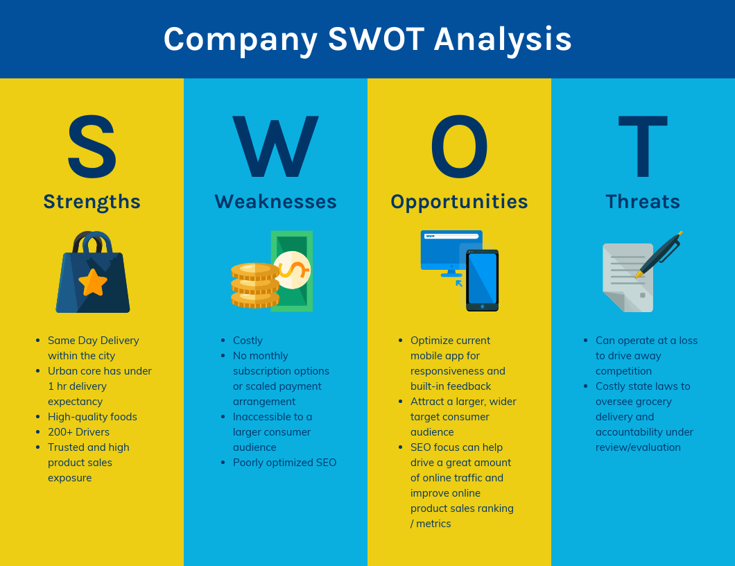
Figure 1: SWOT Analysis Structure
(Source: https://venngage.com)
Weakness
Weakness measurement brings healing power to the firm.
- Online shopping business, where the quality cannot be seen (Masaev, 2019).
- High price range.
- There is no obvious price range for the product.
Opportunity
Future opportunity for MiniMe Business.
- Get minimal competitors for their business.
- Less online baby shops.
- Period graph opportunity.
Threats
Thai business has faced problems in the US market all are assumed as threads for the company.
- This business is very simple and easy to copy.
- The back log of product service provides cause for loss.
- More competition in the market can force them to sell the product in a low price range which can be cause for loss.

PESTLE
PESTLE provides understanding about impact of political, economic, sociological, technological, legal and environmental.
Political Factor
- The Government influences every clothing business to buy local fabric which will be helped to involve in import duty.
- He boycotts the business that uses animal skin or any raw material which comes to harm environmental animals.
- The Government has been found a duty to manage or protect wildlife of the country.
Economical Factor
- Two different types of economical states impact the economic market. Those people belong fr5om high income economic position they can easily afford the MiniMe business product and those are coming from low range they cannot afford.
- Fashion trends influence the public economical stage.
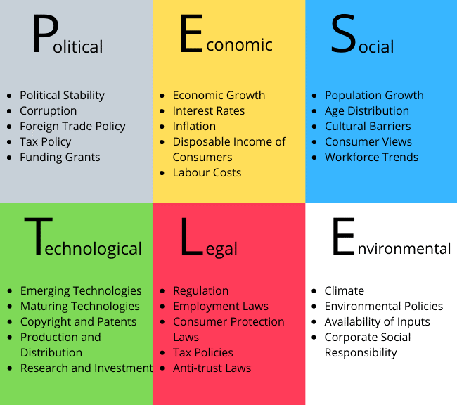
Figure 2: PESTLE Analysis Structure
(Source: https://assignmentstudio.net)
Social Factors
- There are so many fashion events held according to the business stage. These kinds of events attract people a lot and they enjoy this kind of show. New fashion things are started from here which impact consumers.
- This MiniMe business is trying to engage with this type of event.
Technological Factor
- Here use of the internet provides the ability to follow all the trends of the public by this MiniMe business.
- It is not very easy to visit the busy cloth shop with kids (O'Higgins and Zsolnai, 2018).
Environmental Factor
- In the delivery stage the use of vehicles produce toxic gas which causes air pollution.
- MiniMe Company has been estimated as a new target to reduce the green gas production.
Legal Factor
- MiniMe has an out source to collect the business raw material. Different market sources force them to follow rules.
- The workers’ rights have to follow them because the company's worker's working life is always on the safe side.

4. Target Market
The MiniMe market target is mostly over the customer, because this business particularly made for customer product service.
- The customer group has been analyzed by age and income stage and it has also been determined by these people what product types are more like.
- Special discounted email setting has been started by this business. They are trying to provide special discounted service to this major customer (Amankwah-Amoah, Egbetokun and Osabutey, 2018).
- More broad service will make an advantageous path for the customer to get the service from the business.
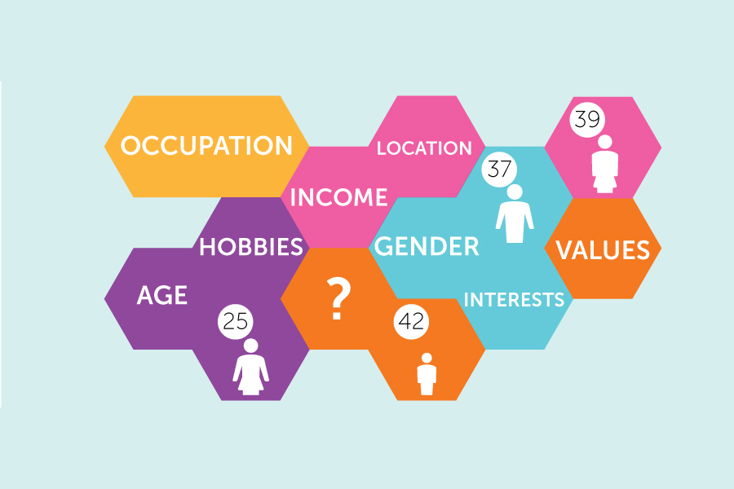
Figure 3: Market target customer
(Source: https://volusiaflagler.score.org)
- Audience target factors provide the visibility information about the business outside factor.

5. Marketing Plan
Here market planning will be followed by seven P tools, which will determine the marketing plan of this MiniMe business.
- First P is Product of the business that has been chosen for sales. If there will be any problem in the selling process they will focus on upgrading the product.
- Second option is Price, which is always maintained by this business as per the product and market cost.
- Promotion is the third factor, here it is very important to increase the sales or attract more customers to the business.
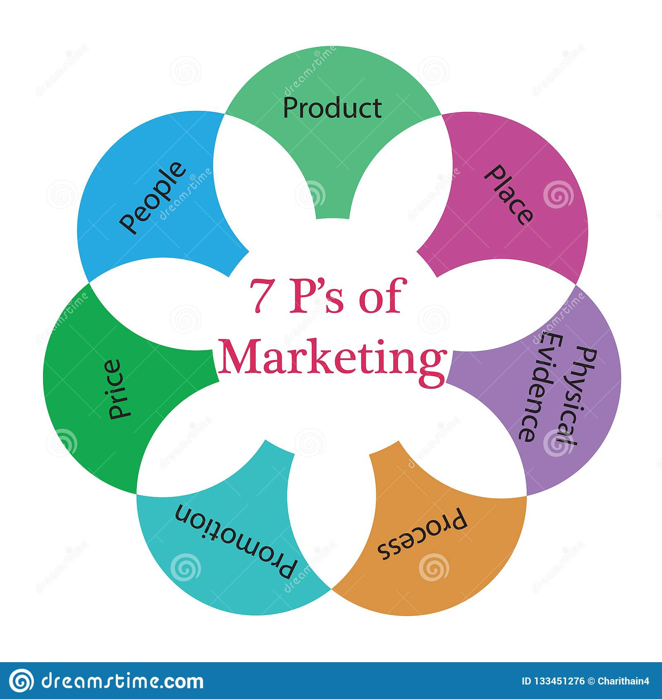
Figure 4: Market plan structure
(Source: https://www.dreamstime.com)
- The fourth P is Place, business place in market and recording the detail about where the product is going to sell is important.
- Fifth P, Packaging of products should be secure to the product and satisfaction provider.
- Position is the sixth number of P developing positions that have increased the value of the Company.
- The last and the seventh P is People, here people not just the customer they are internal and business external both.

6. Management Team
Management team should be strong and for that they need to develop the management team as per the following list.
- Employee relationships should be built.
- Manager should listen to the team.

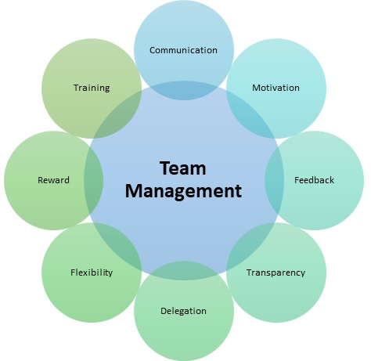
Figure 5: Team management structure
(Source: https://www.google.com)
- Provide a simple and clear strategy to business.
- A valuable team needs to be established.
- Provide technical skill to the team.

7. Financial Plan
Here the business has estimated some profit and cost with assume for the future. Here the manager efficiency has been followed by some financial factors. According to the Appendix 1 the income statement provides value of present income and profit (Katuu, 2020). In appendix 2 the cash flow show a basic cash operation for MiniMe from 2022 to 2024 it show growth in statement. It will be successful if they follow all the previous estimated processes. At present time the selling value for per unit is 4.22 but they will reduce it to 2.7 in 2024. As per the Appendix 4 the break-even sales structure has increased year by from 105300 to 300000. This information provides detail about good growth of this business.

Conclusion
According to this project this is an understanding assignment for market management. Here the MiniMe business has been started and they provide clothes product service to the public. To determine and evaluate the business some marketing and management tools have been used here. All they do is deliver a good report about internal and external impaction.

Reference list
Journal
Amankwah-Amoah, J., Egbetokun, A. and Osabutey, E.L., 2018. Meeting the 21st century challenges of doing business in Africa. Technological Forecasting and Social Change, 131, pp.336-338.
Greaves, R.F., Bernardini, S., Ferrari, M., Fortina, P., Gouget, B., Gruson, D., Lang, T., Loh, T.P., Morris, H.A., Park, J.Y. and Roessler, M., 2019. Key questions about the future of laboratory medicine in the next decade of the 21st century: a report from the IFCC-Emerging Technologies Division. Clinica Chimica Acta, 495, pp.570-589.
Jayakrishnan, M., Mohamad, A.K. and Abdullah, A., 2019. Journey of an enterprise architecture development approach in Malaysian transportation industry. Int. J. Eng. Adv. Technol, 8(4), pp.765-774.
Katuu, S., 2020. Enterprise resource planning: past, present, and future. New Review of Information Networking, 25(1), pp.37-46.
Masaev, S., 2019, October. Destruction of the Resident Enterprise in the Special Economic Zone with Sanctions. In 2019 Twelfth International Conference" Management of large-scale system development"(MLSD) (pp. 1-5). IEEE.
O'Higgins, E. and Zsolnai, L. eds., 2018. Progressive business models: Creating sustainable and pro-social enterprise. Springer International Publishing.

Appendices:
Appendix 1: Forecast Income statement

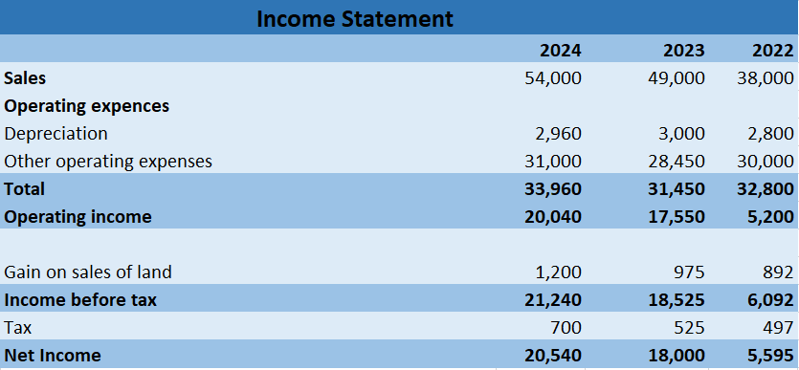
(Source: Self-created)
Appendix 2: Cash Flow Statement

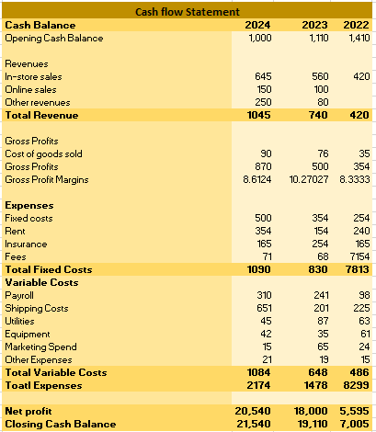
(Source: Self-created)
Appendix 3: Cost Structure

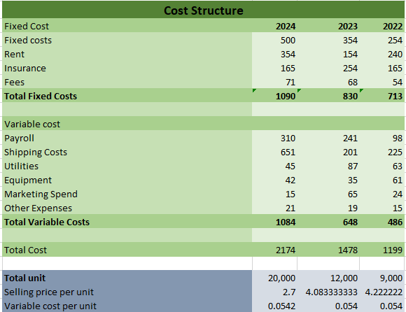
(Source: Self-created)
Appendix 4: Break even quantity and sales

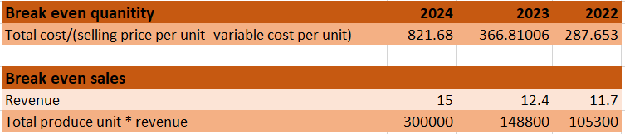
(Source: Self-created)

