

informative poster
Cert HE Business Skills for the Workplace / Digital skills LCLM4002/ Plamen velev 2526069

Contents
How to create a chart in Excel 2

How to create a chart in Excel

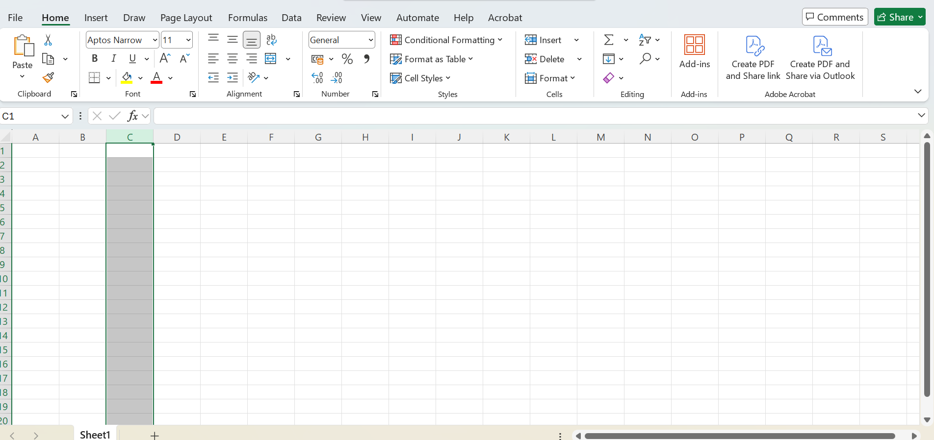
- Open Microsoft Excel
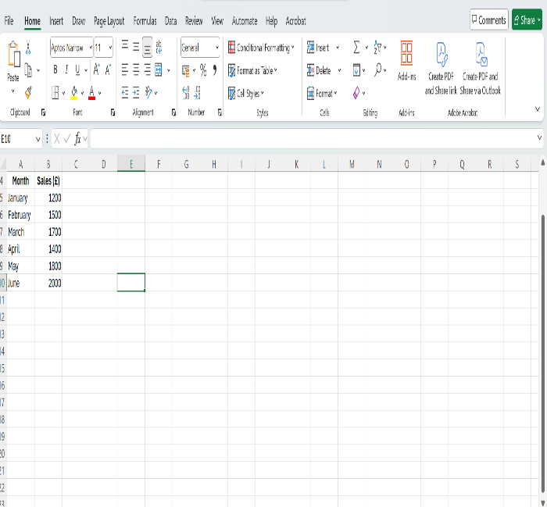
- Insert the data -> select the data

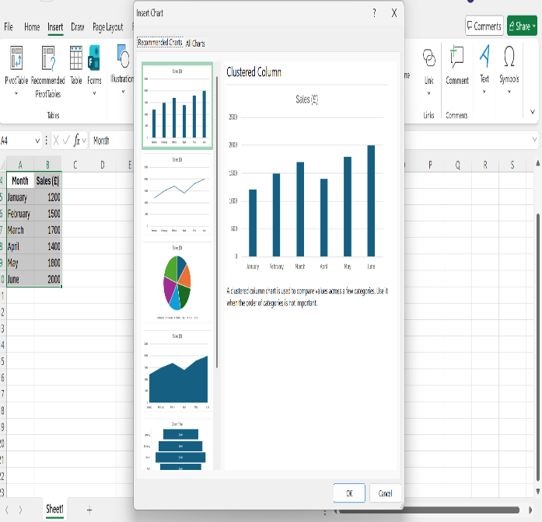
- Go to Insert -> select Insert Chart -> Choose the chart
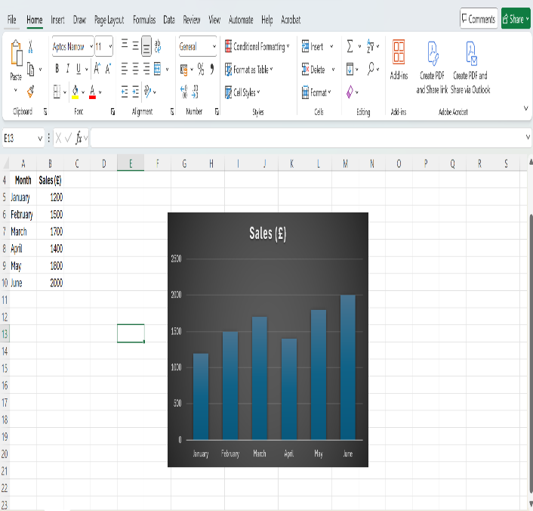
- Select the preferred chart design

