Starters: Regular Large
Our Chefs Special!
Tandoori grilled chicken marinated in exotic herbs and spices served with mint yogurt dressing, salad and merlot wine.
Scampi and Chips with sour dips: £5.99 £7.99
Spicy wedges with choice of dips: £5.99 £7.99
Smoked paprika with chickpea: £4.99 £6.99
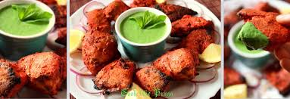
Crispy battered haddock and chips: £9.99 £12.99
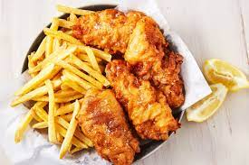

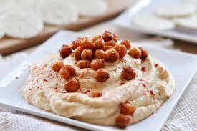

Kids menu:
ONLY 15.99
Fish fingers with onion rings: £3.99 £4.99
Chicken nuggets with Chips: £3.99 £5.99
Chips: £1.80 £2.80
Peri-peri chips: £2.30 £3.30
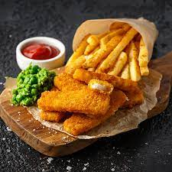

Main course:
- Tandoori lamb with crispy king prawns
marinated with medium spiced exotic herbs and spices cooked in tandoori oven, served with mint yogurt dressing and light red or rich white wine. (pinot noir or chardonnay)
£17.99
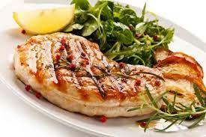
- Butter chicken

Grilled chicken, tossed in butter and yoghurt and cooked in rich and creamy sauce, served with medium red wine (sangiove
£18.99

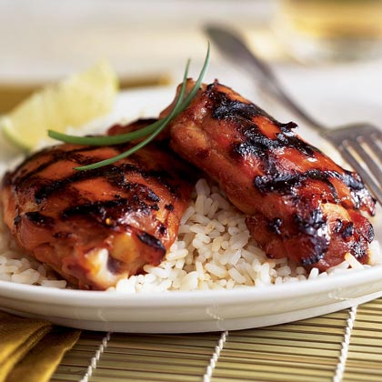
- BBQ Chicken
Full BBQ spicy chicken with white rice and chips served with light red wine, Pinot Noir. Calories, 2 wine each
£16.99

- Lamb Rib
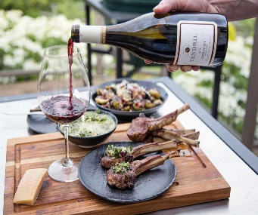
Lamb Ribs with roasted carrots and breadcrumbs served with Tempranilo
£13.99

- Grilled Salmon
Grilled Salmon and dill sauce and coconut rice served with Viognier
£12.99

Desserts
- Apple Pie £1.50
- Ice Cream (Vanilla, Strawberry, Chocolate
Mint, Double Chocolate and brownie) £2.99
- Fruit Salad £1.99
- Chocolate Cake + Ice cream (optional) £2.99 - £3.99 (with ice cream)
- Milkshake £2.50

Allergen information:
If you would like information on ingredients within our menu items, in relation to allergens, please ask a member of staff who will be able to assist you before placing your order. We cannot guarantee that any food or beverage item is free from traces of allergens due to the preparation process.



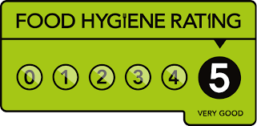
Open Monday – Sunday, 10:00am - 11:00pm
Take away available all day via Deliveroo and UberEats
Hotel Trinity – South Wales, Swansea

Reference

https://www.englishclub.com/vocabulary/food-restaurants.php

