Breaking Barriers: Women in Hospitality Leadership and Culinary Arts

International Meeting Management for the Hotel Industry
(BMIH6007)

Student Name: Ramona Barna
Student ID: 2234369
Lecturer`s Name: Chris Wilkin

Acknowledgement Statement
“I confirm that I have not used any Al tools in the research and creation of this assignment.
I confirm that I have not presented any Al generated materials as my own work. I confirm I have copies of my drafts, notes, and other resources I used, which I may be asked to provide in evidence”
Executive summary
This report highlights the proposal of a project titled: Breaking Barriers: Women in Hospitality Leadership and Culinary Arts. The event cycle model has been included for developing a structural framework for organising the event. It also includes a detailed itinerary of the event. Panel discussion, informal networking and practical sessions are included in the event itinerary. The aim of this event is to address and analyse gender disparities in the leadership sector of the hospitality industry. A detailed budget of the event has also been included in this study.

Table of Contents
Introduction 5
The Event Cycle 6
Event Concept 8
Aim and Objectives of the Meeting / Event 10
Event Management 12
Application of EMBOK 13
Event Budget 14
Industry Trends / Issues / Impacts 15
Situational and Cultural Considerations 16
Conclusion 19
References 20
Appendix – Event Brochure 22
Appendix 2 – Gantt Chart 23

Introduction
Gender inequality is regarded as a crucial issue within the hospitality sector. There is limited representation of female candidates in senior leadership roles like hotel managers, executive chefs as well as housekeeping directors. Nearly 70% of employees of the hospitality industry are female candidates, but female candidates represent only 8% in the senior leadership positions (Ilo.org, 2024). The statistical information highlights that there is a major requirement to address the gender gaps within the leadership roles of the hospital industry. Promoting diversity inclusion as well as equality is the primary objective of this event. It also focuses on recognising and analysing the challenges which can affect the career progression of women in the hospitality industry, and it also proposes interventions for enhancing gender balance.

Name of the event: Breaking Barriers: Women in Hospitality Leadership and Culinary Arts
The specific event can be regarded as a corporate as well as industry-related event, and it will target professionals from the hospital industry, including policy advocates, HR leaders and gender and equality proponents. The event will be organised in London at the Savoy. The specific location is regarded as one of the most prestigious hotels across the globe. The venue is highly attractive as well as spacious conference facilities and workshop rooms, panel discussion facilities and networking sessions will be easily organised in this hotel. It also provides proper accessibility-related features as well as catering services. The audio-visual system of this location has state-of-the-art facilities, and it significantly enhances the overall attractiveness of the location to organise a high-profile industry event.

The Event Cycle
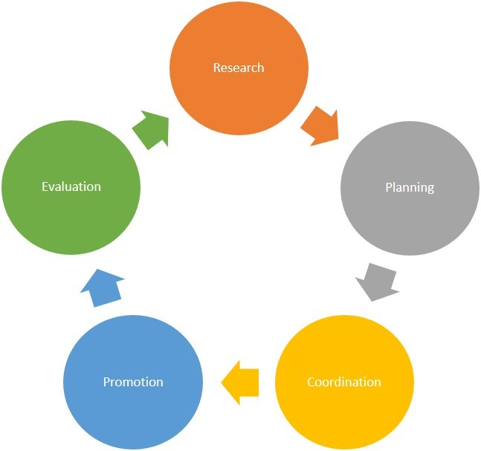
Figure 1: The Event Cycle
(Source: Based on Bowdin et al. 2023)
The event cycle is regarded as a structural element which outlines the step-by-step stages of event management to ensure systematic planning, execution as well as analysis. According to the view of Bowdin et al. (2023), the event cycle includes 5 important stages such as initiation, planning, implementation, event execution and event closure. The first phase is initiation, and it is related to the identification of the purpose, target audience as well as the feasibility of specific events. The planning is the second phase, and it is related to the development of marketing, operational as well as financial strategies. The third phase is implementation, and it is related to the execution of resource allocation, logistics as well as coordination. The fourth phase is event execution, and it is related to the actual conduction of the event. Accessing outcomes and collecting feedback from the overall execution of the event is part of event analysis and closure (Kong, 2025). Based on the view of Tiew et al. (2022), the structure and approach are highly important to ensure the overall effective delivery of an event based on the strategic goals of the event. Promoting the concept of continuous improvement is a dynamic element in the event cycle approach.
The initiation phase of this project includes background research regarding the requirements of gender equality within the hospitality industry. The feasibility study includes a detailed data-driven analysis. For instance, women make up nearly 70% of the total workforce of the hospitality industry but women representation is only 8% in the senior management roles (Ilo.org, 2024). The statistical information highlights the overall requirements of introducing gender equality related initiatives within the hospitality industry. The initial stage includes appropriate market demand analysis and the identification of the target audience. Human resource managers and women professionals are the main target audience for this event.
The planning stage is regarded as the most crucial part to ensure the overall success of a project (Allen et al. 2022). In this project three specific elements such as marketing strategies, operational planning and financial considerations have been included. The event venue selection based on the requirements and characteristics of this project was a major task of the operational planning. Digital marketing strategies have been included to enhance awareness within that target audience regarding the overall project (Dwiana Rahmadiati Putri, 2021)
The implementation stage includes technology integration, resource allocation workshops and panel identification. Critically analysing the facilities and technical support is important to implement the plan of the event. This event will use online registration tools and real-time feedback mechanisms as a part of technology integration. The event execution stage will include networking opportunities, on site coordination and continuous monitoring as well as adjustments. Onsite coordination will ensure that guest speakers and facilitators should follow the schedule of the project. Developing highly structured networking sessions is another major aspect of this project. The last phase will include analysing the long-term impact of this project. The project manager will review the partnerships established in this project and policy recommendations.

Event Concept
Introducing a well-structured event itinerary is crucial to ensure seamless engagement, execution as well as impact. According to the view of Topp et al. (2021), developing the overall schedule for offering a mixture of networking, knowledge sharing as well as practical insights can be helpful to generate more attraction within the target audience. Ensuring motivation within the aspiring female candidates is one of the main objectives of this event.

Time | Description | Perspective
8:30 to 9:30 | - Participants will be welcome within the Grand Ballroom of the Savoy  - Interaction between the attendance will be encouraged | Early networking opportunities or sessions will be helpful to set the overall outline related to professional engagement. It will ensure the concept of mentorship throughout the overall event.
9:30 to 10:15 | - One female leader from a well-known hospitality company will deliver the opening keynotes of the event.  - It will offer detailed information and perspectives related to current challenges, trends as well as policy interventions in the context of hospitality leadership and equality. | The data driven foundation will be helpful to enhance the overall credibility of the event.
10:15 to 11:30 | - The panel discussion will take place  - Topics like barriers to women's advancement in leadership sector strategies to ensure sustainable corporate structure, the importance of corporate policies and HR policies will be discussed  - Interactive discussion will take place. | The panel discussion is highly effective in promoting the concept of multi-dimensional perspectives. It will ensure a detailed as well as comprehensive exploration related to gender equity issues
11:30 to 11:45 | - Informal networking as well as coffee break | It will provide a proper opportunity for the participants to engage with speakers
11: 45 to 13:00 | - Practical sessions will be organised for aspiring executive kitchen leaders and chefs. | The workshop will be helpful in enhancing the concept of skill-based learning opportunities as well as practical implementation.
13:00 to 14:45 | - Industry showcase and networking lunch  - The participants will be able to interact with employers, sponsors as well as industry associations. | The lunch time will be helpful to offer a productive as well as relaxed setting to promote meaningful industry interactions.
14:15 to 15:30 | - This session will address the major aspects of gender bias within hotel operations.  - It will provide a special focus on career advancement-related topics for women within the hotel management and housekeeping sector. | The workshop can offer targeted interventions, and it is highly aligned with the diversity strategies of corporate organisations.
15:30 to 17:00 | - Panel discussion on self-employed women in the context of the operation of managers and executive chefs | It will highlight multiple career opportunities and pathways related to inclusivity within the leadership development process. The overall knowledge as well as perception of the participants will be significantly enhanced through the adaptation of this strategic approach.
17:00 to 17:30 | - Closing keynote as well as future opportunity discussion | The final session highlights the overall impact of the event, and it will summarise the tangible and intangible takeaways of the event.
Table 1: Event Concept

Aim and Objectives of the Meeting / Event
Aim
Addressing as well as analysing gender disparities within the leadership roles in the hospitality sector by offering mentorship opportunities, actionable strategies as well as industry-driven solutions is the primary aim of this event. It will also focus on enhancing female representation within executive positions such as managers, executive chefs as well as housekeeping directors.
Objectives

Specific | - Two organise at least to industry-specific workshops which will equip at least 100 female hospitality professionals with career advancement strategies, negotiation techniques as well and leadership skills.
Measurable | - Collecting feedback from the participants after ending the event and analysing the attendance
Achievable | - Providing proper opportunity to the experts to decorate the overall outline of the workshops and practice sessions
Relevant | - Addressing the overall skill gaps can be helpful in offering attractive training to female candidates
Time-bound | - 1 month
Table 2: SMART Objective 1

Specific | - To offer networking and mentorship opportunities to the candidates by connecting at least 60 female professionals with HR directors, industry leaders as well as executive chefs through a structured mentorship initiative
Measurable | - Extracting the actual number of mentee and mentor connection
Achievable | - Utilising the partnership with hospitality schools, trade associations as well as corporate sponsors
Relevant | - Promoting the concept of career progression through professional support and active mentorship
Time-bound | - 2 months
Table 3: SMART Objective 2

Event Management
Organising a successful event requires the strategic allocation of resources and skills throughout planning operational as well as marketing activities (Silva, 2024). According to the view of Bladen et al. (2022), operational execution includes infrastructure, logistics as well as human resource management activities. Skills in event logistics management, such as expertise in delegate management, venue coordination as well as scheduling are required. Efficiency in seating arrangements, catering management and accessibility requirements is required to organise this event successfully. Audio-visual coordination and technical support are also required in this aspect. Resources such as venue and facilities and event staffing are required. This event will be organised in the Savoy, and it will offer high-quality conference facilities as well as catering services. Event staffing will include event managers, technical support staff, hospitality employees and security personnel. Efficient operational planning is highly important to optimise the concept of resource utilisation.
Planning requirements should be developed according to the execution capabilities and event goals (Intason et al. 2021). The resources, stakeholders as well as the timeline of the overall project should be managed effectively. The project management team should have the proper scale of project and event planning stakeholder management as well as a financial plan. Event planning software and methodology are regarded as critical tools in this aspect. According to the view of Ciric Lalic et al. (2022), following the agile approach can provide proper flexibility to the event manager. However, it is a small-scale project, and including the feedback of the end users in the project planning phase can increase the overall time of completing the project. This project will follow the principles of both the waterfall methodology and the agile methodology. Strategic partnerships and financial resources are required to complete the planning requirements in an effective manner.
Marketing as well as promotion requirements are also important to enhance the overall visibility and reach of the specific event (Neuhofer et al. 2021). Digital marketing skills and public relations skills are important in this aspect to enhance the overall awareness related to equality within the hospitality industry. Digital marketing platforms such as social media platforms and event branding materials are important resources to organise the marketing activities for this event.

Application of EMBOK
The Event Management Body of Knowledge (EMBOK) offers a structural framework for handling multiple stages of an event such as planning, execution and analysis. According to the view of Bladen et al. (2022), the framework includes 5 major domains such as design, administration, operations, marketing and risk management (Silvers et al., 2005)
Administration | Design | Marketing | Operations | Risk
- Total expenditure will be £21000  - There will be to revenue streams such as sponsorship (£10,000) and ticket sales (£25,000)  - Total profit will be £14000  - Human resource budget will be £3000  - Stakeholder management. | - Content and theme design  - AI based tools will be utilised for offering personalised session recommendations as well as networking opportunities  - Female-led culinary games will offer catering services as it is aligned with the mission of the event | - Audience segmentation and market research will be performed to target women in the hospitality industry  - Social media marketing strategies and digital marketing strategies will be used as £2000 budget has been allocated for digital campaigns | - The event will be organised at the Savoy, and it will ensure prestigious environment  - Production and technical setup, Itinerary execution and scheduling | - Financial risk will be mitigated by including multiple revenue streams.  - 1000 budget has been allocated for miscellaneous as well as contingency planning to ensure complete sustainability.
Table 4: Application of EMBOK

Event Budget
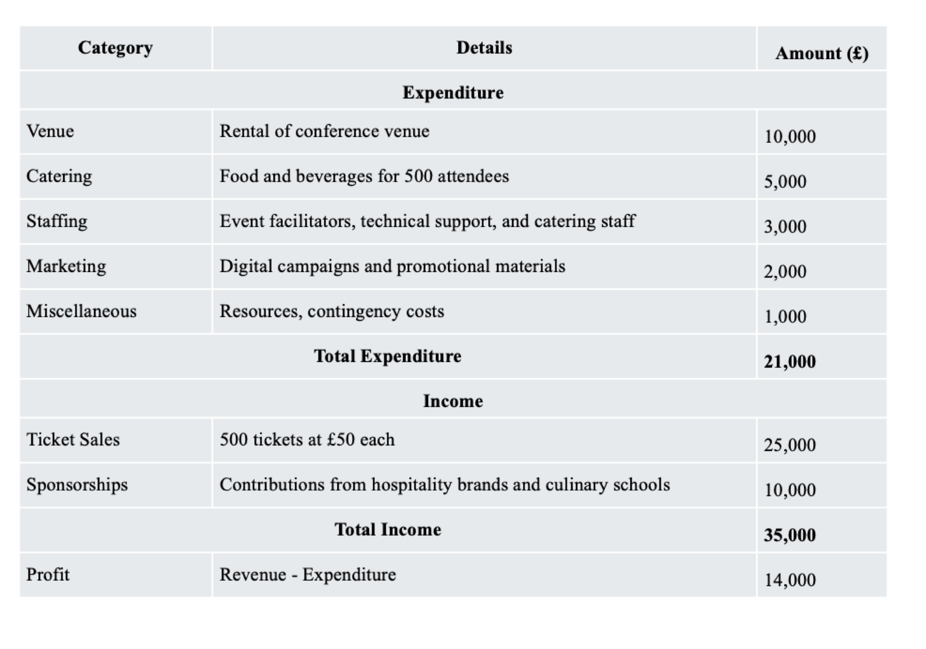
Figure 2: Budget of the event
Financial aspects clearly define the overall feasibility of a project. According to the view of Ekici and Toksoz (2021), a structural financial plan is crucial to ensure the long-term sustainability and success of an event. The financial breakdown highlights that the venue rental will include 47.6% of the total cost as it will be hosted at the Savoy. It is a premium hospitality venue and catering expenses will hold 23.8% of the total cost of the event. It highlights that the project manager is focused on maintaining the highest possible quality. Ticket sales will be responsible for generating nearly 71.4% of the total income, and sponsorships will generate 28.6% of its total income. The revenue streams are limited, and it can increase the challenges of financial sustainability (Abbas et al. 2021).

Industry Trends / Issues / Impacts
The event management industry is experiencing significant transformations due to changing expectations of participants and technological advancements (Haris Chechi, 2024). Female employees play a significant role within the hospitality industry (Gröschl and Sridhar Arcot, 2014) as female employees represent nearly 60% to 70% of the total workouts in the hospitality industry. However, the presence of female candidates in executive positions is limited. It is crucial to address the gender equality related issues within the hospitality industry. Technology can introduce revolution within event management and planning activities. This event will also use AI-based event planning and scheduling tools. It will help to enhance transparency as well as communication between the stakeholders in this project. Sustainability as well as inclusivity have become a central element within the event planning activities and promoting the concept of women empowerment through events can generate a positive impression within the target audience.

Situational and Cultural Considerations
SWOT

Strengths  - The event directly recognises gender inequality as well as diversity issues in the hospital industry.  - Strong alignment with industry requirements can ensure the success of the event.  - The event selected high profile venue, and it attracts industries support  - The overall scheduling and financial plan of the event is well structured, and it can provide long-term success to the event | Weaknesses  - Audience scope is limited in this event  - There are limited revenue streams for the event
Opportunities  - The increasing popularity of women empowerment in the executive rules  - The increasing popularity of technology integration within the event management sector | Threats  - Resistance to participating in gender-focused events can reduce the overall attractiveness.
Table 5: SWOT analysis
PESTLE

Factors | Description | Impact
Political | - The legal structure of the UK is supportive, as people can organise events on any topic. | Positive
Economic | - The size of the market of the hotel industry in UK was 24.7 billion in the year of 2023 (Statista.com,2025) | Positive
Societal | - There were more than 10000 accommodation enterprises in the UK in 2022 (Statista.com, 2025)  - Representation of female candidates within the executive rules in the hospitality industry is only 8% (Ilo.org) | Positive and negative
Technological | - Internet penetration rate is 98% (Statista.com, 2025) | Positive
Legal | - Existence of the equality act 2010 (Gov.uk, 2025) | Positive
Environmental | - Increasing popularity of ethical standards and environmental sustainability | Positive
Table 6: PESTLE analysis

Based on the overall analysis, it can be understood that the event was successful in addressing a major issue within the hospitality industry. The people of the UK are aware of gender equality. Accessing the overall skill gap among the female candidates is important to conducting this project.

Conclusion
The overall discussion indicates that the event will provide proper attention towards addressing the major concerns associated with the limited representation of female candidates in executive roles. Female employees play a significant role in enhancing the overall popularity of a hospital organisation. However, providing equal opportunity to both male and female employees in the context of career advancements is the primary objective of this event. The overall skills and characteristics required to organise this event have been discussed.

References
Abbas, J., Wang, D., Su, Z. and Ziapour, A., (2021). The role of social media in the advent of COVID-19 pandemic: crisis management, mental health challenges and implications. Risk management and healthcare policy, pp.1917-1932.
Allen, J., Harris, R. and Jago, L., (2022). Festival & special event management. John Wiley & Sons.
Bladen, C., Kennell, J., Abson, E. and Wilde, N., (2022). Events management: An introduction. Routledge.
Bowdin, G.A., Allen, J., Harris, R., Jago, L., O'Toole, W. and McDonnell, I., (2023). Events management. Routledge.
Ciric Lalic, D., Lalic, B., Delić, M., Gracanin, D. and Stefanovic, D., (2022). How project management approach impact project success? From traditional to agile. International Journal of Managing Projects in Business, 15(3), pp.494-521.
Dwiana Rahmadiati Putri (2021). Digital Marketing Strategy to Increase Brand Awareness and Customer Purchase Intention (Case Study: Ailesh Green Consulting). European Journal of Business Management and Research, [online] 6(5), pp.87–93. doi:https://doi.org/10.24018/ejbmr.2021.6.5.1063.
Ekici, R. and Toksoz, D., (2021). New trends in event marketing. In Impact of ICTs on event management and marketing (pp. 156-176). IGI Global Scientific Publishing.
Gov.uk, (2025). Equality Act 2010: guidance. Available at: https://www.gov.uk/guidance/equality-act-2010-guidance [Accessed on 21.02.2025].
Gröschl, S. and Sridhar Arcot (2014). Female hospitality executives and their effects on firm performance. Tourism and Hospitality Research, [online] 14(3), pp.143–151. doi:https://doi.org/10.1177/1467358414538997.
Haris Chechi (2024). The future of event planning: How technology is changing the game. [online] Les Roches. Available at: https://lesroches.edu/blog/future-event-planning-technology-changing-game/ [Accessed 26 Feb. 2025].
Ilo.org, (2024). Gender brief . Available at: https://www.ilo.org/media/7016/download [Accessed on 21.02.2025].
Intason, M., Lee, C. and Coetzee, W., (2021). Examining the interplay between a hallmark cultural event, tourism, and commercial activities: A case study of the Songkran Festival. Journal of Hospitality and Tourism Management, 49, pp.508-518.
Kong B. M. (2025). The Three Phases of Event Feedback. [online] Available at: https://www.sertoma.org/News-Stories/View/ArticleId/10324/The-Three-Phases-of-Event-Feedback [Accessed 26 Feb. 2025].
Neuhofer, B., Magnus, B. and Celuch, K., (2021). The impact of artificial intelligence on event experiences: a scenario technique approach. Electronic Markets, 31(3), pp.601-617.
Silva, R. (2024). The Essential Guide to Event Project Management | Eventtia. [online] Eventtia. Available at: https://www.eventtia.com/en/blog/the-ultimate-event-project-management-guide-everything-you-need-to-know [Accessed 26 Feb. 2025].
Silvers, J.R., Bowdin, G.A.J., O’Toole, W.J. and Nelson, K.B. (2005). Towards an International Event Management Body of Knowledge (EMBOK). Event Management, [online] 9(4), pp.185–198. doi:https://doi.org/10.3727/152599506776771571.
Statista.com, (2025). Hotel industry in the UK - statistics & facts. Available at: https://www.statista.com/topics/3146/hotel-industry-in-the-united-kingdom-uk/#topicOverview [Accessed on 21.02.2025].
Statista.com, (2025). Internet usage in the United Kingdom (UK) - Statistics & Facts. Available at: https://www.statista.com/topics/3246/internet-usage-in-the-uk/ [Accessed on 21.02.2025].
Tiew, F., Holmes, K. and de Bussy, N., (2022). Investigating stakeholder salience across the event management life cycle. Event Management, 26(6), pp.1297-1313.
Topp, M.S., van Meerten, T., Houot, R., Minnema, M.C., Bouabdallah, K., Lugtenburg, P.J., Thieblemont, C., Wermke, M., Song, K.W., Avivi, I. and Kuruvilla, J., (2021). Earlier corticosteroid uses for adverse event management in patients receiving axicabtagene ciloleucel for large B‐cell lymphoma. British Journal of Haematology, 195(3), pp.388-398.‌

Appendix – Event Brochure
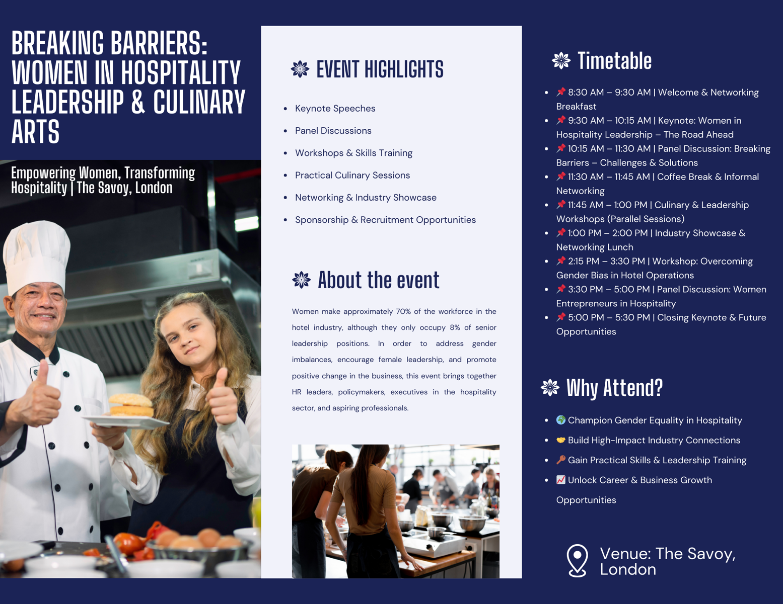
‌

Appendix 2 – Gantt Chart

 | 2025-03 | 2025-04 | 2025-05 | 2025-06 | 2025-07
Initial Research & Feasibility Study
Venue Selection & Booking
Sponsorship & Partnership Outreach
Marketing & Promotion Strategy
Speaker & Panelist Confirmations
Event Logistics Planning
Catering & Accessibility Arrangements
Final Event Preparations
Event Execution
Post-Event Evaluation & Feedback

