DEVELOPING WORKPLACE CRITICAL THINKING

Table of Contents
Introduction 3
1. Briefly Introduce the organization you have chosen to write about 3
2. Briefly introduce the key management theory or theories that will underpin your report 4
3. Answer the question by applying the key theory/theories to your chosen organization 5
4. Provide a critical evaluation of the theory/theories to assess how someone with different beliefs, attitudes and values might interpret the theory differently 8
5. Make recommendations with valid justifications for specific organizational changes for the post-COVID mindset in terms of beliefs, attitudes, and value systems that may help M&S to tackle the challenges they face now and create more resiliency for them in the future. 16
Conclusion 17
Reference List 19

Introduction
After the covid situation, the entire work pattern and culture have been changed drastically and the main focus has been vested on employee wellbeing and development. It is mandatory to change the entire design and many factors are there which also need to be considered while designing. Though remote working and work from home provided many opportunities to employees to maintain their team working and mental pressure release from getting infected but now after covid situation when the work culture will resume again employers must rethink it (Cerutti and Grodoski, 2020). Social distancing, mental wellbeing, physical well-being, and others factors are there which must be included in daily basis activities. The main aim of this report is to evaluate the best design for the workplace which will provide safety from Covid and also promotes mental and physical wellbeing and can contribute towards community development. For this report Marks and Spencer has been selected and the entire report will be formulated on the basis of the selected organization. In the following section, the report briefly described the organization and also analyzed the current situation there. Besides that, various management theories will also be analyzed here to extract exact workplace design and management structure. Schein cultural models, Maslow's motivational theory, Herzberg's two-factor theories, Henry Fayol management theory and Situational leadership theories have been illustrated. Along with the theory application in the organization, those theories have been analyzed with different perspectives. In the end, the report recommended probable solutions and justification. The report concluded with allover findings as well.

1. Briefly Introduce the organization you have chosen to write about
Marks & Spencer is one of the largest retailers in the UK and was established in 1884 with headquarters in London. Stephen Joseph Rowe is the current CEO of the company. They have varieties of products and services and due to this they have expanded their business globally (Marksandspencer, 2021a). In 2020 they generated 10,181.9 million GBP revenue (Statista, 2020). This leading retail company operates its business with over 1500 stores globally, of which around 1037 stores are situated in the United Kingdom, and 472 stores are international (Statista, 2021a). In 2021, the company launched around 46 new websites in the global market including Iceland, Uzbekistan as a part of their digital business expansion (BBC News, 2021). M&S successfully expanded its business in more than 100 countries through an effective digital marketing strategy. The company operates its business with a culturally diverse workforce, which includes around 69,577 global employees. Effective leadership, dedicated and efficient workforce is the key success factor of M&S. The reason for selecting this organization is that it operates in the retail industry and the most drastic changes have occurred in the retail industry during the lockdown and after opening it major changes must need to be done to protect the employees and store customers from getting infected by Covid. Maintaining social distance, sitting arrangement, wellbeing programs, and other segments are needed to be considered effective. Another reason for selecting this organization is that one of my closest relatives worked in the company for around 3 years. I can easily get information about the company’s internal organizational environment.

2. Briefly introduce the key management theory or theories that will underpin your report
Schein cultural model can be evaluated here because according to this model there are 3 segments such as artefacts, values, and assumed values (Khalid et al., 2020). Schein culture model helps to understand basic assumptions that shape values and the values also shape the organizational practices and behaviours which are visible aspects of the culture. In terms of artefacts, the organization needs to change the interior arrangement, physical characters of the organization such as office design. By applying this theory M&S can evaluate their store equipment and arrangements according to the Covid protocol. Also, they can provide value to their customers and employees by using this model and implementing various strategies like pre-booking, drone delivery, and others. On the other hand, the company needs to provide value to the basic assumption which can reflect on employees’ shared options. As opined by Khalid et al. (2020), the third part of Schein culture is the basic assumption, which is one type of belief within the employees that build the culture of the organization more significantly. In this context, M&S need to evaluate the present situation during COVID-19 and based on that the culture needs to change.
Also, Maslow's motivational theory, Herzberg's two-factor theories, Henry Fayol management theory could be considered here for redesigning the employee motivation program and management structure. It is important to bring some changes in management structure also so that more confined decisions can be made to protect employee benefit. Maslow's motivational theory application within the organization can help to motivate the employees providing their needs in the COVID-19 crisis. As per the view of Stoyanov (2017), the five types of needs must be evaluated by the manager and provide the solution based on the needs. The motivational strategies can satisfy their need which is very much important in this crisis period. According to the pandemic situation, the organization must flow to protect the employees by providing masks and sanitisers which will ensure maintaining health and wellbeing as well.
Herzberg's two-factor theories application in M&S can help to remove the dissatisfaction from the employees by providing several motivations to satisfy their needs. According to the viewpoint of Alshmemri et al. (2017), this theory helps to remove obstacles within the organization and build motivation. The organization needs to provide a timely salary which is the most important factor in this crisis period and along with that M&S can allow them to take a free health checkup facility which will identify whether anyone is affected due to COVID-19 or not and it will ensure safety in the workplace as well. As per the view of Tasie (2017), Henry Fayol management theory can help the organization in terms of five functions which includes planning, organizing, commanding, coordination and controlling. According to the current situation of the COVID-19 pandemic, the organization needs to change the process of management and provide motivation to motivate the employees which will help to retain them and reduce workplace turnover as well.
Situational leadership can also be applied here to evaluate the role of the leader on that condition which will help to adopt a suitable leadership approach based on different situations. As per the view of Wrightc (2017), this theory can help the organization to identify the current situation and based on that the leader needs to apply their leadership styles. The strategy implication is also based on the particular leadership style. In this crisis period, the leaders must adopt safety and hygiene precautions first and then focus on the task.
The following section applied the theories within the organization more broadly,

3. Answer the question by applying the key theory/theories to your chosen organization
Organizational beliefs, attitudes, and value systems affect workplace behaviour
Organizational values help in determining the standard of behaviour in the workplace. The attitudes of employees, belief systems of the authorities influence the motivation levels of the workers and determine their behaviour.
How organizational values affect workplace behaviour: An organization’s core values if aligned well in the mindsets of the workers it leads to high productivity, and good correlations between every member of a working team. If leaders are focused, people-oriented, and give value to employee satisfaction, it automatically generates motivation and leads to high-productive work culture.
How attitudes affect workplace behaviours: “Attitude” means a settled way of thought process, or particular behavioural approach that points out to a person's mindset, and beliefs (Verywell Mind, 2021). An employee's attitude can determine the interaction process in a working team. Attitude also affects the interrelationship between management and employees, staff and clients, as well as affects a person's perception of his job role. In M&S 's market culture, every employee maintains respect and dignity which helps in creating positive workplace behaviour.
How organizational beliefs affect workplace behaviour: "Organizational belief" means people's perception of what they feel about working in a certain place. M&S provides its employees with many benefits, parks, and creates a transparent communication channel to empower them. It creates values and helps in creating dedicated, highly competitive, and positive workplace behaviour.
In order to handle the challenges in the post-covid scenario, Marks and Spencer can implement various management theories, motivational theories, and cultural models into practice for developing a high-performing work culture within their organizational setting. The company has built its culture by introducing small changes and behavioural shifts since it came into the retail business in 1884. M&S will implement the concepts of the Schein cultural model to recompose its organizational culture in the post-covid phase.
Artefacts: Marks and Spencer have a huge workforce that is culturally diversified and operates its business in different geographic areas over the Globe. In order to maintain a good reputation, and provide customers with satisfying service, the company will implement some rules and policies. Although each employee has specific dress codes according to their role, and they maintain a good positive attitude with customers which helps in making good relationships with them, employees will be provided with particular training to groom them for better service. All the physical stores of M&S are well decorated, properly furnished, and quick customer services are available (MarksandSpencer, 2021b).
Values: All staff, employees, managers of the company possess high value, are extremely motivated and are accountable for their tasks. In the post-covid period, the strong leadership team, and their transactional leadership style will help in generating a sense of loyalty, aligning each employee's mindset with the company's mission, vision, and purpose that will significantly help in developing a healthy positive work culture. M&S's vision statement mentions that all the staff of M&S is working towards providing quality services to the community and building a positive work environment for employees (Mission-statement, 2021).
Assumed Values: These values are underneath the mindset and belief of employees in M&S which significantly influence the success of the firm. The company prefers to recruit more female employees than men to promote female empowerment. In 2021, 70% of the workforce is female (Statista, 2021b). Along with that, the company will invest more in CSR policies which will add value to its company culture.
Due to the Coronavirus outbreak, M&S also faces losses and has to close many physical stores. Employees have lost hope, motivation in the work, and remote working processes seem difficult to control by the managers. Wearing masks, social distancing, properly sanitizing has become a part of everyone's life, and M&S's workplace also needs to adapt to the "new normal" which requires some organizational changes to tackle these challenges. The leaders of M&S will follow a situational leadership style to provide socio-emotional support to the employees in a difficult time. This empathetic, and relationship-oriented leadership style will help in building trust, and satisfaction among employees' minds to create healthy workplace behaviour in M&S.
In order to motivate the employees in this critical period, the company will also focus on all the needs that are important to fulfil according to “Maslow's hierarchy of needs” theory. Although, the company pays around £8.50– 11.49 per hour to its employees which is way more than the minimum wage in the UK (Payscale, 2021). It helps in meeting all the physiological needs of the workers. The company also takes care of their safety needs, by providing them with job security, pension benefits, sick pay, fringe benefits, education assistance, financial assistance (Glassdoor, 2021). M&S will provide remote working facilities and flexible working hours to fulfil the social needs of their employees. The company will provide a healthy work culture where every employee's ideas are valued, cultures, and thoughts are respected which helps in the fulfilment of their esteem needs and self-actualization needs.
In the post-covid situation, the company will follow the concepts of ”Herzberg's two-factor theories”. In 2019, the company introduced a separate reward scheme for employees which says employees are rewarded according to their best performances, on a quarterly, monthly, and yearly basis. (M&S Corporate Gifts, 2019). The company will continue to provide gift cards and huge discounts which are considered motivators according to Herzberg's theory. Besides that, the authorities will take care of hygiene factors to generate intrinsic motivation among the workers. All of these steps will help in building a family-like work culture where everyone is empowered and dedicated to the success of the firm.
During the COVID 19 pandemic, M&S has gone through critical phases, and the employee turnover rate also increases as most of the workers lost hope, and got frightened because of the infection. In that scenario implementing Henry, Fayol management theory will help the organization to properly manage the procedures in WFH and remote working schedule. The leadership team has to make a proper plan of action or planning about their strategies, and what they want to achieve. The senior management teams will organize the procedures and divide work into different functional areas. The head of each department will make the command, and manage specific skills to specific tasks to reduce confusion during WFH. Junior managers and team leaders of each functional area will help in making the coordination during remote working hours. The overall control of all the operational processes will be in the hands of the authority of M&S. In this way the company can mitigate issues to create a more resilient business in the post-covid situation.

4. Provide a critical evaluation of the theory/theories to assess how someone with different beliefs, attitudes and values might interpret the theory differently
Schein cultural model
The Schein culture model was developed by Edgar Schein and he proposed a new thought on organizational culture. According to this model, everyone needs to understand the organizational culture more broadly to make the changes or to shape with new strategies. As per the view of Coghlan (2021), the model is presented in three different layers that are artefacts, values and basic assumptions. Artefacts represent the visible part or symbol of the organizational culture. It can include the clothing style of the employees, any posters on the wall. On the other hand, the value depends on organizational belief and thought. The basic assumption is the belief that the employees represent through their daily activities. For instance, the employees when incorporating any ideas need to be illustrated in front of everyone which can help to develop the organizational culture and it will also show the value of employees towards the organization.
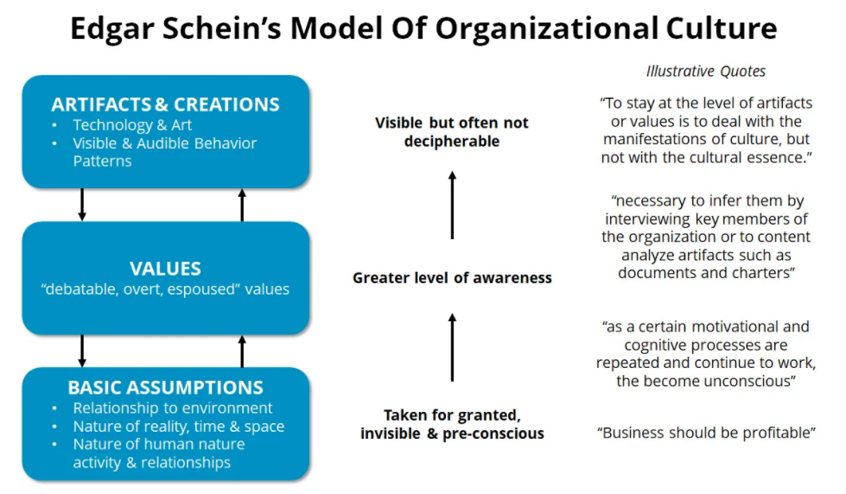
Figure 1: Schein culture model
(Source: Coghlan, 2021)
Judging the culture by seeing artefacts within the organization could be represented through an example such as a foosball table or ping pong table in the office premises can build an assumption that the organization follows a fun and friendly environment in the working days. According to this model organizational culture can solidify through two ways; anxiety avoidance and problem solving-solving processes. The Schein culture model represents three stages of culture; founding and early stages, midlife and maturity and decline.
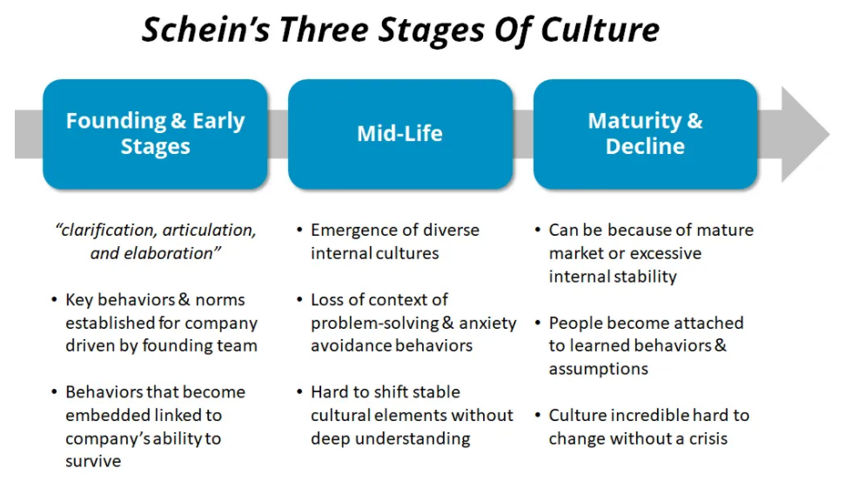
Figure 2: Stages of Schein culture model
(Source: Zarei Matin et al. 2018)
Advantages of Schein culture model: This model helps to modify the organization culture by applying concepts proposed through it. It also highlights organizational cultures at different levels and the concept along with it.
Maslow's motivational theory
Maslow's motivational theory was proposed by Abraham Maslow in 1943 in his psychology paper "A theory of human motivation". As stated by Tripathi (2018), the motivational theory comprises a five-tier model of human needs which represents a pyramid. From the bottom of the model hierarchy upwards, the needs are; psychological need, safety need, social need, self-esteem and self-actualization. In order to achieve the satisfaction level, everyone needs to focus from the lower of the hierarchy of needs. The motivational theory application within an organization is illustrated in the following section,
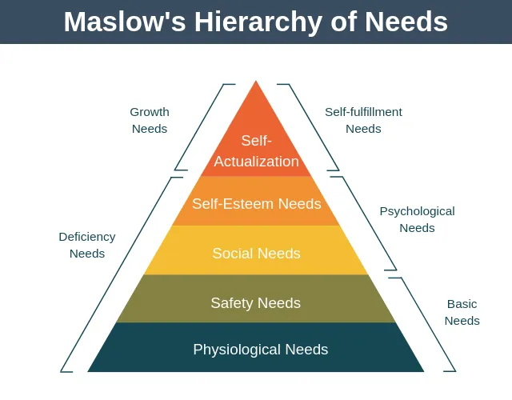
Figure 3: Maslow's motivational theory
(Source: Tripathi, 2018)
In terms of psychological need, an organization needs to provide a restroom, break time, comfortable working area and most importantly provide the salary timely which can satisfy the basic needs of employees which include living, food, utilities, and other essential things. In terms of safety, the HR of an organization needs to ensure safety within the workplace, reduce the risk of injury, secure buildings, and provide emotional and mental safety as well. The manager needs to ensure there is no chance of mass layoff, avoid workplace harassment as well. Social needs represent the relationship with the employees which will ensure the value and engagement within the organization as well. The organization must arrange some sort of social gathering cultural program through which the employees can be socially engaged. Self-esteem represents the higher goal within the organization. The HR or leaders need to provide feedback to improve the performance of employees, encourage them, provide recognition and appreciation which helps to impact self-esteem. Self-actualization is the final level of the pyramid; at this level, the organization needs to provide opportunities to achieve success and career growth. It helps identify all the requirements vary broadly by meeting the hierarchy of needs throughout.
Herzberg's two-factor theories
Frederick Herzberg proposed a two-factor theory or the hygiene theory. According to this theory, there are certain job factors that prevent dissatisfaction in a job. According to the viewpoint of Alshmemri et al. (2017), the job factors are classified into two categories; the Hygiene factor and the Motivational factor. In terms of hygiene factors, this is an essential part of the existence of motivation in the workforce. The hygiene factors include basic pay, fringe benefits, employee status, job security, organization policy, working environment, interpersonal relationship, and others. Every organization needs to take care of these hygiene factors which can reduce dissatisfaction among the employees. Motivational factors include a sense of achievement, responsibilities, recognition, growth and opportunities, challenging and meaningful working culture and others. The HR of an organization needs to incorporate the factors in their policy to increase motivation within the employees.

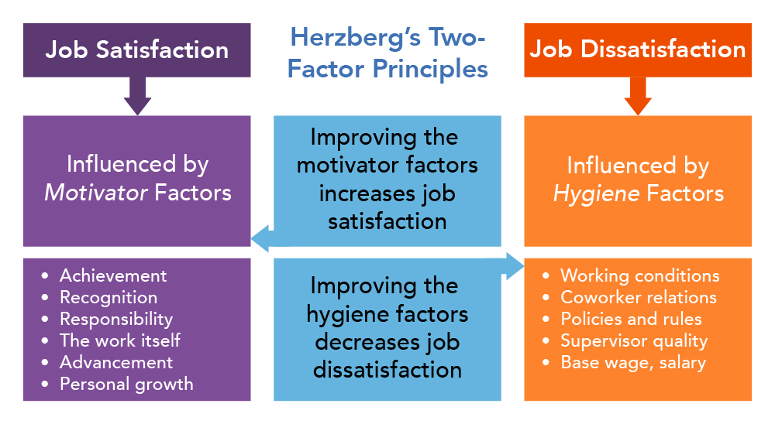
Figure 4: Herzberg's two-factor theories
(Source: Alfayad and Arif, 2017)
The employees who are demotivated within the organization tend to leave the organization more frequently, which impacts on high employee turnover. In order to deal with this factor, every organization needs to motivate the employees and maintain hygiene factors as well. As per the view of Alfayad and Arif (2017), these strategies help to increase employee morale as well as high satisfaction level. On the other hand, this theory is too idealistic and overlooks situational variables. This also has been identified that this theory focuses on satisfaction and ignores productivity. Hence, the theory has certain limitations. Despite these limitations, the theory is accepted everywhere broadly.
Henry Fayol management theory
Henry Fayol management theory was developed by Henri Fayol in the 1990s. This theory is associated with 14 principles that are illustrated below,
Division of work is representing the work differentiation among the employees based on their designation The theory proposes that the employees perform better when they get the task based on their understanding, ability and skills. As stated by Mahindru et al. (2018), Authority and responsibility is the second principle, in which authority represents the right holed by the employees and responsibility associated with the authority which performs accordingly. Discipline represents the workforce's behaviour culture and also maintains the quality and standard of the organization. Unity of command represents unity and concentration and also directs the pathway to achieve the organizational mission. Subordination of individual interest represents that employees need to take care of organizational interest and so should surrender their own interest as well.
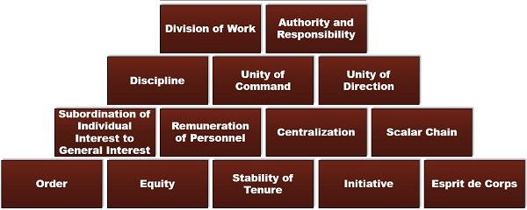
Figure 5: Henry Fayol management theory
(Source: Tasie, 2017)
Remuneration is an effective strategy that helps to keep motivated the employees within the organization. Everyone needs to receive compensation based on their performance. The degree of centralization represents through the concentration of decision-making power within the top management of the organization. Scalar chain varies from senior management to smaller lever within the organization. The order represents the resources that need to complete work within an organization. In terms of social order, an organization needs to be clean, safe and hygiene maintained (Tasie, 2017). Equity represents equality within the organization by avoiding discrimination. Fair and equal distribution of work and pay should be there in the organization. The stability of tenure is the part of the organization that needs to be taken care of by the management department of the organization. The initiative represents the creative idea that is produced by employees. Esprit de corps refers to the worker participation and unity which contributes to the development of culture, mutual trust and atmosphere.
This theory helps to facilitate organizational culture and structure, motivates employees through fair competition and encouragement, and promotes team concept. On the other hand, this theory is based on the author's experience in management, not any empirical research and does not give consideration to customers' needs.
Situational leadership
Situational leadership is an adaptive leadership style and this helps to encourage leaders to take the stock of their team members, choose the leadership that is best for the organization workforce. As per the view of Bosse et al. (2017), this theory ensures to development of people and workgroups, and use a common leadership style across all units in terms of local or international. It helps to adapt to the existing working environment and requirements of the organization. This is not based on certain specific skills of leaders, instead, the leader modifies their management style which could be appropriate for the organization requirements.
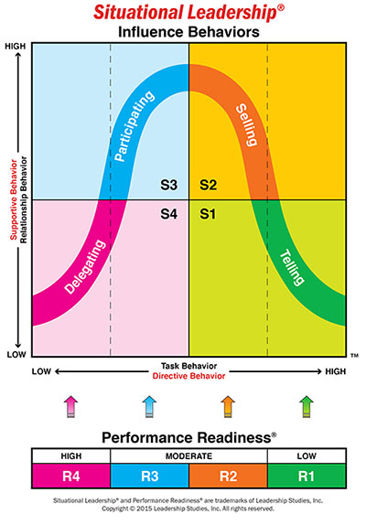
Figure 6: Situational leadership
(Source: Bosse et al. 2017)
Some advantages and disadvantages of situational leadership are also there such as it is easy to use within an organization, simple in the application as leaders have to understand the situations based on that they need to apply correct leadership styles. According to the viewpoint of Wright (2017), leaders also have the right to change their management style. On the other hand, this theory does not take into consideration priorities and communication style, avoids differentiation among managers' genders and this can divert the attention of employees as well.

5. Make recommendations with valid justifications for specific organizational changes for the post-COVID mindset in terms of beliefs, attitudes, and value systems that may help M&S to tackle the challenges they face now and create more resiliency for them in the future.
Covid situation has brought a lot of changes in the mindset of employees and authorities of M&S. Specific organizational changes are required to introduce in order to tackle these challenges that the company is facing in the present time. Here are some recommendations based on previous critical evaluations on how M&S can bring changes to create more resiliency in the future.
- Introducing new technologies: M&S needs to introduce new technologies to speed up the process to recover the losses during the lockdown. As most of the employees are working from home, thus in order to track their performance, M&S needs to introduce a digital employee tracking system. It will help the managers to properly regulate all the procedures of operations. On the other hand, M&S can introduce AI and Robotics technology to conduct some operations with the help of these modern technologies.
- Reward: Reward is an important tool to generate extrinsic motivation among employees. As the employee turnover rate increases during the pandemic, M&S needs to increase the number of rewards to retain the motivation of employees in the work. Both in a hybrid work environment, and remote working, rewards should be the same for every employee. As everybody is very much concerned about health, thus free health checking facilities for employees and their full family, provided by the company can be a good reward option in this time. This will generate positive values on employees' mindsets. M&S can also prove Care-packed gift boxes, paid vacation, organize company-offsite to reward its employees.
- Recognition: Recognition is another effective way to generate motivation, and values in the employee's mind to encourage them for better work in Covid situation (Forbes, 2017). The company can make a "Wall of fame" shown on both offline and online platforms to give recognition to the best employees of the month. M&S can introduce team trophies, virtual parties, social media praise for recognition purposes as well. This will help in creating a positive attitude of employees in difficult periods.
- Flatten the structure: Three or more levels of management between the authority, and front-line employees make the operation process very complex especially during the work-from-home situation. As, after the post-covid situation, a huge number of employees will continue their WFH and remote working, M&S needs to flatten its hierarchical structure to some extent to reduce extra complexities in decision-making.
- Transparent communication network: In work-from-home and remote working cultures, the communication gap between management and employees is a big issue. In order to mitigate that, a fair and transparent communication channel needs to be built. Every employee should be provided with some authority to make appropriate decisions in critical situations and needs to be provided with access to all company information.
- Situational leadership: M&S needs to provide extra support to the employees who live in those geographic areas where internet connection is poor, and who do not have access to modern technologies. Besides, that new employees should be provided with online coaching, and grooming, thus they can quickly adapt to the company's work culture.
- Motivational sessions: Once in 15 days, M&S needs to organize motivational sessions to encourage its employees. The Depression rate is rapidly increasing in every part of the world due to the virus outbreak. In this critical scenario, encouraging workers for good performance is not an easy task. Managers need to sincerely organize motivational sessions, and problem-solving sessions to address the issues of the employees. M&S needs to adapt Henry Fayol management theory that will create a positive organizational belief among the members of M&S.
- Separation of critical skills and roles: As accomplishing group tasks have become difficult during WFH culture, M&S needs to focus more on its employees' critical skills rather than their roles.

Conclusion
It can be concluded that in terms of maintaining an organization developing workforce planning is significant. This report is based on identifying the situation of an organization during the COVID-19 crisis and deep strategy to enhance all over the function. The chosen organization was Marks and Spencer's. The current COVID-19 crisis and its impact on the organization were also analyzed. Several factors have been identified through this analysis. The employees feel demotivated and fear to work in the organization, on the other hand, the organization also needs to maintain certain precautionary measures which are mandatory in this situation. Certain theories have been applied within the organization to enhance the allover function of leaders, management and organization. The theories which have been analyzed further with different perspectives are Herzberg two-factor theories, Maslow’s theory of motivation, Schein culture model, Henry Fayol Fourteen Principles and Situational leadership. The above section has analyzed the concept of those theories and along with that advantages and disadvantages also have been discussed. Some recommendations have been provided to improve allover over the fiction of the organization in this pandemic situation. Introducing new technologies to maintain a smooth workforce, providing motivations and recognition, avoid discrimination, maintaining health and wellbeing are some of the strategies that can be given main priorities to maintain the workforce in this COVID-19 more effectively.

Reference List
Alfayad, Z. and Arif, L.S.M., 2017. Employee voice and job satisfaction: An application of Herzberg two-factor theory. International Review of Management and Marketing, 7(1), pp.150-156.
Alshmemri, M., Shahwan-Akl, L. and Maude, P., 2017. Herzberg’s two-factor theory. Life Science Journal, 14(5), pp.12-16.
BBC News, 2021. Mark & Spencer launches online operations in 46 markets. [online] BBC News. Available at: <https://www.bbc.com/news/business-56327257> [Accessed 19 July 2021].
Bosse, T., Duell, R., Memon, Z.A., Treur, J. and van der Wal, C.N., 2017. Computational model-based design of leadership support based on situational leadership theory. Simulation, 93(7), pp.605-617.
Cerutti, K. and Grodoski, L., 2020. Reshape the Workplace: Five Post-COVID Behaviors and Attitudes. [online] Work Design Magazine. Available at: <https://www.workdesign.com/2020/06/five-post-covid-behaviors-and-attitudes-that-will-reshape-the-workplace/> [Accessed 12 July 2021].
Coghlan, D., 2021. Edgar Schein on change: Insights into the creation of a model. The Journal of Applied Behavioral Science, 57(1), pp.11-19.
Forbes, 2017. 3 Reasons Why Employee Recognition Will Always Matter. [online] Forbes. Available at: <https://www.forbes.com/sites/williamcraig/2017/07/17/3-reasons-why-employee-recognition-will-always-matter/?sh=404a109963c9> [Accessed 17 July 2021].
Glassdoor, 2021. Marks & Spencer Benefits. [online] glassdoor.co.uk. Available at: <https://www.glassdoor.co.uk/Benefits/Marks-and-Spencer-UK-Benefits-EI_IE3278.0,17_IL.18,20_IN2.htm> [Accessed 22 July 2021].
Khalid, A., Bibi, B. and Akhtar, C.S., 2020. Role of leaders in the development and maintenance of organisational culture through artefacts. Middle East Journal of Management, 7(2), pp.132-149.
M&S Corporate Gifts, 2019. The business benefits of employee reward schemes | M&S Corporate Gifts. [online] M&S Corporate Gifts. Available at: <https://marksandspencerforbusiness.com/the-business-benefits-of-employee-reward-schemes/> [Accessed 20 July 2021].
Mahindru, R., Sharma, A., Chopra, S. and Bhatia, S., 2018. A Study of Fayol’s Principles: Applicability in Today’s Organization. Management Today, 8(3), pp.213-220.
Marksandspencer, 2021a. Welcome to Marks & Spencer. [online] Marksandspencer.com. Available at: <https://www.marksandspencer.com/> [Accessed 14 July 2021].
MarksandSpencer, 2021b. Stores. [online] Stores. Available at: <https://corporate.marksandspencer.com/aboutus/stores> [Accessed 16 July 2021].
Mission-statement, 2021. Marks & Spencer Mission Statement Analysis. [online] Mission-statement.com. Available at: <https://mission-statement.com/marks-spencer/> [Accessed 20 July 2021].
Payscale, 2021. Marks and Spencer plc Hourly Pay in United Kingdom | PayScale. [online] Payscale.com. Available at: <https://www.payscale.com/research/UK/Employer=Marks_and_Spencer_plc/Hourly_Rate> [Accessed 21 July 2021].
Statista, 2020. M&S: revenue 2019 | Statista. [online] Statista. Available at: <https://www.statista.com/statistics/413349/group-revenue-marks-and-spencer-mands/> [Accessed 14 July 2021].
Statista, 2021a. Number of Marks & Spencer stores 2021, by region | Statista. [online] Statista. Available at: <https://www.statista.com/statistics/268649/marks-und-spencer-number-of-outlets-by-region/> [Accessed 16 July 2021].
Statista, 2021b. Marks & Spencer: gender diversity of employees 2021 | Statista. [online] Statista. Available at: <https://www.statista.com/statistics/872807/marks-and-spencer-gender-diversity-of-employees-worldwide-uk/> [Accessed 19 July 2021].
Stoyanov, S., 2017. An Analysis of Abraham Maslow’s A Theory of Human Motivation. Macat Library.
Tasie, G., 2017. A Review of the Role of Management as an Integrating Activity using Henry Fayol Fourteen Principles. Advances in Social Sciences Research Journal, 4(22).
Tripathi, N., 2018. A valuation of Abraham Maslow's theory of self-actualization for the enhancement of quality of life. Indian Journal of Health and wellbeing, 9(3), pp.499-504.
Verywell Mind, 2021. How Can Our Attitudes Change and Influence Behaviors?. [online] Verywell Mind. Available at: <https://www.verywellmind.com/attitudes-how-they-form-change-shape-behavior-2795897> [Accessed 21 July 2021].
Wright, E.S., 2017. Dialogic development in the situational leadership style. Performance Improvement, 56(9), pp.27-31.
Zarei Matin, H., Yazdani, H.R. and Rajabzadeh, A., 2018. Designing an effective organizational culture model in project-based organizations. Organizational Culture Management, 16(3), pp.779-804.

