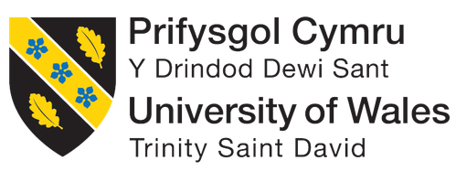

Module Code: BMIH4010
Personnel Resourcing and Development

Assignment title: Portfolio: 2 Elements

Student Name: Kaysar Ahmed
Student ID: 2111257
Table of Contents
Portfolio: 2 Elements 2
1. Introduction 2
2. Task (Element 1) 2
2.1 PESTLE factors 2
2.1.1 Social considerations 3
2.1.2 Technological considerations 3
2.1.3 Environmental considerations 4
2.1.4 Legal considerations 4
2.2 Final Job advertisement 5
3. Task (Element 2) 6
3.1 Details of the onboarding process 6
3.2 Recommended personalised elements and mentorship program 6
3.3 Development strategies (industry examples) 7
3.4 SWOT analysis of the development process 9
4. Conclusion 10
References 11

Portfolio: 2 Elements

1. Introduction
The role of HR professionals is essential to manage the internal and external factors that affect organisations. In the hospitality industry, hiring the right talent is key to delivering excellent customer service. This task highlights the knowledge of employment markets, staffing processes, and legal requirements, as well as the adaptation of technological advancements. At Delta by Mariott, hiring a hotel manager requires an effective job advertisement that attracts skilled candidates. Once hired, a structured onboarding process ensures smooth integration and ongoing development strategies support growth. Moreover, SWOT analysis helps to measure the effectiveness of the process by thoroughly identifying strengths, weaknesses, opportunities, and potential threats.

2. Task (Element 1)

2.1 PESTLE factors
Factors | Impact (only key data in bullet points)
Social | - Diversity and inclusion: In the UK hospitality sector, around 40% of employees have a non-native background (Green, 2024).  - Personalised guest services: 80% of customers expect a more personalised experience, and hotels that implement customisation see a 10-15% increase in revenue per customer (Epsilon, 2018).
Technological | - AI in recruitment: AI-driven recruitment tools improve candidate screening, and have reduced hiring time by 30-50% in the hospitality industry (Fountain, 2019).  - Digital onboarding: Digital onboarding has seen an 82% increase in employee retention, improving workforce stability (HRD Connect, 2024).
Environmental | - Sustainability in hiring: Over 71% of job seekers prefer to work for environmentally responsible companies that influence recruitment policies (Pratt, 2022).  - Energy-efficient operations: 20-30% reduction in operational costs, which drive changes in managerial strategies (WNS, 2024).
Legal | - Equal employment compliance: Laws such as the Equality Act (2010) in the UK ensure fair hiring practices (Government of UK, 2013).  - GDPR compliance: GDPR regulations enforce fines for mishandling candidate data, making compliance an essential aspect of HR operations.
Table 1: Pestle Factors
(Source: Author)

2.1.1 Social considerations
Delta by Marriott is seeking a dedicated Hotel Manager to lead their dynamic team, which provides outstanding, and personalised guest experiences. According to the study of Hayes and Ninemeier (2009, p. 125), a strong commitment to inclusivity ensures a fruitful environment for employees from all backgrounds, which enables a workplace where talent thrives. From another viewpoint of Ibrahim and Islam (2024, p. 171), personalised guest services play an important role in improving guest satisfaction through customisation and innovation. The ideal candidate can also cultivate an inclusive nature, drive operational excellence, and uphold the highest hospitality standards. Therefore, these opportunities offer a chance to be part of a forward-thinking team that values diversity and exceptional service in the hospitality industry.

2.1.2 Technological considerations
Delta by Marriott needs a highly skilled Hotel Manager to oversee operations, improve guest experience, and drive business success. According to the study by Gallagher (2022, p. 94), AI-driven recruitment tools are utilised to streamline candidate selection and ensure an efficient hiring process. Moreover, a digital onboarding system, guided by "Kotter’s Change Model” enables seamless integration for new hires, which promotes workforce stability and engagement (Carreño, 2024, p. 6). Throughout recruitment, "Talent Management Theory” is applied to identify and develop top talent. Therefore, this role offers an opportunity to lead in a dynamic, technology-driven environment. Qualified professionals with strong hospitality expertise are encouraged to apply and ensure seamless operations in a dynamic hospitality environment.

2.1.3 Environmental considerations
An experienced Hotel Manager is required to ensure exceptional guest experiences while including sustainability and innovation. This role mixes environmental responsibility into operations and is aligned with modern hiring trends. As per the view of Inman, O'Sullivan and Murton (2014, p. 29), digital recruitment tools streamline candidate selection and improve efficiency and engagement. Moreover, with the help of developing technology, the role of HR also improves cost-effective, energy-efficient operations as well as ensures compliance with sustainability goals (Bajpai and Tripathi, 2023, p. 857). HR strategies play a key role in enabling a culture of continuous improvement aligned with strategic business objectives. Therefore, ideal candidates will prove leadership, adaptability, and a passion for hospitality excellence.

2.1.4 Legal considerations
A Hotel Manager is required to lead operations to ensure fairness, compliance, and innovation. Recruitment follows strict equal employment laws, which promote a diverse and inclusive workplace (Heath, 2023, p. 10). Similarly, data protection remains a priority, with GDPR-compliant processes to safeguard candidate information (Issaoui, Örtensjö and Islam, 2023, p. 107). It needs to be mentioned that technology improves hiring efficiency while maintaining legal transparency. Moreover, HR strategies align with legal and ethical standards and also ensure fair opportunities for all applicants. Therefore, sustainable practices are combined into operations, which reflect corporate responsibility, and this role demands strong leadership, adaptability, and commitment to excellence. Thus, join a forward-thinking team dedicated to compliance, sustainability, and outstanding hospitality service.

2.2 Final Job advertisement
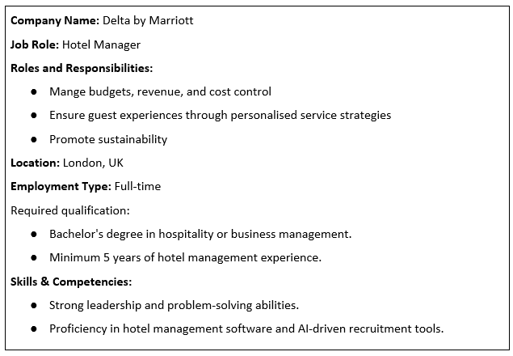
Table 2: Job advertisement
(Source: Author)
Marriott is looking for a dedicated and skilled Hotel Manager to supervise daily operations, ensure excellent guest service, and efficiently manage staff. The role is to handle budgets, maintain high hospitality standards, and improve hotel performance. The ideal candidate possesses strong leadership, problem-solving, and communication skills, along with experience in hotel management (Papageorgiou, Marneros and Efstathiades, 2024, p. 238). This position offers an excellent opportunity to work in a dynamic environment and grow within the hospitality industry. As per the report of Marriott International (2024), Marriott believes “in putting people first, pursuing excellence, acceptance change, and acting with integrity” creates an inclusive and service-oriented culture. They enable a collaborative workplace where team members are empowered to innovate, grow, and deliver exceptional guest experiences. Moreover, their commitment to “Serve 360” initiatives prioritizes guest satisfaction and also contributes to environmental and social responsibility (Marriott International, 2024). Therefore, to bring top service and lead a team, are encouraged to apply and become part of Marriott.

3. Task (Element 2)

3.1 Details of the onboarding process
The onboarding process for the new Hotel Manager at Delta by Marriott will be structured to ensure a smooth transition into their role.
1. Pre-boarding (Before Joining): The HR team will send a welcome email with essential documents, an introduction to company policies, and a schedule for the first week. They will also receive a virtual tour of the hotel operations.
2. First Day Orientation: The manager will be introduced to key department heads and provided with an overview of the corporate values of Marriott, their mission, and brand standards.
3. Training & Compliance (Week 1-2): The manager will experience training on health & safety regulations, guest service protocols, and operational systems such as property management software. They will also track the performance of different department heads to understand workflows.
4. Role-Specific Training (Week 3-4): The manager will be assigned a mentor to provide guidance on budgeting, revenue management, staff scheduling, and customer service strategies. Moreover, real-time problem-solving exercises will also be included.
5. Performance Review (Month 1-3): Regular check-ins will be conducted with senior management to address challenges. A 90-day review will help to measure progress and set short-term goals for improvement.
6. Full Integration: By this stage, the manager should be fully settled into their role with confidence in hotel operations and leadership responsibilities.

3.2 Recommended personalised elements and mentorship program
Incorporation of more personalised elements and mentorship programs would improve employee engagement and integration, which maintain the following ways:
1. Personalized Onboarding Experience
- Tailor onboarding content based on the new hire’s role and career aspirations.
- Provide customised learning paths to address specific skills and knowledge gaps.
- Assign a mentor to provide guidance.
2. Mentorship Programs
- Pair new hires with experienced managers for one-on-one coaching.
- Include regular mentor check-ins during the first 90 days.
- Encourage networking capabilities within the organisation.
3. Interactive Onboarding Activities
- Conduct team-building exercises to enable connections with colleagues.
- Use role-playing exercises for practical learning.
4. Feedback and Continuous Support
- Implement regular surveys to understand new hires’ challenges.
- Offer flexible onboarding timelines to adapt different learning steps.

3.3 Development strategies (industry examples)
Several simple and effective strategies will be used to help the new Hotel Manager grow and succeed. Primarily, leadership training programs such as the ‘Marriott Development Academy’ can provide important managerial skills and hands-on workshops to develop leadership abilities (Marriott, 2020). Similarly, mentorship and coaching will be introduced in combination with the manager with an experienced leader within the company. Similarly, advanced technologies such as AI-driven recruitment and virtual onboarding tools help Marriott to stay ahead in the hospitality industry. AI-powered hiring quickly finds the best candidates by analysing resumes and predicting job fit (Albassam, 2023). Similarly, Virtual onboarding allows new hires to complete training online and improve engagement and retention (Jeske and Olson, 2021). It can be declared that Marriott uses the "HireVue AI system" for video interviews and "M-Learning" for digital training, which makes learning more flexible (Zaytsev, 2024). These tools speed up hiring, reduce costs, and enhance employee skills. This approach is inspired by the ‘Lead@Hilton’ program of Hilton, which has been successful in improving leadership skills (Hilton, 2024). Additionally, the manager will get cross-departmental experience by working in different areas of the hotel, such as housekeeping, front desk, and food & beverage (Andrade, Miller and Westover, 2020, p. 75). ‘Shadowing Experience’ under Accor has shown that this method helps managers gain a complete understanding of hotel operations (Accor, 2024). Finally, regular feedback and performance reviews will be conducted every three months by using a 360-degree review system. As an example, the ‘Real-time Feedback Mechanism’ of IHG has also proven that continuous feedback leads to better performance (IHG, 2021). Therefore, by applying these strategies, the Hotel Manager will develop strong leadership skills, improve customer service, and contribute to the overall success. These steps will ensure continuous learning and career growth in the hospitality industry.
Maslow’s Hierarchy of Needs
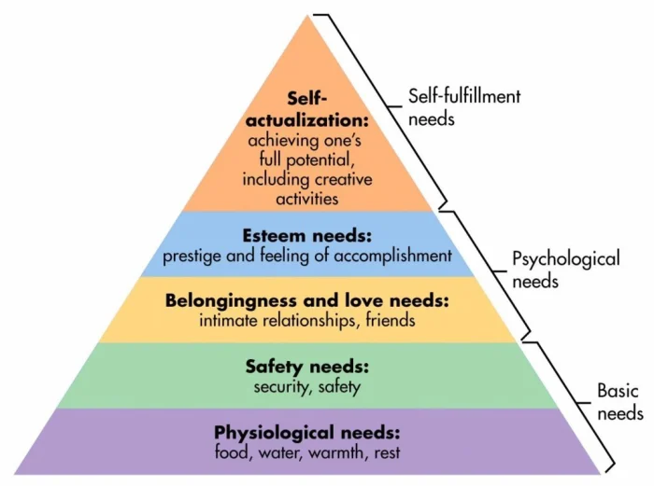
Figure 1: Maslow’s Hierarchy of Needs
(Source: Maslow, 1943)
Maslow’s Hierarchy of Needs can improve recruitment and development strategies in Marriott. As per the theory, Maslow’s Hierarchy of Needs explains that individuals are motivated by five levels of needs, which progress from basic survival to self-fulfilment (Maslow, 1943). Physiological needs are met through fair salaries and job security. Competitive compensation packages, benefits, and financial wellness programs need to be included by Marriott to lead to productivity and job satisfaction. Similarly, Safety needs include a structured onboarding process and compliance training. Recruitment strategies prioritize candidates who align with the company's commitment to workplace safety. Belongingness is addressed by mentorship programs and team-building activities. Includes networking opportunities, diversity programs, and workplace engagement initiatives to improve mentorship programs. Moreover, Esteem needs are fulfilled by leadership training, performance recognition, and career growth opportunities. Structured development strategies ensure employees receive constructive feedback, promotions, and internal mobility for career advancement. Finally, Self-actualization is achieved through continuous learning, cross-departmental exposure, and innovation-driven roles. Therefore, these needs with recruitment ensure motivated employees, and structured development strategies support long-term retention, and success in hospitality.

3.4 SWOT analysis of the development process
Strengths | Weakness
- Structured development processes with strong AI systems and M-learning ensure growth and learning.  - Mentorship from experienced leaders improves decision-making skills (Soegiarto et al., 2024, p. 1925). | - High training costs can be a financial burden (Phillips et al., 2017, p. 150).  - Time-consuming training might delay immediate contributions (Mehner, Rothenbusch and Kauffeld, 2024, p. 15).
Opportunities | Threats
- Advanced certifications improve career prospects.  - Real-time feedback ensures continuous improvement (Giamos, Doucet and Léger, 2023, p. 198).  - Innovation in hotel management improves learning (Andrade, Miller and Westover, 2020, p. 62). | - High turnover rates in the hospitality industry can disrupt development.  - Economic downturns affect the budget for training and development (Dietz and Zwick, 2020, p. 498).  - Competition from rival hotels has shown major concern.
Table 3: SWOT analysis
(Source: Author)

4. Conclusion
In conclusion, hiring and developing a skilled Hotel Manager at Delta by Marriott is vital for success. A well-structured recruitment process with HireVue AI system and M-learning, onboarding, and development plan ensures smooth integration and growth. Moreover, with the help of using AI in hiring, digital onboarding, and leadership training improves efficiency, and SWOT analysis highlights strengths and challenges. Finally, it can also declare that by following legal, social, and environmental standards, Marriott can attract top talent and improve guest experiences to ensure long-term success in the hospitality industry.

References
Accor (2024). Discover Shadow Play by Peppers with Accor Plus. [online] Accor Plus. Available at: https://www.accorplus.com/2024/03/21/discover-shadow-play-by-peppers-with-accor-plus/ (Accessed: 3 March 2025).
Albassam, W.A. (2023). The Power of Artificial Intelligence in Recruitment: An Analytical Review of Current AI-Based Recruitment Strategies. International Journal of Professional Business Review, [online] 8(6). Available at: https://doi.org/10.26668/businessreview/2023.v8i6.2089 (Accessed: 18 March 2025).
Epsilon (2018) New epsilon research indicates 80% of consumers are more likely to make a purchase when brands offer personalized experiences. [online] Epsilon. Available at: https://www.epsilon.com/us/about-us/pressroom/new-epsilon-research-indicates-80-of-consumers-are-more-likely-to-make-a-purchase-when-brands-offer-personalized-experiences (Accessed: 3 March 2025).
Fountain (2019) Reduce Time to Hire by 50%. [online] Fountain. Available at: https://www.fountain.com/posts/how-to-reduce-time-to-hire-rates-by-50 (Accessed: 3 March 2025).
Government of UK (2013) Equality Act 2010. [online] Gov.Uk. Available at: https://www.gov.uk/guidance/equality-act-2010-guidance (Accessed: 3 March 2025).
Green, M. (2024) Diversity in hospitality: how cultural inclusivity defines the industry. [online] Glion. Available at: https://www.glion.edu/magazine/diversity-in-hospitality-how-cultural-inclusivity-defines-the-industry/ (Accessed: 3 March 2025).
Hilton (2024). Management Development Program. [online] Hilton. Available at: https://jobs.hilton.com/us/en/MDP (Accessed: 3 March 2025).
HRD Connect (2024) The make-or-break phase for employee retention - HRD. [online] HRD. Available at: https://www.hrdconnect.com/2024/05/01/the-make-or-break-phase-for-employee-retention/ (Accessed: 3 March 2025).
IHG (2021). IHG journey towards a better future. [online] IHG Development. Available at: https://development.ihg.com/sites/ihgplc/files/IHG/A%20sustainable%20business/I-H-G-R-B-R-Interactive-280222.pdf (Accessed: 3 March 2025).
Jeske, D. and Olson, D. (2021). Onboarding New Hires: Recognising Mutual Learning Opportunities. Journal of Work-Applied Management, 14(1), pp.63–76. Available at: https://doi.org/10.1108/jwam-04-2021-0036 (Accessed: 18 March 2025).
Marriott (2020). Marriott Academy – A place committed to provide a safe and professional environment. [online] Vic.edu.au. Available at: https://www.marriott.vic.edu.au/ (Accessed: 3 March 2025).
Marriott International (2024). Core Values and Heritage | Marriott International Corporate Values. [online] Marriott.com. Available at: https://www.marriott.com/culture-and-values/core-values.mi (Accessed: 3 March 2025).
Maslow, A.H. (1943). A Theory of Human Motivation. Psychological Review, 50(4), pp.370–396.
Pratt, L. (2022) Is Sustainability in Demand with Prospective Employees? [online] FutureBusiness. Available at: https://future-business.org/is-sustainability-in-demand-with-prospective-employees/ (Accessed: 3 March 2025).
WNS (2024) Strategic Approaches to Immediate Cost Reduction in Companies. [online] OptiBuy - a WNS Company. Available at: https://optibuy.com/strategic-approaches-to-immediate-cost-reduction-in-companies/ (Accessed: 3 March 2025).
Ibrahim, M. and Islam, M.J., (2024) Hospitality 2.0: Applying the UTAUT model to understand guest perspectives on personalised technologies in hotels. Research in Hospitality Management, 14(2), pp.171-185.
Andrade, M.S., Miller, D. and Westover, J.H. (2020) Job satisfaction factors for housekeepers in the hotel industry: a global comparative analysis. International Hospitality Review, ahead-of-print(ahead-of-print). Available at: doi:https://doi.org/10.1108/ihr-06-2020-0018 (Accessed: 3 March 2025).
Bajpai, M.D. and Tripathi, S.N. (2023) ROLE OF HUMAN RESOURCE IN PROMOTING SUSTAINABILITY IN THE ORGANIZATIONS OF FUTURE. [online] 28 No 2 (VII)(December 2023), pp.855–973. Available at: https://www.researchgate.net/publication/382000652_ROLE_OF_HUMAN_RESOURCE_IN_PROMOTING_SUSTAINABILITY_IN_THE_ORGANIZATIONS_OF_FUTURE (Accessed: 3 March 2025).
Carreño, A.M. (2024) An Analytical Review of John Kotter’s Change Leadership Framework: A Modern Approach to Sustainable Organizational Transformation. [online] researchgate. Available at: https://doi.org/10.2139/ssrn.5044428 (Accessed: 3 March 2025).
Dietz, D. and Zwick, T. (2020) Training in the Great Recession – Evidence from an Individual Perspective. Jahrbücher für Nationalökonomie und Statistik, 240(4), pp.493–523. Available at: https://doi.org/10.1515/jbnst-2018-0072 (Accessed: 3 March 2025).
Gallagher, K. (2022) Essential Study and Employment Skills for Business and Management Students. Oxford University Press eBooks. Oxford University Press. Available at: https://doi.org/10.1093/hebz/9780198809883.001.0001 (Accessed: 3 March 2025).
Giamos, D., Doucet, O. and Léger, P.-M. (2023) Continuous performance feedback: investigating the effects of feedback content and feedback sources on performance, motivation to improve performance and task engagement. Journal of Organizational Behavior Management, [online] 44(3), pp.1–20. Available at: https://doi.org/10.1080/01608061.2023.2238029 (Accessed: 3 March 2025).
Hayes, D.K. and Ninemeier, J.D. (2009) Human resources management in the hospitality industry. Hoboken, Nj: Wiley.
Heath, A.J. (2023) Addressing equality and diversity in the workplace through recruitment materials: an equality monitoring approach. Available at: https://doi.org/10.15626/lud.500.2023 (Accessed: 3 March 2025).
Inman, M., O’Sullivan, N. and Murton, A. (2014) Unlocking Human Resource Management. Routledge. Available at: https://doi.org/10.4324/9780203781043 (Accessed: 3 March 2025).
Issaoui, A., Örtensjö, J. and Islam, M.S. (2023) Exploring the General Data Protection Regulation (GDPR) compliance in cloud services: insights from Swedish public organizations on privacy compliance. ProQuest, [online] p.107. Available at: https://doi.org/10.1186/s43093-023-00285-2 (Accessed: 3 March 2025).
Mehner, L., Rothenbusch, S. and Kauffeld, S. (2024) How to maximize the impact of workplace training: a mixed-method analysis of social support, training transfer and knowledge sharing. European Journal of Work and Organizational Psychology, [online] pp.1–17. Available at: https://www.tandfonline.com/doi/full/10.1080/1359432X.2024.2319082 (Accessed: 3 March 2025).
Papageorgiou, G., Marneros, S. and Efstathiades, A. (2024) Predicting career success in the hospitality industry of Cyprus: a competency-based approach. Journal of teaching in travel & tourism, pp.1–33. Available at: https://doi.org/10.1080/15313220.2024.2341616 (Accessed: 3 March 2025).
Phillips, R.L., Petterson, S.M., Bazemore, A.W., Wingrove, P. and Puffer, J.C. (2017) The Effects of Training Institution Practice Costs, Quality, and Other Characteristics on Future Practice. Annals of Family Medicine, [online] 15(2), pp.140–148. Available at: https://doi.org/10.1370/afm.2044 (Accessed: 3 March 2025).
Soegiarto, I., Nur, Rahmadhani, M.V. and Ilham, I. (2024) Effects of Leadership Development Programs, Mentorship, and Employee Empowerment on Organizational Performance. International Journal of Business Law and Education, 5(2). Available at: https://doi.org/10.56442/ijble.v5i2.755 (Accessed: 3 March 2025).
Zaytsev, A. (2024). Case Study: How Marriott Leverages AI for Digital Innovation - AIX | AI Expert Network. [online] AIX | AI Expert Network. Available at: https://aiexpert.network/marriott-ai/ (Accessed: 18 March 2025).

