Masood Rana (2512874)

Network and Cybersecurity Essentials
Written Paperwork

Contents
1. Introduction 2
2. Identification of Cybersecurity Threats 3
2.1 Internal Threats 4
2.2 External Cyber Threats 4
3. Cybersecurity and Data Governance Policies 5
3.1 Access Control and Identity Management Policy 6
3.2 Network and OT Security Policy 6
3.3 Data Protection and Governance Policy 6
3.4 Email Security and Acceptable Use Policy 6
3.5 Backup and Incident Response Policy 6
4. Cybersecurity Risk Mitigation Measures 7
4.1 Identity and Access Management 7
4.2 Network Security and Endpoint Protection 8
4.3 Data Protection and Backup 8
4.4 Vulnerability Management 8
4.5 Relationship Between Threats and Mitigation Measures 8
5. Monitoring and Incident Response Plan 9
5.1 Continuous Security Monitoring 9
5.2 Incident Response Process 10
5.3 Incident Reporting and Communication 10
6. Employee Training and Cybersecurity Awareness Programme 11
6.1 Employee Cybersecurity Training 11
6.2 Regular Awareness Activities 12
6.3 Security Reporting and Compliance 12
6.4 Evaluating Training Effectiveness 12
7. Conclusion 13
References 14

1. Introduction
The use of Industry 4.0 technologies has changed manufacturing through automation, IoT, cloud computing, and smart production systems. While these technologies improve productivity and efficiency, they also increase exposure to cyber threats such as phishing, malware, ransomware, and data breaches [1].
SteelForm Manufacturing Ltd (SFM) is a medium-sized company that uses IoT sensors, automated machinery, and a cloud-based production management system. However, the company has recently faced malware infections, phishing emails, and unauthorised attempts to access its production network. This shows the need for stronger cybersecurity and data governance measures [2].
This report will examine the cybersecurity risks facing SFM by identifying internal and external threats, developing security policies, and recommending mitigation, monitoring, and staff training measures.
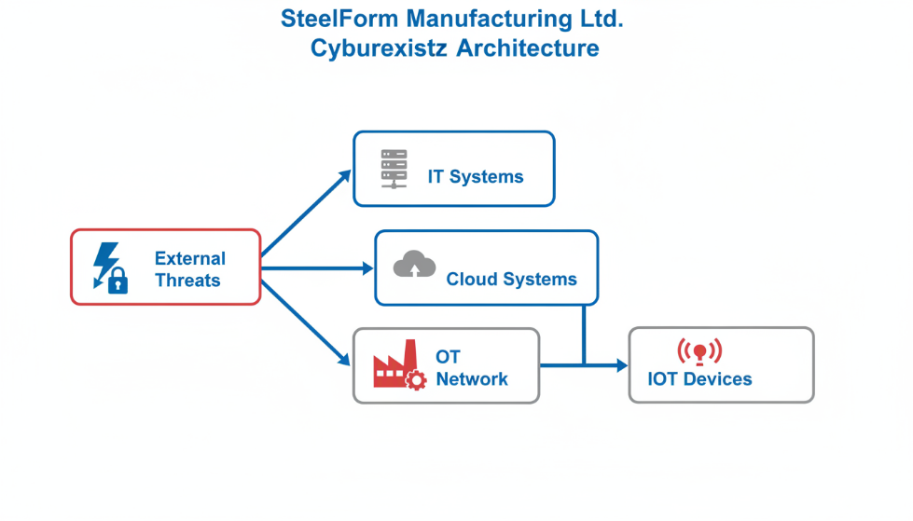
Figure 1. Industry 4.0 cybersecurity architecture of SteelForm Manufacturing Ltd.

2. Identification of Cybersecurity Threats
The use of smart manufacturing technologies has helped SteelForm Manufacturing Ltd improve efficiency through automation, IoT devices, and cloud-based systems. However, the connection between IT systems, OT networks, suppliers, and employees has also increased the company's exposure to cyber threats. These threats can affect the confidentiality, integrity, and availability of SFM's systems and data [3].

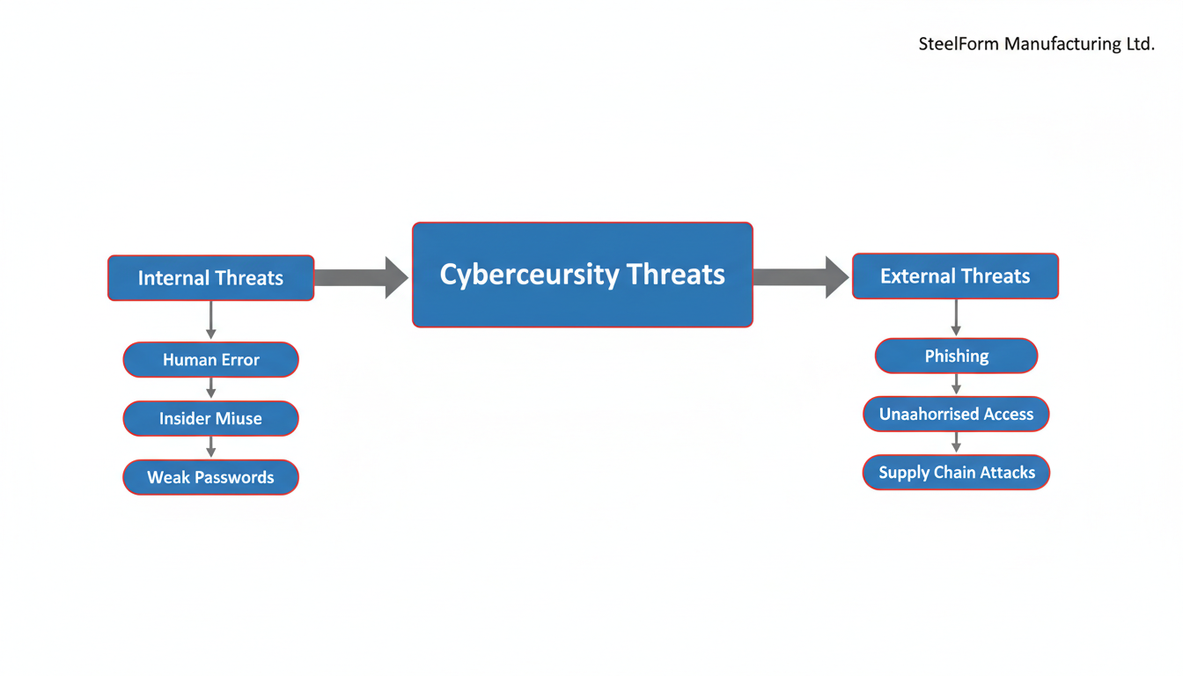

Figure 2. Cybersecurity threat landscape affecting SteelForm Manufacturing Ltd.

2.1 Internal Threats
Internal threats may come from employees, contractors, or other authorised users who have access to company systems. One of the most common internal threats is human error, where staff may open phishing emails, use weak passwords, or ignore security procedures. This is relevant to SFM because procurement staff have already been targeted through phishing attempts [1].
Another important internal threat is insider misuse. Employees or contractors may intentionally or accidentally expose sensitive information such as engineering designs, customer data, or production records. Poor access control, shared accounts, and the misuse of removable devices can increase this risk.

2.2 External Cyber Threats
SFM also faces several external cyber threats due to its connected manufacturing environment. Ransomware is one of the most serious threats because it can encrypt business-critical systems and stop production operations, leading to downtime and financial loss [5].
Phishing and social engineering attacks are also significant because attackers may use fake emails or messages to steal login details or deliver malware. In addition, unauthorised access attempts to the production network may allow attackers to interfere with automated systems or steal valuable company information [4].
Another risk is supply chain attacks, where attackers gain access through suppliers, vendors, or third-party service providers. Since SFM uses cloud systems and connected technologies, weak security in partner organisations may also create vulnerabilities [3].

3. Cybersecurity and Data Governance Policies
To manage the identified cybersecurity risks, SteelForm Manufacturing Ltd needs a clear set of security policies that define responsibilities, control access to important systems, and protect sensitive business data. These policies should follow recognised standards such as ISO/IEC 27001 and the NIST Cybersecurity Framework, which provide guidance for managing, protecting, detecting, responding to, and recovering from cybersecurity risks [6].
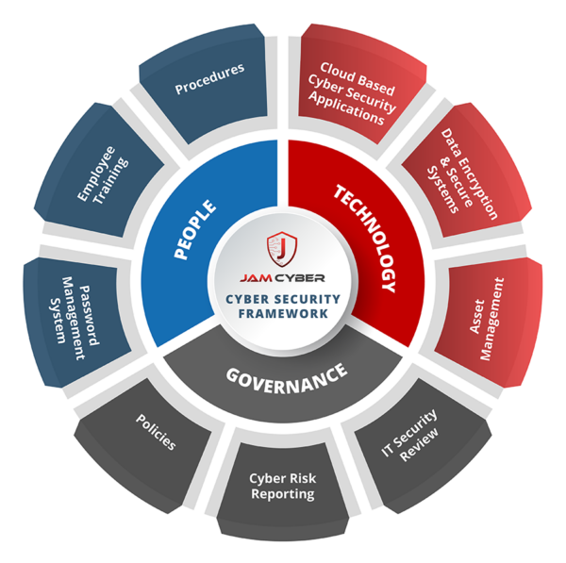

Figure 3. Security policy framework for SteelForm Manufacturing Ltd.

3.1 Access Control and Identity Management Policy
SFM should implement an access control policy based on the principle of least privilege, meaning employees should only access the systems and data required for their job roles. Role-based access control should be applied to production systems, engineering records, and cloud platforms. Multi-factor authentication should also be used for critical accounts to reduce the risk of unauthorised access [7].

3.2 Network and OT Security Policy
Because SFM operates both IT and OT environments, the company should adopt a network security policy that separates office systems, production systems, and IoT devices. Network segmentation, firewalls, secure remote access, and intrusion detection controls should be used to protect the production network from cyberattacks [8].

3.3 Data Protection and Governance Policy
SFM handles valuable information such as engineering designs, customer specifications, production data, and supplier records. A data governance policy should therefore define how data is classified, stored, shared, and securely deleted. Sensitive information should be protected through encryption, regular backups, and restricted access controls [6].

3.4 Email Security and Acceptable Use Policy
Since procurement staff have already been targeted by phishing attacks, SFM should introduce an email security and acceptable use policy. This should require employees to handle suspicious emails carefully, avoid downloading unknown attachments, and follow safe communication practices when using company systems [8].

3.5 Backup and Incident Response Policy
SFM should also have a policy for secure backups and incident response. Critical business and production data should be backed up regularly and tested to ensure that it can be restored after malware or ransomware incidents. In addition, the company should maintain a formal incident response process so that security events can be reported, investigated, contained, and resolved effectively [7].

4. Cybersecurity Risk Mitigation Measures
To reduce the cybersecurity risks identified in the previous section, SteelForm Manufacturing Ltd (SFM) should implement a defence-in-depth strategy. This approach uses multiple layers of security controls to protect the organisation's IT systems, Operational Technology (OT) network, IoT devices, and cloud infrastructure. By combining technical, administrative, and physical security measures, SFM can reduce the likelihood of successful cyberattacks and minimise the impact of security incidents [9].
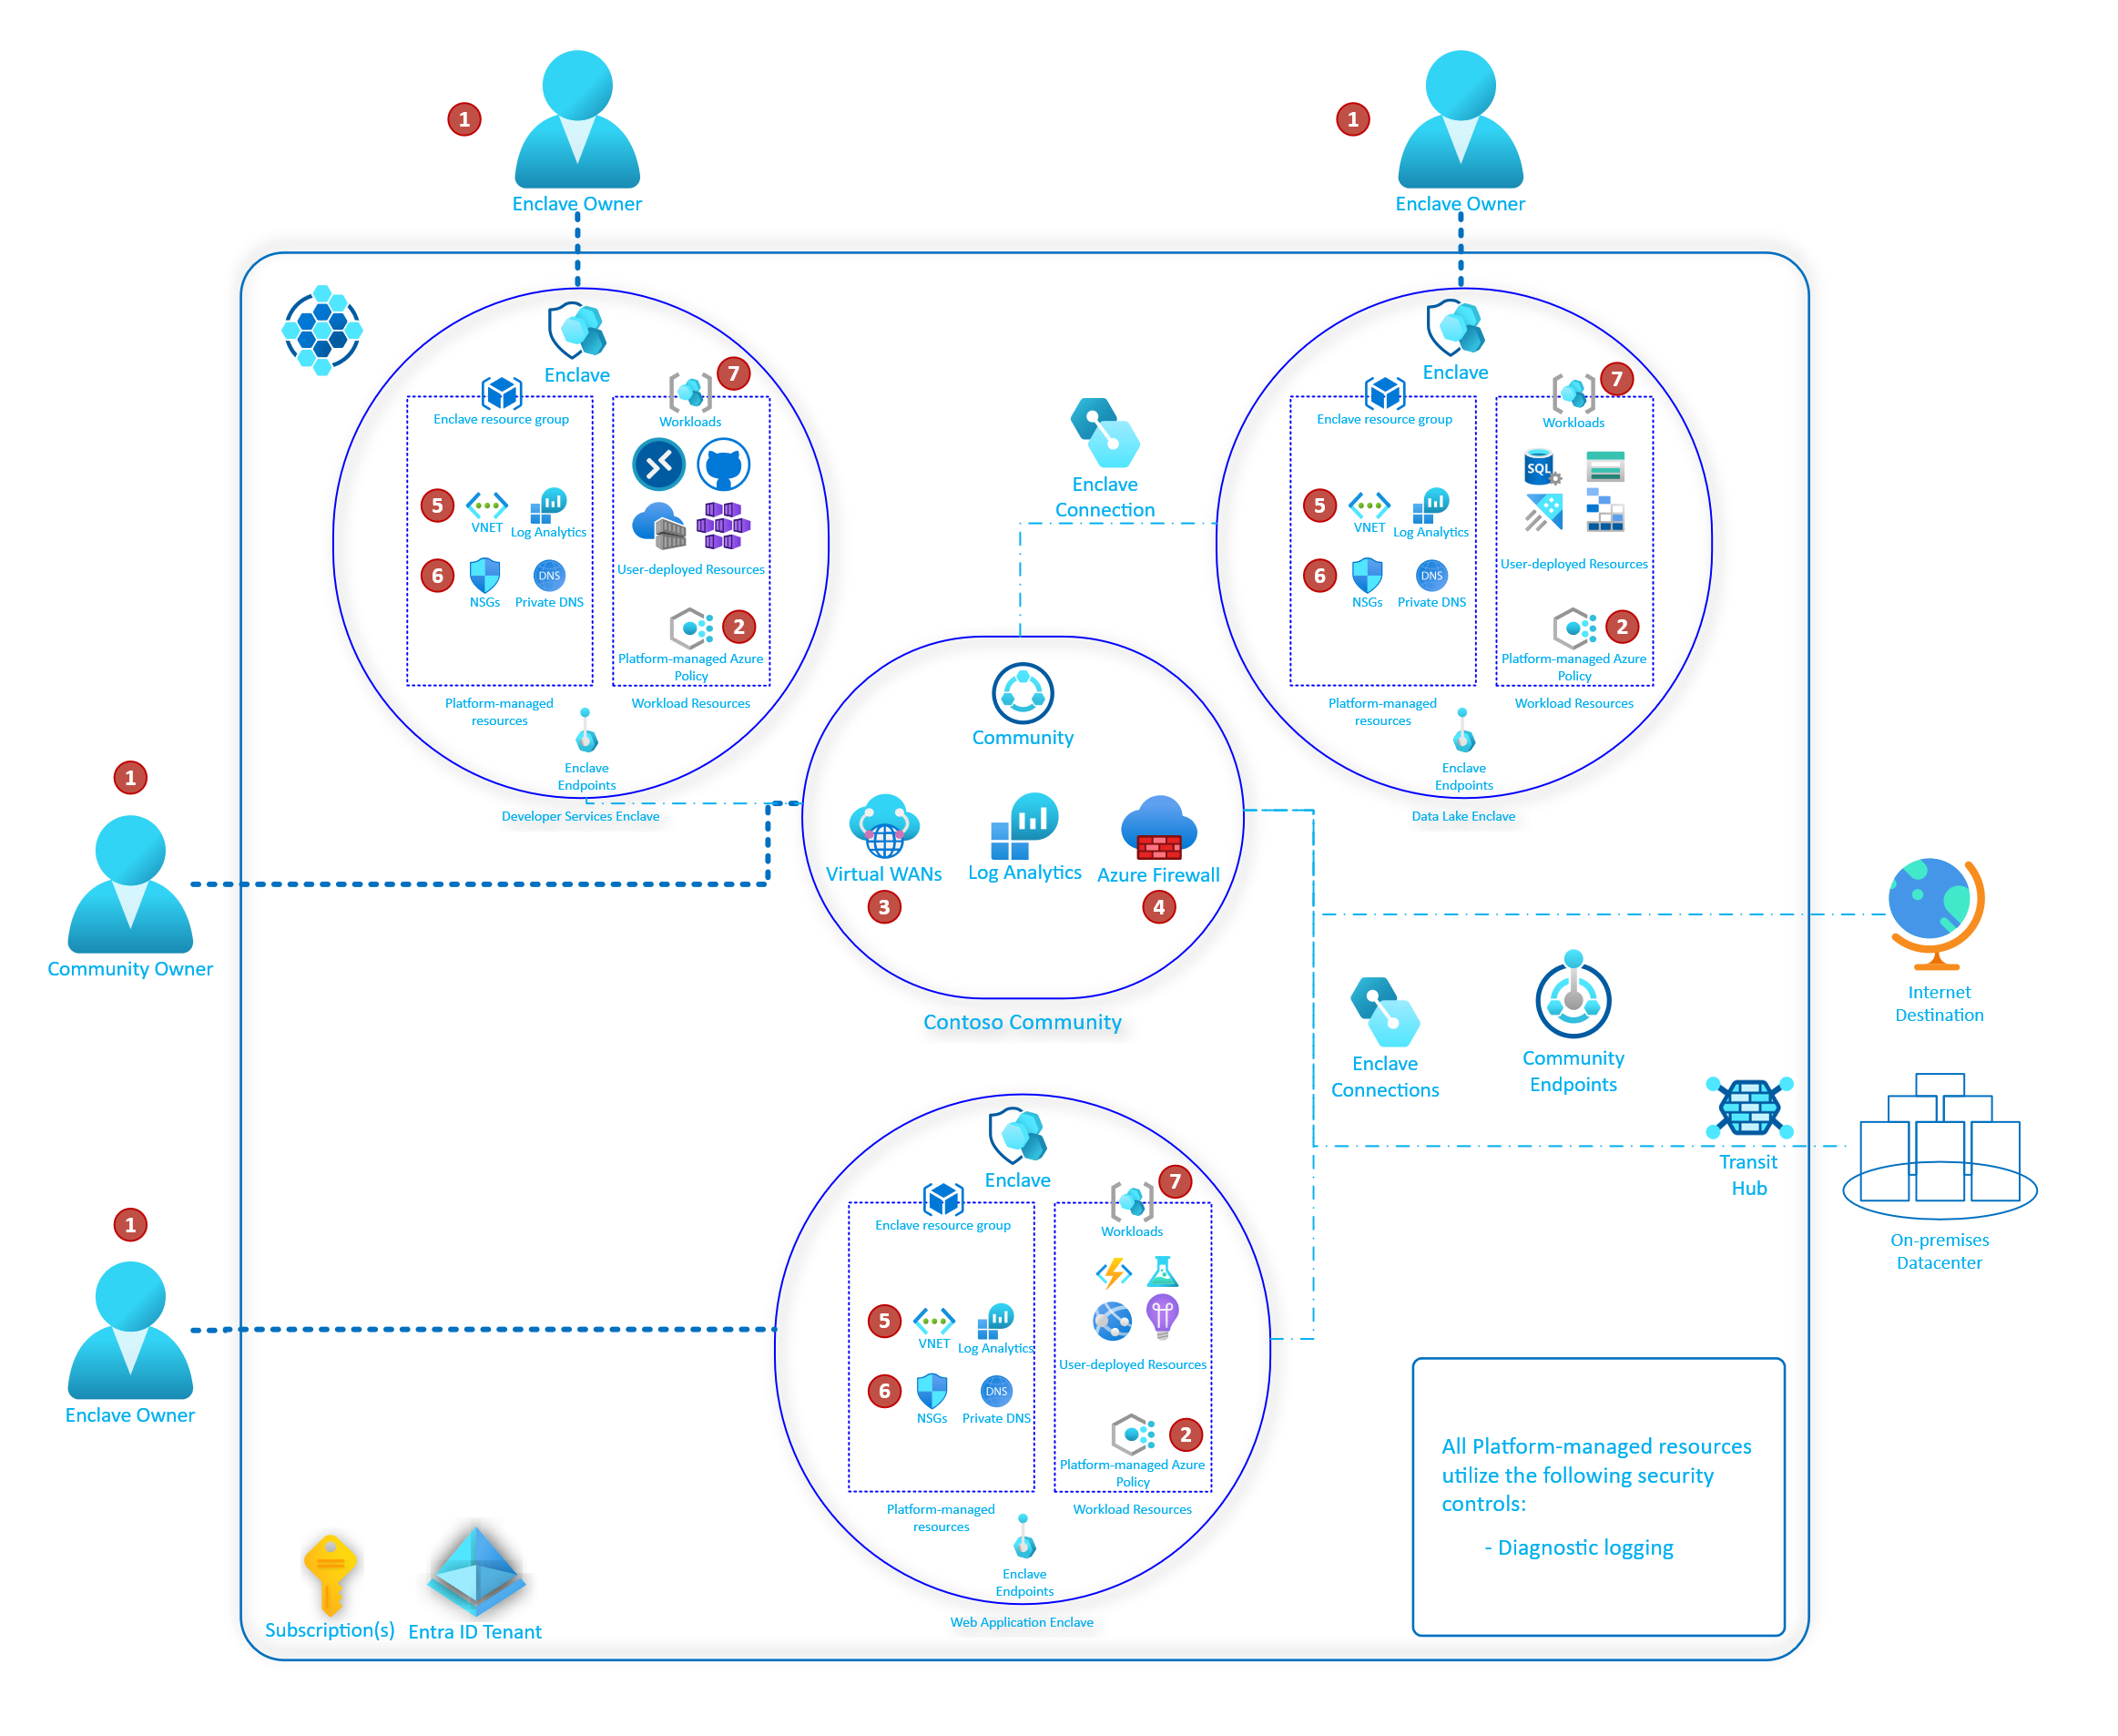
Figure 4. Defence-in-depth security model for SteelForm Manufacturing Ltd.

4.1 Identity and Access Management
SFM should strengthen its identity and access management by implementing multi-factor authentication (MFA) for all administrator accounts, remote access connections, and cloud-based services. Role-Based Access Control (RBAC) should also be applied so that employees only have access to the systems and information required for their specific job responsibilities. User accounts should be reviewed regularly, and unused or inactive accounts should be removed to reduce the risk of unauthorised access. Strong password policies requiring complex passwords and regular password updates should also be enforced [10].

4.2 Network Security and Endpoint Protection
The company's network should be protected using firewalls, intrusion detection and prevention systems (IDS/IPS), and network segmentation. Separating the corporate IT network from the OT environment and IoT devices helps prevent attackers from moving between systems if one network becomes compromised. Secure remote access should also be provided through Virtual Private Networks (VPNs) to protect communications between remote employees and company resources.
All company computers, engineering workstations, and servers should be equipped with centrally managed antivirus software and Endpoint Detection and Response (EDR) solutions. Operating systems, production equipment, IoT devices, and business applications should be updated regularly to ensure known security vulnerabilities are patched before they can be exploited by attackers [9].

4.3 Data Protection and Backup
SFM stores valuable engineering designs, customer information, supplier records, and production data. Sensitive information should therefore be protected using encryption both when stored and when transmitted across networks. Regular backups should follow the 3-2-1 backup strategy, where three copies of important data are maintained on two different storage media, with one copy stored offline or at a separate location. Backup restoration should be tested periodically to ensure that business operations can be recovered quickly following ransomware attacks or hardware failures [11].

4.4 Vulnerability Management
Cybersecurity should be treated as a continuous process rather than a one-time implementation. SFM should perform regular vulnerability assessments and penetration testing to identify weaknesses in its IT and OT environments. Security patches should be applied promptly after testing to reduce exposure to newly discovered vulnerabilities. Continuous monitoring of security logs and periodic security audits will also help identify unusual activities before they develop into major security incidents [10].

4.5 Relationship Between Threats and Mitigation Measures
The recommended mitigation measures directly address the cybersecurity threats identified earlier in this report. Multi-factor authentication, RBAC, and strong password policies reduce the risk of unauthorised access and credential theft. Firewalls, network segmentation, and intrusion detection systems help prevent ransomware attacks and unauthorised access to production systems. Regular vulnerability assessments and continuous monitoring further improve the organisation's ability to detect and respond to emerging cybersecurity threats [9], [10].

5. Monitoring and Incident Response Plan
Continuous monitoring and an effective incident response plan are essential for protecting SteelForm Manufacturing Ltd (SFM) against cyber threats. As the company relies on interconnected IT systems, Operational Technology (OT), IoT devices, and cloud-based services, security events must be detected and managed quickly to minimise operational disruption. Implementing continuous monitoring enables the organisation to identify suspicious activities, respond to incidents promptly, and maintain the confidentiality, integrity, and availability of critical systems and data [10].
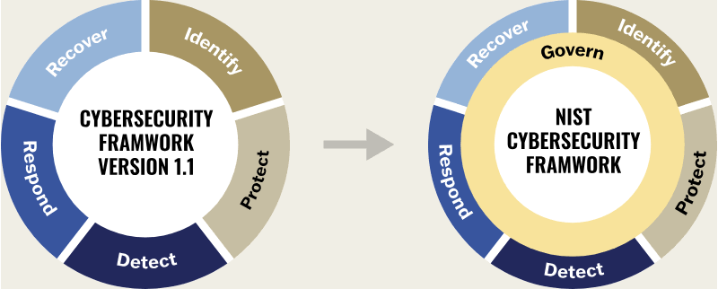
Figure 5. Incident monitoring and response process for SteelForm Manufacturing Ltd.

5.1 Continuous Security Monitoring
SFM should implement continuous monitoring across its IT and OT environments to detect cyber threats before they cause significant damage. A Security Information and Event Management (SIEM) system should be used to collect and analyse security logs from servers, network devices, cloud platforms, endpoints, and industrial control systems. By correlating events from multiple sources, the SIEM can identify unusual behaviour and generate alerts for the security team.
Network traffic should also be monitored using Intrusion Detection Systems (IDS) and Intrusion Prevention Systems (IPS). These technologies help detect malicious activities such as unauthorised access attempts, malware communication, and suspicious network traffic. In addition, regular vulnerability scanning should be carried out to identify outdated software, configuration weaknesses, and security vulnerabilities requiring remediation [9].

5.2 Incident Response Process
SFM should establish a formal incident response plan based on the National Institute of Standards and Technology (NIST) Incident Response Lifecycle. A structured response process enables the organisation to react consistently to cybersecurity incidents while reducing recovery time and limiting business disruption [12].
The incident response process should include the following stages:
- Preparation – Develop incident response procedures, define staff responsibilities, maintain secure backups, and provide security awareness training.
- Detection and Analysis – Monitor systems continuously, investigate alerts, and determine the scope and severity of the incident.
- Containment – Isolate affected systems from the network to prevent the spread of malware or unauthorised access.
- Eradication – Remove malicious software, close exploited vulnerabilities, and eliminate attacker access.
- Recovery – Restore affected systems from verified backups, validate system integrity, and return business operations to normal.
- Lessons Learned – Review the incident, identify weaknesses, update security policies, and implement improvements to reduce the likelihood of future incidents.

5.3 Incident Reporting and Communication
Clear communication is essential during a cybersecurity incident. Employees should be encouraged to report suspicious emails, unusual system behaviour, or suspected security breaches immediately to the IT security team. Incident reports should include details such as the date and time of the event, affected systems, actions taken, and the overall impact on business operations.
Following each incident, management should conduct a post-incident review to evaluate the effectiveness of the response process. Any lessons learned should be incorporated into future security policies, employee training, and technical controls to strengthen the organisation's overall cybersecurity posture [10].
By implementing continuous monitoring, automated threat detection, and a structured incident response process, SFM will improve its ability to detect, contain, and recover from cybersecurity incidents while minimising operational downtime and protecting critical manufacturing systems.

6. Employee Training and Cybersecurity Awareness Programme
Employees play a significant role in maintaining cybersecurity within an organisation. Although technical controls such as firewalls, encryption, and intrusion detection systems provide strong protection, human error remains one of the leading causes of cybersecurity incidents. Since SteelForm Manufacturing Ltd (SFM) has experienced phishing attacks targeting procurement staff, the company should implement a comprehensive cybersecurity awareness programme to reduce human-related risks and promote a culture of security throughout the organisation [10].
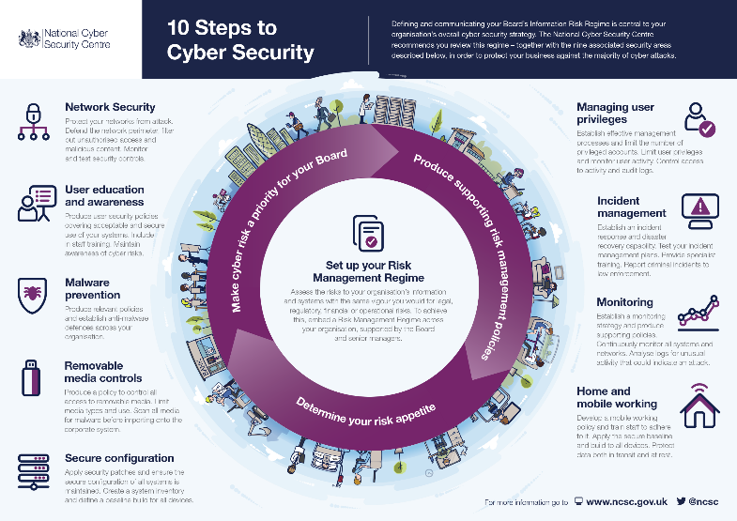
Figure 6. Cybersecurity awareness programme for SteelForm Manufacturing Ltd.

6.1 Employee Cybersecurity Training
All new employees should receive cybersecurity awareness training during their induction process. The training should introduce the company's security policies, acceptable use guidelines, password requirements, multi-factor authentication (MFA), data protection procedures, and incident reporting process. Employees should also be trained to recognise phishing emails, malicious links, suspicious attachments, and common social engineering techniques used by cybercriminals [9].
Specialised training should be provided to employees working in high-risk departments such as procurement, finance, engineering, and IT administration because these roles frequently handle sensitive information and are common targets for cyberattacks.

6.2 Regular Awareness Activities
Cybersecurity awareness should be an ongoing process rather than a one-time event. SFM should organise annual refresher training sessions and provide regular security updates whenever new threats emerge. Monthly security newsletters, awareness posters, and short online training modules can help reinforce good cybersecurity practices across the organisation.
The company should also conduct simulated phishing exercises to evaluate employees' ability to identify fraudulent emails. Employees who incorrectly respond to simulated phishing attacks should receive additional training to improve their awareness without creating a blame culture [10].

6.3 Security Reporting and Compliance
Employees should be encouraged to report suspicious emails, unusual system behaviour, or potential security incidents immediately to the IT security team. A simple and well-defined reporting procedure should be available so that incidents can be investigated quickly. Management should promote a positive reporting culture where employees feel comfortable reporting security concerns without fear of disciplinary action.
Compliance with the organisation's cybersecurity policies should be monitored through periodic audits, knowledge assessments, and phishing simulation results. Training records should also be maintained to demonstrate compliance with organisational security policies and recognised cybersecurity standards [12].

6.4 Evaluating Training Effectiveness
The effectiveness of the cybersecurity awareness programme should be reviewed regularly using measurable performance indicators. These may include phishing simulation success rates, employee assessment results, incident reporting statistics, and policy compliance levels. Feedback collected from employees can also be used to improve future training sessions and ensure that awareness activities remain relevant to emerging cyber threats.
By providing continuous cybersecurity education and promoting responsible security behaviour, SFM can significantly reduce the risk of phishing attacks, insider threats, and accidental security breaches. Well-trained employees become an important layer of defence, supporting the organisation's overall cybersecurity strategy and helping to protect critical manufacturing operations.

7. Conclusion
The adoption of Industry 4.0 technologies has enabled SteelForm Manufacturing Ltd (SFM) to improve manufacturing efficiency through automation, IoT devices, cloud computing, and smart production systems. However, these technologies have also increased the organisation's exposure to cybersecurity threats, including phishing attacks, ransomware, malware infections, unauthorised access attempts, and supply chain attacks. If left unmanaged, these threats could result in financial losses, production downtime, reputational damage, and the compromise of sensitive business information.
This report identified the key internal and external cybersecurity threats facing SFM and proposed a comprehensive cybersecurity and data governance framework based on recognised industry standards, including ISO/IEC 27001 and the NIST Cybersecurity Framework. The recommended security policies focus on access control, network security, data protection, email security, and backup and incident response procedures to strengthen the organisation's overall security posture.
In addition, a range of practical mitigation measures were recommended, including multi-factor authentication, role-based access control, network segmentation, endpoint protection, encryption, regular vulnerability assessments, and secure backup strategies. A structured monitoring and incident response plan based on the NIST Incident Response Lifecycle was also proposed to enable the organisation to detect, respond to, and recover from cybersecurity incidents efficiently.
Finally, the report highlighted the importance of employee training and cybersecurity awareness. Regular security training, phishing simulations, and clear incident reporting procedures will help reduce human error and encourage employees to become an active part of the organisation's cybersecurity strategy.
By implementing these recommendations, SteelForm Manufacturing Ltd will be better prepared to protect its critical manufacturing systems, maintain business continuity, safeguard sensitive information, and strengthen its resilience against evolving cyber threats. Continuous monitoring, regular policy reviews, and ongoing staff awareness will ensure that the company's cybersecurity practices remain effective as new technologies and security challenges emerge.

References
[1] European Union Agency for Cybersecurity (ENISA), ENISA Threat Landscape 2023, 2023.
[2] National Institute of Standards and Technology (NIST), Guide to Operational Technology (OT) Security, Special Publication 800-82 Revision 3, Gaithersburg, MD, USA: NIST, 2023.
[3] National Institute of Standards and Technology (NIST), Cybersecurity Framework (CSF) 2.0, Gaithersburg, MD, USA: NIST, 2024.
[4] International Organization for Standardization (ISO), ISO/IEC 27001:2022 Information Security, Cybersecurity and Privacy Protection — Information Security Management Systems — Requirements, Geneva, Switzerland: ISO, 2022.
[5] Center for Internet Security (CIS), CIS Critical Security Controls Version 8, East Greenbush, NY, USA: CIS, 2021.
[6] National Institute of Standards and Technology (NIST), Security and Privacy Controls for Information Systems and Organizations, Special Publication 800-53 Revision 5, Gaithersburg, MD, USA: NIST, 2020.
[7] National Cyber Security Centre (NCSC), Mitigating Malware and Ransomware Attacks, London, UK: NCSC, 2023.
[8] National Institute of Standards and Technology (NIST), Computer Security Incident Handling Guide, Special Publication 800-61 Revision 2, Gaithersburg, MD, USA: NIST, 2012.

Slides



