How a school develops one aspect of its SDP: a report that critically reflects on the actions, impact and evidence base.
 | Targed/target | Yr hyn yr wyf wedi'i wneud yn yr aseiniad hwn  What I have done in this assignment...
Targed/Target 1
Targed/Target 2
Targed/Target 3

Word Count:

The objective of this assignment is to explore school improvement in a practical setting whilst critically reflecting on how the school from my first placement (school X) is developing one aspect of its School Development Plan (SDP). The aspect identified in this assignment is ‘Progress along the Language Continuum’; ‘to develop Welsh oracy across the school’ (School X, 2023). This aspect is currently priority number one for school X, in line with the Welsh government's strategy for the promotion and facilitation of the use of the Welsh Language with the goal of 1 million Welsh speakers by 2050 (Llywodraeth Cymru, 2017). This report will critically reflect on how School X has addressed this target, with the impact being measured within an evidence-based framework. For context, school X is an English-medium primary school located in South Wales with 353 pupils on role. The area is considered neither prosperous nor economically disadvantaged. School X (2023) reports approximately 9.5% of pupils are entitled to free school meals. 93% of pupils come from English-speaking homes with few pupils speaking Welsh at home - the remainder are from minority ethnic groups. 13% of pupils have additional learning needs with only 6% having statements. The school has 12 full-time teachers and 3 part-time teachers, 1 permanent ALNCo, 2 Admin Officers and 21 Teaching Assistants (8 in STF classes).
Literature Review
The theoretical underpinnings of the school development process, in the context of the Welsh curriculum, are grounded in a national commitment to universal access to quality education (Welsh Government, 2020b). The foundational principles of the Welsh curriculum emphasize the acquisition of experiences, knowledge, and skills essential for employment, lifelong learning, and active citizenship (Welsh Government, 2020a). This commitment is reflected in the School Development Plan (SDP), which serves as the strategic blueprint for school improvement. Under the Education (School Development Plans) (Wales) Regulation 2014, all schools in Wales are required to have an SDP in place (Welsh Government, 2016a).

The SDP, as a key component of the school development process, aligns with the broader goals of improving learner outcomes and addressing national priorities. The Welsh Government’s guidance on the SDP is apprised from a range of national policies and strategies including, but not limited to, the Curriculum for Wales (Welsh Government, 2023a). The purpose of the SDP is to guide schools in setting actions for improvement informed by rigorous self-evaluation and contextual data.
The SDP operates within a cyclical framework (Figure 1.) emphasizing continuous self-evaluation and improvement. This cyclical nature allows schools to adapt and respond to changing circumstances, ensuring the plan remains a dynamic and responsive document. As schools navigate the three-year cycle, they must not only identify and implement actions for the current year but also establish high-level priorities and targets for subsequent years (Welsh Government, 2016a).
This cyclical approach aligns with the dynamic nature of education and emphasizes the importance of adaptability in school improvement efforts (Welsh Government, 2014). The curriculum's role in shaping the SDP is evident in its emphasis on providing the best possible learning experiences and outcomes for all learners, irrespective of their background or circumstances.
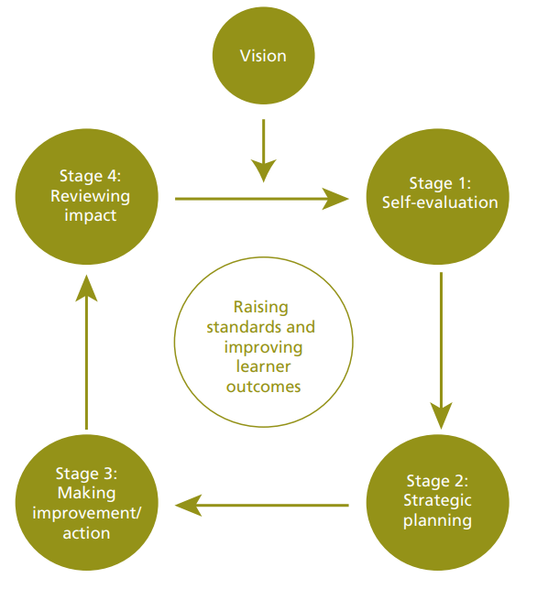
Figure 1: School Development planning cycle (Welsh Government, 2014, page 7).

The theoretical understanding of the school development process, integrates the SDP as a live document, regularly refreshed to align with the latest performance data. The emphasis on staff development, resource utilisation, and the attainment of high standards underscores the commitment to achieving the goals outlined in the Welsh curriculum (Welsh Government, 2014). The Curriculum for Wales, a cornerstone of the educational landscape, further supports the overarching goals outlined by the Welsh Government, including the promotion of a vibrant culture and the thriving Welsh language.
“The place where we feel we belong, where the people and landscape around us are familiar, and the sights and sounds are reassuringly recognisable… cynefin is not just a place in a physical or geographical sense: it is the historic, cultural and social place which has shaped and continued to shape the community in which inhabits it” (Estyn, 2021).
Cynefin has recently been introduced to the Welsh curriculum; at the core of cynefin is the Welsh language, which serves as a conduit connecting individuals to their roots, cultural heritage, and the diverse tapestry of Welsh traditions (Reference, date).
The Minister for Education and the Welsh Language, Jeremy Miles, inclusive assertion that Welsh belongs to everyone resonates as a call to action, urging communities where Welsh thrives, areas with potential growth, and individuals eager to learn to collectively contribute to the language’s prosperity (Thomas, 2022). Kimmerer (2020) cautions against the dangers of languages becoming extinct, suggesting we lose more than just words when a language dies (Adams, 2023). The urgency to push the Welsh language to the forefront of cultural preservation and societal development is underscored by a multifaceted approach, encompassing historical roots, contemporary challenges, and strategic initiatives. The Cymraeg 2050 initiative, initiated by the Welsh Government in 2017, epitomizes this collective effort, setting an ambitious target to increase Welsh speakers to a million by 2050 and double its daily use (Llywodraeth Cymru, 2017). The strategy responds to concerning trends revealed in the 2021 Census data (Appendix 1), indicating a decline in the percentage of Welsh speakers from 19% in 2011 to 17.8% in 2021 (Welsh Government, 2022).
signalling a pressing need to reverse this trend and elevate the language's significance.
To support this linguistic revival, the First Minister introduced a Welsh Language education bill during 2023-2024 intending to empower ‘all pupils in Wales to become confident Welsh speakers’ Welsh Government (2023b). The bill also aims to reform how local authorities plan and promote Welsh language provision, serving as a catalyst for advancing schools along the Welsh language continuum (Welsh Government, 2024). Similarly, the significance of the Welsh language is underlined by its inclusion in the Well-being of Future Generations Act (Wales) 2015. Public bodies across Wales are mandated to work towards seven well-being goals, one of which emphasizes 'A Wales of vibrant culture and thriving Welsh language' (Welsh Government, 2021).
The ability to speak Welsh is not just a skill; it represents an invaluable asset for individuals and communities, fostering a connection to cynefin and reinforcing a distinct cultural identity. The decline in Welsh speakers recorded in the 2021 Census highlights the urgency to reverse this trend, emphasising the need for robust strategies and interventions. The Welsh Government's commitment, outlined in Taking Wales Forward 2016–2021, prioritises the Welsh language as a key driver for economic and societal improvement (Welsh Government, 2016b).

The ability to speak Welsh extends beyond linguistic proficiency; it symbolises a connection to cynefin, fostering a sense of identity and belonging. The decline in the number of Welsh speakers recorded in the 2021 Census raises concerns about the potential erosion of this cultural foundation. With a reported 17.8% of the population aged three years or older able to speak Welsh, marking the lowest percentage ever recorded, and a decrease of roughly 23,700 Welsh speakers since 2011 (Welsh Government, 2022) the Welsh Government's strategic initiatives, legislative measures, and commitment to well-being goals highlight the recognition that preserving and promoting the Welsh language is fundamental to the holistic development and prosperity of Wales.
Developing an Action Point
The Welsh government's (2014) guidance underscores the significance of four key steps within a school's developmental planning cycle which will be discussed below. In essence, the cycle unfolds from September to July with the starting self-assessment (during the summer term) aiming to formulate ideas and priorities for the subsequent academic year. These stages will be the organizational framework for analysing the SDP of school X.
Self-evaluation is the first stage of the SDP cycle; this is where the school reflects on their current performance, by gathering quantitative and qualitative data to gain a better understanding of the level at which the school is performing and identify areas that need improvement and what actions are necessary to make those improvements (Department of Education, 2015). Self-evaluation is vital in enabling the school to identify its strengths and weaknesses to facilitate system-wide improvement (Welsh Government, 2014). School X regularly refer to self-evaluation within their SDP, involving stakeholders to determine the best course of action to hit any targets they have identified. School X collects qualitative data by inviting parents to complete surveys (see Appendix 2.) every term in addition to more specific surveys that relate to the reflections they have made in their self-evaluation. By inviting parents to offer their opinions and ideas, School X is continually improving the collaboration between parents. Strengthening and the constant improvement of relationships/collaboration amongst parents and teachers is greatly encouraged as it is essential for both personal and academic growth (Erdener, 2016; Jeynes, 2011; Makgopa & Mokhele, 2013; as cited in Myende and Nhlumayo, 2020). According to Grant and Ray (2010), active parental involvement in their children's education is associated with fostering a positive outlook toward schools and educators. The collaborative partnership between parents and teachers is asserted to yield various advantages for the child such as lower grade retention rates, learner absenteeism, and a decrease in disruptive behaviour (Daniel, 2011; Lemmer, 2013; Makgopa & Mokhele, 2013). Harris & Goodall (2008) highlight that many parents are inhibited by work commitments and childcare difficulties, preventing their involvement; however, School X’s use of online surveys offers a solution to this and allows more parents to have their say.
*Find more on data analysis for above^^
In the second stage, strategic planning, the school develops a strategic plan based on the findings of the self-evaluation and outlines its long-term goals, objectives, and priorities and a plan is created including timelines, resource allocation, and responsibilities (Department of Education, 2015). For school development planning to be most effective, all school partners and stakeholders should be involved (Welsh Government, 2014). School X adopts a ‘whole-school approach’ that “puts the child at the centre of decisions made about them and relies on partnership and involvement with families, the community, other statutory bodies and the third sector” (School X, 2023, page 7). Reynolds, Schultz and Hekman (2006) contend that consistent communication and oversight involving various stakeholders, such as school staff, school councils, governors, parents, and the school community, should be conducted. Each school will have a different approach to this; however, it is a crucial part of the SDP process and fosters a sense of ownership and collaboration that works towards improvement (Welsh Government, 2014).
During the third stage, making improvements/actions, schools implement the actions and strategies outlined in their SDP. Staff, having been involved in SDP discussions, are aware of their roles in executing these actions. Clear communication of expectations regarding duties, responsibilities, tasks, and timelines is essential to prevent misunderstandings (Welsh Government, 2014). School X ensures staff are well-equipped to make improvements. All staff are granted access to a live document where they can write how they are meeting the goals of the SDP and provide insight into the success of their actions. This document is reviewed termly as a whole school, and bi-weekly among the different phrases showing School X’s clear communication. Staff have regular opportunities to ensure they know what is expected of them.
The use of a live document links to the fourth stage; reviewing impact. The Welsh Government (2014) decreed that SDPs should be regularly monitored and formally reviewed annually at a minimum - school X easily exceeds this expectation. Regular reviews will ensure the context of the school remains up to date with the findings from this stage fed back into the self-evaluation stage, creating a continuous cycle of improvement.
Reflection and evaluation
To improve Welsh oracy, School X has begun implementing ‘slot drilio’ which translates to drilling slot. In this quick, 15-minute period, the class's ‘captain Carwyn’ for the week leads the session of quick-fire Welsh words/phrases. Based on my observations in my year 5/6 class, and the comments from Estyn’s 2022 evaluation (School X, 2023),
‘Year 6 pupils demonstrate a limited recall of simple sentence structures and relevant vocabulary. As a result, their Welsh oracy skills are underdeveloped.’
it suggests having slot drilio sessions as student-led may not be in the pupil's best interests until their Welsh is more developed. It may be beneficial to use Vygotsky’s (1978) zone of proximal development and scaffolding theory involves a knowledgeable person providing temporary support to a learner within their Zone of Proximal Development (ZPD). This assistance is gradually reduced as the learner gains proficiency, promoting independent learning. Scaffolding aims to enhance understanding and skills by adjusting support to the learner's needs, encouraging active participation, and ultimately fostering independence. For school X, this may entail the teacher leading slot drilio sessions as a more knowledgeable person to start until the pupil's Welsh oracy has improved.
School X has also introduced Welsh tokens to the school. When a student asks a teacher a question in Welsh, or if a student answers a question from a teacher in Welsh, they are awarded a Welsh token. Welsh tokens are tallied up throughout the four schoolhouses and winners are announced weekly in the school's celebration assembly on Friday. To date, Welsh tokens have been received positively by students and staff. They act as a form of positive reinforcement which stems from Skinner’s (1963) theory of operant conditioning, a behaviourist approach. In simple terms, this theory employs either positive or negative reinforcement or punishments to encourage or discourage behaviour. This involves applying the reinforcement or punishment promptly after the behaviour has taken place (Rafi, Ansar, and Sami, 2020). The use of extrinsic rewards, such as Welsh tokens, is met with mixed views. Kohn (1994; 2018) argues using extrinsic rewards like tokens can undermine a learner's intrinsic motivation. He posits, that consistently providing rewards to students may lead them to concentrate more on the reward itself (extrinsic motivation) rather than deriving satisfaction from the learning process or the fulfilment gained through engaging in and finishing a task (intrinsic motivation). Dweck (2006) supports this notion, his work on mindset theory implies constant praise can have a detrimental impact on learners.
The need to improve Welsh oracy within School X is of paramount importance. Therefore, it seems counterproductive to remove extrinsic rewards based on the literature if they are working on the implementation of Welsh oracy for School X. Going forward, as more students reap the benefits of Welsh tokens it may be beneficial to only reward new Welsh phrases as opposed to constantly rewarding the same phrases the students are confident speaking. Excessively rewarding children for behaviour that should be standard practice can result in many problems.
Conclusion
In this assignment, I have delved into the practical aspects of school improvement by critically analysing School X's approach to developing Welsh oracy within its School Development Plan. The focus on 'Progress along the Language Continuum' aligns with the Welsh government's language promotion strategy. Through an exploration of the SDP's cyclical nature and alignment with national goals, I gained insights into the dynamic and adaptable nature of school improvement efforts. The importance of the Welsh language as a cultural asset and the challenges posed by declining speakers highlighted the urgency for strategic initiatives.
Personally, this assignment has deepened my understanding of the intricate relationship between national policies, school development, and cultural preservation. The introduction of Cynefin to the curriculum and its connection to the Welsh language emphasized the role of education in shaping cultural identity. As I move forward professionally, I am equipped with valuable insights into the holistic approach needed for effective school improvement, considering cultural, linguistic, and legislative dimensions. The importance of continuous self-evaluation, collaboration with stakeholders, and the dynamic nature of the SDP will inform my future endeavours in contributing to educational enhancement and cultural preservation.

Reference List
Adams, D. (2023). Cynefin – Being of place. An investigation into the perspectives of first-language Welsh speaking hill farmers into the meaning of the word cynefin and the significance for education in Wales and beyond. Journal of Outdoor and Environmental Education. doi:https://doi.org/10.1007/s42322-023-00144-2.
Akif Erdener, M. (2016). Principals’ and Teachers’ Practices about Parent Involvement in Schooling. Universal Journal of Educational Research, 4(12A), pp.151–159. doi:https://doi.org/10.13189/ujer.2016.041319.
Daniel, G. (2011). Family-school partnerships: towards sustainable pedagogical practice. Asia-Pacific Journal of Teacher Education, 39(2), pp.165–176. doi:https://doi.org/10.1080/1359866x.2011.560651.
Department of Education (2015). School Development Planning | Department of Education. [online] Education. Available at: https://www.education-ni.gov.uk/articles/school-development-planning [Accessed 4 Mar. 2024].
Dweck, C.S. (2006). Mindset : The new psychology of success. New York: Ballantine Books.
Estyn (2021). The teaching of Welsh history including Black, Asian and Minority Ethnic history, identity and culture | Estyn. [online] www.estyn.gov.wales. Available at: https://www.estyn.gov.wales/thematic-report/teaching-welsh-history-including-black-asian-and-minority-ethnic-history-identity [Accessed 29 Feb. 2024].
Grant, K.B. and Ray, J. (2010). Home, school, and community collaboration : culturally responsive family involvement. Thousand Oaks, Calif.: Sage Publications.
Harris, A. and Goodall, J. (2008). Do Parents Know They matter? Engaging All Parents in Learning. Educational Research, 50(3), pp.277–289. doi:https://doi.org/10.1080/00131880802309424.
Jeynes, W.H. (2011). Parental Involvement Research: Moving to the Next Level. School Community Journal, 21(1), p.9.
Kohn, A. (1994). A7 Punished by Rewards. Quality Management in Health Care, 2(Supplement), p.4. doi:https://doi.org/10.1097/00019514-199400001-00011.
Kohn, A. (2018). Rewards Are Still Bad News 25 Years Later. [online] Alfie Kohn. Available at: https://www.alfiekohn.org/article/rewards-25-years-later [Accessed 4 Mar. 2024].
Lemmer, E.M. (2013). The parent-teacher relationship as partnership : a conceptual analysis. Journal for Christian Scholarship = Tydskrif vir Christelike Wetenskap, [online] 49(1_2), pp.25–54. doi:https://doi.org/10.10520/EJC139728.
Llywodraeth Cymru (2017). Cymraeg 2050 A million Welsh speakers. [online] Available at: https://www.gov.wales/sites/default/files/publications/2018-12/cymraeg-2050-welsh-language-strategy.pdf [Accessed 7 Feb. 2024].
Llywodraeth Cymru (2020). Introduction to Curriculum for Wales Guidance - Hwb. [online] hwb.gov.wales. Available at: https://hwb.gov.wales/curriculum-for-wales/introduction-to-curriculum-for-wales-guidance/ [Accessed 7 Feb. 2024].
Makgopa, M. and Mokhele, M. (2013). Teachers’ Perceptions on Parental Involvement: A Case Study of Two South African Schools. Journal of Educational and Social Research, 3(3). doi:https://doi.org/10.5901/jesr.2013.v3n3p219.
Myende, P.E. and Nhlumayo, B.S. (2020). Enhancing parent–teacher collaboration in rural schools: parents’ voices and implications for schools. International Journal of Leadership in Education, 25(3), pp.1–25. doi:https://doi.org/10.1080/13603124.2020.1731764.
Rafi, A., Ansar, A. and Sami, M.A. (2020). The Implication of Positive Reinforcement Strategy in dealing with Disruptive Behaviour in the Classroom: A Scoping Review. Journal of Rawalpindi Medical College, 24(2), pp.173–179.
Reynolds, S.J., Schultz, F.C. and Hekman, D.R. (2006). Stakeholder Theory and Managerial Decision-Making: Constraints and Implications of Balancing Stakeholder Interests. Journal of Business Ethics, 64(3), pp.285–301. doi:https://doi.org/10.1007/s10551-005-5493-2.
Robin Wall Kimmerer (2020). BRAIDING SWEETGRASS : indigenous wisdom, scientific knowledge and the teachings of plants. S.L.: Milkweed Editions.
School X (2023) [School X] School Development Plan 2023-2024. Swansea: [School X]
Skinner, B.F. (1963). Operant Behaviour. American Psychologist, 18(8), pp.503–515. doi:https://doi.org/10.1037/h0045185.
Thomas, N. (2022). Cymraeg belongs to us all. [online] GOV.WALES. Available at: https://www.gov.wales/cymraeg-belongs-us-all [Accessed 27 Feb. 2024].
Vygotsky, L. S. (1978). Mind in society: The development of higher psychological processes. Cambridge, MA: Harvard University Press.
Welsh Government (2014). School development plans Guidance. [online] Available at: https://www.gov.wales/sites/default/files/publications/2018-03/school-development-plans.pdf [Accessed 7 Feb. 2024].
Welsh Government (2016a). FaCE the challenge together: Family and community engagement toolkit for schools in Wales Main guidance Family and community engagement toolkit. [online] Available at: https://www.gov.wales/sites/default/files/publications/2018-12/face-the-challenge-together-family-and-community-engagement-toolkit-for-schools-in-wales-main-guidance.pdf.
Welsh Government (2016b). Written Statement - Taking Wales Forward: The Welsh Government’s well-being objectives (2016) (4 November 2016). [online] GOV.WALES. Available at: https://www.gov.wales/written-statement-taking-wales-forward-welsh-governments-well-being-objectives-2016 [Accessed 1 Mar. 2024].
Welsh Government (2017). Curriculum for Wales: overview | GOV.WALES. [online] www.gov.wales. Available at: https://www.gov.wales/curriculum-wales-overview#:~:text=Improving%20education%20is%20our%20national [Accessed 7 Feb. 2024].
Welsh Government (2020a). Curriculum for Wales: Overview. [online] GOV.WALES. Available at: https://www.gov.wales/curriculum-wales-overview [Accessed 23 Feb. 2024].
Welsh Government (2020b). WELSH GOVERNMENT INTEGRATED IMPACT ASSESSMENT CURRICULUM FOR WALES GUIDANCE. [online] Welsh Government. Available at: https://www.gov.wales/sites/default/files/consultations/2020-01/welsh-government-integrated-impact-assessment.pdf [Accessed 29 Feb. 2024].
Welsh Government (2021). School categories according to Welsh-medium provision. [online] GOV.WALES. Available at: https://www.gov.wales/school-categories-according-to-welsh-medium-provision [Accessed 1 Mar. 2024].
Welsh Government (2022). Welsh language in Wales (Census 2021). [online] Available at: https://www.gov.wales/sites/default/files/pdf-versions/2022/12/3/1671609478/welsh-language-wales-census-2021.pdf [Accessed 1 Mar. 2024].
Welsh Government (2023a). Curriculum for Wales - Hwb. [online] hwb.gov.wales. Available at: https://hwb.gov.wales/curriculum-for-wales [Accessed 21 Feb. 2024].
Welsh Government (2023b). Cymraeg 2050: Welsh language strategy action plan 2023 to 2024 [HTML]. [online] GOV.WALES. Available at: https://www.gov.wales/cymraeg-2050-welsh-language-strategy-action-plan-2023-2024-html [Accessed 1 Mar. 2024].
Welsh Government (2024). Consultation -summary of response White paper on proposals for a Welsh Language Education Bill. [online] Available at: https://www.gov.wales/sites/default/files/consultations/2024-02/welsh-language-education-summary-of-responses.pdf [Accessed 1 Mar. 2024].

Appendix
Appendix 1
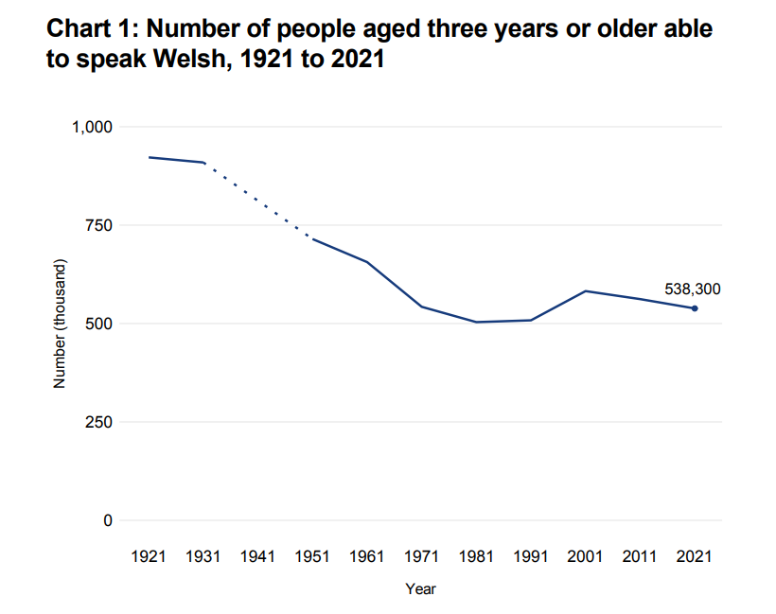

Appendix 2


