Elis Edward Park (P149475)
Jane thomas/wynne jones Criminal Justice and Policing Dissertation (BMCJ7004)
Findings

Contents
Introduction 2
Findings 3
Q1. Are you the UK or Canadian Citizen? What nationality are you? UK Canada Other 3
Q2. Age of Respondents 3
Q3. Respondents by Gender 4
Q4. Diversity of respondents 4
4
Q 5 Understanding of the term vulnerable individual 5
Q6 Types of Cybercrime 6
Q7. Opinions on whether cybercrime is a current threat 6
Q 8. Impact of a personal cybercrime incident 7
Q9. How many times have you been involved in a cybercrime incident? 8
Q 10. Handling of cybercrime incidents by the police 8
Q 11. Number of times police were contacted about cybercrime incidents 9
Q 12. Charities approached for support 9
Q 13. Effectiveness of the police in combatting cybercrime 9
Q 14. UK Government strategies to protect vulnerable people from cybercrime 11
Q 15. Opinions on what the Canadian government should be doing to protect vulnerable people adequately from cybercrime 11
Q 16. How UK & Canadian governments can inform the public of measures to protect vulnerable people from cybercrime 12
Q 17. Parental responsibility for their children’s online activities (up to the age of 15) 13
Q. 18. Opinions on whether Shamima Begum should be allowed to re-enter the UK following her involvement with ISIS 14
Q 19. Views on the UK Online Harm White paper and the Canadian National Cyber Security Action Plan (2019-2024) 15
Q20. Opinions on what the UK & Canadian governments should be doing about the current Cybercrime legislation 16
Conclusion 17
Recommendations 18
References 19

Introduction
This research of the dissertation is evaluating the United Kingdom (UK) & Canada’s Cybercrime Policies, whether they protect vulnerable people and whether they are relevant in today’s society. The dissertation viewed many different papers and documents of authors who looked into this subject before the researcher itself. Currently, the UK & Canadian governments have been working towards ensuring that their citizens are safe from any sort of danger from the cyber world. For the primary research, the researcher developed a 20-question online questionnaire using the Google Documents platform instead of using online Survey Monkey due to its limitations, the researcher received 87 replies from people online. However, there was one respondent who took it upon themselves to insult the researcher and their work this respondent’s answers will be ignored. The results are based on 86 responses. An analysis of all the primary research is shown below.

Findings

Q1. Are you the UK or Canadian Citizen? What nationality are you? UK Canada Other
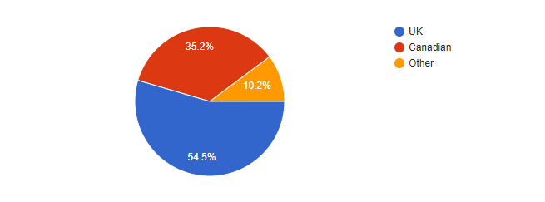
A s seen above, Fig. 1 shows a pie chart of the number of people that took part in the online survey. Within this, 54.5% that took part in the survey are people from the UK, while the second highest group are Canadians which was 32.2% and 10.2 % represents others from any another country. This means that the highest number of responses came from citizens from the UK; however, the researcher did a post on Canadian Facebook social media sites, and asked family members and friends from UK and Canada. This shows that a fair balance of attempts was made to obtain responses from both countries.
Figure 1 UK, Canadian or Other pie Chart

Q2. Age of Respondents
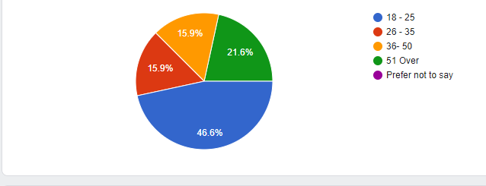
The age range of the people taking part in the survey varies in different ages, the highest age group being 18 -25-year-olds, this means that age range will likely know more about the cybercrime compared to second which is the group range of 51 plus and over; which is deemed to be one of the groups who are unaware of cybercrime and what it is. The third group being joint third are people aged of 26-35 & 36-50 which both resulted with 15.9%; both age groups should be aware of what cybercrime is and some may know what they are dealing with e.g., it could be someone in that field of work.
Figure 2 Age Groups

Q3. Respondents by Gender
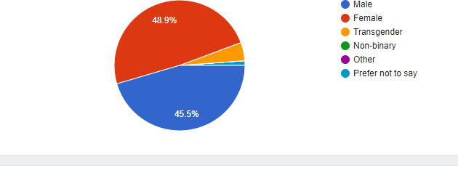
The largest gender group who responded to this online survey is females with 43 females replying to the online questionnaire, while the second largest group were 40 who identified as male. Only three people declared themselves as transgender; this was a disappointing result as the researcher believes that transgender people are also one of the highest groups to be vulnerable to cybercrime especially cyberbullying - there has been some research from America that implies this link.
Figure 3 Genders Groups

Q4. Diversity of respondents
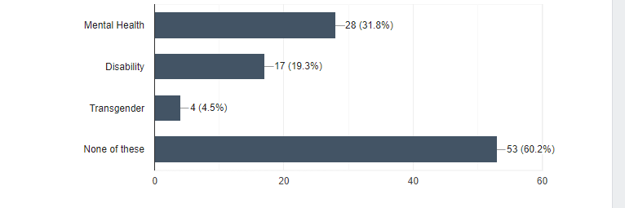
The researcher of this paper believes that apart from children and older people, there are also other groups which are mental health, disability and transgender, who are vulnerable to cybercrime. Fig. 4 shows how the respondents are made up of these groups when responding to this questionnaire. It shows that 53 people that took part in the online survey fall outside these categories; the second highest being mental health 28, then disability 17 and transgender 4.
Figure 4 Categories Groups

Q 5 Understanding of the term vulnerable individual
When given this question 72 out of 86 the respondents gave the same answers on what they define the term vulnerable person or individual.
R41 stated, “Those who are at risk, like cancer survivors or people with really bad mental health or disabilities.”
R50 said, “An individual who, through lack of education, mental or physical capacity, or access to information, is unable to make good decisions on issues affecting their well-being.”
R51 “A person who, because of age or physical/mental disability, cannot protect their interests”.
R80 believes that the term vulnerable individual is “An individual who is at risk mentally or physically.”
R87 “A person how doesn't have the capacity even mental, physically or socially to take care of themselves and/or other people may take advantage of easy.”
The reason why these five respondents' answers were picked was that they all are similar to each other and are the ones closest to Chesnay & Anderson (2008) who define a vulnerable person as someone likely to be influenced or harmed by a particular individual or communities. From a public perspective, this means that the term vulnerable individual is someone who suffers from mental health and/or physical disabilities and is unable to have a normal daily life without having support put into place. which under the UK Government Equity act 2010 states that a person who has a disability has the following suffers from mental health or physical health issues (Home Office,2020). Another point to make as well is R87 who states that the vulnerable person is also easy to be taken advantage of as well. This links back to the theory that many terrorist groups will target as they know they do anything because their vulnerable, the theory comes from Torok’s (2007) who stated that terrorist groups tend to target young males who are in university in the UK.

Q6 Types of Cybercrime

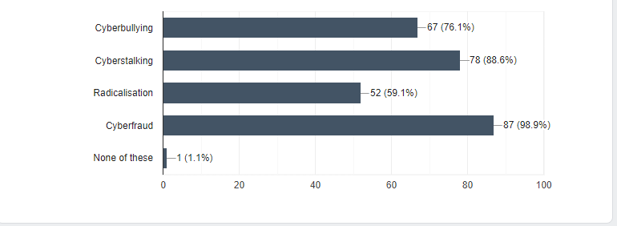
People were asked to explain what they believe cybercrime includes. Although some do not have any knowledge in the area, a lot of people believed that cybercrime only consists of cyberfraud as it is one of the most common types of cybercrime around the world. However, most listed cyberfraud, but different forms of cybercrime exist, for example cyberbullying is part of cybercrime but a different form of it. It is very unlikely that people have heard of it because it tends to be a crime committed by younger people who may still be in the education system.
Figure 5 Types of Cybercrime

Q7. Opinions on whether cybercrime is a current threat
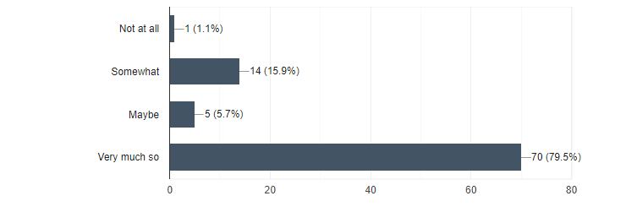
Fig. 6 shows what the responders thought about cybercrime being a threat today, 70 (79.5%) believed it was a threat while some responders 14 (15.9%) of them believed it was “somewhat” a threat in today's world. While one person thought it was nothing to worried about while another person may be believed it was the art into worlds. This shows that the responders believe that cybercrime is a threat in our society today and action should be taken; while the other person believes that cybercrime maybe a threat in today society and government should be relax about it and the finally comment that cybercrime is no threat in today society and both government should not worry about it.
Figure 6 Cybercrime a Threat

Q 8. Impact of a personal cybercrime incident
Out of the 86 respondents, only 23 stated that they were involved in some sort of cybercrime incident; a small number of them gave details on what happened.
R48 “Yes, cyberstalking. Found out my address, where I lived etc, and followed me to my house. I was a lot younger than them as a young woman felt extremely vulnerable.”
R9 “Depends on your view of cyber harassment”.
R48 & R9 are both from the UK one is female and the other is male, both respondents had experienced cyber-harassment. This links with a government report by Davidson et al., (2019) which argues that females are likely to be harassed and cyber-stalked by other people e.g. males, however, R9 is a male who suffered a similar experience. This supports Davidson et al’s theory that females are more likely to be cyberstalked does have flaws as they did not acknowledge that males could also be victims of cyberstalking.
R16 “Yes. A fellow Etsy seller made up fake names and emails, purchased low-priced items from me, and then gave me bad reviews. Yes, I felt vulnerable.”
R19 “yes my father in law almost got caught with believing that he needed to send money to someone in another country to help them”
R33 “Online purchases .cyber fraud”.
R62 “Yes. My wife's bank account information was skimmed. She did not feel vulnerable as the matter was discovered quickly and resolved by the bank.”
R74 “Credit card fraud. When I spoke to the bank I asked if there was anything, I could have done to be safer. They said no. I do not feel vulnerable. It is just a fact of life now that someone will steal your shit on the internet at some point. That's why we have insurance.”
Many of the 23 respondents explained that they or a family member dealt with cyber fraud many times, R74, a female Canadian, made an interesting comment, saying that their money is “insurance” so that if cyber fraud does occur, the insurance company will be able to pay them compensation.
R16 & R74 reported that they both felt vulnerable at the time of the incidents as they also felt nothing could be done about their cases. This shows that the public’s confidence is affected by cyber fraud.

Q9. How many times have you been involved in a cybercrime incident?
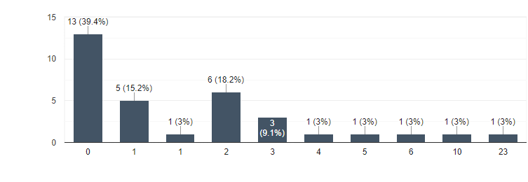
Figure 7 Involved in a cybercrime incident
Fig. 7 shows the responses that when asked how many times people were involved in cybercrime incidents, the responses varied from 23 times (highest), second 10 times, then 6 times, 5 times, 4 times,3 times, and 2 times and once. The amount of respondents becoming a victim of cybercrime must be doing something wrong as they have been targeted so many times by cybercriminals, however the individuals have not stated what happened, only that they have been involved in cybercrime incidents so is hard to acknowledge what has happened- it could be from cyberbullying to cyberfraud. In contrast, the people who experienced it once or twice have must have taken advice from the police or reported it to them to deal with it.

Q 10. Handling of cybercrime incidents by the police
When respondents were asked how the police services dealt with their case, only a handful gave answers about their experience.
R16 “The police will only investigate if they think it is a large-scale operation”.
R21 “I haven’t contacted the police”.
R24 “phishing emails, I did not respond, to email and just deleted the emails, bit clicking on the link”.
R33 “Didn't call”.
R38 “Did not contact police”.
R50 “, they barely understand the issue and if they do, you aren’t going to be put high on their priority lists.”
The above five respondents that were selected from the number of responses all explain how the police services did not understand how serious their cases were, for example, R50 explains how the police did not understand them and what they were going through at the time. This does link with the argument that many police forces still do not understand cybercrime; this also aligns with the case study of Breck when the police force did not understand Breck’s parents’ concerns.
R21, R33, and R38 all gave similar answers to this question which was not to bother calling the police at all about their case; this agrees with the Netherlands’ Government research that many of the victims do not call the police as they do not see it necessary to take legal action regarding their cases. Overall, the responses are negative about how the police services responded to these cases.

Q 11. Number of times police were contacted about cybercrime incidents
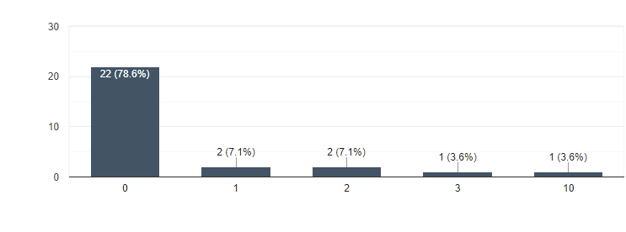
Figure 8 Number of times police were contacted about cybercrime inicdents
The bar chart shown in Fig. X on the X-axis shows how many times people tried to contact the police about their cybercrime incidents. The Y-axis shows that 22 people did not contact the police at all following their incident; while only 2 people contacted them once. Two victims called the police twice, 1 one person called three times and one person ten times. The highest amount relates to the 22 respondents who did not contact the police at all about their cybercrime incident. This links with the CBS (2019) research in which the Dutch police argued that many people did not contact them; they believe it is to do with victims' banks are able to sort out the fraud issue before legal action is taken as many of the cybercrime incident in the Netherlands are related to financial fraud.

Q 12. Charities approached for support
Of the respondents who replied to this question, they explained that many of the charities like Victim Support did not contact them after the incident was reported to the police, neither did the police service give advice or contact details about the charities themselves.
R88 stated due to their own behaviour, they do not want to share information with others:
“No, I got a stubborn nature, I don't like letting people know my issue as I scared they would laugh and shrug it off or look down on me ... effectively my conditions make me scared and give me anxiety around in social and people I don't know”.
For this person, contacting the police is a challenge as they suffer from anxiety, so describing their situation would be hard for them to explain; unfortunately, due to their reluctance to come forward, the person would not be able to get the support they needed unless the police provide some sort of support.

Q 13. Effectiveness of the police in combatting cybercrime
People were asked how they think the police are currently dealing with cybercrime:
R2. “No because cybercrime teams are very small.”
R3 “No, more can be done to make others aware of what to look out for in cybercrime.”
R4 “I believe so, the police are beginning to adapt to the changing environment of social media platforms and other issues on the Internet”.
R6 “No. Lack of resource / finance. The pace at which cybercrime is developing and moving, and the sheer volume of organised criminal groups now involved in perpetrating these crimes means local and national forces like NCA cybercrime division have little resource to trave down all such incidence. Also, banks/financial institutions have also taken an historical lax attitude to wanting to investigate or support prosecution. Many hides behind the veil of AML tick box policies and raising SARS. This had led to exponential growth in financial cybercrime/scams, and now lack of controls on many social media platforms continue to perpetuate the problem.”
R21 “Yes they are always playing catch up with criminals”.
R48 “No I do not think they are doing enough. They do put effort and resources into investigating cybercrime, but it is definitely a problem which is much bigger than anyone realises. The many types of cybercrime and the vast number of different ways these crimes can be committed means it must be difficult for the police to investigate these matters and keep on top of it. There also doesn't seem to be many police officers trained specifically to deal with cybercrimes.”
R85 “Yes. I don't think there's much more that they can do. Cybercrime is difficult to regulate/monitor”.
R2,R3 & R4 all believe that that the police services are doing the best they can during this time for example R4 explains that is not really the police service’s fault due to austerity and lack of resources to deal with growing cases of cybercrime; R4 is British - this links with the ten years of public sector budget cuts. Although there is nothing in the literature review to back up this comment, there is a recent article from the CIPFA that backs R4’s comments about the police services having a lack of resources and money to deal with cybercrime (CIPFA, 2019).
While R21 & R85 believe that police services should be doing more to combat cybercrime, R21 stated that the police are always playing “catch up”, whilst R85 said it is challenging for them to catch the criminals at all due to the nature of the crimes. R85 backs up a comment made by the media in 2018 stating that the police in the UK are having to catch up with the offenders, the main argument again being that police resources and budgets are insufficient to deal with cybercrime (Dodd,2018). This means UK police and Canadian police are always playing catch up with the offenders because of the lack of resources; however, the Canadian government will give RCMP more resources to police force.

Q 14. UK Government strategies to protect vulnerable people from cybercrime
UK respondents given this question indicated that many citizens believe that the UK government should make people more aware of cybercrime policies and how they are protecting its residents.
R6 “1. Provide more resource to local forces to not only investigate but also to work with other partners on education (initiatives like friends against scams etc); 2. Make telecoms companies, ISPs and financial institutions and payment providers more accountable through legislative changes.”
R9 “ Work together with individuals and organisations to help ensure a safe and secure cyberspace for all”
R20 “Provide more training courses for vulnerable people to identify if they are a victim of cybercrime and also ways in which they can protect themselves online.”
R86 “Protecting, amending, or adding rights and protection to vulnerable individuals / group in society”
These four answers stand out because R6 & R9 believe that the government should be working with other services such as the UK police forces and other services in the cybercrime industry, such as GCHQ. R6 makes it clear that there should be new legal work that allows the telecoms companies, financial institutions and payment providers more accountable. R9 and R6 both agree that all the services in the cyberworld should work together to ensure a safer place is made for UK citizens. R20 & R86 make very good points about what should be done which is to provide training course for people who are vulnerable to ensure that the groups will be aware of the signs of cybercrime. This means that vulnerable groups like children, elderly and other groups should be educated about the signs of cybercrime, for example young children should be taught about cybercrime and the risks of online grooming.

Q 15. Opinions on what the Canadian government should be doing to protect vulnerable people adequately from cybercrime
As for Q14, this question asks Canadian citizens what their government could do to improve to combat cybercrime and project vulnerable people.
R2 “Take more action against cyber criminals by targeting them individually”
R16 “Hire more cybercrimes investigators.”
R28 “television information clips on phishing emails, malware, and phone calls asking for private information, Scenarios to warn the general public. maybe same for school students as well in the school system.”
R50 “Beat it at its source. Use regulations to punish or enforce companies that allow these crimes to happen using their networks or infrastructure.”
R62 “Education. Helping to prevent it from happening.”
Like the UK citizens, the Canadian people also believe more resources are needed for the police forces to combat cybercrime; for example, R2 & R16 both stated that action is needed to address cybercrime and to do so the Canadian police force need more resources to combat it. Recently, the Canadian government announced that as part of the cybercrime policy, it will increase the number of cybercrime officers (Government of Canada, 2019). In contrast, R28, R50 & R62 suggest that the government of Canada should ensure that people are educated about cybercrime and the warning signs of this. R28 commented that by using TV, posters and through education, it would be an innovative idea to be taught in schools as children are one of the groups to be vulnerable to cybercrime. Therefore, this shows that people should be made more aware of the risks of cybercrime.

Q 16. How UK & Canadian governments can inform the public of measures to protect vulnerable people from cybercrime
Respondents were asked should the UK & Canadian government explain what they are doing to project their own people from the cybercrime especially vulnerable people.
R3 “Yes because this could reduce the amount of crime that happens.”
R4 “Yes, because the government need to explain what the measures will do and how they will reduce cybercrime”
R30 “No to keep ahead of the perpetrators”
R36 “Yes, and how they'll protect the more vulnerable.”
R 38 “Yes. Data transparency should be a basic right, and a government should be able to demonstrate a basic level of respect for an individual's privacy. Cybercrime laws are naturally going to infringe on that right to privacy, so the government needs to be open and honest about how data is handled and by whom. It's no different from offering to check a vulnerable person's locks to make sure they're safe and secure but having the common decency and professionalism not to judge.”
R61 “No. Don’t want fraudsters to see the tactics that are being applied.”
Many of the respondents agreed that both governments should be explaining how they are protecting the citizens within each nation,
For example, R3, R4, R36 & R38 believe that governments should explain what is happening about the policies and how they should be protected.
However, the Home Office (2019) has updated its strategy which is the Online Harms White Paper which will progress through Parliament in 2021. Similarly, the Canadian government has developed a policy for the next four years. However, some of the people who took part believe that governments should not share what each are doing about cybercrime and protecting vulnerable people. A reason for this could be that people may not want the government to release information about their secret policies. So, this infers that both governments should release only a limited amount of information e.g. how they will protect vulnerable people while retaining sensitive information that should be kept a secret within both governments and associated security services.

Q 17. Parental responsibility for their children’s online activities (up to the age of 15)
The reason why people were given this question linked with a case study in the literature review which was about Shamima Begum. It is a debatable topic whether her parents should be held responsible for her actions. There is evidence in the Online Harms White Paper that many of the social media companies in the UK believe that parents should be held responsible for their children’s actions.
R16 “Yes. If parents are held responsible, some of these crimes can be averted.”
R19 “Yes, they are responsible for that child and should be aware of what they to online. The internet can be very dangerous and young children should be monitored for their safety”
R33 “Yes I think so, but at 15 that might be too old.”
R35 “No. They can’t be held criminally responsible for the actions of another person.”
R45 “No. It is impossible to expect that parents can control their children's online activities at all times. Kids have access to the internet in all aspects of their lives and couldn't be controlled by their parents.”
Many of the people agree that parents should be held responsible for their children’s actions as they are still under their care, however in the UK the criminal age of responsibility is 11 which makes it challenging for the parents, whilst in Canada it is 21. Some people disagree that parents should be held responsible for their children’s actions at the age of 15 years old, with R35 & R45 saying it would be too difficult for the parents to police their children as the children will have more understanding about tech than their parents. This means that responders agree with the the online white harm paper report statement about parents taking responsibility for their children action while online.

Q. 18. Opinions on whether Shamima Begum should be allowed to re-enter the UK following her involvement with ISIS
In the UK, there is fierce debate by the government and Law enforcement about whether Shamima Begum should be allowed to come back to the UK. Currently, the UK Government has denied her re-entry, but there has been a ruling from Court of Appeal (BBC News,2020). However, in cybercrime terms Shamima Begum was groomed by ISIS members as a recruit to support their cause. Many of the respondents agreed with the UK government’s decision to deny her return. Here, a handful believe she should be permitted to return to the UK with an appropriate penalty and rehabilitation support.
R2 “Definitely no, she gave up her citizenship to join an enemy of the UK”
R8 “Yes, after undergoing rehabilitation and a full psychological assessment.”
R10 “No, willingly joins an extremist group that have been responsible for the deaths of innocents”
R11 “No, she poses risk to carry out the same crime again.”
R31 “Yes she should be allowed to return. The girl was radicalised and ran away at 15 believing rubbish being spouted by that hate organisation. She should be put on trial in the UK and after any judgment / prison time has happened rehabilitated. She has been treated worse than Michael Adebolajo who should never leave prison in my opinion for his actions.”
R2, R10 & R11 all believe that she is a threat to the UK which she stated during an interview in 2019 where she agreed with some of the ISIS views on bombing innocent people. She admitted that she views it as revenge for other Western governments have done to ISIS (BBC, 2019). This supports people’s comments about Shamima Begum being a threat to the UK. Yet, R8 & R31 disagree and would support Shamima Begum’s return to the UK as long she had an appropriate rehabilitation treatment, was dealt with by the UK justice system to spend time in prison. Again, in her BBC interview she agreed to action by the UK justice system and rehabilitation If allowed back.

Q 19. Views on the UK Online Harm White paper and the Canadian National Cyber Security Action Plan (2019-2024)
The majority of the respondents were not aware of the White Harms Paper for the UK and The National Cyber Security Action Plan. A very small number (2) knew what they were to be able to comment:
R9 “The U.K. online harm white paper is quite informative but very long which may turn people against wanting to read it all and learn about cyber security”
R15 “Nothing.”
R17 “Nothing”
R20 “I don’t know anything”
R25 “I believe it is a new action plan to providing a safer internet. Primarily aimed at children.”
It is concerning that people are unaware what the UK & Canadian governments are doing to protect their citizens, while some people do, for example R9 knew what it was about and believed that the online white harm paper is too lengthy which will put off readers. This could be one of the reasons that people do not know what it is about.

Q20. Opinions on what the UK & Canadian governments should be doing about the current Cybercrime legislation
The final question was asking what the UK & Canadian governments should be doing about their current cybercrime legislation. Many of the respondents believe that the legislation should be updated.
R9 “I think there needs to be a lot of change for example: The 1990 freedom of information act currently exposes cyber professionals to prosecution if they carry out certain research against cyber criminals, it also doesn’t have any proper law enforcement as there is still need for a warrant to prosecute.”
R13 “Making harsher laws”
R20 “Many people don’t know anything about the legislation, so I believe that they should inform and educate individuals about it first. Some young people do not know what is legal and what is not.”
R24 “reinforcing this to better protect individuals from becoming prey to cyber criminals.”
R88 “Giving police powers and resources that they need to combat cybercrime more better”
The respondents argue that the UK & Canadian governments should educate people about cybercrime especially for young people which R20 said many of the children in this day and age are unaware of what is legal in their view.

Conclusion
In conclusion, the results of the findings suggest that people who suffer from mental health and disability are more likely to be vulnerable to cybercrime alongside children and the elderly. However, many of the respondents to the online questionnaire without mental health issues or disabilities have also fallen victim to cybercrime as well.
Unfortunately, the researcher was unable to obtain a larger number of responses from transgender people to the online questionnaire and is thus unable to deem transgender people as a specific vulnerable group to cybercrime due to lack of evidence.
From the number of occasions that respondents fell victim to cybercrime and also from the views of those who responded to the survey, it shows that respondents believe that cybercrime is a significant threat today and should be taken seriously by both the UK and Canadian governments.
The participants strongly supported the UK & Canadian police being given more resources and funding to tackle cybercrime, alongside harsher punishments for offenders; the lack of resources can be attributed to cuts that both governments made during the global financial crisis.
A common issue raised by the contributors that were affected by cybercrime was the lack of police sympathy over the cause of the incident which resulted in some of them not contacting the police, this often has a knock-on effect, the lack of crime reports can lead to a dearth of knowledge on cybercrime resulting in the department of cybercrime being targeted for budget cuts. This lack of sympathy extends to the charitable sector where there has been a lack of support for the victims of cybercrime by charities.
Many of the respondents believe that both governments should clarify to the public what they are doing to protect them though not without jeopardising police procedures on combatting cybercrime e.g., “how to combat cyber terrorism”.
UK citizens in the survey voiced strong support for a single united umbrella when fighting cybercrime rather than several groups having their own goals [ e.g., police solely with cybercrime, GCHQ dealing with cyber terrorism etc].
One of the questions, (Q 17) asked if parents should be held responsible for their child’s actions when online, for example, the Online Harms white paper report discusses who should be held responsible for their children; many people believe that parents should be held responsible for their children’s actions instead of placing the blame on social media companies.
UK & Canada are doing their best to protect vulnerable people however they have yet to fully accomplish their goals, for example, they need to implement more strategies to combat cybercrime. Though both countries have now highlighted vulnerable groups who are more likely to be affected to cybercrime such as children and elderly. This could also include measures for the disabled and those with mental health issues.

Recommendations
- That both the UK & Canada should update their cybercrime legislation especially in the UK as some people believe the “Computer Misuse Act 1990” is now outdated. While the Canadian for Competition Act; however, there is some news that the Canadian government is bringing in new cybercrime legislation in 2021.
- That the UK & Canadian police services need to train their police to understand cybercrime as many of the victims in the online survey stated how they felt scared of talking to the police officers about the incident as they have felt guilty themselves. Such training would lead to more people reporting cybercrime to the police without feeling they uncomfortable reporting it.
- Both governments should start clarifying the dangers of cybercrime to vulnerable groups e.g. young people and the elderly, they could accomplish this tv adverts or anti cyber bullying classes that can be done in the school system, free prevention classes for elderly or online. This could mean that many crimes such as online grooming, online child pornography, phone and email scams could be report easily and delt with
- Charities like victim support should be more active with cybercrime by supporting cybercrime victims as much as they can. Though the NSPCA does a lot already about children and cybercrime e.g., online grooming, charities like victim support and Mind should playing a bigger part in supporting vulnerable people that have bene the victims of cybercrime supporting them and helping them recover rather than alone and vulnerable.
- Both UK and Canadian governments should provide more funding to their police services and especially the UK police to combat cybercrime, this would mean that the police services would have more resources to combat cybercrime hopefully reducing it.
- The final proposal is that banks should inform the police services about online cyber fraud instead of dealing with it themselves meaning the police will not be able to help or have a record of it. If banks changed how they operated it would be mean police services would be able to help and could get more resources due reliable reporting.

References

BBC News (2019) Shamima Begum: 'I didn't want to be IS poster girl', Available at: https://www.bbc.co.uk/news/uk-47276572 (Accessed: 24 August 2020).
BBC News (2020) Shamima Begum can return to UK to fight for citizenship, Court of Appeal rules Available at: https://www.bbc.co.uk/news/uk-53427197 (Accessed: 19 December 2020).
Chesney, M. Anderson,B (2008) Caring for the Vulnerable: Perspectives in Nursing Theory, Practice, and Research, Burlington : World Headquarters .
CIPFA (2019) “Achieving finance” Available at: https://www.cipfa.org/services/achieving-finance-excellence-in-policing (Accessed: 16 December 2020).
excellence in policing
Davidson, J., Livingstone, S., Jenkins, S., Gekoski, A., Choak, C. Ike, T. & Phillips, K. (2019) 'Adult Online Hate, Harassment and Abuse: A rapid evidence assessment', [Online]. Available at: https://assets.publishing.service.gov.uk/government/uploads/system/uploads/attachment_data/file/811450/Adult_Online_Harms_Report_2019.pdf (Accessed: 14 September 2020).
Dodd, V. (2018) Policing at 'tipping point' over budget cuts, warns police chief Available at: https://www.theguardian.com/uk-news/2018/oct/10/policing-at-tipping-point-over-budget-cuts-warns-police-chief (Accessed: 19 September 2020).
Home Office, (2020) “Equality and diversity” Available at: https://www.gov.uk/government/organisations/home-office/about/equality-and-diversity (Accessed: 14 December 2020).
Torok, R. (2010) “Make A Bomb In Your Mums Kitchen”: Cyber Recruiting And Socialisation of ‘White Moors’ and Home Grown Jihadists', AUSTRALIAN COUNTER TERRORISM CONFERENCE, (), pp. [Online]. Available at: https://ro.ecu.edu.au/cgi/viewcontent.cgi?referer=https://scholar.google.co.uk/&httpsredir=1&article=1005&context=act (Accessed: 12 September 2020).

