ADVANCED STATISTICAL PROGRAMMING
ALIEN COLONY RESOURCE MANAGEMENT SIMULATION

Name: Patel Manankumar Kamleshbhai.
Student no: 2515077
Course name: MSc Date and Artificial Intelligence
Module: Advanced Statistical Programming

Table of Contents
PART I – TASK 1: CODE IMPLEMENTATION AND EXPLANATION 3
1. Generation of Production Data (Task 1A) 3
2. Total Production per Station (Task 1B) 6
3. Detection of Production Anomalies (Task 1C) 8
4. Identification of Peak Productivity Days (Task 1D) 10
5. Efficiency Score Calculation (Task 1E) 11
PART II – TASK 2: DOCUMENTATION AND REFLECTION 12
1. Explanation of Code Design and Testing Strategy 12
2. Reflection and Critical Evaluation 19

PART I – TASK 1: CODE IMPLEMENTATION AND EXPLANATION

1. Generation of Production Data (Task 1A)
Task 1A was intended to be accomplished with the initial aim the development of a complete simulation of a production dataset that would reproduce an activity of operating in an alien colony resource management system. It could not be any other way than that in which the data could model daily production, 30 sols, 6 stations, and 4 teams of workers in a station. Each observation needed to have 4 attributes namely: Sol, Station, Team and Output.
The Output variable did not just come up by itself but it was needed to complete a well-organized mathematical equation with deterministic and stochastic components. The deterministic component illustrates the premeditated productivity difference between teams and stations and the stochastic component introduces variability in the environment to comprehend uncertainty in the real world.
High level aggregation and vectorised functions were apparently not allowed. The limitation required a sequential programmable design of its algorithmic strategy and a programmed formulation of its data set with a transparency of the data generation procedure.
Logical Design and Loop Structure
The simulation required the systematic generation of all valid combinations of Sol, Station and Team. To accomplish this a three-layered nested loop design was employed:
- Outer loop → Sol (1–30)
- Middle loop → Station (1–6)
- Inner loop → Team (1–4)
This order was chosen to show the order of priority of the colony operations. Each Sol depicts a day action. All stations are in operation within one day. Every station has four output teams. The logical alignment of the loops is logical, as they are listed in the sequence of the conceptual model.
The outside cycle of Sol ensures that there is a production and delivery of one full-day which is produced and delivered to another day. The mid loop makes sure that all the Sols have been processed by all the stations. The nearest cycle to the center will ensure that every team within a station makes a contribution to an observation.
The design will ensure that the entire production area is well covered. Every combination of Sol × Station × Team is generated exactly once. The length of the rows is thus:
30 × 6 × 4 = 720 observations
Use of this deterministic design eliminates chance of disqualifying combinations or it can be applied to reproduce records.
The row construction algorithm meant computing the Value of the Output in the innermost loop and reducing the reflection of the Sol, Station, Team, and Output values to the synchronized vectors. This makes sure that there is row level alignment.
The random noise was generated as a whole number between -5 to +5. It is a subdued stochastic component that approaches the environmental noise, climatic unsteadiness or episodic sources. It is realistic due to the bounded range, and will not produce extreme outliers.
The equation followed was the Output:
Output = BaseOutput + (Station × 3) + (Team × 2) + RandomNoise
BaseOutput value was held at 50. The station multiplier introduces systematic productivity differentiation between the stations. Stations having high number produce more output in a systematic manner. The incremental contribution difference at the stations is known as the team multiplier.
The addition of random noise prevents perfect linearity, making the dataset analytically meaningful.
Data Frame Construction
The Sol, Station, Team, and Output values were placed in single vectors rather than preallocating a matrix. A row of values was added to each of the vectors at each of the outer loops.
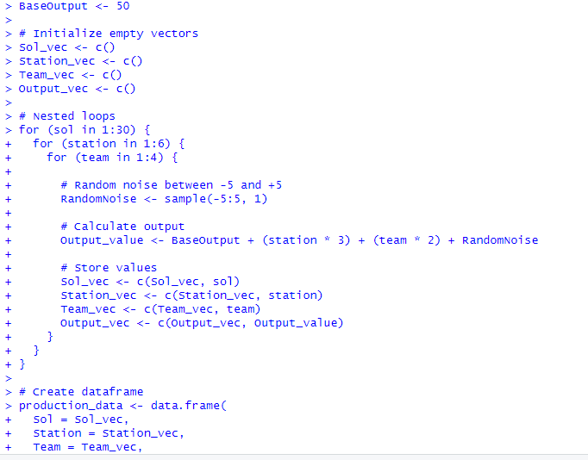
Figure 1: Generation of Production Data
(Source: Obtained from Rstudio)
This row format ensures that the values of the columns have the same location. The vectors were then combined into a dataframe named production_data after completing all the loops.
The loops were fully deterministic and that is why the total number of entries added was exactly 720. It was verified by counting the number of rows after dataframes were built.
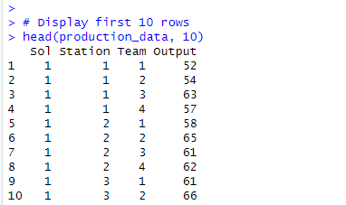
Figure 2: Production Data Overview
(Source: Obtained from Rstudio)
The strategy of vectors incremental appending is easier to understand and apply strictly to loop rules, such that no rows were created implicitly.
Testing and Validation
Experimentation was performed on different levels.
Firstly, a small subset was manually substitution tested. The Output formula was calculated manually as an example Sol = 1 Station = 1 Team = 1. The outcome obtained was found to be the same as the synthesized value with sampled random noise.
Second, the theoretical output range was put to test. Minimum deterministic component = Station =1, and Team=1:
(1 × 3) + (1 × 2) = 5
The maximizing deterministic part is at the Station = 6 and Team = 4:
(6 × 3) + (4 × 2) = 26
Assuming the random noise ∈ [ -5, +5], the output value will be in high 40s to low 80s. This calculated range agreed with actual outputs.
Third, the number of rows was verified and 720 observations were found.
Finally, the initial 10 rows were checked and confirmed the appropriate format, sequence, and flow of logic values.

2. Total Production per Station (Task 1B)
Task 1B was to determine the amount of production per station per sol and team. Aggregation was possible using loops but not inbuilt summarisation functions.
Loop-Based Aggregation Logic
Station values between 1 and 6 were treated on an outer loop. The accumulator variable of each station was set to 0.
The whole dataset was done in rows by a smaller loop. The corresponding Output was also added to the accumulator in case the Station was equal to the current station under analysis.
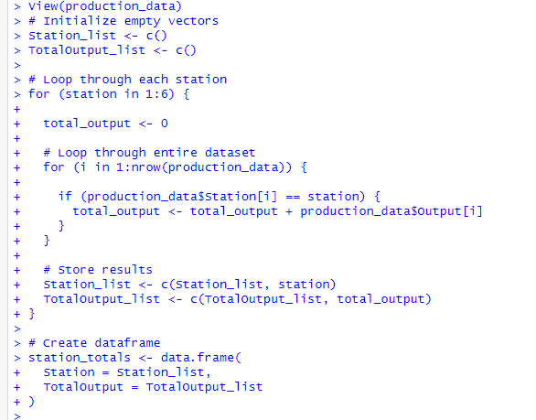
Figure 3: Total Production per Station
(Source: Obtained from Rstudio)
The accumulator held total production at that station once all the 720 rows had been scanned. The outcome was made and sent to the next station.
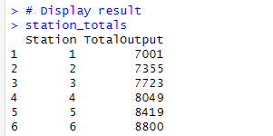
Figure 4: Total Production
(Source: Obtained from Rstudio)
The technique is a simulation of group-wise aggregation logic on a clear and open foundation.
Testing
The results in partial sums were manually verified by adding up the output values of a small percentage of Station 1. It is justified by the fact that the summs of Station 1 and Station 6 rise, which is confirmed by the correctness of the test because the bigger the station, the bigger the deterministic multiplier.
The resulting results station_ totals were in the correct format and numerically make sense with six rows.

3. Detection of Production Anomalies (Task 1C)
Task 1C was to identify the abnormal production behaviour. Any team output that was 10 percent less than the daily output in the station was viewed as an aberration.
Daily Average Calculation
To identify the anomaly, one needed to do two calculations:
- Regard the overall production of the considered station.
- Splitting the number of teams by four will give the average number of games per day.
These implied that the explicit computation of the totals per day and the comparison of the outcomes of each team with the calculated average needed to be performed twice. This has been planned to ensure the Sol and Station is considered in a context.
Anomaly Condition Logic
The deviation relative to each team output was calculated as:
|TeamOutput − StationAverage| / StationAverage
A deviation greater than 0.10 indicated flagging of the observation as TRUE. Only the anomalies dataframe stored STRUE cases.
The existence of the absolute deviation is significant to give balanced detection of the abnormally high or low outputs.
Testing
The testing on manual was carried out that is a specific Sol and Station was selected and the means of a given day were computed manually and the deviations of all the four teams where found out. The program produced the same output as the flagged anomalies.
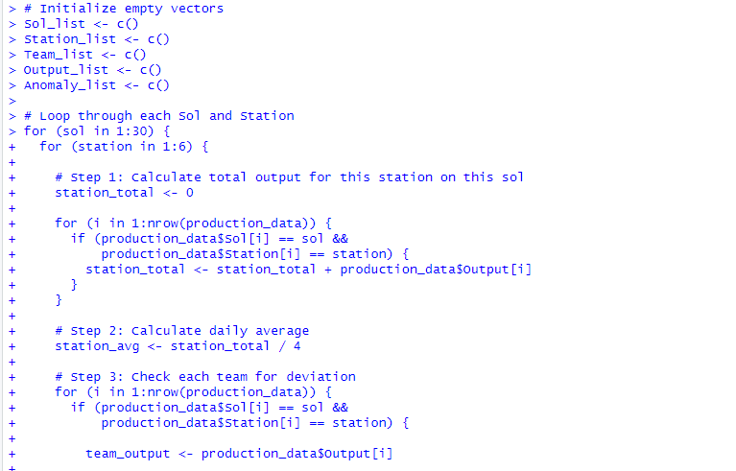
Figure 5: Production Anomalies
(Source: Obtained from Rstudio)
This was in order to affirm the correct structure and rationality, and thereafter 10 anomalies were affirmed.
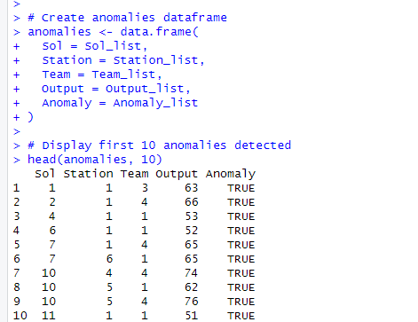
Figure 6: First 10 Production Anomalies
(Source: Obtained from Rstudio)

4. Identification of Peak Productivity Days (Task 1D)
The purpose of Task 1D was to determine, for each station, the Sol with the highest total production.
Maximum Tracking Strategy
A maximum variable was a very low amount assigned to each of the stations. The continuation of Sol algorithm up to Sol value 1 to 30 at which the daily totals were calculated.
The Sol and maximum value were also updated with respect to a higher daily total having been stored. This conditional replacement strategy must be done to ensure that it can detect sufficiently the maximum.
Storage Structure
The output was put in a dataframe peak_days with Station, Sol, and TotalOutput. One was the number of rows to be manufactured in each station.
Testing
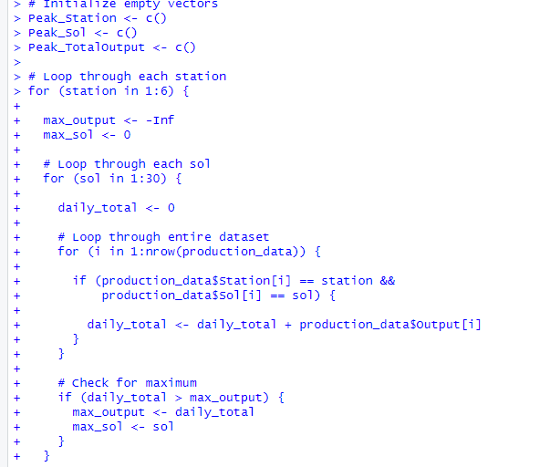
Figure 7: Identification of Peak Productivity Days
(Source: Obtained from Rstudio)
The Sol stored was the largest amount of sol obtained as calculated by manual examination of manually computed totals of daily early sols. Continuity formed the basis of the logical progression of one station to another.
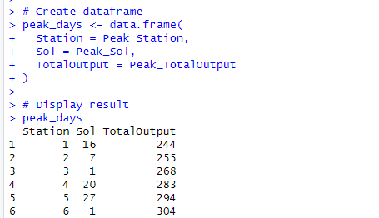
Figure 8: Peak Productivity Days
(Source: Obtained from Rstudio)

5. Efficiency Score Calculation (Task 1E)
The final area was calculation of an efficiency measure that was defined as:
EfficiencyScore = Output / (Station + Team)
The measure normalises output with regard to structural weighting.
Implementation Logic
All 720 rows were repeated. Each row had its denominator (Station + Team) the denominator calculated and subsequently divided to obtain output per row. The values received were added together in the form of a column.
This strategy guaranteed row level integrity and data integrity.
Testing
Manual checking of correctness was done. For example:
If Output = 50, Station = 1, Team = 1
EfficiencyScore = 50 / (1 + 1) = 25
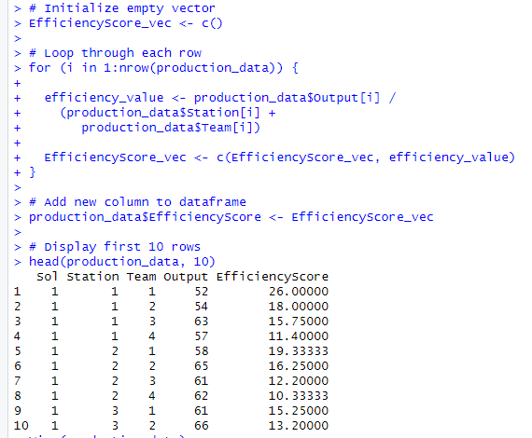
Figure 9: Efficiency Score Calculation
(Source: Obtained from Rstudio)
Calculations were expected and exhibited values were within the expectations. The initial 10 rows were confirmed and they were identified to have been properly integrated.

PART II – TASK 2: DOCUMENTATION AND REFLECTION

1. Explanation of Code Design and Testing Strategy
Overall Programming Strategy
The overall programming style was a procedural design built up loops. The primary constraint of the assignment was the prohibition of high-level aggregation functions such as apply(), aggregate() and vectorised row or column operations. The answer thus required a straight forward data creation, manipulation and analysis.
The program mechanism has chosen loops because it allows systematic scanning of the problem space that is multidimensional. The alien colony simulation had three levels of hierarchy: Sol, Station and Team.
The evasion of high-level functions was not simply a compliance factor, but also an opportunity to demonstrate the familiarity with low-level computational skills. Despite the more efficient and concise vectorised operations in R, it conceals the iterative logic in aggregation and comparison. The loops raised every step of calculation. Each row was drawn intentionally, each accretion was carefully tracked and each conditional comparison hand rated.
The program organization was well planned and then implemented. The modules of development were based on the following process:
- Generate complete dataset.
- Perform manual aggregation.
- Installing conditional anomaly detection.
- Comparison logic will be used to track maximum values.
- Determine obtained efficiency indicators.
This systematic progress ensured that one step relied on the already established outcomes. An example of anomaly detection was a well-shaped dataset and actual day totals. Correct summation logic was used to determine peak productivity. The design was therefore serial and interdependent.
The other tactical step was to separate data storage and computation. The totals were accumulated in accumulator variables and tabulated storage in vectors, and dataframe was created. This division increased the degree of clarity and debugging.
Systematic Testing Approach
To ensure the correctness and reliability, systematic and stratified testing methodology was selected.
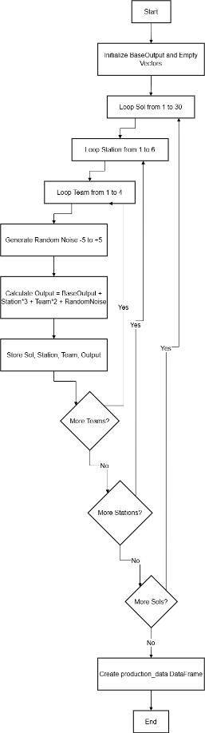
Figure 10: Production Data Flow Chart
(Source: Obtained from Draw.io)
The small dataset was conceptually tested, and the entire 720-row generation performed. This was verified through the SolStationTeam combination by manually testing the Accuracy of the Output formula. This ensured that deterministic and stochastic elements were integrated accordingly.
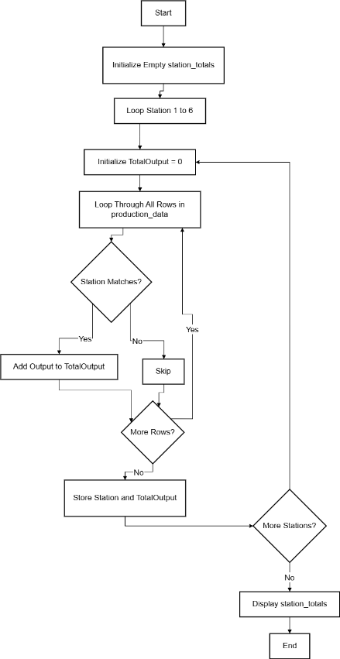
Figure 11: Total Production per station Flow Chart
(Source: Obtained from Draw.io)
The testing of the boundaries was performed based on the initial and final Sol values (Sol = 1 and Sol = 30). This ensured proper and inclusive definition of loop boundaries. Had loop indexing been incorrect, the final or initial Sol would have been missing in the data set.
Output values were range tested by determining the theoretical maximum and minimum values using the formula constraints. The outputs were compared with the anticipated ranges to establish the absence of arithmetic and indexing errors.
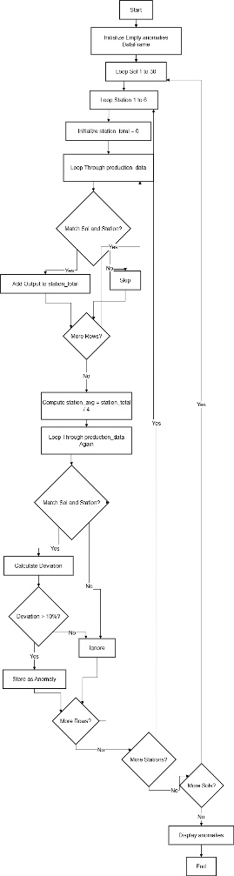
Figure 12: Anomaly Detection Flow Chart
(Source: Obtained from Draw.io)
Rational validation was required to identify anomalies. The team averaged the four productions manually by picking one Sol and Station. The variation of each team was then calculated individually and compared with the anomaly flag of the program.
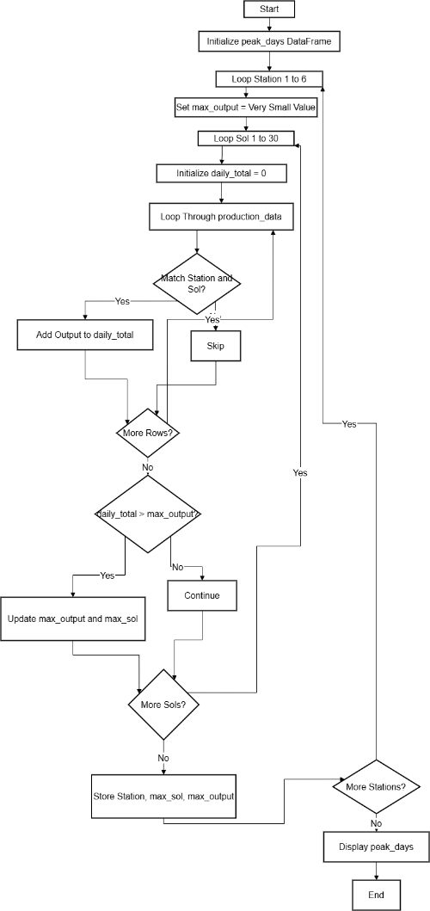
Figure 13: Peak Productivity Identification Flow Chart
(Source: Obtained from Draw.io)
The maximum detection logic was checked by testing the daily totals of early Sol values of a certain station manually. This demonstrated that the comparison condition updated the maximum where a larger total was reached. It also made sure that maximum variable was predetermined and then comparison was made.
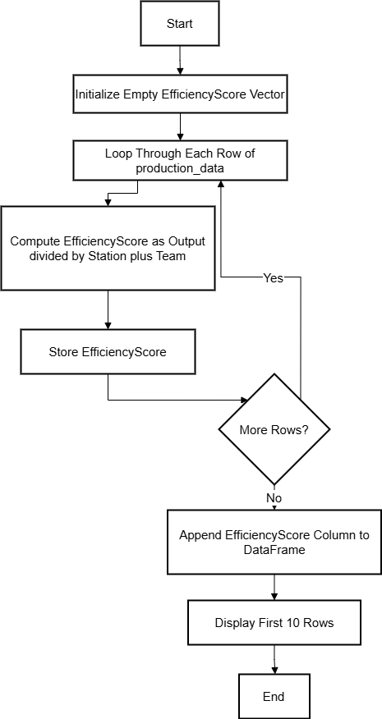
Figure 14: EfficiencyScore calculations flow Chart
(Source: Obtained from Draw.io)
The calculations of the EfficiencyScore were compared to the hypothetically constructed values. The values of efficiency calculated by substituting the known numbers in formula were checked.
In addition to this, the number of rows was verified at various points. It was ensured that the production dataset has not more than 720 rows. It was verified that the dataset station contained six rows. The data set of maximum days only had one row per station. These checks assisted in checking the logical completeness.
The testing plan was therefore manual arithmetic checking, structural checking, boundary checking, and logical condition checking.

Error Handling and Debugging
One of the greatest risks was the indexing errors. The fact that the solution was to repeat the scanning of the entire dataset in nested loops meant that a false indexing could have resulted in Sol, Station and Team values being misaligned. The matching in conditions was done with care and by referencing position of rows.
The other challenge was logical errors in conditional statements particularly where anomaly detection was occurring. First implementations of deviation logic do not calculate or compute percentage cutoff.
Accumulator variables also had to be initialised. Carry-over errors in stations or sols would have happened due to the inabilities to reset totals at the right points.
The debugging was to be reading intermediate totals and viewing manually the data subsets. The discrepancies could be identified and corrected well by isolating specific stations or sols.

2. Reflection and Critical Evaluation
Challenges Encountered
The management of numerous nested loops simultaneously was also one of the key issues. The deep structures are more cognitively challenging, particularly where inner loop conditions depend on the outer loop values. Certain caution was required in the arrangement because of the necessity to ensure clarity of the variables in operation at any level.
The other challenge was manual aggregation. High-level functions tend to simplify group-wise calculations. This functionality was not repeatable with explicit accumulator variables, dataset scanning, and there was more risk of logical oversight.
The accuracy was also required in order to trace conditional logic in anomaly detection. The anomaly was defined as a percentage variation to the dynamically estimated average. It was crucial to ensure that the mean was the correct Sol and Station.
The other one was to flee prohibited functions. Operations which are vectorised are efficient and sui generis in R. This required a conscious adherence to loop based logic where smaller forms can be adopted.
Alternative Approaches Considered
Several other approaches were also considered and shunned specifically due to the assignment limitations.
The code length would be reduced significantly and efficiency would be high with the use of vectorised techniques. The resulting examples would be that wholly combinations would be generated (via matrix operations) in real time and totals per group generated via aggregate functions.
The use of family of functions would also provide shortcut aggregation instead of grouping data. Similarly repeatable aspects of logic such as day-to-day total computation or deviation checking can be modularised as special functions.
Loops also provide fine granularity of control. The step-by-step comparison logic is more plausible and meets the reasoning about in the case of anomaly detection and peak tracking than abstracted functional programming primitives.
Computer implementation Vectorised methods are faster to compute but loop based implementation are easier to understand and debug.
Concluding Reflection
The alien colony simulation project required a great deal of discipline and logical structuring of programming and systematized testing. It was implemented in a manner that centered on transparency of algorithms and control of computation by shunning high-level functions.
The experience complemented learning of iteration, conditional logic, accumulator control, and dataset building. It also revealed the tradeoff of efficiency and clarity in the design of the programs.

