

Student name: Lavina Fernandes
Student ID:2440648
Module name: Halth and Socal Care
Module code: LCHS4003
Lecturer name: Muhammad Aliyu
Contents
Task 1: 3
Task 2: 4

Task 1:
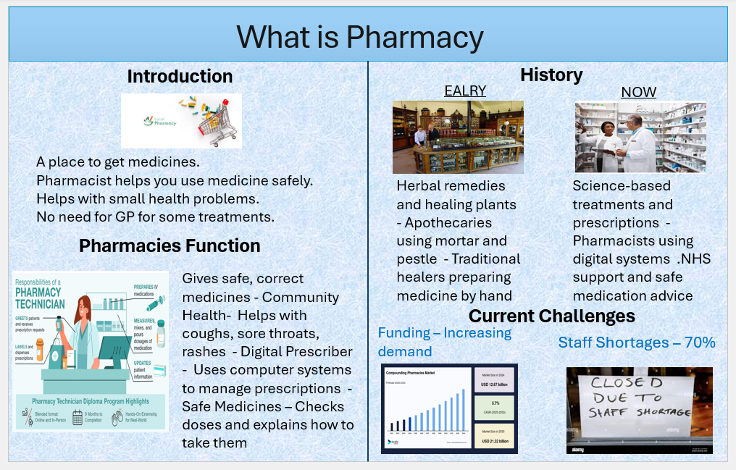

Task 2:

Origins of the National Health Service (NHS):
The National Health Service (NHS) is the UK’s public healthcare system. It was created to make sure everyone could get medical help, no matter how much money they had. Today, the NHS is a big part of British life and helps millions of people every day. But it also faces many challenges.
Before the NHS began in 1948, healthcare in Britain was not fair. Rich people could pay for doctors and hospitals, but poor people often had no help or had to rely on charity. Some workers paid into small health plans, but many people were left out. During World War II, the government helped run hospitals and health services. People saw that this worked well. After the war, many wanted a better life for everyone. They wanted health care to be fair and free.
In 1942, a man called William Beveridge wrote a report. He said the UK should fight problems like poverty, illness, and poor housing. One of his ideas was a health service for all people. Later, the Labour government, led by Clement Attlee, agreed to build the NHS. The Minister of Health, Aneurin Bevan, helped make it happen. He believed that people should get care based on need, not money. The NHS officially began on 5 July 1948.

The NHS was built on three simple ideas. First, care should be free when people use it. Second, it should be available to everyone, no matter their income or background. Third, it should be paid for by taxes, so everyone helps support it. These ideas helped make healthcare fairer and safer for all.
Today, the NHS is very large and works in four parts—England, Scotland, Wales, and Northern Ireland. Each part has its own NHS team. In England, the NHS is managed by NHS England and the Department of Health and Social Care. The NHS gives many services. People can see local doctors, called GPs, when they feel sick. Hospitals help with serious problems, surgery, and emergencies. Community care includes help at home, mental health support, and maternity care. Public health services give vaccines, health advice, and help stop illness before it starts. Most NHS care is free. Some things, like dental care or prescriptions, may cost a little.
Even though the NHS is loved by many people, it has some problems. More people need care, and it costs a lot to run the NHS. There are not enough doctors, nurses, and care workers. This makes waiting times longer and puts pressure on staff. Many people wait weeks or months for treatment. Mental health services need more support and money. Some people also worry that private companies are doing more NHS work, which may not be fair or good for patients.
Even with these problems, the NHS still helps millions of people every day. It remains a symbol of care, fairness, and support. The NHS was created to make healthcare fair and free for everyone. It started after World War II, when people wanted a better life. Its main ideas free care, care for all, and paid by taxes are still important today. To keep the NHS strong, we need to support its workers, give it enough money, and protect its values. The NHS is a big part of life in the UK, and it shows how we care for each other.

References:

*NHS England – About the NHS*
This official page explains how the NHS works today, including its structure, services, and guiding principles.
[Visit NHS England](https://www.england.nhs.uk/about/nhs-history/)

2. *UK Government – The NHS Constitution for England*
This document outlines the values and rights that guide the NHS, including its founding principles and responsibilities.
[View the NHS Constitution](https://www.gov.uk/government/publications/the-nhs-constitution-for-england)

