Introducing the Modern Workplace As1
Student Id: 1920733

Table of Contents
Introduction 3
Organisational Structure 4
Organisational Culture 5
Schein’s Model of Organisational Culture 6
Relationship with Organisational Performance 7
Conclusion 8
References 10

Introduction
An organisation always needs a formal business structure to fulfill the objectives set forth by the management. An organisational structure states the roles and responsibilities each employee has (Bright, 2019). Moreover, a well-defined structure makes the flow of communication efficient across the organisation and lets the employees realize the importance of the roles they have been assigned (Taylor, 2015). A formal structure complements the organisational culture as it helps to properly communicate and establish a culture. In this era of global competition, cultural adaptation is a must for any company that wants to go global, and for this reason, understanding organisational culture is vital for all the employees of an organisation (Griffin and Pustay, 2020). An organisational culture considers the beliefs, attitudes, behaviors, values, and norms of the people working for the organisation (Bright, 2019). Employee beliefs and behaviors can affect the organisational culture of a firm. The culture of one company differentiates it from the other organizations. Both organisational structure and culture help to increase the performance of a business. In this report, the theoretical aspects of organisational structure and culture with relevant examples will be discussed. Edgar Schein’s model of organisational culture will be considered in discussing the cultural aspects. The relationship of these with organisational performance will also be discussed.

Organisational Structure
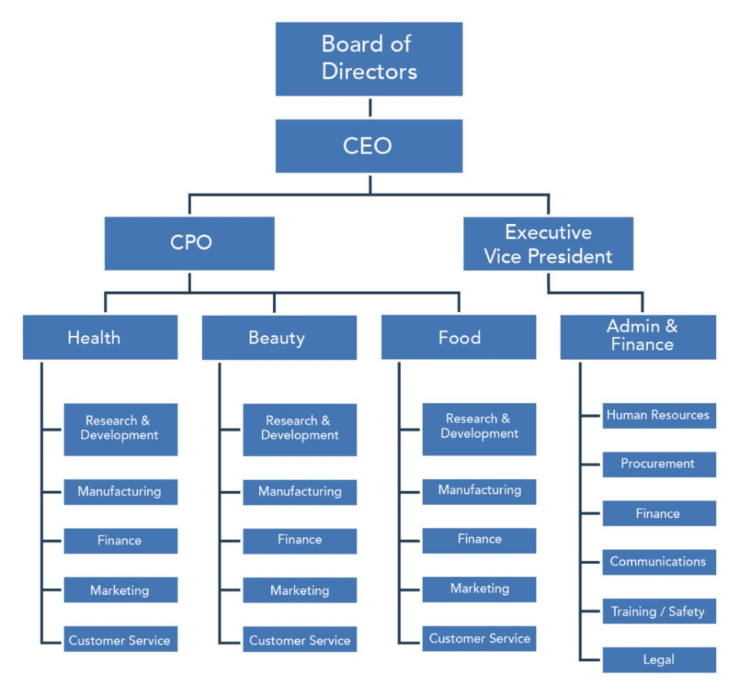
Organisational structure has been defined as a structural system that directs how the activities are to be conducted or how people of a company should be grouped so that the organisation can achieve its goals, objectives, missions, and visions (Bright, 2019). Moreover, a business structure also defines how the information should flow across the organisation (Taylor, 2015). For instance, in a centralized organisation, decision-making power generally belongs to the top management and so, information flows from top to bottom management (Eriksson, Robertson and Näppä, 2020). On the other hand, in a decentralized organisation, different levels of management are given decision-making power. The structure of a company helps it to run efficiently and be focused on the core objective of the organisation. The majority of the firms design specific structures for their efficient operation and layout certain hierarchy aligning with each firm’s business processes, as shown in figure 1. This structure helps an organisation to distribute the roles and responsibilities among the employees and place the right people for the roles that best fit them (Bright, 2019).
Figure 1: An organisational hierarchy; Source: Author
There are 4 types of organisational structure commonly used in the business arena (Taylor, 2015). These structures have been briefly discussed below.
Functional Structure: In this structure, specialized groups of people are given specific responsibilities and roles. The employees work under certain departments with the required skills. For instance, a firm may divide the organisation into different departments such as Marketing, Finance, Supply Chain, Human Resources, etc., and assign managers who would then be responsible for overseeing each department.
Divisional Structure: Large firms generally layout this structure in which various teams are assigned for specific projects or products. All the teams work for a shared or common goal. For instance, a car manufacturing firm may divide the company into sedan, SUV, electric, and sports car branches whereby the common goal can be increasing the market share of the holding company.
Flatarchy Structure: This structure of business has little or no managerial levels. A firm that follows this structure may have only one manager for overseeing the whole business and employees. Generally, small businesses follow a flatarchy structure as those businesses have a smaller workforce and narrow operations to oversee.
Matrix Structure: In this structure, the whole workforce is divided into groups who report to two superior managers- a product or project manager and an operational manager. Employees working for companies that follow this structure have the possibility of enhancing their skillset as they could be assigned to projects that will allow them to explore different areas of a business.

Organisational Culture
Organisational culture consists of norms, values, behaviors, assumptions, artifacts of the members of an organisation (Schein, 2017). Each organisation, society, or even country has its own distinct culture. Every member of it can sense the presence of their own culture. The culture can be portrayed through the behavior of the employees, the type of clothing they wear, the kind of furniture the organisation prefers, or the way management communicates with the external stakeholders. An understanding of culture is particularly important for a business as the competition is global nowadays and it must operate globally (Griffin and Pustay, 2020). The culture of different countries differs a lot from each other. Thus, aligning the culture of the organisation with that of the host country is vital if the organisation wants to succeed in the global market (Griffin and Pustay, 2020). Moreover, organisational culture shapes the way a business runs, and the type of leader needed to operate efficiently. For instance, Apple has a culture of innovation, and every member of Apple including the CEO must adopt this culture to uphold the legacy of the organisation (Leśniak-Moczuk, 2016). This culture of innovation at Apple has made it to choose Tim Cook as the CEO of it who also personally nurtures creative and innovative culture (Podolny and Hansen, 2020). This good match with the culture of an organisation with that of a leader is one of the reasons Apple still holds its legacy of innovation (Leśniak-Moczuk, 2016).

Schein’s Model of Organisational Culture
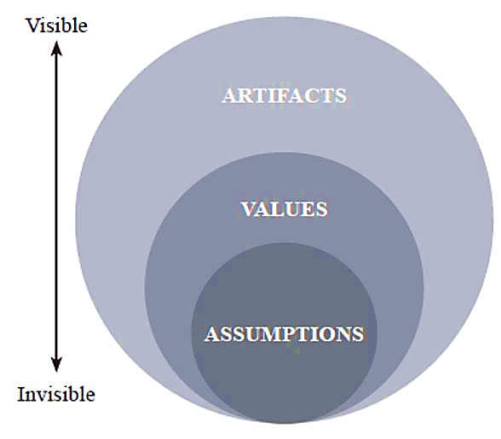
A well-known model of organisational culture was introduced by Edgar Schein (Burkus, 2014). The model proposes that basic assumptions help an organisation to form its values and then values form behaviors and practices (Schein, 2017). An organisation does not form a culture within a day but take learnings from the previous experiences and practice the desired culture every day to form a distinct corporate culture within the workplace. According to Schein’s model, there are three layers in an organisation’s culture (Burkus, 2014), as depicted in figure 2, which have been discussed below.
Figure 2: Schein’s Model of Organisational Culture; Source: Author
Artifacts: Artifacts are considered to be the most visible part of an organisation and it can be heard, viewed, and felt by almost all the members of an organisation. Artifacts include the company furniture, dress code of the workforce, infrastructure, facilities, behaviors of the management, code of conduct, missions, and visions of a company (Burkus, 2014). For instance, an organisation may instruct its employees to appear formally, respect and follow orders of its superiors, and have a strict order of meeting the deadlines. On the other hand, another organisation in the same industry may instruct the workforce to wear casual dresses, encourage co-operation with the superiors and have flexibility in meeting deadlines considering the type of projects assigned. These two organisations have two different organisational cultures being in the same industry.
Values: The next level of the culture is the values of its employees. The attitude, mindset, and thought process of the workforce play a crucial role in shaping the organisational culture (Burkus, 2014). For instance, the thought process of the employees of Apple and Zappos is different and at the same time best suited for its corporate culture. Whereas the employees at Apple have the mindset of innovating something for its next version of iPhone or MacBook (Podolny and Hansen, 2020), the workforce at Zappos has the mindset of providing the best customer service (Hsieh, 2010). These two thought processes and mindsets are different yet highly important for the corporate culture of Apple and Zappos.
Basic Assumptions: These assumptions are not visible but subtly affect the corporate culture (Burkus, 2014). These beliefs stay dormant within the individuals of an organisation yet are expressed in the day-to-day operation of a business. For instance, an organisation may have the basic assumption that the first few rows of the auditorium are to be left for the female employees. This basic assumption is not officially discussed much but may be practiced for a long time. A new employee might take time to grasp these kinds of assumptions as these are not formally told to them. Basic assumptions might seem to be something that no one talks about but in fact, these are the beliefs that shape the values of an organisation.

Relationship with Organisational Performance
A business structure is a vital framework for an organisation to operate effectively and efficiently (Taylor, 2015). A manager has to ensure that employees are assigned specific tasks that need to be done within a certain time. If the roles of the employees are not properly communicated, the same task might be done by multiple employees which would halt the efficiency of the organisation. A proper business structure, therefore, communicates what are the roles of the employees, to whom they should report, and what objectives are to be fulfilled (Bright, 2019). This clear communication of business structure will help the workforce to be focused on their assigned responsibilities and complete the tasks before the deadline. So, a formal organisational structure, ultimately, assists in improving the business performance (Chung, 2017). On the other hand, a formal structure helps to implement and communicate the corporate culture. A business structure, thus, accelerates the proper implementation of organisational culture. Culture describes the way a workforce should do the tasks, communicate with the management and cooperate with each other in fulfilling the responsibilities (Schein, 2017). These cultural aspects consequentially help an organisation to improve its performance (Chung, 2017). For instance, in a bureaucratic company operating in a competitive business environment, employees must follow the orders of and complete the tasks assigned by the superiors within the deadlines. The salesforce might be given with certain sales quota to fulfill within a week to retain the market share or increase the sales. This type of corporate culture in sales might help that company to improve their performance or might demotivate salesforce due to increased pressure for fulfilling sales quota. On the contrary, an innovative company might groom the employees with their organisational culture and give the employees flexibility for thinking and innovating newer services or technologies. For instance, Google provides their employees a flexible work environment to nurture their creative thinking and help them to innovate by giving them independence in communicating new ideas (Coleman, 2016). This type of organisational culture provided by Google helped them to improve their performance. Moreover, organisational culture has multiple impacts on the performance and motivation levels of the workforce (Schein, 2017). Employees will proactively take initiatives and willingly fulfill the organisational objectives if employees are regarded as a vital part of the organisation’s success by the management. Recognizing the contribution of the employees are also a part of organisational culture which motivates them to contribute more and thus, contributes to the organisational performance.

Conclusion
The majority of the businesses that have been able to reach the peak of their success had a well-defined structure. For the efficient operation of a firm, a formal structure must be present as it helps employees realize their specific roles and responsibilities. Organisational culture, on the other hand, differentiates an organisation from the others through the behaviors, attitudes, norms, and values of the people involved. As organisations are continuously going global, the management of those organisations must align and adapt their culture with that of the host country. Both organisational structure and culture help to improve the performance of a business. A business that is currently operating or is planning to operate in different regions must have a well-defined structure and adopt a corporate culture that portrays the mission and vision of that organisation.

References
Bright, D., 2019. PRINCIPLES OF MANAGEMENT. 12th ed. [Place of publication not identified]: 12TH MEDIA SERVICES.
Burkus, D., 2014. How to Tell if Your Company Has a Creative Culture. [online] Harvard Business Review. Available at: <https://hbr.org/2014/12/how-to-tell-if-your-company-has-a-creative-culture> [Accessed 4 April 2021].
Chung, D., 2017. THE RELATIONSHIPS OF ORGANISATIONAL STRUCTURE, COMPETITIVE STRATEGY AND PERFORMANCE. International Journal of Business Strategy, 17(2), pp.53-60.
Coleman, A., 2016. Is Google's model of the creative workplace the future of the office?. [online] The Guardian. Available at: <https://www.theguardian.com/careers/2016/feb/11/is-googles-model-of-the-creative-workplace-the-future-of-the-office> [Accessed 4 April 2021].
Eriksson, T., Robertson, J. and Näppä, A., 2020. Functional top management teams and marketing organisation: exploring strategic decision-making. Journal of Strategic Marketing, pp.1-18.
Griffin, R. and Pustay, M., 2020. International business. 9th ed. Harlow, United Kingdom: Pearson Education.
Hsieh, T., 2010. How I Did It: Zappos’s CEO on Going to Extremes for Customers. [online] Harvard Business Review. Available at: <https://hbr.org/2010/07/how-i-did-it-zapposs-ceo-on-going-to-extremes-for-customers> [Accessed 4 April 2021].
Leśniak-Moczuk, A., 2016. Vision, Strategy, Innovation in Apple Company. Zeszyty Naukowe Uniwersytetu Szczecińskiego Finanse Rynki Finansowe Ubezpieczenia, 83, pp.33-40.
Podolny, J. and Hansen, M., 2020. How Apple Is Organized for Innovation. [online] Harvard Business Review. Available at: <https://hbr.org/2020/11/how-apple-is-organized-for-innovation> [Accessed 4 April 2021].
Schein, E., 2017. Organisational culture and leadership. 5th ed. San Francisco, CA: Jossey-Bass.
Taylor, B., 2015. Introduction to Management Science. 12th ed. Pearson.

