Using loops (2) – For (SOLUTIONS)

1. Write a for loop that counts from 0 to 12 (print the counter on the screen).

Sample output:

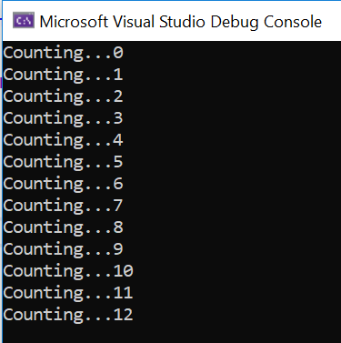

Solution:

#define _CRT_SECURE_NO_WARNINGS
#include <stdio.h>

void main()
{
int counter;

for (counter = 0; counter < 13; counter++)
{
printf("Counting...%d\n", counter);
}

}

2. Write a for loop that counts from 4 to 16 and goes up in increments of 2:

Sample output:

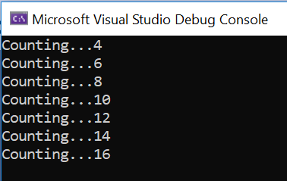

Solution:

#define _CRT_SECURE_NO_WARNINGS
#include <stdio.h>

void main()
{
int counter;

for (counter = 4; counter <= 16; counter+=2)
{
printf("Counting...%d\n", counter);
}

}

3a. Write a for loop that counts from 1 to 12 and goes up in increments of 1.

Sample output:

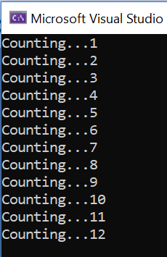

Solution:

#define _CRT_SECURE_NO_WARNINGS
#include <stdio.h>

void main()
{
int myCounter;

for (myCounter = 1; myCounter <= 12; myCounter++)
{
printf("Counting...%d\n", myCounter);
}

}

3b Adapt your for loop from 3a to do some simple calculations to reproduce the 7 times table.

Multiple myCounter by 7 each time around the loop, store the result, and then print the result.

Sample output:

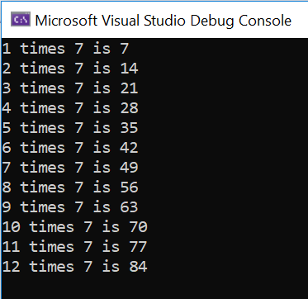

Solution:

#define _CRT_SECURE_NO_WARNINGS
#include <stdio.h>

void main()
{
int myCounter, total;

for (myCounter = 1; myCounter <= 12; myCounter++)
{
total = myCounter * 7;
printf("%d times 7 is %d\n", myCounter, total);
}

}

3c Adapt your solution to allow the user to choose the times table they want.

Sample output:

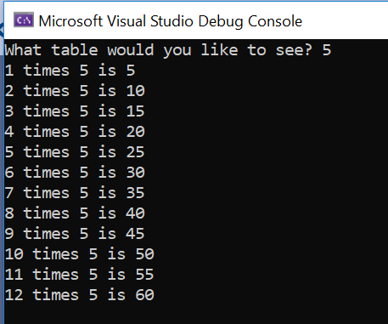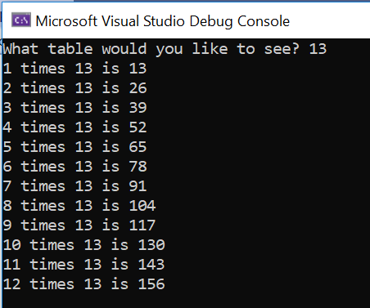

Solution:

#define _CRT_SECURE_NO_WARNINGS
#include <stdio.h>

void main()
{
int myCounter, total, userTable;

printf("What table would you like to see? ");
scanf("%d", &userTable);

for (myCounter = 1; myCounter <= 12; myCounter++)
{
total = myCounter * userTable;
printf("%d times %d is %d\n", myCounter, userTable, total);
}

}

3d Adapt your program even further! This time allow the user to go up as far as they want:
Sample output:
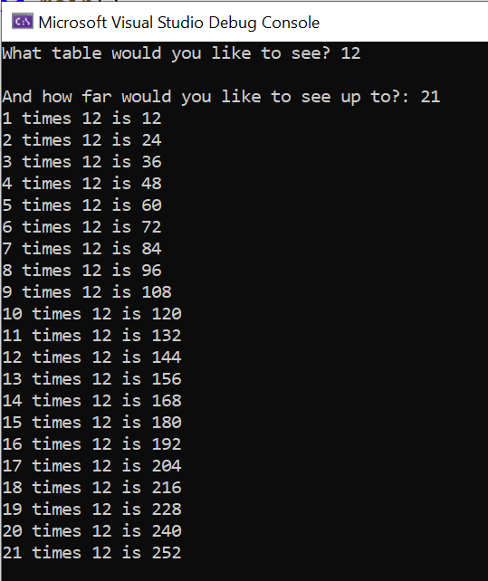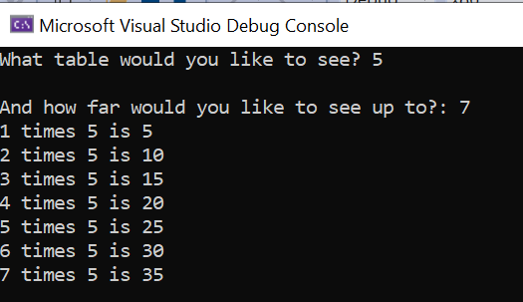

Solution:
#define _CRT_SECURE_NO_WARNINGS
#include <stdio.h>

void main()
{
int myCounter, total, userTable, top;

printf("What table would you like to see? ");
scanf("%d", &userTable);

printf("\nAnd how far would you like to see up to?: ");
scanf("%d", &top);

for (myCounter = 1; myCounter <= top; myCounter++)
{
total = myCounter * userTable;
printf("%d times %d is %d\n", myCounter, userTable, total);
}

}

4a. Print "XXXXX\n" on the screen. This is the width (5) of a rectangle.

Using a for loop, repeat this down the screen so that you achieve a 5 x 7 rectangle. You can do this in the two lines of code

Sample output:

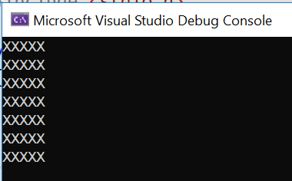

Solution:

#define _CRT_SECURE_NO_WARNINGS
#include <stdio.h>

void main()
{
int i;

for (i = 0; i < 7; i++)
{
printf("XXXXX\n");
}

}

4b Extend your solution to allow the user to choose the height of their rectangle (but the width stays as XXXXX)

Sample output:

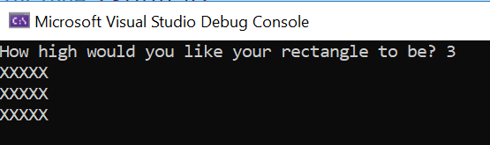

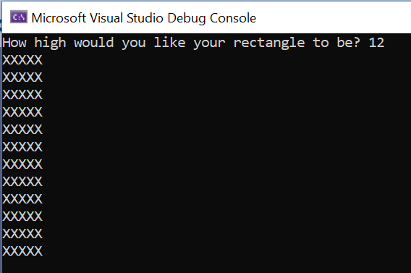

Solution:

#define _CRT_SECURE_NO_WARNINGS
#include <stdio.h>

void main()
{
int i, userHeight;

printf("How high would you like your rectangle to be? ");
scanf("%d", &userHeight);

for (i = 0; i < userHeight; i++)
{
printf("XXXXX\n");
}

}

4c (Harder) For the adventurous among you, write a program to allow the user to enter both the width and length. You will need to print just one X - print("X") and use a nested loop.

Sample output:

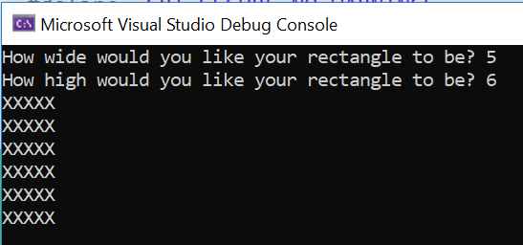

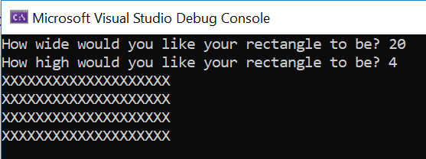

Solution:
#define _CRT_SECURE_NO_WARNINGS
#include <stdio.h>

void main()
{
int i, j, userHeight, userWidth;

printf("How wide would you like your rectangle to be? ");
scanf("%d", &userWidth);

printf("How high would you like your rectangle to be? ");
scanf("%d", &userHeight);

for (i = 0; i < userHeight; i++)
{
for (j = 0; j < userWidth; j++)
{
printf("X");
}
printf("\n");
}

}

5. Write a for loop to print out the traditional children's rhyme "One potato, two potato" (if you don't know the rhyme, see the sample output below)

Most lines are similar, apart from "4" so you will need to stop it printing "potato" on that line only.

Sample output:

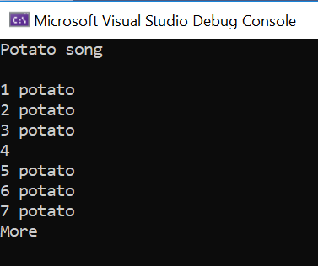

Solution:

#define _CRT_SECURE_NO_WARNINGS
#include <stdio.h>

void main()
{
int pCount;
printf("Potato song\n\n");

for (pCount = 1; pCount < 8; pCount++)
{
if (pCount != 4)
{
printf("%d potato\n", pCount);
}
else
{
printf("%d\n", pCount);
}
}
printf("More\n\n");

}

6. Write a child's program to simulate a rocket blasting off. Use a for loop for the countdown.

Note: You do not have to draw the rocket (but it is fun )

Sample output:

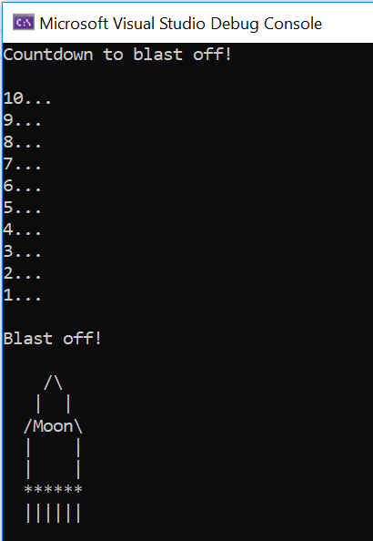

Solution:

#define _CRT_SECURE_NO_WARNINGS
#include <stdio.h>

void main()
{
int counter;

printf("Countdown to blast off!\n\n");

for (counter = 10; counter > 0; counter--)
{
printf("%d...\n", counter);
}

printf("\nBlast off!\n\n");

printf(" /\\\n");
printf(" | |\n");
printf(" /Moon\\\n");
printf(" | |\n");
printf(" | |\n");
printf(" ******\n");
printf(" ||||||\n");

}

