

Changemakers: Creativity and Value Creation
BMHP5014
Dignity Drones - Bridging the Rural Care Gap

Lecturer:
G1: Dr Laila Surani
G2: Caroline Salami (Module leader)

Student name: Tania Habib
Student ID number: 2336623
Submission Date: 17-12-2025

Confession: AI not applied in this assignment at all. Only for Spelling and Grammar check Microsoft word utilized.
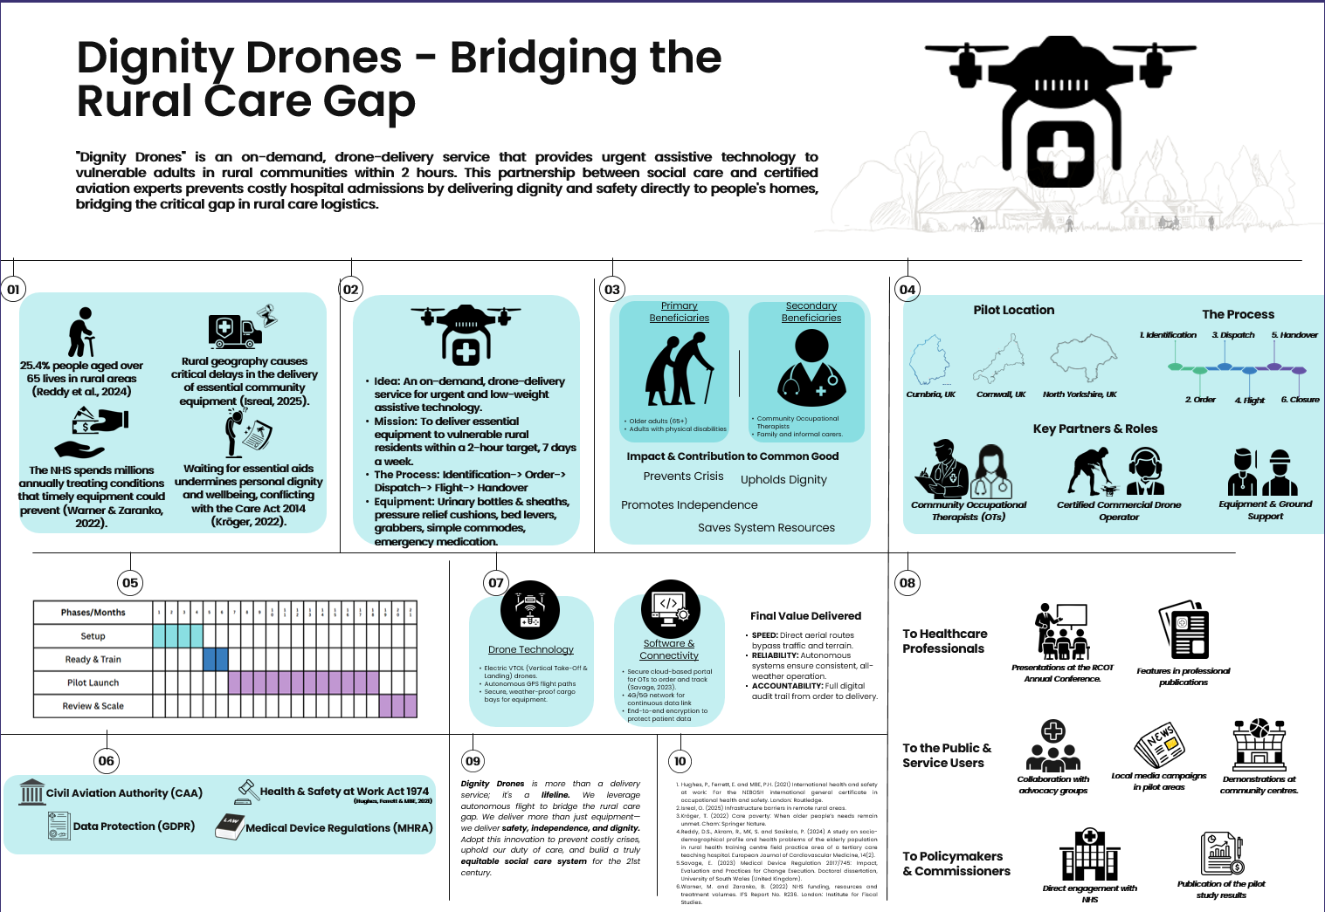

1.The Gap in Health & Social Care:
In the rural area of the UK, there are many unmet needs of older people who suffer from falls and fractures(Huang et al., 2017). There are around 1.4 million older people who live in rural areas. 25.4% people aged over 65 live in rural areas (Reddy et al., 2024). A larger portion of the elderly are living in these areas. Most of them have limited access to minimal social care. Minimum community equipment is hardly found in these areas(Deaney et al., 2024). Although there are social care professionals and medical doctors in some areas, the lack of proper equipment leads to a lack of proper treatment. Transportation barriers in these geographies are stopping the elderly and adults with physical disabilities from having health care equipment. Sometimes delays become months of waiting to have community equipment like bed levers, commodes, and pressure cushions.Rural geography causes critical delays in the delivery of essential community equipment (Isreal, 2025). It shows our disrespect for the older and those who have physical disabilities. NHS spends around £11,000-£16,000 per patient, which could be prevented by timely treatment (Warner & Zaranko, 2022). Older people often face ulcer pressure. A short delay in receiving proper equipment leads to painful sores. These undignifying behaviour goes beyond the Care Act 2014 (Kröger, 2022).. Undoubtedly, there is a failure in the duty of care. These gaps in social care can be covered by Dignity Drones.

2. Innovation Overview:
Dignity drone is an on-demand medical equipment delivery service. Partnership with local social care authorities and certified drone operators, Dignity Drone will be able to deliver the required equipment within 2 hours. The mission is to deliver essential equipment on time in rural areas to make an equitable society. Dignity Drones has the capability to carry low-weight community equipment like urinary bottles & sheaths, pressure relief cushions, bed levers, grabbers, or simple commodes. This is also able to provide emergency medication. The whole service will be ensured in 6 stages. At first, a therapist in the rural areas will identify a need for medical equipment, for example, a pressure relief cushion. He/she will make an order through our service. Then the equipment will be dispatched from our end and flown to the destination by drones. After proper handover of the equipment, the service will be closed.

3. Target Audience and Impact:
The target audience of this service includes older people aged over 65 and adults with physical disability issues. They are the primary target audience. The second target audience is the community of Occupational Therapists and informal social workers.
In remote rural areas, falls and fractures among older people are very common(Yan et al., 2020). Dignity Drones will be able to prevent crises. National Hip Fracture records aronnd 2,20,000 hospital admissions annually, and most of them are from rural areas (Eardley & Johansen, 2024). They also have ulcer problems, and these are often neglected because of geographical barriers(Mudyarabikwa et al., 2022). This inequality also harms their dignity and well-being. Dignity Drones will promote independence and uphold dignity. Similarly, adults with physical disability face a lack of timely service for their medical needs. Therapist in these rural areas often needs equipment to ensure proper treatment (Felter et al., 2022). Informal social care workers also need medical equipment like urinary bottles & sheaths, pressure relief cushions, bed levers, grabbers, or simple commodes. Dignity Drone will ensure an equitable social care system for the common good of these two groups.

4. Implementation:
Primarily, areas like Cumbria, Cornwall and North Yorkshire are selected to run pilot tests. The drone service will be implemented via a 12-month pilot test in these rural areas. To implement this idea, a partnership with different parties is required. Key partners include Community Operational Therapists, certified drone operators and community care specialists. The primary funder and commissioner will be the Integrated Care Board. Their therapists and social workers will identify the urgency in rural areas. Secondly, certified drone operators like Skyports or Aviando will look after the technical part. Local care agencies will perform the final handover and guidance. The process will be identification, order, dispatch, fly, handover and closure.

5. Timeline:
The first phase is the setup phase,which will take 4 months. Within the first four months, we will finalise partnerships, get permission from the CAA Operational Authorisation. After that, in the next two months, we will establish warehouse logistics, train therapists and social workers. Then, in phase 3, we will launch the service and start our pilot testing. We will collect data and outcomes in this phase. Finally, after 10-12 months, in phase 4, we will review data and refine the model to scale up the service nationwide.

6. Development and Regulations:
To operate this service, Digital Drones need to comply with some regulations. It has to comply with the Civil Aviation Authority (CAA) to operate BVLOS flights. Personal data and the tracking portal will be secured by the General Data Protection Regulation (GDPR). Side by side, we will comply with the Health & Safety at Work Act 1974 for ground operations (Hughes, Ferrett & MBE, 2021). This innovation also needs to comply with Medical Device Regulations (MHRA) to ensure all the delivered equipmentis CE-marked (Savage, 2023).

7. Technology Integration:
In this innovation, technologies like Electric VTOL drones, 4G/5G networks, GPS navigation, and a secure cloud platform are primarily integrated. Electric VTOL drones and GPS navigation will be used as drone hardware to avoid collisions. These technologies will ensure speed, reliability and accountability of our service.

8. Dissemination: How the Innovation Will Be Promoted:
The innovation will be promoted to three parties. At first, it will be promoted to the healthcare professionals by featuring community care at the Royal College of Occupational Therapists' annual conference. We can feature this innovation in professional publications like Community Care and Nursing Times. Secondly, this innovation will be promoted to the Public & Service Users in the rural areas. It can be done by local advocacy groups, newspaper campaigns or a short demonstration on local streets or in community centres. Thirdly, it will be promoted to the Policymakers & Commissioners. It can be done by direct engagement with NHS Integrated Care Boards or with the Department of Health and Social Care. Side by side, publications in the health policy journal about the results can be used as a tool of promotion.

9. Conclusion:
A short delay in receiving proper equipment leads to painful sores. Geographical barriers, as a reason for proper care and treatment, also disrespect a person's dignity. Our solution, Dignity Drones, is not just a delivery company; it is a lifeline. We will commit to making medical services available at all times and at every place. We use autonomous flight to close the rural care gap. We provide not just equipment but also safety, independence and dignity. This innovation will help us have a truly fair social care system in the 21st century.

References:
Deaney, C., Hemingway, E., Reesby, D. and Scott, V. (2024) ‘Evaluating the care gaps and inequalities arising in continuing healthcare (CHC) delivery in rural areas’, Journal of Primary Care & Community Health, 15, p. 21501319241305968.

Eardley, W. and Johansen, A. (2024) ‘The national hip fracture database: lessons learned and future horizons’, Orthopaedics and Trauma, 38(2), pp.108–113.

Felter, C.E., Zalewski, K., Jermann, R., Palmer, P.L., Baier, A.E. and Falvey, J.R. (2022) ‘Rural health: the dirt road less traveled’, Physical Therapy, 102(11), p.pzac112.

Huang, J.W., Lin, Y.Y., Wu, N.Y. and Chen, Y.C. (2017) ‘Rural older people had lower mortality after accidental falls than non-rural older people’, Clinical Interventions in Aging, 12, pp. 97–102.

Hughes, P., Ferrett, E. and MBE, P.H. (2021)International health and safety at work: For the NEBOSH international general certificate in occupational health and safety. London: Routledge.

Isreal, O. (2025)Infrastructure barriers in remote rural areas.

Kröger, T. (2022)Care poverty: When older people’s needs remain unmet. Cham: Springer Nature.

Mudyarabikwa, O., Regmi, K., Ouillon, S. and Simmonds, R. (2022) ‘Refugee and immigrant community health champions: a qualitative study of perceived barriers to service access and utilisation of the National Health Service (NHS) in the West Midlands, UK’, Journal of Immigrant and Minority Health, 24(1), pp. 199–206.

Reddy, D.S., Akram, R., MK, S. and Sasikala, P. (2024)A study on socio-demographical profile and health problems of the elderly population in rural health training centre field practice area of a tertiary care teaching hospital. European Journal of Cardiovascular Medicine, 14(2).

Savage, E. (2023)Medical Device Regulation 2017/745: Impact, Evaluation and Practices for Change Execution. Doctoral dissertation, University of South Wales (United Kingdom).

Warner, M. and Zaranko, B. (2022)NHS funding, resources and treatment volumes. IFS Report No. R236. London: Institute for Fiscal Studies.

Yan, Y., Zhu, Y., Lian, X., Lv, H., Hou, Z., Zhang, Y., Chen, W. and Liu, G. (2020) ‘A comparative epidemiologic study of fractures among people in rural and urban areas’, Injury, 51(8), pp. 1784–1790.

