Contract Practice & Procedures

M5X01878

Jacob Passmore

1706871

Table of Contents
1.0 Introduction 3
2.0 Type of Contract Used 3
2.1 NEC Contract 3
3.0 Early Warnings 3
3.1 Early Warning Handout 5
4.0 Compensation Events 5
4.1 Compensation Procedure 6
5.0 Conclusion 7
6.0 References 8

1.0 Introduction

This report will show how a contract administrator would deal with a significant variation within the contract that has impacts on the delivery timeframe of the project and cost. It will also evaluate factors that will affect the choices of the construction procurement methods and the contractual arrangements, check the roles and activities of all involved parties and organisations of the procurement of construction projects and assess the significant administrative factors that are involved with the contracts and talk about the contractual obligations placed upon the parties and to understand the time cost and quality of the construction contracts.

2.0 Type of Contract Used

The type of contract used will be a NEC contract, this contract “facilitates the implementations of sound practise” (Davies, 2017) also characterizes legal relationships. This contract is used for all types of works, major framework projects through minor works, services and supply and buying of supplies and goods, applying the NEC contracts has helped in greatly for the projects all over the world in terms such as cost saving, costs and quality improvement.

2.1 NEC Contract

The NEC provides a wide range of definitive end to end project management contracts that grants the user to deliver projects on time, on budget and to the best of standards. In these contracts it basically tells you that the parties involved have to oblige to what it states in the contract and have trust amongst the client and contractor. Issues can be notified to each other that are stated in the contract, these are:
- Early Warning notices
- Compensation Events

3.0 Early Warnings

If there is a matter which could increase the price of the job, competition delay or not meeting a key date, the contractor and project manager can give an early warning so they notify the client as soon as possible so they become aware of this. If an early warning is given, this does not mean that a compensation event is also notified as these two require separate notifications and both the contractor and project manager have an obligation to inform the client of any early warnings. Either the project manager or contractor will inform the other to attend a risk reduction meeting, at this meeting they will discuss about
- How the risks can be avoided or reduced?
- Finding solutions to gain advantage to those who are affected
- Deciding the actions that will be taken
- Deciding what risks have been avoided so they can be taken off the risk register.
The project manager then goes through the risk register to record the decisions made at the risk reduction meeting and present the issues to the contractor and if a decision needs to be changed in the works information then the project manager changes them at the same time as he/she issues the revised risk register.
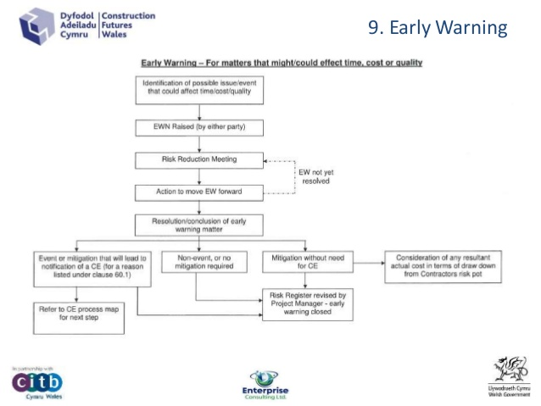
In one of the NEC Clause it states that (clause 61.5) if the project manager says that the contractor didn’t give an early warning which an experienced contractor could have given then he/she then notifies the decision to the contractor when he/she instructs to submit quotations.

Fig 1 (Davies, 2017)

3.1 Early Warning Handout

Fig 2 (Davies, 2017)

4.0 Compensation Events

Compensation events are loss, expense and extensions of time, so an assessment that handles with all the effects of an event that comes under time and money, not all events are compensation events, these are when it’s not the fault of the contractor but this doesn’t mean the faults are caused by others. They can be faults caused by the weather or that the site conditions affect it, these are classed as fault neutral and in this event the compensation events are used to allocate risk between all the parties.

4.1 Compensation Procedure

There are four steps in this procedure
- Notification
- Quotation
- Assessment
- Implementation
Notification – The project manager notifies the contractor on what the compensation event it and tell them to provide a quotation.
Quotation – This deals with all the compensation event effects on the time and money, this must be assessed using the correct procedures in the contract being used and when the quotation is presented to the project manager it must include the details of the assessment and that if the compensation event will affect any completion dates or any key dates.
Assessment – This is assessed as the effect of the compensation event on a number of conditions such as, all costs for already done work plus the fees, work that has not been done yet and fees and the planned completion that is shown on the last accepted programme.
Implementation – When implemented this means it has been finalised and tis cannot be changed by whoever done it but only an adjudicator can.
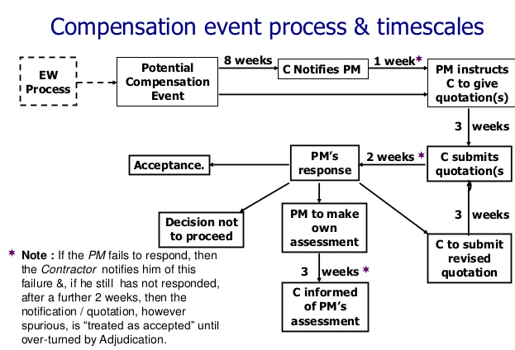
Fig 3 (Slideshare.net, 2015)

If an event does happen that the contractor believes that there is to be a compensation event then they have to notify this to the project manager within eight weeks of the awareness of the event, if not done in this eight weeks then this cannot be considered as a compensation event. When the project manager receives this they have one week to agree whether they will consider it’s a compensation event or not. The contractor then has three weeks to provide quotations and the project manager has another two weeks to respond, when all agreements have been made, the changes to the contract are implemented.

5.0 Conclusion

To conclude, as there has been a significant variation within the contract that has impacted the delivery on the time frame of the project and the costs, a compensation event should be done but only if there wasn’t an early warning notice. as it doesn’t state that if an early warning was given but if this has been handed to the contractor then a compensation event can be debated whether or not it should be used.

6.0 References

Slideshare.net. (2015). M5 - NEC3 Compensation Events:agreeing contractual change promptly, a…. [online] Available at: https://www.slideshare.net/ProjectControlExpo/m5-nec3-compensation-eventsagreeing-contractual-change-promptly-amicable-and-constructively [Accessed 17 Feb. 2019].
Davies, R. (2017). CFW NEC Management of change under the NEC3. [online] Slideshare.net. Available at: https://www.slideshare.net/RaeSDavies/cfw-nec-management-of-change-under-the-nec3 [Accessed 9 Feb. 2019].
Neccontract.com. (2014). About NEC - NEC Contracts. [online] Available at: https://www.neccontract.com/About-NEC [Accessed 17 Feb. 2019].
C Evans, S. (2019). NEC3 Compensation Events – a Practical Guide. [online] Steven C Evans Ltd. Available at: http://www.stevencevans.com/nec3-compensation-events-a-practical-guide/ [Accessed 17 Feb. 2019].

