Strategic Sustainable Growth for
CHILWELL CROFT ACADEMY
(Primary Element of EquitasTrustAcademies)



Rahela Begum (1818336)
Lecturer: Bente Fatema
Strategic Management for SMEs (BMSW6104)
September 2023

Contents Page
Introduction…………………………………………………..…...3
Chilwell Croft overview and strategy……………….…4,5,6,7,8
Pestle Analysis……………………………………………9,10,11
SWOT Analysis ………………………………………....….12,13
Stakeholders in Chilwell………………………………...….….14
Power Interest grid……………...……………………….….15,16
Ansoff Matrix framework………..…………………..…..17,18,19
Recommendations……………..……………………………….20
Conclusion……………………...……………………...…….….21
References…………………..…………...………..………..22,23
Appendix……………………..………...………………………..24
Poster…………………………..……...……………………..….25

Introduction

This report contains the Strategic Management of the education institute Chilwell Croft Academy. Within the context of the report, there will be an analysis of the concept of identification, implementation, monitoring, analysis, and assessment of the strategies that management can carry out to achieve the goals and objectives of the organizations' sustainable development for the future. According to Barney et al, (2018), the strategic management process involves a series of assessments and decisions that might raise the possibility that a corporation will select a good strategy, i.e., a strategy that delivers results.
Using scanning tools PESTLE and SWOT will give a formative insight into the organisation's current external (Makro) and (Micro) internal environment. Used in conjunction with the Ansoff Matrix framework to help determine Chilwell Academy’s growth strategies.
A stakeholder analysis will assess each stakeholder's expectations as well as the relative influence they possess. Investigating a possible new sustainable strategy for the future of Chilwell Croft Academy. The cumulative strength of sustainability influences a firm's potential to save resources and reduce its carbon footprint in an industry (Baxter,2019).
Strategic sustainable Crucial strategic recommendations for Chilwell Croft Academy's future developments and implementations.

Source: Chilwell Croft Academy
Chilwell Croft Academy Overview and Strategy
Chilwell Croft Academy is an inner-city primary school operating as part of Equitas Academies Trust. With 72 employees (Schools financial benchmarking, Gov.com) on the payroll and revenue of £4,821,143 as of 31.08.22 (Companies House, Gov.com). A diverse school representing over 40 nationalities and over 30 different dialects spoken. Chilwell Croft's ethos is all Different, all Equal, all achieving. The vision is to be the best local school not only for education but for the whole multicultural community. Culture of the school pupils learn to behave, have a good attitude to learning and respect. Taking pride in their work and any extracurricular.
The mission of the school is to provide an environment where children can progress academically as well as develop personally, incorporating better future choices. A recent campaign has been helping the ‘Earth Heals’ which focuses on environmental sustainability. On the grounds of the school, a small section has been kept raw for educational purposes known to pupils as a ‘Forest School’ school. Here the children can delve into how the ecosystem works, starting with the basics of creating a sustainable environment through practice and testing. Within the school, a group of children have been elected to the school council which helps the school community come up with strategic ideas for sustainability within the school.
Below are the ideas that have been the focus of the campaign:

Figure 1: Current strategies at Chilwell Croft
Energy:
- Lighting
- Heating and Insulation
Students have been asked to design and stick labels for switches around the school. One label for switches that should be switched off after usage, and another for switches that must be always on. Simple and instant implementation.
LED lightbulbs utilise around 60% less energy than traditional bulbs, saving energy, emissions, and money.
Using as much natural light as feasible in the school facility. The walls and surfaces should be painted white to reflect light around the room.
Installing automatic lighting controls that turn off lights when no one is there is already installed in classrooms.
Using as much natural ventilation as possible to lessen the demand for heating and cooling. Closing blinds on hot days, opening windows in the morning to let in cold air closing them when it gets hot, and closing doors and windows when it becomes cold. Examining the sources of heat loss and repairing holes.
Creating a whole school culture of energy conservation and making the students understand, every unit of energy consumed uses up natural resources on our planet. Energy saved means resources saved.

Waste and Recycling:
- Refuse/Reuse
- Reduce

Primary schools produce an estimated 45kg of waste. Which contributes to more than 250,000 tonnes of waste annually. Students are encouraged to research the most discarded objects. Elected eco-assistants can sort through rubbish including lost property, recording the sorts and quantities of products.
Once the data have been examined, putting them together can help identify the most often thrown items. Then the question becomes, can these be recycled? Are there any items in the school that are no longer required?
After the pupils have prevented and repurposed as much rubbish as possible, recycle as much as possible and reuse.
Many products at Chilwell Croft Academy, particularly natural materials including paper and cards, can be recycled.
Getting inventive and collecting boxes and recyclable plastics to raise recycling awareness.
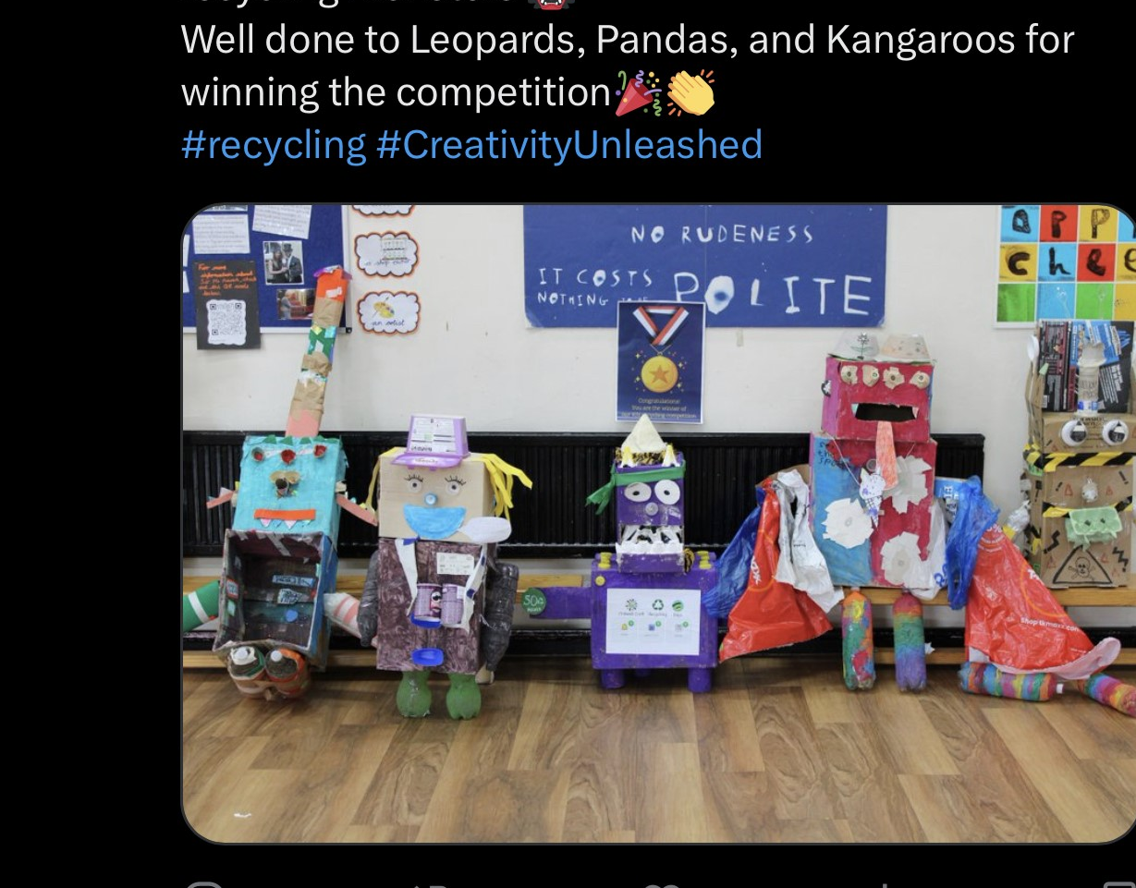
Source: Chilwell Croft Academy, Twitter, (2023)

Food and Farming:
- Food
- School Garden Projects

Food waste is the most common waste in landfills. When food decays, methane and greenhouse gases are released. More potent than carbon dioxide. Food waste must be prioritised in the fight against climate change in all education institutes.
While the school is unable to handle all the cafeteria waste. Students have come up with a strategic plan for waste reduction in the classrooms. Small containers are made available for collecting any scraps from classroom snacks and teachers' lunches, which are then disposed of in the schools' garden area and composting bins daily.
As mentioned, the school has a wooded garden area which is known to students as the ‘Forest School’. The children can gain a better understanding of their surroundings here. Improving student health and well-being benefits the entire institution. Naidu et al., (2021) speak of ‘chemical pollution’ and its potential implications on the environment and human health. In addition to teaching, the students learn about the environment. Children are more inclined to try new foods if they are involved in planting and harvesting their own produce, educating them about nutritional benefits.

Figure 3: Upside down Hierarchy of Sustainable Plans

- Reducing waste saves precious resources and raw materials.
- Reuse/Recycling Plastics, paper, glass, and clothing.
- Disposal Less precious resources end up in landfills.
The word sustainability is defined as providing current demands without jeopardising future generations' Kumar (2022) ability to meet their own needs. It is possible to educate the next generation about the significance of replenishing a variety of resources, from food to water, and of being self-sufficient.

Pestle Analysis (Makro environment)
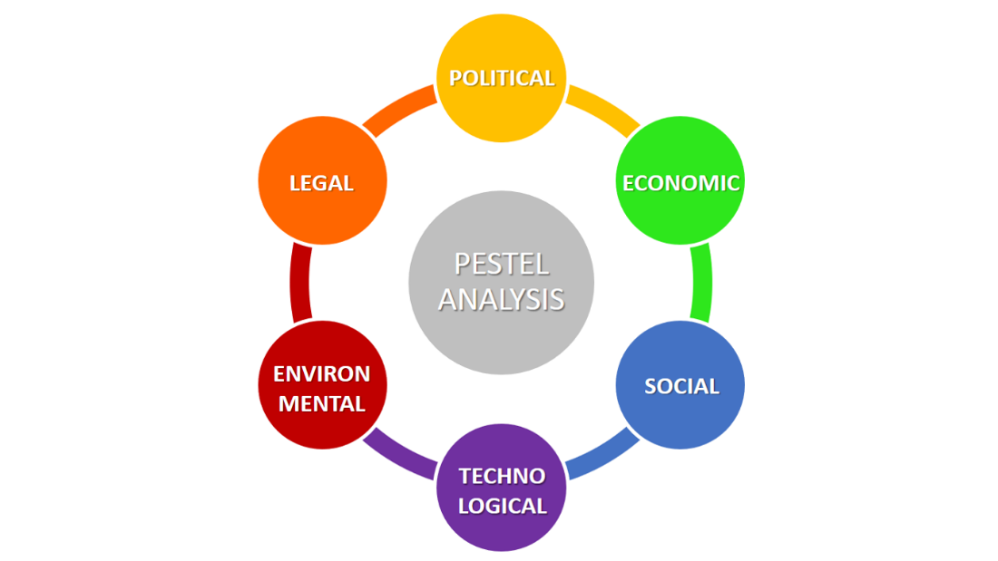
Figure 1. Pestle Model (Bruin,2016)

Political Factors
Political Factor is the most significant challenge for organisations because each country has different government bodies, and organisations that operate in more than one country will have to follow several and sometimes conflicting regulations, which may impede efficiency. According to Ozilil, (2021) a country's strategy, policies, aims, and results may be affected by national political factors that may influence the success or failure of a business venture.
Factors related to government policies and regulations. Governments have a large influence on the education industry.
Public education institutions owned by the government. The government provides funding to these public organisations. A specific amount of the budget must be set aside by governments for public education facilities.
Assume that any government allocates a larger portion of its entire budget to education. Then, new schools will be built, the education sector will prosper.
Less funding allocated to the education sector, on the other hand, would impede the industry's expansion. Aside from that, the education sector is greatly impacted by government tax policy.
High taxes could force many educational institutions to close, which would be a significant loss for the education sector.
Furthermore, political stability is critical to the expansion of the education sector. The pursuit of education is encouraged in a politically stable atmosphere.
Other factors:
- Changes to curriculum
- Government change
Economic Factor
Different industries are affected severely. Similarly, economic factors influence the education industry. Taking into consideration that inner city primary schools have a high Pupil Premium intake. Schools receive extra funding for children who are on welfare benefits e.g., Universal Credit. These students are entitled to subsided school excursions as well as free school meals.
Other economic factors are:
- Cost of providing resources: Staff, Basic resources, and technological solutions such as laptops.
- General Taxes
- Local government funding decisions that may affect the early years provision.
- Parents not paying dinner monies/trips can lead to bad debts.

Social Factor
Social considerations include a year's birth rate decline or increase. Parental preference-parents have control over their children's education. The local population is changing. Demographic changes, for example, students learning English as a second language, may have an impact on the nature of their demands. Integration into the local community is critical.
Other factors:
- Lifestyle trends
- Cultural/faiths
- Inability to attract staff
- Highly valued staff moving on.

Technological Factor
Technological factors affecting the school has been having a good broadband provider with access across the whole school. Providing online training packages Online learning journals, staff training packages, and student home learning opportunities.
Notifications and firewall activation if a child visits any inappropriate website.
Other factors:
- Social networking e.g., Twitter, School website updated.
- Competency of ICT resources
- Affordability of laptops/iPads/Printers

Legal Factors
Legal factors all schools/ childcare providers are inspected every 4/5 years by the governing body Ofsted to inspect the internal affairs of the school. Ofsted also sets the regulations as to how a school should provide teaching and the management of Senior Leads. They check all safeguarding legislation and child protection procedures are known to all staff members.
Other factors:
- SEN funding
- Employment Laws
- Minimum wage/Living wage
- Health and Safety law and guidance
- Change to school hours. Recently changed from 3 pm finish and extended to 3.30 for Chilwell.
- Early years funding entitlement (Free school meals up to Year 2 pupils)

Environmental Factors
Environmental factors can affect different aspects of the business. These include climate change, weather, pollution, and employee efficiency. British weather is temperamental, during winter months the productivity of staff and pupils might not be as high. A season that sees many absences from staff and pupils due to viruses being passed on through interaction.
Other factors:
- Reducing carbon footprint
- Waste disposal
- Planning laws (Build a separate SEN unit)
- Recycling
- Transport to school by child. Reducing pollution to encourage walking.

Swot Analysis

Figure 3: SWOT Analysis of Chilwell Croft

Chilwell Croft has strength through the diversity and culture of the staff and pupils who are in the school community. Learning about the significance of waste, including energy waste Recycled paper and plastics are encouraged in the bins positioned throughout the school playground. Teaching students starting in reception has a significant influence on subsequent year groups. The youngsters have learned about the importance of plantations and the insect ecosystem to the health of the planet and future generations thanks to the forest school. They have also been able to cultivate fruits and vegetables like strawberries thanks to it. The area is limited and only a few people can enter at a time, which is a weakness.
Installing solar panels to create their own electricity is a significant possibility and an opportunity to save money and sell unused power back to the grid. The current threat is the heavy tax on energy consumption. Mariano-Hernandez, (2021) states residential, educational, office, hospital, and industrial buildings are becoming significant energy consumers when it comes to electricity consumption.
Building energy usage accounts for 30-45% of total global energy consumption and having no energy plans to save on efficiency.
According to (Eyinade et al,2020) One of the sustainable farming practices is organic farming, which provides insight into the fundamental shift from industrial agriculture to diverse agroecological systems in relation to people's access to food and nutritional well-being. Building a small allotment area to sow seeds for homegrown organic produce to sell to the community will be a fantastic self-sufficient sustainable project, that can be continued at home for pupils.

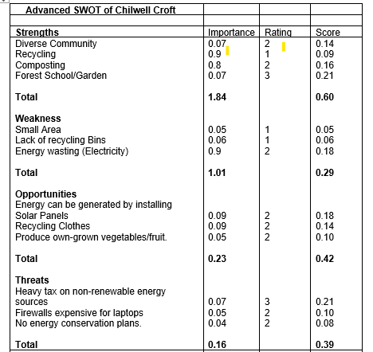
Table: Column rated 0.01 being the least 1 the most. Rating 1(least) to 3 (most). Then multiplied.
This demonstrates that Chilwell Croft is already laying the groundwork for long-term success. The weakness (0.29) The lack of square footage for expansion is a downside.

Stakeholders Analysis
List of Chilwell Crofts Stakeholders Analysis, Internal and External:

Figure 4: Stakeholders Analysis of Chilwell Croft

Each stakeholder holds a purpose in the school. Working with key stakeholders and sharing ideas they can often achieve common goals. Working together increases the likelihood of achieving these objectives and producing favourable student results.
The interest of all stakeholders who may affect the school achieving its sustainable objectives. Potential conflicts or risks that could jeopardise the initiative.

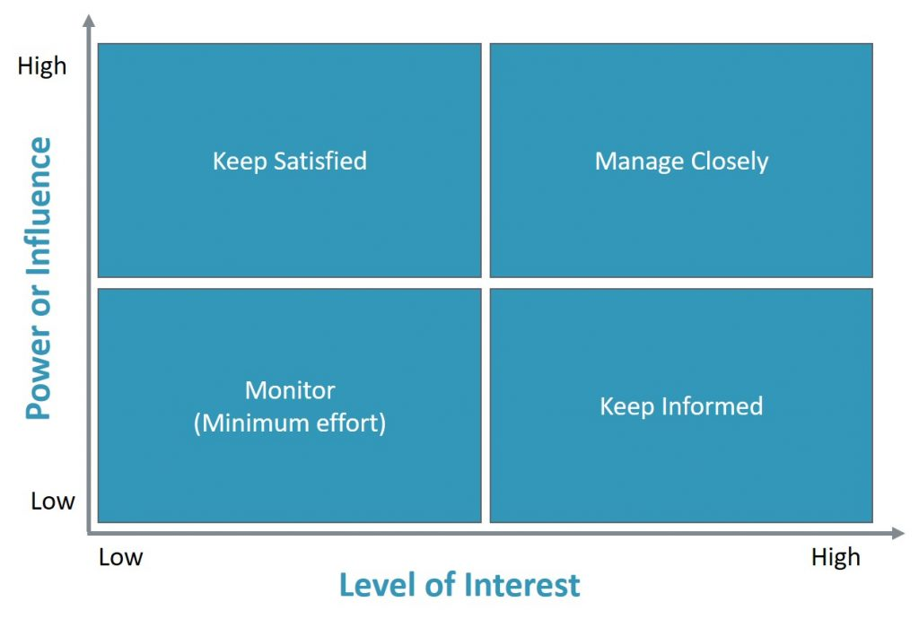
The power and influence that stakeholders have within the school are mapped by the power interest matrix tool. It assists in identifying the stakeholders to pay attention to and the steps that should be taken to ensure the school's long-term viability.

Source: Mindtools (2023)

Figure 5: Power/Interest Matrix of Chilwell Croft

The matrix power of interest shows the stakeholders who hold the most power and the decision-making. Without the agreement of the trust directors, nothing can be achieved, Schermerhorn et al, (2020) stated they need to have an interest in sustainability, social values demand that we pay greater attention to protecting the environment for coming generations and comprehending the impact of employment on human welfare. Without the agreement of the trust directors, nothing can be achieved, Schermerhorn et al, (2020) state powerful stakeholders need to have an interest in sustainability, social values demand that we pay greater attention to protecting the environment for coming generations and comprehending the impact of employment on human welfare. The headteacher can put forward her future objectives/ plans to the directors and ultimately, they hold the final say for any future sustainable plans at Chilwell Croft. The government has a high interest, as the Trust will seek funding from them. Communities and local authorities have high power as to what happens in the community, local authority planners will hold Area Forum drop-in sessions for community feedback. Community feedback is critical to the success of generator and solar panel installation, it offers constructive criticism. According to Mina et al., (2020) bringing people together and fostering a healthy flow of communication. and will listen to objections before approving and giving the go-ahead. and the impact it may have on their environment but if everything is satisfactory, they hold low power. The bottom half of the matrix grid employees are interested in what is happening but have the least power. Chilwell Croft works with local universities in the final year of their teaching degree education offering three months of work experience. They hold very little interest and power in what happens within the school as do trade unions.

Strategic Growth for Long-term Sustainability
In this section, we will look at how Chilwell Croft can propose a new sustainable strategy for the future. Using the Ansoff Matrix model framework the management can use an intuitive way to visualize for considering growth opportunities. It can be characterised as a set of four quadrants for development intended to advance the company while safeguarding it against various kinds of risks (Clarissia,2020).

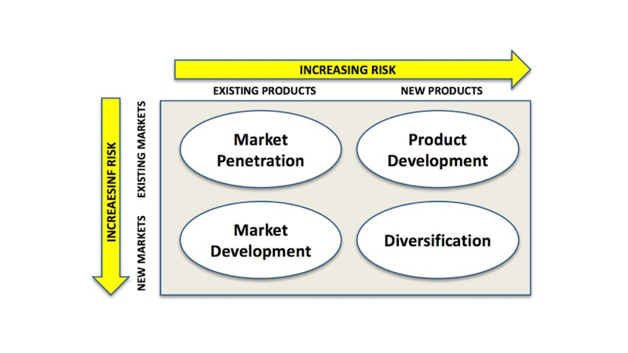
Source: Ansoff Matrix, Tutor 2U (2021)

Market Penetration
Companies like Olleco, which transform wasted cooking oils into pure biodiesel—a clean-burning fuel used to power cars and heat homes—can collect food waste and liquid waste separated by schools. A study by Han et al., (2019) argues finding a viable outlet for the commercial application of bio-oil remains a difficulty. Given that the school has access to an outdoor facility and a minibus, this is a fantastic proposal with potential benefits.
Plastics can be gathered and recycled to make fleece garments.
The school has four separate buildings with 100% flat roofs, which are excellent for solar panels to create renewable energy for the classrooms, offset gas carbon emissions, earn additional cash, and be utilised as an educational tool. Solar panel grants from the government are available for schools, and they are critical for the future. The challenges that may come with this could be a long application process for the grant to be approved. Also, the British summer does not last long. While solar panels perform best in the summer due to increased sunlight hours, they can be used all year.

Product Development
Using creativity to help youngsters comprehend the concept of sustainability through activities is both enjoyable and effective. Students can create their own papers by working together. This teaches kids the value and benefits of recycling, as well as how it affects their lives.
All school communications are now sent to parents on paper. One approach for the school to move away from paper documents would be to communicate with parents via email or SMS.
Changing suppliers to one that uses sustainable materials and prioritises quality. Although it may be more expensive, quality over quantity is preferred because the materials are more resilient and last longer.

Market Development
Chilwell Croft should consider upgrading the existing heating system by purchasing a commercial HVAC system. This allows for three separate operations: air conditioning, heating, and ventilation. This system also includes heat pumps, which will aid with energy efficiency in the school building and have the added benefit of being directly connected to the solar panel power inverter.

Diversification
The school currently runs a waste recycling operation. They could even broaden this initiative to include apparel. Throughout the year, there is an accumulation of unclaimed lost property left by children. These items can be donated to a local charity or organised with the local government, which collects and recycles unwanted clothing and turns it into padding for chairs and seats.
Hot beverages are popular among parents and teachers. When parents are dropping off or collecting their children, a mobile coffee shop providing reasonably priced drinks and snacks in the playground can be a terrific idea. Drinks made from sustainable organic coffee beans and loose tea leaves which can be composted. All drinks are served in paper cups.
Encouraging parents to walk their children to school. This will minimise traffic congestion and air pollution over time. Employees are encouraged to car share, take public transport, or cycle to work. Chilwell can opt into the Electric vehicle salary sacrifice scheme.

Recommendations
Based on the above report analysis I recommend the following strategic recommendations for Chilwell Croft to be sustainable for the future and the generation of children to come.
One recommendation is to use sustainable IT. New IT is expensive. Purchasing remanufactured laptops is one approach to avoid adding physical expenditures to an already constrained educational budget. High-quality, high-spec, and dependable devices that seem brand new.

The consumption of paper can be reduced thanks to technological advancements such as smartphones, tablets, and laptops. Soft copies and the internet are becoming increasingly important in today's world. Chilwell Croft could start encouraging students to make use of computers and iPads for schoolwork instead of books.
Make certain that classrooms are insulated with sustainable materials for repairs and reconstruction, such as reused wood/bricks. These are all progressive actions that assure the school's overall viability.
A zero-waste event is being promoted. Children should learn about zero-waste and recycling tactics from their preschool years since it will stick with them and will be one of the most crucial reasons for raising social awareness about how to create a more sustainable planet. Bulut, (2020) argues children have little knowledge of zero-waste and recycling more research should be undertaken on how such awareness will contribute to children's social and emotional development, as well as research on how children can learn by doing.
Wrappers that are compostable or easily recyclable can also be used in arts and crafts lessons.
Every student has access to a refillable water bottle.
There are alternatives for youngsters who do not want to or are unable to walk to school unaccompanied. The walking bus service, for example, allows children to walk safely to and from school in supervised groups. An adult is stationed at the front and back of the walking bus that follows a set path.

Conclusion
When it comes to sustainability at Chilwell Croft, the phrase "Rome wasn't built in a day" comes in handy. Hopefully, the ideas made above are attainable as part of a practical and progressive strategy. Even the tiniest actions can be extremely beneficial, not just for the schools' environmental credentials but also for the financial stability. Solar energy is environmentally friendly because it is a renewable, clean energy source a long-term solution for
Children are the future and can be powerful change agents. Encouraging kids to be a part of a sustainability framework, according to Ansoff, (2007) helps bridge the theoretical-practical divide by providing an explanatory theory that can be used for both evaluation and the development of practical technology. Both educationally and socially, can offer them a sense of shared responsibility. Chilwell's sustainability journey is anchored by the school's present recycling programme and gardening.
The United Nations (UN) defines sustainable development as simply meeting current demands without compromising future generations' ability to meet their own expectations (Tsalis et al.,2020)
Finally, by implementing sustainability initiatives, the school can lead the way for other educational institutions to follow suit.

References
Ansoff, H., (2007). Strategic Management, Palgrave Macmillan UK, London. Available from: ProQuest E-book Central.
Barney, J.B. and Hesterly, W.S., (2019). Strategic management and competitive advantage: Concepts and cases. Pearson.
Baxter, G., (2019). A strategic analysis of Cargolux Airlines International position in the global air cargo supply chain using Porter’s Five Forces Model. Infrastructures, 4(1), p.6.
Bruin, L., (2016) Pestle Model. Scanning the Environment: Pestle Analysis. Business to you.
Bulut, A., (2020). Teacher Opinions about Children’s Awareness of Zero-Waste and Recycling in the Pre-School Education Years. Review of International Geographical Education Online, 10(3), pp.351-372.
Clarissia, S.M.S., (2020). A study on Ansoff Matrix Technique: As a growth strategy and an adaptive learning technique adopted in the leading brand of products. BIMS Journal of Management, 18.
Eyinade, G.A., Mushunje, A. and Yusuf, S.F.G., (2021). The willingness to consume organic food: A review. Food and Agricultural Immunology, 32(1), pp.78-104.
Han, Y., Gholizadeh, M., Tran, C.C., Kaliaguine, S., Li, C.Z., Olarte, M. and Garcia-Perez, M., 2019. Hydrotreatment of pyrolysis bio-oil: A review. Fuel processing technology, 195, p.106140.
Kumar, S., (2022). A quest for sustainium (sustainability Premium): review of sustainable bonds. Academy of Accounting and Financial Studies Journal, 26(2), pp.1-18.
Mariano-Hernández, D., Hernández-Callejo, L., Zorita-Lamadrid, A., Duque-Pérez, O. and García, F.S., (2021). A review of strategies for building energy management system: Model predictive control, demand side management, optimization, and fault detect & diagnosis. Journal of Building Engineering, 33, p.101692.
Mina, J.C., Garcia, M.D. and Reyes, E.J.G., (2020). Industry Partners’ feedback on the OJT performance of Bachelor of Science in Information Technology (BSIT) Students. International Journal of Advanced Engineering, Management and Science, 6(4).
Mindtools, (2023). Power of Interest Matrix.
Naidu, R., Biswas, B., Willett, I.R., Cribb, J., Singh, B.K., Nathanail, C.P., Coulon, F., Semple, K.T., Jones, K.C., Barclay, A. and Aitken, R.J.,( 2021). Chemical pollution: A growing peril and potential catastrophic risk to humanity. Environment International, 156, p.106616.
Ozili, P.K., (2021), October. Financial inclusion research around the world: A review. In Forum for social economics (Vol. 50, No. 4, pp. 457-479). Routledge.
Schermerhorn Jr, J.R., Bachrach, D.G. and Wright, B.,( 2020). Management. John Wiley & Sons.
Tsalis, T.A., Malamateniou, K.E., Koulouriotis, D. and Nikolaou, I.E., (2020). New challenges for corporate sustainability reporting: United Nations' 2030 Agenda for sustainable development and the sustainable development goals. Corporate Social Responsibility and Environmental Management, 27(4), pp.1617-1629.
Tutor 2U, (2021). Ansoff Matrix Model.
Twitter, (2023), Chilwell Croft Academy.

Appendix

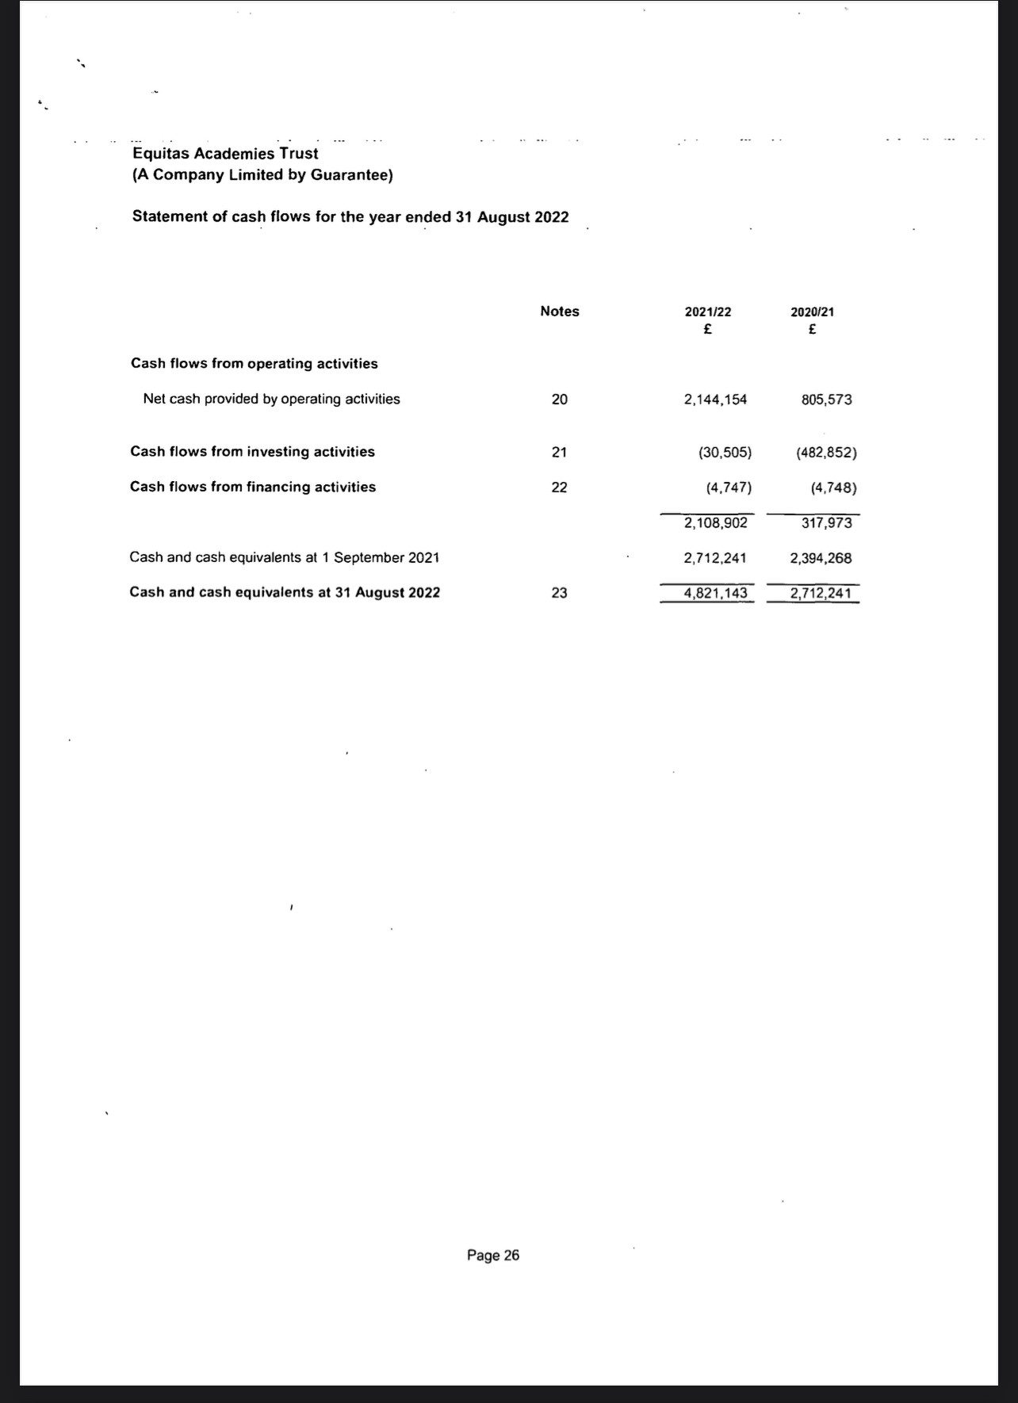

Poster



