MODULE CODE: LCBB4002
COMMUNITY ENGAGEMENT
Student’s Name: Radu Neata
Teacher Name: Tanja Nathan

Contents
Introduction: 3
Discussion: 3
Analysis 6
Recommendation 8
Conclusion 9
Reference List 10

Introduction:
The NHS is an acronym representing the National Health Service. The National Health Service is considered a system of public healthcare providers located in the United Kingdom. The NHS is inclusive of NHS England, wales, and Scotland and affiliate health and social care in Ireland. The NHS was established following the major social reforms in 1948 following the Second World War. The NHS was founded based on the principle of services should be comprehensive, free, and universal at the point of delivery. According to Anderson and Gillam (2014) the services at the NHS are comprehensive in range and free at the point of need for people the ordinary residents in the United Kingdom. The National Health Service is, therefore, a government-funded health and medical care services for everyone in the United Kingdom without paying for the entire cost of the services. Some of the services include; visiting a nurse or doctor at a doctors surgery, gaining treatment and help at a hospital if one is unwell, access to a midwife for the pregnant mothers, receiving emergency health from care professionals working in the ambulance if one has severe life-threatening injuries and health problems. Individuals refer to these services as free at the point of use, which means that any United Kingdom resident is able to go and see a doctor who can diagnose and treat for an illness without requesting for pay from then for the services offered during and after the doctor's visit (Bain, 2016). This is so as most health care services are funded publicly, which refers to that money has been set aside by the national government to pay for this treatment, and the funding is primarily gathered from the United Kingdom resident’s tax.

Discussion:
The national health service is one of the largest organizations in the United Kingdom Statistics show that the national health service net expenditure which is resource plus capital bt excluding the depreciation to increase from about seventy-eight billion in the year 2007 to about one hundred and twenty in the year 2017. The planned expenditure for the year 2018 is one hundred and twenty-three and one hundred and twenty-six for the year 2019 (Claxton and Carroll, 2011). In reality, the budget is expected to hike by the year 2020, and this is inclusive of the health expenditure, which includes health research, medical, and other health services per capita in England. There are various providers and commissioners of the National health services in England they include; two hundred and seven clinical commissioning groups, one hundred and thirty-five acute non-specialist trusts which includes eighty-four foundational trust, seventeen acute specialist trust inclusive of sixteen foundational trust (Department of Health, 2010). Fifty four mental health trust inclusive of about forty two foundational trust, thirty five community providers inclusive of eleven national health service trust, six foundations, seventeen social enterprises and a limited company, ten ambulance trust, seven thousand GP practices and about eight hundred not for and for-profit independent sector organizations offering care to the National health service patients from various locations (Webster, 2012). The National Health Service staff as of March 2017 according to the NHS confederating across community and hospital health services the NHS on a full time equivalent employed about a hundred thousand doctors, two hundred thousand nurses, twenty thousand midwives and a hundred thousand technical and therapeutics staff with nineteen thousand ambulance staff, twenty thousand managers and nine thousand senior managers.
Initially the national health service in the first few decades had a tripartite system structure that was made up of the following services; Hospital services which were organized into regional hospital boards which have the mandate of administration, primary care which is inclusive of GPs, dentists and opticians who worked as independent contractors instead of government employees with a salary and community services which include child welfare, ambulance services and vaccination and maternity (Desombre and Eccles, 2018). But this system was later called for unification, and it was met with a ten-year plan of building a new district general hospital to care for each population area. In the year 1980, the black report concluded which was despite the National Health Service Foundation, the vulnerable people still have a significant rate of mortality and low life expectancies, and the advancements in medicine meant a rise in cost which meant that the National Health Service almost always had financial issues. This was, however, resolved through the introduction of the internal market concept, which till now, guides the National Health Service (Pfeffer and Pollock, 2013). Additionally following the NHS and community care act 1990, it offered regional health mandate budget to buy health provisions from hospital putting the hospitals to compete to sell their services and in the year 2003 the government introduced the payment by result where the bodies in the NHS were allocated money based on how many patients they have checked. But all this has been followed with continuous reforms and the next overhaul with the Health and Care Act (2012), which brought about some structural shift to the National Health Service. It was now categorized into a series of organizations which work at a local and national level. The structure includes:
The Department for Health – This refers to the department in the government which is responsible for funding and developing policies that pertain to healthcare in the United Kingdom.
The NHS England – This refers to the umbrella organizations which oversee healthcare. It refers to an independent body, which means that the department for health has no mandate to get involved directly with its decisions.
Clinical Commissioning Group – The CCGs are mandated to the commissioning of healthcare for their local area. They are administrated over by the GPs, nurses, and consultants who assess local health needs and commission the services to match them. They have a mandate over about sixty percent of the National Health Service budget.
NHS Foundation Trust – It offers care which the Clinical Commissioning group requires, like the hospital, mental health, ambulance, primary and social care services.

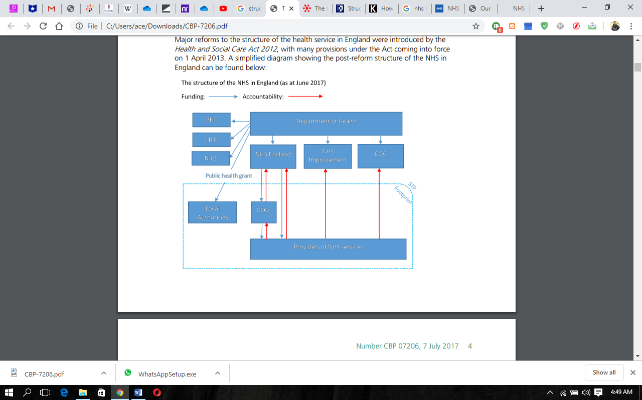
The four countries in the United Kingdom, through the structure, have their own NHS services. This highlights that the mandate for running the National Health Service in these places has been delegated from the central government to the powers in England, Ireland, Wales, and Scotland (Robinson and Le Grand, 2014). The national government, through the United Kingdom parliament, allocates block funds to each of the national governments, but it's their responsibility to ensure how it is best spent.
The National Health Service mission is to offer care and services that families would want to use their vision is to enable people to live a healthy and more independent life through quality seamless care. The core values include; Respect and dignity, where they value everyone's as an individual and respect their commitments and aspirations and seek to understand their priorities, needs, abilities, and limits (Sambrook, 2017). Commitment to quality of care were they strive to get the fundamental rights every time through safety, professional and managerial integrity and accountability and compassion where they choose to always respond with humanity and kindness to every person's pain and need

Analysis
According to Proctor (2009), SWOT analysis refers to a tool used to analyses the strength, weaknesses, opportunities, and Threats to gather and provide information for making an informed decision. The Strengths and opportunity will refer to the factors which are likely to have a potentially positive effect towards achieving the NHS objectives, Weakness, and Threats are the elements with detrimental impacts on the objectives.
The SWOT analysis of the National Health service Include
Strength  The NHS have a highly professional and skilled staff  NHS has a strong Ethos of universal free and quality care for all  Services are readily and cheaply available to residents | Weakness  Nurses are not able to meet all patients often enough due to the number of cases.
Opportunity  Patients contribute to practice delivery for more patient-focused care | Threats  Limited funding for care delivery offered due to economic trends and legislation.

According to Belton and Stewart (2001), the PESTEL analysis, unlike SWOT, looks into the Political, Economic, Sociocultural, and Technological, Legal, and Environmental Factors which affect NHS. The PESTEL analysis is as follows;
Political Factors
This refers to the political aspect which have a potential impact on the HNS like the Brexit Uncertainties. The United Kingdoms' decision to leave the European Union is set to have some inherent limitations on the society, and this is inclusive of the public institutions like the NHS (NHS, 2019). The more severe issue affected would be staffing as a significant number of the medical professionals originally from other countries, which raises concerns that the workforce in NHS would have an impact with stricter living public conditions for the foreigners.
Economic Factors
Refers to the economic factors like the Austerity measures; in response to the recent economic downtime, the United Kingdom national government is looking to introduce some austerity measures which is aimed towards cutting down on public spending, and it is believed it will have an indirect impact on the NHS finances.
Sociocultural Factors
Such factors include the aging population. Across the world experience the phenomenon of the aging population, which though a good thing, the elderly population tends to have more health conditions, which causes additional strain to the NHS (NHS, 2019).

Technological Factors
It includes improved health care were new technologies coming up the health care quality is continuously enhanced through the integration of sophisticated technologies into care provision, which make the care standards more reliable and of quality.
Legal Factors
They include such as Litigations, which is a developing trend where if a patient who is not satisfied with the care quality is able to take to court and seek retribution, which means that the NHS is prone to receive some lawsuits which impact the reputation and service of the NHS.
Environmental Factors
They include natural disasters that often impact the NHS through strained service delivery to people who need the care.

Recommendation
The National Health Service as an organization is dependent on its staff for service delivery from the doctors to the technical staff to make service delivery and objectives of the organization are met. The employees in the NHS have various roles from the provision of primary care by the doctors and nurses to emergency response by ambulance staff. The entire staff is made up of professional and experienced personnel who are able to handle their respective roles. The staff have undergone some training and development to be able to gain competency to handle their role in excellence (Wall and Appleby, 2015). Training and development are considered a pillar to the improvement of the performance measure of any organization. The experience and knowledge that come with training and development is the base which experience builds upon to create quality. The more trained staff is in the provision of care, the less the errors, and the better the performance measure. For example, the ambulance staff. This is a critical role in the NHS as they are considered the first responders to emergencies and the effectiveness of this staff in completing their role the more lives are saved and cared for. The ambulance staff is always required to be alert in case of an emergency as they are called upon at any time to provide their services.
The ambulance staff role requires a set of skills set and knowledge in carrying out the role. Initially, they need to be able to provide quality first response first aid and basic medical operations that would play a significant role in responding to an emergency. Additionally, it is considered a requirement to be sober and mentally stable, given the speed of response, it is required that the staff is on high alert to not make any errors that would compromise care delivery. Such staff requires a series of training and development like basic first aid and medical operations like resuscitations and evasive driving training.

Conclusion
In conclusion, the National Health Service has been said to be a system of public healthcare providers offering health care services to residents with no pay as it is fully funded by the national government. The organization, however, has some strengths, weaknesses, opportunity, and threats which best inform how to manage the organization in and around the available factors facing the NHS. The NHS structure allows for easy provision of the services which complement the training and development the staff has in the provision of care.

Reference List
Anderson, W. and Gillam, S., 2014. The elusive NHS consumer: 1948 to the NHS Plan. Economic Affairs, 21(4), pp.14-18.
Bain, J., 2016. The new NHS. Budget holding: a step into the unknown. BMJ: British Medical Journal, 302(6779), p.771.
Belton, V. and Stewart, T.J., 2001. Multiple criteria decision analysis: An integrated approach. 2nd edn. Boston, MA: Kluwer Academic Publishers
Claxton, K. and Carroll, S., 2011. Value-based pricing for pharmaceuticals: Its role, specification and prospects in a newly devolved NHS.
Department of Health, 2010. Equity and excellence:: liberating the NHS (Vol. 7881). The Stationery Office.
Desombre, T. and Eccles, G., 2018. Improving service quality in NHS Trust hospitals: lessons from the hotel sector. International Journal of Health Care Quality Assurance, 11(1), pp.21-26.
Proctor, T., 2009. Creative problem solving for managers: Developing skills for decision making and innovation. 3rd edn. New York: Routledge.
Pfeffer, N. and Pollock, A.M., 2013. Public opinion and the NHS. BMJ: British Medical Journal, 307(6907), p.750.
Robinson, R. and Le Grand, J., 2014. Evaluating the National Health Service reforms (Vol. 8). Transaction Publishers.
Sambrook, S., 2017. HRD as an emergent and negotiated evolution: An ethnographic case study in the British National Health Service. Human Resource Development Quarterly, 12(2), pp.169-193.
Wall, A. and Appleby, J., 2015. The reorganized National Health Service. Chapman & Hall.
Webster, C., 2012. The National Health Service: A political history. Oxford University Press, USA.

