

NAME: HARSHA VARDHAN MACHERLA
STUDENT NUMBER: 2215773

MODULE CODE: LCMB 7020

TITLE: DISSERTATION

SUPERVISOR: HUSAM HELMI

RESEARCH QUESTION:
EXPLORING THE IMPACT OF CUSTOMER SATISFACTION AND BRAND IMAGE ON THE BRAND LOYALTY OF APPLE

DECLERATION FORM


Master’s Degrees by Examination and Dissertation
Declaration Form.
1. This work has not previously been accepted in substance for any degree and is not being concurrently submitted in candidature for any degree.
Signed……………..…Harsha Vardhan Macherla…………………………………
Date ………………………..18/10/2023…………………………………………

2. This dissertation is being submitted in partial fulfilment of the requirements for the degree of Master in Business Administration.
Signed …………………… Harsha Vardhan Macherla………………………
Date …………………………18/10/2023……………………………………
3. This dissertation is the result of my own independent work/investigation, except where otherwise stated.
Other sources are acknowledged by footnotes giving explicit references.
A bibliography is appended.
Signed candidate: ………… Harsha Vardhan Macherla….……………….
Date: …………………………18/10/2023………………………….………

4. I hereby give consent for my dissertation, if accepted, to be available for photocopying, inter- library loan, and for deposit in the University’s digital repository
Signed (candidate)………………… Harsha Vardhan Macherla…….…………
Date……………………………18/10/2023…………………….…………….…
Supervisor’s Declaration.
I am satisfied that this work is the result of the student’s own efforts.
Signed: …………………Sent to Husam Helmi for signature……………
Date: …………………………19/10/2023…………………………………..



EXPLORING THE IMPACT OF CUSTOMER SATISFACTION AND BRAND IMAGE ON THE BRAND LOYALTY OF APPLE

ABSTRACT
This research delves into the critical connection between customer satisfaction, brand image, and brand loyalty in the context of Apple. Apple has been recognized as an iconic tech giant and the brands global success hinges on its ability to cultivate a loyal customer base. This study employs a comprehensive framework to scrutinize the intricate relationship between customer satisfaction, brand image and brand loyalty among Apple users.
The research methodology involves a survey and data analysis, collecting responses from a diverse range of apple customers using a set of structured questionnaire, with a sample size of 100 respondents. Findings underscore that customer satisfaction and brand image are pivotal determinants of brand loyalty. As Apple consistently delivers innovative products, customers who are satisfied with their purchases exhibit a stronger commitment to the brand. Furthermore, Apple’s impeccable brand image, characterized by its premium quality, design, and user experience, reinforces brand loyalty.
This study offers profound insight into the strategic importance of customer satisfaction and brand image management for Apple’s long-term success. It not only underscores the need for continual product innovation but also the imperative of nurturing a positive brand image to foster unwavering customer loyalty. These insights have significant implications for businesses aiming to replicate Apple’s remarkable brand success.

ACKNOWLEDGEMENT
I would like to express my heartfelt gratitude to all those who have supported and guided me throughout the journey of completing this dissertation. First and foremost, I am deeply thankful to my supervisor Husam Helmi for his unwavering guidance, patience, and expertise. His Invaluable insights and constructive feedback have been instrumental in shaping this research. I would like to extend my appreciation to my family and friends for their constant encouragement and understanding during this demanding period. Furthermore, I want to acknowledge the participants of my study for their cooperation and contribution to this research. This dissertation is a culmination of collective efforts, and I am profoundly grateful to all who have played a part in its realization.

TABLE OF CONTENT
Chapter 1:
  - Introduction……………………………………………………………………….10
  - Research Background.…………………………………………………………….11
  - Rationale of the Study.……………………………………………………………11
  - Literature Gap.……………………………………………………………………12
  - Research Aims.………………………………………………………………...…12
  - Research Objectives.……………………………………………………………...12
  - Research Questions.………………………………………………………………13
  - Hypothesis.………………………………………………………………………..13
  - Dissertation Outline.………………………………………………………………14
Chapter 2:
  - Literature Review…………………………………………………………...…….15
  - Brand Image…………………………………………………………………....…15
  - Customer Satisfaction…………………………………………………………….17
  - Brand Loyalty…………………………………………………………………….18
  - Brand Equity…………………………………………………………………...…19
  - Aaker’s Brand Equity Model……………………………………………………..20
  - Purchase Intention……………………………………………………………......23
  - Brand Preference…………………………………………………………………24
  - Brand Trust………………………………………………………………….……25
  - Maslow Hierarchy of Needs Theory……………………………………………..26
    - Physiological Needs………………………………………………………….27
    - Safety Needs……………………………………………………………..…...27
    - Social Needs…………………………………………………………..……...28
    - Esteem Needs…………………………………………………………….…..28
    - Self-Actualization Needs…………………………………………...………..28
    - Limitations of Maslow Hierarchy of Needs Theory………………..………..28

Chapter 3:
  - Methodology………………………………………………………………..……29
  - Definition of Research…………………………………………………………...29
  - Research Onion Model…………………………………………………………….29
    - Research Philosophy………………………………………………….………..30
    - Research Approach…………………………………………………………….31
    - Research Strategy………………………………………………………….…...31
  - Types of research……………………………………………………………….….32
    - Primary Research………………………………………………………...…….32
    - Secondary Research………………………………………………………...….32
    - Advantages and Disadvantages of Primary and Secondary Research…………33
  - Methodological Choice……………………………………………………………34
    - Advantages and Disadvantages of Qualitative Data Analysis…………………35
    - Advantages and Disadvantages of Quantitative Data Analysis………………..35
  - Time Horizon………………………………………………………………………36
  - Data Collection and Analysis………………………………………………………36
    - Sampling…………………………………………………………………….…36
    - Sampling and Sampling type………………………………………..…………37
    - Advantages and Disadvantages of Cluster Sampling Method…………………37
  - Data Collection………………………………………………………………….…38
    - Survey Questionnaire………………………………………………………..…38
  - Analysis of Data……………………………………………………………………38
  - Ethical Considerations…………………………………………………………...…39

Chapter 4:
  - Findings and Discussions………………………………………………………..…40
  - General Information………………………………………………………….…….40
  - Response Rate…………………………………………………………………...…40
  - Presentation and Interpretation of Data………………………………………….…41
    - Questionnaire Design………………………………………………………..…41
    - Demographic Analysis…………………………………………………………41
      - Gender of Respondents…………………………………………………….......41
      - Age of Respondents………………………………………………………........42
    - Association with Apple Products………………………………………………44
      - Time Spent with Apple Products………………………………………………44
      - Experience with Apple’s Customer Service………………………………….45
      - Customer Satisfaction and Trust……………………………………….……..45
      - Impact of Brand Image on Purchase Decision……………………………….47
      - Customer Brand Loyalty………………………………………………….….48
      - The likelihood of recommending Apple products……………………………49
  - Discussion…………………………………………………………………….…..50

Chapter 5:
  - Conclusion and Recommendations…………………………………………...…..52

Chapter 6:
  - Limitations…………………………………………………………………….….54
  - Future Research…………………………………………………………………..54

Chapter 7:
  - Reflection…………………………………………………………………...……55

Chapter 8:
  - References…………………………………………………………………..……56

Chapter 9:
  - Appendix………………………………………………………………………...59
  - Research Questionnaire………………………………………………….………59

TABLES AND FIGURES CONTENT
- Figure 1…………………………………………………………………………………13
- Figure 2…………………………………………………………………………………21
- Figure 3…………………………………………………………………………………27
- Figure 4……………………………………………………………………………...…30
- Figure 5…………………………………………………………………………...……42
- Figure 6……………………………………………………………………………...…42
- Figure 7……………………………………………………………………………...…43
- Figure 8………………………………………………………………………………...44
- Figure 9……………………………………………………………………………...…45
- Figure 10…………………………………………………………………………….…45
- Figure 11…………………………………………………………………………….…46
- Figure 12…………………………………………………………………………….…47
- Figure 13…………………………………………………………………………….…48
- Figure 14………………………………………………………………………..…...…49

- Table 1…………………………………………………………………………………41
- Table 2…………………………………………………………………………………43
- Table 3…………………………………………………………………………………44
- Table 4…………………………………………………………………………………46
- Table 5…………………………………………………………………………………47
- Table 6…………………………………………………………………………………48
- Table 7…………………………………………………………………………………49

Chapter 1
1.0 Introduction
Companies have always invested a huge amount of money in their marketing activities. This is to maintain and improve the organization's brand image. Apple is a globally popular technological company that is known for producing I phone’s, I Pad’s, Mac Book’s and other smart devices. This research will analyse primary and secondary data on Apple to understand the reason behind the company’s high brand equity to explore the impact of customer satisfaction and brand image on the brand loyalty of Apple. Apple was founded by Steve Jobs and Stephen G. Wozniak in the year 1976 (Levy, 2023). They started their journey by building the world’s first microcomputer know as Apple II. After their success in the field of computers, Apple invented the world’s first smartphone with a touchscreen and named it I Phone in 2007 (Levy, 2023). Apple has generated a revenue of 365.8 billion USD revenue in the year 2022 and the company has invested 97.3 million USD on their marketing activities. This number is higher than one of the Apple’s main competitor Samsung who invested only 80.4 million in their marketing activities in the year 2022 (Thuy and Klymova, 2022). In the extremely competitive business environment, establishing and sustaining brand loyalty is a major priority for companies in a variety of industries. Brand loyalty is not only a loyal customer base, but also a competitive asset that can lead to long-term business growth and success. It is a demonstration of a brand's capacity to engage with customers on a more profound level, creating lasting relationships that go beyond mere transactional interactions. To gain a better understanding of the complex network of elements that contribute to brand loyalty, we embark on a journey to investigate the relationship between customer satisfaction and brand reputation, with an emphasis on the fundamental implications for businesses' long-term success. In order to gain a better understanding of the mechanisms that create and sustain brand loyalty, it is necessary to consider the relationship between customer satisfaction and the image of a brand. These two elements are often the primary drivers of consumer decision-making and loyalty. This research study will explore how these two elements interact, interact with one another, and contribute to the formation and preservation of brand loyalty. Brand loyalty is the ultimate goal of marketing. It is the elusive yet coveted status where customers not only consistently select a particular brand's offerings over others, but also become passionate supporters and advocates for that brand. This level of loyalty is essential for companies seeking to succeed in a world where customers are bombarded with choices and information. The following research will focus on exploring the impact of customer satisfaction and brand image on the brand loyalty of the Apple from a customer’s perspective and will identify if an apple customer prioritizes customer satisfaction or brand image when making a purchase decision.

  - Research Background:
In the current competitive landscape, it is essential for companies to build and maintain brand loyalty in order to remain successful. Apple is one of the most renowned technology company in the world, and this research seeks to uncover the complex relationship between customer satisfaction, brand image, and brand loyalty in the Apple ecosystem. Customer satisfaction is a measure of customer level of satisfaction with their product or service, is a key factor in determining customer loyalty (Manyanga et al., 2022). Brand image on the other hand, encompasses the perceptions and associations that consumers have with a brand. Apple has cultivated a brand image synonymous with innovation and elegance. Investigating how this brand image influences brand loyalty is essential as it offers insights into how brand identity contributes to customer loyalty (Levy, 2023). Brand Image is the perception of a brand identity that a consumer has of it. A positive brand image would significantly boost a brands consumer base and create a long-term consumer base (Parris and Guzmán, 2022). Therefore, presenting the significance of a brand’s important factors like customer satisfaction, brand Image and brand loyalty.

1.2 Rationale of the Study:
Apple is a company with over 2 billion users across the world. Therefore, making this one of the globally recognized and leading brand in the world. It should be noted that Apple only had 1 billion users in the year 2016 and 1.5 billion users by the year 2020. By the year 2023, Apple witnessed a remarkable increase in users (Shakir, 2023). This research will uncover the reason behind the apple’s remarkable growth, while understanding the things prioritized by an Apple customer. This research can be used to understand the importance of brand image and customer satisfaction from a customer’s perspective through a globally recognized company. The results of this research could influence the market positioning tactics in the future and could assist an upcoming technological brand to grow in the future by boosting their brand equity.
1.2 Literature Gap:
Marketing literature has traditionally placed a great emphasis on the connection between satisfaction, brand image, brand loyalty. However, in the case of Apple, there is a considerable literature gap that needs to be addressed. This is especially important as Apple is a globally recognized technology company and its customers base is highly loyal. One of the most significant literature gaps concerns the relationship between customer satisfaction and brand image. Existing research often focuses on those factors separately, rather than as part of Apple experience. It is essential to investigate how customer satisfaction and brand image interact in order to gain better understanding of what motivates Apple customers to remain loyal to the brand. In addition, the literature often does not keep up with the ever-changing technological markets and consumer preferences. As a technology giant, Apple is constantly innovating with new products and services. Therefore, it is essential to conduct a detailed analysis of the brand loyalty determinants.

1.4 Research Aims:
The main aim of this research is to explore the impact of customer satisfaction and brand image on the brand loyalty of Apple. This research will primarily focus on understanding the role of customer satisfaction and brand image on the brand loyalty. The company Apple was chosen to understand the practical impact on this theory.

1.5 Research Objectives:
The objectives of this research:
- To explore the reason behind Apple’s popularity.
- To analyse and understand whether a customer prioritizes customer satisfaction or brand image when making a purchase decision.
- To understand the influence of a brand’s image on the brand loyalty.

1.6 Research Questions:
- To explore the impact of a brand’s image on the brand loyalty of Apple customers.
- To explore the impact of customers on the brand loyalty and brand image of Apple.
- To investigate the reasons behind an Apple’s customer’s motivation to remain brand loyal to Apple.

1.7 Hypothesis:
- Satisfaction of a customer with the brand is essential for the customer to become brand loyal.
- Brand image has a significant role in the development of brand loyalty.
- Customer satisfaction has a greater influence on the brand loyalty than brand loyalty.
The hypothesis listed above will be examined by analysing the data collected from the primary research. The results will be later compared against the existing secondary data to highlight the distinction between the two outcomes.

Figure 1: Research hypothesis design
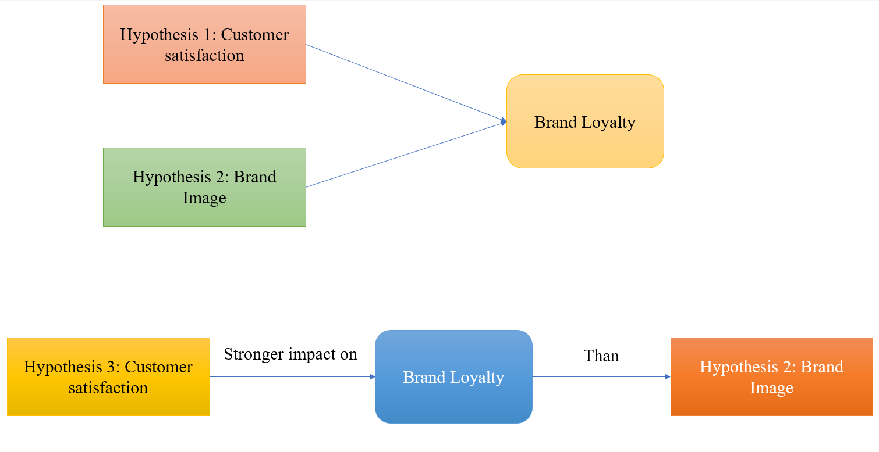
(Source: Author)

1.8 Dissertation Outline:
Chapter 1: Introduction
Chapter 1 presents the introduction for this dissertation and provides an overview for the research study, overview of the company’s background and the products offered by the company, the rationale of the research, literature gaps found in the research topic and the description of the dissertation’s aims and objectives.

Chapter 2: Literature Review
The chapter 2 provides a comprehensive review of the existing secondary data on the key variables related to this research study. This chapter will critically analyse the secondary data and will highlight the major benefits and limitations of the current secondary data. Recognised models and theories will be used to form a conceptual framework for demonstrating the relevance of the research topic and the research findings.

Chapter 3: Research Methodology
The chapter 3 presents the details of the procedure followed to conduct the research study. The information provided in this section covers the research design, strategies used for the investigation, collection of primary data and sampling methods used in this research study.

Chapter 4: Key Findings and Discussions
The chapter 4 provides a comprehensive analysis on the data collected from the respondents for the primary research. The data will be presented in an organised manner using Pie charts, tables, and graphs. The data will be analysed using Microsoft Excel.

Chapter 5: Conclusion and Recommendations
Chapter 5 will summarize the research study, Key findings of the research study, and conclude the research study by highlighting the important sections of this research. Furthermore, this section will provide recommendations that could further strengthen the findings of the research study.

Chapter 6: Limitations
The chapter 6 will highlight and address the limitations of this research study. A detailed review of the limitations will be provided in this section.

Chapter 7: Reflection
The chapter 7 will provide the author’s reflection on the research study, highlighting the key challenges encountered during the research journey and key skills developed during the research journey.

Chapter 2
2.0 Literature Review
2.1 Brand Image:
The perception on a Brand has significantly changed since 1990’s when brands were considered as a used for identification. The brands have evolved into valuable intangible assets for companies (Parris and Guzmán, 2022). An intricate and multifaceted notion, brand image includes both tangible and ethereal components. The visual identity of a brand, including logos, packaging, and product calibre, are examples of tangible aspects. In contrast, intangible factors include the associations and emotional ties that customers develop with a brand. A strong brand image has a substantial impact on customer purchasing decisions, fosters brand loyalty, and allows for premium pricing (Grimm and Wagner, 2021). Several hypotheses have been put out to explain how and why brand image develops. According to the schema theory, consumers construct mental frames or schemas to classify and remember brands. Through several interactions with the brand, including commercials, reviews, and personal experiences, these schemas develop (Grimm and Wagner, 2021). The brand image is customer’s perception of a brand based on their interaction with a brand. The perception of a brand can evolve over time, and it does not involve a consumer making purchases or using the services or products of a brand (Qualtrics XM, 2023). The perception of a brand image is reflected from the consumer memory with the association they had with the brand as stated by Keller in 1993. According to Aaker in 1996, a consumer will create a perception on a brand’s image and evaluate the brand on the good vs bad scale in a weighing manner to form their impression on a brand’s image. Aaker later created the concept of brand personality in the year 1997, this concept can be operationalized to measure a brand’s image (Parris and Guzmán, 2022). Brand image has a significant impact on consumer behaviour, influencing purchase decisions, product pricing, and consumer propensity to repeat purchases. People tend to gravitate towards brands with whom they have a strong emotional connection, which can lead to brand loyalty. Furthermore, positive brand images can help to mitigate negative experiences, as consumers may be more likely to be forgiving of minor product issues or service interruptions when they have a positive perception of a brand. Therefore, it is essential to consistently manage and enhance brand image in order to maintain consumer trust (Mai and Cuong, 2021). A strong brand image gives an organization an advantage in a crowded market, as customers are more likely to pay higher prices for products that are associated with reputable brands. Additionally, well-established brands can be used to break into new markets or product categories, since their brand recognition is already established. This is especially important in industries that are largely composed of homogeneous products, such as those in the markets for smartphones (Mai and Cuong, 2021). The digital age has revolutionized the way brand image management is conducted. Companies now have direct access to customers through social media, allowing for more personal and interactive communication. Positive customer feedback on social media can help to improve a brand's reputation, whereas negative feedback can damage it. Additionally, online reviews and content created by users can have a significant impact on a brand's reputation. Potential customers often base their purchasing decisions on the experiences and opinions of others. Companies that actively interact with their online audience and address any issues they may have been more likely to maintain a positive image. Brand image is an integral part of contemporary marketing, encompassing both the tangible and intangible elements that shape consumer perceptions and interactions. Establishing and managing a strong brand image is essential for creating trust, loyalty, and an edge in today's competitive environment.

2.2 Customer Satisfaction:
Customer satisfaction is the result of superior experience a customer received from the product or a service (Manyanga et al., 2022). Satisfaction results from a customer’s cognitive state of receiving or not receiving an adequate reward for the sacrifice they made. As an example, a customer who receives a product or a service worth the amount they paid is likely to be more satisfied than the customer who did not receive the same. Thus, increasing the purchase intent (Tanveer and Lodhi, 2016).
Customer satisfaction is an essential concept in the business and marketing world, as it is a measure of customer satisfaction based on the level of satisfaction customers experience with a company's products or services. This metric encompasses a variety of aspects, such as product quality, customer service, and overall value, and is essential for the reputation, loyalty, and success of a company. The quality of a product or service is a key factor in customer satisfaction, as it is expected to meet or exceed customer expectations. Additionally, customer service can have a significant impact on customer satisfaction, as the interactions and support provided by a company can have a significant effect on customer perception (Mai and Cuong, 2021). Customer satisfaction also has a direct effect on the company's financial performance, as satisfied customers tend to be more likely to spend, buy more, and be less price sensitive. This, in turn, leads to higher revenue and lower marketing and acquisition expenses, as acquiring new customers is typically more expensive than keeping existing ones. Customer satisfaction is a key factor in determining success in today's highly competitive market. Companies that prioritize customer satisfaction tend to have stronger relationships with their customers, higher customer retention rates, and better financial performance. Customers who are satisfied with a company not only remain customers but become advocates for the company and refer others to it, resulting in organic growth through word of mouth (Suchánek and Králová, 2019). Companies that prioritize customer satisfaction also tend to be better able to manage their public relations and crisis management. When customers feel valued and have experienced a great level of satisfaction with the brand, they may be more likely to become brand loyal. Customer satisfaction results from receiving the anticipated performance from a product or service (Abedi and Jahed, 2020). Customer satisfaction can be considered as a performance measurement used to typically measure the superiority of a customer experience, this can be used to understand the actual gap between customer expectations and service received (Manyanga et al., 2022). The satisfaction of a customer contributes to actions like favourable word of mouth promotion, loyalty, repeat purchases and thus eventually contributing towards higher profits and reduction of costs (Manyanga et al., 2022).

2.3 Brand Loyalty:
In the year 1999, Oliver stated brand loyalty as a deep commitment held by a customer to repeatedly patronize or rebuy a product/service for the same brand or service provider despite the situational influences or marketing efforts from other brands as brand loyalty (Parris and Guzmán, 2022). While in 1978, Jacob and Chestnut stated that consistently purchasing a product might not be an indicator of brand loyalty as in could be the result of a preference for convenience or a happenstance buying as there is a possibility if masking loyalty if the customers are multi brand loyal (Parris and Guzmán, 2022).
Research has identified a variety of elements that influence consumer loyalty to a brand. These elements can be divided into four main categories, they are brand trust, image and perception, customer satisfaction, and community and engagement. Brand trust is a fundamental element of brand loyalty. It is essential for consumers to have faith in a brand to consistently deliver the quality and value they are looking for. Trust is fostered through consistent performance, transparency, and ethical behaviour. A positive brand image can encourage brand loyalty, while a negative image can discourage it. Satisfaction with a brand is a key determinant of brand loyalty. Customers who are satisfied with their experience are more likely to remain loyal to the brand. Consumers are more likely to be loyal to a brand if they feel part of the brand community or if they are actively engaging with the brand (Chen, 2015). The importance of brand loyalty in modern marketing cannot be overstated. With the proliferation of options available to consumers, brands must invest in strategies that encourage loyalty. The factors that determine brand loyalty, such as trustworthiness, customer satisfaction, brand image and engagement, have changed over time, reflecting shifts in consumer behavior and marketing strategies. To foster and maintain brand loyalty, marketers must use consistent branding, tailored customer journeys, loyalty programs, emotive branding, social media activation and experiential advertising (Chen, 2015). In today's highly competitive market, the capacity to build and sustain brand loyalty is essential for a brand's long-term success and profitability.

2.4 Brand Equity:
Brand equity is a concept that is widely recognized in the marketing and business world. It is a measure of a brand's perceived value and strength, and is a valuable asset that companies strive to maintain and protect. This essay will explore the importance of brand equity in today's competitive environment, the elements that influence its development, and strategies for constructing and maintaining it. Additionally, we will look at practical examples to demonstrate how brand equity can revolutionize businesses and lead to success (Jeon, 2017). Brand equity is a concept that is not measured in monetary terms, but rather in terms of the perception that consumers have of a brand. It is the emotional and psychological association that people form with a brand when they hear its name. This association is based on the qualities that consumers associate with a strong brand, such as quality, reliability, and trustworthiness (Jeon, 2017). According to David Aaker, a leading authority on brand management, brand equity is a collection of liabilities and assets associated with a brand, including its symbol and name, that contribute to or detract from the value that a service or product provides to a company or its customers. Essentially, brand equity is the goodwill that a brand has built up over time (Parris and Guzmán, 2022). The brand equity is a financial asset that develops a positive image of the brand to the customers. In the year 1991, Aaker suggested that brand equity includes brand image, brand awareness, perceived quality, brand loyalty and other brand assets (Faircloth et al., 2015). Aaker expressed brand equity as a set of liabilities and assets that includes other influencing factors like the brand’s name, symbol that could influence the brand positively or negatively (Parris and Guzmán, 2022). In the year 1993, Keller stated that consumer-based brand equity grows from positive response of a firm’s marketing efforts. This could be the result of positive consumer behaviour towards a brand. In today's highly competitive market, brand equity is of paramount importance. It provides a range of advantages that can be of great benefit to businesses, such as consumer preference where consumers are more likely to choose a brand that has high equity, even when there are other similar brands in the market. This preference can lead to increased sales and market share for the brand. Customers are more likely to pay a higher price for a brand that has strong equity, as they are confident in the quality and reliability of the product or service (Tanveer and Lodhi, 2016). Customers who are loyal to a brand are more likely to purchase from the brand multiple times, thus reducing the cost of acquisition, and Brand equity can make it easier for a brand to expand into new markets and product categories. Brand equity can also provide a significant competitive advantage, as it is difficult for competitors to duplicate the emotional and psychological connections that consumers have to well-established brands (Jeon, 2017). Keller stated that he views a brand’s equity as perceptual belief that associates with the brand’s attribute, attitude, and benefit (Faircloth et al., 2015). Thus, holistically constructing the brand’s image and positively influencing a consumer’s evaluation towards the brand. The brand equity can be viewed as a consumer’s biased actions and attitude towards an object and brand’s image (Faircloth et al., 2015). In the year 1992, Holden stated that a brand’s equity increases from a consumer’s willingness to pay a premium price for a particular brand over other similar brands (Faircloth et al., 2015). In the year 2007, Liaogang stated that generating and managing the brand equity of a brand is important. The brand equity of a company can helps differentiate a product from competition. Thus, helping the brand gain competitive advantage (Tanveer and Lodhi, 2016). Brand equity is an invaluable asset that can have a major impact on a business's success. It is the intangible value that consumers attach to a brand and is of great importance in today's highly competitive market. The factors that influence brand equity are complex and require a long-term strategy to build and maintain it (Jeon, 2017). Companies that understand the value of brand equity can benefit from it, as it can lead to an increase in consumer preference, higher pricing, and a more devoted customer base. In an era where consumers have so many options, brand equity serves as a symbol of trustworthiness, excellence, and consistency, and businesses that prioritize it are better equipped to succeed in a rapidly changing and competitive environment.

2.5 Aaker’s Brand Equity Model:
In the highly competitive business landscape, the development of a strong brand is imperative for success. Brand equity is the intangible essence that distinguishes a product or company from its competitors. Developed by David Aaker, a renowned marketing expert, the Brand Equity Model is a comprehensive framework for businesses to understand and manage brand equity (Ekinci et al., 2023).
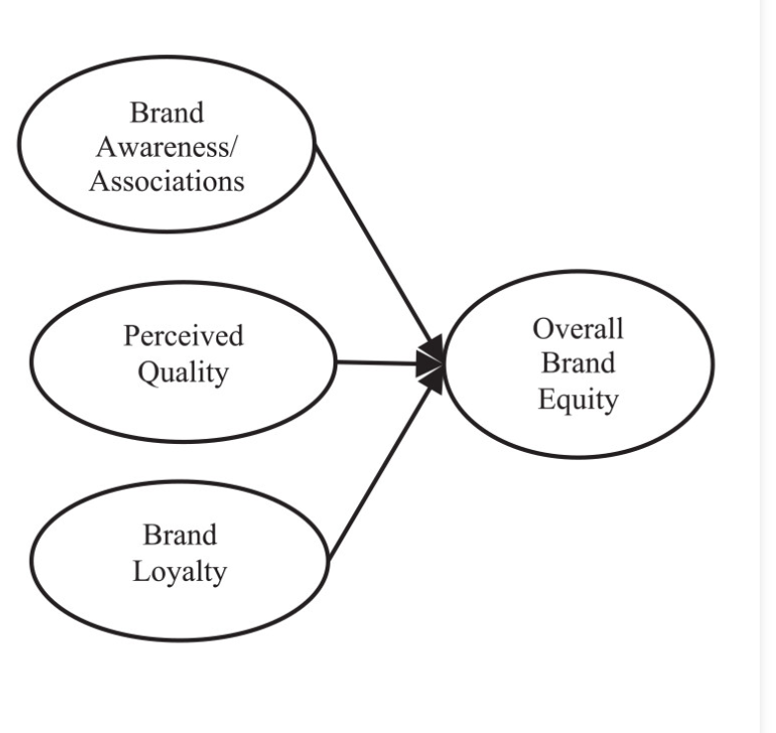
Figure 2: (Ekinci et al., 2023)

Figure 1 presents the Aaker’s brand equity model. This model associates a brand’s awareness, associations, perceived quality, and brand loyalty as the overall brand equity of a brand.
In the year 1991, Aaker proposed this consumer-based brand equity model (CBBE model) to theorize brand equity. The four dimensions of this model are considered intangible assets that influence a brand’s equity (Ekinci et al., 2023). According to Aaker’s model, brand loyalty is play’s a significant role in maintaining loyal customers, this gives a brand advantage over their competitors. Brand awareness in Aaker’s brand equity model suggests that a brand with high brand awareness can take advantage of their visibility to attract customers (Indeed Editorial Team, 2022). This awareness help’s customers feel comfortable with their decision to purchase products or services from a company. The perceived quality of a brand can lead the customers to believe in a brand’s reliability (Indeed Editorial Team, 2022). Thus, helping the brand to differentiate from its competitors. Brand associations measures the connection that a customer has with a brand, this helps a brand create a positive image of the brand among the consumers (Indeed Editorial Team, 2022). These four dimensions help a brand to create brand equity. Aaker's model emphasizes the importance of brand identity, which encapsulates the unique characteristics, personality, and values of the brand. This dimension encompasses the brand's vision, culture, personality, and positioning, all of which contribute to a strong brand identity. An effective brand identity helps to create a connection between consumers and the brand, while also giving it a humanistic character. For instance, Apple's identity is characterized by its innovative, straightforward, and elegant design. Brand awareness in Aaker’s brand equity model refers to the extent to which consumers recognize and remember a brand. This includes both brand recall and brand recognition, which is the ability to identify a brand when presented with a logo or packaging. High brand awareness means that consumers will remember the brand even if they have not used the product or service in the past (Ekinci et al., 2023). Brand loyalty is a measure of consumer loyalty to a brand, which can range from a simple preference to a full-fledged commitment. Customers who are loyal to a brand are more likely to make repeated purchases and act as advocates for the brand, recommending it to others. This level of loyalty can be achieved through excellent customer experiences, superior product quality, and meaningful emotional connections. Brand associations are the mental associations and perceptions that consumers form of a brand. These can be both tangible like physical characteristics and intangible like emotions or values. When a brand has positive brand associations, it sets itself apart from competitors and makes it more attractive (Ekinci et al., 2023).
The brand equity model, developed by Aaker, provides a comprehensive framework for businesses to navigate the intricate world of brand management. This model emphasizes the importance of developing a distinct brand identity, building brand recognition, building brand loyalty, and cultivating positive brand associations. Establishing a strong brand can result in an increase in customer preference, loyalty, and advocacy, which in turn can lead to increased revenue and growth. Employing the principles of the Aaker brand equity model, organizations can construct a brand that will endure and make a lasting impression on consumers.
Advantages of Aaker’s Brand Equity Model:
The Aaker Brand Equity Model provides a comprehensive approach to brand strength, taking into account the various dimensions of brand identity, brand awareness, brand loyalty, and brand associations. This model encourages marketers to build and manage their brand equity in a structured and organized manner, emphasizing the importance of developing relationships, creating trust, and developing a distinct brand personality. Additionally, Aaker's framework enables marketers to measure and monitor specific components of their brand, providing data-driven insights that enable them to make informed decisions in real-time and strengthen their brand (IPL, 2023). Aaker's model emphasizes the importance of investing in brand building over the long-term. Companies that take this approach invest in long-term, consistent efforts to create a recognizable, trustworthy, and resilient brand. The model discourages strategies that may damage the reputation of a brand in the short-term, and instead encourages companies to focus on building a strong brand that is known, trusted, and loyal to consumers. This can result in increased market share, customer preference, and competitive advantage. Additionally, the framework can be used to guide brand extensions, ensuring that new products or services align with existing brand equity and minimize the risk of dilution (IPL, 2023).
Disadvantages of Aaker’s Brand Equity Model:
The complexity of Aaker's model can be a challenge for small businesses and those with limited resources. It requires a significant investment of time, resources, and resources to conduct market research, build and maintain brand identity, and foster brand loyalty. Additionally, the model may not be applicable to all industries or brand types and may not be particularly effective in highly commoditized markets (IPL, 2023). Finally, the dynamic nature of markets can lead to discrepancies between the strategy and the changing consumer preferences, making it difficult for Aaker's model to keep up. Aaker's model does not take into account the complexities of digital branding or the ever-evolving online environment, making it difficult to accurately measure and track progress in the area of brand equity. This is especially true when it comes to measuring emotional associations, which are intangible elements that can be difficult to quantify (IPL, 2023).

2.6 Purchase Intention:
Purchase intention is a concept that describes a consumer's intention or inclination to purchase a particular product or service at a future date. It is the consumer's intention or plan to purchase the product or service at that time, regardless of whether or not the purchase is actually made. Purchase intention plays an essential role in consumer behaviour research and marketing, as it provides insight into consumer decision-making and assists businesses in comprehending their prospective customer base (Cuong, 2020).
In 1975, Fishbein and Ajzen proposed that purchase intention is the consumer's genuine intention to purchase goods or services. This was seen as a combination of the consumer's worries and the likelihood of purchasing the product. Previous research has also indicated that purchase intention is strongly linked to attitude and preference towards the brand or product (Cuong, 2020). In 2003, Kotler suggested that purchase intention can also be influenced by an individual's perception and unexpected circumstances. An individual's private preferences and unexpected events can influence the conditions that alter the purchase intention. Additionally, other researchers have proposed that buying intention is defined as the consumer's tendency to purchase the product. The greater the customer's desire to purchase a product, the greater the purchase intention (Cuong, 2020). In summary, purchase intention is a key component of consumer decision making and marketing tactics. It is the willingness of a consumer to engage with a particular product or service and serves as a bridge between thought and action. Purchase intention does not necessarily lead to a sale, but it provides valuable insight into consumer preferences and needs, thus providing a roadmap for businesses navigating the intricate world of consumer behaviour. It is essential for businesses to understand the various elements that influence purchase intention in order to create effective marketing campaigns. These elements include the perceived value of the product or service, the level of trust and credibility, the social influences, the emotional connections, the perceived risk, and the convenience. With this understanding, businesses can refine their strategies to better target their target audience and increase the likelihood of conversion.

2.7 Brand Preference:
In this highly competitive market, brand preference can have a major impact on a company’s bottom line. It’s the tendency of consumers to prefer one brand to others in a product category. Brand preference is one of the most important elements of brand loyalty. It shapes consumer decisions and purchases. Brand preference has been a topic of interest to scholars. It is a state of preference where a customer prefers a particular brand due to their positive feelings towards it (Cuong, 2020). Brand preference is defined as a tendency towards a particular brand that is reviewed by the customer's cognitive information processing in response to brand stimuli. The central control unit of the customer and the mental capacities of the customer were highlighted in this concept. This suggested that a customer's perception of the brand attributes results in preferences or attitudes which influence the buyer's intentions and brand choice. The preference describes a changing phase between the input and output of the buyer's choice model. In addition, some scholars have proposed that brand preference is a critical pre-condition for purchase intention and has a positive effect on purchase intention. Furthermore, brand preference is a behavioural tendency that reveals a buyer's attitude towards a particular brand (Cuong, 2020). Brand preference is a fundamental element of successful business operations and customer loyalty. It is the tendency of consumers to consistently select a particular brand over others in its category. This preference is based on positive experiences, trustworthiness, emotional connection, and trust in the brand. It facilitates the consumer's decision-making process and fosters brand loyalty, resulting in long-term profitability for businesses and market resilience for consumers. For consumers, brand preference simplifies the purchasing process, allowing them to choose a reliable brand without extensive testing. This preference is not limited to product quality and price; it is often based on the brand's reputation and image, as well as its emotional appeal (Cuong, 2020). Brand preference also provides a competitive advantage for businesses, as a strong preference can isolate a brand from price competition, reduce marketing expenditure, and open the door to brand extensions and innovation. To maintain and expand brand preference, businesses need to consistently deliver on their commitments, prioritise customer satisfaction, and adjust to changing market dynamics.

2.8 Brand Trust:
Brand trust is a concept in the branding literature that is based on the relationship between a brand and its consumer. Trust was defined as a consumer's confidence in the quality and reliability of the products provided by the seller. Brand trust is an intangible asset of immense value in the world of business. It is the foundation upon which successful companies are built and is a key factor in distinguishing them from their competitors, influencing consumer behavior, and providing long-term growth opportunities (Qualtrics XM, 2023). It is the trust and confidence that consumers have in a brand, indicating that they will fulfill their promises in a consistent and reliable manner. Brand trust is a multi-faceted concept that encompasses not only product quality, but also ethical factors, customer service standards, and more. It is essential for the success of a business, as it forms the foundation upon which customer loyalty and advocacy are built and has a direct impact on a company's financial performance. In year 2001, Chaudhuri found that brand trust was accepted as the clients' willingness to rely on the brand's sense of purpose to achieve its stated goal (Cuong, 2020). Similarly, brand trust is a form of belief, where the connection with the brand is based on the belief that the brand will remain dependable and satisfy the buyer. The concept of trust is only appropriate in the context of risk. In this context, trust declined when the buyer perceived the goods to be extremely unsafe, as they knew that they could rely on the trusted brand. Brand trust was also defined as the willingness of the buyer to trust the brand from the point of uncertainty, as they expected positive outcomes from the brand (Cuong, 2020). It has been suggested by some researchers that when consumers have increased their trust in a brand, the likelihood of repurchasing is likely to increase, resulting in a shift towards the brand's preference. This has been supported by previous research, which has shown that brand trust is predictive of brand preference. Additionally, there was a correlation between brand trust and purchasing intent, suggesting that if brand trust has increased, the rate of purchasing will increase. This has been confirmed by other studies, which have shown that brand trust has a positive impact on purchase intention (Cuong, 2020).

2.9 Maslow Hierarchy of Needs Theory:
In 1943, Abraham Harald Maslow proposed his Theory of Motivation, which is one of the most widely cited theories of motivation. This theory is based on the hierarchy of human needs, according to which human behavior is linked to the needs to be met. Maslow identified five types of human need, arranged in order of importance and priority, and concluded that when a set of needs was met, it ceased to be a motivator. This hierarchy can be likened to a pyramid, with the largest and most fundamental needs being at the bottom, and the need to self-actualize and transcendence being at the peak. At the beginning of Maslow's hierarchy, there is a set of needs that are described as basic and universal in nature. Subsequent sets of needs are then placed in the hierarchy (Trivedi, 2019).

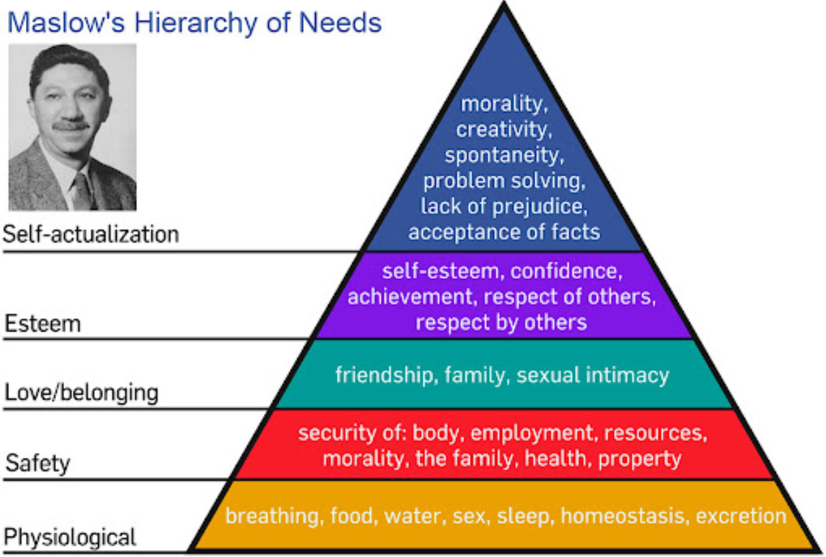
Figure 3 Source: (Trivedi, 2019)

2.9.1 Physiological needs:
Physical needs are the fundamental requirements for the maintenance of human life, which include sustenance, protection, clothing, relaxation, ventilation, water, rest, and sleep. These fundamental human needs (also referred to as biological needs) rank at the bottom of the hierarchy, as they take precedence over all other requirements. These requirements cannot be put off indefinitely. Until and unless these fundamental physiological needs are met to the desired level, other requirements will not be met. For example, a hungry person is unable to think about anything else, only their hunger or their food. Maslow states that a man lives by bread only when no bread is available. The management seeks to meet these physiological needs through equitable wages (Trivedi, 2019).

2.9.2 Safety Needs:
People seek protection from the psychological fears associated with job loss, property loss, natural disasters, and other hazards. They prioritize safety or security measures, such as protection from job security, physical harm, retirement benefits, and life insurance coverage, in order to meet these needs. When these physiological needs are met, they lose their motivational power and are replaced by safety needs, which then become the driving force behind human behavior. Safety needs only act as a motivator when unsatisfied (Trivedi, 2019).
2.9.3 Social Needs:
People are typically treated as members of a social animal, with the desire to remain in a group and to be accepted with love and affection by the other members. This is seen as a fundamental social need for an individual and is second only to the need for friends and interaction with peers and superiors (Trivedi, 2019).

2.9.4 Esteem Needs:
Esteem needs are a set of needs that include respect from others, recognition from others, power, and prestigious positions. Satisfaction with these needs leads to a sense of being held in esteem by oneself and others. Self-esteem needs include those related to self-confidence, self-esteem, competence, etc. The second set of esteem needs is related to the state of one's reputation, appreciation, and recognition from others, which is a form of personal ego that must be satisfied. An organization can satisfy this need (ego) by rewarding employees for their hard work. Therefore, esteem needs do not assume the motivational properties until the prior needs are satisfied (Trivedi, 2019).

2.9.5 Self-actualization Needs:
Self-actualization is the highest of the needs outlined in Maslow's hierarchy of needs. It is a fundamental 'growth' need, requiring a worker to be productive in order to be content. Here, the individual believes that they should strive to reach their full potential and strive to become what they are capable of becoming. They desire to face challenges and achieve something unique in their life or field of expertise. Although everyone is capable of achieving self-actualization, many fail to do so, and this need is rarely fulfilled (Trivedi, 2019).

2.9.6 Limitations of Maslow Hierarchy of Needs Theory:
Maslow's hierarchy of needs theory is subject to a number of limitations, including its oversimplification and its reliance on human needs alone. There is no direct causal link between need and behavior, and the theory must take into account other motivating factors such as expectations, experience, and perception. Furthermore, the needs of employees are not homogeneous, with many satisfied with the security of employment and physiological needs. Maslow's model of hierarchy of needs may not be applicable to all individuals, as everyone has a variety of needs that may not necessarily be in line with his or her need hierarchy. The theory is generally accepted, but there is limited empirical evidence to back it up. It is largely untested and tentative, with its writings being more philosophical than scientific (Trivedi, 2019).

Chapter 3
3.0 Methodology
This section provides information on the specific steps and procedures used in the execution of this research study. This section also discusses the design of the research question, the demographics of the research subjects to be studied, and the rationale for the selection of these components, as well as the anticipation findings and methods used to analyse the research finding to support various hypothesis. Research methodology is a decision-making process that is essential for demonstrating the co-ordination between the process of research and the impact of decisions on the stages of the research (Song, 2021).

3.1 Definition of Research
The field of research is concerned with the development of new knowledge, and the utilization of existing information in novel and innovative ways to create new ideas, methods, and insights. This may include the analysis and synthesis of prior research to the extent to which it yields novel and innovative results (Song, 2021).

3.2 Research Onion Model
The research onion model is a research tool that provides a description of each strategic level that every researcher must pass through to develop a successful methodology for a particular research. The research onion model is composed of five key layers that contain information regarding each research step that a researcher must follow in order to create a strategy. By utilizing the research onion strategy, a researcher can gain a better understanding of the research questions that will be addressed and guide them in selecting the most suitable method based on their research topics and ideas when they analyse their findings. The research commitment that a researcher makes in formulating a research strategy can be found within the research onion and serves as a structured foundation for conducting research (Melnikovas, 2018).
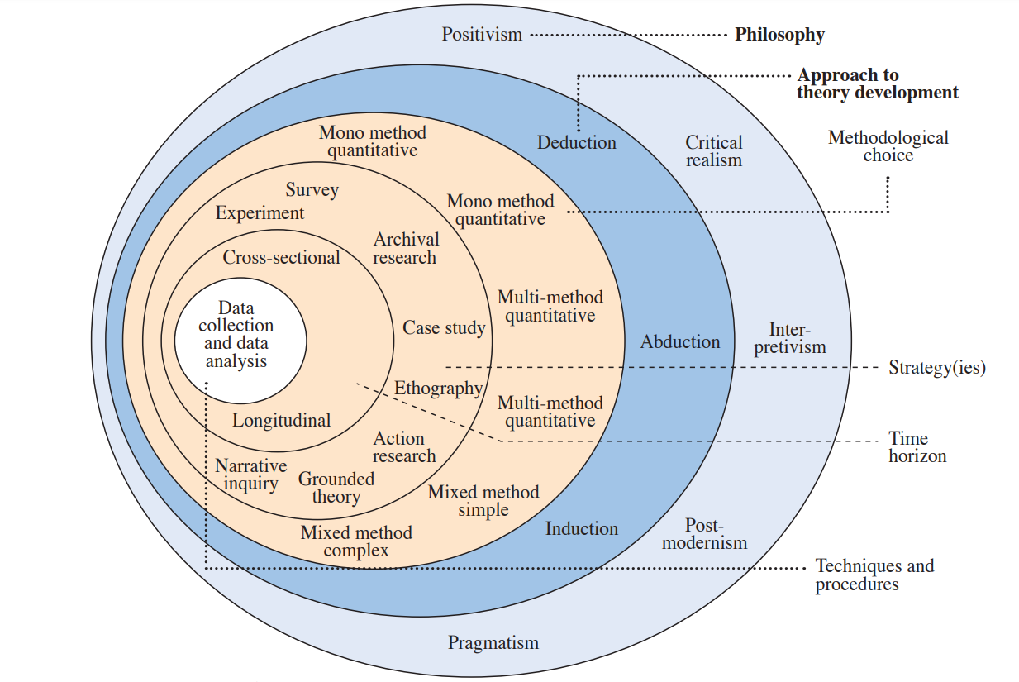
Figure 4 Source: (Melnikovas, 2018)

3.2.1 Research Philosophy:
The research philosophy of a study is focused on the overall relevant assumption based on the researcher’s views of their environment. This assumption will ultimately shape the research strategy and the methods chosen as part of a research development strategy. The philosophy stage is essential for the development of the research process, as the philosophy adopted will depend on the researcher’s direct observation of the connection between the knowledge acquired and the stages of the research process (Melnikovas, 2018). The research onion model offers three main philosophy that researchers may adopt on the initial stages of the research strategy, they are positivism, realism and interpretivism. The positive approach provides a highly organised methodology supported by quantitative observations and statistical analyses. This approach is highly preferred by many researchers as it allows the researchers to perform an independent observation that solely focuses on the results of the quantitative data analysis. However, some researchers may apply a combination of positivism and mixed methodology. The research strategy will be based on the existing information around the topic area and quantitative data collection method. This allows for a comprehensive and successful conclusion to be reached (Melnikovas, 2018).

3.2.2 Research Approach:
A research approach refers to the methodology employed by a researcher to arrive at a conclusion or determine the overall result of their research. A research study approach should be understood as serving the primary purpose of the research and addressing all relevant issues prior to initiating the research. In the year 2005, List suggested that there are two distinct approaches to study the future. The first approach is quantitative forecasting, which is based on mathematical techniques such as extrapolation and econometric modelling. The second approach is alternative futures, which refer to the concept of multiple futures and are based on foresight methods (Melnikovas, 2018). In the year 2013, Inayatullah mentioned that there are four main approaches to study the future, they are identified as predictive, interpretive, critical, and participatory. The predictive approach is based on the empirical sciences and requires scientific evidence. The interpretive approach is based on competing visions of the future. While the critical approach focused on asking who would benefit from a certain future; and participatory approach is based on the action of learning or research. These approaches would allow a researcher to effectively analyse the predetermined problem of the study and reach a comprehensive conclusion while analysing the data collected (Melnikovas, 2018).

3.2.3 Research Strategy:
In the year 2016, Saunders proposed that the main research strategies are Action Research, Survey, Case Study, Archival Research, Ethnography, Grounded Theory Experiment, and Narrative Inquiry. However, the research strategies in the area of Futures Studies can be differentiated in a slightly different way. In the year 2005, List suggested that there are two main categories of research methods in Futures Studies are Qualitative and Quantitative (Melnikovas, 2018). Additionally, In the year 2008, Kosow distinguish between Explorative and Pragmatic Research Methods. Explorative methods focus on examining multiple futures and exploring potential future developments, while Pragmatic methods focus on shaping the desired/unwanted future and constructing the pathways or sequence of events for achieving it. Towards an explicit research methodology, adapting research onion model Research strategy can be described as a general approach that allows the researcher to select the main data collection method or sets of methods to answer their research question and meet their research objectives. Future studies can be divided into three main strategies, they are descriptive, normative, and explorative (Melnikovas, 2018). Each of these approaches can be employed to achieve the specific objectives of the research, to describe the precise patterns of future development and to investigate the potential of future events.

3.3 Types of Research
3.3.1 Primary Research
Primary Research involves the direct collection of research data from study participants or study samples for the purpose of conducting current and future study analysis. Research studies typically involve levels of observation in which new or existing is collected for the purpose of incorporating it into study. Primary research involves the collection of first-hand data directly from the data source on which the study is based. Primary research intelligence involves the adoption of a structured observation approach with a predetermined set of questions and a predetermined ranges of responses (Lowe and Zemliansky., 2011, pp. 153-154). For the purposes of this study, primary research strategy will be employed through the use of survey questionnaire, thus enabling research sample to deliver the desired data in accordance with the research design. A set of 14 structured survey questions are sent in the form of a survey questions to 100 respondents requesting a response within a specified time frame. The questions are designed to provide feedback on key elements of the research objectives and goals. The responses are mainly collected in quantitative form, and they form a fundamental component of primary research, with exception of a few question designed for the collection of qualitative data.

3.3.2 Secondary Research
The secondary research involves the collection and utilization of existing data and information collected from other research, publications, or governments in order to provide evidential support for a research investigation. This method of research offers a cost-effective way of obtaining essential information for a research study and is always derived from a primary research study conducted prior to the initiation of the secondary research study (George, 2023). In this study, secondary research data was utilized through literature review, which involves the review of existing research results, theories, and publications related to the relevant research topic area by authors and experts. This data is then used as evidence for the proposed hypothesis and is subsequently tested against new data from the primary research study.

3.3.3 Advantages and Disadvantages of Primary and Secondary Research
Advantages of primary research:
Primary research offers four key advantages over secondary research. Primary research is relevant to set of objectives, it fills in the gaps from desk research, it can uncover customer and potential customer attitudes and opinions, it is up to date and accurate, and it does not need to be shared with other companies. Additionally, primary research is better interpreted as it is conducted with the objectives in mind, rather than by someone with no connection to the business, which is the case with secondary research. Finally, it provides greater privacy (Anpar Research, 2020).
Disadvantages of primary research:
Primary research can be a beneficial tool for businesses and websites, however, it comes with certain limitations that must be taken into account. It can be more time-consuming than secondary research, as it requires a longer period of time to conduct accurate research. Additionally, it can be more expensive when conducting large-scale international studies or continuous surveys, as it is designed for a specific purpose. On the other hand, online surveys can be relatively inexpensive, particularly DIY surveys. Lastly, the amount of resources required may vary depending on the scope of the research, such as conducting a large-scale, quarterly survey (Anpar Research, 2020).

Advantages of secondary research:
Secondary research offers three key advantages, they are accessibility, guidance for further research, and free sources of information. Accessibility is achieved by being able to access information in a timely manner, as it is likely to be available online. Guidance is provided through free sources of information, however, this can be costly if the information is more specific, such as market reporting or social media tracking. This can be beneficial for exploratory research as it allows for the identification of a research problem and the development of a solution (Anpar Research, 2020).
Disadvantages of secondary research:
Secondary research offers a number of advantages. However, it is not without its drawbacks. These include relevance to the research, the limited insights it can provide due to its purpose and methods, and the lack of accuracy due to its objectives, nature, and methods. Additionally, research may not be up to date, so research conducted in the past year or two is likely to be taken into account. Finally, the sheer amount of data available can be daunting, so it is important to focus on the task at hand rather than jumping to conclusions (Anpar Research, 2020).

3.4 Methodological Choice
In 2016, Saunders outlined research choices by reference to qualitative and quantitative research, as well as a complex or simple combination of the both or mono methods. Quantitative research involves numerical and mathematical operations, whereas qualitative methods involve the collection of large-scale descriptive data (Melnikovas, 2018). Mono methods are used when the research focuses on either qualitative or quantitative data collection, while mixed methods are used when both qualitative and quantitative methods are employed within the same research to accomplish different objectives and overcome the limitations of a single method. Multi-method choice eliminates the use of both quantitative and qualitative methods while the other method serves as an auxiliary or supplementary one. In 2008, Saleh suggested that this presentation of research choices also applies to futures studies. The scope of research choices can be divided into quantitative choices such as trend analysis, causal analysis, time series analysis, and qualitative choices such as scenario construction, and modelling (Melnikovas, 2018).

3.4.1 Advantages and Disadvantages of Qualitative Data Analysis
Advantages:
Qualitative research offers a range of advantages, including the ability to explore and understand complex phenomena in a rich and comprehensive manner, the ability to capture the full range of human experience, emotion, and motivation, the capacity to study in natural settings, and the flexibility to adapt approaches to emerging findings and unexpected findings, as well as the ability to generate new theories and hypotheses through exploratory research. Additionally, qualitative analysis is often characterized by a holistic approach that takes into account the full range of variables and their interactions, allowing for a better understanding of the interdependence of factors (Rahman, 2017).
Disadvantages:
Qualitative analysis has a number of disadvantages, such as subjectivity, small sample sizes, time-consuming collection and analysis, difficulty in replication, lack of quantification, limited objectivity, and limited generalizability. Subjectivity refers to the interpretation of data by researchers, which can be affected by their own biases and beliefs. Small sample sizes and lack of quantification make it difficult to generalize findings to larger populations or contexts. Data management can also be difficult, particularly without the use of specialized software tools (Rahman, 2017).

3.4.2 Advantages and Disadvantages of Quantitative Data Analysis
Advantages:
The use of quantitative analysis offers a range of advantages, such as objectivity, precision, reproducibility, and efficiency. With the use of statistical software, it is possible to analyse a large amount of data in a relatively short period of time, allowing for more accurate measurements, calculations, comparisons, and predictions. Furthermore, quantitative methods are often able to be replicated, which is an essential part of the scientific method, and can be used to verify and validate results. Furthermore, statistical analysis can be used to gain insight into the relationship between variables and the relevance of findings. Finally, quantitative research can be used to make predictions and inferences, which can be used in scientific research (Rahman, 2017).
Disadvantages:
Despite numerous advantages of the quantitative analysis, there are a few disadvantages, such as simplification, limited context, lack of richness, and inaccuracy of data quality. Quantitative methods tend to be rigid and may not be able to accommodate unexpected insights or variables, whereas qualitative methods are more flexible. Additionally, the reduction of data to numerical values may reduce the complexity of the phenomenon being studied and may lead to inaccurate or biased conclusions. Finally, the assumption of independence in many quantitative techniques may not always be applicable to real-world situations (Rahman, 2017).

3.5 Time Horizon
The time horizon refers to the overall duration of the research study, the amount of time allocated to the collection of necessary data as mandated by the research design and how this can influence the overall results of the research (Melnikovas, 2018). The time horizon adopted for this study is 16 weeks. This period includes the collection, analysis, and interpretation of data.

3.6 Data Collection and Analysis
3.6.1 Sampling
Sampling is the process of analysing a finite number of observations taken from a larger population in order to validate research objectives when the entire population under investigation cannot be observed or measured, thus allowing researchers to conclude their findings to a larger population (McCombes, 2019). Researchers are able to utilize a wide range of sampling techniques which can be divided into two main categories, they are non-probability sampling and probability sampling. When the probability of the outcome is known, probability sampling is employed. Cluster sampling and simple random sampling are the examples of probability sampling. The non-probability sampling is employed when the probability of sampling is not known. Examples of non-probability sampling are convenience sampling and purposive sampling (McCombes, 2019).

3.6.2 Sampling Type and Size
This research will apply cluster sampling to this study to collect the data from a specific group instead of the whole population. The data will only be collected from Apple customers and users instead of collecting the data from general consumers. This has been done to keep the collected data as accurate as possible and to avoid collecting inconsistent data from non-Apple customers. To collect the required data on a global company like Apple, the survey was not geographically restricted to any location. The survey questionnaire was shared with Apple customers across the world. The initial sample size considered for this research was 50 respondents. However, to increase the accuracy of the data collected, the sample size was later increased to 100. Although it was possible to collect data from a larger sample size, it was not possible to implement in this study due to the time restriction placed on this study. However, this aspect of the research has created an opportunity for a future research on this study with a larger sample size.

3.6.3 Advantages and Disadvantages of Cluster Sampling Method
Advantages:
Cluster sampling is a cost-effective and time-efficient method of sampling, as it is cheaper and faster than other sampling techniques. For instance, it can reduce travel costs for large geographic populations. Additionally, cluster sampling has a high external validity, as it accurately reflects the entire population if the population is clustered correctly to capture all possible characteristics. Furthermore, this type of sampling process is practical and easy, allowing researchers to analyse large populations which would otherwise be too difficult or complex to analyse (Simkus, 2023).

Disadvantages:
When clusters do not accurately reflect the characteristics of the population or act as a partial representation of the population, there is a risk of a high sampling error, resulting in a lack of statistical reliability and precision. This risk is exacerbated when multiple stages of cluster sampling are employed. The complexity of cluster sampling design typically necessitates additional attention, as researchers must identify strategies for efficiently and correctly dividing a larger population (Simkus, 2023).

3.7 Data Collection Methods
3.7.1 Survey Questionnaire
In order to obtain the evidence required for analysis, primary research and secondary research will be employed. Primary research involves the scientific method of gathering direct data, raw data, or information by using questions or hypotheses which are non-discriminatory, measurable, and quantifiable (Lowe and Zemliansky., 2011, pp. 153-154). Primary research will involve the use of a set of standardized questionnaires will be shared using the Google forms platform. This allows respondents to select the most applicable response to 14 structured questions. The predicted time for each respondent to finish answering their responses would be 10 minutes. If the initial study does not yield the desired or necessary number of responses, a broader conceptual model may be necessary. Secondary research, such as literature or academic reviews will be used to support the primary research findings and to investigate hypotheses within the domain of study.

3.8 Analysis of Data
The data analysis is an important aspect of every research study and is described as an important part that analysis the numerical information within the first layer of the research onion model. This research study involves the analysis of quantitative data collected through a survey questionnaire. The data collected for this study will be analysed using Microsoft Excel and Google forms. The Microsoft Excel will be used to create tables and charts to illustrate and present the data collected from the respondents. The data will be presented in the form of numbers and percentages to provide a better understanding of the data. The analysis will include the information regarding the respondent’s demographic representation and their time spent as Apple’s consumers to gain a greater understanding about the respondents. The secondary data will be presented in the form of literature review in chapter 2. The secondary data will be act as the conceptual foundation for the conclusion presented in the primary research. The respondent’s opinion on a brand’s image and their satisfaction with the Apple products will have a significant impact on the conclusion of this research study.

3.9 Ethical Considerations
This research study will be conducted following all ethical considerations and all data collected form Apple customers for completing this research is considered private and sensitive information and will be kept confidential. This research will respect and adhere the GDPR guidelines.
GDPR Guidelines:
GDPR stands for General Data Protection Regulation. The GDPR was adopted by the European council and European parliament in the year 2016. In United Kingdom (UK), GDPR lead to the creation of Data Protection Act (2018), this act superseded the previous Data Protection Act (1998) (Burgess, 2020). GPDR has 7 core principles, they are fairness, lawfulness, transparency; data minimisation; storage limitation; accuracy; Purpose limitation; integrity and confidentiality; and accountability (Burgess, 2020). The European Information Commissioner (ICO) has stated that the data minimisation principle is essential in an era where we are producing more information than ever before. This principle states that organisations should not collect more personal information from their users than is necessary to meet their purpose (Burgess, 2020). The ICO further states that organisations should hold the minimum amount of data they need to meet their purpose, but not more than that. This principle is intended to ensure that organisations do not exceed the amount of data they can collect about their users. For example, an online retailer would not need to collect a person's political opinion when they sign up to their email mailing list to be notified of sales (Burgess, 2020). The General Data Protection Regulation (GDPR) stipulates that personal data must be safeguarded from unauthorised or unlawful processing, as well as from accidental loss, destruction, or damage. In other words, adequate information security measures must be implemented to ensure that information is not accessed by malicious actors or accidentally disclosed as part of a breach (Burgess, 2020). The GDPR does not provide a definition of what constitutes good security practices, as it varies from organisation to organisation. For example, a bank may need to protect information more strongly than a local dentist. Nevertheless, in general, proper access controls should be implemented, websites should be secured with encryption, and pseudonymisation should be promoted (Burgess, 2020). The European Union's General Data Protection Regulation (GDPR) is designed to safeguard the rights of individuals, with eight distinct rights outlined in its text. These rights range from facilitating access to data held by companies to the deletion of data in certain circumstances. The GDPR outlines the full rights of individuals, including the right to information, access, rectification, erasure, restriction of processing, data portability, objecting, and rights related to automated decision-making and profiling (Burgess, 2020). This research study will strictly adhere all the GDPR principles and guidelines to ensure data safety and confidentiality.

Chapter 4
4.0 Key Findings and Discussions
The following chapter will present the research findings by analysing the data collected thorough the survey questionnaire. The sample size was chosen from the Apple customers located across the globe. The results findings resulted from the data collected from the respondents will have a significant impact in concluding the hypothesis. The data collected from the survey questionnaire will be presented as the evidence used for concluding the hypothesis.

4.1 General Information
The research design necessitated the collection of study samples from a single source, with a fixed number of samples to be collected. A structured questionnaire was created to ensure the uniformity of the responses received from the respondents. Demographic questions related to the respondent’s gender and age were used to verify the credibility of research respondents. In addition to choosing the options presented in the questionnaire survey. The respondents were given a chance to express their personal opinions for a particular questions in the questionnaire. The respondents were asked to provide their instinctive feelings about their experience with Apple products to reduce associated issues of bias.

4.2 Response Rate
An initial sample size of 50 respondents was considered for the research. However, the sample size was later changed to 100 respondents. The respondents were contacted through social media apps like WhatsApp and the link for the questionnaire was shared to them. A total of 102 respondents answered 100% of the questionnaire. Thus, meeting the required sample size for this research.
4.3 Presentation and Interpretation of Data
4.3.1 Questionnaire design:
The questionnaire is designed using 14 questions to gather required feedback from the respondents on important areas of the research objective. The questionnaire includes 2 key demographic information on regarding the respondents. They are the age and gender of the respondents. The respondents were given an option to avoid the question by allocating an option ‘prefer not to say’. This was done to respect and protect the respondent’s demographic preferences. The questions regarding the demographic were included in the questionnaire to observe and analyse the average of the respondents age and gender categories using Apple products. 10 questions were in the questionnaire were designed to collect quantitative data from the respondents to analyse their overall experience with the brand and other general preferences. While 2 questions were designed to receive a personal feedback from the respondents about their opinion on the brand, the responses achieved from these responses will be used to perform qualitative analysis on Apple. The main purpose of this questionnaire is to understand the respondents’ views on the key metrics of the research to measure the impact of brand image and customer satisfaction on the brand loyalty of Apple.

4.3.2 Demography Analysis
4.3.2.1 Gender of Respondents:
How do you Identify yourself? | Count of How do you Identify yourself?
Male | 51
Female | 50
Prefer not to say | 1
Grand Total | 102
(Table 1: Gender of Respondents)
(Source: Author)
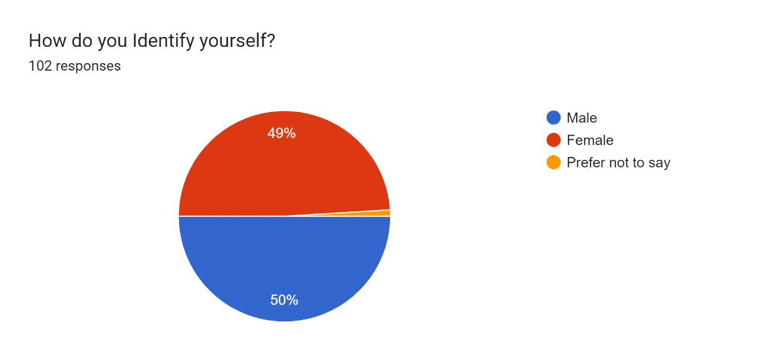
(Figure 5: The Ratio of Respondents Gender)
(Source: Author)

The questionnaire was answered by 102 respondents. The total number of male respondents is 51, while the total number of female respondents is 50 as illustrated in figure 5. Meanwhile, 1 respondent preferred not to disclose their gender. Thus, making the ratio respondents 50% male and 49% female, while 1% remained undisclosed as presented in table 1.

4.3.2.2 Age of Respondents:

(Figure 6: Age category of the respondents) (Source: Author)
What is your Age? | Count of What is your Age?
31 to 45 | 46
46 to 60 | 24
24 to 30 | 14
18 to 23 | 13
Prefer not to say | 5
Grand Total | 102

(Table 2: Number of Respondents in each age group)
(Source: Author)

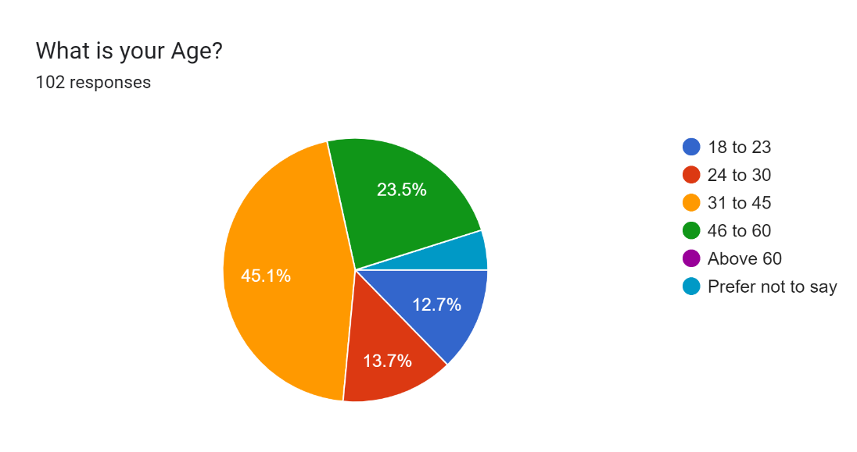
(Figure 7: Ratio of the Respondents Age)
(Source: Author)
As shown in figure 6, majority of the respondents who answered the questionnaire belong to the age category ‘31 to 45’. 46 respondents belong to the age category of ‘31 to 45’ as shown in table 2 and this category make’s up 45.1% of the respondents as figure 7 illustrates. The second most common age category of the respondents is ‘46 to 60’ and this category is followed by the third most common age category ‘24 to 30’. The ratio of respondents who belong to these categories is 23.5% and 13.7% respectively. The least common age category is the ‘18 to 23’, making their ratio 12.7% as illustrated in figure 7. A total of 5 respondents preferred not to disclose their age category.
4.3.3 Association with Apple Products
4.3.3.1 Time Spent with Apple Products:

(Figure 8: Most appeared category) (Source: Author)

Since when were you using Apple products? | Count of Since when were you using Apple products?
more than 5 years | 37
0 to 1 Years | 34
2 to 3 years | 16
4 to 5 years | 15
Grand Total | 102

(Table 3: Time spent with Apple Products) (Source: Author)
A total of 37 respondents belong to the category of the customers who used apple products for more than 5 years as shown in table 3, making the respondents who belong to this category the largest as illustrated in figure 8. While 34 respondents used apple products for less than 1 year, placing the category ‘0 to 1 years’ in the second position. The number of respondents who belong to the categories ‘2 to 3 years’ and ‘4 to 5 years’ is 16 and 15 respectively as presented in table 3. Thus, appearing less frequently than the top 2 categories.

4.3.3.2 Experience with Apple’s Customer Service:
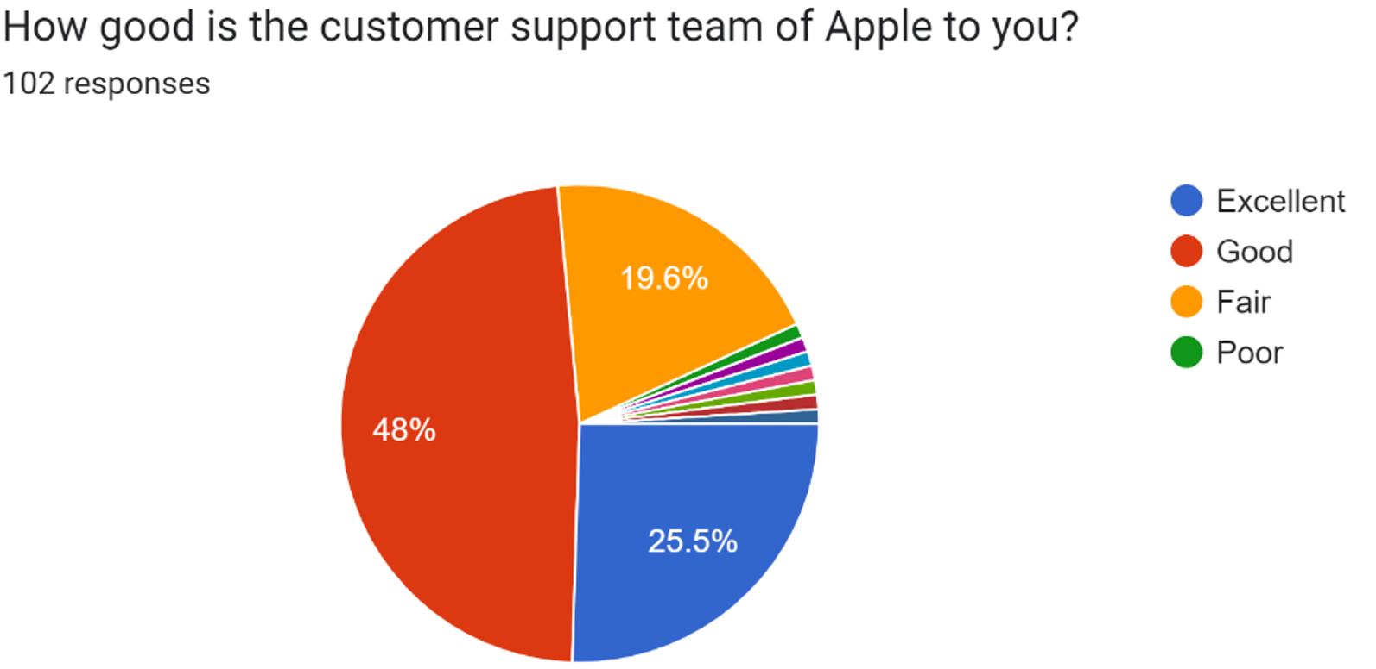
(Figure 9: The quality of Apple’s customer Service) (Source: Author)
48 % of respondents have rated Apple’s customer support team as good, while 25.5% of respondents rated Apple’s customer support team as excellent, as illustrated in figure 9. However, 19.6% respondents rated Apple’s customer support team as Fair as illustrated in figure 9. Meanwhile, 6.9 percent respondents presented varied responses. Overall, it can be assumed that Apple has been delivering a good customer service experience to their customers.

4.3.3.3 Customer Satisfaction and Trust:
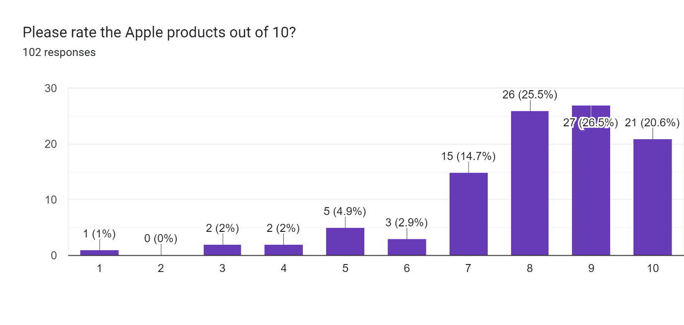
(Figure 10: Customer Satisfaction Index) (Source: Author)
The customer satisfaction index in figure 10 presents the number and percentage of respondents rating apple products based on their satisfaction with the brand. 20.6% respondents gave a 10 out of 10 rating for the apple products, expressing their complete satisfaction with the brand. Furthermore, 26.5% respondents gave a rating of 9 and 25.5% respondents rated Apple products an 8 out of 10, expressing their satisfaction with Apple products as illustrated in figure 10. Therefore, 72.6 percent of respondents, expressed their satisfaction with apple products by giving a rating above 8. Meanwhile, 17.6 percent of respondents expressed their moderate satisfaction with Apple products by giving a rating of 6 or 7. Furthermore, 10 % of the respondents expressed their dissatisfaction with Apple products by giving a rating below 5.

Do you trust this Brand? | Count of Do you trust this Brand?
Yes | 90
Maybe | 8
No | 2
Can't say | 1
Not sure | 1
Grand Total | 102

(Table 4: Number of respondents who trust Apple brand) (Source: Author)

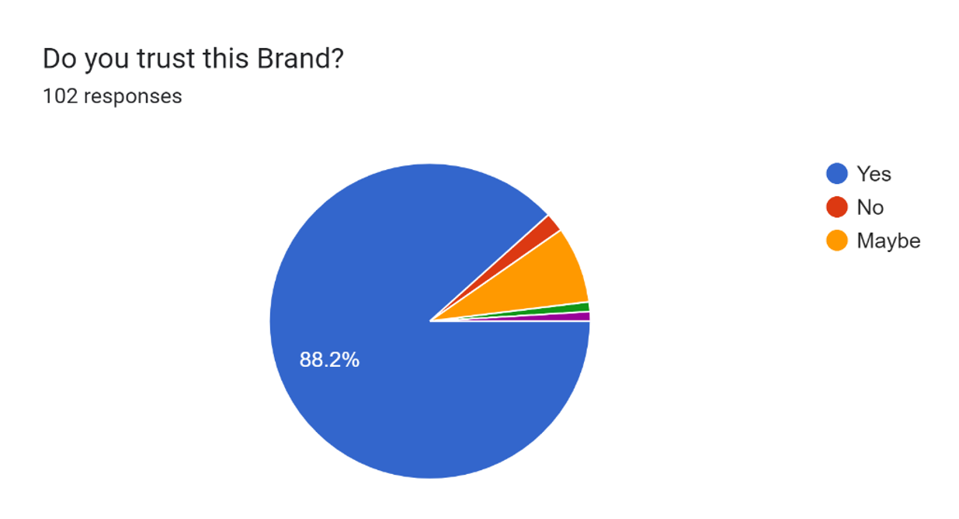
(Figure 11: Percentage of respondents who trust Apple brand) (Source: Author)
A total of 90 respondents expressed their trust in apple products by choosing ‘yes’ for the question ‘do you trust this brand?’ as presented in table 4. Thus, showing that 88.2% respondents trust Apple products as illustrated in figure 11. However, 10 respondents expressed their doubts about the Apple products by choosing the option ‘Maybe’ or giving a varied opinion. While 2 respondents expressed their distrust in Apple products by choosing the option ‘No’ as presented in table 4.

4.3.3.4 Impact of Brand Image on Purchase Decision:

Does Apple's brand image affect your purchase decision? | Count of Does Apple's brand image affect your purchase decision?
Yes | 53
No | 26
Maybe | 23
Grand Total | 102
(Table 5: Number of respondents effected of Apple’s brand image on purchase decision)
(Source: Author)

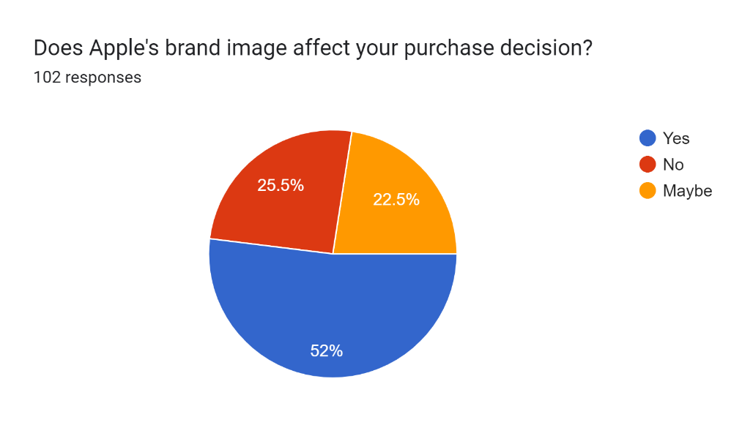
(Figure 12: Percentage of respondents effected of Apple’s brand image on purchase decision)
(Source: Author)
The above table and figure present the number and percentage of respondents who are prioritizing the image of a brand when making a purchase decision. A total of 53 respondents has expressed that a brand’s image impacts their purchase decision as presented in table 5. Making this category the largest with 52% respondents prioritizing the image of a brand as illustrated in figure 12. Meanwhile, 26 respondents expressed that a brand’s image does not affect their purchase decision. While 23 respondents implied that a brand’s image might or might not affect their purchase decision.

4.3.3.5 Customer Brand Loyalty:
Are you willing to purchase Apple products again in the future? | Count of Are you willing to purchase Apple products again in the future?
Yes | 69
Maybe | 26
No | 7
Grand Total | 102

(Table 6: Number of respondents willing to purchase Apple products again in the future)
(Source: Author)
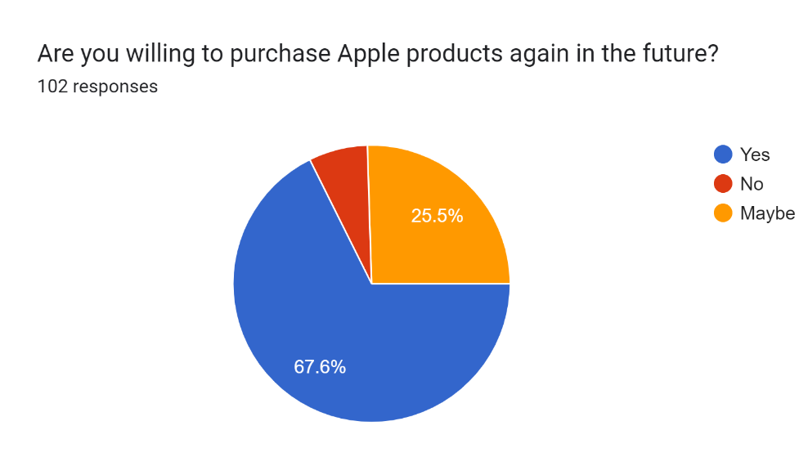
(Figure 13: Percentage of respondents willing to purchase Apple products again in the future)
(Source: Author)
The table 6 and figure 13, presents the number and percentage of respondents willing to purchase Apple products again in the future. A total of 69 respondents expressed their desire to purchase apple products again in the future as presented in table 6. Making this category the largest as 67.6% of respondents are willing to purchase Apple products again in the future, showing their brand loyalty as illustrated in figure 13. Meanwhile, 26 respondents expressed that they are unsure if they are willing to purchase apple products again in the future as presented in table 6. While 7 respondents expressed that they are not willing to purchase apple products again in the future as presented in table 6.

4.3.3.6 The likelihood of recommending Apple products:

How likely are you to recommend Apple products to others? | Count of How likely are you to recommend Apple products to others?
Likely | 36
Neutral | 28
Not Likely | 3
Very Likely | 35

(Table 7: Number of respondents willing to recommend Apple products to others)
(Source: Author)

(Figure 14: Percentage of respondents willing to recommend Apple products to others)
(Source: Author)
The table 7 and figure 14, presents the data about the respondents based on how likely they are willing to recommend Apple products to others. A total of 36 respondents have responded that they are ‘likely’ to recommend Apple products to others as presented in table 7. While 35 respondents have responded that they are ‘very likely’ to recommend apple products to others as presented in table 7, making the above 2 categories the largest with 35.29% and 34.31% respondents respectively as illustrated in figure 14. Meanwhile, 28 respondents expressed their desire to remain neutral. While 3 respondents expressed that they are not likely to recommend Apple products to others as presented in table 7.

4.4 Discussion
The primary purpose of this study is to understand the role of customer satisfaction and brand image on the brand loyalty. In order to gain a proper understanding of the practical implications of this theory, a globally successful brand like Apple, which boasts a large consumer base was chosen. The following discussion will cover all the aspects of the research including the primary aims and objectives of this research study. A critical analysis of the questionnaire results will be provided in this section. The result of the hypothesis 1,2 and 3 will be specified at the end of this discussion. According to hypothesis 1, Customer satisfaction is the essential for creating brand loyalty. While hypothesis 2 states that brand image has a significant role in the development in brand loyalty. However, according to the hypothesis 3 mentioned at the start of this research study, customer satisfaction has a stronger impact on the brand loyalty than the brand image of a brand.
The survey questionnaire was answered by a 102 respondents. The ratio of the respondents is 50% male and 49% female, while 1% preferred not to answer the question as presented in figure 5. The ratio male is closely followed by the female ratio of the respondents, presenting an approximately equal number of responses from all the mentioned gender groups. A majority of the respondents belong to the age category of ‘31 to 45’, this is followed by the ‘46 to 60’ age category as presented in figure 7. Thus, the average age of the respondents is over 30 years. while none of the respondents belong to the category of above 60 years. Most of the respondents have used Apple products for over 5 years, with 37 respondents belonging to this category. This number is closely followed by the new Apple customers who used Apple products for less than 1 year as presented in table 3. These numbers indicate brand’s capacity to attract newer customers, while also presenting the consumers brand loyalty. This shows that Apple boasts a large consumer base with brand loyal customers. 74 respondents have rated Apple over 8 in the survey, showing the brands customer satisfaction to be very high as illustrated in figure 10. Meanwhile, only 53 out of 102 respondents answered ‘yes’ to the question ‘does Apple’s brand image affects your purchase decision’ as presented in table 5. While 48% respondents opted for the options ‘No’ or ‘Maybe’. Thus, presenting the insignificance in the number for responses for brand image compared to the satisfaction of respondents. Apple has proved itself to be a trustable brand with over 88% of respondents trusting the brand as illustrated in figure 11. Over 67% respondents are willing to purchase again in the future, while 25.5% respondents are considering purchase Apple products again in the future as illustrated in figure 13. These numbers indicate that Apple has 69 confirmed brand loyal customers and 26 possible brand loyal customers among the respondents as presented in table 6. 72.6% of respondents among Apple’s possible brand loyal 93.1% customers have rated Apple products above 8, showing their satisfaction as illustrated in figure 10. Meanwhile, only 52% of respondents are willing to invest in a brand again based on the brand image as illustrated in figure 12. These numbers indicate the stronger impact of customer satisfaction over the brand image on the brand loyalty of Apple, while both customer satisfaction and brand image could influence brand loyalty among the customers. Thus, supporting the hypothesis 3. These results are further supported by the evidence gathered through secondary research that was presented in the chapter 2 literature review section, which states that the customer satisfaction is the result of superior experience a customer received from the product or a service (Manyanga et al., 2022). Meanwhile, brand image is a customer’s perception of a brand used for identification (Parris and Guzmán, 2022). While the significance of a brand’s image evolved over the years, the evidence found indicates that customer satisfaction has a stronger impact on the brand loyalty than the brand image of a brand. This hypothesis further solidifies with the addition of respondent’s feedback for the question ‘What do you like the most about apple brand?’, A majority of respondents stated that they like the ‘quality’ and ‘security’ of the Apple products. Thus, further supporting hypothesis 3. However, despite the stronger impact of customer satisfaction on brand loyalty, based on the responses received from the respondents, it can be presumed that the brand image of a brand does play an important role on the brand loyalty. Furthermore, 52% of the respondents stated that the brand image of a brand has an influence on their purchase decision as illustrated in figure 12. Therefore, proving the importance of the brand image on purchase decision and brand loyalty.
Chapter 5
5.0 Conclusion and Recommendations
In the competitive business environment, it is essential for brands to be proactive in engaging with their customers, comprehending their requirements and preferences, and continually strive to foster customer loyalty. This is of utmost importance for any organization that wishes to achieve long-term success. This study sought to gain insight into the relationship between consumer satisfaction and brand image of Apple, a globally renowned and innovative company, to gain a better understanding of how Apple has managed to maintain customer loyalty, generate innovation, and remain a leader in the market. The results of the study are applicable to a wide range of industries. Customer satisfaction leads the satisfied customers to become brand loyal. This process would allow a brand to further improve the brand image. Apple's success in establishing itself as a world-renowned and influential brand is largely attributed to its customer-focused approach. The company's focus on user experience has been a key factor in its success. This has not only resulted in positive customer reviews and referrals, but also in a strong emotional bond between customers and the company. Satisfaction with Apple products is largely based on their design, performance, and user experience. The study has also highlighted the importance of brand image in the context of Apple's brand loyalty. Apple's consistent branding strategies, competitive pricing, and distinct design language have enabled the company to cultivate a strong and aspirational image. Furthermore, a majority of the respondents stated that Apple products security and quality are the things they liked the most about the brand. Thus, compelling them to give a higher rating for their user experience as illustrated in figure 10. The elements specified by the respondents mentioning the aspects they like about the brand could be the primary reason behind Apple’s popularity. The brand image has been able to appeal to its target audience, not only by attracting new customers, but also by strengthening the loyalty of existing customers. This is further supported from the data collected form the responses where 52% of respondents mentioned that brand image effects their purchase decision as illustrated in figure 12. The study examined the relationship between customer satisfaction and brand image, as well as the impact of different product categories on brand loyalty. The results of the study suggest that customer satisfaction is crucial to achieve a higher level of brand loyalty. In this age of rapid technological progress, Apple's commitment to quality and innovation is essential for sustaining customer satisfaction. This study examined the influence of brand image on customer loyalty. The results of this study revealed that customer satisfaction has a stronger impact on brand loyalty than the brand image of a brand. This conclusion was reached after analysing the responses received from the respondents through the questionnaire survey. Moreover, the conclusion reached in this study aligns with the hypothesis 3 mentioned in chapter 1. It is important to emphasize that this research, which focuses on the correlation between customer satisfaction and brand image and brand loyalty in relation to Apple, is subject to limitations. The primary methodology used in the study is quantitative research, which provides useful information but may not accurately capture the entire range of customer sentiment and experience. More in-depth qualitative research, such as interviews or focus groups, could provide a more in-depth understanding of the emotional and psychological components of brand loyalty. Furthermore, the scope of the study is restricted to a specific time-period, and the dynamics in the smartphone and technology sector are highly dynamic, necessitating continuous research to ensure that the findings remain relevant. Businesses should strive to replicate the success of Apple in terms of customer satisfaction, branding, and brand loyalty. This study outlines the key takeaways for businesses to consider when creating a strong and unique brand image. Customer satisfaction is a key factor in creating a strong and lasting brand image, which is based on the customer's emotional connection to the product or service. To ensure customer satisfaction, companies should prioritize product quality, customer experience, and post-sale support. Additionally, investing in innovation is essential for sustaining customer satisfaction and brand loyalty. Finally, businesses should strive to be leaders in their industry, rather than followers. This study demonstrates the importance of customer satisfaction and brand image, as well as brand loyalty, in Apple’s success. Through its unwavering commitment to providing exceptional customer experiences, creating a strong brand identity, and cultivating a devoted customer base, Apple has established itself as a global pioneer in the technology sector. This success serves as a valuable lesson for any organization looking to succeed in a rapidly changing market. As technology advances and consumer preferences evolve, understanding and utilizing these dynamics will be essential for businesses looking to build long-term brand loyalty and reach long-term success.

Chapter 6
6.0 Limitations
Determining the influence of customer satisfaction on brand loyalty and brand image is a complex process with its own inherent limits and complexities. Consumer satisfaction is a subjective experience, affected by individual variability, and is closely linked to expectations management. While brand image is influential, it comes with limitations of control, issues of consistency, and a need to align with customer experience. Companies that understand these limitations and take a comprehensive approach to balance them will be more likely to build and maintain brand loyalty in a rapidly changing market. The sample size of this research study is 100. While the results seemed accurate, the values presented in research might vary compared to a larger sample size. Increasing the sample size in this research was not possible because of time constraints. However, with sufficient time and resources it is possible to get a result that is more accurate what was presented in this research. The data presented in this research might become less accurate or relevant as the time passes. This could be the result of internal or external factors that might change the respondents’ opinions or responses in the future. Therefore, creating the need to perform the same research again in the future. The conclusion reached as a part of this research study might be significantly different in the future due to any unforeseen short-term or long-term effect on the brand. Therefore, creating the need for further research on the research question in the future.

6.1 Future Research
This study has acknowledged that customer satisfaction is a key determinant of brand loyalty. Customers who are satisfied are more likely to return to the brand and are more likely to recommend it to others. In the future, this research could explore multiple aspects of customer satisfaction and their impact on brand loyalty. One potential aspect of inquiry could be to explore the influence of customer satisfaction and brand image on the brand loyalty across different industries. Furthermore, this research question could be answered with a larger sample size to possibly reach a different outcome for this study. Additionally, it is essential to understand the emotional components of customer satisfaction. Research could explore the role of emotional connections, trust, and a sense of belonging in promoting brand loyalty. As consumer expectations evolve, understanding how customer satisfaction is met will be of great importance. Examining the influence of customer satisfaction on brand loyalty and brand image is a constantly changing and developing area of research. Consumer preferences and behaviours are constantly changing, and it is important for businesses to understand how these factors affect brand loyalty in order to remain competitive and successful in the ever-evolving marketplace. Future research on this topic promises to provide valuable insights, allowing companies to develop more effective strategies to build and sustain brand loyalty in a constantly evolving business landscape.

Chapter 7
7.0 Reflection
This dissertation has been an educational journey that prospered my intellectual growth and personal development. The numerous hours I spent on researching, writing, and revising, made me realise the true charm of research. Choosing the right topic was the first significant challenge. After much contemplation and consultation with my supervisor, I settled on “Exploring the impact on customer satisfaction and brand image on the brand loyalty of Apple”. It is a topic with significant importance in the field of Marketing and is vital for every business. Writing a comprehensive literature review was an important aspect of my dissertation. It was here that I truly grasped the depth of the topic and identified gaps in existing research. The information was overwhelming, but I learned to refine my research question and critically evaluate sources to identify the most relevant literature. This helped me strengthen my research skills and provided me a solid foundation for my study. Collecting data through questionnaire was a challenge, it took me a significant amount of time to carefully prepare a questionnaire. It was a challenge to share my questionnaire with various Apple customers and reach my target for receiving 100 responses. Analysing the data received through the questionnaire and comprehending the responses was more straightforward than I expected. One of the biggest challenges I faced during this journey was time management. Managing time effectively become a critical skill I required during my journey, it was crucial for balancing coursework, personal life, and part-time job. Beyond the academic skills acquired, the dissertation journey has fostered personal growth. This taught me resilience, discipline, and the value of perseverance and helped me develop a deep appreciation for the importance of research and its potential to drive positive change in the world. As I look back on my dissertation journey, I am filled with a sense of accomplishment and gratitude. It was a challenging yet rewarding experience that has shaped me as a scholar and as an individual. This journey has pushed me beyond my comfort zone and honed my academic skills. The lessons in research, time management, and personal growth are invaluable and will undoubtedly benefit me in my future endeavours. I am now equipped with the knowledge and resilience to tackle my future research endeavours with enthusiasm and confidence. This journey has not only enriched my academic journey but has also left a lasting impact on my personal and professional life.

8.0 References
Abedi, E., and Jahed, A. (2020) ‘Investigating the effect of customer experience affinity and brand on brand equity with the mediating role of customer satisfaction in Iran Insurance company (case study: Tehran province branches customers)’, International Journal of Information, Business and Management, 12(1), pp. 165-176. Available at: https://www.proquest.com/docview/2344258414?pq-origsite=gscholar&fromopenview=true (Accessed: 27 July 2023).
Anpar Research (2020) Primary Research vs Secondary Research: Pros & Cons. Available at: https://www.anparresearchltd.com/post/primary-research-vs-secondary-research (Accessed: 29 September 2023).
Chen, S. C. (2015) ‘Customer Value and Customer Loyalty: Is competition a missing link?’, Journal of Retailing and Consumer Services, 22(1), pp. 107-116. Available at: https://doi.org/10.1016/j.jretconser.2014.10.007
Cuong, D. T. (2020) ‘Influence of Brand Trust, Perceived Value on Brand Preference and Purchase Intention’, Journal of Asian Finance Economics and Business, 7(10), pp. 939-947. Available at: doi:10.13106/jafeb.2020.vol7.no10.939
Ekinci, Y., Japutra, A., Molinillo, S., and Uysal, M. (2023) ‘Extension and Validation of a Novel Destination Brand Equity Model’, Journal of Travel Research, 62(6), pp. 1257-1276. Available at: https://doi-org.ezproxy.uwtsd.ac.uk/10.1177/00472875221125668
Faircloth, J. B., Capella, L. M., and Alford, B. L. (2015) ‘The Effect of Brand Attitude and Brand Image on Brand Equity’, Journal of Marketing Theory and Practice, 9(3), pp. 61-75. Available at: https://doi-org.ezproxy.uwtsd.ac.uk/10.1080/10696679.2001.11501897
George, T. (2023) What is Secondary Research? Definition, Types, & Examples. Available at: https://www.scribbr.co.uk/research-methods/secondary-research-explained/ (Accessed: 16 September 2023).
Grimm, M. S., and Wagner, R. (2021) ‘Intra-brand image confusion: effects of assortment width in brand image perception’, Journal of Brand Management, 28(1), pp. 446-463. Available at: https://doi.org/10.1057/s41262-020-00225-3
Indeed Editorial Team (2022) What is Aaker brand equity model? Definition and Components. Available at: https://www.indeed.com/career-advice/career-development/brand-equity-aaker-model (Accessed: 27 July 2023).
IPL (2023) Advantages and Disadvantages of Aaker Brand Equity Model. Available at: https://www.ipl.org/essay/Case-Study-Of-Aakers-Brand-Equity-F3SENL2PJ48R (Accessed: 29 September 2023).
Jeon, J. E. (2017) ‘The impact of brand concept on brand equity’, Asia pacific Journal of Innovation and Entrepreneurship, 11(2), pp. 233-245. Available at: https://doi.org/10.1108/APJIE-08-2017-030
Levy, S. (2023) Apple Inc. Available at: https://www.britannica.com/topic/Apple-Inc (Accessed: 27 July 2023).
Lowe, C. and Zemliansky, P. (2011) Writing Spaces 2: Readings on Writing. Anderson: Parlor Press LLC.
Manyanga, W., Makanyeza, C., and Muranda, Z. (2022) ‘The effect of customer experience, customer satisfaction and word of mouth intention on customer loyalty: The moderating role of customer demographics’, Cogent Business & Management, 1, article number 2082015. Available at: https://doi.org/10.1080/23311975.2022.2082015
Mai, D. S., and Cuong, D. T. (2021) ‘Relationship between Service Quality, Brand Image, Customer Satisfaction, and Customer Loyalty’, Journal of Asian Finance Economics and Business, 8(3), pp. 585-593. Available at: DOI: 10.13106/jafeb.2021.vol8.no3.0585
McCombes, S. (2019) Sampling Methods | Types, Techniques & Examples. Available at: https://www.scribbr.com/methodology/sampling-methods/ (Accessed: 26 September 2023).
Melnikovas, A. (2018) ‘Towards an explicit research methodology: Adapting research onion model for future studies’, Journal of Futures Studies, 23(2), pp. 29-44. Available at: DOI:10.6531/JFS.201812_23(2).0003
Parris, D. L., and Guzmán, F. (2022) ‘Evolving brand boundaries and expectations: looking back on brand equity, brand loyalty, and brand image research to move forward’, Journal of Product and Brand Management, 32(2), pp. 191-234. Available at: https://doi.org/10.1108/JPBM-06-2021-3528
Qualtrics XM (2023) What is brand image and how do you measure it. Available at: https://www.qualtrics.com/uk/experience-management/brand/brand-image/?rid=ip&prevsite=en&newsite=uk&geo=GB&geomatch=uk (Accessed: 27 July 2023).
Qualtrics XM (2023) What is brand trust and why is it so important?. Available at: https://www.qualtrics.com/uk/experience-management/brand/brand-trust/ (Accessed: 21 September 2023).
Rahman, S. (2017) ‘The Advantages and Disadvantages of Using Qualitative and Quantitative Approaches and Methods in Language “Testing and Assessment” Research: A Literature Review’, Journal of Education and Learning, 6(1), pp. 102-112. Available at: http://dx.doi.org/10.5539/jel.v6n1p102
Song, D. W. (2021) ‘What is research?’, WMU Journal of Maritime Affairs, 20(1), pp. 407-411. Available at: https://doi.org/10.1007/s13437-021-00256-w
Shakir, U. (2023) Apple surpasses 2 billion active devices. Available at: https://www.theverge.com/2023/2/2/23583501/apple-iphone-ipad-active-2-billion-devices-q1-2023 (Accessed: 26 September 2023).
Simkus, J. (2023) Cluster Sampling: Definition, Method and Examples. Available at: https://www.simplypsychology.org/cluster-sampling.html (Accessed: 30 September 2023).
Suchánek, P., and Králová, M. (2019) ‘Customer Satisfaction, Loyalty, Knowledge and competitiveness in the food industry’, Economic Research-Ekonomska Istraživanja, 32(1), pp. 1237-1255. Available at: https://doi.org/10.1080/1331677X.2019.1627893
Tanveer, Z., and Lodhi, R. N. (2016) ‘The Effect of Brand Equity on Customer Satisfaction: An Empirical Study Based on David Aaker’s Brand Equity Model’, IUP Journal of Brand Management, 13(3), pp. 43-54. Available at: https://www.proquest.com/docview/1827827810?fromopenview=true&pq-origsite=gscholar (Accessed: 20 July 2023).
Thuy, T. T. T., and Klymova, E. (2022) ‘Assessment of marketing costs on the example of Apple and Samsung companies’, Technology audit and production reserves, 4(66), pp. 14-17. Available at: doi:10.15587/2706-5448.2022.265572
Trivedi, A. J. (2019) ‘Maslow’s Hierarchy of needs – Theory of Human Motivation’, International Journal of Research in all subjects in Multi Languages, 7(6), pp. 38-41. Available at: https://www.raijmr.com/ijrsml/wp-content/uploads/2020/01/IJRSML_2019_vol07_issue_06_Eng_09.pdf (Accessed: 12 October 2023).

9.0 Appendix
9.1 Research Questionnaire

- What is your Age?

- 18 to 23

- 24 to 30

- 31 to 45

- 46 to 60

- Above 60

- Prefer not to say

- How do you Identify yourself?

- Male

- Female

- Prefer not to say

- Other…

- What do you prioritize in a Brand?

- Price

- Brand

- Quality

- Other…

- How are you aware of Apple Brand?

- Social Media

- Family and Friends

- Advertisement

- Other…

- How likely are you to recommend Apple products to everyone?

- Very Likely

- Likely

- Neutral

- Not Likely

- How long have you been purchasing products from Apple?

- 0 – 1 year

- 2 – 3 years

- 4 – 5 years

- More than 5 years

- How good is the customer support team of Apple to you?

- Excellent

- Good

- Fair

- Poor

- Please rate the Apple products out of 10?

- 1
- 2
- 3
- 4
- 5
- 6
- 7
- 8
- 9
- 10

- Do you trust this Brand?

- Yes

- No

- Maybe

- Other…

- Does the brand image of Apple affect your purchase decision making process?

- Yes

- No

- Maybe

- Other…

- Which promotion media do you prefer the most?

- Social media

- Websites

- Leaflets

- Other…

- What do you like the most about apple?

- Short or Long Answer text

- What could Apple change to improve their products?

- Short or Long Answer text

- Are you willing to purchase Apple products again in the future?

- Yes

- No

- Maybe

