

Programme: BSc Health and Social Care
Module: Protecting and Supporting Families in Health and Care
Module code: BMHP5021
Assignment Title: Component 2: Written Report
Student Name: Elena Coroeanu
Student number:2325653
Teacher name: Philip Jones

Table of Contents
Introduction 2
Explanation of the Early Help System 3
Explanation of Multi-Agency Working 4
Evaluation of Each Local Authority Website 5
Comparative Analysis 8
Conclusion 9
Recommendations 10
References 11

Introduction
This research analyses the presentation of the Early Help system to families via local authority websites in the United Kingdom. The objective is to assess the clarity and efficacy of online communication on Early Help and family support programs. Early Help is essential in protecting children by identifying issues swiftly and providing support before problems intensify. It fosters collaboration among experts and families to improve children's welfare and reduce the need for governmental intervention. As stated in Working Together to Safeguard Children (HM Government, 2023), Early Help guarantees that children and families have prompt, coordinated assistance through collaborative efforts across health, education, and social care providers. The Early Help System Guide (Department for Education, 2022) emphasises the significance of local collaborations in establishing accessible and responsive family support systems. The article examines three local authorities: Leeds City Council, Norfolk County Council, and Staffordshire County Council, to evaluate the presentation of Early Help material on their websites. The analysis evaluates the strengths and shortcomings of each site and indicates which provides the most effective and accessible information for families in need of support.
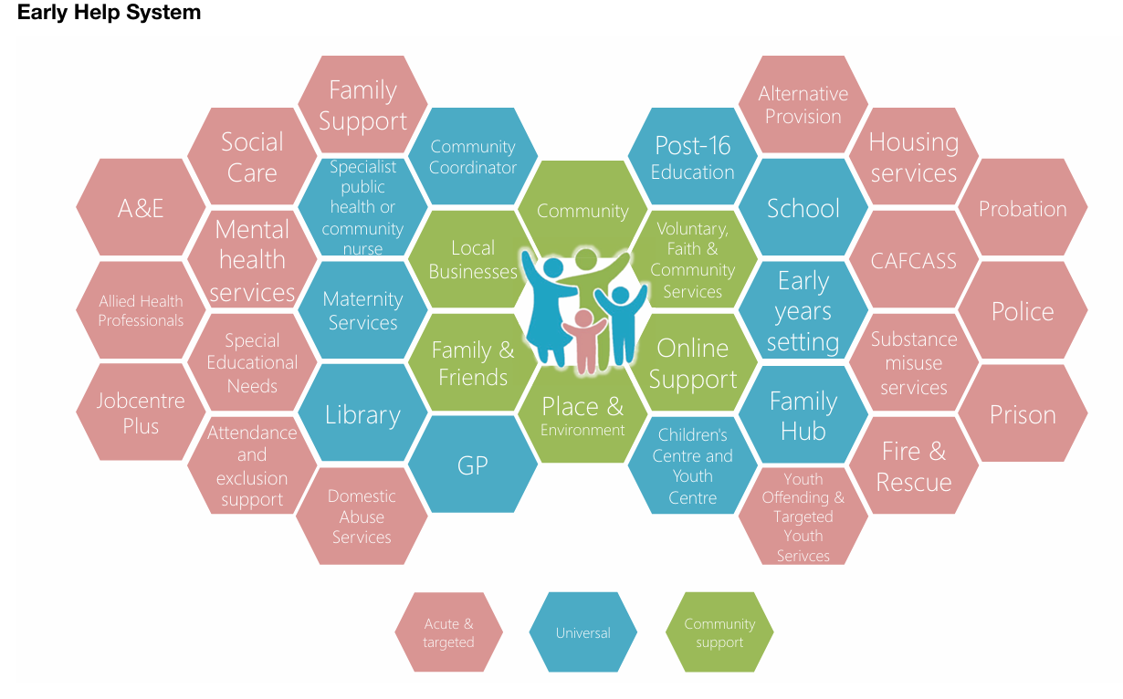
Fig 1. The Early Help System
(Sources: https://assets.publishing.service.gov.uk/media/628de13be90e071f5f7e1bd2/Early_Help_System_Guide.pdf).

Explanation of the Early Help System
The Early Help system is a nationwide framework aimed at identifying and addressing the growing needs of children, young people, and families prior to the escalation into significant issues. The Early Help System Guide (Department for Education, 2022) states that Early Help seeks to provide families with timely, coordinated, and appropriate help from pertinent services. It aims to enhance family resilience, promote child well-being, and diminish the necessity for statutory interventions. Early Help relies on collaborative efforts among specialists in education, health, and social care to deliver support customised to the specific requirements of each family.
The Keeping Children Safe, Helping Families Thrive report (Department for Education, 2024) underscores that Early Help empowers families to surmount obstacles to opportunity by prioritising prevention over crisis intervention. It assists parents in enhancing their ability to nurture their children, while tackling difficulties like as poverty, mental health disorders, and domestic strife. This proactive strategy seeks to diminish long-term expenses for public services by implementing early interventions and fostering durable transformations within families.
The Early Help System Guide (Department for Education, 2022) delineates key ideas such as collective accountability among agencies, service accessibility, and an emphasis on familial strengths. The guide emphasises that efficient Early Help systems depend on well-defined local strategies, robust leadership, and evidence-based practices. Services must be readily accessible and effectively promoted, ensuring that families are informed on how to obtain support. Inter-agency communication is essential for early identification of needs and the coordination of suitable solutions.
Early intervention is essential to child wellbeing. The Early Intervention Foundation (2018) claims that high-quality early intervention improves educational, social, and emotional outcomes for children, especially those from low-income families. This research supports the government's Supporting Families project (Gov.UK, 2021), which promotes inter-agency collaboration to help needy families gain tangible results. The Early Help system embodies a systematic, proactive strategy for family assistance. It depends on robust collaborations, prompt recognition of requirements, and readily available local services. By responding promptly, professionals can mitigate dangers, enhance familial bonds, and guarantee that children are raised in secure and nurturing homes.

Explanation of Multi-Agency Working
Multi-agency collaboration unites specialists to deliver coordinated assistance for children, adolescents, and families. It encompasses collaborative planning, collective decision-making, and transparent communication among services. The document "Working Together to Safeguard Children" (HM Government, 2023) asserts that effective safeguarding relies on robust partnerships in which agencies comprehend their responsibilities and collaborate to address children's needs. This method guarantees early identification of concerns and ensures that support is systematic and well-coordinated.
A variety of agencies participate in multi-agency practice. Schools are crucial as they monitor children every day and can detect alterations in behaviour or wellness. Health visitors assist parents and oversee a child's growth in the early years. Social workers evaluate risk and organise assistance for families requiring systematic intervention. Additional collaborators including law enforcement, early childhood providers, juvenile services, and nonprofit groups. These agencies exchange information to develop a comprehensive knowledge of a family's situation and provide support that is consistent with Early Help protocols.
Collaboration between agencies has several advantages. It avoids repeated assessments, enhances communication, and coordinates family support. Cooperation boosts professional confidence and improves results since agencies share knowledge and abilities, according to Atkinson, Jones, and Lamont (2018). Health, school, and parenting issues can be addressed simultaneously with this approach.
Challenges affect collaboration. Intervention thresholds vary per agency, delaying support. Uncertain protocols impede information sharing. High workloads can also limit meeting and early intervention time for professionals. HM Government (2023) says strong leadership, shared training, and clear communication assist agencies overcome these problems and coordinate Early assist support.

Evaluation of Each Local Authority Website
Leeds City Council
Leeds provides Early Help information via its Children and Families webpages. The website provides distinct access points for families, featuring Early Years and broader family assistance material organised under clear headings (Leeds.gov.uk, 2025). Navigation is straightforward, allowing families to transition from the primary Children and Families page to details regarding Early Help and local resources without ambiguity (Leeds.gov.uk, 2022). The style uses brief, simple portions to help families understand Early Help and its benefits. Succinct, simple language makes the material accessible.
The Leeds website's strength is in its straightforward layout, which provides guidance to support options for children aged 0 to 5, along with addressing broader requirements. A further strength lies in its implementation of uniform headings that enable families to locate guidance swiftly. What is lacking is clearer Early Help labelling and a consolidated page that comprehensively describes Early Help in one location. The website is informative yet disseminates Early Help information across multiple interconnected sections. Leeds provides excellent accessibility and transparency for families in need of assistance.
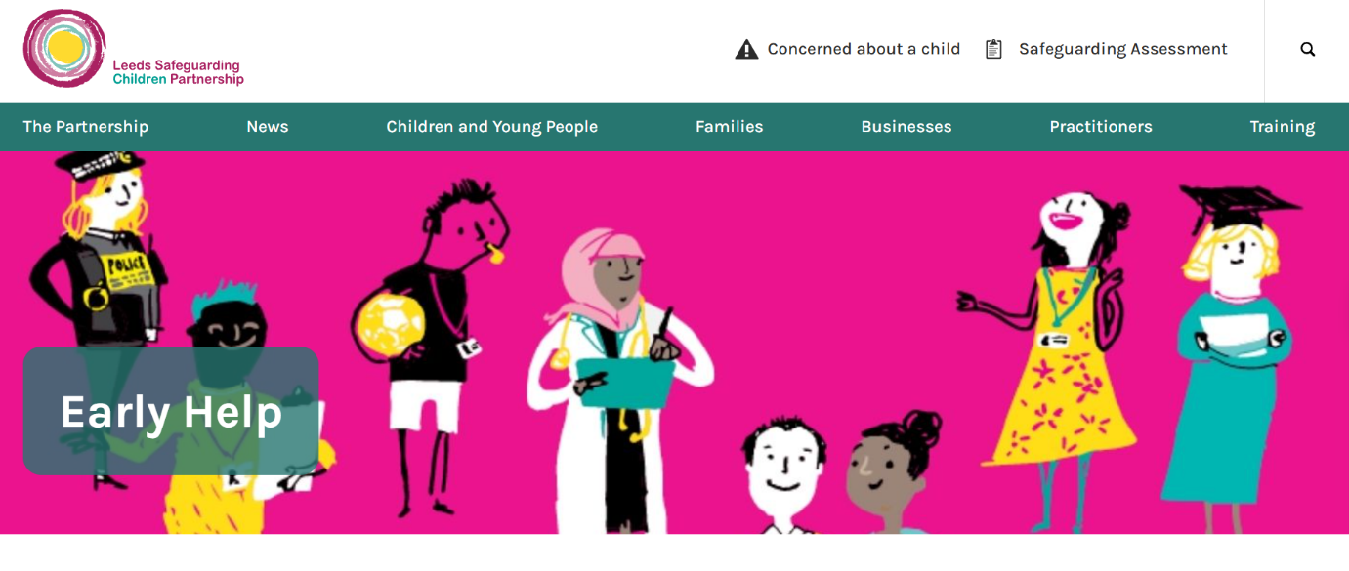
Figure 2. Official Early Help Page – Leeds Safeguarding Children Partnership.
(Sources: https://www.leedsscp.org.uk/practitioners/working-with-families/early-help).

Norfolk County Council
Norfolk offers specialised Early Help page detailing assistance for children and young individuals up to eighteen years old, or twenty-five for those with exceptional requirements (Norfolk County Council, 2025). The page employs titles like “How We Can Help” and “Request Early Help Support,” providing straightforward elucidations. The navigation is user-friendly as the Early Help page is prominently located within the primary Children and Families section. The format is clear and employs concise paragraphs, facilitating ease of comprehension for families. The Norfolk website's strength is in its extensive content encompassing mental welfare, conduct, educational challenges, family routines, and practical concerns.
The page assists families in identifying indicators that they may want assistance. User-friendly visual aids, such as diagrams or downloadable checklists for families, are lacking. The information is dense with language, potentially hindering accessibility for those who choose visual organisation. Norfolk communicates effectively regarding Early Help but can enhance usability by implementing more prominent visual signposting and a more streamlined layout.
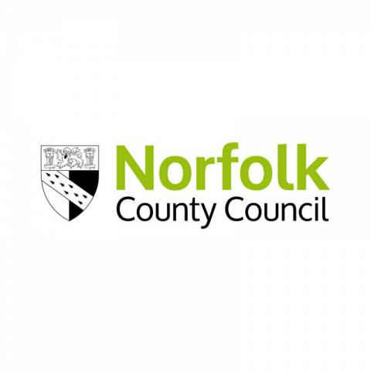
Figure 3. Norfolk County Council Official Logo.
(Sources: https://www.norfolk.gov.uk/).

Staffordshire County Council
Staffordshire disseminates Early Help information via its Families First pages. This document outlines how professionals assist families with various issues and provide explicit descriptions of the Early Help role (Staffordshire.gov.uk, 2023). The website enumerates issues including behaviour, attendance, and parenting concerns, assisting families in recognising when support may be necessary. Navigation necessitates additional steps compared to Leeds or Norfolk, as certain information is located within sections intended for partners rather than families.
The layout is straightforward however employs technical terminology and references to partnership structures, which may provide comprehension challenges for families lacking professional expertise (Staffordshire.gov.uk, 2023). The Staffordshire website's strength is in its comprehensive elucidation of services and referral pathways. The site offers concrete examples that assist families in comprehending the scope of Early Help. A more family-oriented layout and clearer explanations tailored for parents are lacking. The information is informative but might improve with more explicit titles and simplified language tailored for families.
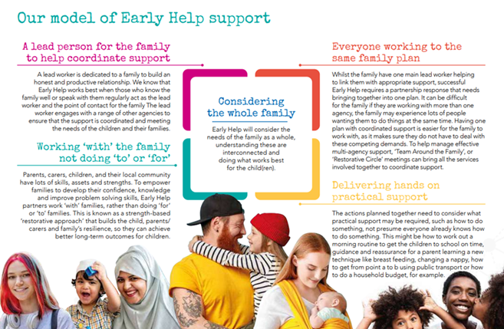

Figure 4. Staffordshire Safeguarding Children Partnership - Model of Early Help Support.
(Sources: https://www.staffsscp.org.uk/).

Comparative Analysis
The three local authority websites exhibit distinct variations in the presentation of Early Help information, particularly on accessibility, family orientation, and clarity of navigation. Leeds provides the most robust family-oriented framework. The Early Years and Children and Families sections are concise and easy to navigate for parents seeking help (Leeds.gov.uk, 2022; 2025). Leads’ clean layout is its biggest virtue, but its biggest flaw is spreading Early Help material across numerous pages.
Norfolk offers a singular Early Help website, establishing a distinct access point for families in need of assistance (Norfolk County Council, 2025). Its advantages encompass extensive topic coverage and comprehensible explanations that assist families in recognising the appropriateness of Early Help. Norfolk further has distinct sections, like "How We Can Assist." The deficiency resides in its text-dominant design, which diminishes accessibility for individuals who require visual assistance. The structure is instructive yet might enhance user-friendliness.
Staffordshire provides Early Help information via its Families First pages. This document provides comprehensive descriptions of support paths and illustrations of challenges that families may encounter (Staffordshire.gov.uk, 2023). This information is beneficial for comprehending the objective of Early Help. The drawback is that several sections are designed for a professional audience and employ technical terminology that may perplex families. Navigation necessitates additional steps, hence diminishing accessibility for novice users.
All three authorities demonstrate strength in their dedication to articulating Early Help through unambiguous statements, aligning with the goals outlined in Working Together to Safeguard Children (HM Government, 2023). Leeds most closely adheres to the guidance due to its use of clear language and explicit signposting. Norfolk effectively aligns with its emphasis on early identification, whilst Staffordshire adheres to the guidance through its comprehensive service descriptions.
In overall, Leeds has the easiest-to-find and most family-friendly Early Help information. Norfolk has strong breadth but needs clearer visual signposting. Staffordshire gives detailed information about its services, but the language is too complicated and the navigation is too indirect.

Conclusion
The assessment of Leeds, Norfolk, and Staffordshire reveals distinct variations in the manner each local authority conveys Early Help information to families. Leeds presents the most effective strategy as its Children and Families websites employ plain language, straightforward navigation, and organised sections that facilitate comprehension for families. The website adheres closely to the principles outlined in the Early Help System Guide, which underscores accessibility, clarity, and effective communication. Leeds offers information for all age groups and assists families in identifying when Early Help is necessary. The design and navigation facilitate families in transitioning between pages and swiftly identifying support.
Norfolk offers a singular, dedicated Early Help portal that assists families in locating information in a centralised manner. The content is explicit and addresses a broad spectrum of challenges that families may encounter. This method embodies the recommendations for establishing Early Help systems that facilitate early detection. Norfolk's primary challenge is its substantial dependence on text, which diminishes usability for families who favour visual information or explicit step-by-step instructions. While the messages are beneficial, the presentation might be enhanced to more effectively facilitate accessibility.
Staffordshire provides comprehensive information via its Families First pages. This information aids families in comprehending the objectives of Early Help and the many forms of assistance accessible. The structure provides pertinent instances of issues, assisting families in identifying when Early Help may be applicable. However, the language exhibits a more professional tone, and the navigation necessitates additional steps compared to Leeds and Norfolk. This diminishes clarity for families inexperienced with Early Help or requiring clear directions.
Leeds is the most efficient because to its amalgamation of clarity, simplicity, and robust indications. Norfolk is informative, it requires a more family-oriented framework. Staffordshire offers valuable information but requires more precise wording and streamlined navigation to enable families to confidently utilise Early Help guidelines.

Recommendations
Local authorities ought to adhere to the Early Help System Guide by enhancing clarity, consistency, and accessibility. Norfolk ought to integrate visual aids and streamlined designs. Staffordshire ought to minimise professional jargon and establish a parent-centric Early Help section with straightforward navigation. Leeds should consolidate its Early Help material onto a single site to enhance coherence. All authorities must delineate explicit procedures for families to request Early Help support.

References
- Atkinson, M., Jones, M. and Lamont, E. (2018). Multi-agency Working and its Implications for Practice. University of Warwick.
- Department for Education. (2022). Early Help System Guide a Toolkit to Assist Local Strategic Partnerships Responsible for Their Early Help System. https://assets.publishing.service.gov.uk/government/uploads/system/uploads/attachment_data/file/1078299/Early_Help_System_Guide.pdf (Accessed on 08 November 2025).
- Department for Education. (2024). Keeping Children Safe, Helping Families Thrive Breaking down barriers to opportunity. https://assets.publishing.service.gov.uk/media/67375fe5ed0fc07b53499a42/Keeping_Children_Safe__Helping_Families_Thrive_.pdf (Accessed on 08 November 2025).
- Early Intervention Foundation. (2018, October 30). Realising the potential of early intervention. Early Intervention Foundation. https://www.eif.org.uk/report/realising-the-potential-of-early-intervention (Accessed on 08 November 2025).
- Gov.UK. (2021, March 26). Supporting Families - 2021-22 and beyond. GOV.UK. https://www.gov.uk/government/publications/supporting-families-2021-to-2022-and-beyond/supporting-families-2021-22-and-beyond (Accessed on 08 November 2025).
- HM Government. (2023). Working Together to Safeguard Children 2023. https://assets.publishing.service.gov.uk/media/6849a7b67cba25f610c7db3f/Working_together_to_safeguard_children_2023_-_statutory_guidance.pdf (Accessed on 08 November 2025).
- Leeds.gov.uk. (2025). Early years (ages 0 to 5) | Leeds.gov.uk. [online] Available at: https://www.leeds.gov.uk/children-and-families/early-years (Accessed 10 Nov. 2025).
- Leeds.gov.uk. (2022). Available at: https://www.leeds.gov.uk/children-and-families (Accessed 10 November 2025).
- Norfolk County Council. (2025). Early help for children and families. [online] Available at: https://www.norfolk.gov.uk/article/40407/Early-help-for-children-and-families https://www.leeds.gov.uk/children-and-families (Accessed 10 November 2025).
- Parliament.uk. (2020). The Health Protection (Coronavirus, Restrictions) (North East of England) (Amendment) Regulations 2020 (S.I., 2020, No. 1012) - Committees - UK Parliament. [online] Available at: https://committees.parliament.uk/work/666/childrens-social-care/publications/ (Accessed 10 November 2025).
- Strengthening Early Help NCB’s response to the Independent Review of Children’s Social Care ‘Call for Ideas’. (2021). Available at: https://www.ncb.org.uk/sites/default/files/uploads/files/20210513_Call%20for%20Ideas%20-%20v4.pdf (Accessed 10 November 2025).
- Staffordshire.gov.uk. (2023). Families First - Staffordshire County Council. [online] Available at: https://www.staffordshire.gov.uk/Care-for-children-and-families/Familiesfirstpartners/Families-First.aspx (Accessed 10 November 2025).

