
Module: Strategic Management
LCMB7003
Amma-harar Russell Young
1808757

Executive Summary
The Tesco plc, the largest retail grocery company in the UK, is seeking a new wave of global expansion following the globalisation of its business. Vietnam is a good growth option as it has high economic growth rates, an emerging middle-class, urbanisation and growing demand of modern reliable retail formats. The UK-Vietnam trade deals and the rapid pace of digital adoption also provide additional appeal to the market. Strategic analysis reveals positive macroeconomic environment, disaggregated competition and high potential of omni-channel retailing. The Tesco supply-chain competence, own-label potential, brand recognition and data-driven retailing have obvious VRIO benefits that can fit the developing Vietnamese retail market. A joint venture is suggested to create a balance between the control of operations and local knowledge and regulatory alignment. The anticipated results are expansion of market share, diversification of revenue and consolidation in Southeast Asia. Measures of performance will be KPIs such as financial outcomes, customer rise, operational effectiveness and digital acceptance and ability building in the workforce.

Table of Contents
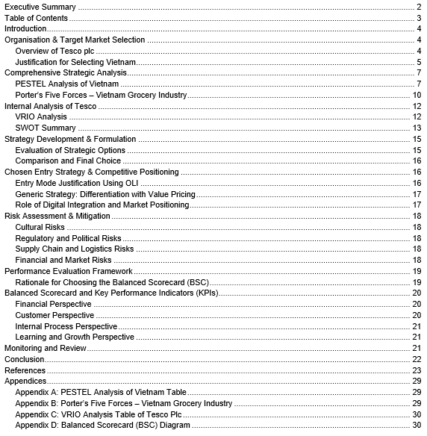

Introduction
Global retail is characterised by a fast-moving volatility brought on by changing consumer demands, technological noise and heightened competition among discount and digital-first retailers. The current economic uncertainty, supply chain fragility and unstable demand that retailers become more tactical in their operations (Jean, 2024). Utilisation of one mature market would make them more vulnerable to saturation, regulation, and various market cycles, and that is why, diversification abroad is the necessary factor to ensure future growth and reduce the risk (Kashob, Abdellatif Chakor and Al-Ansi, 2025). The UK-based Tesco plc, the largest grocery retailer in the country, has been streamlining its international presence over the recent years, and has left the non-performing markets and reinforced its digital retailing, supply-chain and own-label presence (Li and Zeng, 2024). These improved capabilities have now offered a formidable base of selective expansion into the high growth emerging markets where modern formats of retailing are rising. This report is aimed at coming up with a strategic expansion plan to the entry of Tesco into Vietnam. It analyses macro-environment and competitive environment in Vietnam, analyses internal strength and strategic orientation in Tesco, and gives a proposed evidence based market-entry and competitiveness strategy. The report dwells on the grocery business of Tesco in the Vietnamese environment, then a performance appraisal framework, and the closing conclusions (Zhao and Priporas, 2017).

Organisation & Target Market Selection

Overview of Tesco plc
Established in 1919, Tesco plc has over the years developed to become the 0nst largest food and grocery retailer in the UK, with a network of supermarkets, hypermarkets, convenience stores and a well-established online platform. Its established experience as a market leader in the UK retail environment represents a strong size benefit, extensive customer reach and deep integration in the physical and digital space where it can serve millions of households every week and retain its place as a key stakeholder in the UK food system (Chowdhury, 2025). In addition to the UK, Tesco has gained extensive global experience in operation in Ireland, Central Europe, Thailand, South Korea, Japan, Turkey, Malaysia, Poland and the United States. Such expansions were by acquisition or joint venture and had the benefit of rapid market entry and scale. Yet, strategic consolidation throughout the last 10 years has seen Tesco leave some of its non-core or low-performing markets but maintain a more focussed global presence in Central Europe and Ireland (Coe, Lee and Wood, 2017). Tesco has advanced strategic competencies today that support its competitiveness. Its digital transformation, which is reinforced by analytics-based decision-making using dunnhumby, online grocery services and customer loyalty ecosystem Clubcard, boosts personalisation and retention (Chaiyan Pimsen et al., 2024). The Tesco expertise in supply-chain that includes national logistics, effective distribution centres and effective supplier relationships is resilient and cost effective. Its own-label brands such as Tesco Finest have been differentiated and they come with quality assurances and better margins. With the competitive and low-margin UK grocery market, which is pressurised by discounters and increasing operational costs, Tesco has limited growth options at home. The company has a better balance sheet and polished operational capability, and builds selective entry into high-growth international markets, where modern retail formats are growing, and its capabilities can create unique value (Li and Zeng, 2024). Vietnam is one of the opportunities in this strategic change.

Justification for Selecting Vietnam

Market Size and GDP Growth
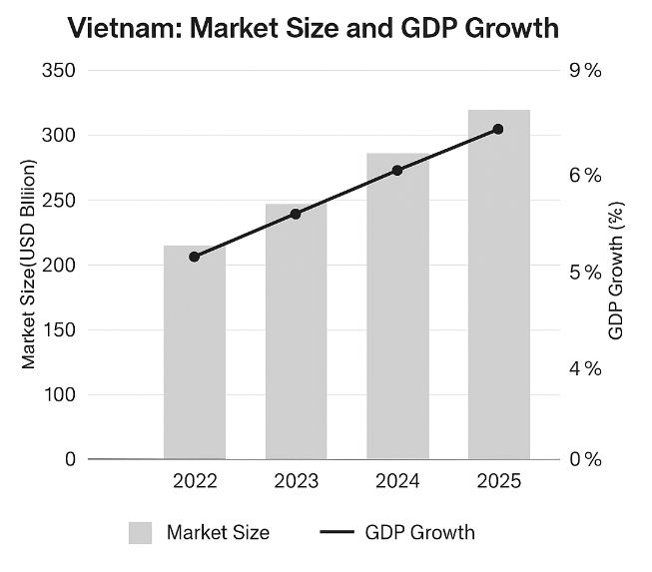
Figure: Vietnam Market Size & GDP Growth (Davis, 2025)
Vietnam is one of the quickest developing economies in Asia, and its retail market is projected to reach USD 300 billion by 2025 and good prospects of future consumption growth. The combination of sound GDP growth, export-driven and increased household income is contributing to continuous growth in consumer expenditure, making Vietnam a very lucrative target market to multinational retailers (Davis, 2025).

Modern Retail Adoption and Consumer Behaviour
Vietnamese shoppers are moving off the old wet market to the new retailing styles like supermarkets, hypermarkets and convenience shops. The growing demand is now influenced by food safety, uniform pricing, brand loyalty and comfort (Khaled Al Falah, Abdulrahman Al Sughayir and Albarq, 2024). At the same time, the use of digital is increasing, and young consumers are likely to adopt online grocery services and omnichannel purchasing behaviour. The trends resonate well with Tesco's online retailing strengths, loyalty programmes and combined format initiatives.

Urbanisation Trends
The retail scene is changing due to rapid urbanisation of the major cities in Ho Chi Minh City, Hanoi and Da Nang. Urban families prefer organised shopping with higher hygienic standards, broader selection and guaranteed quality. With growing urban population density, convenience stores and mixed-format retail have an opportunity to grow, and Tesco already has a ready supermarket, express and online format (Fu, 2024).

Preferential UK-Vietnam Trade Relations (EVFTA/UKVFTA)
The connexion between Vietnam and UK is the free trade agreement (UKVFTA), the extension of the previous EU-Vietnam arrangement. This treaty lowers tariffs, enhances the transparency of regulations and makes investments more favourable to UK companies. Inclusion in the CPTPP also makes the UK increasingly integrated with the Indo-Pacific region, which increases the strategic appeal of Vietnam to British multinationals.

Opportunity Tesco Can Use
Although the grocery retail market is growing, it is still fragmented and no single player dominates it in Vietnam and is relatively low about the penetration of modern formats. This division is a structural advantage of a retailer that Tesco is by size, brand-strength, a personal-label and a supply-chain sophistication (Stecula, Wolniak and Aydin, 2024). Tesco has the opportunity to provide unity in quality, fresh food standards and value package which respond to the new consumer priorities.

Strategic Fit of Tesco Capabilities
The young population, increasing incomes, and the use of digital and the changing retail formats are strengths of Vietnam compared to Tesco in its operational efficiency, data analytics, the production and development of its own labels and omnichannel retailing. Vietnam would provide diversification to the Tesco revenue base and enable long-term strategic development and place the company in a strong position in a fast-growing market in the Southeast Asian region (Coe, Lee and Wood, 2017).

Comprehensive Strategic Analysis

PESTEL Analysis of Vietnam
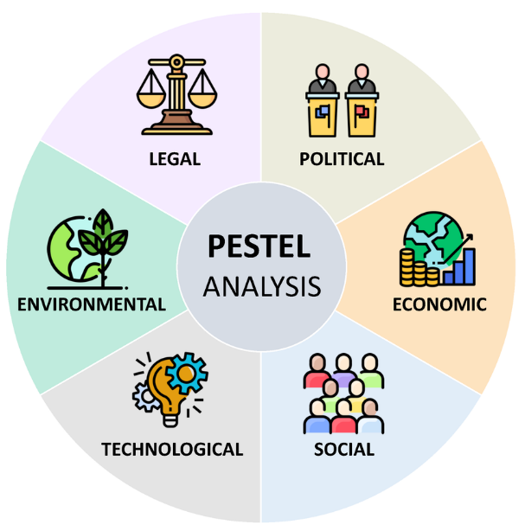
Figure: PESTEL Analysis (Chokdee Siawsolit and Gaukler, 2019)
Factor | Key Points | Implications for Tesco
Political | Stable government; supportive retail modernisation policy; improving trade environment | Predictable environment; supportive for foreign retailers through modernisation incentives
Economic | Strong GDP growth; rising incomes; expanding middle class; urbanisation | Increasing demand for modern grocery retail and value-focused offerings (Chokdee Siawsolit and Gaukler, 2019)
Sociocultural | Growing preference for convenience, food safety, trusted brands, younger demographic | Opportunity to leverage Tesco’s quality standards and private-label proposition
Technological | High mobile penetration, rapid growth of e-commerce, digital retail incentives | Strong alignment with Tesco’s omnichannel capability and loyalty systems (Roy, 2024)
Environmental | Increasing sustainability regulation; waste management focus | Need for strong supply-chain transparency and sustainability practices
Legal | Evolving FDI laws, structured licensing, and compliance requirements | Requires partnerships, regulatory alignment, and phased expansion

Political & Regulatory Environment
The retail market in Vietnam has a stable political environment due to the socialist oriented market economy. The government has continued to liberalise trade, promote foreign investment and modernise the regulatory frameworks since the Doi Moi reforms in the late 1980s. The recent national strategy seeks to construct a contemporary, competitive and sustainable retail market by 2030, enhancing supply-chain expansion, digitalisation and involvement of foreign retailers. This direction of policy lowers barriers to entry and increases regulatory predictability to companies such as Tesco. Nevertheless, it may still be difficult to manoeuvre through the regulatory environment in Vietnam, especially in terms of licensing, foreign investment and compliance procedures. These red tapes emphasise the significance of effective local collaborations and effective compliance (Githu and Waithaka, 2025).

Economic Environment
The economy of Vietnam has also remained the fastest growing in Asia, with increasing incomes, more middle classes, and higher urban spending. Retail sales increased by almost a fifth in 2022, indicating a good post-pandemic recovery and increasing demand. The retail market is worth hundreds of billions of US dollars and is set to grow in the next few years in the single digits (Mordor Intelligence, 2024). The modern grocery retail is also enhanced by demographic changes such as a large young population, and increased disposable income. It is a favourable economic trend that allows international retailers who scale operations effectively (Caro, Kok and Martinez-de-Albeniz, 2020).

Sociocultural Trends
The changing consumer behaviour is due to urbanisation and increasing expectations of the middle class. Customers are placing greater emphasis on convenience, food safety, product consistency and new retail experience. Although conventional wet markets are still important, supermarkets, convenience stores and hypermarkets are on the rise (TRAN, 2023). The younger consumers are also more inclined towards branded and own-label products, healthier lifestyles and international retail norms- aspects that resonate well with what Tesco is offering.

Technological & Digital Retail Trends
Vietnam is a fast-digitalising country, and smartphone and internet penetration rates are high. Online grocery shopping and e-commerce are on the rise because of better digital literacy and payment systems (Docas Akinleye, Godwin Olaoye and Joseph, 2023). Omnichannel retailing is also supported by government policy underlining digital transformation. Analytics, digital logistics and loyalty systems allow Tesco to be in a good position to cater to digitally oriented consumers in Vietnam (Enders and Jelassi, 2017).

Environmental and Sustainability Concerns
Vietnam is becoming more sustainable in the development of retail, and this is promoting efficient supply chains, waste management, and environmentally friendly operations. In the case of Tesco, sustainable sourcing, packing, management and transparent supply chains would contribute to more trust between stakeholders and can raise the brand among city shoppers (Sah, Hong and Huang, 2025).

Legal & FDI Environment
The changing FDI regime is a pointer to Vietnam being integrated into global trade systems since it became a WTO member. Retail modernisation policies have enhanced the environment of foreign retailers (Sugiharto and Deniar, 2021). However, other requirements like store approvals, localisation regulations and regulatory controls are tough and joint ventures or partnerships present a good entry strategy in compliance.

Critical Evaluation of the PESTEL Method
While the PESTEL analysis provides a useful, comprehensive overview of external macro-factors influencing entry into Vietnam, it has limitations. PESTEL is inherently descriptive and static: it identifies trends and conditions but does not predict how quickly these will change or how market players will respond. It also cannot fully capture the interaction between factors (e.g., how regulatory reforms, digital adoption, and consumer behaviour may converge or conflict). Finally, by focusing on macro-level factors, PESTEL may omit micro-level competitive dynamics, cultural nuances, or firm-specific operational challenges (Alanzi, 2018). These limitations mean that PESTEL should be complemented with industry-level and internal analyses to build a robust strategy.

Porter’s Five Forces – Vietnam Grocery Industry
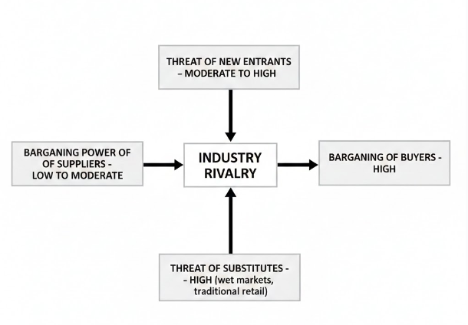
Figure: Porter’s Five Forces – Vietnam Grocery Industry (Nassar, Gad and Kortam, 2021)

Buyer Power
Buyer power in the grocery market of Vietnam is also high since the retail formats are diverse, such as the traditional wet markets, supermarkets, hypermarkets, convenience stores and e-commerce which is rapidly increasing. The switching cost of consumers is low and tends to price, quality, and convenience comparison, particularly among the lower- and middle-income groups (Nassar, Gad and Kortam, 2021). This high bargaining power compels the retailers to offer competitive prices and standards of services.

Supplier Power
The power of suppliers is in general low due to the fragmentation of the agricultural and FMCG markets in Vietnam where numerous small producers are battling to win contracts at retail. Nevertheless, there are still issues regarding quality assurance, food safety and supply chain reliability (Sharma, 2025). Tesco will thus have to invest in supplier development and strict logistics control, in spite of its global procurement systems which has an advantage.

Threat of New Entrants
There is a high threat of new entrants. The fast-paced growth of retail, the availability of favourable government policies and relatively low investment to enter the convenience stores and digital-first format make the entry point to the market accessible to both local and international retailers (Platin, Goksel Ataman and Hizir Konuk, 2022).

Threat of Substitutes
Substitution pressures are strong due to the fact that old ways of retailing wet markets, street vendors and small neighbourhood stores are deeply entrenched in the consumer behaviour, especially in rural areas (Gebreyesus Yimer, 2024). Sales directly off the manufacturer and online-only stores further increase the substitution possibility.

Industry Rivalry
The competition in the industry is very stiff with domestic chains, regional companies and multinational retailers competing in store formats and online platforms. The competition is growing more and more about the price, the availability of the stores, the quality of the product, the performance of the supply-chain and the integration of the omnichannels services (Scapin et al., 2025).

Critical Evaluation of Porter’s Five Forces
Although Porters five forces provide a systematic means of analysing competitive forces, it has weaknesses in the Vietnam market that is dynamic and fast changing. The model is a snapshot of the industry at a point in time, but Vietnam is changing rapidly in terms of its retail sector because of the adoption of digital retail, regulatory change, urbanisation, changing consumer behaviour and globalisation. The model fails to easily reflect the impact of coordination between the firms (e.g., partnerships, joint ventures), the influence of digital channels or omnichannel competition. Also, it does not represent the institutional or informal-sector complexity (e.g., traditional markets) that still play a role in Vietnam. Thus, Porters Five Forces are helpful, but they should be supplemented by internal analysis and dynamic capabilities evaluation.

Internal Analysis of Tesco

VRIO Analysis
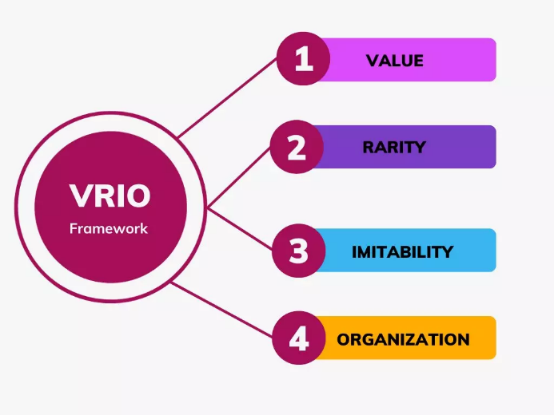
Figure: VRIO Analysis (Dieu et al., 2025)
Resource/Capability | Valuable? | Rare? | Inimitable? | Organisation to Exploit? | Strategic Implication
Brand Reputation | Yes | Yes | Moderate | Yes | Competitive advantage
Supply Chain & Logistics | Yes | Yes | Yes | Yes | Sustainable advantage
Private-Label Portfolio | Yes | Moderate | Moderate | Yes | Differentiation potential
Digital & Data Analytics | Yes | Yes | Yes | Yes | Strong, durable advantage
Retail Format Expertise | Yes | No | Moderate | Yes | Useful but not unique
The use of VRIO Framework on the core resources and capabilities of Tesco shows that the company has several strengths that may facilitate sustainable advantage in Vietnam:
- Brand & Reputation: Tesco is a world-known retail brand with the high level of recognition as the quality, convenience, own-label production, and customer loyalty. This brand value is unique among most local Vietnamese retailers and useful when customers want to find regularity and quality (Dieu et al., 2025).
- Supply Chain & Logistics Capability: Tesco has a wealth of experience in international sourcing, distribution channels, cold-chain, logistics, and supplier coordination, all of which are hard-to-replicate competencies, particularly in the area of retailing fresh food (Sparks, 2019).
- Digital Capability and Omnichannel Retailing: Tesco has built unique online grocery retailing capabilities (data analytics: customer segmentation, demand forecasting), loyalty programmes (e.g. member cards), and end-to-end logistics, which are very unusual and difficult to replicate.
- Organisational Structure and Resources: Tesco is structured to take advantage of these resources and it has known procurement groups, international purchasing experience, quality control and sustainability management systems and capacity to invest in infrastructure and technology.
To a great extent, these resources meet VRIO criteria value, rare, difficult to imitate, well-organised, which implies that Tesco can achieve a lasting competitive advantage in case of its appropriate implementation in Vietnam.

SWOT Summary
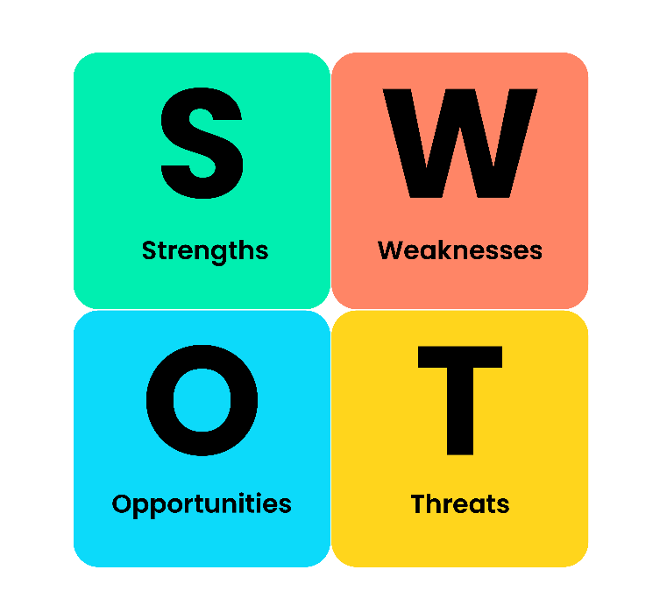
Figure: SWOT Analysis (Vietnam Briefing, 2025)
- Strengths: robust brand fame; effective and well-advanced supply-chain and logistics; online retail and omni-channel functioning; own-label and merchandise; economies of scale.
- Weaknesses: being a foreign entry, it may not know the local area; high start-up expenses; cultural and regulatory issues of adapting to the new geography; supply-chain of perishable items.
- Opportunities: there is a fast-paced retail market in Vietnam; the increase of middle classes and urbanisation; a surge in demand of the modern retail format; favourable regulatory environment towards foreign retail; rise in e-commerce and omni-channel shopping (Vietnam Briefing, 2025).
- Threats: stiff competition among local retailers and other foreign competitors; strong rivalry and price elasticity; traditional retail markets; supply-chain, logistic and quality control; regulatory, compliance risk; political or policy changes.
In general, Tesco has a good fit (alignment) between the opportunities of the market in Vietnam and its strengths. The supply-chain, logistics, digital capability, and global retail base at Tesco match closely with the demands of a modern retail in Vietnam, in terms of quality, convenience, value on the label of own-label, and access to omni-channel.

Critical Reflection: Limitations of VRIO in Dynamic Contexts
Although VRIO can help determine sustainable resources and relative advantage, it is inherently fixed and retroactive: it examines what the firm possesses, but not how it can develop (Knott, 2015). VRIO might not reflect the dynamic capabilities required in a fast moving dynamic market such as Vietnam where consumers tastes, regulations, and retail technologies are changing fast: flexibility, adaptation, speed, local learning and continuous innovation. Additionally, VRIO fails to consider the external environmental change or reactions to competition; although Tesco may have a high advantage based on VRIO, success requires implementation, local adaptation, and continuous growth in capabilities. Hence, in the entire report, VRIO ought to be coupled with dynamic capability and strategic-learning.

Synthesis: Strategic Implications from the Analysis
Vietnam has an attractive macro-environment to the expansion of Tesco, which is politically stable, well growing economically, increasing household incomes and growing demand of modern retail format as is noted in the PESTEL analysis. Porters five forces also shows that it is a very competitive industry with high buyer power, supplier pressures manageable, threats of new entrants and substitutes are high, and industry rivalry is high, making Tesco compete on differentiation, omnichannel convenience and brand trust, not on price alone. Tesco has strong VRIO strengths internally (brand reputation, supply-chain capability, digital retailing, and organisational resources) that can offer a good base to venture into Vietnam, the dynamic market of grocery (Li and Zeng, 2024). Nevertheless, the dynamic environment and constraints of the static analytical models imply that success will be determined by Tesco capacity to localise operations, create relations with suppliers, learn cultural peculiarities and create adaptive and responsive capacities. All in all, the expansion is highly encouraged yet has to take a cautiously controlled, contextually sensitive approach.

Strategy Development & Formulation

Evaluation of Strategic Options
In the Matrix of Ansoff, Tesco's entering Vietnam is essentially a market development approach: current core formats and capabilities are implemented in a new geographic market. Three key strategic alternatives may be discussed:

Option 1: Joint Venture with a Vietnamese Retailer
JV with a mid-sized local supermarket chain has moderate capital cost, moderate speed and moderate risk. Tesco would get local market expertise, current store locations, personnel and regulatory expertise. In exchange, it offers brand equity, supply-chain systems, own-label knowledge and online strengths. Governance is more complex than wholly owned entry, but there is a shared risk exposure, and it is easier to adapt to local preferences with the help of a partner that is familiar with Vietnamese consumers and institutions (Persson and Dagsberg, 2025).

Option 2: Acquisition of a Mid-Sized Chain
Full acquisition is very controlled and possibly very fast, particularly when a chain has prepared store networks and supplier contacts. But, acquisition can be quite expensive, there is a risk in integration, possibility of local opposition. Value may be lost due to cultural conflicts, challenges in integrating systems, and issues related to the local workforce (Ek, 2023). In the case of Tesco, having learned a few lessons through its international follies in the past, a big acquisition in a new culturally far market would be strategic and financial risky.

Option 3: Organic Expansion / Hypermarket Rollout
The most strategic control, as well as the purity of the brand, lies in organic entry by constructing Tesco-named hyper-marks and supermarkets directly. However, it is sluggish and capital intensive as it entails intense investment in land, construction, licences, supply-chain infrastructure and marketing. Tesco must risk a slow build-out in a market where the competitors are already growing and have a shifting demand, before the company becomes large enough to gain first-mover benefits and find strong competition (Sayan, 2025).

Comparison and Final Choice
In contrast to the three, acquisition as well as Greenfield expansion is characterised by increased capital investment and institutional and cultural risk. A JV is more cost-effective, fast and risky; it is able to enter major cities much faster, it can utilise the local resources and shares risk (Dinu, 2016). It also helps learn together and enables the transfer of capabilities gradually. Hence, the most suitable primary entry mode would be a joint venture with a mid-sized Vietnamese supermarket chain.

Chosen Entry Strategy & Competitive Positioning

Entry Mode Justification Using OLI
Applying the OLI paradigm by Dunning, the decision made by Tesco could be explained in the following way:
- Ownership benefits (O): Tesco has good brand recognition, own-label expertise, bulk buying, high-tech logistics and data-based retailing. These are exclusive features that give rise to high performance.
- Location benefits (L): Vietnam has high GDP growth, urbanisation, a young population and a growing demand of modern retail. Free trade deals and favourable retail policies make it even more desirable to have its operations there (Andy, Idris and Rajenthyran Ayavoo, 2024).
- Internalisation benefits (I): i.e., instead of merely licencing its brand, Tesco gains the internalisation of major activities (supply chain, merchandising, and digital systems) to safeguard know how and quality.
A JV maximises the following OLI factors: Tesco retains key operation factors but forms a joint venture with a local firm that provides local expertise, networks and regulatory manoeuvring. This minimises foreignness liability, coupled with strategic control over core capabilities.

Generic Strategy: Differentiation with Value Pricing
Tesco should be using a hybrid approach of differentiation and value pricing in the price-sensitive but quality seeking market in Vietnam. Differentiation comes from:
- quality and food safety standards that are reliable;
- good value high-end private-labels;
- clean, modern store surroundings;
- excellent fresh-food handling and merchandise;
- Omni-channel convenience.
Meanwhile, Tesco needs to be very competitive at the core of the basket goods and project definite value to attract the middle-income families. This quality plus trust plus affordability makes Tesco a reliable everyday value chain as opposed to a high-end niche chain.

Role of Digital Integration and Market Positioning
Tesco is characterised by digital integration. Based on its Tesco.com case, the JV can build an Omni-channel platform, which consists of online ordering, click-and-collect, home delivery and digital loyalty. Club-card-like programmes are able to collect customer information, tailor offers and enhance loyalty. Tesco should be a trusted, modern, Omni-channel food retailer in the Vietnamese market which provides safe products, fair prices, and convenient access in both physical and digital channels. Within the first focus would be big city centres, supported by small supermarkets, convenience stores allied with powerful online services, followed by selective expansion as abilities and brand awareness would increase.

Risk Assessment & Mitigation

Cultural Risks
Cultural distance poses difficulties in identifying consumer preference, managerial and employee requirements. A wrong understanding of local preferences, store atmosphere or communication standards can undermine the Tesco positioning (Yang, Mohammad and Farzana Quoquab, 2024). Some actions to curb this are to capitalise on the local knowledge of the joint venture partner, empower local managers, cross-cultural training of the expatriate workers and product range, marketing, store designs to suit the local culture.

Regulatory and Political Risks
The dynamic retail policy, the foreign ownership and planning policies in Vietnam could be a source of uncertainty. The growth or compliance costs can be slowed by bureaucratic and licensing restrictions (Michael, 2025). Mitigation involves ensuring good government and stakeholder relationship with the JV partner, undertaking stringent legal due diligence, formulating flexible roll out plans and adopting compliance systems as per the governance standards of the Tesco and Vietnamese regulations.

Supply Chain and Logistics Risks
Establishing sound cold chains, food safety and dealing with local suppliers are operational risks in a new market. Unpredictability in the product quality or stock-outs may undermine consumer confidence (Tariq and Ali, 2025). Tesco must gradually switch to mixed sourcing, build logistics and quality-assurance infrastructure in the JV, invest in supplier training and audit as well as increase store networks in phases to align with supply-chain maturity.

Financial and Market Risks
Financial returns can be affected by currency volatility, reduced penetration into the market, increased cost of operation and stiff competition response. Tesco can address these risks through JV investment stages, piloting in large cities, setting performance milestones with adjustment options and conservative financial planning.
On the whole, a JV model backed by localisation, gradual investment and effective compliance and supply-chain frameworks would help Tesco to deal with major risks and achieve sustainable growth in Vietnam.

Performance Evaluation Framework

Rationale for Choosing the Balanced Scorecard (BSC)
The Balanced Scorecard (BSC) would be the right tool to evaluate the expansion of Tesco in Vietnam as it links strategic goals with the performance measurement metrics in both financial and non-financial aspects. To a multinational retailer venturing in an emerging market which is dynamic, defining success cannot be measured by short-term profitability but also by customer involvement, operational capacity, organisational learning and long-term market placement. This integrated perspective is made possible by the BSC aligning its performance indicators with Tesco strategic goals of sustaining growth, creating brand confidence, enhancing supply-chain quality and creating local workforce capacity (Vu and Mai, 2016). Moreover, the BSC fits in this regard especially well in terms of multinational rollouts since it builds a consistent measurement framework and enables local adjustments. Tesco will be able to keep corporate standards of performance and adjust KPIs to the market conditions in Vietnam, the environment and consumer behaviour. Its multi dimension approach helps in detecting customer retention, supply chain, cost efficiency or organisational preparedness challenges early on, and this is essential during the first few years of entering the market (Israel, 2022). The proactive decision-making and strategic learning is also supported by the BSC when the leading indicators like staff capability and digital adoption are included.

Balanced Scorecard and Key Performance Indicators (KPIs)
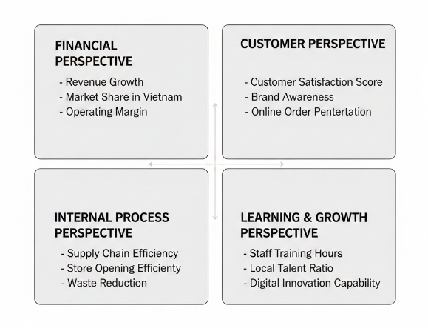
Figure: Balanced Scorecard (BSC) Diagram (Fatricia, 2024)

Financial Perspective
- Revenue Growth: Annual percentage change in total sales of the Vietnamese operations which shows market penetration.
- Market Share: Tesco has had its share of the modern grocery market in Vietnam, which indicates its competitive power and acceptance in the market (Fatricia, 2024).
- Operating Margin: Store, logistics and procurement efficiency, which shows the business model sustainability.

Customer Perspective
- Customer Satisfaction Score (CSS): Surveys were conducted on the experience in the store, perception of prices, quality of products and service (Prasetyo et al., 2022).
- Brand Awareness: the awareness and recognition of the brand Tesco after its introduction using a periodical market research.
- Online Order Penetration: Share of all sales via e-commerce processes, which denotes digital adoption and effectiveness of omnichannels.

Internal Process Perspective
- Supply Chain Efficiency: Indicators include quality of fresh-foods, availability of stock and on-time delivery.
- Store Opening Efficiency: Time and cost differences in line with the scheduled rollout plans, demonstrating the execution ability (Przywara and Rak, 2021).
- Waste Reduction: Food and operational waste reduction, signalling, sustainability and cost management.

Learning and Growth Perspective
- Hours of Training Staff: Investment in store operation and customer service skills, compliance and food safety skills training.
- Local Talent Ratio: The ratio of Vietnamese employees in managerial and supervisory positions to promote the localization process (Thien, Wilfried Admiraal and Saab, 2020).
- Innovation and Digital Capability KPIs: The use of Tesco digital tools, inclusion of loyalty, and application of data analytics to make decisions.
These KPIs, as a combination, reflect the short-term commercial results and as well as the long-term capability development that is necessary to maintain a competitive advantage in Vietnam.

Monitoring and Review
The performance monitoring is to be done on a quarterly basis by combining the quantitative reports of KPI with qualitative reports by store managers, supply-chain teams and the representatives of the JV board (Kushariyadi et al., 2025). There should be varied responsibility among functional heads: finance for profitability metrics and operations to supply-chain and store efficiency and HR to develop capability and marketing to measure customer and brand indicators. An organised feedback mechanism will provide that the knowledge of every review will be used to adjust strategies. When customer measures fall, marketing or product changes might be needed; when supply chain measures are poor, more investment in logistics or supplier development can be given precedence. This continuous monitoring will help Tesco to work out its path, consolidate the position in the market and guide the growth towards the long-term success.

Conclusion
Tesco has a strategic motivation to venture into Vietnam since the country is well off in economic growth and is very urbanised and rising in demand on newer forms of retailing. The Tesco strengths of supply-chain excellence, expansion in own-label and online shopping make Tesco a stable fit in the market, and Vietnam is the right place to embark on a new level of internationalisation. The strategic analysis has demonstrated the ability of Tesco to align with the consumer trends, regulatory facilitation of the retail modernisation and the growing importance of the omnichannel shopping in the Vietnam cities. The selected joint venture model is the most rational approach in terms of cost/speed rate and risk because it will enable Tesco to combine its foreign experience with the required local market expertise. A compelling strategy is reinforced by the Balanced Scorecard, which offers a wide range of KPIs related to both financial performance and customer engagement, operational efficiency and organisational growth, to make sure that the advancement is gauged on long-term and short-term levels. They will however require careful attention to cultural adjustment, regulatory changes as well as supply-chain. Tesco needs to invest into localisation, step by step implementation and common governance as a solution to uncertainty. With this consideration, Vietnam is a highly promising destination that Tesco can use to establish sustainable presence and long term sustainable competitive advantage in Southeast Asia.

References
Alanzi, S. (2018). Pestle Analysis Introduction. [online] ResearchGate. Available at: https://www.researchgate.net/publication/327871826_pestle_analysis_introduction
Andy, A., Idris, A. and Rajenthyran Ayavoo (2024). Location Attractiveness in the New Norm: A Systematic Review. SAGE Open, 14(3). doi:https://doi.org/10.1177/21582440241281036
Caro, F., Kök, A.G. and Martínez-de-Albéniz, V. (2020). The Future of Retail Operations. Manufacturing & Service Operations Management, 22(1). doi:https://doi.org/10.1287/msom.2019.0824
Chaiyan Pimsen, Srisuda Namraksa, Tanpat Kraiwanit and Atipon Satranarakun (2024). Digital Transformation of Grocery Stores in the Digital Age. ResearchGate, [online] 3(4), pp.1–9. Available at: https://www.researchgate.net/publication/394402412_Digital_Transformation_of_Grocery_Stores_in_the_Digital_Age
Chokdee Siawsolit and Gaukler, G.M. (2019). The Value of Demand Information in Omni-Channel Grocery Retailing. [online] ResearchGate. Available at: https://www.researchgate.net/publication/331048136_The_Value_of_Demand_Information_in_Omni-Channel_Grocery_Retailing [Accessed 10 Dec. 2025].
Chowdhury, R.H. (2025). Digital Engagement and Customer Experience Leadership: Strategies for the Modern Enterprise. doi:https://doi.org/10.70593/978-93-7185-445-0
Coe, N.M., Lee, Y.-S. and Wood, S. (2017). Conceptualising contemporary retail divestment: Tesco’s departure from South Korea. Environment and Planning A: Economy and Space, 49(12), pp.2739–2761. doi:https://doi.org/10.1177/0308518x17733265
Davis, F. (2025). Vietnam Rising: Why Multinational Corporations Should Invest in Southeast Asia’s Fastest-Growing Economy. doi:https://doi.org/10.58445/rars.3245
Dieu, T., Tran, Q.B., Cam, T., Anh, T. and Thuy, M. (2025). The impact of brand value on consumer shopping behavior at the governance of retail chains and mini supermarkets. Journal of Governance and Regulation, [online] 14(2, special issue), pp.394–404. doi:https://doi.org/10.22495/jgrv14i2siart18
Dinu, A.-M. (2016). INTERNATIONAL EXPANSION THROUGH JOINT VENTURE - RISKS AND BENEFITS. [online] ResearchGate. Available at: https://www.researchgate.net/publication/369298763_INTERNATIONAL_EXPANSION_THROUGH_JOINT_VENTURE_-_RISKS_AND_BENEFITS
Docas Akinleye, Godwin Olaoye and Joseph, O. (2023). Digital Payments and Wallets in Grocery Shopping. [online] Available at: https://www.researchgate.net/publication/385420984_Digital_Payments_and_Wallets_in_Grocery_Shopping
Ek, A. (2023). Cultural Values and Productivity. Journal of political economy. doi:https://doi.org/10.1086/726239
Enders, A. and T. Jelassi (2017). Leveraging Multichannel Retailing: The Experience of Tesco.com. [online] MIS Q. Executive. Available at: https://www.semanticscholar.org/paper/Leveraging-Multichannel-Retailing%3A-The-Experience-Enders-Jelassi/df7ffca0a2302ad2691cd4f67e634e031f658292 [Accessed 10 Dec. 2025].
Fatricia, R.S. (2024). STRATEGIC ANALYSIS OF TESCO SUPERMARKET. Jurnal Manajemen Terapan dan Keuangan, [online] 6(2), pp.69–86. doi:https://doi.org/10.22437/jmk.v6i2.4046
Fu, R. (2024). Analysis of Business Operation Mode and Marketing Strategy of British Mainstream Supermarket: Case study of Tesco. Journal of Education Humanities and Social Sciences, 43(1), pp.279–285. doi:https://doi.org/10.54097/895tzt69
Gebreyesus Yimer (2024). Informal Credit Market: A General Overview. pp.5–37. doi:https://doi.org/10.1007/978-3-031-71653-9_2
Githu, P. and Waithaka, S. (2025). Regulatory Environment and Performance of Projects in State-Owned Manufacturing Firms in Kenya. International Journal of Entrepreneurship and Project Management, 10(1), pp.55–88. doi:https://doi.org/10.47604/ijepm.3301
Israel, B. (2022). Enhancing Customer Retention in Manufacturing SMEs through Supply Chain Innovative Practices. Management Dynamics in the Knowledge Economy, 10(3), pp.272–286. doi:https://doi.org/10.2478/mdke-2022-0018
Jean, G. (2024). Supply chain flexibility and responsive strategies to demand volatility. [online] Available at: https://www.researchgate.net/publication/381924599_Supply_chain_flexibility_and_responsive_strategies_to_demand_volatility
Kashob, H., Abdellatif Chakor and Al-Ansi, A.M. (2025). Economic diversification and sustainable development: Evaluating progress in SDGs 7, 8 and 11, 12. Multidisciplinary Reviews, [online] 9(2), p.2026058. doi:https://doi.org/10.31893/multirev.2026058
Khaled Al Falah, Abdulrahman Al Sughayir and Albarq, A.N. (2024). The importance of environmental concern, trust and convenience in consumers’ purchase intentions of organic foods in a developing country. Cogent Business & Management, 11(1). doi:https://doi.org/10.1080/23311975.2024.2361319
Knott, P. (2015). Does VRIO help managers evaluate a firm’s resources? | Request PDF. [online] ResearchGate. Available at: https://www.researchgate.net/publication/281979547_Does_VRIO_help_managers_evaluate_a_firm
Kushariyadi, K., Wahid, D.A., Albashori, M.F., Rustiawan, I., ARDENNY, A. and Wahyudiyono, W. (2025). Performance Management Based on Key Performance Indicators (KPI) to improve Organizational Effectiveness. Maneggio, [online] 2(1), pp.90–102. doi:https://doi.org/10.62872/7yx54j15
Li, L. and Zeng, J.H. (2024). Strategic Analysis of Tesco’s International Purchasing and Supply Chain Management: Challenges, Opportunities, and Future Directions. International journal of science and business, 35(1), pp.132–143. doi:https://doi.org/10.58970/IJSB.2360.
Michael, I. (2025). Regulatory Hurdles and Permitting Delays. [online] ResearchGate. Available at: https://www.researchgate.net/publication/392558086_Regulatory_Hurdles_and_Permitting_Delays
Mordor intelligence (2024). Retail Industry Size & Share Analysis - Growth Trends & Forecasts (2025 - 2030). [online] Mordorintelligence.com. Available at: https://www.mordorintelligence.com/industry-reports/retail-industry
Nassar, Y., Gad, G. and Kortam, W. (2021). The Effect of Demographic Variables on Price Sensitivity of Customers A Field Study. Archives of Business Research, 9(4), pp.101–142. doi:https://doi.org/10.14738/abr.94.10023
Persson, F. and Dagsberg, M. (2025). BUSN09 -Business Administration Degree Project in Strategic Management One Size Fits All? A review of how multinational companies adapt their business model to enter emerging markets in Asia successfully Master’s Programme in International Strategic Management. [online] Available at: https://lup.lub.lu.se/student-papers/record/9207684/file/9207685.pdf [Accessed 10 Dec. 2025].
Platin, N., Göksel Ataman and Hızır Konuk (2022). THE EVALUATION OF MARKET ENTRY BARRIERS AND STRATEGIC ALLIANCES WITHIN THE FRAMEWORK OF RESOURCE DEPENDENCE THEORY: THE CASE OF TURKISH FURNITURE INDUSTRY. [online] (ISBN: 978-625-7464-90-1), pp.756–765. Available at: https://www.researchgate.net/publication/366992971_THE_EVALUATION_OF_MARKET_ENTRY_BARRIERS_AND_STRATEGIC_ALLIANCES_WITHIN_THE_FRAMEWORK_OF_RESOURCE_DEPENDENCE_THEORY_THE_CASE_OF_TURKISH_FURNITURE_INDUSTRY
Prasetyo, B., Sholichah, M., Adil, M., Soelistya, D. and Rosyihuddin, M. (2022). The Importance of Product Quality, Price Perception and Service Quality in Achieving Customer Satisfaction. Budapest International Research and Critics Institute-Journal (BIRCI-Journal), [online] 5(1). doi:https://doi.org/10.33258/birci.v5i1.4252
Przywara, D. and Rak, A. (2021). Monitoring of Time and Cost Variances of Schedule Using Simple Earned Value Method Indicators. Applied Sciences, 11(4), p.1357. doi:https://doi.org/10.3390/app11041357
Roy, B. (2024). DIGITAL TRANSFORMATION STRATEGIES IN TRADITIONAL RETAIL INDUSTRIES: A CASE OF TESCO. ResearchGate. doi:https://doi.org/10.13140/RG.2.2.35757.40168
Sah, A.K., Hong, Y.-M. and Huang, K.-C. (2025). Enhancing Brand Value Through Circular Economy Service Quality: The Mediating Roles of Customer Satisfaction, Brand Image, and Customer Loyalty. Sustainability, 17(3), p.1332. doi:https://doi.org/10.3390/su17031332
Sayan, G. (2025). Retail_Multinational_Learning_A_Case_Study_of_Tesc. [online] Scribd. Available at: https://www.scribd.com/document/483994300/Retail-Multinational-Learning-A-Case-Study-of-Tesc [Accessed 10 Dec. 2025].
Scapin, T., Romaniuk, H., Feeley, A., Corrêa, K.P., Kupka, R., Gomez-Donoso, C., Orellana, L., Gupta, A., Sacks, G. and Cameron, A.J. (2025). Global food retail environments are increasingly dominated by large chains and linked to the rising prevalence of obesity. Nature Food. [online] doi:https://doi.org/10.1038/s43016-025-01134-x
Sharma, S. (2025). ‘Sustainable Sourcing and Supply Chain Management in The Food Industry’. [online] ResearchGate. Available at: https://www.researchgate.net/publication/389938149_Sustainable_Sourcing_and_Supply_Chain_Management_in_The_Food_Industry
Sparks, L. (2019). Tesco: how supply chain strategy supports retail success. The Business & Management Collection, 2019(1), p.e1007132. doi:https://doi.org/10.69645/zoiq8396
Stecuła, K., Wolniak, R. and Aydın, B. (2024). Technology development in online grocery shopping—from shopping services to virtual reality, metaverse, and smart devices: A review. Foods, 13(23), p.3959.
Sugiharto, A. and Deniar, S.M. (2021). Retail Policy Dilemma and The Existence of Modern Retail in Indonesia and Malaysia. Jurnal Studi Sosial dan Politik, [online] 5(1), pp.9–21. doi:https://doi.org/10.19109/jssp.v5i1.7604
Tariq, H. and Ali, M.H. (2025). Reducing food loss and waste within cold food supply chains – empirical evidence from developing economies. British Food Journal, pp.1–20. doi:https://doi.org/10.1108/bfj-01-2025-0096
Thien, T., Wilfried Admiraal and Saab, N. (2020). Work-Related Values in International Workplaces in Vietnam: Cross-Cultural Differences between Employers... [online] ResearchGate. Available at: https://www.researchgate.net/publication/342891992_Work-Related_Values_in_International_Workplaces_in_Vietnam_Cross-Cultural_Differences_between_Employers_and_Employees
TRAN, T.T.N. (2023). Sustainability of Traditional Retail in an Emerging Market: A Conceptual Framework Applied to a Vietnamese Wet Market. Asia Marketing Journal, 24(4), pp.143–151. doi:https://doi.org/10.53728/2765-6500.1598
Vietnam Briefing (2025). Vietnam E-Commerce Sector Outlook: Key Growth Trends. [online] Vietnam Briefing News. Available at: https://www.vietnam-briefing.com/news/vietnams-e-commerce-sector-outlook-in-2026.html/
Vu, N. and Mai (2016). IS THE BALANCED SCORECARD USEFUL IN A COMPETITIVE INDUSTRY? [online] Available at: https://www.theseus.fi/bitstream/handle/10024/118756/Mai%20Vu.pdf?sequence=1
Yang, X., Mohammad, J. and Farzana Quoquab (2024). A study of cultural distance, eWOM and perceived risk in shaping higher education students’ destination image and future travel plan. Journal of tourism futures. doi:https://doi.org/10.1108/jtf-03-2023-0080
Zhao, S. and Priporas, C.-V. (2017). Information technology and marketing performance within international market-entry alliances. International Marketing Review, 34(1), pp.5–28. doi:https://doi.org/10.1108/imr-01-2016-0024

Appendices

Appendix A: PESTEL Analysis of Vietnam Table
Factor | Key Points | Implications for Tesco
Political | Stable government; supportive retail modernisation policy; improving trade environment | Predictable environment; supportive for foreign retailers through modernisation incentives
Economic | Strong GDP growth; rising incomes; expanding middle class; urbanisation | Increasing demand for modern grocery retail and value-focused offerings (Chokdee Siawsolit and Gaukler, 2019)
Sociocultural | Growing preference for convenience, food safety, trusted brands, younger demographic | Opportunity to leverage Tesco’s quality standards and private-label proposition
Technological | High mobile penetration, rapid growth of e-commerce, digital retail incentives | Strong alignment with Tesco’s omnichannel capability and loyalty systems (Roy, 2024)
Environmental | Increasing sustainability regulation; waste management focus | Need for strong supply-chain transparency and sustainability practices
Legal | Evolving FDI laws, structured licensing, and compliance requirements | Requires partnerships, regulatory alignment, and phased expansion

Appendix B: Porter’s Five Forces – Vietnam Grocery Industry

Appendix C: VRIO Analysis Table of Tesco Plc
Resource/Capability | Valuable? | Rare? | Inimitable? | Organisation to Exploit? | Strategic Implication
Brand Reputation | Yes | Yes | Moderate | Yes | Competitive advantage
Supply Chain & Logistics | Yes | Yes | Yes | Yes | Sustainable advantage
Private-Label Portfolio | Yes | Moderate | Moderate | Yes | Differentiation potential
Digital & Data Analytics | Yes | Yes | Yes | Yes | Strong, durable advantage
Retail Format Expertise | Yes | No | Moderate | Yes | Useful but not unique

Appendix D: Balanced Scorecard (BSC) Diagram

