Student Name: Ionut Margarit  Student ID: 2229576  Module Title: Foreign Languages and Cultural Awareness  Module Code : BMIH5003  Lecturer: Giulia Chifari | 
ASSIGNMENT 1: PORTFOLIO
(4 Components)

Component 1: Professional Reflection (500 words +/- 10%)

Weighting: 25%
Cultivating Cultural Awareness within the Hospitality Industry
Within the hospitality industry cultural sensitivity is an important aspect, it ensures that the customers visiting the hotel must feel comfortable and relaxed (Nazarian et al., 2021). So during the rush hours of lunch in the hotel restaurant, the misunderstanding of cultural aspects often occur between the workers of Food and Beverages (F&B) and the hotel guest. I will describe the situation of cultural misunderstanding which I have seen between the employee and the guest of hotel and which made me realized that cultural interaction within the hospitality industry is very important.
There was a guest named Mr. Alex who belong to non-English country, probably he was from Spain. He asked the waiter about the most special dish of the restaurant in his broken English and he also told the waiter that he doesn’t like mushrooms in his dish. The waiter doesn’t understood clearly about the preferences of Mr. Alex. He suggested him the most liked dish of the restaurant and he thought that Mr. Alex likes mushrooms in his dish. When the dish was served and eaten by the Mr. Alex he started screaming on the waiter. This situation clearly reflects the cultural misunderstandings among the people. For providing better services to the customers it is necessary to understand the cultural differences of the guest properly (Gui et al., 2020). In this scenario, the language barrier have create problem between Mr. Alex and the waiter in the restaurant which has also disturbed other guest of the restaurant.
Based on this scenario, I have experienced that the cultural awareness among the people is very important. Cultural barriers are broken down and help to understand the perspective of other people, also help to appreciate and respect those people who belong to different culture with the help of cultural awareness (Burikova, 2020). Cultural awareness basically helps in understanding the spirits of values and beliefs of different cultures. It helps to understand more about ourselves and our own culture, also help to connect to better individuals from different background of cultures.
Number of behavioural changes we can make to avoid cultural misunderstanding. Firstly knowledge about different culture is very important. Share those knowledge with your co-workers and team members and also help them to learn and practice more, this would help to gain experience to how to deal with people of different culture (Drame et al., 2021).
Secondly, try to learn different languages. It is important especially for the hotel employees of F&B because they have to deal with many people belonging to different culture. By understanding the language of the guest, employees of the hotel can avoid any unintended wrongdoing or uneasiness for guest (Treuren et al., 2021). Moreover, the staff of F&B hotel must develop cultural sensitivity and compassion that help them to understand and respect their guests, they can able to understand the perspective of the guest and their expectations.by encouraging the environment of F&B hotel and restaurant the staff members must effectively understood the importance of cultural awareness which help them to create most enrich dining experience in their hotel.
References:
Burikova, S., 2020. Developing Students’ Intercultural awareness and skills. European Proceedings of Social and Behavioural Sciences, 97.
Drame, I., Unonu, J., Turner, M., Taylor, M.D., Bush, A., Jarvis, M. and Cawthorne, T.A., 2021. The association between students' emotional intelligence, cultural competency, and cultural awareness. Currents in Pharmacy Teaching and Learning, 13(9), pp.1146-1152.
Gui, C., Luo, A., Zhang, P. and Deng, A., 2020. A meta-analysis of transformational leadership in hospitality research. International Journal of Contemporary Hospitality Management, 32(6), pp.2137-2154.
Nazarian, A., Velayati, R., Foroudi, P., Edirisinghe, D. and Atkinson, P., 2021. Organizational justice in the hotel industry: revisiting GLOBE from a national culture perspective. International Journal of Contemporary Hospitality Management, 33(12), pp.4418-4438.
Treuren, G.J., Manoharan, A. and Vishnu, V., 2021. The hospitality sector as an employer of skill discounted migrants. Evidence from Australia. Journal of Policy Research in Tourism, Leisure and Events, 13(1), pp.20-35.

Component 2: Training Plan (500 words +/- 10%)

Weighting: 25%

Identified cultural misunderstanding
Productivity and efficiency of the hotel can be decreased if the cultural misunderstandings cannot be overcome, because it delay workflows and team dynamics. Therefore because of the challenges which has been arisen within the hospitality industry, the training of the employees is very important. Training of the employees with their co-workers and team members will help them to work more effectively with the colleagues and guest belonging to different cultural backgrounds, which can also lead to the productivity and efficiency of the restaurant (Jhaiyanuntana and Nomnia S., 2020). Following is the training plan which concludes the importance of cultural awareness within the hotel.
Training plan (Why/What//Who/Where/When):

Orientation and workshops:
Train the employees of the hotel by giving them opportunities to attend workshops and different orientations related to cultural awareness. Raise the awareness among the employees about the variety of the workplace and also about the importance of broadmindedness and understanding (Roque and Ramos, 2019). With the help of these workshops the employees will help to gain cultural practices, different styles of communication and culinary preferences. It would also help them to understand the perspectives of the customers and provide warm welcoming to the guest belonging to different backgrounds.
Customer Service Training:
The employees of the hotel must trained about how to deal with the customers. Customer service training emphasizes on the communication, language barriers, active listening and resolution of the conflict and understanding. It will teach the workers of hotel to provide excellent services to the guests based on the standards of the hotel (Lam et al., 2022). The employees of the hotel must be trained about the foreign languages to remove the language barrier. At least they must improve their language skills in common foreign languages which are commonly spoken by customers such as Spanish, French or Chinese depending upon the culture of the customers visiting the hotel and restaurant.
Hard skill Training
In the hospitality industry, the hotel staff must be given training about hard skill. This training emphasizes on improving the specific skill set of the workers which include the knowledge about software, technology and numerous operations within hospitality industry. With the help of hard skill training the employees will remain competitive to their roles and also help them to ensure that they have gain most updated and skills and knowledge (Oriade, et al., 2021).
Product Knowledge Training
For training of the employees within the hospitality industry product knowledge training is very important. This training provide the employees with the knowledge about the products and services which the restaurant provide to the customers (Nazarian et al., 2019). The products might include food and beverages, software, services such as tourism packages and entertainment options. This training is important to the workers because it help them to know that which product they are selling to their customers and which dish is the most demanding in their restaurant and what is the reason behind that demand, which also help them to increase the sale of that product or dish (Abo-Murad and Abdullah, 2019).
References:
Abo-Murad, M. and Abdullah, A.K., 2019. Turnover culture and crisis management: Insights from Malaysian hotel industry. Academy of Strategic Management Journal, 18(2), pp.1-14.
Jhaiyanuntana, A. and Nomnian, S., 2020. Intercultural communication challenges and strategies for the Thai undergraduate hotel interns. PASAA: Journal of Language Teaching and Learning in Thailand, 59, pp.204-235.
Lam, R., Cheung, C. and Lugosi, P., 2022. The impacts of cultural intelligence and emotional labor on the job satisfaction of luxury hotel employees. International Journal of Hospitality Management, 100, p.103084.
Nazarian, A., Velayati, R., Foroudi, P., Edirisinghe, D. and Atkinson, P., 2021. Organizational justice in the hotel industry: revisiting GLOBE from a national culture perspective. International Journal of Contemporary Hospitality Management, 33(12), pp.4418-4438.
Oriade, A., Osinaike, A., Aduhene, K. and Wang, Y., 2021. Sustainability awareness, management practices and organisational culture in hotels: Evidence from developing countries. International Journal of Hospitality Management, 92, p.102699.
Roque, H.C. and Ramos, M., 2019. The importance of cultural training in the hospitality sector. European Journal of Tourism, Hospitality and Recreation, 9(2), pp.58-67.
Component 3: Student Self-Reflection (500 words +/- 10%)

Weighting: 25%
Within the hospitality industry, I have understood that the awareness of culture is very essential. Importance of valuing the individual differences and focusing on changing relationships, cultural awareness is very important for enjoyment and satisfaction at work (Kaihlanen et al., 2019). I have come to realise that differences among the individual can encourage creativity, enjoyment and satisfaction at the workplace.
Kolb’s reflective Cycle
Through the reflection, I understand that awareness of culture is increasing with time. I came to know that cultural awareness is basically the understanding spirited beliefs and values of different cultures (Burikova, 2020). It provides better opportunities, understandings and beliefs of different cultures. This can help to engage people belonging to different backgrounds together.
By seeing of diversity of people or guest coming in the restaurant, I realise that effective communication is very important. The best advantage of cultural awareness is that it provide effective communication with the people of different background (Dolzhenko and Young, 2020). Lack of cultural awareness create misunderstanding among people and also create misjudgement. It also make it difficult to understand the perspective of people and to know their intentions. I understood that cultural awareness help us to communicate and build strong relations with others.
Despite of the fact that culture awareness helps to communicate, I came to realise that it also help us to gain respect for different cultures. As a result, people are adopting new strategies for supporting cultural differences and for moving forward in the society. By understanding different cultures, it helps to breakdown the cultural barriers and to create interaction and respect with diverse communities (Loo and Loo, 2021).
Moreover, this reflection taught me that cultural awareness provide benefits in leadership and management roles. This provide better outcomes and increase the productivity of the restaurant. With the help of this we can make appropriate decisions and motivate other workers (Pratita, 2023). In this way the managers of the hotel can make decision with global mind-set and this will to develop appreciation among the employees, workers feel acknowledged and valued in the organization. Further this taught me empathy, active listening and how to deal with the different type of interaction with guest. Creating strong relationship with the guests is very essential, with their language and culture a good experience and relationship can be develop with them (Alraqiq et al., 2021).
Cultural awareness help to create successful globalization. I realise that connection about culture is getting stronger which also reduces the risk of cultural conflicts. When we aware are about the culture of our guest we would able to know how to deal with them, indirectly help to increase globalization more easily and also reduces the cultural barriers (Pattiwael, A.S., 2019).
References
Alraqiq, H.M., Sahota, S.K. and Franks, C.L., 2021. Cultural awareness training for dental students. Journal of Dental Education, 85(10), pp.1646-1654.
Burikova, S., 2020. Developing Students’ Intercultural awareness and skills. European Proceedings of Social and Behavioural Sciences, 97.
Dolzhenko, I.N. and Young, J.L., 2020. Understanding Teachers' Cultural Competencies: Supporting the Development of Teachers' Self-Awareness and Social Awareness. In Multicultural Instructional Design: Concepts, Methodologies, Tools, and Applications (pp. 1447-1467). IGI Global.
Kaihlanen, A.M., Hietapakka, L. and Heponiemi, T., 2019. Increasing cultural awareness: qualitative study of nurses’ perceptions about cultural competence training. BMC nursing, 18, pp.1-9.
Loo, F.Y. and Loo, F.C., 2021. The importance of a cultural-embedded learning model: Raising awareness of cultural heritage. In INTED2021 Proceedings (pp. 308-316). IATED.
Pattiwael, A.S., 2019, January. Literature for Developing Student's Humanity Awareness. In Journal International Seminar on Languages, Literature, Arts, and Education (ISLLAE) (Vol. 1, No. 1, pp. 79-88).
Pratita, I.I., 2023, January. The Importance of Education in Improving Local Cultural Awareness in the Globalization Era: Japanese Language Studies in Cross-Cultural Communication. In Unima International Conference on Social Sciences and Humanities (UNICSSH 2022) (pp. 1154-1162). Atlantis Press.
Component 4: Training Presentation (6 Slides)

Weighting: 25%
[Slide 1]
Module title: Foreign Languages & Cultural Awareness
Module code: BMIH5003
Lecturer’s name: Giulia Chifari
Student Name:
Student ID:
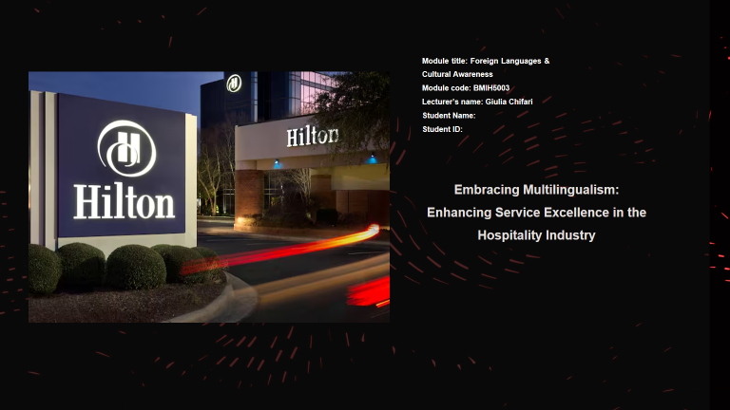
(SLIDE 2)
Benefits of Multilingualism
Build Multitasking Skills
Bilingual people can switch between their tasks more quickly as compare to the people that only know one language. These people are able to speak more languages and translate information more rapidly and efficiently (Pietrzyk-Kowalec, 2023).
Enhance Employability
Many sectors like tourism, hospitality and international business the managers mostly prefers to hire the individuals who understand and speak multiple languages (Schroedler et al., 2023). Therefore multilingualism increase employability within few sectors. It has been discovered that there is positive correlation between language proficiency and employability.
Improve Hotel Reputation
Reputation of the hotel can be improve by increasing effective communication with guests. Communication can be effective and the guest would be satisfied if the employees of the hotel are able to understand their language and culture (Žerajić, 2019).
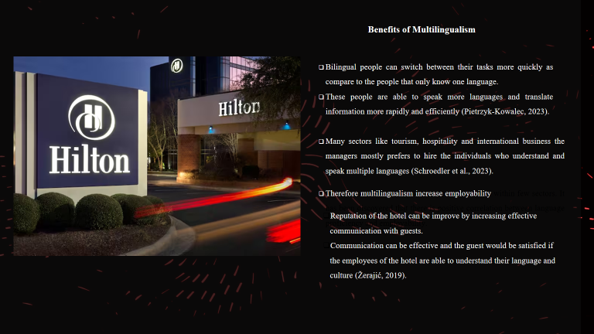
(Slide 3)
Importance of language Awareness
Customer Satisfaction
Within the hospitality industry effective communication is very essential in order to provide satisfaction to the customers. Through this communication the guests would be relaxed that their expectations and needs are clearly understood by the employees of the hotel. Hotels then provide good services to the customers and gave good experience to the clients (Prima, 2022).
Service Quality
Effective communication among staff members of hotel help to deliver good and efficient services. Proper communication among the workers of front desk to the housekeeping workers of hotel ensures that the all the services must be delivered accurately and promptly, contributing to higher level of service quality (Firharmawan and Andika, 2019).
Cultural sensitivity
In the hospitality industry, employees of the hotel have to interact guests of diverse cultures. Effective cultural communication skills help to solve language barriers and cultural differences also ensuring the respectful and inclusive interactions (Sonia et al., 2022).
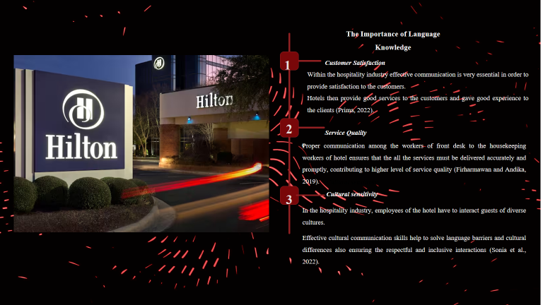

(Slide 4)
Language Example: French
French: A language of Global Significance
French language also known as Romance language is widely spoken by about 72 million people in France, Belgium, Switzerland, Canada (mainly Quebec) and many other countries (Martin et al., 2019). It is an official language of more than 25 countries.
Rewards for Learning French
By learning French language will increases the chances of communicating in non-English speaking countries. French will help to create international friendships as well as it help to communicate through internet.
Politeness and formality in French Communication
In French language, while addressing the colleague Monsieur' or 'Madame' is used, especially to those people whom you are unfamiliar. Moreover, for professional respect formal 'vous' over the informal 'tu' is used.
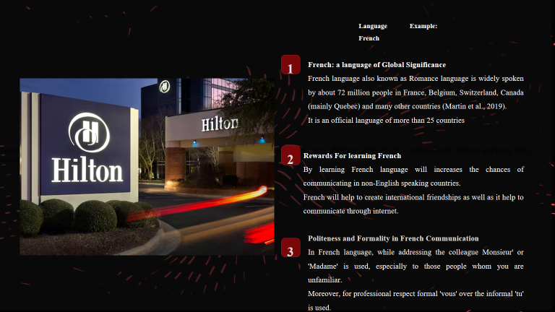
(Slide 5)
Examples from the hotel industry
Warm welcoming
The guest must be given warm welcoming on their arrival at hotel. It improves the mood of the guest and also increases their overall experience. Always greet and welcome the guest with the smile and in their native language. This leaves the good impression on the guest.
Training of the staff
For developing good experience to the guest, the staffs of the hotel must be trained properly. They must now about the language and culture of guest and must provide best facilities o the guest.
Diverse dietary preferences
The menu of the restaurant or hotel must be in multiple languages and also include every option such as vegetarian, non-vegetarian or gluten free meals for developing better dining experience to the guest.
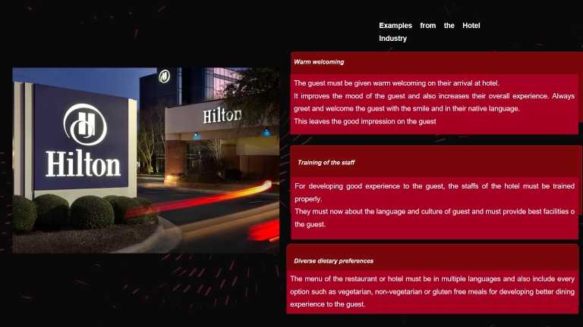
References (no screenshots):
Schroedler, T., Chik, A. and Benson, P., 2023. The value of multilingualism for sustainable development: a case study of languages in Australia. International Multilingual Research Journal, 17(4), pp.289-303.
Prima, S., 2022. A study of perception of the importance of English language skills among Indonesian hotel employees. J-SHMIC: Journal of English for Academic, 9(1), pp.73-86.
Firharmawan, H. and Andika, A., 2019. Needs and problems in English for hospitality industries: A case study of the hotel employees at Meotel hotel Kebumen. Journal of English Language Learning, 3(2), p.318833.
Sonia, S., Nabilah, A., Shahira, S., Adawiyah, R. and Othman, N.A., 2022. The Importance of English Language Proficiency among Employee in Hospitality Industry.
Martin, L., Muller, B., Suárez, P.J.O., Dupont, Y., Romary, L., de La Clergerie, É.V., Seddah, D. and Sagot, B., 2019. CamemBERT: a tasty French language model. arXiv preprint arXiv:1911.03894.
Žerajić, A., 2019, June. Intercultural management and the importance of foreign languages in modern hotel industry. In Tourism International Scientific Conference Vrnjačka Banja-TISC (Vol. 4, No. 1, pp. 360-377).
Pietrzyk-Kowalec, P., 2023, August. Multilingualism and the Job Market in the European Union: A Comprehensive Analysis. In Proceedings of The World Conference on Education and Teaching (Vol. 2, No. 1, pp. 1-8).


