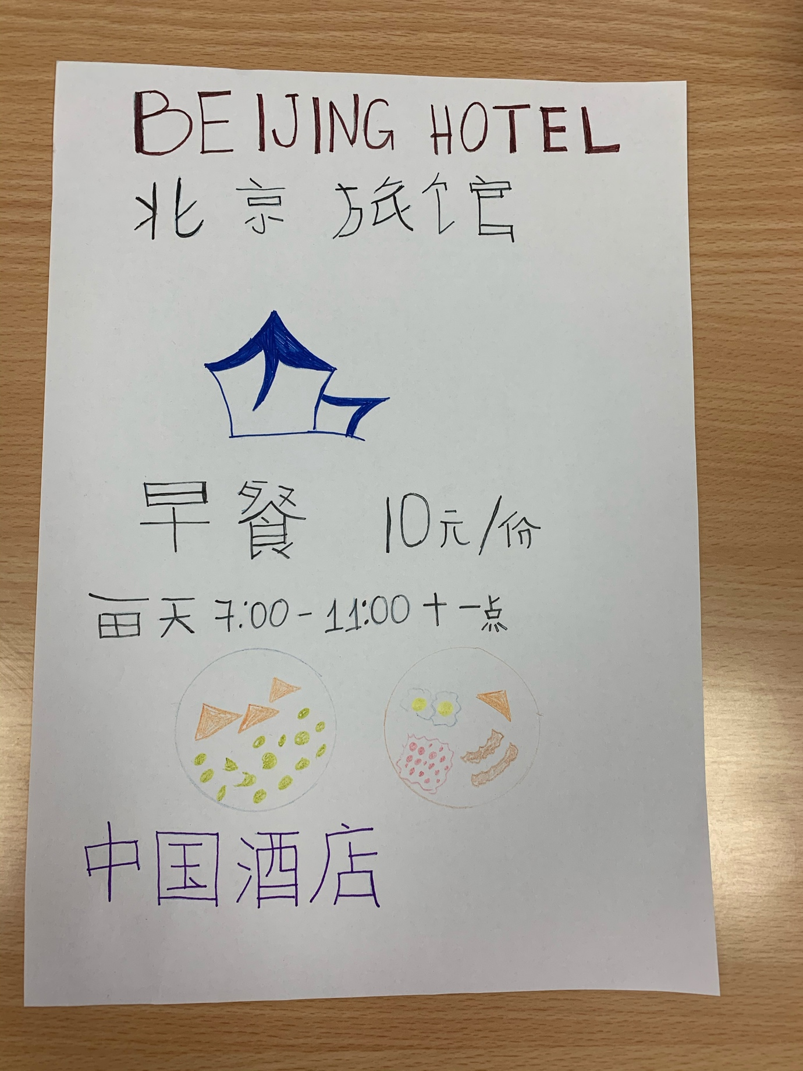
Zheni Angelova Andonova
Student number – 1815042
Foreign languages and cultural awareness
(MPX01923- LON)
13 December 2019
Lecturer : Jinping Li
Hotel practise for Chinese

