FINAL YEAR PROJECT / DISSERTATION

Tittle:
Intelligent Smart Recycling Bin Using Artificial Intelligence for
Automated Waste Classification

Submitted by: EFTALI NOTE

Student ID: 2231182

BSc (Hons) Applied Computing

University of Wales Trinity Saint David

Supervisor: FAHAD AHMED

Academic Year:2023–2026

Submission Date :August 2026

Contents
Chapter 1 – Introduction 2
1.1 Introduction 2
Chapter 2 – Literature Review 4
2.1 Introduction 4
2.2 Waste Management and Recycling Challenges 5
2.2.1 Global Waste Management Challenges 5
2.2.2 Recycling Contamination and Human Error 5
2.2.3 UK Context and Need for Intelligent Technologies 6
2.3 Smart Recycling Systems 6
2.4 Artificial Intelligence 6
2.5 Computer Vision 7
2.6 Embedded Systems 7
2.7 Internet of Things and Monitoring 8
8
Figure.2.1, IoT Smart Waste Monitoring Concept 8
2.8 Existing Research and Research Gap 8
9
Figure.2.2, Comparison of existing smart recycling research. 9
2.9 Chapter Summary 10
Chapter 3 – Research Methodology 10
3.1 Research Methodology 10
3.1.1 Introduction 10
3.1.2 Research Philosophy 10
3.1.3 Research Approach 11
3.1.4 Experimental Product Development 11
3.2 Agile Development Methodology 12
3.2.1 Agile-Inspired Development 12
12
3.2.2 Agile Development Lifecycle 13
13
Figure 3 The Agile-inspired lifecycle 13
3.3 Data Collection Methods 13
3.4 Specialist Development Methods and Techniques 14
3.5 Methodological Summary 15
Chapter 4 – System Design and Implementation 15
4.1 Chapter Introduction 15
4.2 System Requirements 16
4.2.1 Functional Requirements 16
4.2.2 Non-Functional Requirements 16
4.3 Overall System Design 16
4.4 Hardware Design 17
4.4.1 Raspberry Pi 4 Model B 18
4.4.2 Arduino Uno 18
4.4.3 Camera, Ultrasonic Sensor and Servo Motor 18
4.4.4 Prototype Assembly 19
4.5 Software Design 19
4.5.1 Python and Arduino Programming 20
4.5.2 OpenCV 20
4.5.3 TensorFlow and ONNX Runtime 20
4.5.4 Software Communication 20
4.6 Artificial Intelligence System Design 21
4.7 Operational Workflow 22
4.8 UML System Design 22
4.9 Dashboard and Database Design 23
25
Figure 4.10, entity relationship diagram 25
4.10 Prototype Implementation and System Integration 25
4.11 Chapter Summary 26
5.1 Chapter Introduction 26
5.2 Testing Environment 27
5.3 Experimental Testing Strategy 28
Experimental Testing Method 28
5.4 Ultrasonic Sensor Testing 28
5.4.1 Object/Hand Detection Testing 28
Table 5.1 – Object Detection Functional Test Results 29
5.4.2 Fill-Level Sensing 29
5.5 Artificial Intelligence Classification Testing 30
Table 5.2 – AI Classification Test Summary 30
5.5.2 AI Confidence 31
5.5.3 Classification Limitations 31
5.6 Integrated System Response and Reliability Testing 31
5.6.1 System Response Time 31
Table 5.3 – System Response Time Results 32
5.6.2 Integrated Reliability 32
Table 5.4 – Integrated System Functional Testing 32
5.7 Dashboard Validation 32
Table 5.5 – Dashboard Operational Summary 33
5.7.1 Fill-Level Dashboard Validation 33
5.7.2 Dashboard Functional Validation 34
Table 5.6 – Dashboard Functional Validation 34
5.8 Results Analysis and Discussion 34
5.9 Limitations 35
5.10 Future Improvements 36
5.11 Evaluation Against Research Objectives 36
5.12 Chapter Summary 37
References 41

Chapter 1 – Introduction

1.1 Introduction
Waste management has become a significant environmental challenge due to rapid urbanisation, population growth and increasing levels of domestic and commercial waste. Recycling plays an important role in reducing landfill dependency, conserving natural resources and supporting environmental sustainability. However, recycling effectiveness is frequently reduced by contamination, where non-recyclable materials are incorrectly placed within recycling streams. This can reduce the quality of recovered materials, increase processing costs and negatively affect overall recycling efficiency. [1]
Traditional recycling systems depend heavily on individuals correctly identifying and separating waste. Despite public awareness campaigns, uncertainty remains regarding which materials can be recycled, particularly because recycling requirements may differ between locations. This challenge is especially relevant in universities, workplaces, shopping centres and transport facilities, where users may have limited knowledge of local recycling requirements. [2]
Recent developments in Artificial Intelligence (AI), Computer Vision, Embedded Systems and the Internet of Things (IoT) provide opportunities to improve this process. Computer Vision enables machines to analyse digital images, while AI models can learn visual characteristics and classify different waste materials automatically. Embedded and IoT technologies can integrate sensors, processors and software applications to support automated decision-making, monitoring and data collection. [3]
The need for improvement is evident within the United Kingdom. Government statistics indicate that approximately 64.1% of UK packaging waste was recycled in 2024. Nevertheless, contamination remains problematic, with WRAP reporting that 82% of UK households place at least one locally unacceptable item into recycling, while material recovery facility sampling identified contamination of approximately 16.6%. The challenge is particularly relevant in London, where household recycling rates are approximately 33%, demonstrating the potential value of technologies that assist users directly at the point of disposal. [4] [5]
To address this problem, this research develops an Intelligent AI-Based Smart Recycling Bin capable of automatically determining whether a waste item is recyclable or non-recyclable. The prototype integrates a Raspberry Pi 4, Arduino Uno, HC-SR04 ultrasonic sensor, Raspberry Pi Camera Module, servo motor and an AI classification model deployed using ONNX Runtime. When an object is detected, its image is captured and analysed. The classification result determines whether the servo-controlled lid opens or remains closed. [6]
The prototype additionally records classification results, AI confidence scores and timestamps through an integrated dashboard, enabling recycling activity and system performance to be monitored. [7]
1.2 Rationale and Justification
The motivation for this research originates from the continuing problem of recycling contamination and the limitations of systems that depend predominantly on human decision-making. Although conventional recycling infrastructure encourages responsible disposal, users may incorrectly identify waste, resulting in recyclable materials becoming contaminated. [8]
Existing smart waste technologies demonstrate the potential of AI and IoT to improve waste management. However, many systems concentrate on bin fill-level monitoring and collection optimisation rather than helping users determine recyclability before disposal. Commercial intelligent systems may also require expensive equipment and infrastructure, reducing their accessibility for smaller organisations. [9]
This research addresses this gap by investigating whether affordable embedded technologies can be combined with AI-based image classification and automated lid control to support recycling decisions at the point of disposal. The dashboard further enables classification activity and system performance to be recorded. The resulting prototype therefore provides a practical proof of concept relevant to universities, workplaces and similar public environments. [10]
1.3 Industry and Organisational Context
Waste management organisations, local authorities and public institutions are increasingly adopting digital technologies to improve operational efficiency and environmental sustainability. AI, IoT and embedded computing provide opportunities to automate processes that traditionally require manual monitoring or decision-making.
Within the UK, recycling services are widely available, yet contamination and inconsistent understanding of recycling requirements remain significant challenges. Intelligent technologies could complement existing recycling infrastructure by providing immediate automated assistance rather than relying solely on awareness campaigns.
The proposed system reflects wider technological developments in automation and edge computing. Unlike solutions primarily concerned with bin capacity or collection logistics, this project investigates automated waste classification before disposal. Its use of accessible embedded hardware also demonstrates how intelligent environmental technologies can be explored without requiring industrial-scale infrastructure. [11]
1.4 Research Aim
The aim of this research is:
To design, develop and evaluate an Intelligent AI-Based Smart Recycling Bin that uses Artificial Intelligence and Computer Vision to determine automatically whether a waste item is recyclable or non-recyclable and control the bin lid accordingly.
The research aims to reduce incorrect waste disposal while demonstrating the practical integration of Artificial Intelligence, Computer Vision, Embedded Systems and IoT technologies within an intelligent recycling prototype. [12]
1.5 Research Objectives
To achieve the research aim, four objectives were established:
- To critically review existing research relating to Artificial Intelligence, Computer Vision, Embedded Systems, IoT and intelligent waste management to identify technological developments, limitations and research opportunities.
- To design and develop an intelligent recycling prototype integrating a Raspberry Pi, Arduino Uno, HC-SR04 ultrasonic sensor, Raspberry Pi Camera Module, servo motor and AI classification model capable of identifying recyclable and non-recyclable waste.
- To develop a monitoring dashboard capable of recording and displaying classification results, AI confidence scores, detection history and recycling statistics generated during operation.
- To experimentally evaluate the accuracy, reliability and overall performance of the completed prototype through structured testing and performance analysis.
These objectives provide measurable criteria through which the success of the research can subsequently be evaluated.
1.6 Expected Outcomes and Deliverables
The principal expected outcome is a functional proof-of-concept capable of automatically detecting and classifying waste before controlling the recycling bin lid according to the AI prediction. Successful implementation requires reliable integration between the Raspberry Pi, Arduino Uno, ultrasonic sensor, camera, servo motor and AI model deployed using ONNX Runtime.
A monitoring dashboard represents a second major deliverable. It is designed to record classification results, confidence scores, timestamps, detection history and recycling statistics, enabling system activity to be reviewed and supporting subsequent performance evaluation. [13]
Supporting technical deliverables include the system architecture, operational workflow, UML modelling, [14] database design and implementation documentation. Experimental evaluation examines ultrasonic sensor accuracy, AI classification performance, response time, system reliability and dashboard functionality.

Chapter 2 – Literature Review

2.1 Introduction
The increasing generation of municipal solid waste represents a significant global environmental challenge. Population growth, urbanisation, industrial development and changing consumption patterns have increased pressure on existing waste management infrastructure. Although recycling initiatives and circular economy policies aim to reduce landfill dependency and recover valuable resources, their effectiveness is frequently limited by poor waste segregation and contamination. [15]
Recent developments in Artificial Intelligence (AI), Computer Vision [16], Embedded Systems and the Internet of Things (IoT) provide opportunities to improve conventional recycling processes. Intelligent systems can automatically analyse waste, support disposal decisions and record operational information, reducing dependence on human judgement. However, existing smart waste systems often focus on bin capacity and collection optimisation rather than preventing incorrect disposal.
This chapter critically reviews literature relating to waste management, intelligent recycling, AI, Computer Vision [17], Embedded Systems and IoT. It evaluates existing approaches and their limitations before establishing the research gap addressed by the proposed Intelligent AI-Based Smart Recycling Bin.

2.2 Waste Management and Recycling Challenges

2.2.1 Global Waste Management Challenges
Global waste production continues to increase due to population growth, urban expansion and consumer demand. Poorly managed waste contributes to landfill expansion, greenhouse gas emissions, water and soil pollution and ecosystem degradation. Plastic waste is particularly problematic because many plastics degrade slowly and can remain within terrestrial and marine environments for extended periods. [18]
The circular economy has emerged as an alternative to the traditional linear "take–make–dispose" model. It aims to maintain materials within productive use through reduction, reuse and recycling, thereby reducing demand for raw materials and minimising waste generation. Recycling is therefore an important component of sustainable resource management.
However, effective recycling depends on accurate waste segregation. Contamination occurs when unsuitable materials enter recycling streams or recyclable materials are mixed with general waste. This can increase processing costs, reduce material quality and result in potentially recyclable resources being rejected.

2.2.2 Recycling Contamination and Human Error
Human error represents an important cause of recycling contamination. Despite increased environmental awareness, users frequently remain uncertain about which items are recyclable. Differences between local recycling policies further complicate disposal decisions because materials accepted in one geographical area may not be accepted elsewhere.
Recycling behaviour is influenced by environmental awareness, convenience, labelling and knowledge. Modern packaging creates additional difficulties because individual products may contain several materials requiring separation. Consequently, even users intending to recycle correctly may make incorrect decisions.
UK research discussed within the literature indicates that households frequently place locally unacceptable items within recycling collections. This suggests that education alone cannot completely eliminate contamination. Intelligent technologies capable of providing automated assistance at the point of disposal could therefore complement public awareness initiatives by reducing dependence on individual judgement. [19]

2.2.3 UK Context and Need for Intelligent Technologies
The United Kingdom has introduced policies intended to increase recycling and support the transition towards a circular economy. Nevertheless, recycling performance varies considerably according to material and region. Paper, cardboard, glass and metal generally benefit from established processing infrastructure, whereas plastic remains more challenging because of material diversity and contamination. [20]
London presents additional difficulties associated with population density, storage limitations and complex waste collection requirements. Its comparatively low household recycling performance demonstrates that collection infrastructure alone may not address incorrect segregation.
Traditional recycling bins provide little direct assistance during disposal. AI and Computer Vision offer an alternative by enabling waste items to be analysed automatically before they enter the recycling stream. Embedded and IoT technologies can then connect classification with physical automation and monitoring. This provides the basis for investigating intelligent systems designed specifically to improve recycling decisions at the point of disposal.

2.3 Smart Recycling Systems
Smart recycling systems combine conventional waste infrastructure with sensors, embedded processors, communication technologies and increasingly Artificial Intelligence. Early smart bins predominantly used ultrasonic sensors to estimate fill levels. When combined with IoT connectivity, capacity information could support collection-route optimisation and reduce unnecessary vehicle journeys.
More recent systems have introduced cameras and Artificial Intelligence to recognise waste materials. This represents an important transition from monitoring what occurs after disposal towards influencing the disposal decision itself.
Smart systems offer several potential advantages. Automated monitoring can reduce manual inspection, while continuous data collection allows recycling activity and system performance to be analysed. AI-based classification may also reduce incorrect disposal by assisting users who are uncertain about recyclability. Affordable platforms such as the Raspberry Pi and Arduino have further enabled researchers to investigate these technologies without industrial-scale equipment. [21]
However, important limitations remain. Many systems continue to prioritise fill-level monitoring and collection logistics, which improve operational efficiency but do not directly prevent contamination. Commercial systems may depend on expensive hardware, proprietary software or continuous cloud connectivity. Cloud processing can provide substantial computational resources but introduces network dependency, latency and additional infrastructure requirements.
Furthermore, many research projects evaluate individual components rather than demonstrating complete integration between AI, sensing, mechanical control and monitoring. These limitations support investigation into affordable, modular systems capable of combining these functions within a single prototype.

2.4 Artificial Intelligence
AI enables machines to perform tasks involving pattern recognition, learning and automated decision-making. Within waste management, its primary relevance to this research is the automatic recognition of waste materials. Instead of requiring users to determine recyclability manually, AI models can analyse visual information and generate classification predictions.
Machine Learning (ML) enables computational models to learn relationships from training data rather than depending entirely on explicitly programmed rules. Deep Learning (DL) extends this approach through multi-layer neural networks capable of automatically extracting increasingly complex features from data.
Convolutional Neural Networks (CNNs) are particularly effective for image classification because they identify spatial patterns within images. Early layers may recognise features such as edges or colours, while deeper layers learn more complex visual structures. Consequently, CNN-based approaches have been widely investigated for recognising waste categories including plastic, paper, glass and metal.
Deployment nevertheless presents challenges because deep learning frameworks may require considerable computational resources. For embedded applications, efficient inference is particularly important. The proposed research therefore uses the Open Neural Network Exchange (ONNX) format for model deployment. ONNX enables trained models to operate across different platforms and reduces dependence on the original training environment. Using ONNX Runtime on the Raspberry Pi supports local edge-based inference while maintaining portability and reducing computational overhead.

2.5 Computer Vision
Computer Vision enables computers to interpret information contained within digital images and is therefore central to image-based waste classification. In an intelligent recycling system, a camera captures the waste item before image-processing techniques prepare the image for classification. [22]
Preprocessing may involve resizing, colour processing and normalisation to ensure that input images correspond with the format expected by the AI model. The proposed prototype uses OpenCV for this purpose because it provides efficient image-processing functionality and integrates effectively with Python and embedded platforms.
Computer Vision offers greater flexibility than systems relying exclusively on proximity or physical sensors because it can analyse the visual appearance of the object itself. However, its effectiveness depends strongly on image quality. Lighting, camera position, object orientation, background complexity and occlusion can influence classification accuracy. Waste objects can also be damaged, folded or visually similar despite belonging to different material categories.
Consequently, model performance under controlled conditions may not directly represent real-world performance. Diverse training datasets and realistic testing conditions are therefore important when evaluating intelligent recycling systems.

2.6 Embedded Systems
Embedded systems provide the physical computing infrastructure required to integrate sensors, cameras, processing and mechanical control. Affordable platforms have made the development of intelligent environmental prototypes increasingly accessible.
The proposed system combines an Arduino Uno and Raspberry Pi, allocating tasks according to the strengths of each platform. The Arduino manages the HC-SR04 ultrasonic sensor and servo motor, providing responsive hardware control. The Raspberry Pi performs computationally intensive operations including image acquisition, OpenCV preprocessing and AI inference using ONNX Runtime.
This distributed architecture addresses limitations associated with using either platform independently. Microcontrollers such as the Arduino provide reliable hardware interaction but lack the computational capability required for advanced Computer Vision. Conversely, the Raspberry Pi can execute complex software but operates through a multitasking operating system rather than providing the same deterministic hardware control.
Separating these responsibilities therefore provides an appropriate balance between computational capability, hardware responsiveness and affordability while also improving modularity and maintainability.

2.7 Internet of Things and Monitoring

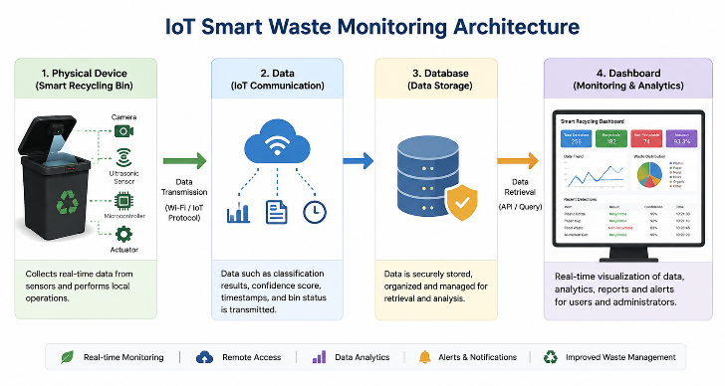

Figure.2.1, IoT Smart Waste Monitoring Concept

IoT technologies connect physical devices with digital systems, enabling information to be collected, exchanged and analysed. Within smart waste management, IoT is frequently associated with remote capacity monitoring and collection optimisation. However, its principles can also support the recording and visualisation of recycling activity.
Dashboards provide a practical mechanism for presenting operational data through tables, charts and statistical summaries. The proposed system records each classification event together with its confidence score and timestamp. Its dashboard includes Recent Activity, Detection History, AI Confidence, Recycling Statistics, Daily Trend, Weekly Chart, Pie Chart and Export PDF functionality.
This approach differs from smart bins focused on fill-level monitoring because the dashboard evaluates classification activity and AI performance rather than bin capacity. Furthermore, AI inference occurs locally rather than requiring captured images to be continuously transmitted to a cloud service. Local edge processing can reduce network dependency and latency while allowing relevant classification metadata to be retained for monitoring.
Nevertheless, IoT systems can introduce challenges relating to connectivity, infrastructure, security and scalability. These considerations become increasingly important when moving from a single prototype towards multiple interconnected recycling units. [23]

2.8 Existing Research and Research Gap

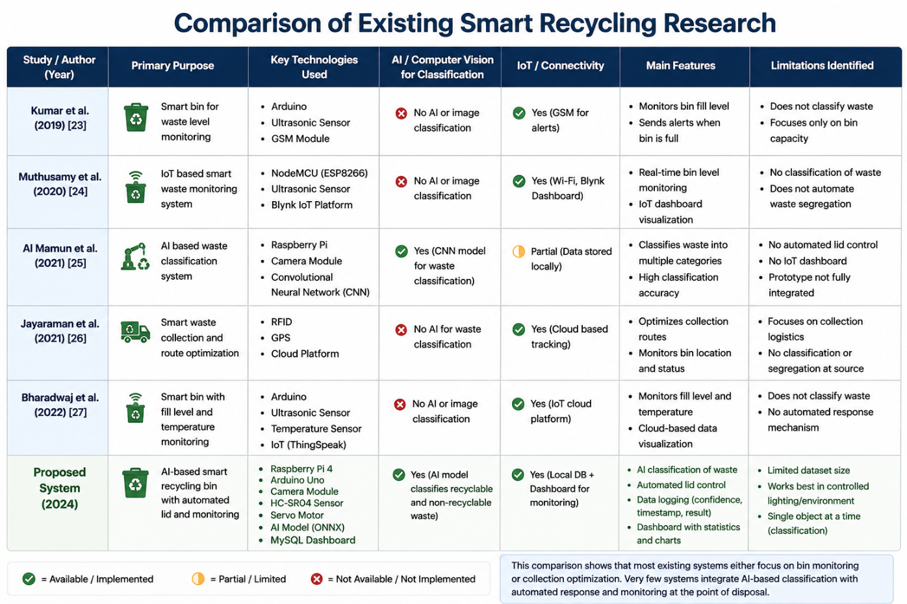

Figure.2.2, Comparison of existing smart recycling research.
Existing smart waste research demonstrates substantial progress but also reveals fragmentation between different technological approaches. Early IoT systems predominantly addressed fill-level monitoring, providing operational benefits through improved collection scheduling but leaving waste segregation dependent on users.
AI and Computer Vision research subsequently demonstrated that image-based models could classify common waste categories. However, many studies concentrate primarily on classification accuracy rather than evaluating how AI performs when integrated with sensors, cameras, actuators and monitoring systems in a complete prototype.
Industrial solutions provide more advanced automation through technologies such as conveyor systems, robotics and high-performance computing. Although these systems can achieve high throughput and classification performance, their cost and infrastructure requirements make them less appropriate for small organisations, universities and similar public environments.
Cloud dependence represents another limitation. Sending images to remote servers can provide greater computational capacity but introduces communication delays and dependence on stable network connections. This is potentially problematic where classification must immediately control a physical mechanism.
Collectively, these findings identify a research gap for an affordable, integrated and edge-based intelligent recycling prototype capable of supporting waste decisions before disposal. The proposed system addresses this gap by combining a Raspberry Pi, Arduino Uno, camera, ultrasonic sensor, servo-controlled lid and ONNX-deployed AI model. Classification is performed locally, while relevant results are recorded through a monitoring dashboard.
The contribution is therefore not based on claiming that individual technologies are novel. Instead, it concerns their practical integration into a low-cost proof-of-concept designed specifically to address recycling decisions at the point of disposal.

2.9 Chapter Summary
This chapter reviewed the literature underpinning the proposed Intelligent AI-Based Smart Recycling Bin. Increasing waste generation and recycling contamination demonstrate the continuing need for more effective approaches to waste segregation. Existing research shows that AI and Computer Vision can automate visual waste recognition, while Embedded Systems provide the infrastructure required for sensing, processing and mechanical control. IoT technologies further support data recording and system monitoring.
Critical analysis nevertheless identified limitations within existing approaches. Fill-level systems improve collection logistics without necessarily preventing contamination; AI research often concentrates on model performance without complete hardware integration; industrial solutions may be financially inaccessible; and cloud-based processing can introduce connectivity and latency requirements.
The resulting research gap concerns the need for an affordable integrated prototype that combines local AI-based waste classification, embedded automation and monitoring at the point of disposal. The proposed research addresses this gap through an edge-based system designed to classify waste, control the bin lid according to the prediction and record recycling activity for subsequent evaluation. [24]

Chapter 3 – Research Methodology

3.1 Research Methodology

3.1.1 Introduction
This chapter presents the research methodology adopted for the design, development and evaluation of the proposed Intelligent AI-Based Smart Recycling Bin. As the project focuses on developing a functional technological prototype, the methodology combines engineering development with experimental evaluation. This approach enables the practical implementation of Artificial Intelligence (AI), Computer Vision, Embedded Systems and Internet of Things (IoT) technologies while providing measurable evidence of system performance.
The research progressed through several stages. A literature review initially examined existing intelligent waste management technologies and identified limitations within current approaches. The findings informed the system requirements and technical design. An Agile-inspired process was then used to develop and integrate the hardware and software components incrementally. Finally, controlled experiments were conducted to evaluate AI classification accuracy, ultrasonic sensor performance, response time, reliability and dashboard functionality.
This methodology was selected because it provides a systematic connection between the theoretical research, technical development and experimental evaluation required to determine whether the proposed prototype achieved its research objectives. [25]

3.1.2 Research Philosophy
A pragmatic research philosophy was adopted because the project focuses on solving a practical problem through the development and evaluation of a technological solution. Pragmatism is appropriate for applied computing research because it allows research methods to be selected according to their usefulness in addressing the research problem rather than requiring adherence to a single philosophical perspective.
Both qualitative and quantitative evidence supported the research. Qualitative evidence obtained through the literature review established an understanding of recycling challenges, existing technologies and research limitations. Quantitative evidence was subsequently generated through prototype testing, including sensor measurements, AI classification results and system performance data.
Combining these forms of evidence enabled the prototype to be informed by existing knowledge while ensuring that conclusions regarding its effectiveness were supported by measurable results.

3.1.3 Research Approach
The research primarily followed a deductive approach. Existing literature indicates that AI, Computer Vision and Embedded Systems can support automated waste recognition and intelligent waste management. These established concepts were applied to the development of a low-cost recycling prototype to determine whether they could operate effectively as an integrated system.
Following implementation, predefined performance measures were used to evaluate the resulting prototype. These included AI classification accuracy, ultrasonic sensor accuracy, response time and system reliability. This provided a structured mechanism for assessing whether the proposed solution satisfied the research objectives.

3.1.4 Experimental Product Development
The principal research strategy was Experimental Product Development, combining the creation of a technological artefact with systematic experimental evaluation. This strategy was appropriate because the purpose of the research was not simply to analyse an existing system but to design, implement and assess a new intelligent recycling solution.
The strategy consisted of four main phases:
- Literature review and problem identification to establish the research gap and technical foundation.
- System design and prototype development to integrate the required hardware, software and AI components.
- Implementation and testing to verify individual subsystems and complete system operation.
- Performance evaluation to determine effectiveness through quantitative experimental measurements.
Development followed a modular approach. Sensor detection, camera operation, image processing, AI inference, servo control and dashboard functionality were initially implemented and tested independently. The components were subsequently integrated into the complete prototype. This reduced development complexity and allowed faults to be identified before they affected other subsystems.
Experimental Product Development was preferred over methodologies such as surveys, interviews or case studies because these alternatives would provide limited evidence regarding the technical feasibility of the proposed solution. The selected strategy instead allowed the research to produce a functional artefact and objectively evaluate its performance.

3.2 Agile Development Methodology

3.2.1 Agile-Inspired Development

An Agile-inspired development methodology was adopted to guide prototype implementation. The integration of hardware, Computer Vision, Artificial Intelligence and dashboard functionality created technical dependencies that could not always be predicted before development. An iterative process therefore provided greater flexibility than a strictly sequential methodology.
The prototype was developed through repeated cycles of planning, implementation, testing, evaluation and refinement. Each cycle concentrated on a specific subsystem before progressing towards complete integration.
Initial development established communication between the Arduino Uno, HC-SR04 ultrasonic sensor and servo motor. Subsequent iterations incorporated camera operation and image acquisition before introducing AI classification. Dashboard recording and visualisation were then integrated with the operational prototype.
Testing was conducted throughout development rather than being postponed until completion. This was important because faults could be isolated within individual components. For example, sensor behaviour could be verified independently of AI inference, while image-processing problems could be corrected before introducing mechanical control. Following each testing cycle, modifications were made where necessary to improve reliability and communication between components.

3.2.2 Agile Development Lifecycle

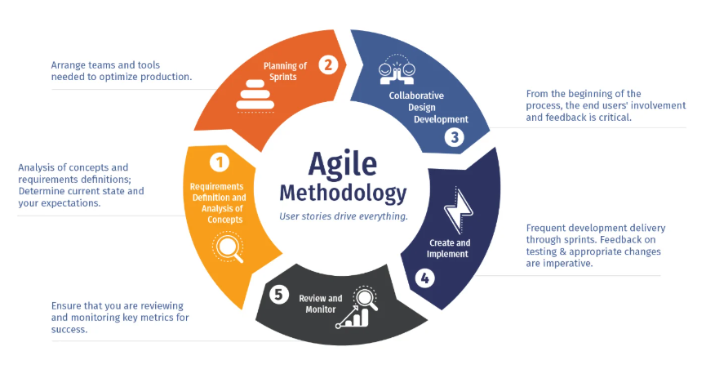

Figure 3 .The Agile-inspired lifecycle

It consisted of five stages:
Planning and Requirements Analysis: Research findings were translated into functional and non-functional requirements defining the expected behaviour of the prototype.
Prototype Design: The system architecture was developed, including hardware configuration, software processing, AI workflow and communication between components.
System Development: Sensor detection, camera acquisition, AI classification, servo control and dashboard functionality were implemented incrementally.
Testing and Evaluation: Individual components were tested before complete system integration. Controlled experiments were subsequently used to assess system performance.
System Refinement: Results obtained during testing informed modifications intended to improve reliability, processing efficiency and communication.
Agile was selected over alternatives such as Waterfall, Spiral and V-Model because prototype development required greater flexibility to respond to technical problems discovered during implementation. A rigid sequential process could make late design modifications more difficult, whereas iterative development enabled components to be refined progressively.

3.3 Data Collection Methods

Data collection provided both the theoretical information required to guide development and the quantitative evidence needed to evaluate the completed prototype.
Secondary qualitative data were collected from academic journals, conference papers, government publications and technical documentation. These sources were used to examine developments in AI, Computer Vision, Embedded Systems, IoT and intelligent waste management. The literature review identified limitations within existing approaches and provided justification for the proposed system architecture.
Primary quantitative data were generated during prototype implementation and experimental testing. During development, sensor measurements, captured images, AI predictions, communication outputs and servo responses were observed to verify correct subsystem behaviour.
Following integration, structured experimental data were collected to evaluate system performance. Measurements included ultrasonic sensor accuracy, Artificial Intelligence classification accuracy, response time and system reliability. Testing was conducted under consistent conditions and repeated where appropriate to reduce measurement variability. [26]
Additional operational data were automatically recorded by the monitoring dashboard. Each classification event stored the prediction, AI confidence score and detection timestamp, creating a history of system activity. These records provided further evidence that information was being communicated successfully between the classification and monitoring components.
The combination of secondary research and primary experimental data enabled the study to connect theoretical findings with practical system evaluation.

3.4 Specialist Development Methods and Techniques

Development of the prototype required the integration of four principal computing technologies: Artificial Intelligence, Computer Vision, Embedded Systems and IoT. Each technology performed a specific function within the overall architecture.
Artificial Intelligence provided the decision-making capability required for waste classification. A labelled image dataset was used to train the model, which was subsequently deployed using ONNX Runtime. ONNX was selected to support efficient local inference on the Raspberry Pi while avoiding the requirement to execute the complete training framework during operation.
Computer Vision supported image acquisition and preprocessing. Images captured by the Raspberry Pi Camera Module were processed using OpenCV, including operations such as resizing and normalisation before being submitted to the AI model. Standardising input images improved consistency between training and operational classification.
Embedded Systems connected the software intelligence with the physical recycling mechanism. The Raspberry Pi performed image processing, AI inference and communication with the monitoring system, while the Arduino Uno managed hardware-level operations. The Arduino monitored the HC-SR04 ultrasonic sensor and controlled the servo motor responsible for lid movement. Dividing responsibilities between the two platforms allowed computationally intensive processing and real-time hardware control to be handled independently.
IoT principles were incorporated through the collection and monitoring of operational data. Following classification, the system recorded the prediction, confidence score and timestamp. The dashboard then presented historical and statistical information relating to recycling activity and system performance.
Together, these specialist methods enabled the prototype to perform the complete operational sequence from object detection and image acquisition to classification, mechanical response and data recording. Importantly, the technologies were not evaluated only as independent components; their integration was central to determining whether an affordable embedded system could provide automated waste classification. [27]

3.5 Methodological Summary

This chapter has established the methodological framework used to develop and evaluate the Intelligent AI-Based Smart Recycling Bin. A pragmatic philosophy supported the use of both qualitative literature evidence and quantitative experimental measurements, while a primarily deductive approach enabled established technologies identified within previous research to be applied and evaluated within a new prototype.
Experimental Product Development provided the principal research strategy because it enabled the creation of a functional technological artefact followed by objective evaluation. An Agile-inspired methodology supported iterative development, continuous testing and progressive integration of hardware and software components.
Data were collected from both secondary literature and primary experimentation, while specialist methods involving AI, Computer Vision, Embedded Systems and IoT enabled the complete prototype to be implemented.

Chapter 4 – System Design and Implementation

4.1 Chapter Introduction

This chapter presents the design and implementation of the proposed Intelligent AI-Based Smart Recycling Bin, demonstrating how the theoretical concepts and methodological decisions discussed in previous chapters were transformed into a functional prototype. The system integrates Artificial Intelligence (AI), Computer Vision, Embedded Systems and Internet of Things (IoT) technologies to automatically identify recyclable and non-recyclable waste and control the disposal mechanism accordingly.
A modular architecture was adopted to separate object detection, image processing, AI classification, hardware control, data storage and monitoring. This approach reduced implementation complexity, simplified debugging and created a flexible structure that could support future expansion. The following sections describe the system requirements, overall architecture, hardware and software components, AI implementation, operational workflow, UML modelling, dashboard and database design, and final prototype integration.

4.2 System Requirements
System requirements were established before development to define the expected functionality and quality characteristics of the prototype.

4.2.1 Functional Requirements
The system was required to perform a complete automated recycling sequence. The HC-SR04 ultrasonic sensor first detects the presence of a waste item. This event triggers image acquisition using the Raspberry Pi Camera Module. The captured image is processed using OpenCV and analysed by the trained AI model to determine whether the object is recyclable or non-recyclable.
Following classification, the prediction is communicated from the Raspberry Pi to the Arduino Uno. If the object is identified as recyclable, the Arduino activates the servo motor and opens the swing lid. For non-recyclable objects, the lid remains closed. The system must also record the classification result, AI confidence score and timestamp before updating the monitoring dashboard.
These requirements establish a fully automated sequence from initial detection to classification, physical response and data recording.

4.2.2 Non-Functional Requirements

Several non-functional requirements were considered. Classification needed to achieve sufficient accuracy for proof-of-concept evaluation, while the overall system required a reasonable response time between object detection and lid activation.
Reliability was necessary because communication between multiple hardware and software components needed to remain stable during repeated operation. Maintainability was supported through modular design, allowing individual components to be modified without redesigning the entire system. Scalability was considered by providing an architecture that could later accommodate additional waste categories, sensors or communication technologies.
Affordability was also important. Widely available components were selected to demonstrate that intelligent recycling could be investigated without expensive industrial hardware. Finally, usability required the system to operate automatically with minimal user interaction.

4.3 Overall System Design

The prototype uses a modular architecture consisting of five interconnected subsystems: object detection, image processing and AI classification, hardware control, dashboard monitoring and data storage.
The operational process begins when the ultrasonic sensor detects an approaching object. The Arduino Uno communicates this event to the Raspberry Pi, which activates the camera and captures an image. OpenCV preprocesses the image before it is passed to the AI model deployed through ONNX Runtime.
The model produces a classification and confidence score. The classification is transmitted to the Arduino, which determines the required servo action. Recyclable items cause the lid to open, whereas non-recyclable items leave the lid closed. Simultaneously, the Raspberry Pi stores the classification result, confidence score and timestamp for dashboard monitoring.
Separating these functions provides a clear division between physical sensing, computational processing, mechanical control and information management. This improves troubleshooting and provides a foundation for future modifications. [28]

Overall System Architecture
Figure 4.1, illustrates the interaction between the user, embedded hardware, Artificial Intelligence model, data storage and monitoring dashboard.

4.4 Hardware Design
The hardware architecture consists of a Raspberry Pi 4 Model B, Arduino Uno, Raspberry Pi Camera Module, HC-SR04 ultrasonic sensor and servo motor. Responsibilities were distributed between components according to their capabilities rather than assigning all processing to a single controller.

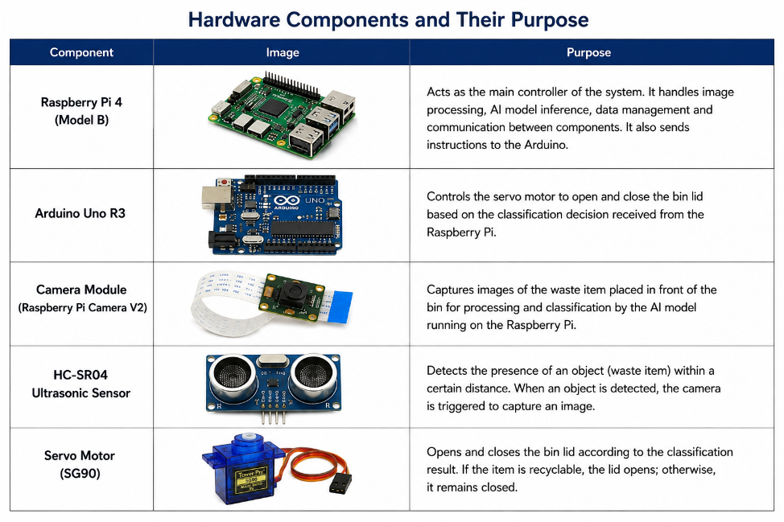
Figure 4.2, Hardware Components and Their Purpose

4.4.1 Raspberry Pi 4 Model B
The Raspberry Pi serves as the main computational platform. Following object detection, it controls image acquisition and performs image preprocessing using OpenCV. The processed image is then analysed by the AI model through ONNX Runtime. The Raspberry Pi also communicates the classification result to the Arduino and records operational information for the dashboard.
The platform was selected because it provides sufficient processing capability for embedded AI while supporting Python, OpenCV, ONNX Runtime and database communication. Alternatives such as the ESP32 provide lower computational capability, while platforms such as the NVIDIA Jetson Nano may offer greater AI performance but at increased cost. The Raspberry Pi therefore provided an appropriate balance between affordability, performance and software compatibility for the prototype.

4.4.2 Arduino Uno
The Arduino Uno manages hardware-level operations. It continuously monitors the HC-SR04 ultrasonic sensor and communicates with the Raspberry Pi when an object is detected. Following classification, it receives the AI decision and controls the servo motor.
Separating hardware control from computational processing ensures that sensor monitoring and lid movement remain responsive while the Raspberry Pi performs image processing and AI inference. This distributed architecture also simplifies hardware troubleshooting.

4.4.3 Camera, Ultrasonic Sensor and Servo Motor
The Raspberry Pi Camera Module provides visual input for classification. It is activated following object detection and captures the waste item from a fixed position. Controlled positioning and lighting were used during prototype evaluation to improve image consistency.
HC-SR04 Ultrasonic Sensors
The prototype incorporates two HC-SR04 ultrasonic sensing functions to support object detection and bin monitoring. The first ultrasonic sensor is positioned near the waste input area and is used to detect when an object or user's hand approaches the bin. The detection threshold is configured at 15 cm. When an object is detected within this range, the Arduino generates a HAND_DETECTED signal, which initiates the waste-classification process.
A second HC-SR04 sensor is used to monitor the internal fill level of the recycling bin. The system calculates the approximate fill percentage by comparing the measured distance with the configured bin height of 30 cm. Fill-level measurements are obtained periodically and transmitted through the serial connection as FILL: data, allowing the information to be displayed through the monitoring dashboard. The use of two sensing functions therefore enables the prototype to support both automated waste detection and continuous monitoring of available bin capacity.
The servo motor provides the physical response. When the Arduino receives a recyclable prediction, the motor rotates to open the swing lid. For a non-recyclable prediction, the lid remains closed. Servo control was suitable because the mechanism requires precise angular movement rather than continuous rotation.

4.4.4 Prototype Assembly
Following individual component testing, the hardware was assembled into the recycling bin. The ultrasonic sensor was positioned to detect approaching objects, while the camera was mounted to provide a consistent view of the presented waste. The servo motor was connected mechanically to the swing lid. The Raspberry Pi and Arduino were integrated through serial communication, enabling information to move between computational and control subsystems.
Hardware Architecture Diagram
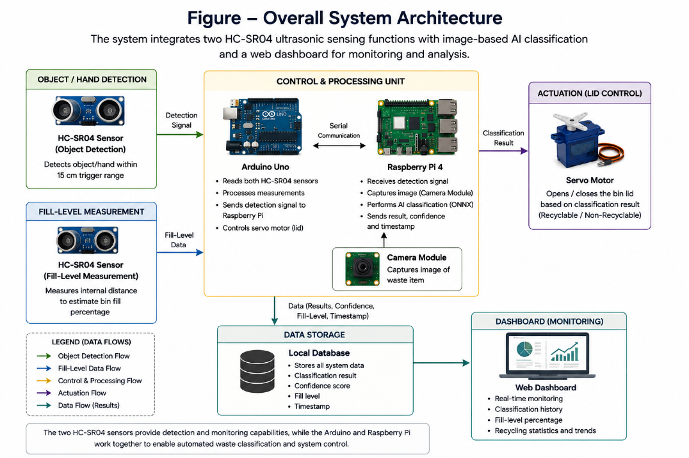
Figure 4.3. demonstrates the communication between the Raspberry Pi, Arduino Uno, ultrasonic sensor, camera and servo-controlled lid.

4.5 Software Design

A modular software architecture was implemented to coordinate image processing, Artificial Intelligence inference, hardware communication and data storage. The principal technologies included Python, Arduino IDE, OpenCV, TensorFlow, ONNX Runtime and MySQL.

4.5.1 Python and Arduino Programming
Python coordinates the primary computational workflow on the Raspberry Pi. It manages camera operation, OpenCV preprocessing, ONNX inference, serial communication and database recording. Python was selected because of its extensive AI and Computer Vision ecosystem and compatibility with the Raspberry Pi.
The Arduino IDE was used to develop the embedded program executed by the Arduino Uno. This program monitors sensor measurements, sends detection signals and controls the servo according to classification information received from the Raspberry Pi.
Dividing software responsibilities reflects the hardware architecture: the Raspberry Pi handles computational processing while the Arduino manages time-sensitive physical operations.

4.5.2 OpenCV
OpenCV provides the Computer Vision functionality required between image acquisition and AI classification. Captured images are processed into the format expected by the trained model, including resizing and normalisation where required.
This preprocessing stage is important because the AI model expects input data in a consistent format. Separating preprocessing from inference also makes the system easier to maintain because image-processing operations can be adjusted without retraining or redesigning the complete model.

4.5.3 TensorFlow and ONNX Runtime
The AI model was developed using TensorFlow, which supported neural network training using labelled waste images. After training, the model was converted to the Open Neural Network Exchange (ONNX) format for deployment.
ONNX Runtime was used on the Raspberry Pi to execute the trained model. This separation between development and deployment reduced dependence on the complete TensorFlow environment and provided a lightweight approach suitable for embedded inference. ONNX also improves model portability because the trained network can be deployed independently of its original training framework.

4.5.4 Software Communication
During operation, the Arduino first detects an object and sends a signal to the Raspberry Pi. Python activates the camera, captures the image and uses OpenCV for preprocessing. ONNX Runtime then performs AI inference.
The resulting prediction is returned to the Arduino for servo control. At the same time, the classification result, confidence score and timestamp are stored in the database. This sequence connects sensing, image processing, decision-making, physical response and monitoring while maintaining separation between individual modules.

Software Architecture Diagram

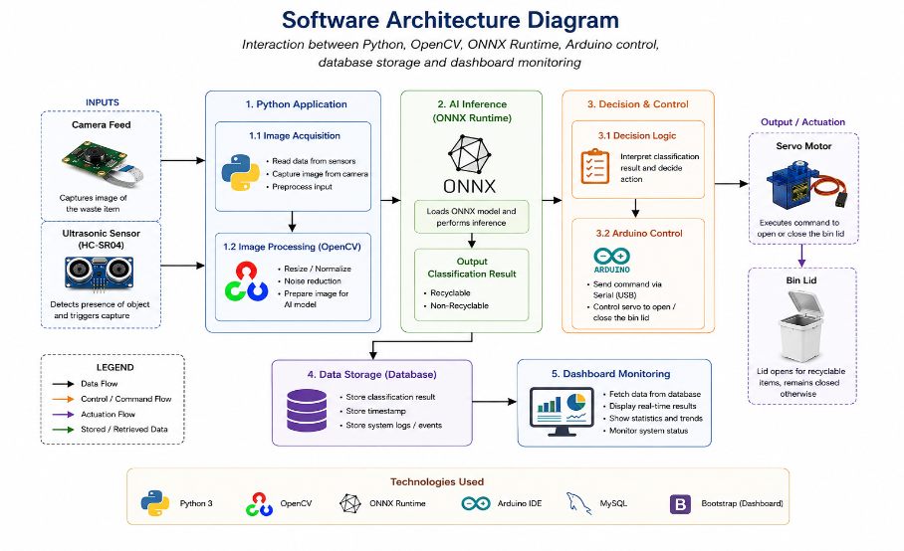
Figure 4.4, illustrates the interaction between Python, OpenCV, ONNX Runtime, Arduino control, database storage and dashboard monitoring.

4.6 Artificial Intelligence System Design
Artificial Intelligence provides the principal decision-making capability of the prototype. The AI development process consisted of dataset preparation, model training, deployment and real-time inference. [29]
Labelled images representing the required waste categories were prepared for supervised learning. The model was trained using TensorFlow to learn visual characteristics that differentiate the waste categories. Following training, it was converted to ONNX format and deployed on the Raspberry Pi.
During operation, an image captured by the camera is preprocessed through OpenCV and submitted to the model. ONNX Runtime produces the predicted class together with an associated confidence score. The classification is then translated into the physical recyclable/non-recyclable decision required for lid control.
Local inference was an important design decision because it avoids the requirement to transmit images continuously to a remote cloud service. This reduces network dependency and supports faster interaction between AI classification and mechanical control.

Artificial Intelligence Classification Pipeline

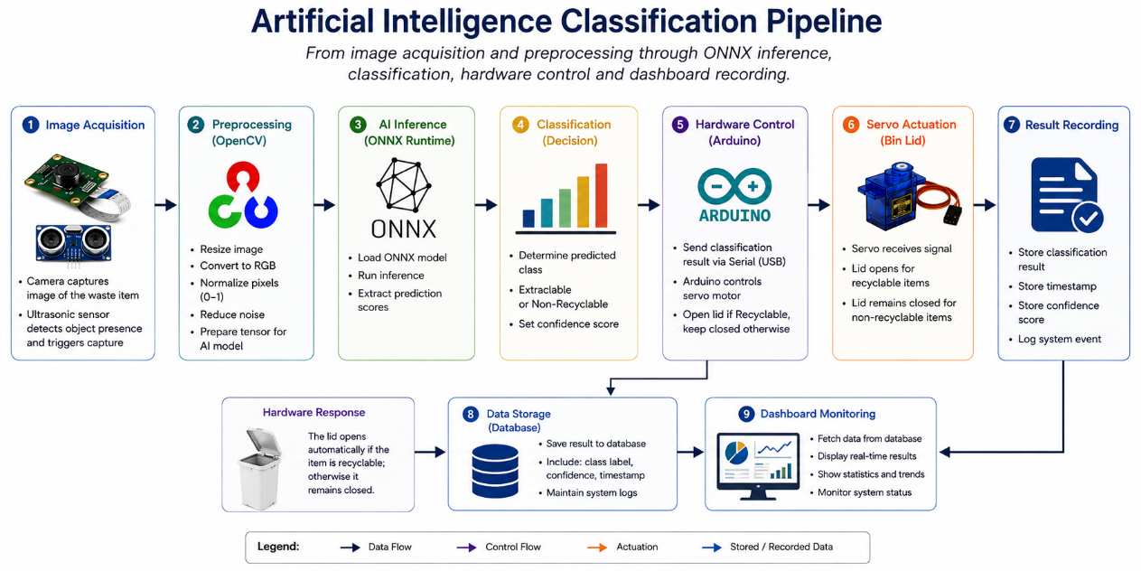
Figure 4.5, presents the sequence from image acquisition and preprocessing through ONNX inference, classification, hardware control and dashboard recording.

4.7 Operational Workflow

The operational workflow is event-driven. In the waiting state, the ultrasonic sensor continuously checks for an approaching object. Once the detection threshold is reached, the Arduino triggers the Raspberry Pi to capture an image.
The image is processed and classified using the deployed AI model. If the prediction corresponds to recyclable waste, the Arduino activates the servo and opens the lid. Otherwise, the lid remains closed. The classification, confidence score and timestamp are recorded before the system returns to its waiting state.
This workflow ensures that AI processing is performed only when an object is detected, improving computational efficiency and supporting continuous automated operation.

4.8 UML System Design

A UML Use Case Diagram was created to represent system functionality from the perspective of its actors. The two principal actors are the User and System Administrator.
The User presents a waste item, after which detection, classification, lid control and recording occur automatically. The System Administrator interacts primarily with the dashboard, where classification history, confidence information and recycling statistics can be reviewed.

The UML representation defines the system boundary and distinguishes automated processes from administrator interactions.
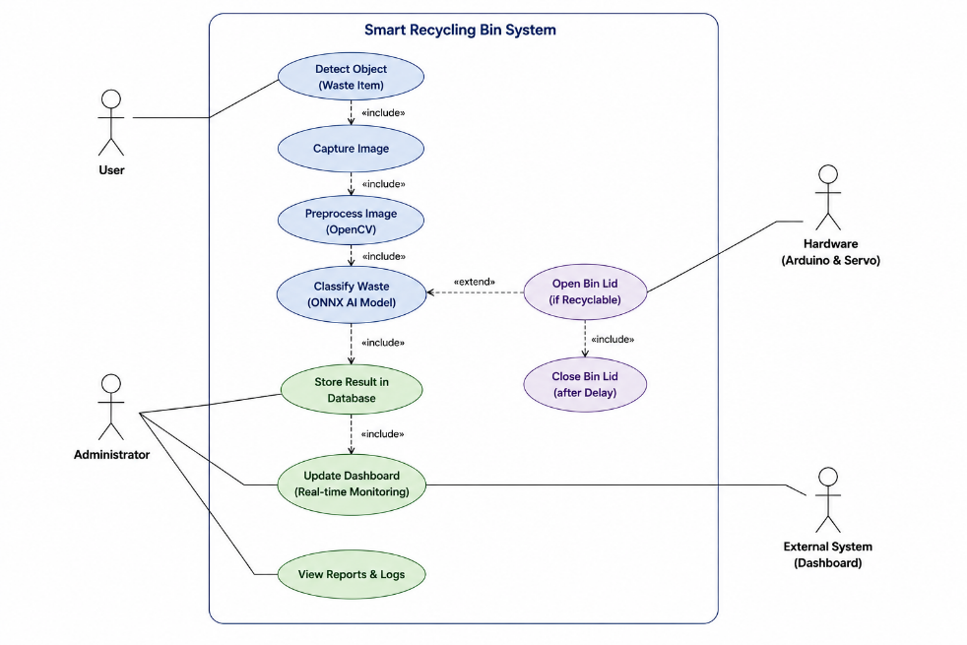

Figure 4.6, UML Use Case Diagram

4.9 Dashboard and Database Design

The dashboard extends the physical prototype by providing a digital monitoring interface. After each classification event, the system records relevant information in a MySQL relational database.
The dashboard provides Recent Activity, Detection History, AI Confidence, Recycling Statistics, Daily Trend, Weekly Chart, Pie Chart and Export PDF functionality. Recent Activity displays current classifications, while Detection History provides a chronological record. Statistical charts allow recycling activity to be interpreted visually, and confidence information assists with evaluating AI predictions.
Each database record stores the classification result, confidence score, date and time and is associated with a unique detection identifier. This structure supports efficient retrieval of historical information and provides a foundation for future expansion.
Importantly, the dashboard monitors classification activity, AI performance and estimated bin fill level, providing both recycling decision data and operational capacity information. This maintains alignment with the project objectives while extending the prototype's monitoring functionality. [30]

Dashboard Interface
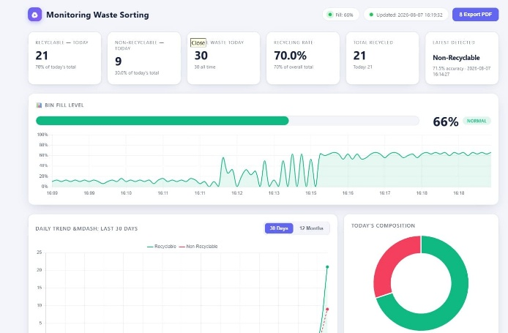
Figure 4.7 Dashboard Overview

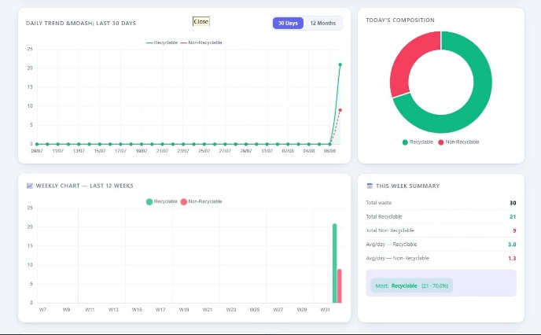
Figure 4.8 Recycling Analytics

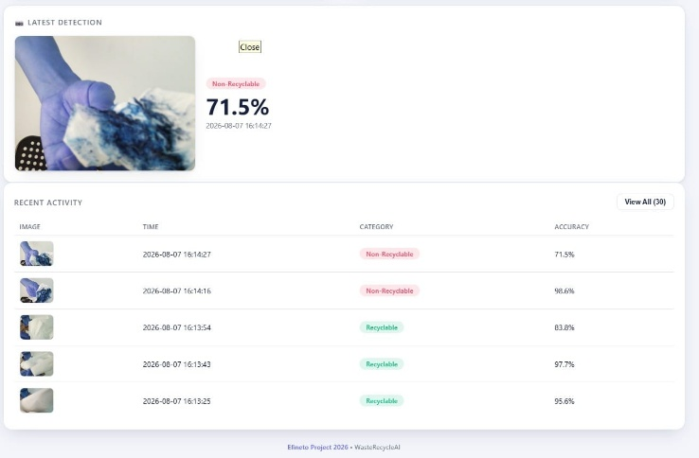
Figure 4.9 Detection History

Entity Relationship Diagram

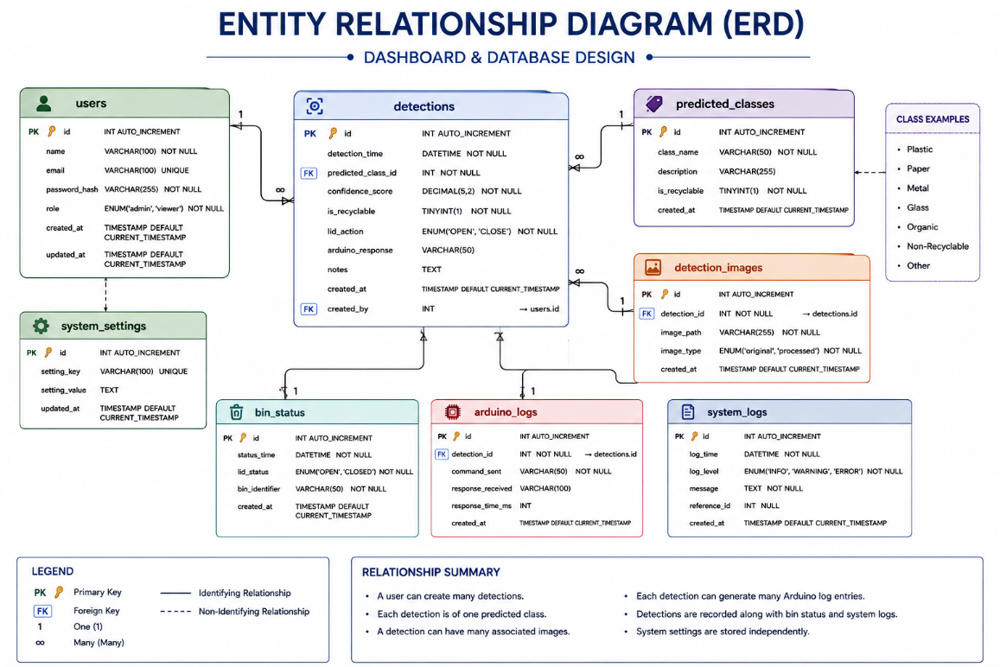

Figure 4.10, entity relationship diagram

4.10 Prototype Implementation and System Integration
Implementation followed the Agile-inspired methodology established in Chapter 3. Individual components were developed and tested before complete integration. This included sensor and servo testing, camera configuration, AI deployment, serial communication and dashboard development.
The completed prototype combines the hardware and software into a single operational platform. Object detection initiates the workflow; the Raspberry Pi performs image processing and classification; the Arduino controls the mechanical response; and the database records the completed event.
The modular architecture represents an important design strength. Computationally intensive AI tasks are allocated to the Raspberry Pi, while the Arduino provides responsive physical control. Local AI inference reduces cloud dependency, and individual components can be modified independently. Consequently, future versions could introduce additional waste categories, alternative sensors, more powerful AI models or enhanced communication functionality without requiring complete system redesign. [31]

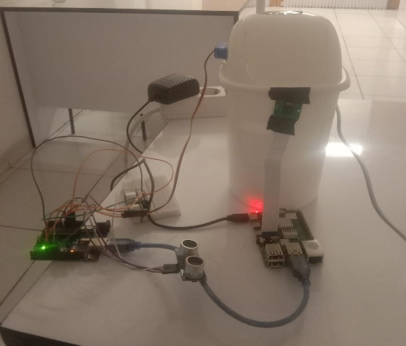
Figure 4.11, final prototype photograph

4.11 Chapter Summary
This chapter presented the design and implementation of the Intelligent AI-Based Smart Recycling Bin, explaining how the methodological framework established in Chapter 3 was transformed into a functional prototype.
The system combines an ultrasonic sensor for object detection, a Raspberry Pi Camera Module for image acquisition, OpenCV for preprocessing, an AI model deployed through ONNX Runtime for classification, an Arduino-controlled servo for automatic lid movement and a database-supported dashboard for monitoring recycling activity.
A modular architecture was adopted to separate computational processing, hardware control and data monitoring. This improved maintainability, simplified development and provided a scalable foundation for future improvements.
The completed system demonstrates the successful practical integration of Artificial Intelligence, Computer Vision, Embedded Systems and IoT-related monitoring within an affordable prototype. Importantly, the system focuses on assisting recycling decisions before waste is disposed of, rather than primarily monitoring bin fill levels after disposal.

5.1 Chapter Introduction
This chapter presents the testing, results and evaluation of the Intelligent AI-Based Smart Recycling Bin developed in Chapter 4. The purpose of the evaluation was to determine whether the completed prototype operated according to its functional requirements and to assess the performance of its individual hardware and software components.
The evaluation considered both subsystem performance and complete system integration. Testing focused on ultrasonic sensing, Artificial Intelligence (AI) classification, system response, hardware–software communication, servo-controlled lid operation, fill-level monitoring and dashboard functionality. [32]
A structured experimental approach was adopted in which individual components were first examined independently before the complete operational workflow was evaluated. This made it possible to identify potential faults within specific subsystems while also determining whether the Raspberry Pi, Arduino Uno, HC-SR04 ultrasonic sensors, Raspberry Pi Camera Module, OpenCV processing, ONNX Runtime inference, servo motor, database and monitoring dashboard operated successfully as an integrated system.
The results presented in this chapter are interpreted within the limitations of a proof-of-concept prototype. Testing was performed primarily under controlled indoor conditions; therefore, the findings demonstrate technical feasibility rather than commercial or industrial readiness.

5.2 Testing Environment
Experimental testing was conducted within a controlled indoor environment to improve consistency and repeatability. The testing configuration corresponded with the final prototype described in Chapter 4 and consisted of the following principal components:
- Raspberry Pi 4 Model B;
- Arduino Uno;
- Raspberry Pi Camera Module;
- two HC-SR04 ultrasonic sensing functions;
- servo-controlled recycling bin lid;
- OpenCV image-processing software;
- AI classification model deployed using ONNX Runtime;
- serial communication between the Raspberry Pi and Arduino;
- database storage; and
- monitoring dashboard.
The two ultrasonic sensing functions performed different roles within the prototype. The first HC-SR04 sensor was responsible for detecting the presence of an object or user's hand near the waste input area. A detection threshold of approximately 15 cm was configured within the Arduino program. When this threshold was reached, the Arduino generated the HAND_DETECTED signal, initiating the classification workflow.
The second ultrasonic sensing function monitored the internal fill level of the recycling bin. Distance measurements from this sensor were converted into an estimated fill percentage and transmitted periodically for presentation through the monitoring dashboard.
The Raspberry Pi performed image acquisition, OpenCV preprocessing, ONNX-based AI inference, database interaction and dashboard-related processing. The Arduino Uno handled sensor monitoring and servo motor control. Communication between the Raspberry Pi and Arduino was performed through serial communication.
During classification testing, the camera was maintained in a fixed position and individual waste objects were presented separately. Lighting and object positioning were kept as consistent as reasonably possible. These controls reduced unnecessary experimental variation; however, they also mean that the results should not automatically be generalised to uncontrolled public recycling environments.

5.3 Experimental Testing Strategy
A structured testing strategy was adopted to evaluate both individual components and complete system behaviour.
The evaluation consisted of five principal stages:
Preparation and Component Verification:
Before formal testing, the hardware connections, Raspberry Pi–Arduino serial communication, camera operation, ultrasonic sensing, ONNX model loading, servo motor movement, database connection and dashboard operation were verified.
Ultrasonic Sensor Testing:
The object-detection HC-SR04 function was tested to determine whether objects entering the configured trigger range were detected consistently. The fill-level sensing function was additionally checked to confirm that distance information was converted and communicated to the dashboard.
Artificial Intelligence Testing:
The AI classification process was evaluated by presenting waste items to the camera and examining the classifications and associated confidence scores generated by the deployed ONNX model.
Integrated System Testing:
The complete operational sequence was tested from initial object detection through image capture, preprocessing, AI inference, classification decision, Arduino communication, servo response and database recording.
Dashboard Validation:
The monitoring interface was evaluated to confirm that classification results, confidence information, timestamps, recycling statistics, detection history, graphical summaries and fill-level information were displayed correctly.
This staged approach provided a systematic method of evaluating the prototype and supported the identification of problems at both subsystem and integrated-system levels.

Experimental Testing Method

Preparation → Sensor Testing → AI Classification Testing → Integration Testing → Dashboard Validation → Results Analysis

5.4 Ultrasonic Sensor Testing

5.4.1 Object/Hand Detection Testing
The first HC-SR04 ultrasonic sensing function was evaluated because reliable object detection is necessary to initiate the recycling workflow. If the sensor fails to recognise an approaching object, image capture and classification cannot begin. Conversely, false detections could initiate unnecessary classification cycles.
The Arduino program configured an object/hand detection threshold of approximately 15 cm. During testing, an object was presented within the trigger range and the system was observed to determine whether the HAND_DETECTED signal was generated and whether this successfully initiated the subsequent classification process.

Table 5.1 – Object Detection Functional Test Results

Test | Object Within Trigger Range | HAND_DETECTED Received | Classification Triggered | Result
1 | Yes | Yes | Yes | Pass
2 | Yes | Yes | Yes | Pass
3 | Yes | Yes | Yes | Pass
4 | Yes | Yes | Yes | Pass
5 | Yes | Yes | Yes | Pass
All five recorded functional trials successfully generated the required detection signal and initiated the classification process. This demonstrates that the object-detection function operated reliably during the recorded short-term tests.
The results are sufficient to demonstrate functional operation of the trigger mechanism but should not be interpreted as a complete characterisation of HC-SR04 measurement accuracy. A larger experiment involving multiple reference distances, approach angles and different object surfaces would be required to establish measurement accuracy statistically.

5.4.2 Fill-Level Sensing

The second ultrasonic sensing function was used to estimate the internal fill level of the recycling bin. Unlike the first sensor, this measurement does not initiate AI classification. Instead, its purpose is to provide operational monitoring information.
The Arduino periodically obtains the distance between the ultrasonic sensor and the nearest detected surface inside the bin. This measurement is converted into an estimated fill percentage according to the configured bin-height reference before being transmitted through serial communication.
During prototype operation, fill-level information was successfully communicated to the monitoring dashboard, where the current estimated bin level could be viewed alongside classification statistics.
The inclusion of two sensing functions therefore extends the prototype beyond a single ultrasonic application. One function provides event-driven waste detection, while the second supports ongoing bin-capacity monitoring.
However, fill-level estimation using ultrasonic sensing can be affected by the irregular shape and distribution of waste. Consequently, the displayed percentage should be interpreted as an estimated capacity measurement rather than an exact measurement of waste volume. [33]

5.5 Artificial Intelligence Classification Testing
Artificial Intelligence classification represents a critical component of the prototype because the prediction generated by the AI model determines whether the presented item is treated as recyclable or non-recyclable.
The implemented classification process begins when the camera captures an image following an object-detection event. OpenCV preprocesses the image before the resulting input is submitted to the AI model using ONNX Runtime on the Raspberry Pi. The model produces a predicted class together with an associated confidence value.
The classification output is subsequently mapped to the required physical decision: recyclable or non-recyclable. This decision is communicated to the Arduino Uno, which determines whether the servo-controlled lid should open or remain closed.

Table 5.2 – AI Classification Test Summary

Measure | Result
Waste Classes | 6
Samples per Class | 20
Total Test Samples | 120
Correct Classifications | 112
Incorrect Classifications | 8
Overall Accuracy | 93.33%
Overall classification accuracy is calculated using:
Accuracy (%) = (Correct Classifications ÷ Total Classifications) × 100
Therefore:
Accuracy = (112 ÷ 120) × 100 = 93.33%

If supported by the recorded test data, this result demonstrates promising classification performance for an embedded proof-of-concept system. Nevertheless, an accuracy of 93.33% also indicates that classification errors remain possible. This is particularly important within the proposed application because an incorrect prediction can produce an incorrect physical disposal decision.

Performance should therefore be interpreted within the experimental conditions. Objects were presented individually and testing was performed under comparatively controlled lighting and camera positioning. Greater variation in background, illumination, orientation, object condition and packaging could influence classification performance in real-world operation.

5.5.2 AI Confidence
In addition to the predicted classification, the system generated an AI confidence value for individual detection events. These confidence values were recorded and displayed through the monitoring dashboard.
It is important to distinguish confidence from accuracy. Confidence represents the model's certainty regarding an individual prediction, whereas accuracy describes the proportion of correct classifications across a labelled test dataset.
A high-confidence prediction is therefore not necessarily correct. Consequently, dashboard confidence values were used as supporting information regarding model behaviour rather than as direct evidence of classification accuracy.

5.5.3 Classification Limitations
Several factors can influence image-based waste classification. Objects belonging to different material categories may have similar colours, shapes or surface characteristics. Packaging may also contain several materials, while transparent, damaged, folded or partially obscured objects may produce greater visual ambiguity.
The prototype additionally processes one object at a time. Multiple overlapping objects were outside the scope of the implemented system and would require more advanced object detection or segmentation techniques.
These factors demonstrate why the AI evaluation should be interpreted as evidence of prototype feasibility rather than proof of equivalent performance across all real-world recycling environments.

5.6 Integrated System Response and Reliability Testing
Following subsystem evaluation, the complete operational workflow was tested to determine whether the hardware and software components functioned correctly as an integrated system.

Each integrated test involved the following sequence:

Object Detection → Image Capture → OpenCV Preprocessing → ONNX Inference → Classification Decision → Raspberry Pi–Arduino Communication → Servo Response → Database Recording → Dashboard Update

5.6.1 System Response Time

System response time represents the interval between initial object detection and completion of the principal automated response.
Your current report records five response-time trials:

Table 5.3 – System Response Time Results

Trial | Response Time (seconds)
1 | 2.3
2 | 2.4
3 | 2.2
4 | 2.3
5 | 2.4
Average | 2.32

The mean response time was:
(2.3 + 2.4 + 2.2 + 2.3 + 2.4) ÷ 5 = 2.32 seconds
The range between the fastest and slowest recorded trials was only 0.2 seconds, indicating relatively consistent system behaviour during these tests.
For a proof-of-concept recycling system, the observed response demonstrates that image acquisition, preprocessing, local ONNX inference and hardware communication can be completed within a short period. [34]
However, only five recorded trials were used. Consequently, the result provides evidence of short-term prototype responsiveness rather than a comprehensive performance benchmark.

5.6.2 Integrated Reliability
Reliability was assessed by repeatedly executing the complete workflow.

Table 5.4 – Integrated System Functional Testing
Test | Detection | Image Capture & AI | Arduino Communication | Correct Servo Response | Data Recorded | Result
1 | Pass | Pass | Pass | Pass | Pass | Pass
2 | Pass | Pass | Pass | Pass | Pass | Pass
3 | Pass | Pass | Pass | Pass | Pass | Pass
4 | Pass | Pass | Pass | Pass | Pass | Pass
5 | Pass | Pass | Pass | Pass | Pass | Pass
All five recorded cycles completed the required operational sequence successfully.
This provides evidence that the Raspberry Pi, Arduino, camera, ultrasonic detection, AI inference, servo control and database recording were successfully integrated during short-term operation.
Nevertheless, five cycles cannot establish long-term system reliability. Extended continuous testing involving substantially more operational cycles would be necessary before claims regarding deployment reliability or industrial robustness could be justified.

5.7 Dashboard Validation
The monitoring dashboard was evaluated during operation of the Smart Recycling Bin to determine whether information generated by the physical and AI components was successfully received, stored, processed and displayed.
The dashboard represents an important part of the integrated prototype because it transforms individual classification events into information that can be reviewed and analysed.
During the recorded operational period, the dashboard contained 30 waste detections. Of these:
- 21 detections were classified as recyclable;
- 9 detections were classified as non-recyclable; and
- the displayed recycling rate was therefore 70.0%.

Table 5.5 – Dashboard Operational Summary

Dashboard Measure | Recorded Value
Total Detections | 30
Recyclable | 21
Non-Recyclable | 9
Recycling Rate | 70.0%
The recycling rate is calculated as:
Recycling Rate = (21 ÷ 30) × 100 = 70.0%

Importantly, this 70% value does not represent AI classification accuracy. It represents the proportion of the 30 recorded operational detections that the system classified as recyclable.
This distinction is important because dashboard operational statistics and controlled AI evaluation answer different questions. AI accuracy measures whether predictions are correct against known labels, whereas the dashboard recycling rate describes the distribution of classifications produced during actual prototype operation.
For each detection, the system recorded information including the classification result, confidence score and timestamp. Detection History provided a chronological record of previous events, while Recent Activity allowed recent classifications to be reviewed.
The dashboard additionally presented graphical summaries including daily activity, weekly trends and recyclable/non-recyclable distribution. These visualisations made it possible to interpret system activity more effectively than through individual database records alone.

5.7.1 Fill-Level Dashboard Validation

The dashboard also displayed estimated bin fill-level information generated by the second HC-SR04 sensing function.
Successful display of this information confirmed that ultrasonic measurements generated by the physical system could be communicated to the monitoring software and represented through the user interface.
This functionality complements the AI classification features by providing operational information regarding available bin capacity.

Table 5.6 – Dashboard Functional Validation

Function | Expected Behaviour | Result
Recent Activity | Display recent classifications | Pass
Detection History | Store and display historical events | Pass
AI Confidence | Display confidence information | Pass
Recycling Statistics | Summarise classification activity | Pass
Daily Trend | Visualise daily activity | Pass
Weekly Chart | Present weekly detection information | Pass
Waste Distribution | Compare recyclable/non-recyclable events | Pass
Fill-Level Monitoring | Display estimated bin capacity | Pass
Data Recording | Store classification and timestamp information | Pass

5.8 Results Analysis and Discussion

The combined experimental findings demonstrate that the prototype successfully integrated sensing, Computer Vision, Artificial Intelligence, embedded hardware control, database storage and digital monitoring within a single proof-of-concept system.
The object-detection tests demonstrated that the HC-SR04 trigger mechanism successfully initiated the classification workflow during all five recorded functional trials. This is important because object detection represents the first stage of the automated sequence. Failure at this stage would prevent all subsequent processing.
The second ultrasonic sensing function extended the prototype by providing fill-level information. This demonstrates that the system can simultaneously support automated waste interaction and operational bin monitoring. However, because ultrasonic fill-level estimation depends on the distance to the nearest waste surface, irregularly distributed waste may reduce measurement precision.
The Artificial Intelligence component provides the central decision-making functionality. If the reported 120-sample evaluation is supported by the original test records, the stated 112 correct classifications correspond to an overall accuracy of 93.33%. This would represent encouraging performance for a proof-of-concept embedded classification system, although the remaining errors demonstrate that AI predictions cannot be assumed to be completely reliable.
The distinction between AI accuracy and dashboard statistics is particularly important. The dashboard recorded 30 operational detection events, of which 70% were classified as recyclable. This value represents the composition of the recorded activity and not the model's classification accuracy.
The integrated system also demonstrated relatively consistent response times across the five recorded trials, with an average of 2.32 seconds. Local inference through ONNX Runtime allowed AI processing to occur directly on the Raspberry Pi rather than requiring continuous communication with a cloud inference service. This reduced network dependency and enabled the AI prediction to interact directly with the physical control system.
The successful completion of five integrated workflow tests additionally demonstrated short-term interoperability between the Raspberry Pi and Arduino. The division of responsibilities between the two devices proved appropriate: the Raspberry Pi handled computationally intensive image processing and AI inference, while the Arduino performed sensor monitoring and servo control.
The dashboard provided an additional layer of functionality by converting individual detection events into persistent monitoring information. Classification results, confidence scores, timestamps, historical records, statistical visualisations and fill-level information could be reviewed through a single interface.
Collectively, the findings therefore support the technical feasibility of the proposed architecture. However, the results should be interpreted according to the scale of testing performed. The prototype demonstrates successful operation under controlled conditions rather than evidence of production-level reliability. [35]

5.9 Limitations
Several limitations should be considered when interpreting the experimental findings.
First, testing was primarily performed under controlled indoor conditions. Lighting, camera positioning and object presentation were maintained relatively consistently. Real recycling environments may involve variable lighting, cluttered backgrounds, irregular object orientations, damaged packaging and partially obscured waste. These conditions could reduce classification performance.
Second, the prototype processes one waste item at a time. Multiple or overlapping objects were not addressed by the implemented classification workflow. Supporting such scenarios would require more advanced Computer Vision methods such as object detection or image segmentation.
Third, the integrated reliability assessment consisted of a relatively small number of recorded test cycles. Although all five completed successfully, this is insufficient to establish long-term reliability. Continuous operation over substantially longer periods would be required to evaluate hardware degradation, communication failures, sensor instability and mechanical wear.
Fourth, ultrasonic fill-level monitoring provides an estimated measurement. Waste does not necessarily form a flat surface inside the bin, and irregular object placement can therefore influence the distance measured by the sensor.
Finally, AI performance depends strongly on the quality and diversity of the data used during model development and evaluation. A larger and more varied test dataset would provide stronger evidence regarding model generalisation.
These limitations do not invalidate the prototype results but establish appropriate boundaries for their interpretation.

5.10 Future Improvements
Several improvements could extend the current proof of concept.
Future AI development should incorporate a larger and more diverse image dataset containing different object orientations, backgrounds, lighting conditions, packaging states and levels of deformation. This would allow model robustness to be evaluated under conditions that more closely represent real recycling environments.
More advanced Computer Vision techniques could also be investigated to support multiple objects or partially overlapping waste. Object-detection or segmentation architectures could enable individual items to be identified separately rather than assuming a single object within the camera view.
Long-term reliability testing should be conducted over hundreds or thousands of operational cycles. Such testing would provide stronger evidence regarding servo durability, sensor consistency, serial communication stability and overall system uptime.
Fill-level monitoring could also be improved through repeated measurements, filtering algorithms or additional sensing technologies to reduce the influence of uneven waste distribution.
The dashboard could subsequently support secure remote monitoring and centralised management of multiple recycling bins. This would extend the system from a standalone prototype towards a distributed IoT recycling infrastructure.
Finally, future hardware development could investigate more compact component integration, improved cable management, a more robust enclosure and higher-performance embedded AI platforms where additional computational capability is required. [36]

5.11 Evaluation Against Research Objectives
The experimental findings can be evaluated against the four research objectives established in Chapter 1.
Objective 1: To critically review existing research relating to Artificial Intelligence, Computer Vision, Embedded Systems, IoT and intelligent waste management.
This objective was achieved through the literature review presented in Chapter 2. Existing approaches were evaluated and a research gap was identified concerning the integration of affordable AI-based classification, embedded automation and monitoring at the point of disposal.
Objective 2: To design and develop an intelligent recycling prototype integrating a Raspberry Pi, Arduino Uno, HC-SR04 ultrasonic sensing, Raspberry Pi Camera Module, servo motor and AI classification model.
This objective was achieved through development of the operational prototype described in Chapter 4. The system successfully integrated object detection, image acquisition, OpenCV preprocessing, ONNX-based classification, Arduino communication and automated servo control.
Objective 3: To develop a monitoring dashboard capable of recording and displaying classification results, AI confidence scores, detection history and recycling statistics.
This objective was achieved. During recorded operation, the dashboard stored and presented classification results, confidence information, timestamps, historical detections, statistical summaries and fill-level monitoring. Thirty operational detection events were available within the recorded dashboard data.
Objective 4: To experimentally evaluate the accuracy, reliability and overall performance of the completed prototype through structured testing and performance analysis.
This objective was addressed through subsystem and integrated-system testing. Object detection, AI classification, response time, hardware–software integration, servo operation and dashboard functionality were evaluated. The results demonstrate successful prototype operation under controlled conditions while also identifying limitations requiring further investigation.
Overall, the four research objectives were addressed within the defined proof-of-concept scope.

5.12 Chapter Summary
This chapter presented the experimental testing, results and evaluation of the Intelligent AI-Based Smart Recycling Bin.
Testing examined the individual sensing, Artificial Intelligence, hardware control and monitoring components before evaluating complete system integration. The object-detection HC-SR04 sensing function successfully initiated the classification workflow during the recorded functional tests, while the second ultrasonic sensing function provided estimated fill-level information for dashboard monitoring.
Artificial Intelligence classification was performed locally on the Raspberry Pi using OpenCV preprocessing and ONNX Runtime inference. The classification result was subsequently communicated to the Arduino Uno, enabling the servo-controlled lid to respond according to the recyclable/non-recyclable decision.
Integrated testing demonstrated successful communication between the principal hardware and software components. Five recorded response-time trials produced an average of 2.32 seconds, while five complete workflow tests successfully performed detection, classification, physical response and data recording.
Dashboard validation demonstrated that operational information could be stored and presented successfully. The recorded dashboard contained 30 detections, consisting of 21 recyclable and 9 non-recyclable classifications, producing a 70.0% recycling rate. This figure represents the distribution of operational classifications rather than AI model accuracy.
Overall, the findings demonstrate the technical feasibility of combining Artificial Intelligence, Computer Vision, embedded hardware, ultrasonic sensing, automated mechanical control and digital monitoring within an affordable intelligent recycling prototype. However, the controlled testing environment, limited reliability trials and constraints of image-based classification mean that further evaluation would be required before real-world deployment could be considered.

Chapter 6 – Conclusion and Recommendations

6.1 Chapter Introduction

This chapter concludes the dissertation by evaluating the extent to which the proposed Intelligent AI-Based Smart Recycling Bin achieved the research aim and objectives. It summarises the principal outcomes of the project, identifies its contribution to intelligent waste management, acknowledges the limitations of the developed prototype and presents recommendations for future research and development. Overall, the project demonstrates how Artificial Intelligence (AI), Computer Vision, Embedded Systems and Internet of Things (IoT) technologies can be integrated within an affordable prototype to support automated waste classification and recycling monitoring. [37]

6.2 Achievement of the Research Aim
The primary aim of this research was to design, develop and evaluate an intelligent recycling bin capable of automatically identifying recyclable and non-recyclable waste using Artificial Intelligence while integrating embedded hardware and monitoring functionality. The findings demonstrate that this aim was successfully achieved within the scope of the prototype.
The completed system integrated a Raspberry Pi 4, Arduino Uno, Raspberry Pi Camera Module, HC-SR04 ultrasonic sensor and servo motor. When an object was detected, an image was captured and processed before the AI model classified the waste item. The classification result was then used to determine whether the servo-controlled lid should open or remain closed.
The monitoring dashboard further extended the system by recording classification results, confidence scores, timestamps and recycling statistics. Consequently, the completed prototype demonstrated not only automated classification but also the collection and visualisation of operational information.

6.3 Achievement of the Research Objectives

All four research objectives established in Chapter 1 were addressed during the project. First, existing research relating to intelligent recycling, Artificial Intelligence, Computer Vision, Embedded Systems and IoT technologies was critically reviewed. This identified limitations within existing approaches and established the research gap addressed by the proposed system.
Second, a functional intelligent recycling prototype was successfully designed and implemented. The integration of sensing, image acquisition, AI classification and automated lid control demonstrated the practical application of the technologies investigated within the literature.
Third, a monitoring dashboard was developed to record and visualise recycling activity, including classification results, AI confidence scores, detection history and statistical information.
Finally, the completed prototype was experimentally evaluated. Sensor accuracy, Artificial Intelligence performance, system reliability and dashboard functionality were assessed, providing measurable evidence that the proposed solution satisfied its intended functional requirements under the conditions tested.

6.4 Main Contributions of the Research

The principal contribution of this research is the development of an integrated, low-cost proof-of-concept that addresses recycling decisions at the point of disposal. Rather than relying entirely on users to determine whether waste is recyclable, the system applies image-based Artificial Intelligence to support automated decision-making.
A further contribution is the deployment of the trained AI model using ONNX Runtime on the Raspberry Pi. Local edge-based inference reduces reliance on continuous internet connectivity while demonstrating that intelligent classification can be performed using accessible embedded hardware.
The dashboard represents another contribution by connecting physical recycling activity with digital monitoring. Classification history, confidence scores and statistical information can be reviewed after operation, extending the prototype beyond a standalone automated bin.
Finally, the modular architecture separates sensing, AI processing, hardware control and monitoring functionality. This provides a flexible foundation from which individual components could be upgraded without requiring complete redesign of the system.

6.5 Research Limitations

Despite the encouraging results, several limitations affect the generalisability of the findings. The Artificial Intelligence model was evaluated using a relatively limited dataset and under controlled indoor conditions. Real recycling environments may contain variations in lighting, object orientation, background complexity and packaging condition that could reduce classification performance.
The prototype also processes one waste item at a time and supports a limited set of waste categories. More complex environments involving multiple or overlapping objects would require advanced object detection and segmentation methods.
Furthermore, the prototype was developed using affordable embedded hardware. Although the Raspberry Pi provided sufficient performance for the implemented model, more computationally demanding AI architectures may require higher-performance hardware. Therefore, the results demonstrate proof-of-concept feasibility rather than readiness for industrial or large-scale deployment. [38]

6.6 Recommendations for Future Work

Future development should prioritise expanding and diversifying the Artificial Intelligence dataset. Training images should include a wider range of waste materials, backgrounds, lighting conditions, orientations and packaging states to improve model robustness and generalisation.
The system could subsequently be extended to recognise additional waste categories and support multiple-object detection. More advanced deep learning architectures could also be investigated, provided that acceptable inference performance can be maintained on embedded hardware.
Further evaluation should take place in realistic public environments and over longer operating periods to investigate reliability, environmental effects and practical user interaction. The dashboard could also be extended with secure cloud connectivity and remote monitoring, enabling data from multiple recycling units to be analysed centrally.

6.7 Final Conclusion

This dissertation has demonstrated the successful design, implementation and evaluation of an Intelligent AI-Based Smart Recycling Bin integrating Artificial Intelligence, Computer Vision, Embedded Systems and monitoring technologies. The completed prototype successfully performed object detection, image-based waste classification, automated lid control, fill-level monitoring and recycling activity recording within a single integrated system.The research does not establish that the prototype is ready for commercial deployment; instead, it provides a functional and experimentally evaluated proof of concept from which further development can proceed. Larger and more diverse datasets, broader environmental testing, additional waste categories and extended reliability evaluation would be required to determine the system's performance under real-world operating conditions.
Experimental findings, including an overall AI classification accuracy of 93.33%, successful object detection during the recorded functional trials, and an average integrated system response time of 2.32 seconds, provide encouraging evidence of the technical feasibility of the proposed system under controlled conditions. However, classification accuracy alone does not provide a complete evaluation of the AI model's performance. Therefore, the classifier was further evaluated using a confusion matrix, presented as a heat map, to identify the distribution of correct and incorrect predictions between the recyclable and non-recyclable classes. The confusion matrix distinguishes between true positives, true negatives, false positives and false negatives, providing a clearer indication of how effectively the model differentiates between the two waste categories. In particular, false-positive results represent non-recyclable items incorrectly classified as recyclable, while false-negative results represent recyclable items incorrectly classified as non-recyclable. This analysis provides greater insight into the types of classification errors made by the system than overall accuracy alone.
The monitoring dashboard further demonstrated successful system integration by recording classification results, confidence scores, timestamps, recycling statistics and estimated bin fill-level information. Overall, the experimental results demonstrate that affordable embedded computing and AI technologies can be combined to reduce dependence on human judgement during recycling decisions while simultaneously providing useful operational information. Although the results are encouraging, the confusion-matrix analysis also provides a more comprehensive assessment of the classifier's effectiveness and highlights areas where further training and optimisation may be required.

Actual / Predicted | Recyclable | Non-recyclable
Recyclable | True Positive | False Negative
Non-recyclable | False Positive | True Negative

- True Positive (TP): Recyclable item correctly identified as recyclable.
- True Negative (TN): Non-recyclable item correctly identified as non-recyclable.
- False Positive (FP): Non-recyclable item incorrectly identified as recyclable.
- False Negative (FN): Recyclable item incorrectly identified as non-recyclable.

Overall, the research aim and objectives were successfully achieved within the defined project scope. The findings demonstrate the potential of intelligent embedded technologies to support more accurate, automated and data-driven recycling practices while establishing a foundation for future research into scalable and sustainable intelligent waste management systems. [39].

References

[1] | S. Majchrowska, A. Mikołajczyk, M. Ferlin, Z. Klawikowska, M. A. Plantykow, A. Kwasigroch, and K. Majek,, “Deep learning-based waste detection in natural and urban environments,”,” Waste Management,, Vols. vol. 138,, no. doi: 10.1016/j.wasman.2021.12.001., pp. pp. 274–284,, 2022.
[2] | G. White, C. Cabrera, A. Palade, F. Li, and S. Clarke,, ““WasteNet: Waste classification at the edge for smart bins,”,” no. arXiv preprint arXiv:2006.05873,, 2020.
[3] | M. Aarif et al.,, ““Smart bin: Waste segregation system using deep learning–Internet of Things for sustainable smart cities,”,” Concurrency and Computation: Practice and Experience,, no. doi: 10.1002/cpe.7378., 2022.
[4] | X. Yang and X. Thung,, “Classification of trash for recyclability status,”, Stanford University,: CS229 Project Report,, 2017.
[5] | O. A. Awe, R. Mengistu, and V. Sreedhar,, Smart Trash Net: Waste localization and classification,”, Stanford University,: CS229 Project Report,, 2017.
[6] | J. Bobulski and M. Kubanek,, ““Waste classification system using image processing and convolutional neural networks,”,” in Advances in Computational Intelligence, Lecture Notes in Computer Science,, vol. vol. 11507. , no. doi: 10.1007/978-3-030-20518-8_30., pp. Cham, Switzerland: Springer,, 2017.
[7] | P. F. Proença and P. Simões,, ““TACO: Trash annotations in context for litter detection,”,” no. arXiv preprint arXiv:2003.06975,, 2020.
[8] | S. Adedeji and Z. Wang,, ““Intelligent waste classification system using deep learning convolutional neural network,”,” Procedia Manufacturing,, Vols. vol. 35, pp., pp. 607–612,, 2019.
[9] | R. A. Aral, Ş. R. Keskin, M. Kaya, and M. Hacıömeroğlu,, “Classification of trashnet dataset based on deep learning models,”,” in IEEE International Conference on Big Data, Seattle,, WA, USA,, in 2018.
[10] | G. Thung and M. Yang,, “Classification of trash for recyclability status,”, Stanford, CA, USA,: Stanford University,, 2016.
[11] | H. Wang et al.,, ““Recycling waste classification using optimized convolutional neural network,”,” Vols. vol. 164, Art. no. 105132, 2021,, no. doi: 10.1016/j.resconrec.2020.105132..
[12] | K. He, X. Zhang, S. Ren, and J. Sun,, ““Deep residual learning for image recognition,”,” in Proc. IEEE Conf. Computer Vision and Pattern Recognition (CVPR), pp. pp. 770-778, 2016.
[13] | M. Toğaçar, B. Ergen, and Z. Cömert,, ““Waste classification using AutoEncoder network with integrated feature selection method in convolutional neural network models,”,” Measurement,, Vols. vol. 153,, no. Art. no. 107459, 2020..
[14] | A. Krizhevsky, I. Sutskever, and G. E. Hinton,, ““ImageNet classification with deep convolutional neural networks,”,” in Advances in Neural Information Processing Systems,, Vols. vol. 25,, p. pp. 1097–1105., 2012.
[15] | M. Tan and Q. Le, , ““EfficientNet: Rethinking model scaling for convolutional neural networks,”,” in Proc. 36th International Conference on Machine Learning,, p. pp. 6105–6114., 2019,.
[16] | A. G. Howard et al.,, ““MobileNets: Efficient convolutional neural networks for mobile vision applications,”,” no. arXiv preprint arXiv:1704.04861,, 2017.
[17] | M. Sandler, A. Howard, M. Zhu, A. Zhmoginov, and L.-C. Chen,, “MobileNetV2: Inverted residuals and linear bottlenecks,”,” in Proc. IEEE/CVF Conference on Computer Vision and Pattern Recognition,, pp. pp. 4510-4520, 2018.
[18] | Y. LeCun, Y. Bengio, and G. Hinton,, ““Deep learning,”,” Nature,, vol. vol. 521, no. no. 7553, pp. pp. 436–444, , 2015.
[19] | A. Voulodimos, N. Doulamis, A. Doulamis, and E. Protopapadakis,, ““Deep learning for computer vision:,” A brief review,” Computational Intelligence and Neuroscience,, vol. vol. 2018, pp. no. 7068349,, 2018.
[20] | G. Bradski, ““The OpenCV library,”,” Dr. Dobb’s Journal of Software Tools,, vol. vol.25., pp. no. 11, pp. 120-125, 2000.
[21] | R. Szeliski, “Computer Vision:,” in Algorithms and Applications,, Switzerland:, Springer,, 2022, p. 2nd ed. Cham.
[22] | W. Shi, J. Cao, Q. Zhang, Y. Li, and L. Xu,, ““Edge computing: Vision and challenges,”,” IEEE Internet of Things Journal,, Vols. vol. 3, no. 5, no. doi: 10.1109/JIOT.2016.2579198., pp. pp. 637–646,, 2016.
[23] | M. Satyanarayanan, ““The emergence of edge computing,”,” Computer, vol. vol. 50, pp. pp. 30–39,, 2017.
[24] | A. Zanella, N. Bui, A. Castellani, L. Vangelista, and M. Zorzi,, ““Internet of Things for smart cities,”,” IEEE Internet of Things Journal,, Vols. vol. 1, no. 1,, no. doi: 10.1109/JIOT.2014.2306328., pp. pp. 22–32,, 2014.
[25] | doi: 10.1109/JIOT.2014.2306328., ““The Internet of Things:,” A survey,” Computer Networks, Vols. vol. 54,, pp. no. 15, pp. 2787–2805,, 2010.
[26] | A. Baby, A. Ranjendran, J. K. Joseph, and J. K. R.,, ““Smart waste management system using IoT,”,” International Journal of Software Computing and Testing,, Vols. vol. 5, no. 2,, no. doi: 10.37628/ijosct.v5i2.555., pp. pp. 30–37,, 2019,.
[27] | L. A. Guerrero, G. Maas, and W. Hogland,, ““Solid waste management challenges for cities in developing countries,”,” Waste Management,, Vols. vol. 33, no. 1,, pp. pp. 220–232,, 2013.
[28] | D. C. Wilson, L. Rodic, P. Modak et al.,, “Global Waste Management Outlook.,” United Nations Environment Programme,, Nairobi, Kenya:, 2015.
[29] | S. Kaza, L. C. Yao, P. Bhada-Tata, and F. Van Woerden,, “What a Waste 2.0: A Global Snapshot of Solid Waste Management to 2050.,” World Bank,, Washington, DC, USA:, 2018.
[30] | J. Kirchherr, D. Reike, and M. HekkerT,, ““Conceptualizing the circular economy: An analysis of 114 definitions,”,” Resources, Conservation and Recycling,, Vols. vol. 127,, pp. pp. 221–232,, 2017.
[31] | M. Geissdoerfer, P. Savaget, N. M. P. Bocken, and E. J. Hultink,, ““The circular economy—A new sustainability paradigm?",” Journal of Cleaner Production,, vol. vol. 143, pp. pp. 757–768,, 2017.
[32] | J. Korhonen, A. Honkasalo, and J. Seppälä,, ““Circular economy: The concept and its limitations,”,” Ecological Economics,, Vols. vol. 143,, pp. pp. 37–46,, 2018.
[33] | J. K. Singh and M. Laurenti, ““Environmental implications of recycling and circular economy approaches,”,” Journal of Cleaner Production,, 2020.
[34] | M. A. Hannan et al.,, ““Waste collection route optimisation model for linking cost saving and emission reduction to achieve sustainable development goals,”,” Sustainable Cities and Society, Vols. vol. 62,, no. 102393, 2020., 2020.
[35] | M. A. Hannan et al.,, ““IoT-enabled smart waste management systems for smart cities: A systematic review,”,” IEEE Access,, no. doi: 10.1109/ACCESS.2022.3188308., 2022.
[36] | P. Hohl, J. Klünder, A. van Bennekum et al.,, ““Back to the future: Origins and directions of the ‘Agile Manifesto’—Views of the originators,”,” Journal of Software Engineering Research and Development,, Vols. vol. 6,, pp. no. 15,, 2017.
[37] | B. Boehm and R. Turner,, Balancing Agility and Discipline:, Boston, MA, USA:: Addison-Wesley,, 2003.
[38] | M. Saunders, P. Lewis, and A. Thornhill,, Research Methods for Business Students,, 8th ed. Harlow, U.K.:: Pearson,, 2019.
[39] | J. W. Creswell and J. D. Creswell,, Research Design: Qualitative, Quantitative, and Mixed Methods Approaches,, , CA, USA: SAGE,: 5th ed. Thousand Oaks,, 2018..
[40] | J. Bobulski and M. Kubanek,, ““Waste classification system using image processing and convolutional neural networks,”,” in Advances in Computational Intelligence, Lecture Notes in Computer Science,, p. 2019.

Declaration of Originality

I, Eftali Note, declare that I am the sole author of this Project; that all references cited have been consulted; that I have conducted all work of which this is a record, and that the finished work lies within the prescribed word limits.

This work has not previously been accepted as part of any other degree submission.

Signed : EN

Date : 09/08/2026

FORM OF CONSENT

I, Eftali Note, hereby consent that my Project, submitted in candidature for the B.Sc.(Hons) Computer Networks degree, if successful, may be made available for inter-library loan or photocopying (subject to the law of copyright), and that the title and abstract may be made available to outside organisations.

Signed : EN

Date : 09/08/2026

Copyright Acknowledgement

I acknowledge that the copyright of this project report, and any product developed as part of the project, belong to University of Wales Trinity Saint David, Swansea.

