Student Name | Meet Dilipbhai Patel
Student ID | 2532591
Programme | Master of Business Administration
Module Name | International Business Concepts
Module Code | LCMB7023
Assessment Title | Individual Report
Report Title | HR Strategy
Lecturer | Dr. Charles Oham
Date of Submission | 20 March 2026

Table of Contents
Part 1: Building a Culture of Innovation & Future Work Practices 2
Current practices in culture and work among the tech companies 3
Cultural and structural initiatives that embed innovation 4
Future of Work model (hybrid/remote) that supports collaboration and creativity 5
Way the new approach would motivate and enable staff to perform optimally 7
Part 2: Reflection 8
Reflection using Gibbs Model 9
Way I plan to stay relevant 11
References 12

Part 1: Building a Culture of Innovation & Future Work Practices

Current practices in culture and work among the tech companies
Technology firms are very competitive and dynamic worlds, where innovation, collaboration, and quick experimentation are critical to maintaining competitive edge. Consequently, most technology companies have created organisational cultures that are focused on creativity, flexibility, and constant learning (WIPO, 2025b). A major distinguishing factor of the technology industry is that it is largely focused on innovation-based organisational culture. To ensure technological leadership and new product development, global technology companies spend a lot of money on the research and development (R&D). IT spending is projected to grow to 5.61 trillion in the year 2025 by a 9.8% increase compared to the year 2024, which indicates that technology companies are spending heavily in the digital infrastructure, software, and IT services to spur innovation and technology development (Cisco, 2025).
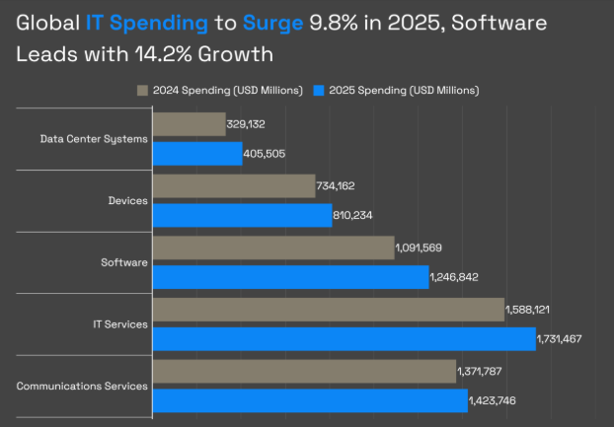
Fig 1: Global IT Spending’s
Source: (Ahmed, 2025)
Concurrently, the level of innovation activity at the global level is rising at an accelerated pace as a result of corporate R&D, though the pace has been declining over the past years. The Global Innovation Index 2025 found that the growth rate in global corporate R&D expenditure has lowered to approximately 3%/year (as compared to 8%/year over the last 10 years) demonstrating the mounting pressure on firms to produce more and more innovation with less and less spending (WIPO, 2025a). In a bid to encourage innovation, agile organisational forms which have replaced the traditional hierarchical management systems have been embraced by a number of technology companies. Rather than strict bureaucracies, corporations are moving towards small, independent teams that address particular projects or products. Agile teams can react very fast to changes in technology and customer requirements (Chanty, 2026). This fluid system supports experimentation, expedited decision making and increased employee participation in problem solving.
Flexible work arrangements are another important trend in the technology firms. The development of cloud computing, collaboration systems and communication facilities has allowed staff to perform efficiently at various sites. Workplaces based on modern technology have become a major point of work through hybrid and remote employment. Studies indicate that 7 out of 10 companies in the world currently favour hybrid or online work set-ups, and this is a huge change in the way organisations conduct their work. Employee expectations also drive the need to have a flexible work. In the workplace, 83% of workers prefer to have hybrid work schedules, which entails working away followed by in-person work (Forbes, 2025). The concept of hybrid work enables employees to be productive and enjoy flexibility and better work life balance.

Cultural and structural initiatives that embed innovation
Cultural Initiatives that Embed Innovation
Innovation is integrated within organisations through the culture of experimentation, creativity, and empowering employees. Technology companies tend to encourage intrapreneurship, psychological safety, and lifelong learning, which allows workers to pursue novel ideas and not be afraid of failure. The significance of this cultural approach is that it is the level of employee engagement and creativity that can have a strong impact on the outcome of innovation. The productivity and profitability of the companies with highly engaged employees are 21% and 23% higher, respectively, which supports the importance of enabling innovation cultures (Founder Reports, 2025). Moreover, international corporate investment in research and development is still high with multinational organisations charged with approximately 40% of the total world research and development spending in 2025 indicating the significance of organisational culture in aiding research and technological advancement.

Structural Initiatives that Embed Innovation
Structural initiatives are also important in facilitating innovation by determining the ways teams work and how to make decisions. The agile organisational structure, cross-functional teams, and innovation labs are adopted by many technology-oriented companies to facilitate knowledge sharing and fast experimentation (WorkTime, 2026). Cross-functional teams integrate the employees of various departments like engineering, marketing, and design departments enabling organisations to combine the varied perspectives and speed up the problem solving process. Moreover, the workplace organization is changing by adopting hybrid and remote work arrangements backed by digital collaboration tools. It is indicated that around 53% of employees worldwide currently operate in hybrid while a significant change in organisational structures is witnessed compared to the period before the pandemic. Innovation also requires the use of digital collaboration tools as 93% of employers have indicated that technology platforms play a pivotal role in facilitating collaboration in hybrid workplaces (Gallup, 2025). Through these structural modifications, organisations are able to become more flexible, enhance knowledge sharing and generate conditions under which innovation can be done more quickly.

Future of Work model (hybrid/remote) that supports collaboration and creativity
The 3–2 Hybrid Collaboration Model
One of the most popular future-of-work models, which are also used by modern organisations, is the 32 Hybrid Collaboration Model. This model allows employees to be in the office three days a week and work remotely two days a week, which is a balance between the ability to work together in the office and the ability to work anywhere (WaveCNCT, 2025). Technology firms are increasingly adopting this strategy since it enables organisations to retain creativity, innovation, and organisational culture within the team and also encourages employee autonomy and productivity. By 2026, approximately 75% of global companies work in hybrid work arrangements, and hybrid work is the model of knowledge-based industries (Great Place to Work, 2025). Moreover, the data on the labour market reveals that approximately 35-36% of new employment opportunities in 2025 involve remote and hybrid opportunities, and it is essential to note that the flexibility of work arrangement is becoming institutionalised in contemporary organisations. The hybrid model promotes teamwork and innovation and organizes work processes according to their character (WIPO, 2025c). Activities that are best facilitated through face-to-face interaction are normally conducted during in-office days, which include brainstorming, design thinking, cross-functional, and innovation sprints. Physical contact augments idea generation spontaneously and reinforces team cohesiveness which is paramount in creative problem solving. In contrast, remote working days enable employees to do specific tasks like coding, analysis of data, or research without having to be disrupted at their workstations. 58-61% of the workforce state that they become more productive at home, and 81% report work-life balance is better, indicating that the hybrid format can be more effective to both performance and the wellbeing of employees (Intuition, 2026).
The hybrid work model includes digital collaboration technologies as its indispensable elements. Cloud platforms, video conferencing applications, and project management software are the tools used by organisations to ensure communication and knowledge sharing among distributed teams. Such technologies enable teams to work together regardless of geographical distance without being denied organisational knowledge and resources. It has been shown, however, that more than 9 out of 10 organisations regard digital collaboration tools as essential to face hybrid teamwork, which proves the ways in which the technology infrastructure facilitates flexible and innovative workspaces. Strategically, the hybrid model offers serious economic and organisational advantages as well. A possibility of remote and hybrid work structures can help companies save money that is spent on operations like office space, utilities, and travel. Organisations can save around 10000-11000 dollars per employee per year with remote and hybrid employment (Neat, 2025). Simultaneously, flexible work policies have the potential to enhance talent acquisition and retention, especially in relation to younger professionals who are becoming more focused on autonomy and work-life balance. On the whole, the 3-2 Hybrid Collaboration Model is a moderate perspective on the future of work.
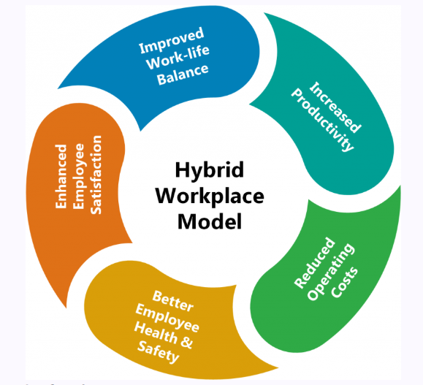
Fig 2: Hybrid Workplace Model
Source: (CorpHR, 2023)

Way the new approach would motivate and enable staff to perform optimally
Employee motivation and performance can be greatly enhanced with the introduction of hybrid and innovation-oriented work models. Flexible work arrangements give flexible workers more control on time and place of work and this enhances job satisfaction and productivity. Recent workplace surveys indicate that approximately 81% of workers state that their work-life balance is enhanced when they operate in a hybrid or a remote setting, and about 5861% of them claim to be more productive than when working under the traditional office-based working models (Neat, 2025). Flexible schedule and less time in commuting enable employees to organize their work more effectively, which has a favourable impact on wellbeing and work performance.
Greater autonomy and trust in organisations is another factor that increases motivation. The contemporary systems of hybrid workplace are as concerned with the resultant performance as with the time of working. Employees will have higher chances of being ownership takers of their tasks and commitment to organisational goals when they are entrusted with the responsibility of handling their tasks independently. Companies which encourage employee autonomy achieve approximately 21% superior productivity and increased employee engagement proving the worth of empowering working conditions (WIPO, 2025d).
Employees are also motivated by innovation-specialized programmes like cross-functional teams, innovation sprints, and intrapreneurship programmes that promote creativity and collaboration (Robert Half, 2025). The collaboration with the employees of other departments gives employees an opportunity to share their knowledge, acquire new skills, and generate innovative ideas. Moreover, the digital collaboration technologies are also essential in performance support in hybrid environments. In hybrid workplaces, more than 90% of organisations believe that digital collaboration tools are a necessity in terms of productivity and teamwork (Stanford University, 2025).

Part 2: Reflection

Reflection using Gibbs Model
Description
This Human Capital Management module was valuable because of the insights given on the dynamic nature of work and the role of people management in organisational success. A number of important topics were discussed during the module, such as international human resource management, team management, recruitment and performance management, training and development, and the future of work (WIPO, 2025e). These discussion points raised the way organisations use talent and nurture employees to attain strategic objectives. One of the learning areas that was important was the development of organisational cultures that facilitate innovation and adaptability. The module also touched upon the change towards flexible work patterns that modern organisations are moving towards including hybrid and working remotely with the help of digital technologies. Lectures and discussions made me understand more deeply how the leadership, learning and development, and organisational culture affect the motivation and innovation of employees.
Feelings
By the start of the module, I was keen on knowing how organisations handle employees in international and fast changing environments. Certain notions including international HR management and organisation design at first appeared difficult. Nonetheless, as the module continued, I felt more confident about my grasp of the way these concepts can be applied to actual organisational practice. The information about the culture of innovation and the future work practices helped me to understand the necessity of constant learning and flexibility in the contemporary professions. I was inspired by the notion that people can effectively lead to organisational innovation by working together, being creative and sharing knowledge. This prompted me to consider the skills and competencies which I should acquire to succeed in workplaces that are dynamic and technology-oriented.
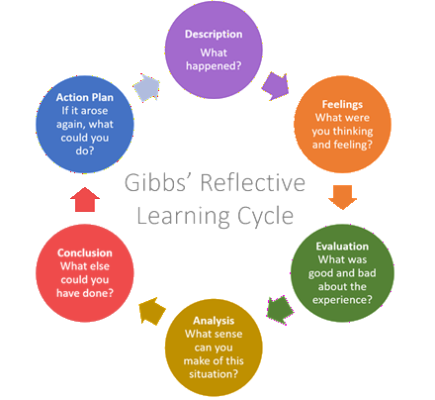
Fig 3: Gibbs Model
Source: (Martin, 2021)
Evaluation
Generally, the module was very useful in broadening my knowledge on human capital management and organisational innovation. The good news was that the module connected theoretical knowledge and current workplace trends like hybrid work, online teamwork, and agile organisational frameworks. These illustrations made me realise how organisations react to technological change and globalisation (SurveyMonkey, 2026). The module too stressed the significance of training and development to enhance the employee skills and organisational performance. Nonetheless, one of the problems was the implementation of theoretical models into real-world scenarios at the beginning of the course.
Analysis
The module has brought into focus the importance of continuous learning and development on both individual and organisational levels. Innovation and competitiveness in the fast changing environment requires organisations to have experienced and flexible employees (Zoom, 2025). Training and development, cross-functional teamwork and talent management were just a few concepts that show how organisations build employee capacity to realise strategic goals. The future-of-work discussions also revealed that the technological changes and digital collaboration tools are changing the way organisations conduct themselves. Hybrid work patterns involve employees to acquire communication skills, collaboration, and self-management skills (Visual Capitalist, 2025). The reflection on this learning process has allowed me to realise the need to embrace a growth mindset. Growth mindset positively influences people to be constantly engaged in learning, adjusting to challenges, and to see mistakes as learning opportunities.
Conclusion
To summarise, this module has gone a long way in enhancing my knowledge about human capital management and the role of learning and development in contemporary organisations. It showed the way organisations can develop innovative cultures through good leadership and staff development as well as flexible work practices. Another thing that the module made me realise was the value of life-long learning and flexibility in professional growth. My reflection on this learning experience has enabled me to realise that building a growth mindset could assist people to appropriately react to organisational change and technological innovations.
Action Plan
On this reflection, I intend to keep on building my skills and knowledge to facilitate my professional development. I will engage in online training courses and professional training programmes to enhance my leadership skills, communication and problem solving skills. I also will get a chance to cooperate with others and get involved in the projects that promote creativity and innovation. I also want to ensure that I consistently look back and analyse my experience and progress in learning to determine areas that I need to improve. These learning and development strategies will enable me to develop a growth mindset, and be a valuable employee in innovative and progressive organisations.

Way I plan to stay relevant
Artificial intelligence (AI) is rapidly progressing and altering the work character of numerous industries and the character of work. With the emerging possibilities of AI technologies, more and more routine and data-driven tasks previously performed by humans can be handled by computers. It is said that AI and automation may affect about 300 million full-time working jobs all over the world, and those that presuppose repetitive administrative and analytical tasks. Simultaneously, AI will generate new opportunities and jobs that will demand human ingenuity, thoughtfulness, and emotional intelligence. Thus, it is important to remain relevant in the AI era with the help of constant learning and the skills to combine human abilities with technology.
In order to be competitive with this changing environment, I will be concentrating on skills that match and not rival AI. AI systems can hardly imitate human capabilities, who include critical thinking, leadership, creativity, and complex problem solving. By enhancing these capabilities, I would be able to contribute value in aspects where human judgement and innovation is vital. Also, enhancing excellent digital literacy and knowledge of AI technologies will enable me to collaborate successfully with intelligent systems.
Another effective way to utilize AI is to increase productivity with the help of AI instead of eliminating people. By way of example, AI will be useful in processing vast amounts of information, creating insights, automating routine procedures, and aiding in decision making. With the help of AI tools to perform time-consuming routine work, I will be able to spend more time on strategic planning, creative thoughts, and building relationships. This is a way that enables professionals to enhance efficiency without compromising on making important decisions.
Moreover, life-long learning will be essential in making the career relevant in the long term. Professional training, acquisition of technological skills, and keeping up to date with new trends will enable people to be able to fit into the changing workplace environment. Taking the spirit of lifelong learning and applying AI as a supportive tool will enable professionals to stay valuable members in organisations.
The net effect is that although AI will radically redefine the labour market, it is more of a cooperative technology and not a substitution of human talent. Human knowledge and AI analytical power will allow a person to increase productivity and stay up to date in the employment environment.

References
Ahmed, A. (2025) Global IT spending to reach $5.61 trillion in 2025, driven by AI investments. Available at: https://www.digitalinformationworld.com/2025/01/global-it-spending-to-reach-561.html
Chanty (2026) Remote work statistics and trends. Available at: https://www.chanty.com/blog/remote-work-statistics/
Cisco (2025) Cisco hybrid work study. Available at: https://newsroom.cisco.com/c/dam/r/newsroom/pdfs/Cisco-Hybrid-Work-Study.pdf
CorpHR (2023) Hybrid workplace model: Meaning, benefits and best practices. Available at: https://corphr.in/blog/hybrid-workplace-model-meaning-benefits-and-best-practices/
Forbes (2025) Remote work statistics and trends. Available at: https://www.forbes.com/advisor/in/business/remote-work-statistics/
Founder Reports (2025) Return-to-office and hybrid work statistics. Available at: https://founderreports.com/return-to-office-statistics/
Gallup (2025) State of the global workplace report. Available at: https://www.gallup.com/workplace/349484/state-of-the-global-workplace.aspx
Great Place to Work (2025) Remote work productivity study. Available at: https://www.greatplacetowork.com/resources/blog/remote-work-productivity-study-finds-surprising-reality-2-year-study
Intuition (2026) Remote working statistics you need to know in 2026. Available at: https://www.intuition.com/remote-working-statistics-you-need-to-know-in-2026/
Martin, H. (2021) Gibbs’ reflective learning cycle. Available at: https://helendenheld.com/tag/gibbs-reflective-learning-cycle/
Neat (2025) The state of remote work 2025 statistics report. Available at: https://us.neat.no/resources/the-state-of-remote-work-2025-statistics/
Neat (2025) The state of remote work statistics 2025. Available at: https://neat.no/resources/the-state-of-remote-work-2025-statistics/
Robert Half (2025) Remote work statistics and trends. Available at: https://www.roberthalf.com/us/en/insights/research/remote-work-statistics-and-trends
Stanford University (2025) AI Index Report 2025. Available at: https://hai.stanford.edu/ai-index/2025-ai-index-report
SurveyMonkey (2026) Remote and hybrid work statistics. Available at: https://www.surveymonkey.com/learn/employee-feedback/remote-hybrid-work-statistics/
Visual Capitalist (2025) The world’s most innovative countries in 2025. Available at: https://www.visualcapitalist.com/ranked-the-worlds-most-innovative-countries-in-2025/
WaveCNCT (2025) Hybrid work statistics and trends. Available at: https://wavecnct.com/blogs/news/hybrid-work-statistics
WIPO (WIPO) (2025a) Global innovation index 2025 results. Available at: https://www.wipo.int/web-publications/global-innovation-index-2025/en/gii-2025-results.html
WIPO (WIPO) (2025b) Global innovation index overview. Available at: https://www.wipo.int/en/web/global-innovation-index
WIPO (WIPO) (2025c) Global innovation index 2025 report. Available at: https://www.wipo.int/web-publications/global-innovation-index-2025/assets/89507/global-innovation-index-2025-en.pdf
WIPO (WIPO) (2025d) Global innovation tracker 2025. Available at: https://www.wipo.int/web-publications/global-innovation-index-2025/en/global-innovation-tracker.html
WIPO (WIPO) (2025e) Global innovation index blog insights. Available at: https://www.wipo.int/en/web/global-innovation-index/w/blogs/2025/end-of-year-edition
WorkTime (2026) Remote work statistics. Available at: https://www.worktime.com/blog/statistics/remote-work-statistics
Zoom (2025) Hybrid work statistics and trends. Available at: https://www.zoom.com/en/blog/hybrid-work-statistics/

