MARKETING MANAGEMENT
LCMB7001
ASSESSMENT 1

STUDENT NAME
HARNEET KAUR
STUDENT ID
2121279

IKEA

Table of Contents
Introduction 3
Ikea’s Mission 3
What is communication? 4
Communication Model: 4
What is Integrated Marketing Communication? 4
Promotional strategies to increase Ikea’s awareness: 5
Digital adoption: 9
What is branding? 10
What is brand equity? 10
Keller’s brand equity model 11
Ikea’s Customer Journey Map 13
Total Engagement Model for Ikea 14
Conclusion 16
References: 17

Introduction
On the first day of IKEA's inauguration in Hyderabad in August 2018, about 40,000 people visited the shop, making it a high-profile launch. IKEA is a global leader in the furniture retail sector, serving a diverse range of customers.
IKEA's goods are sold all over the world, including in India. India's GDP is expected to reach $5 trillion by 2025, with an average annual growth rate of around 7%, providing a multibillion-dollar market for Indian furniture producers. IKEA opened its first store in Hyderabad in 2018 after 30 years in India and 6 years of market research. The company now has a digital presence in Mumbai, Hyderabad, and Pune, with a second store in Mumbai in the works.
Ikea India is noted for its basic designs for a wide range of home décor and furnishings products, as well as its interior design work, which is often associated with low emissions and cost. Furthermore, Ikea is noted for its cost-cutting efforts and continual product development, among other business characteristics, and as a result, it was able to drop its prices by an average of 3% during its global expansion from the decade to 2010.

Ikea’s Mission
Their major objective as a company is to "provide a diverse range of well-planned, practical home furnishing goods at prices so low that any number of people who can afford it will want to pay for them." Similarly, their concept extends beyond house furnishing. They aim to improve the standard of living for everyone who is impacted by our company.

What is communication?
Correspondence is the transmission and receiving of information. It can be done one-on-one or in groups, and it can be done face to face or through specialized devices. Correspondence necessitates a shipper, or the one who initiates conversation, to move their thoughts or encrypt a signal. This message is sent to the recipient, who is the person who receives it. Finally, the collector must unravel, or interpret the message. This appears to be basic, but it is more convoluted.

Communication Model:
A model is a visual representation that identifies, arranges, and depicts many aspects of an interaction. Shipper, messages, media, and collectors are all involved in the correspondence exchanged. The communications program commences with the communicator's delivery of a message and ends with the collector's input. This conversation cycle is referred to as a correspondence model when it is handled through a line or an image. As a result, a correspondence model is a graphical representation of the correspondence process.
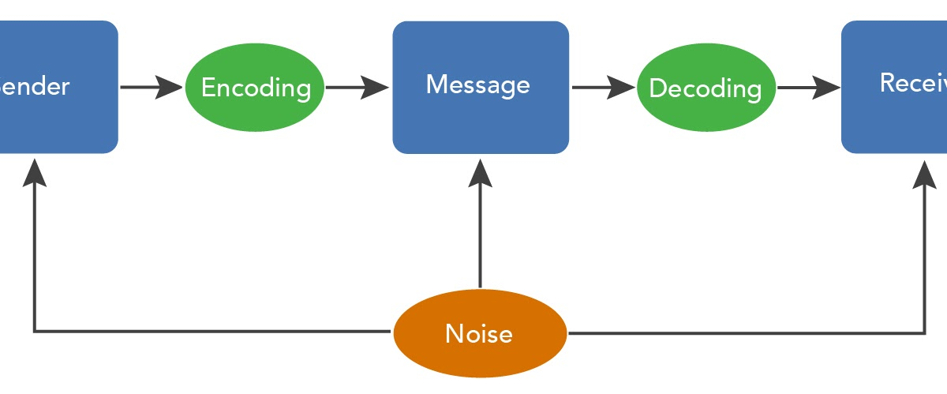
(Google, 2022)

What is Integrated Marketing Communication?
Bringing together all of the brand-building approaches to promote a certain product or service among target customers. In integrated promoting correspondence, all aspects of promoting correspondence work together to increase sales and save costs.
Aspects of Integrated Marketing Communication:
The Foundation - As the name implies, the foundation stage entails thorough research of both the products and the target market. Understanding the brand, its contributions, and end clients is critical for advertising (Juska, 2021). You truly want to know what the objective clients' requirements, mentalities, and assumptions are. Keep a close eye on the activities of the contestant.
The Corporate Culture - The aspects of things and services should be consistent with the company's work culture (Blakeman, 2018). Every organization has a dream, and advertisements must recall something extremely similar before designing things and services. Allow us to obtain it through the use of a model.
Association A's ambition is to make the world a greener and cleaner place. In general, its objects should be environmentally friendly and biodegradable, in keeping with the association's mission.

Brand Focus - The corporate nature of the brand is addressed in Brand Focus.
Buyer Experience - Marketers must focus on the buyer experience, which refers to how customers feel about a product (Kliatchko, 2019). A buyer is likely to receive an item that has excellent wrapping and appeals to the eye. Client expectations must be met and exceeded.

Promotional strategies to increase Ikea’s awareness:
Photos/interactive phone and desktop application:
It's far preferable to have a professional shot of their items or design concepts in a specific context than a single product photograph (Khan and Shafiq, 2021). Using high-quality standard photographs which might resonate with the target consumer unless the company wants its buyers to relate better to their business, is crucial.
Since its inception, the company's mobile app has gotten a lot of attention, but it could enhance the notification element for providing new deals, discounts, and promotions, as well as reminders for things left in the basket (unpurchased) or information on any new workshop activities.
Remarketing videos:
Ikea can create before and after videos to showcase its ingenuity. They can allow the buyers to witness behind-the-scenes film of the design and development phases that Ikea might provide to individuals if the company want to share their untold stories.
Producing tailored content, on the other hand, is not always easy. To improve the content marketing techniques, Ikea can hire creative home furnishings freelancers.
Displaying 1-minute or 15-20 second related video advertisements with customer feedback to visitors who have already browsed the site could be one of the remarketing techniques (Mishra, et al., 2019). This is focusing efforts on those who are previously intrigued by their offerings and encouraging them to return to the site.
Social media Influencers:
Around 80% of consumers accept suggestions from influencers because they provide a natural opportunity for companies to win people's confidence (Li, 2021). When an influencer endorses your items, their vast fan following notices and is more inclined to buy your product.
Some companies opt to deal with a large collection of nano- or micro-influencers to reach out to a wide range of individuals about their products without breaking the wallet. Meanwhile, some firms with significant expenditures team up with celebrities' personalities with a massive following to reach a broad people in one go. Collaborating with these influencers is a terrific method to reach a huge audience more intuitively than targeted advertisements, regardless of which route the company uses.
Managing customer touchpoints through multiple channels:
New sorts of customer-organization interactions have evolved in recent years as new gadgets such as smartphones, smartwatches, as well as tablets have hit the market. Customers are no longer limited to communicating with organizations by phone, email, or website; they may now do so via a variety of methods, including Web apps for mobile phones and tablets, Apps for smartwatches, Kiosks for live chat, instant messaging through email, Pages on social media (Purwantono, et al., 2021). As a result, buyer engagements are far more variable and integrated than they have ever been. To create strategic solutions that satisfy the demands of their connected consumers, today's enterprises need to go far beyond the typical business approach.
Website experiences:
Everybody realizes that when it comes to researching a business, the customer's primary point of contact is the website, and having a clean, efficient site with an easy customer lifecycle is critical.
Trying to make sure the website is properly optimized, with working social networking links and sales funnels that go to the appropriate location, may seem apparent, but these are common mistakes.
Ikea may also leverage a specialized firm's superior technological knowledge to add more endpoints to the website that their opponents would not have.
The Social media game:
Social networking is equally as crucial as the website these days. A brand may be made or broken by a widespread social media post.
But, before Ikea considers about promotion strategy, the company should make sure it has a presence on each appropriate platform, well they’re putting effort into the platforms that will enhance their brand recognition and bring them more revenue.
In-store encounters:
If the company is delivering an elevated product but is unable to invest in housing in a nice part of town, they could invest some money in educating their personnel to provide great customer service and purchasing an item of classy clothing to demonstrate it as part of the client journey. Encouraging the employees to adopt a cheerful tone and start having a conversational discussion with consumers can be another way to keep them involved. It's critical to have a strong set of rules in any product development strategy that the employees may turn to as a beacon of light.
SEO:
SEO is the most popular method of improving your site's visibility for relevant searches. The greater the perceptibility of your pages in query items, the more likely you are to stand out and attract new and existing clients to your business.
IKEA may improve its SEO by focusing on unambiguous high-level goals for its brand and items, such as:
8100 is the number to call if you want to buy furniture over the internet.
Furniture purchase: 1600
390 is the best place to buy furniture.
140 reviews of Ikea furniture
Ikea furniture may be purchased online for a total of ten dollars.
Ikea may also distribute webpages on the following topics based on the watchwords:
Apps for buying furniture over the internet
Instructions for buying furniture via the internet
On the internet, where can you get beautiful furniture?
On the internet, you may get step-by-step guidelines for arranging furniture.
Is it a good idea for you to buy furniture over the internet?
Aside from that, IKEA could focus on streamlining its content by targeting on-page and off-page SEO efforts toward improved rankings.

SEM:
Internet search engine marketing is a computerized advertising strategy for increasing a website's visibility on search engine results pages. In most cases, the word refers to paid search advertising.
Web index advertising is referred to as paid search marketing or Pay Per Click (PPC). With an increasing number of people conducting product research and purchasing on the internet, search engine marketing (SEM) is becoming increasingly important in gaining a competitive advantage.
IKEA may do this by utilizing the following competitor explicit, high objective, and purchase catchphrases:
480 Pepperfry Offers - 3,600 Pepperfry Reviews - 1,000 Amazon Furniture Offers
These blog ideas were also fabricated by the understudies to center on the most-searched-for elements by clients:
Ikea vs. Pepperfry vs. Amazon: Which is the Best Online Furniture Store?
Is it safe to buy furniture over the internet?
What is the greatest place to shop for furniture on the internet?
These online journals will not only improve SEO and SEM, but they will also provide value to readers and build brand trust and image.
SMM:
On Facebook, Instagram, Twitter, and Youtube, IKEA's Indian accounts are quite active. Without a question, their advanced presence is notable. We should take a look at a quick rundown of their online entertainment advertising procedures.
It has 30 million Facebook fans, 350 thousand Instagram followers, 5.3 thousand Twitter followers, and 41.2 thousand YouTube subscribers.
The Instagram bio of IKEA includes a link to the company's website. The website is also entirely integrated into all of their web-based entertainment articles.
The 'view store' option is available, which displays a list of IKEA item inventories.
The 'phone' option is also available for immediate assistance from customer service.
The company makes use of features that have externally entertaining and informative content.
The use of swipe-up articles to drive site traffic is also common, which is a good strategy.

Digital adoption:
In addition to social media, establishing a positive presence online is critical for gaining front-of-mind recognition among the clients.
For keeping the target demographic informed, the company could use emails and newsletters. Customers may not visit the pages on social media daily, but they do read their emails often.
Making something valuable that people will want to see and giving out free information to entice them to return for more. Using email as a direct route to keep the company’s list of emails to speed on the happenings within the business appealingly and uniquely is fantastic for keeping them engaged throughout the services you offer.

What is branding?
Marking is the process of forming a solid, positive image of a company, its products, or services in the minds of customers by including elements like a logo, a design, a statement of purpose, and a trustworthy subject throughout all marketing correspondences. Organizations may use compelling branding to set themselves apart from their competitors and build a loyal customer base.
In-store marking differs from web-based marking in that you must consider the placement of objects and props, which might affect how a customer perceives your image. In-store marking is more immersive since customers can walk about and pick up items, but online shoppers are confronted with a two-layered scenario. Certain aspects of marking are dependable both on the web and in the real world. These are well-known iconography and logos.

What is brand equity?
In business, brand value refers to the degree of effect a brand name has on customers' personalities, as well as the advantage of having a known and well-considered brand. Organizations establish brand value by providing enjoyable experiences that entice people to buy from them over competitors that provide similar goods. This is accomplished through instilling awareness through crusades that address target-shopper values, carrying through on promises and capabilities when customers use the product, and committing to and maintaining the item.
Customers are more likely to buy from your brand than from a competitor if you provide them with dependable motivational elements like points that can be swapped for restrictions or a free item on their birthday. The two most important aspects of brand value are mindfulness and experience:
Brand Recognition: Can customers tell the difference between your image and someone else's? The messaging and symbolism around your image should be long-lasting so that buyers can always tell it apart from other items. What values do customers associate with the brand? Maybe they think about things like supportability, quality, and family-friendliness.
What has been your brand's experience with direct contact with your image? This might signal that everything went as it should, that interactions with business agents and client support groups were pleasant and helpful, and that loyalty programs were beneficial.

Keller’s brand equity model
Keller's Brand Equity Model (also known as the Customer-Based Brand Equity (CBBE) Model) was initially proposed by marketing instructor Kevin Lane Keller in his widely read book "Key Brand Management." [1]
The Brand Equity Model's premise is simple: to build a strong brand, you must influence how customers think and feel about your product. You must create the correct kinds of experiences around your image so that customers have specific, positive thoughts, feelings, beliefs, and discernments about it.
When you have a strong brand, your customers will buy more from you, recommend you to others, be more loyal, and you will be less likely to lose them to competitors.
Step 1: Brand Identity
First and foremost, if Ikea wants to create "brand notability," or mindfulness - that is, Ikea wants to make sure that its image stands out and that clients remember and are aware of it.
They’re not just creating brand personality and awareness; they’re also aiming to ensure that brand distinctions are "correct" at important stages of the purchase process.
They should begin by learning about their target market. They should research their market to have a thorough understanding of how their clients see their image and discover if there are multiple market segments with varied needs and connections with their image (Raut et al., 2019).
Then, they must analyze how their clients narrowed down their choices and settled on their image vs that of their competitors. They must consider the following questions:
- When their customers choose their product, what dynamic cycles do they go through?
- What is the best way for them to organize their product or brand?
- How well does their image stand out in comparison to others?

Step 2: Brand meaning
They must Recognize and communicate how their image influences their clients, as well as a major incentive. They must Consider their picture in terms of "execution" and "symbolism" to achieve this:
The quality of their item's execution determines how successfully it meets their clients' problems. Essential features and highlights; item steadfast quality, strength, and functionality; administration viability, productivity, and compassion; style and plan; and cost, according to Keller's model.
Symbolism refers to how successfully their image meets their clients' social and psychological difficulties (AKBAROV, 2018). Their image can directly address these difficulties, based on a client's interactions with an item; or indirectly, through designated advertising or by overhearing people's talks.
Step 3: Brand Response
The responses of their clients to their picture will often fall into two categories: "decisions" and "sentiments."
The selections they make will almost always be based on the four classifications listed below.
Clients evaluate an item or brand based on its perceived and genuine quality. They must consider how they may approach these two types of value about their product or brand.
Clients evaluate validity based on three factors: ability (which includes development), dependability, and amiability. They must consider how they may improve their legitimacy in these three areas.
Clients assess their item's suitability for their unique requirements. They could Use the buyer research they conducted in step one to help them identify their clients' specific requirements (Alexandra and Cerchia, 2018). Then, they can explain how they’re going to handle these criteria and how they’re going to communicate how they’re going to support them.
Clients assess the image's prevalence by contrasting them with competitors' brands. They must Ask themselves, honestly, how well their image compares to that of their competitors. Is there anything additional or unique that their competitors provide that they don't, or vice versa? What else could they possibly do at any point?
Step 4: Brand Resonance
Because it's the most difficult - and best - level to achieve, brand "reverberation" is at the top of the brand value pyramid. When their clients form a strong mental association with their picture, they’ve achieved brand reverberation.
Keller divides reverberation into four categories:
Consistency in action - this includes routine, rehash purchases.
Attitudinal link - their customers adore their image or product, and they think it's a great deal.
Feeling of place - their consumers have a sense of place when they interact with people associated with the company, such as various purchasers and friends delegates (Esan et al., 2018). The most concrete indication of brand trustworthiness is dynamic commitment.

Advantages
Sustainable consumer loyalty
Less cost expenditure on consumer retention
Improved profit margins
Improved consumer lifetime value

Disadvantages
It is impossible to resonate with consumers in the market overloaded with information.
Requirement of highly talented personal is essential for maintaining the brand equity.

Stages in the consumer journey
- Awareness is amongst the first processes of consumer journey. It is done as a pre-sale process with the help of various marketing methods, information gathering, and research phase, looking for a better messaging and initial problem-solving.
- The second step in the process is also a pre-sale process which is recognised as consideration. The major touch points that IKEA focuses pre purchase or pre sale are described as all of a potential customer's interactions with a company before they connect with the company directly.
- Purchase is the third step in the process and is a post sale processes. The post purchase touch points of the IKEA can be described with the example of a purchaser who has purchased the furniture on credit.
- Retention is another process in the consumer journey and is regarded as one of the most difficult. It is also regarded as the process which most of the companies find difficulty with.
- The last step in the process is advocacy. If an organisation handle the other phases well, its consumers will turn into fans, and fans will give the finest marketing you can receive.

Ikea’s Customer Journey Map
Clients should scan the QR code, which will direct them to an Ikea instructional website, where they may complete their information (name, address, number, postal district, and coincidentally, IKEA has no real way to be aware assuming the data that you are finishing up is the right data, so you might place in spurious substance or another person data).
Then you'll sign a disclaimer acknowledging that you understand that the furniture you're buying must be attached to a partition or connected to a divider.
Then you continue to your request (ideally in a different part of the store) where you will be greeted by an Ikea store representative who will ask you to show your signed waiver (on your phone) and accompany you to your furniture (which before you would simply stroll to the walkway of where your furniture is, yet now that passageway is locked, and an IKEA representative should open the path).
A representative will accompany you to the container number and observe you loading your belongings onto your truck (side note, the refined man that accompanied me to the walkway where my furniture was found informed me that the workers are not permitted to assist clients with stacking furniture into their truck). The client exits the walkway so that an Ikea representative may secure the passageway.

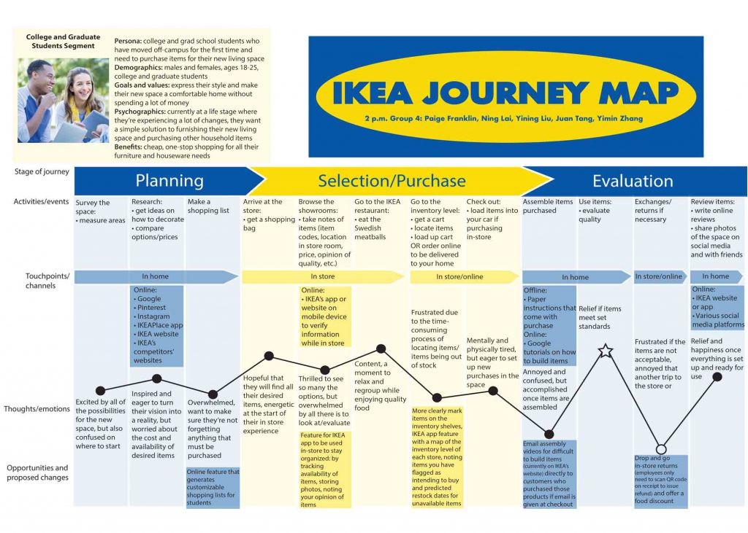
(Digital Marketing, 2022)

Total Engagement Model for Ikea
The approach starts with the suggestion that the essential components of a business be planned and altered to build connections with customers. Most associations include these components, and their unique advantages of them are well-documented. They are: Your Customer Value Proposition (CVP) is the value you provide to your customers. As a result, this is why customers should choose you over your competitors.
In addition to your logo or name, your brand is the sum of your identity and a major incentive for you. Your incentive should play an important role in shaping your brand's image and promotion, which is how you communicate the brand to customers.
Culture refers to 'how we do things around here,' and it refers to the association's interior viewpoints, such as its aims, values, and inward ways of functioning. It would be excellent if this was done to create an environment where employees can dependably provide the brand's offer and a planned customer experience.
Client Experience is a combination of physical and emotional elements that customers encounter when they work with a brand or an organization.
To connect with customers, a business should take the following steps:
1. Develop a compelling offer based on excellent customer knowledge and competitor positioning.
2. It must then consistently communicate this offer to customers through its brand promotion.
3. This assurance is then definitely given by connected employees who assist and understand the approach, and, more importantly, receive their one-of-a-kind duty in creating it a success.
This social institution enables the delivery of a planned client experience that lives up to the promise expressed in the brand's advertising.

Recommendation
In order to attract more and more consumers towards the business IKEA might offer new consumer discounts and promotions.
Networking can also be practiced in the business of IKEA as it is one of the best and cheapest ways in which brand awareness can be increased and taking new people towards the business.
Promoting the brand’s expertise can also be a helpful aspect as Ikea may build curiosity and even create buzz by exhibiting industry experience, which can help it in attracting new consumers as well as earn more revenue from their current client base.

Conclusion
It can be concluded from this report that every time the company develops a plan will make it targets the correct individuals with appropriate information. It has been analyzed that the more they put their efforts into planning…the more possibilities will be there to increase the sales of the company. The company should understand the requirements of its clients. The only way to satisfy the customers is by offering the goods and services in the right way. For a company, it is always beneficial to have a well-thought-out strategy.

References:
Åberg, E., 2019. EVALUATION OF IKEA AS A SUSTAINABLE FORESTRY ACTOR IN THE CONTEXT OF INDIA. https://lup.lub.lu.se/student-papers/record/8978275/file/8992180.pdf
Alrubah, S.A., Alsubaie, L.K., Quttainah, M.A., Pal, M., Pandey, R., Kee, D.M.H., Ling, L.K., Nadirah, N.A. and Aishan, N., 2020. Factors Affecting Environmental Performance: A Study of IKEA. International Journal of Tourism and hospitality in the Asia Pacific (IJTHAP), 3(3), pp.79-89. http://www.ejournal.aibpm.org/index.php/IJTHAP/article/view/949
Al-Zghool, M., An evaluation of IKEA’s global position and marketing standing. https://www.researchgate.net/profile/Mohammed-Alzghool/publication/346059671_An_evaluation_of_IKEA's_global_position_and_marketing_standing/links/5fb94628458515b7975d11a8/An-evaluation-of-IKEAs-global-position-and-marketing-standing.pdf
Al-Zghool, M., An evaluation of IKEA’s global position and marketing standing. https://www.researchgate.net/profile/Mohammed-Alzghool/publication/346059671_An_evaluation_of_IKEA's_global_position_and_marketing_standing/links/5fb94628458515b7975d11a8/An-evaluation-of-IKEAs-global-position-and-marketing-standing.pdf
App, 2022. Image. [Online]. Available at: https://images.app.goo.gl/4Wa9k54bHnVhrZ3eA [Accessed on: 5 April 2022]
Digital Marketing, 2022. IKEA. [Online]. Available at: https://digitalmarketing.temple.edu/abethune/2021/07/20/230/
Goel, R. and Garg, S., 2018. India as a Marketplace: A Case Study of IKEA. Available at SSRN 3282924. https://papers.ssrn.com/sol3/papers.cfm?abstract_id=3282924
Google, 2022. Findia. [[Online]. Available at: https://www.google.com/imgres?imgurl=https%3A%2F%2Fstatic.toiimg.com%2Fthumb%2Fmsid-70287610%2Cwidth-1200%2Cheight-900%2Cresizemode-4%2F.jpg&imgrefurl=https%3A%2F%2Ftimesofindia.indiatimes.com%2Fbusiness%2Findia-business%2Fbefore-store-opens-ikea-to-go-online-in-mumbai%2Farticleshow%2F70285600.cms&tbnid=AFPDdsL4COAIPM&vet=1&docid=MD1E6-N37px4PM&w=1200&h=900&hl=en-US&source=sh%2Fx%2Fim [Accessed on: 5 April 2022]
Google, 2022. IKEA. [Online]. Available at: https://www.google.com/url?sa=i&url=http%3A%2F%2Fbconsi.blogspot.com%2F2012%2F12%2Fimportance-of-communication-model.html&psig=AOvVaw3XgbNmUyT1iskdPt0aCwtz&ust=1649954224303000&source=images&cd=vfe&ved=0CAwQ3YkBahcKEwjIxezPvJH3AhUAAAAAHQAAAAAQAw
Jiang, Y., Jia, F. and Gong, Y., 2018. IKEA: global sourcing and the sustainable leather initiative. International Food and Agribusiness Management Review, 21(5), pp.627-640. https://www.wageningenacademic.com/doi/abs/10.22434/IFAMR2017.0109
Khan, A. and Shafiq, A.A., 2021. Internationalization Challenges for Retail Firms in Emerging Asian Markets: A case study of IKEA. https://www.diva-portal.org/smash/record.jsf?pid=diva2:1563364
Kostov, T., 2020. IMPACT OF SOCIAL MEDIA MARKETING ON CONSUMER BEHAVIOR. https://www.theseus.fi/handle/10024/346836
Kumar, V., 2021. Emergence of Disruptive Technologies & Their Impact on Marketing of Products and Services. Available at SSRN 3993471. https://papers.ssrn.com/sol3/papers.cfm?abstract_id=3993471
Lawrence, G., Harvey, A., Hunter, J., Mohammed, A., Nolan, W., Stallings, L. and Jones, C., 2021. IKEA: GROWING THE MARKET IN INDIA–AN INTERNATIONAL CASE STUDY. https://digitalcommons.kennesaw.edu/undergradsymposiumksu/spring2020/presentations/104/
Li, Y., Business Insight: Leadership and Human Resource Management Analysis for IKEA. http://ijmrap.com/wp-content/uploads/2020/07/IJMRAP-V3N1P47Y20.pdf
Mishra, A., Shukla, A., Rana, N.P. and Dwivedi, Y.K., 2021. From “touch” to a “multisensory” experience: The impact of technology interface and product type on consumer responses. Psychology & Marketing, 38(3), pp.385-396. https://onlinelibrary.wiley.com/doi/abs/10.1002/mar.21436
Mishra, R.K., Raj, A.S. and Karuna, M., 2019. IKEA, Furnishing the Indian Homes: The Challenges of Culture, Competition and Channel. IPE Journal of, p.95. https://www.ipeindia.org/wp-content/uploads/journals/ijm/IPE%20JoM%20(Jan-Jun%202019).pdf#page=99
Mustaphi, B.M., 2020. Digital Marketing Strategies for Effective Customer Relationship Management. Journal of Modern Accounting and Auditing, 16(8), pp.376-384. https://www.davidpublisher.com/Public/uploads/Contribute/5fa8fa0b3bd6d.pdf
Purwantono, H.Y., Gunawan, A.A., Tolle, H., Attamimi, M. and Budiharto, W., 2021. A literature review: Feasibility Study of technology to improve shopping experience. Procedia Computer Science, 179, pp.468-479. https://www.sciencedirect.com/science/article/pii/S1877050921000351
Roy, D., 2020. Impact of Consumer Market Preferences on Expansion Strategies: Strategies Used by IKEA in the International Market. https://www.theseus.fi/handle/10024/334652
Sheela, P. and Rao, S.G., 2020. Social entrepreneurship concept and reality: An Indian perspective. SMART Journal of Business Management Studies, 16(2), pp.96-103. https://www.indianjournals.com/ijor.aspx?target=ijor:sjbms&volume=16&issue=2&article=010
Sin, L.G., Utama, A.G.S., Pandey, S., Pandey, R., Harsha, Y.S.S.V.S., Massand, A., Safitri, A.D.I., Yan, N.P., Kee, D.M.H., Yue, W.S. and Zhin, P.M., 2021. A Case Study of the Factors that Affect Consumer Behavior in IKEA. Asia Pacific Journal of Management and Education (APJME), 4(2), pp.20-28. http://www.ejournal.aibpm.org/index.php/APJME/article/view/1068
Tronvoll, B., Edvardsson, B. and Möllerskov-Jonzon, M., 2019. From customer feedback to innovation: The IKEA innovation journey from screws to click. In Service Innovation For Sustainable Business: Stimulating, Realizing and Capturing the Value from Service Innovation (pp. 75-93). https://books.google.com/books?hl=en&lr=&id=I7ySDwAAQBAJ&oi=fnd&pg=PA75&dq=Ikea+India+vision+and+challenges&ots=AWhhoVewlu&sig=itfvMIG0KVmuXnxnXhhmRkKrjK0
Tronvoll, B., Edvardsson, B. and Möllerskov-Jonzon, M., 2019. From customer feedback to innovation: The IKEA innovation journey from screws to click. In Service Innovation For Sustainable Business: Stimulating, Realizing and Capturing the Value from Service Innovation (pp. 75-93). https://books.google.com/books?hl=en&lr=&id=I7ySDwAAQBAJ&oi=fnd&pg=PA75&dq=ikea+india+website+user+experience&ots=AWhhoWdtrC&sig=JE2us66ZngD2pSjanOQWWeEiEb8
Yadav, N., 2020. IKEA Inc.: the India way. Emerald Emerging Markets Case Studies. https://www.emerald.com/insight/content/doi/10.1108/EEMCS-05-2019-0098/full/html
Yang, Z., 2019. Culture and Website: User experience in website redesign based on cultural differences. https://odr.chalmers.se/handle/20.500.12380/300511
Juska, J.M., 2021. Integrated marketing communication: advertising and promotion in a digital world. Routledge. https://www.taylorfrancis.com/books/mono/10.4324/9780367443382/integrated-marketing-communication-jerome-juska
Blakeman, R., 2018. Integrated marketing communication: creative strategy from idea to implementation. Rowman & Littlefield. https://books.google.com/books?hl=en&lr=&id=m-1DDwAAQBAJ&oi=fnd&pg=PR3&dq=integrated+marketing+communication&ots=REKfsrqkYt&sig=V2FvrgF72aTPG8rWu14hh9Z20XE
Kliatchko, J., 2019. Integrated marketing communication: Putting the human person at the core. Cambridge Scholars Publishing. https://books.google.com/books?hl=en&lr=&id=gge9DwAAQBAJ&oi=fnd&pg=PR5&dq=integrated+marketing+communication&ots=77RsfETyQB&sig=WZ53fw2ZjFZZ771yx0bk0eCu298
Raut, U.R., Pawar, P.A., Brito, P.Q. and Sisodia, G.S., 2019. Mediating model of brand equity and its application. Spanish Journal of Marketing-ESIC. https://www.emerald.com/insight/content/doi/10.1108/SJME-04-2019-0021/full/html
AKBAROV, S., 2018. Antecedents of Customer Based Brand Equity-Research in Azerbaijan. Journal of Business and Management Sciences, 6(2), pp.54-58. http://article.businessmanagementsciences.com/pdf/jbms-6-2-5.pdf
Alexandra, Z. and Cerchia, A.E., 2018. The Influence of Brand Awareness and Other Dimensions of Brand Equity in Consumers Behaviour: The „Affordable Luxury” Strategy.“. Ovidius” University Annals,. Ovidius Univ Annal Economic Sci Series, 18(1), pp.222-427. https://stec.univ-ovidius.ro/html/anale/RO/wp-content/uploads/2018/08/27-1.pdf
Esan, E.A., Nordin, N. and Radzi, W.N.W.M., 2018. A study of customer-based brand equity prioritization by using Analytical Hierarchy Process. Applied Mathematics and Computational ıntelligence, 7(1), pp.23-32. http://103.86.130.96/images/Artikel/AMCI_jun_2018/AMCI_Vol_7_2018_23-32.pdf

