Comparing the physiological Effects of a Cool and Hot Enviroment During a 30-minute Wattbike Trial Test
Introduction
Engaging in physical activity under hot temperatures imposes more significant physiological demands on the body compared to exercising at the same intensity in moderate conditions, compromising exercise performance (Tyler, et al. 2016). Elevated body temperatures have been directly associated with physiological changes that effect cardiovascular, neuromuscular, metabolic, immunological, and perceptual functions, which can result in premature fatigue (Cheung, 2010). A notable behavioural reaction observed during physical activity in warm surroundings is a decrease in exercise intensity. Hence, behavioural thermoregulation emerges as a significant factor influencing exercise capacity in hot conditions (Flouris and Schlader, 2015). This highlights how behaviour can affect physiological processes and maintain internal balance (Flouris and Schlader, 2015). While exercising, most of the chemical energy from food is transformed into heat, with only a small portion utilized to generate mechanical energy for external tasks (Flouris and Schlader, 2015). A significant proportion of the metabolic rate required for external work generates heat that needs to be dissipated, influencing behaviour and performance during exercise (Flouris and Schlader, 2015). This occurrence arises as the metabolic rate of muscles increases at the start of exercise, leading to a gradual rise in temperature difference between the muscles and the body's core (Flouris and Schlader, 2015). Consequently, the muscles contain more heat than the core region (Flouris and Schlader, 2015). The heat generated in muscles during cellular respiration is transferred to the core through processes such as conductive and convective heat exchange between the active muscles and the blood, as well as between the muscles and the surrounding tissue (Flouris and Schlader, 2015). Under conditions of constant exercise intensity and mechanical efficiency, the rate of metabolic heat production stabilizes within approximately 10 minutes and persists throughout the exercise session (Flouris and Schlader, 2015). With prolonged exercise, the accumulation of body heat and subsequent core temperature rise prompt autonomic responses for heat loss, including skin vasodilation and sweating. However, in environments where ambient temperature surpasses skin temperature and/or high humidity impedes evaporative heat loss, achieving thermal balance becomes challenging despite maximal activation of the body's autonomic heat loss mechanisms (Flouris and Schlader, 2015).
After approximately 10 minutes of sustained, steady-state, moderate-intensity exercise (50-75% of maximal oxygen uptake, there is a gradual, continuous alteration over time known as cardiovascular drift (Wingo, et al. 2018). During this period, heart rate steadily increases, while stroke volume, mean arterial pressure, and pulmonary pressures gradually decrease (Wingo, et al. 2018). Despite these changes, cardiac output remains relatively stable (Wingo, et al. 2018). This cardiovascular drift occurrence is observed in both thermoneutral and warm environments, with more notable changes occurring in warmer conditions (Wingo, et al. 2018). Active muscles depend on blood flow, mainly for oxygen delivery, to fulfil the energy requirements during muscle activity, whereas blood flow to the skin is essential for regulating body temperature (González‐Alonso, Calbet, and Nielsen, 1999). These two blood flow requirements compete for the available cardiac output. Diminished blood flow to working muscles constrains the intensity and duration of exercise, while decreased skin blood flow hampers heat dissipation, leading to elevated body temperature, which can have negative consequences (González‐Alonso, Calbet, and Nielsen, 1999).
In a study investigating the impact of heat stress on cardiac baroreflex sensitivity, it was determined that heat did not significantly affect the body's automatic response to exercise when the intensity was not fixed (Pecanha, Forjaz, and Low, 2017). However, in a subsequent investigation where exercise intensity remained constant, the introduction of heat led to heightened heart rate and perceived exertion (Pecanha, Forjaz, and Low, 2017). Notably, another study involving experienced cyclists found that while riding at a consistent intensity in heated conditions, their heart rate increased without a significant rise in perceived exertion (RPE) after the initial 10 minutes, suggesting that environmental changes may not significantly impact perceived exertion in trained cyclists (Borg, et al.2018). Previous research has indicated a potential decrease in VO2max during exercise in hot conditions, as evidenced by a study involving nine male athletes performing a Wingate anaerobic test in heated dry and also heated humid conditions (Zhao, et al. 2013). Interestingly, humidity levels did not significantly affect VO2max, suggesting that while heat may impair performance, humidity does not appear to have a substantial impact on these athletes (Zhao, et al. 2013).
The primary objective of the current study was to examine the physiological responses of thirteen recreationally active students exercising in cool versus hot conditions. Specifically, the study aimed to assess changes in core temperature, heart rate, perceived exertion, VO2, and weight loss.

Method

Participants - Thirteen students of both genders, from the Sport and Exercise Science discipline, were recruited for this study. All participants were engaged in regular recreational exercise. Prior to commencement, each participant underwent health screening utilizing the Physical Activity Readiness Questionnaire (PAR-Q), and informed consent was obtained. The mean age of the participants was recorded at (29.6), with an average pre-testing body weight of 79.2 kilograms.

Experimental Protocol - The experimental protocol began with participants undergoing a preliminary watt bike trial test using the Wattbike atom x (Wattbike, Nottingham, uk). to determine their maximum oxygen uptake (VO2 max). Subsequently, 60 percent of the VO2 max was calculated to ascertain the appropriate workload for both trial tests. A Polar H7 chest strap was used to collect heart rate data (Polar electro, Warwick, uk).
Environmental conditions were controlled throughout the experiment. Test 1 was conducted under ambient conditions, with an air temperature of 7 degrees Celsius and a humidity level of 50%. Test 2, however, was carried out under different conditions, with an air temperature of 32 degrees Celsius and a humidity level of 65%.
Each participant performed two 30-minute watt bike trial tests, maintaining a workload equivalent to 60% of their individual VO2 max. Prior to and post each test, body weight was recorded, while core temperature was measured before the trial and subsequently at 10, 20, and 30 minutes into the exercise. Additionally, heart rate and RPE were assessed at the same intervals. VO2 max was quantified using expired air analysis, employing the Douglas 100litre with 2100 series 3 way stop cock method (Hans Rudolph, Kansas, USA).
The experimental design employed a Paired Sample t-test to analyse the collected data, while the effect size was determined using the ETA squared equation.

Results

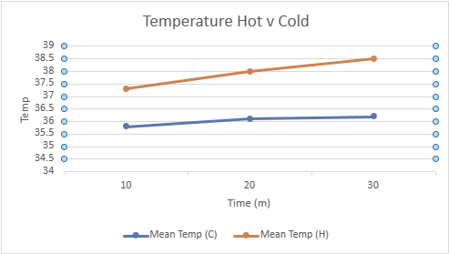
Figure 1: Cold v hot temperature at 10, 20 & 30 minutes

Figure 1 illustrates a progressive rise in core body temperature under both cool and hot environmental conditions. Specifically, the data reveals a 1.1% increase from 10 to 30 minutes in the cool environment, while in the hot environment, this elevation is greater, reaching 3.2%.
Moreover, a comparative analysis between the two environments indicates significant differences in core body temperature response. By the 10-minute mark, the increase in core body temperature was 4.1% higher in the hot environment compared to the cool, escalating to 5.2% by 20 minutes and peaking at 6.3% higher by the 30-minute interval. Highlighting a pronounced effect of the environmental temperature on core body temperature dynamics during the physical exertion.

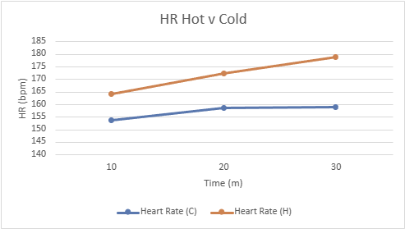
Figure 2: Cold v hot heart rate at 10, 20 & 30 minutes

The findings presented in Figure 2 demonstrate a notable trend in heart rate response across different temperature conditions. Specifically, there was a discernible elevation in mean heart rate (measured in beats per minute) over the duration of the trial. In the cool temperature setting, there was an observed increase of 3.4% from the 10th to the 30th minute. Conversely, in the hot temperature environment, the mean heart rate exhibited a more pronounced escalation, rising by 9% during the same time frame.
Furthermore, a comparative analysis between the two temperature conditions revealed significant disparities in heart rate response. Notably, by the 10-minute mark, participants exhibited a mean heart rate 6.6% higher in the hot environment compared to the cool. This discrepancy widened to 8.7% by the 20-minute interval and reached a peak of 12.5% higher by the end of the 30-minute period. These observations reveal the influence of environmental temperature on cardiovascular response during exercise, with higher temperatures showing a more substantial increase in heart rate over time.

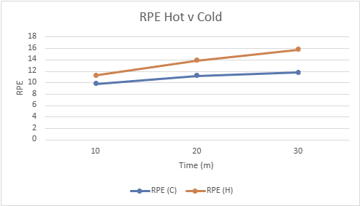
Fig 3: Cold v hot RPE at 10, 20 & 30 minutes

Figure 3 presents the progression of RPE over time in both cool and hot temperature conditions. Notably, RPE increased by 20.4% from the 10th to the 30th minute in the cool environment, whereas in the hot temperature, this increment was notably higher at 39.8%.
Furthermore, a comparative analysis highlights differences in RPE response between the two temperature conditions. By the 10-minute mark, the increase in RPE was 15.3% higher in the hot environment compared to the cool, increasing to 24.1% by 20 minutes and then tapering slightly to 15.8% higher by the 30-minute interval. These observations show the impact of temperature on perceived exertion during exercise, with higher temperatures correlating with greater perceived effort.

Table 1: Cold v hot weight loss, pre and post test
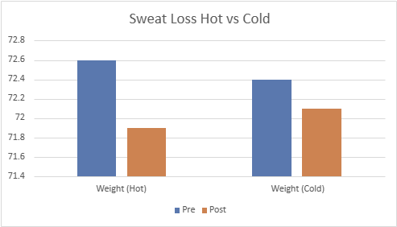

Table 1 presents the results indicating a slight decrease in weight, with a 0.4% reduction observed in the cool environment and a 0.9% decrease in the hot environment from pre to post weighing. These findings suggest a marginal weight loss during the experimental trials.

There were no significant differences in V02; However, a notable difference was observed for individuals but just not reflected in a study of this size.

Table 2: The Significance and Effects of the Changes in Temperature, Heart Rate, RPE, V02 and Sweat loss Between a Cool and Hot Environment.

 | Cool | Hot | Significance | Effect
Temperature | 0.3 | 1.1 | P = 0.003 | 0.54
Heart Rate | 5.2 | 14.8 | P = 0.003 | 0.52
RPE | 2.0 | 4.5 | P = 0.003 | 0.53
V02 | 1.4 | 4.8 | P = 0.68 | 0.25
Sweat Loss | 0.3 | 0.6 | P = 0.008 | 0.45
▪

Significant changes were observed (p < 0.05) in temperature, heart rate, RPE, and sweat loss. However, there was no significant difference in VO2 change.

Discussion
The findings of this study highlight the physiological responses of recreationally active individuals to exercise in cool versus hot environmental conditions, providing insights into the influence of temperature on exercise performance. These results align with previous research, as outlined in the introduction, which emphasizes the significant impact of environmental temperature on various physiological parameters during physical activity.
Consistent with previous studies (Flouris & Schlader, 2015) & (Wingo, et al. 2018), our results demonstrate a progressive increase in core body temperature during exercise, with a significant rise observed in hot conditions compared to cool conditions. This signifies that environmental temperature plays a crucial role in core temperature changes during physical exertion, highlighting the pronounced effect of heat stress on thermoregulatory mechanisms.
Similarly, our findings regarding heart rate response mirror those reported in previous research (Wingo et al., 2018), with participants exhibiting a more substantial increase in heart rate in hot conditions compared to cool conditions. This emphasizes the influence of environmental temperature on cardiovascular function during exercise, with higher temperatures causing a more pronounced cardiovascular response over time.
Furthermore, the study highlights the impact of temperature on perceived exertion during exercise. These findings are consistent with previous research highlighting the role of environmental temperature in shaping individuals' subjective perceptions of effort during physical activity (Flouris & Schlader, 2015).
Interestingly, while our study did not find a significant difference in VO2 change between cool and hot conditions, this contrasts with previous research indicating a potential decrease in VO2max during exercise in hot conditions (Zhao et al., 2013). However, the individual variations and the limitations of our study design in capturing more subtle changes in VO2 must be considered. A significant difference in sweat loss between cool and hot conditions was observed, presenting the role of environmental temperature in modulating thermoregulatory responses during physical activity.
In conclusion, this study investigated the physiological effects of exercising in cool versus hot environmental conditions, focusing on core temperature, heart rate, perceived exertion, and weight loss. The findings of this study contribute to the understanding of how environmental temperature influences physiological responses during exercise.
The results demonstrate that exercising in hot conditions leads to a more significant increase in core body temperature, heart rate, and perceived exertion compared to exercising in cool conditions. These findings align with previous research, highlighting the substantial impact of environmental temperature on various physiological parameters during physical activity. The differences in physiological responses between cool and hot conditions highlight the importance of considering environmental factors in exercise performance and health outcomes. Understanding how temperature affects the body's response to exercise can inform strategies for optimizing performance and minimizing the risk of heat-related illnesses.
Overall, this study emphasizes the relationship between environmental temperature and physiological responses during exercise. Further research is needed to explore individual differences and additional factors that may influence these responses, ultimately enhancing the ability to tailor exercise interventions for different environmental conditions and populations.

Word Count - 2108

References
Borg, D.N., Stewart, I.B., Costello, J.T., Drovandi, C.C. and Minett, G.M., 2018. The impact of environmental temperature deception on perceived exertion during fixed-intensity exercise in the heat in trained-cyclists. Physiology & behavior, 194, pp.333-340.
Cheung, S.S., 2010. Interconnections between thermal perception and exercise capacity in the heat. Scandinavian journal of medicine & science in sports, 20, pp.53-59.
Flouris, A.D. and Schlader, Z., 2015. Human behavioral thermoregulation during exercise in the heat. Scandinavian journal of medicine & science in sports, 25, pp.52-64.
González‐Alonso, J., Calbet, J.A. and Nielsen, B., 1999. Metabolic and thermodynamic responses to dehydration‐induced reductions in muscle blood flow in exercising humans. The Journal of Physiology, 520(2), pp.577-589.
Pecanha, T., Forjaz, C.L. and Low, D.A., 2017. Additive effects of heating and exercise on baroreflex control of heart rate in healthy males. Journal of Applied Physiology, 123(6), pp.1555-1562.
Tyler, C.J., Reeve, T., Hodges, G.J. and Cheung, S.S., 2016. The effects of heat adaptation on physiology, perception and exercise performance in the heat: a meta-analysis. Sports medicine, 46, pp.1699-1724.
Wingo, J.E., Lafrenz, A.J., Ganio, M.S., Edwards, G.L. and Cureton, K.J., 2018. Cardiovascular drift is related to reduced maximal oxygen uptake during heat stress.
Zhao, J., Lorenzo, S., An, N., Feng, W., Lai, L. and Cui, S., 2013. Effects of heat and different humidity levels on aerobic and anaerobic exercise performance in athletes. Journal of Exercise Science & Fitness, 11(1), pp.35-41.

